Alex Hortin
Assignment 3
2/14/2007

- Describe a method for creating all of these files without creating each one manually. (Hint: The touch command can create a given file.)
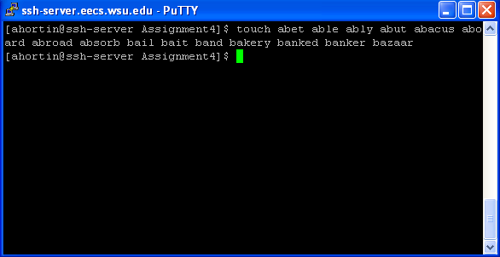
- Use the ls command with a single argument to list all files whose names end with the letter 'd'. (Include the command and its output for full credit on this and all the following questions.)
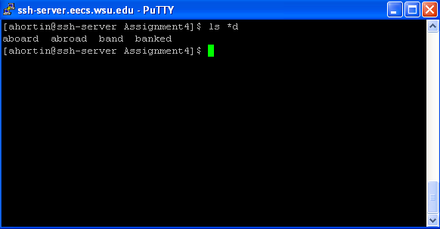

- Use the ls command with a single argument to list all files whose names contain the letter 'l'.
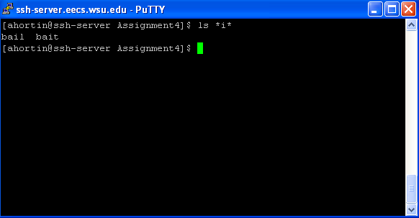
- Use the ls command with a single argument to list all files whose names start with 'ba' followed by a vowel.
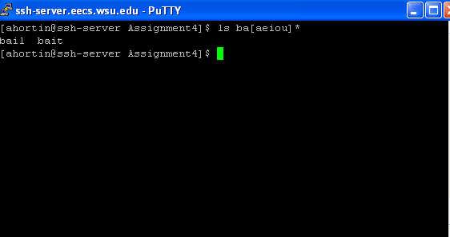

- Use the ls command with a single argument to list all files whose names start with 'ab' and contain an 'r' somewhere in the name.
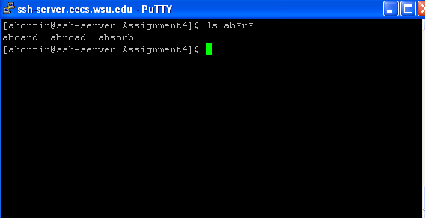
- Use the ls command with a single argument to list all files whose names contain two consecutive vowels.
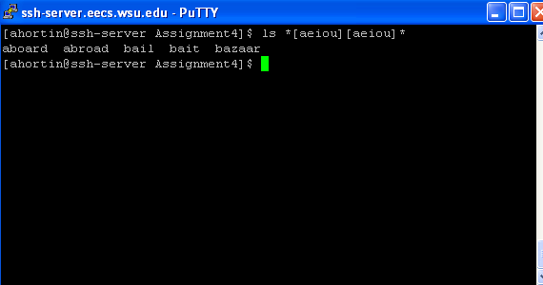

- Use the ls command with a single argument to list all files whose names start with a 'b' and contain two consecutive vowels.
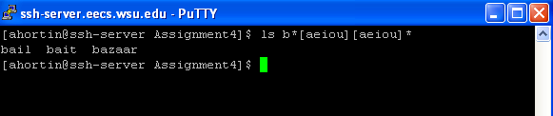
- Use the ls command with a single argument to list all files whose names contain only 4 letters.
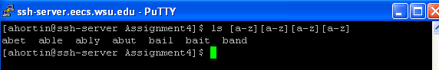
- Use the ls command with a single argument to list all files whose names contain either an 'l' or an 'n' as the third letter.
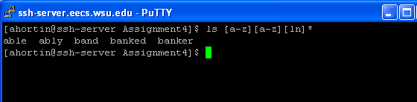
- Use the ls command with a single argument to list all files whose names end with a letter from the second half of the alphabet (letters 'm' through 'z').

