Alex Hortin
2/26/2007
Assignment 5

1. Find a regular expression that will allow you to grep for all lines containing words that start with "T" and end with "," (a comma).
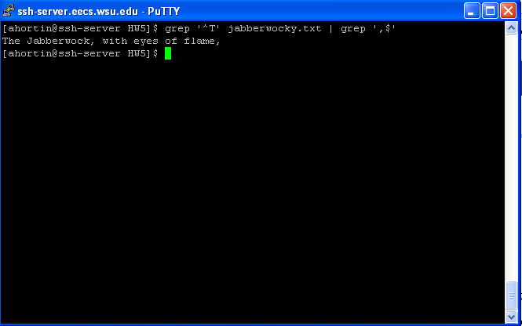
2. Find a regular expression that will match all lines containing a capital "A", but not if capital "A" is the first character in the line.
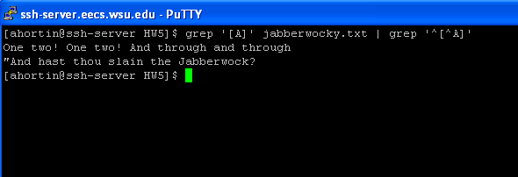

3. Using sed, replace "'Jabberwock" with "Rabid Squirrel" .
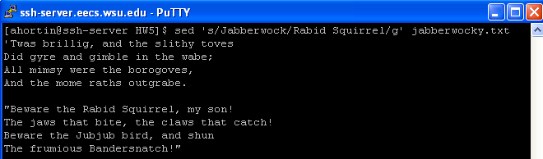
4. Using sed, replace all occurrences of "he" or "He" with "she" or "She", "his" with "her", "son" with "daughter", and "boy" with "girl" (preserving the capitalization of the original).
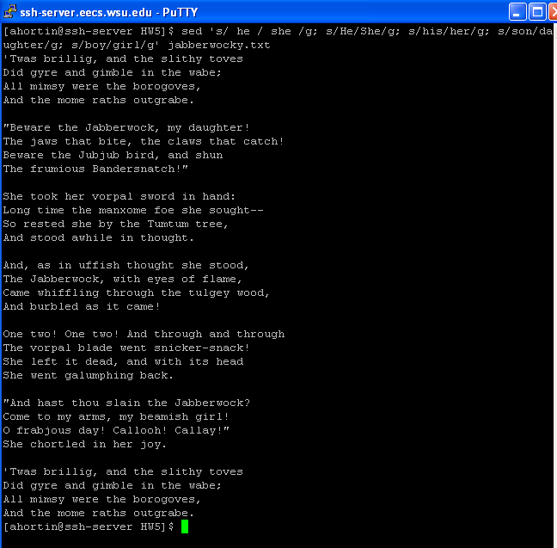

5. Find all of the punctuation marks used in the poem, and give a count of the number of occurrences of each. (Hint: you can do something similar to the "tr + sort" word count example.)
