Deep Learning In Medicine CDSW Demo

[skiaie@cloudera.com](mailto:skiaie@cloudera.com)

Demo Summary:

* Use Case: Diagnosing Melanoma
* Broader Healthcare Applicability:
  + Disease diagnosis using medical images
    - radiology (arteriography, mammography, radiomics)
    - dermatology
    - oncology
* Broader Industry applicability
  + Biotech
  + Pharma
  + Semiconductor Fabrication
  + Vegetation Management (Electricity Transmission, Distribution)

Story

1. We take open source images of skin lesions, and use those to build a classifier to detect malignant skin lesions
2. We evaluate the performance of our model using TensorBoard, and matplotlib in CDSW
3. We deploy the model onto a mobile device for use in clinical settings
4. We use our mobile app to determine if a patient needs critical attention from a physician (Note: in the demo we use a model deployed on a mobile device, for simplicity. I.e. inference happens on the edge, using a low latency, MobileNet model. The more likely choice for this use case would be to perform classification in batch or perform the inference centrally, using a model with superior performance characteristics (measured by AUC).

**1.**

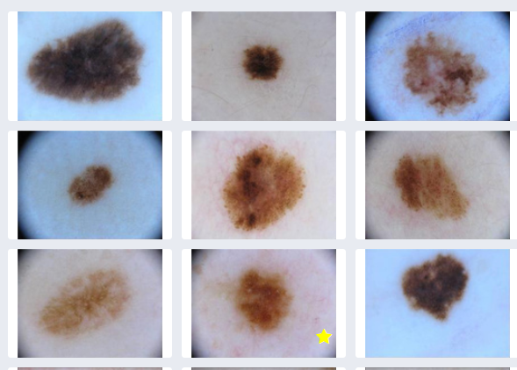

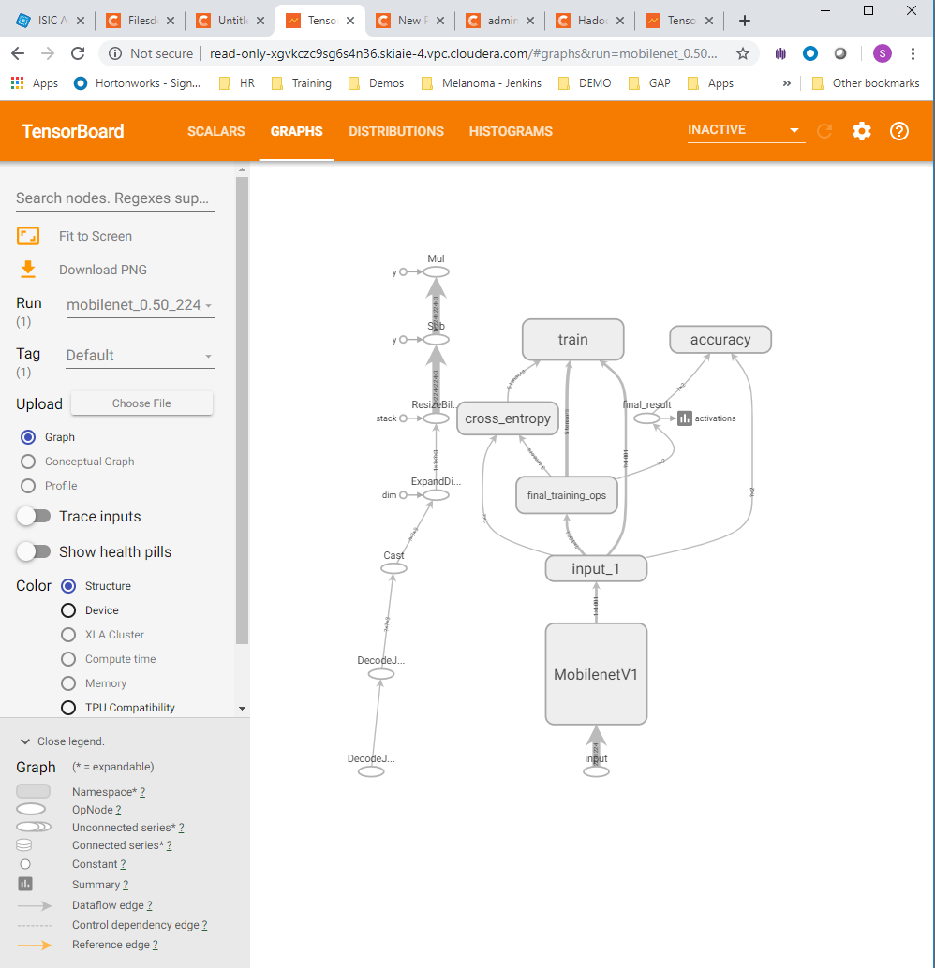

**2.**

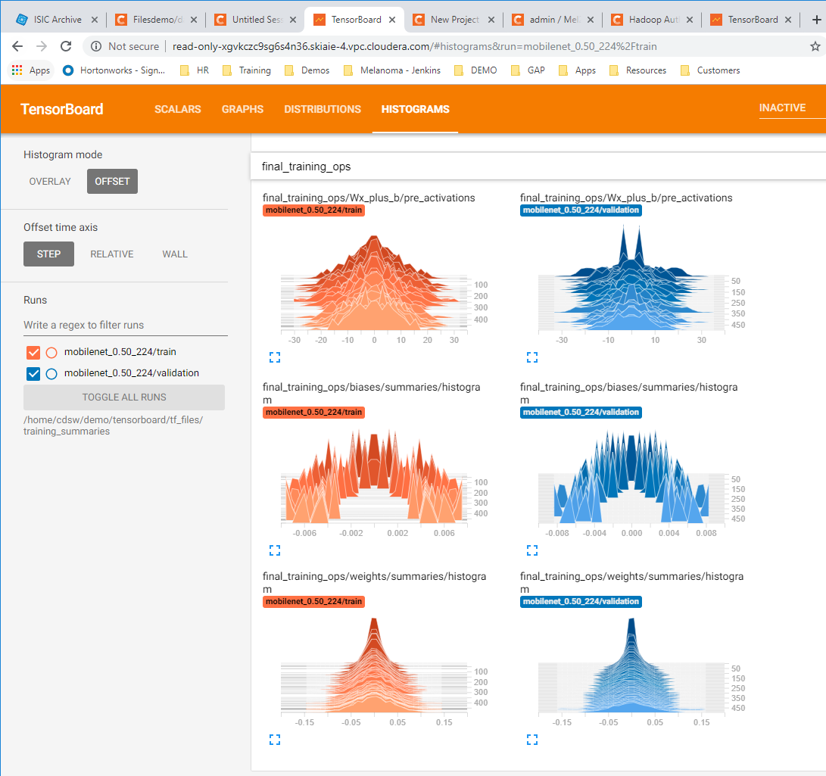

**3,4.**

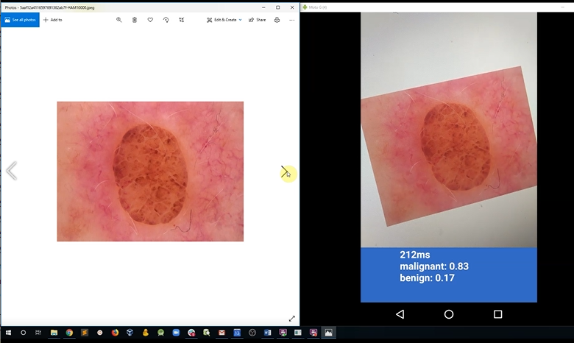

The talk track video for the intro is included, below. The deck is also included:

* Talk Track
* Deck

The demo talk track video is included below

* Talk Track

Demo Setup

The setup takes 5 minutes

1. In CDSW Go to Projects, and create a New Project

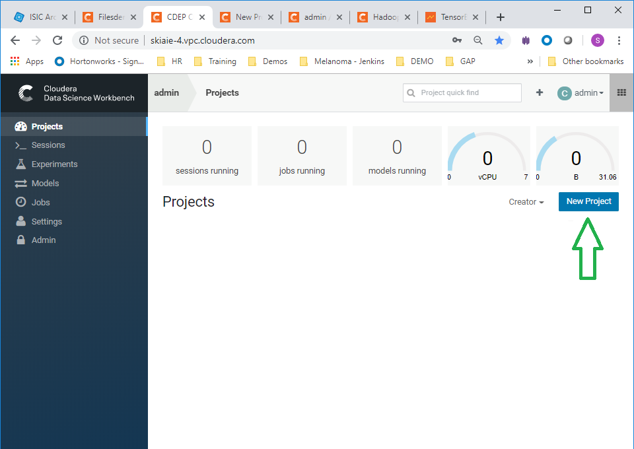

1. Name the Project “Melanoma Classification”, and in the initial setup use git repo: <https://github.com/hortonworks-sk/CDSW-Melanoma2.git> , and hit the create button

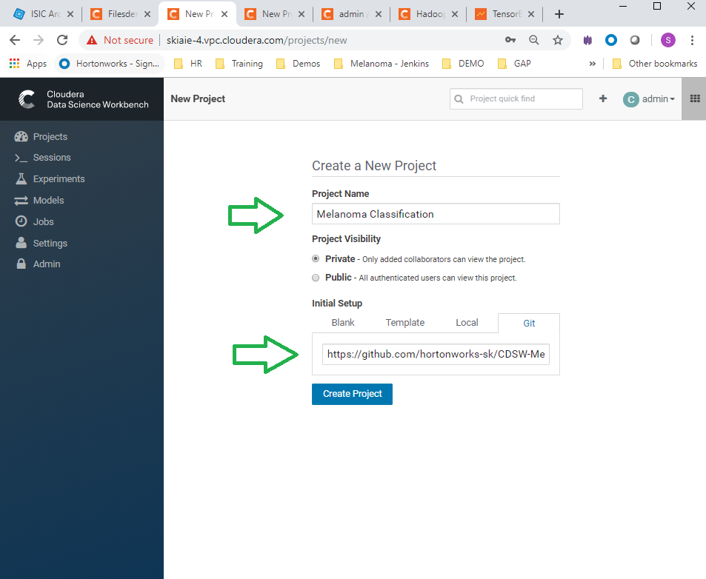

1. Launch a Python 3 workbench session

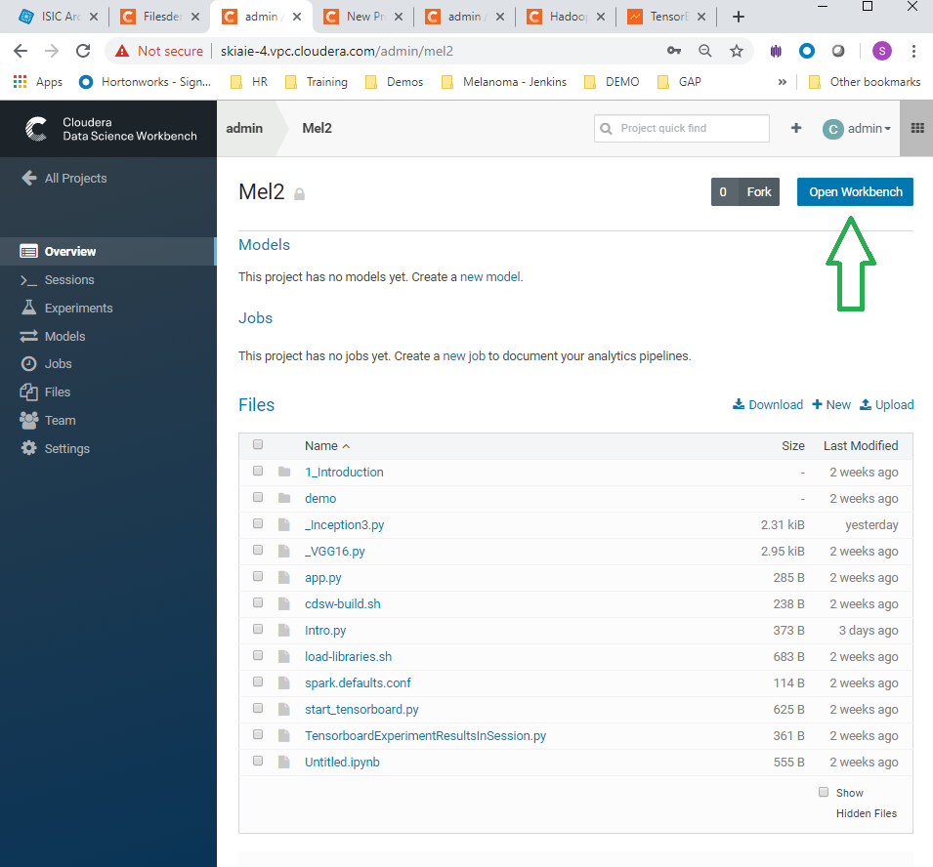 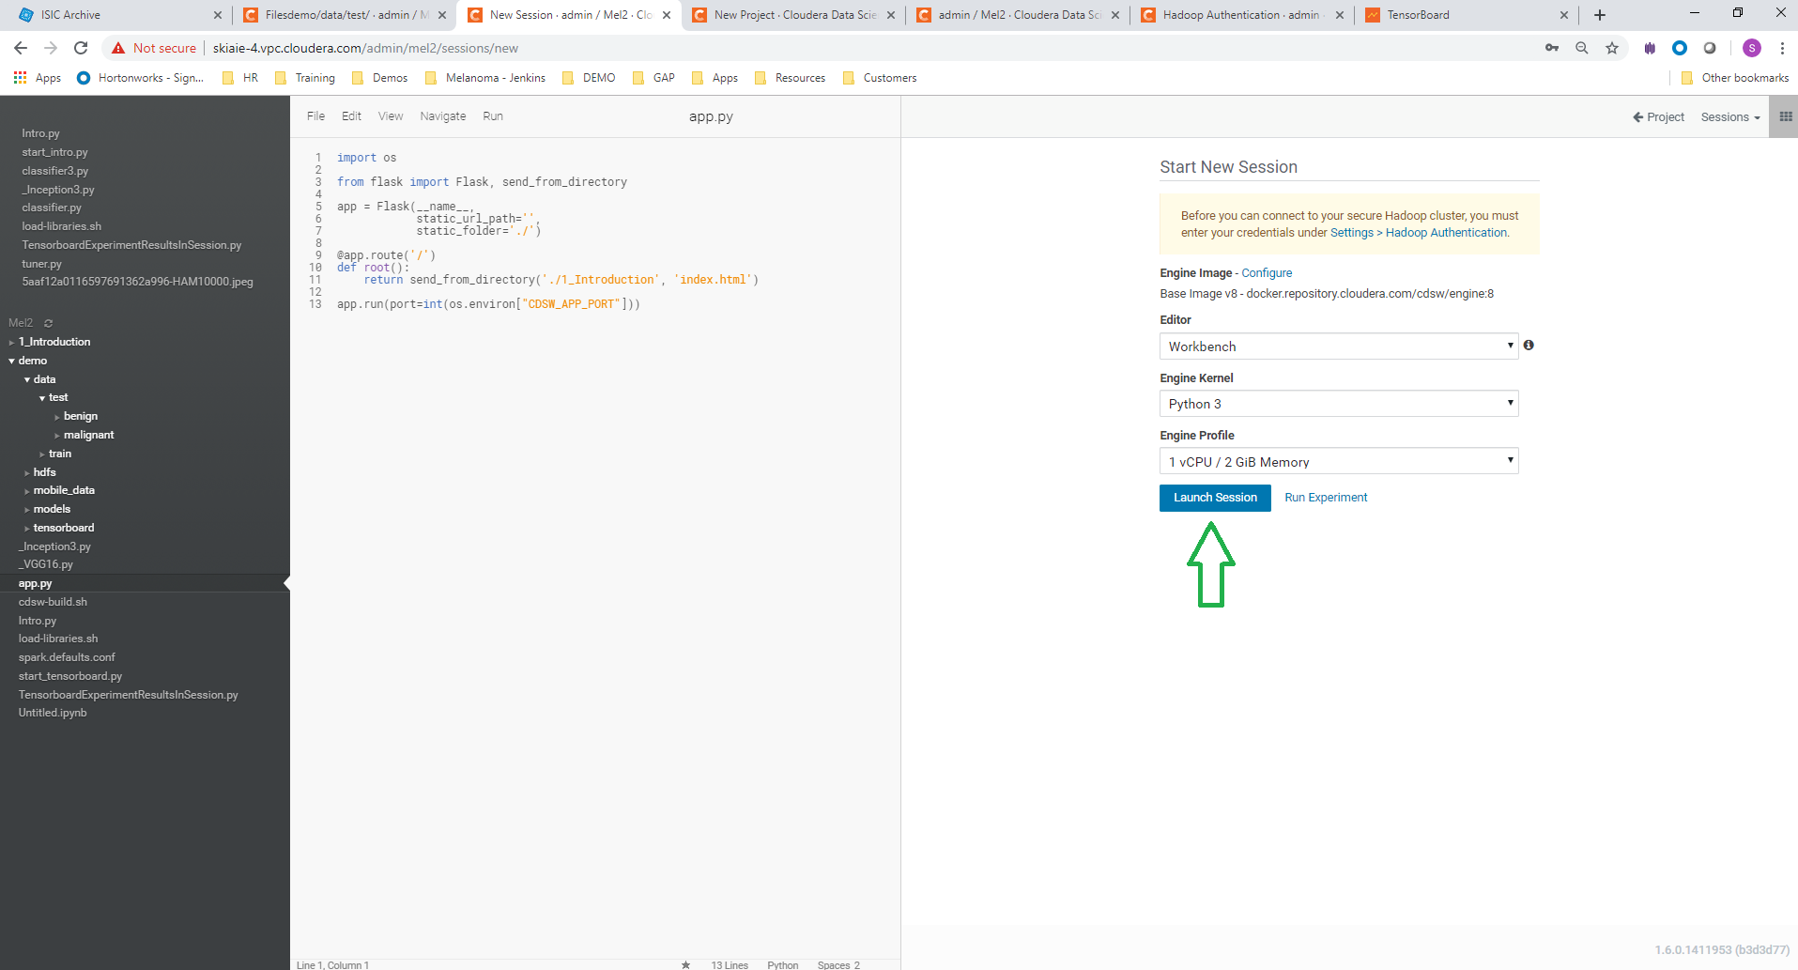

1. Navigate to the **load-libraries.sh** script, and run the script. This will load the libraries needed for the demo.

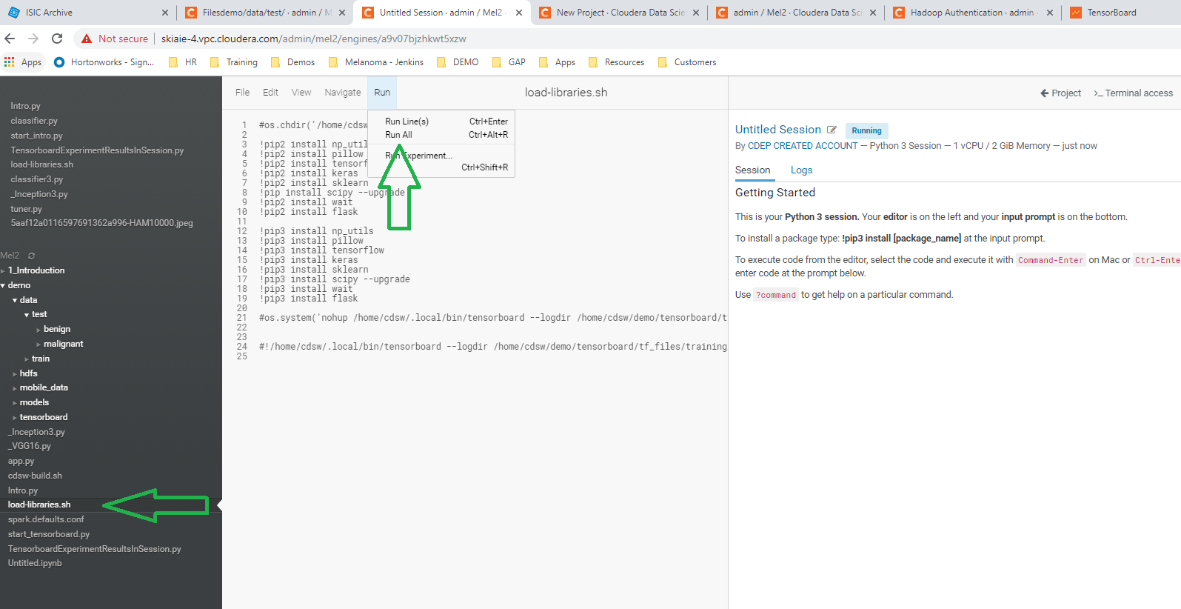

1. Stop the Python 3 workbench session, and open another Python 3 session. This is required for some of the libraries to be available.

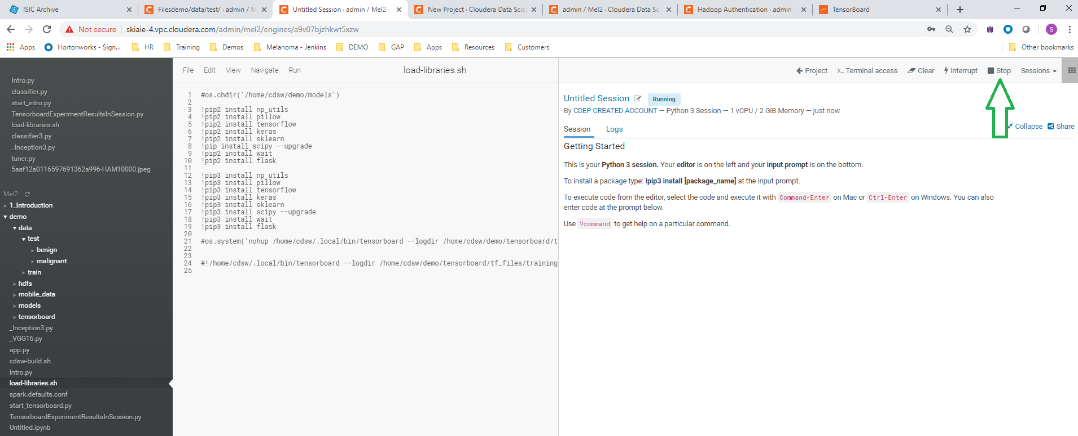

1. Navigate to the **start_tensorboard.py** script, and run this.

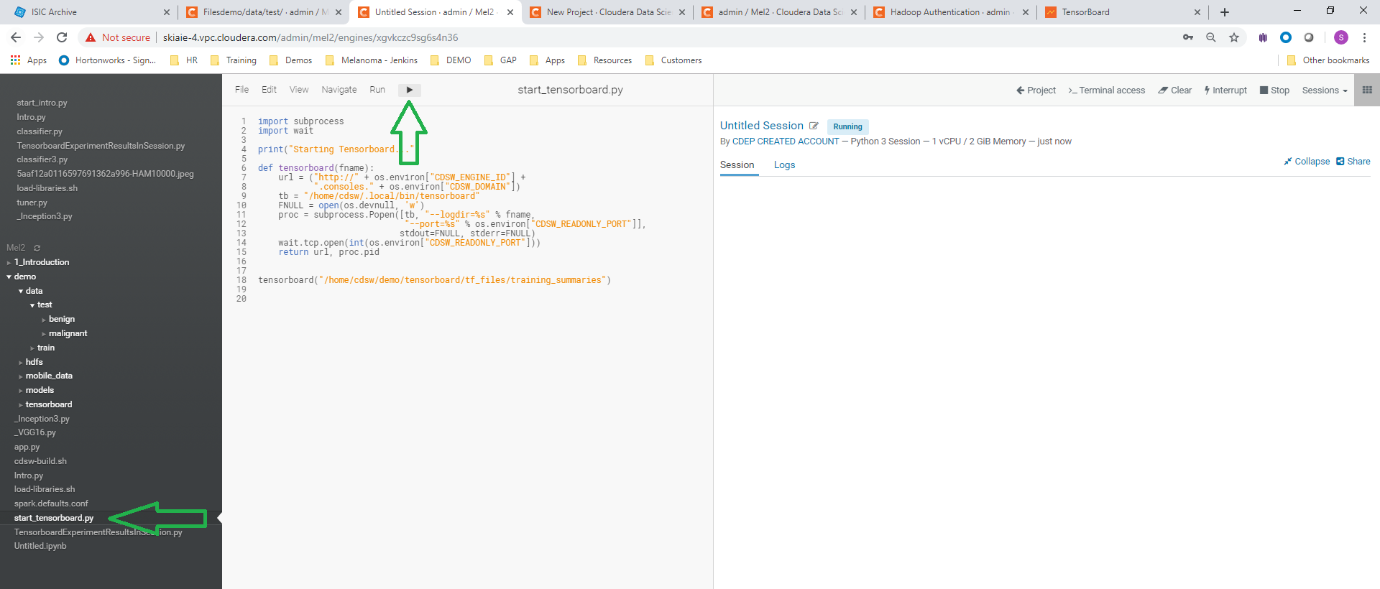

1. Check that the Tensorboard link is displaying in CDSW and that tensorboard is running, by clicking the tensorboard link

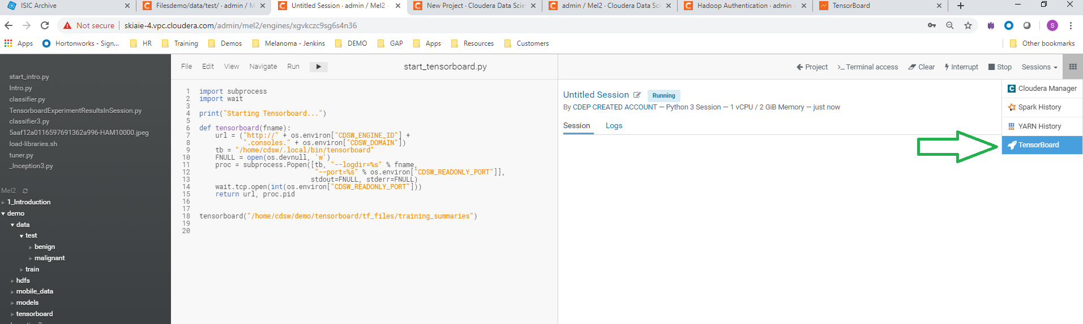

1. Click on the tensorboard tabs for **Scalars**, **Graph** and the **Histograms**, to check that these are displaying correctly (each are shown in order below)

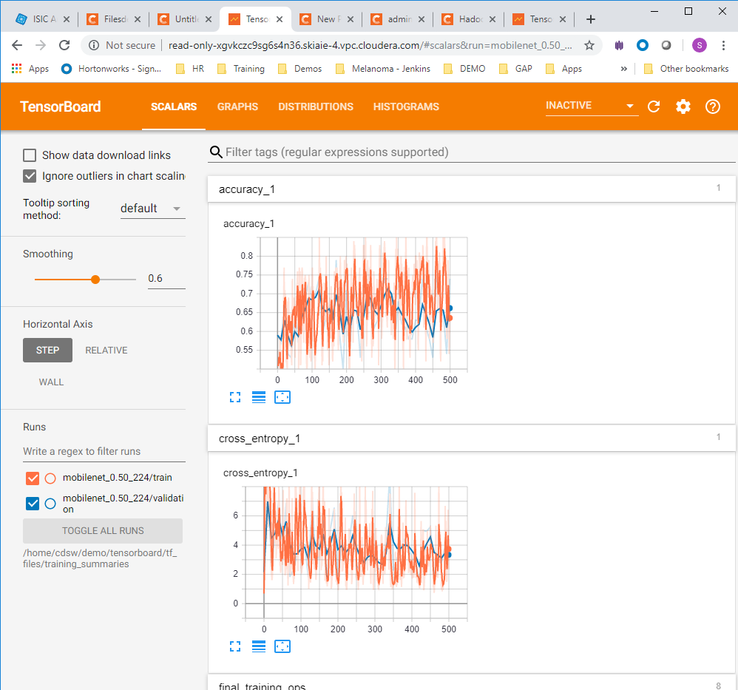  

1. Navigate to experiments and click run experiment

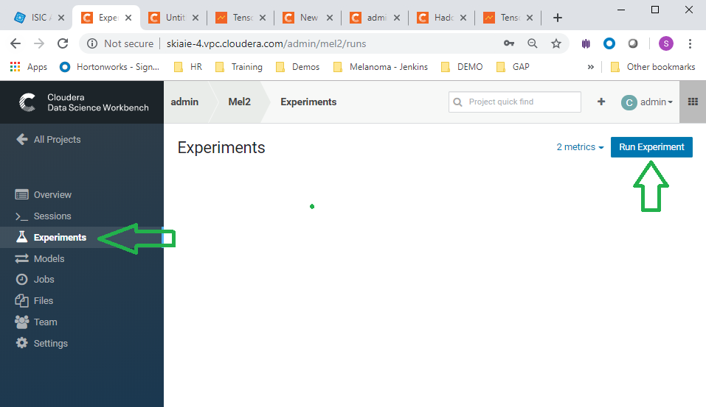

1. Run experiments for the **_Inception3.py**, and **_VGG16.py, scripts.** Use the python 3 kernel. No need to supply arguments for these.

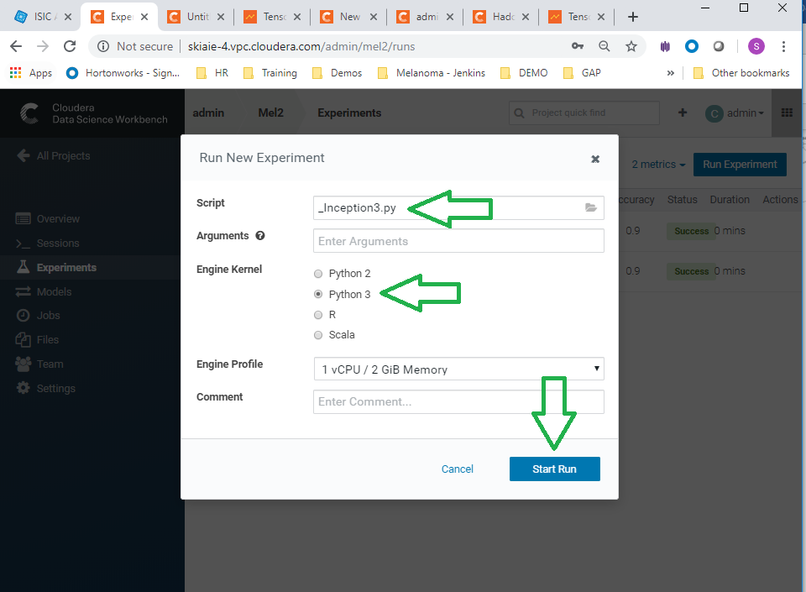

1. When these runs have completed, you should see the experiments listed as successful in the experiments view (as in the screenshot below)

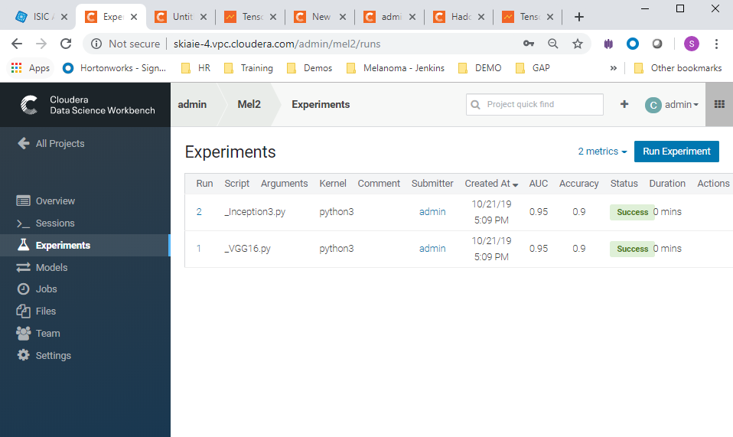

Pre-Demo Setup:

Watch the demo video, before following these instructions, to see how this will look in the demo.

Have the following tabs open (in order), in a Chrome window:

1. The ISIC dataset homepage (<https://www.isic-archive.com/#!/topWithHeader/wideContentTop/main>)
2. The CDSW file view of the training data folder <http://your-cdsw-host.and-domain.com/yourusername/melanoma-classification/files/demo/data/test/> (This is at the folder path: **demo > data > test** in CDSW)

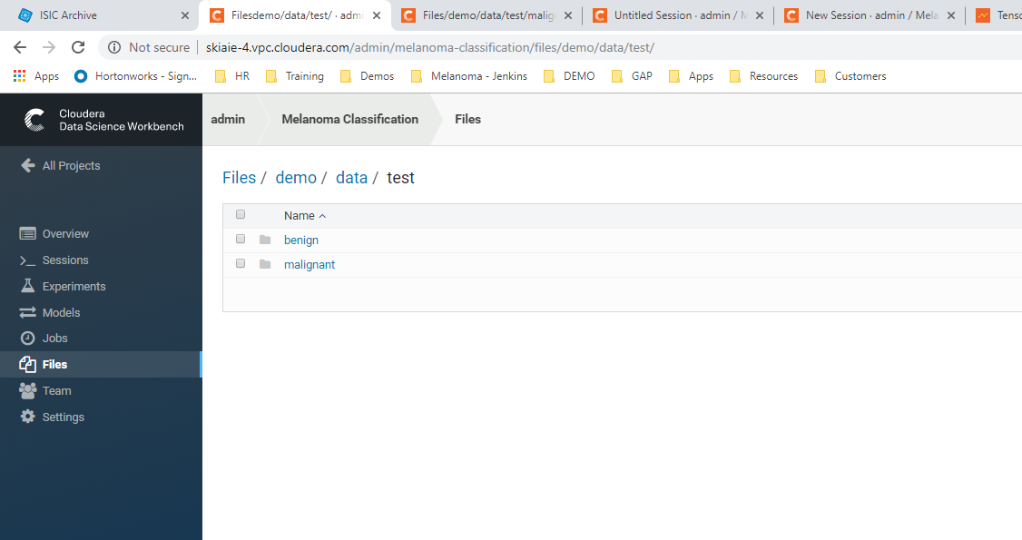

1. A Python 3 workbench session (loaded within the Classifying Melanoma project) pointing to the script to train the classifier (This is at the path: **demo > models > classifier3.py**, in CDSW)

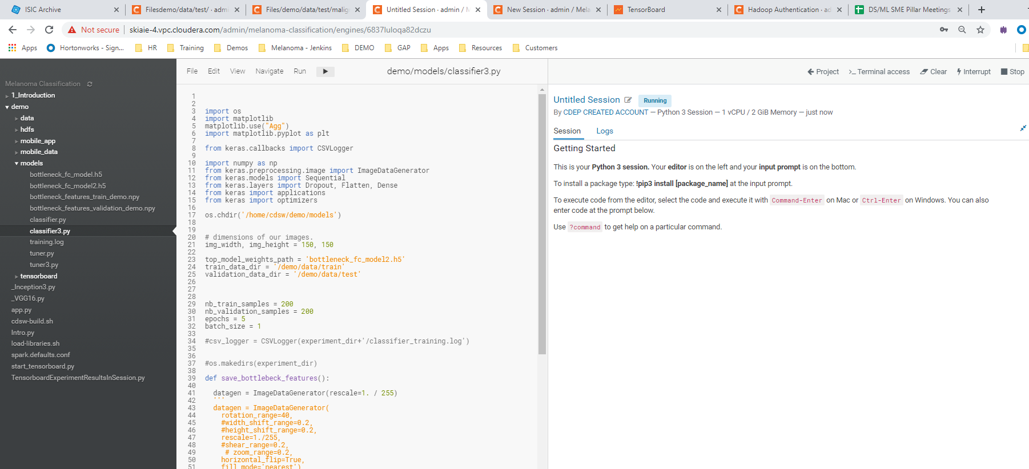

1. Tensorboard, with the Graph view



1. The new Projects <http://your-cdsw-host.and-domain.com/projects/new>
2. The experiments tab with a the
3. [http://[your-cdsw-host.and-domain.com]/projects/new/[your-username]/mel2/runs](%20http://%5byour-cdsw-host.and-domain.com%5d/projects/new/%5byour-username%5d/mel2/runs) admin/mel2/runs