RADARSCAPE WEBSITE -TECHNICAL PROPOSAL

Prepared by
Sonito Cassamo

1 INTRODUCTION
This document outlines the website structure, functional design, and content architecture for the official digital platform of Radarscape Mozambique Limitada. The primary goal of the website is to establish an authoritative digital presence that reflects the company's execution capabilities, compliance standards, and track record in Mozambique's engineering, construction, and infrastructure sectors

2 SYSTEM OVERVIEW
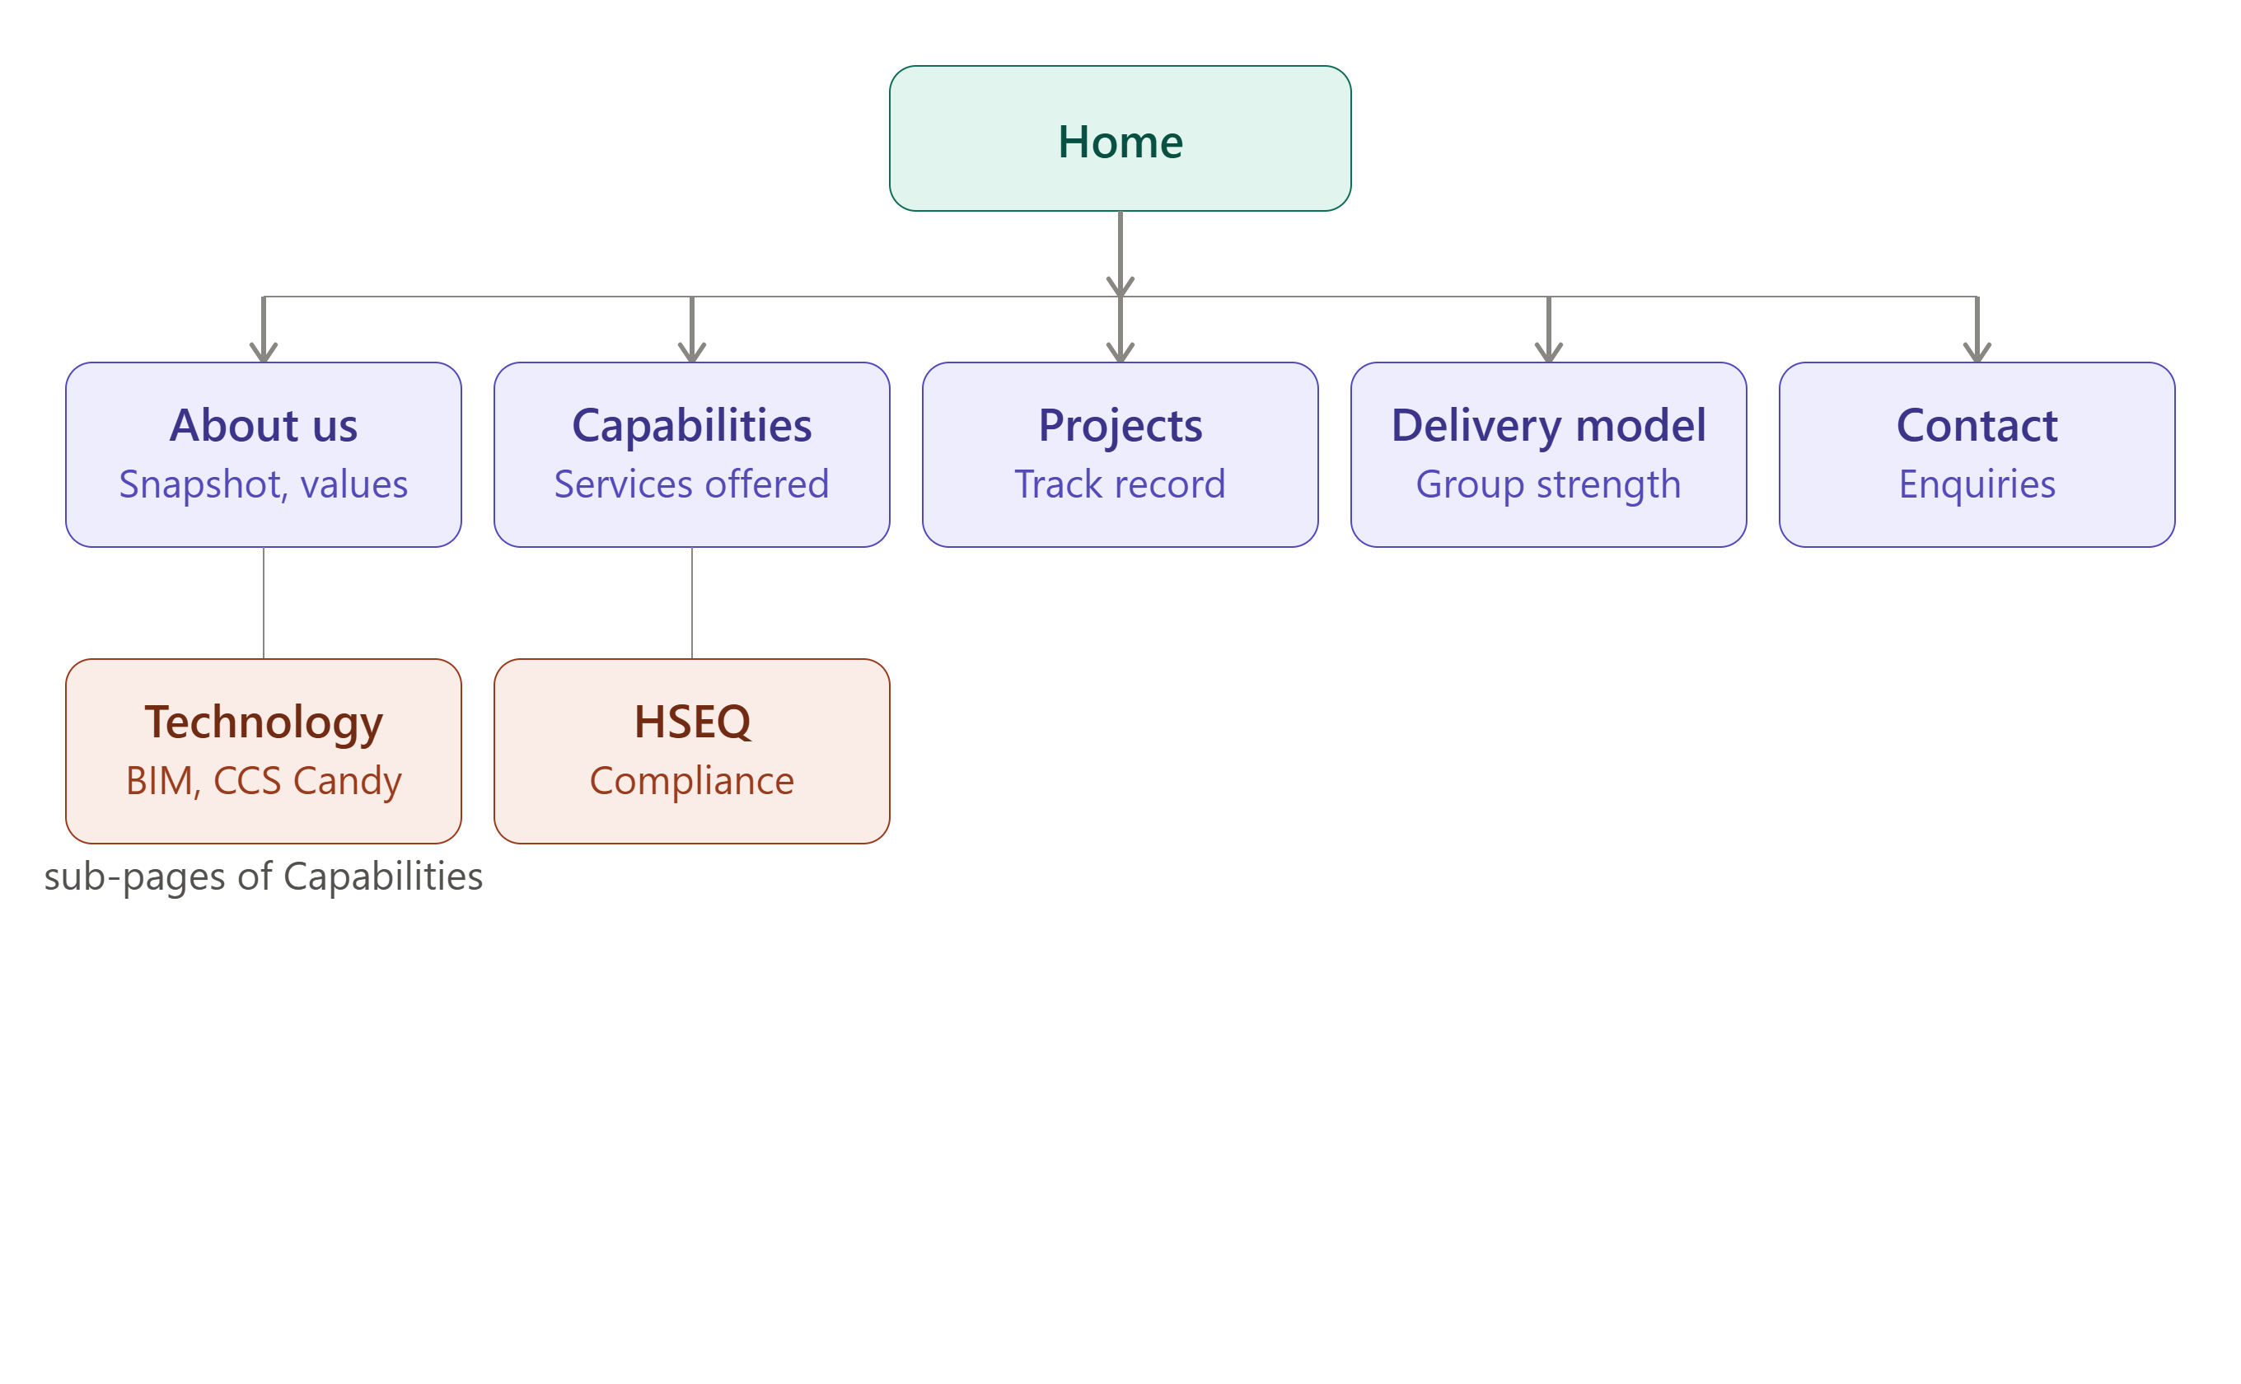

3 Radarscape Mozambique Limitada — Website Structure & Content

1. Site Map / Navigation
Primary navigation (header):
- Home
- About Us
- Capabilities
  - Engineering, Civil & Industrial Construction
  - Design-Build & Turnkey Delivery
  - Energy, Power & Electrical Infrastructure
  - Water, Utilities & Essential Infrastructure
  - Maintenance, Facilities & Operational Support
  - Technology, Systems & Controls
  - HSEQ & Compliance Assurance
- Projects
- Delivery Model & Group Strength
- Why Radarscape
- Contact
Footer navigation:
- Quick links: Home / About / Capabilities / Projects / Contact
- Registered address, phone, email
- Legal line: "Radarscape Mozambique Limitada — Class 7 ALVARA | Maputo, Mozambique"
- Social links (LinkedIn, if applicable)
Persistent elements:
- Header: logo (top-left), nav, "Contact Us" button (top-right, always visible)
- Footer: on every page, contact block + quick links + copyright line

2. Home Page
URL: /

Hero Section
Headline: Mozambique's trusted execution partner for Oil & Gas, energy, and infrastructure
Subheadline: Engineering, construction, and infrastructure delivery — built for reliability, speed, safety, and commercial discipline.
Background: Aerial photo of the Afungi solar PV installation (as in the profile), or a project photo carousel.
CTA buttons: "View Our Capabilities" | "Talk to Us"

Snapshot Strip (4 stat blocks)
Est. 2021 | Operational since 2022 | Cabo Delgado | Class 7 ALVARA
Founded in Mozambique | Active delivery track record | Core operating area — Afungi LNG corridor | Licensed for construction & engineering works

Intro Section — Who We Are
Radarscape Mozambique Limitada is a Mozambican engineering and construction partner positioned to help clients deliver complex projects with reliability, speed, safety, quality, and commercial discipline. With proven operating exposure in the Afungi LNG corridor, a strong local market presence, and access to wider group capability, Radarscape is a trusted choice for clients seeking a credible local partner for Oil & Gas, industrial, energy, and strategic infrastructure delivery.
CTA: "Learn more about us →" (links to About Us)

Why Choose Radarscape (3-column strip)
Local Execution Strength Strong on-ground capability in Mozambique, including experience in LNG-linked operating environments.
Buyer Confidence Strong HSEQ alignment, disciplined delivery, and practical commercial control.
Scalable Support & Strategic Value Group-backed capacity, partnership-driven delivery, local content participation, execution agility, and dependable project performance.

Capabilities Preview (icon grid, links to Capabilities page)
- Engineering, Civil & Industrial Construction
- Design-Build & Turnkey Delivery
- Energy, Power & Electrical Infrastructure
- Water, Utilities & Essential Infrastructure
- Maintenance, Facilities & Operational Support
CTA: "See all capabilities →"

Featured Projects (3-card preview, links to Projects page)
- Afungi site improvement works
- 5MW solar PV plant, Afungi
- Palma fish market road construction
CTA: "View our project experience →"

Strategic Advantage Banner
Relevant Oil & Gas exposure in the Afungi LNG operating ecosystem. Strong local presence backed by scalable group and partner capability. A commitment to local content and long-term market presence in Mozambique.
CTA: "Build with confidence — Contact us"

Closing CTA Section
Headline: Let's Build with Confidence
Radarscape is ready to support clients seeking a credible local partner with execution discipline, scalable delivery support, and a strong fit for demanding, high-compliance project environments. We welcome opportunities to engage on tenders, subcontracting partnerships, direct awards, and strategic project collaboration across Mozambique.
CTA button: "Contact Us"

3. About Us
URL: /about

Page Header
Headline: About Radarscape
Subheadline: A Mozambican engineering, construction, and infrastructure delivery company built on execution discipline.

Company Snapshot
Radarscape Mozambique Limitada is a Mozambican engineering, construction, and infrastructure delivery company serving clients in Oil & Gas, energy, industrial, and strategic infrastructure environments. We deliver practical, execution-focused solutions that help clients complete critical projects safely, on time, and with strong commercial control.
Established in September 2021 and operational since 2022, the company has rapidly built a credible execution presence in Cabo Delgado, with experience in demanding project environments linked to the TotalEnergies Mozambique LNG Area 1 ecosystem. This gives Radarscape relevant exposure to the standards, responsiveness, and delivery discipline expected on high-specification projects.
Radarscape combines local market access, execution agility, and group-backed technical depth. Supported by its parent group, Macefield Ventures Mozambique Limitada, and affiliated expertise from established regional businesses, the company gives clients a strong combination of local participation, scalable delivery capability, and international project standards.

Corporate Snapshot (table)
Item | Description
Company Name | Radarscape Mozambique Limitada
Year of Establishment | 2021
Registration | Mozambique
License | Class 7 ALVARA
Head Office | Maputo, Mozambique
Core Operating Area | Cabo Delgado (Afungi LNG Corridor)
Parent Company | Macefield Ventures Mozambique Limitada

Vision
To be Mozambique's most trusted and innovative Oil & Gas infrastructure partner.

Mission
To deliver value through strong partnerships, efficient execution, and practical solutions.

Core Values (icon list)
- Safety-first execution
- Integrity and accountability
- Client-focused delivery
- Operational excellence
- Innovation and continuous improvement
- Sustainable local impact

Leadership, Team & Execution Support
Our delivery model is supported by a multidisciplinary team equipped to manage technical coordination, commercial control, procurement, HSEQ, and site execution across diverse project scopes.
- Engineers and project managers
- Quantity surveyors and HSE specialists
- Commercial, procurement, and logistics professionals
This is reinforced by:
- Group-level support in legal, commercial, tax, and contract management
- A flexible staffing model that scales with project demand
CTA: "See how we deliver →" (links to Delivery Model page)

4. Capabilities (Overview Page)
URL: /capabilities

Page Header
Headline: Core Capabilities
Subheadline: High-value, execution-focused capabilities that support clients from project planning through construction, infrastructure delivery, utilities, commissioning support, and ongoing maintenance.

Capability Cards (grid, each links to an anchor or sub-page)
Engineering, Civil & Industrial Construction
- Civil, structural, and infrastructure construction
- Mechanical and electrical installation works
- Roadworks, site preparation, and earthworks
- Industrial buildings, operational facilities, and support infrastructure
Design-Build & Turnkey Delivery
- Concept development and detailed engineering support
- Integrated project design coordination
- Turnkey delivery for selected project scopes
Energy, Power & Electrical Infrastructure
- Low- and medium-voltage electrical systems
- Solar and renewable energy infrastructure
- Substations and associated electrical works
Water, Utilities & Essential Infrastructure
- Water treatment, reticulation, and distribution systems
- Wastewater and support utility infrastructure
Maintenance, Facilities & Operational Support
- Civil, electrical, and HVAC maintenance services
- Industrial and commercial facilities support
- Responsive maintenance teams for mission-critical environments

Sub-navigation cards (link out)
- Technology, Systems & Controls →
- HSEQ & Compliance Assurance →
CTA: "See this capability in action — view our projects →"

4a. Sub-page: Technology, Systems & Controls
URL: /capabilities/technology
Headline: Technology, Systems & Controls
Radarscape uses modern project systems and digital controls to improve planning quality, cost visibility, coordination, and execution certainty.
- Building Information Modeling (BIM)
- Digital estimating and cost control systems using CCS Candy: a specialized, contractor-focused software suite designed for construction and engineering estimation, planning, and project control.
Benefits include:
- Stronger project coordination and design visibility
- Better cost control and reduced rework exposure
- Improved real-time monitoring for timely decision-making

4b. Sub-page: HSEQ & Compliance Assurance
URL: /capabilities/hseq
Headline: HSEQ & Compliance Assurance
Radarscape is built to operate in high-compliance, high-consequence environments. Our delivery approach is anchored in strong HSEQ discipline and alignment with client, regulatory, and international project requirements.
- Strict health and safety management
- Quality-focused project controls
- Environmental responsibility and sustainable work practices
For clients, this means:
- Safer project execution and reduced delivery risk
- Stronger compliance with site and regulatory requirements
- Greater confidence in project governance and performance

5. Projects
URL: /projects

Page Header
Headline: Relevant Project Experience
Subheadline: Our project experience demonstrates the ability to mobilize, execute, and deliver in remote, compliance-sensitive, and operationally demanding environments.

Project Gallery (photo + short caption per entry)
- Rehabilitation of housing infrastructure — Quitunda, Palma
- Afungi site improvement works (including structure and steel works)
- Construction of Palma fish market road
- Construction of barracks and security infrastructure
- Installation of a 5MW solar PV plant — Afungi
- Afungi Airstrip Expansion
(Each project card: hero photo, one-line description, and optionally a "capability tags" row — e.g. Civil / Electrical / Roadworks — linking back to the relevant Capabilities section.)

What This Experience Demonstrates
Together, these projects demonstrate Radarscape's ability to:
- Operate under strict HSEQ and client compliance expectations
- Perform in LNG-linked and remote project environments
- Manage multi-disciplinary scopes with execution discipline
- Support local content delivery with practical on-ground capability
CTA: "Discuss your project with us →"

6. Delivery Model & Group Strength
URL: /delivery-model

Section A — Delivery Platform & Group Strength
Through its wider group ecosystem, including affiliated regional contractors and technical businesses, Radarscape benefits from broader delivery depth, cross-border expertise, and additional execution capacity across engineering and infrastructure projects.
- Large-scale industrial and commercial projects
- Energy and power infrastructure
- Road, civil, and urban development works
For clients, this translates into:
- Greater technical depth and engineering support
- Enhanced project mobilization and delivery capacity
- Access to broader specialist expertise when projects scale

Section B — Delivery Model
Radarscape applies a flexible, partnership-enabled execution model designed to help clients deliver complex scopes with the right balance of local presence, technical support, and commercial control.
Partnership-Driven Project Access
- Collaboration with established EPC and specialist contractors
- Access to complex Oil & Gas and infrastructure opportunities
- Balanced risk sharing and greater cost efficiency for clients
Execution Control & Asset Strategy
- Project-specific delivery teams aligned to scope and schedule
- Flexible equipment strategy combining leasing, rental, and selective ownership
- Disciplined cost control and efficient use of equipment and resources
Capability Growth & Localization
- Ongoing expansion in engineering, execution, and commissioning support
- Progressive growth of in-house delivery capability
- Stronger local content participation and long-term operational autonomy
CTA: "See our strategic advantage →" (links to Why Radarscape)

7. Why Radarscape
URL: /why-radarscape

Strategic Advantage (feature list)
- Relevant Oil & Gas exposure in the Afungi LNG operating ecosystem
- Strong local presence backed by scalable group and partner capability
- Flexible commercial model that supports cost-effective delivery
- Execution agility in challenging and remote environments
- Growing in-house technical depth across engineering and project execution
- Commitment to local content and long-term market presence in Mozambique

Market Position & Growth Strategy
Radarscape offers a strong value proposition for clients looking for a local contractor that can combine responsiveness, compliance discipline, and scalable delivery capability in Mozambique.
- Oil & Gas construction and support infrastructure
- Industrial and strategic infrastructure delivery
- Energy and utility-linked project execution
The company's growth strategy is focused on:
- Earning higher-value work through stronger execution credibility
- Delivering greater value through better project control and resource efficiency
- Growing into adjacent sectors while building on our Oil & Gas expertise
- Building long-term client partnerships and recurring project opportunities
CTA: "Partner with Radarscape — Contact us"

8. Contact
URL: /contact

Page Header
Headline: Let's Build with Confidence
Radarscape is ready to support clients seeking a credible local partner with execution discipline, scalable delivery support, and a strong fit for demanding, high-compliance project environments. We welcome opportunities to engage on tenders, subcontracting partnerships, direct awards, and strategic project collaboration across Mozambique.

Contact Details
Radarscape Mozambique Limitada Av. do Zimbabwe, No. 1512 Bairro da Sommershield Maputo, Mozambique
Tel: +258 849 459 905 Email: info@radarscapegroup.com

Contact Form
Fields: Name, Company, Email, Phone, Subject (dropdown: Tender Enquiry / Subcontracting Partnership / General Enquiry / Other), Message. Submit button: "Send Message."

Map
Embedded map pin at the Maputo head office address.

9. Footer (site-wide)
Column 1 — Company Radarscape Mozambique Limitada Av. do Zimbabwe, No. 1512, Bairro da Sommershield, Maputo, Mozambique Tel: +258 849 459 905 | info@radarscapegroup.com
Column 2 — Quick Links Home | About Us | Capabilities | Projects | Delivery Model | Why Radarscape | Contact
Column 3 — Capabilities Engineering & Construction | Energy & Power | Water & Utilities | Maintenance & Facilities | Technology | HSEQ
Bottom bar © [Year] Radarscape Mozambique Limitada. Class 7 ALVARA. All rights reserved.

