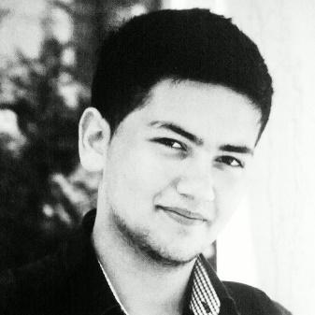



|  |  |
| --- | --- |
| 1. **About me** | **LANGUAGES**  Russian - Native  English – good  Azerbaijani – good |

|  |  |
| --- | --- |
| **Additional knowledge** | Photoshop, File-zilla, Word, Excel, Docker, Vagrant. |

|  |  |
| --- | --- |
| **Skills** | **PROGRAMS SKILLS**  Git ★★★★★★★★★★  Arduino ★★★★★★★★★★  **PROGRAM LANGUAGES**  C/C++ ★★★★★★★★★★  JavaScript ★★★★★★★★★★  Vue.js ★★★★★★★★★★  Python ★★★★★★★★★★  **WEB DEVELOPING**  PHP ★★★★★★★★★★  SQL ★★★★★★★★★★  Bootstrap ★★★★★★★★★★  HTML/CSS ★★★★★★★★★★  Zend Framework ★★★★★★★★★★  MVC ★★★★★★★★★★  OOP ★★★★★★★★★★  Laravel ★★★★★★★★★★  Composer ★★★★★★★★★★  SQLite3 ★★★★★★★★★★  **CMS**  WORDPRESS ★★★★★★★★★★  PHPBB ★★★★★★★★★★  XENFORO 1.1-1.5 ★★★★★★★★★★ |
| 1. **Work History** | ARTICLE.AZ 2012 – 2013  **IT-MANAGER**  STARLADDER 2013 – 2014  **Referee**  AZERCOSMOS 2016 – 2017  **WEB Developer**  **Microcontrollers**  BITEP 2017-2018  **Full-stack developer**  AAemu.info 2018-2019  **Owner/creator**  DevHub 2019-present  **Owner/creator**  **(my own project)** |
| 1. **Education** | BKU STATE UNIVERSITY 2019 - present  **Computer science**  MOSCOW STATE UNIVERSITY 2013 - 2019  **Mathematics & Computer science**  BAKI EURO LYCEUM 2002-2013  **School** |
| 1. **Awards** | DUNYA TELEKOMMUNIKASIYA AND INFORMASIYA 17 may - 2014  CEMIYYETI  **Certificate**  CULTURAL-ECOLOGICAL TRADITIONS OF THE WORLD 2011  **Certificate for Active participation in CET Project**  Azerbaijan Developers Olympiad 2013  for Azerbaijan Universities  **21 place**  STUDY PROG (MSU olympiad) 2014  **Third place at the Olympiad** |