Supplementary Material
This supplement accompanies the chapter “Global Insights of the Urban Microbiome and AMR Landscape from Metagenomic Mapping” (Academic Press, Elsevier). It reports every accepted statistical figure (Figs. S1–S30) and statistical table (Tables S1–S96) from the chapter’s verified analysis (31 October 2026), each followed by an interpretation. Table values were generated programmatically from the verified analysis files without manual transcription; tables longer than 120 rows are abridged here and given in full in the accompanying Supplementary Data workbook (one sheet per table). Streams 1–3 use different pipelines, reference databases and abundance units (RPKM, FPKM, FPKM-16S) and must not be compared in magnitude. Detection of a resistance gene indicates DNA presence, not phenotypic resistance, expression, viability, exposure or transmission.

Contents
Supplementary Material 1
1. Supplementary Figures 9
1.1 Evidence base 9
1.2 Taxonomic relative abundance 12
1.3 Microbiome variance 13
1.4 AMR gene presence 22
1.5 Predictive modeling 29
1.6 Environmental monitoring 31
1.7 Environmental monitoring and robustness 32
1.8 Global microbial communities 34
1.9 Risk mapping 40
2. Supplementary Tables 44
2.1 Evidence base and geographic coverage 44
2.2 Stream 1 (Indian open drains): taxonomic composition, diversity and ordination 61
2.3 Stream 1 (Indian open drains): resistome composition, abundance and determinants 68
2.4 Stream 2 (curated global resource): urban matrices and food-related contextual units 84
2.5 Stream 3 (uniform reprocessing): Dhaka and South Asian comparisons 94
2.6 Predictive modeling 124
2.7 Spatial analysis (2016 Global Sewage Surveillance pilot) 129
2.8 Robustness and sequencing-depth sensitivity 131

List of Figures
Fig. S1 Included urban metagenomes by sample type and continent (A) and by sequencing-platform family (B). n = 8,053 included samples; counts compiled from repository metadata on 31 October 2026. 10
Fig. S2 Processed annotations (A; samples on a log scale) and sequenced bases per sample (B; Gbp, log scale) by sample type. The depth is the number of sequenced bases in the repository, not post-QC depth. 11
Fig. S3 Global distribution of included urban metagenomes with source-reported coordinates (6,134 of 8,053 samples), colored by sample type. The points indicate the location of data, not AMR magnitude. 12
Fig. S4 Phylum (A) and genus (B) composition of the 16S prokaryotic fragments assigned to each rank (first 4,000,000 read pairs) of the 16 Dhaka metagenomes after uniform reprocessing (Kraken 2/SILVA 138). Muni., municipal; Hosp., hospital; Comm., community; Surf., surface water. 13
Fig. S5 Phylum-level alpha diversity of Indian open-drain wastewater: Shannon index (A) and rarefied phylum richness (B) by city with site-level Kruskal–Wallis tests (19 sites, whole-site permutation) and Shannon index by season (C) with a site random-intercept mixed model. n = 447 samples. 14
Fig. S6 Genus Shannon diversity (A) and observed genus richness (B) across urban matrices and food-related contextual units in the curated ResFinder resource (SILVA rRNA alignment), with unit and study counts (n = 551 units from 19 studies). 15
Fig. S7 Prokaryotic phylum composition in Indian open-drain wastewater: scores by city with the top loadings (A), scores by season (B), and scree plot (C) using centered log-ratio principal component analysis (CLR-PCA). 21 phyla with prevalence ≥ 50%; n = 447. 16
Fig. S8 CLR-PCA of resistance-class composition (13 class groups) in Indian open-drain wastewater: scores and loadings (A) and scree plot (B). n = 447. 17
Fig. S9 Ordination of resistome composition across urban matrices in the ResFinder resource: CLR-PCA of class composition (A), principal coordinates analysis of Bray–Curtis gene composition (B), and non-metric multidimensional scaling (C; stress 0.217). n = 551 units. 18
Fig. S10 Spearman correlations between abundances of phyla after CLR transformation and log10 resistance-class abundance (RPKM) in Indian open-drain wastewater (n = 447). Asterisks denote Benjamini–Hochberg q < 0.05, < 0.01, and < 0.001 across 150 tests. 19
Fig. S11 Study-level mean log10 total ARG abundance (FPKM; 95% t-intervals) in the ResFinder resource by matrix. Random-effects (DerSimonian–Laird) pooled means are indicated by dashed lines. 21
Fig. S12 Resistome of Indian open-drain wastewater (CARD/RGI, producer-processed): mean share of total ARG abundance by antibiotic-class group (A) and total normalized ARG abundance per sample (B; RPKM, logarithmic scale) with the site-level Kruskal–Wallis test (19 sites; whole-site permutation), n = 447 (Delhi 100, Mumbai 189, Chennai 109, Kolkata 49). 22
Fig. S13 Log10 mean abundance (RPKM) of the 30 most abundant CARD gene families by city and season in Indian open drain wastewater (n = 447). 24
Fig. S14 Detection of clinically important resistance determinants by city in Indian open-drain wastewater (CARD/RGI). Filled symbols, high-confidence detection (with Wilson 95% CIs); open symbols, any hit (unconfirmed upper bound). 25
Fig. S15 Antibiotic-class composition (A; share of total FPKM-16S) and normalized ARG abundance against high-confidence gene richness (B) in the 16 Dhaka metagenomes, as a function of sample type. 27
Fig. S16 Detection of clinically important resistance determinants in the 16 Dhaka metagenomes (ResFinder/KMA). Filled symbols, high-confidence detection (identity ≥ 90%, coverage ≥ 60%) with Wilson 95% CIs; open symbols, any hit. 28
Fig. S17 Model A: exploratory classification of municipal wastewater against other urban matrices from CLR class composition, with 4-fold cross-validation holding out whole studies. ROC curves (A), precision – recall curves (B), confusion matrix (C), and calibration (D) for one repeat. 396 units, 15 studies. 30
Fig. S18 Model B exploratory prediction of log10 total ARG abundance (RPKM) from CLR phylum composition in Indian wastewater samples, trained before September 2023 (n = 332) and tested on the remaining samples (n = 115) - A) random forest, B) ridge regression and C) permutation importance. 31
Fig. S19 Observed monthly median abundance of total normalized ARG (RPKM) ± interquartile range (IQR) (25 rounds; 1–8 samples/city/month) from Indian open-drain wastewater collected from March 2022 to March 2024. No values are modeled or forecast. 32
Fig. S20 Robustness of key contrasts relative to Delhi (A) and relative to municipal wastewater (B): fold changes (95% CI, log scale) for Indian city contrasts (A) and ResFinder matrix contrasts (B) with the alternatives to the basic specifications. City specifications for (A) are sample-level models, so only direction is informative. 33
Fig. S21 Sensitivity to sequencing depth: site-level city tests in Indian open drains (A), ResFinder matrix fold changes across depth thresholds (B), and median ARG gene richness following binomial thinning of reprocessed runs (C). 34
Fig. S22 Dhaka sampling locations plotted with respect to the map of Dhaka North and South City Corporation boundaries (A) and all uniformly reprocessed runs by city (B). Observed points only. 35
Fig. S23 Ordination of the 16 metagenomes from Dhaka by methods of genus Bray–Curtis PCoA (A), genus CLR-PCA (B), and ARG gene Bray–Curtis PCoA (C). There is confounding by dataset/year/instrument and sample type. 36
Fig. S24 Within-Dhaka comparison of normalized ARG abundance, high-confidence ARG genes, genus Shannon index, and rarefied genus richness by sample type and dataset; horizontal bars show medians. 37
Fig. S25 Phylum composition (A) and genus Bray–Curtis PCoA (B) of Dhaka metagenomes compared with open drains in Delhi and municipal sewage from Karachi, Kathmandu, Kochi, and Colombo after uniform reprocessing. 38
Fig. S26 Normalized ARG abundance, high-confidence ARG genes, and genus Shannon index for Dhaka compared with Karachi, Kathmandu, Kochi, and Colombo under a matched Global Sewage Surveillance protocol (2017–2019; Illumina NovaSeq 6000), with exact permutation p-values for Dhaka versus Karachi. 39
Fig. S27 Calibration of the uniform reprocessing pipeline against the ResFinder resource for the same sewage units: gene-level FPKM-16S versus resource FPKM with Spearman ρ (A) and the ratio of total normalized abundance (B). 40
Fig. S28 Observed log10 total normalized abundance of ARG (FPKM) in the studied municipal wastewater at the reported sampling locations in the ResFinder resource (278 units, 7 studies). Only observed values, not an interpolated surface or risk map. 41
Fig. S29 Continental variation in the Global Sewage Surveillance 2016 pilot: total ARG FPKM over continents (A; Kruskal–Wallis over continents with ≥ 5 units) and mean resistance-class composition (B). 42
Fig. S30 Spatial structure of the sewage resistome among 86 units (mostly one per city) in the 2016 pilot: Bray–Curtis dissimilarity against great-circle distance with medians per 1,000-km bin and Mantel test (A), and Moran scatterplot of standardized log10 total FPKM against its five-nearest-neighbor spatial lag (B); 9,999 permutations each. Not a risk surface. 43

List of Tables
Table S1 Overview of the analyzable evidence base: included urban shotgun metagenomes and separately held food-related contextual samples 44
Table S2 Included urban samples by sample type: dataset, country and city coverage, annotation availability, and repository-reported sequencing depth 45
Table S3 Included urban samples by reported country and continent, with numbers of types of samples, cities, datasets, and AMR-annotated samples 46
Table S4 Cross-tabulation of included urban samples by continent and sample type 49
Table S5 Included urban samples by source-labeled city, with sample types, contributing datasets, and AMR- and taxonomy-annotated samples 49
Table S6 Summary of city coverage in evidence base included and implications for the chapter’s multi-city framing 50
Table S7 Distribution of samples across sequencing platform families by sample type for the included urban samples 51
Table S8 Availability of coordinates, AMR gene tables, taxonomic tables and diversity indices by sample type among included urban samples 51
Table S9 Inventory of the 112 datasets containing urban samples: sample type, country, number of verified corrections, number of recovered site identifiers, AMR profiles and reprocessed runs 52
Table S10 Coverage of the global sample map: included samples with and without source-reported coordinates, distinct locations, and coordinate-country mismatches 57
Table S11 Country coverage by ISO code: included urban samples, number of sample types and samples with producer-processed AMR tables 57
Table S12 Chapter target cities (Delhi, Dhaka, Karachi): included datasets, producer-processed AMR and taxonomy coverage, and runs reprocessed uniformly in this update 60
Table S13 Bacterial, archaeal, eukaryotic and viral proportions of phylum-classified reads in Indian open drain wastewater at the domain level (mean and standard deviation per city) 61
Table S14 Mean relative abundance of the ten most abundant prokaryotic phyla in Indian open-drain wastewater, by city 62
Table S15 Mean relative abundance of the top 10 prokaryotic phyla from Indian open-drain wastewater, by season 62
Table S16 Phylum-level alpha diversity of prokaryotic communities in Indian open-drain wastewater: observed and rarefied richness, Shannon, Gini–Simpson and Pielou evenness by city 63
Table S17 Site-aware tests of city, season and year differences in phylum-level alpha diversity of prokaryotic communities in Indian open-drain wastewater. 64
Table S18 Mixed-effects model of phylum-level Shannon diversity of prokaryotic communities in Indian open-drain wastewater from city, season and year with site random intercept 65
Table S19 Explained variance of principal components of centered log-ratio PCA of prevalent prokaryotic phyla in Indian open-drain wastewater. 65
Table S20 Loadings and percentage contributions of the prevalent prokaryotic phyla to the first three principal components of the centered log-ratio PCA of Indian open-drain wastewater 66
Table S21 Discrete prokaryotic taxonomic clusters in Indian open-drain wastewater obtained from k-means clustering on the first three principal components: size, city composition, and median phylum abundance 67
Table S22 Associations of discrete prokaryotic taxonomic clusters in Indian open-drain wastewater with city, season, year, sequencing depth and total normalized resistance gene abundance 67
Table S23 Antimicrobial resistance gene families identified in Indian open drain wastewater (mean and median abundance, % of total abundance, and coverage-qualified prevalence) 68
Table S24 Resistance-class composition of Indian open-drain wastewater resistomes: share of total CARD abundance by class group, overall and mean share by city 69
Table S25 Resistance mechanisms in Indian open-drain wastewater resistomes: percentage of total CARD abundance by resistance mechanism, total and mean percentage per city 71
Table S26 Total normalized antimicrobial resistance gene abundance and gene-family richness and diversity in Indian open-drain wastewater, per city 71
Table S27 Site-aware tests of city and season/year differences in total normalized resistance gene abundance, gene-family richness and diversity in Indian open-drain wastewater 72
Table S28 Mixed-effects model of total normalized resistance gene abundance in Indian open-drain wastewater by city, season and year, with a site random intercept; fold changes are relative to Delhi 73
Table S29 Sequential PERMANOVA and dispersion tests of prokaryotic phylum and resistance gene-family composition in Indian open-drain wastewater by city, season and year. 73
Table S30 Concordance between prokaryotic community structure and resistome structure in Indian open-drain wastewater: Mantel and Procrustes tests 75
Table S31 Spearman correlations between centered log-ratio abundances of phyla and log-transformed abundances of resistance class-groups in Indian open-drain wastewater, with Benjamini–Hochberg adjustment 75
Table S32 Explained variance of principal components from centered log-ratio PCA of resistance class-group composition in Indian open-drain wastewater 76
Table S33 Loadings and percentage contributions of resistance class groups to the first three principal components of the centered log-ratio PCA of Indian open-drain wastewater 77
Table S34 Detection of clinically important resistance determinants in Indian open-drain wastewater by city: high-confidence, stricter-coverage and any-hit detection with Wilson confidence intervals 77
Table S35 Site-aware city comparisons of high-confidence detection of clinically important resistance determinants in Indian open-drain wastewater, prevalence at site level by city 80
Table S36 Monthly median total normalized resistance gene abundance in Indian open-drain wastewater by city, with interquartile ranges and samples per city-month 81
Table S37 Total ARG abundance (FPKM) and ARG gene richness by urban matrix and food-related contextual stratum in the curated ResFinder/KMA resource 84
Table S38 Mean abundance (FPKM) and prevalence (any hit) of individual ResFinder genes (allele-collapsed for bla and mcr families) in all units and by matrix 85
Table S39 Mean share (%) of total ResFinder ARG abundance by antibiotic-class group in each urban matrix and the food-related contextual stratum 86
Table S40 Bacterial genus-level diversity (SILVA rRNA alignments) and sequencing depth by urban matrix and food-related contextual stratum in the ResFinder resource 87
Table S41 Linear mixed model of genus Shannon diversity by urban matrix, adjusting for log10 mapped fragments, with a study random intercept 87
Table S42 Linear mixed model of log10 total ARG abundance (FPKM), with municipal wastewater as reference, and a study random intercept 88
Table S43 Study composition of each urban matrix in the ResFinder resource and the resulting identifiability of matrix effects from study effects 89
Table S44 Linear mixed model of ARG gene richness by urban matrix, after controlling for the log10 number of bacterial fragments, with a study random intercept 89
Table S45 Linear mixed model comparing food-related contextual environments with municipal wastewater in log10 total ARG abundance (FPKM) with a study random intercept 90
Table S46 Study-level mean log10 total ARG abundance (FPKM) with 95% t-intervals for each study and matrix in the ResFinder resource 90
Table S47 Pooled mean log10 total ARG abundance and between-study heterogeneity using the random-effects (DerSimonian-Laird) model for matrices for which at least four studies were available 91
Table S48 PERMANOVA of ResFinder gene composition (Bray-Curtis, relative FPKM) by matrix with study-block permutation, study-within-matrix test and dispersion test (PERMDISP) 91
Table S49 Spearman correlations between bacterial genus diversity and ARG diversity and total ARG abundance, overall and within each matrix, with Benjamini-Hochberg adjustment 92
Table S50 Linear mixed model of ARG gene Shannon diversity on genus Shannon diversity, urban matrix and log10 bacterial fragments, with a study random intercept 93
Table S51 Percentage of variation accounted for by the first ten axes of the Principal Coordinates Analysis (PCoA) and the two-dimensional NMDS stress for Bray-Curtis ResFinder gene composition 93
Table S52 Dhaka metagenome inventory by dataset: BioProjects, sequencing platform, collection period, sequencing depth and sample-type composition (3 datasets, 16 samples) 94
Table S53 Dhaka sample-level metadata: verified sample type, reclassification record, collection date, coordinates and coordinate precision of the 16 Dhaka-labeled metagenomes 94
Table S54 Geographic verification of Dhaka-labeled samples: coordinate provenance and precision, point-in-polygon test against official city-corporation boundaries, distance to boundary and classification 96
Table S55 Number of Dhaka-labeled samples by geographic verification status (16 samples) 98
Table S56 Read-level quality control and sequencing-depth assessment for each Dhaka metagenome after uniform subsampling of 4,000,000 read pairs per run 98
Table S57 Relative abundance (mean, median, maximum) and prevalence of each prokaryotic phylum, class, order, family and genus in all 16 metagenomes from Dhaka, overall and by dataset. 100
Table S58 Five most abundant phyla and genera in each Dhaka metagenome, by dataset and verified sample type, showing relative abundance 101
Table S59 Taxonomic resolution of Dhaka metagenomes: Prokaryotic 16S fragments not resolved at phylum, family, and genus level; 16S fragments resolved at genus level 103
Table S60 Genus alpha diversity (rarefied to 850 genus-assigned 16S fragments; richness, Shannon, Gini-Simpson, Pielou) and ARG diversity per Dhaka metagenome 103
Table S61 Per-sample normalized ARG abundance, high-confidence gene, allele and class richness and ARG diversity in 16 Dhaka metagenomes. 104
Table S62 All ResFinder genes aligned in Dhaka metagenomes: class, mechanism, mean and median FPKM-16S, percent of total and any-hit and high-confidence detection overall and by dataset. 106
Table S63 Antibiotic-class composition of the Dhaka resistome: Share of total FPKM-16S and mean per-sample share by class group. 107
Table S64 Clinically important resistance determinants in Dhaka metagenomes: high-confidence and any-hit detection, overall, by dataset and by sample type, with Wilson 95% CI and detected alleles 108
Table S65 PERMANOVA and PERMDISP of Dhaka genus and ARG composition by dataset and by sample type 110
Table S66 Concordance of microbiome and resistome structure in metagenomes from Dhaka: Mantel test of genus Aitchison distances against ARG Bray-Curtis distances 111
Table S67 Matched-protocol (Global Sewage Surveillance, uniform reprocessing) ARG and genus diversity summary for municipal sewage collected from Dhaka and 4 South Asian cities 111
Table S68 Dhaka comparative analysis: all tests with independent units, group sizes, statistic, p-value, Benjamini-Hochberg adjustment within comparison level, effect size and inferential status 112
Table S69 Sensitivity of Dhaka versus Delhi exact permutation tests to four definitions of the Dhaka sampling unit (unreported DS01 sites; DS84 inlet co-located with the Pagla treatment area) 117
Table S70 Mean percentage of total FPKM-16S by antibiotic-class group in three datasets from Dhaka and seven comparator groups following uniform reprocessing 118
Table S71 High-confidence and any-hit detection of clinically important determinants by the Dhaka dataset and comparator city after uniform reprocessing, with Wilson 95% CI 119
Table S72 Gene-level agreement and total-abundance ratio for the five 2016 pilot sewage units between the uniform reprocessing pipeline and the Martiny et al. ResFinder resource 121
Table S73 Gene-level FPKM from the uniform reprocessing pipeline and from the Martiny et al. ResFinder resource for each of the five calibration sewage units 122
Table S74 Cross-pipeline check for 12 Delhi samples: samples with each clinically important determinant by tier and by pipeline, and agreement of ResFinder high-confidence calls with each CARD tier 123
Table S75 Total normalized ARG abundance in 12 Delhi samples: producer CARD/RGI RPKM versus independent ResFinder/KMA totals (Spearman rho 0.68 for CARD versus ResFinder RPKM) 123
Table S76 Design of exploratory Model A, classification of municipal wastewater against other urban matrices from resistome class composition 124
Table S77 Classification performance of Model A when using study-grouped and study-ignorant cross-validation, and a prior-only baseline 124
Table S78 Accuracy of Model A on each held-out study when applying leave-one-study-out validation: by model and study matrix 125
Table S79 Feature importance in Model A: held-out permutation importance and impurity importance (random forest) and standardized logistic coefficients 126
Table S80 Performance of exploratory Model B predicting log10 total ARG abundance (RPKM) in Indian open-drain wastewater from CLR prokaryotic phylum composition 127
Table S81 Model B random forest permutation importance for CLR phylum features on the temporal test set 128
Table S82 Feasibility of predictive modeling targets based on available data – requirements, data availability and decisions taken 129
Table S83 Total ARG abundance (FPKM) and gene richness by continent in the 2016 Global Sewage Surveillance pilot (single protocol, mostly one unit per city) 129
Table S84 Mean resistance-class share (%) of total ARG abundance by continent in the 2016 Global Sewage Surveillance pilot 130
Table S85 Global spatial autocorrelation (Moran's I) of resistome measures and Mantel distance decay among 86 city sewage units in the 2016 Global Sewage Surveillance pilot 130
Table S86 Feasibility of spatial analyses based on the data available: requirements, data availability and decisions made 131
Table S87 Sensitivity of the city fold changes for total normalized ARG abundance to model specification at the sample level for DS02 132
Table S88 Sensitivity of the city effect on total normalized ARG abundance (epsilon-squared) for six sample-level specifications 132
Table S89 Sensitivity of ResFinder matrix and food-related contrasts in total normalized ARG abundance to project duplication, KMA version, denominator, and template coverage. 133
Table S90 Sensitivity analysis of ResFinder matrix differences in total normalized ARG abundance (study-level medians used as the unit of analysis) 134
Table S91 Additional robustness checks: phylum richness with and without rarefaction, resistome composition under Aitchison distance, and random-forest stability across seeds 134
Table S92 Included urban samples retained at each repository sequencing-depth threshold, used as sensitivity denominators 135
Table S93 DS02 Site-aware tests for differences in resistome metrics between cities at each sequencing-depth threshold (site-level Kruskal-Wallis and mixed-model likelihood-ratio tests) 135
Table S94 ResFinder study-random-intercept model of total normalized ARG abundance, by matrix, at each sequencing-depth threshold, as fold change compared to municipal wastewater 136
Table S95 Median genus Shannon diversity, ARG gene richness and total normalized ARG abundance at each sequencing-depth threshold 137
Table S96 Uniformly reprocessed runs: median ARG gene richness by analysis group at successive fractions of the analyzed sequencing depth 138

Supplementary Figures

Evidence base
This section presents Figs. S1, S2 and S3.
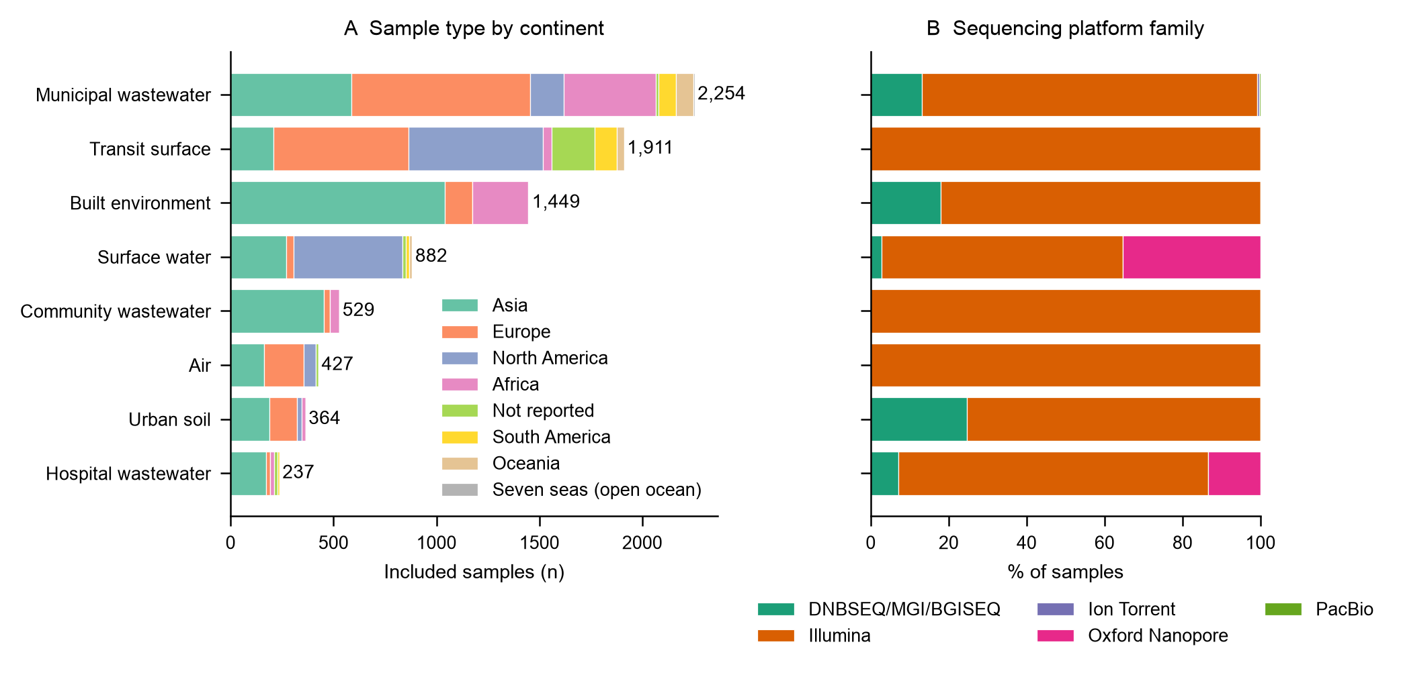
Fig. S1 Included urban metagenomes by sample type and continent (A) and by sequencing-platform family (B). n = 8,053 included samples; counts compiled from repository metadata on 31 October 2026.
There are 8,053 samples, with the majority being from municipal wastewater (2,254), transit surfaces (1,911), and built environments (1,449), and the Illumina platforms are the most common. The matrix mix varies across continents, and any summary of urban matrices is weighted towards the ones that are prevalent in certain regions. Limitations: Descriptive counts, platform families only.
Source data: Table S2, Table S4, Table S7.
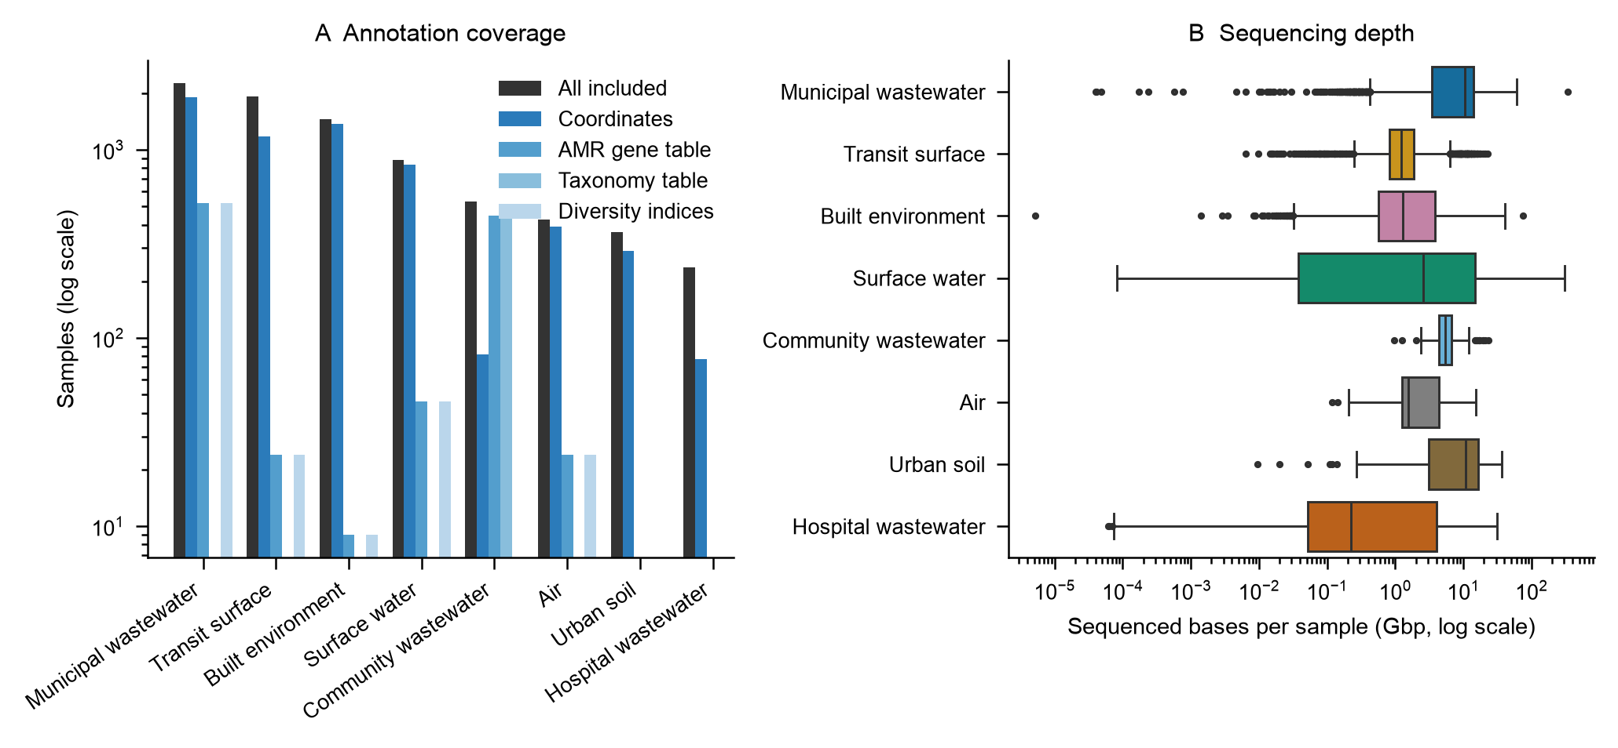
Fig. S2 Processed annotations (A; samples on a log scale) and sequenced bases per sample (B; Gbp, log scale) by sample type. The depth is the number of sequenced bases in the repository, not post-QC depth.
For most samples, only raw reads and metadata are available, with processed AMR tables being concentrated in community wastewater (DS02) and municipal wastewater. The difference in median depth, from 0.22 Gbp (hospital wastewater) to 10.7 Gbp (urban soil), is 50-fold and can alone affect detection frequencies. Limitation: Depth is based on total sequenced bases from repository records, not post-QC depth.
Source data: Table S8, Table S2.
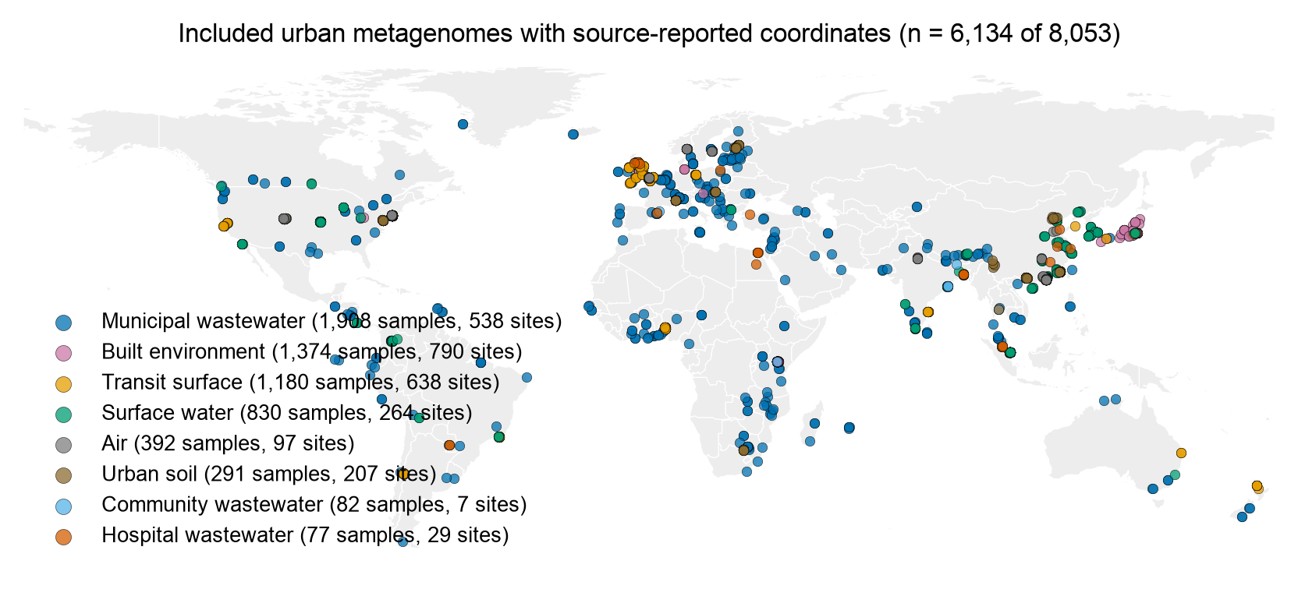
Fig. S3 Global distribution of included urban metagenomes with source-reported coordinates (6,134 of 8,053 samples), colored by sample type. The points indicate the location of data, not AMR magnitude.
Sampled locations (6,134 samples with coordinates) are clustered mainly in North America, Europe, and East Asia, while Africa is represented largely by sewage points. All the DS02 Indian samples lack coordinates and are therefore absent. Limitation: No correction of 228 flagged mismatches; Coordinates as reported.
Source data: Table S10.

Taxonomic relative abundance
This section presents Fig. S4.
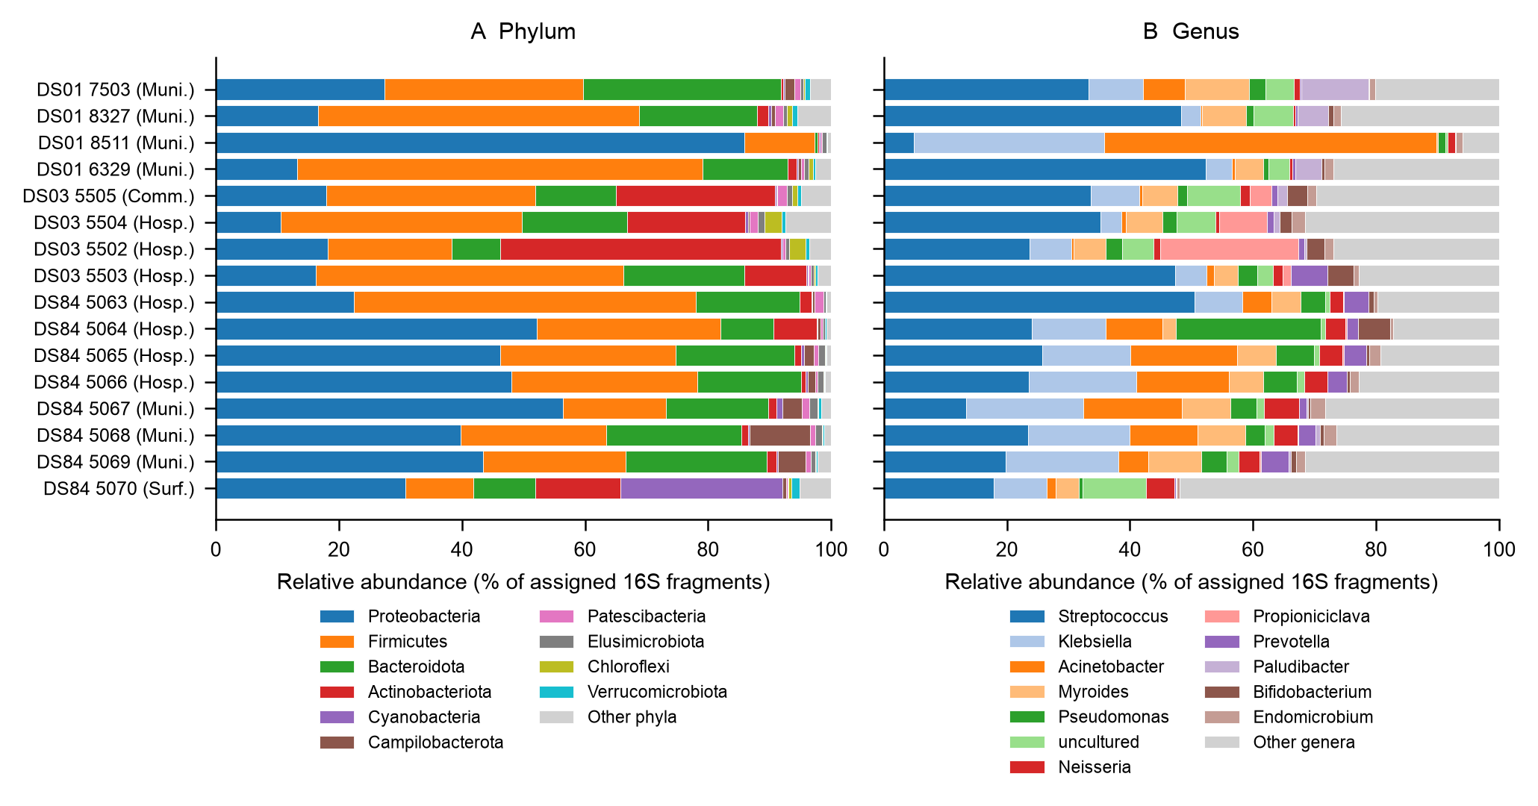
Fig. S4 Phylum (A) and genus (B) composition of the 16S prokaryotic fragments assigned to each rank (first 4,000,000 read pairs) of the 16 Dhaka metagenomes after uniform reprocessing (Kraken 2/SILVA 138). Muni., municipal; Hosp., hospital; Comm., community; Surf., surface water.
Proteobacteria 34.1%, Firmicutes 32.7%, and Bacteroidota 16.0% (means) are the major phyla in Dhaka communities, with Streptococcus, Klebsiella, and Acinetobacter being the leading genera. The pond sample is characterized by a high proportion of Cyanobacteria, DS01 samples by Firmicutes/Streptococcus, although one DS01 sample is dominated by Acinetobacter. Limitations: 52–72% of 16S fragments were not resolved below family level; Enterobacteriaceae genera were not well resolved.
Source data: Table S57, Table S58, Table S59.

Microbiome variance
This section presents Figs. S5, S6, S7, S8, S9, S10 and S11.
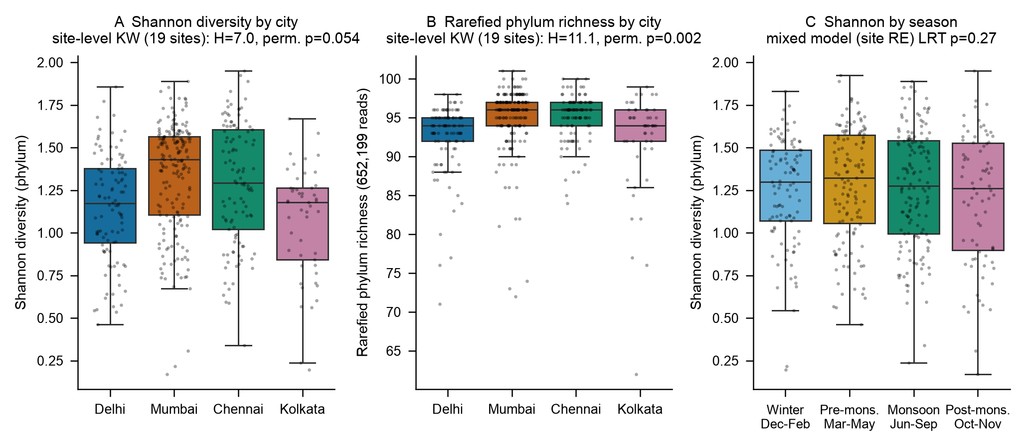
Fig. S5 Phylum-level alpha diversity of Indian open-drain wastewater: Shannon index (A) and rarefied phylum richness (B) by city with site-level Kruskal–Wallis tests (19 sites, whole-site permutation) and Shannon index by season (C) with a site random-intercept mixed model. n = 447 samples.
The values of median phylum Shannon diversity (1.17–1.43) and rarefied richness (94–96 phyla) varied between cities. Richness was detected to vary among cities (perm. p = 0.002), but Shannon diversity differed only marginally (perm. p = 0.054), and season had no detectable effect within sites (p = 0.27). Limitation: The diversity is at the phylum level, and sample points are repeated measures from 19 sites.
Source data: Table S16, Table S17, Table S18.
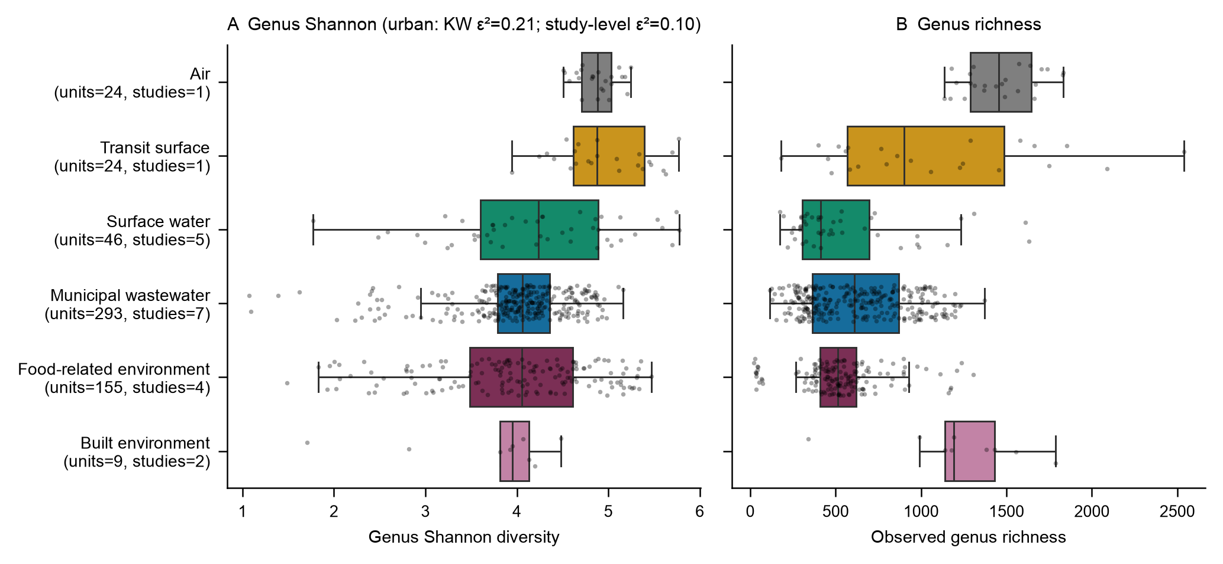
Fig. S6 Genus Shannon diversity (A) and observed genus richness (B) across urban matrices and food-related contextual units in the curated ResFinder resource (SILVA rRNA alignment), with unit and study counts (n = 551 units from 19 studies).
Genus Shannon medians: air 4.88, transit 4.88, surface water 4.24, municipal wastewater 4.06, food-related 4.06, built environment 3.95. After adjusting for study and depth, no matrix contrast was supported (p = 0.14–0.73; study ICC = 0.56), so apparent matrix differences are largely study differences. Limitations: rRNA mapping (SILVA via KMA); richness depth-dependent.
Source data: Table S40, Table S41.
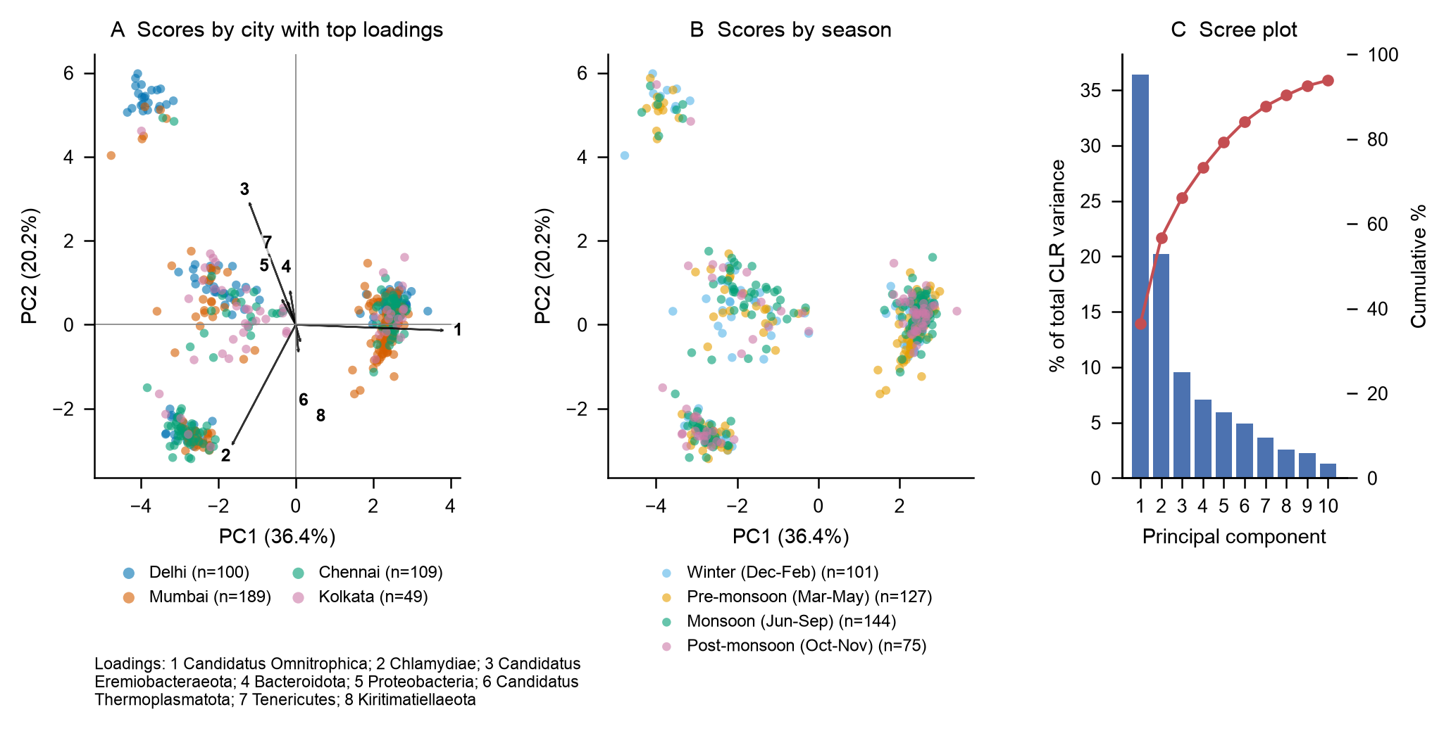
Fig. S7 Prokaryotic phylum composition in Indian open-drain wastewater: scores by city with the top loadings (A), scores by season (B), and scree plot (C) using centered log-ratio principal component analysis (CLR-PCA). 21 phyla with prevalence ≥ 50%; n = 447.
CLR-PCA of 21 prevalent phyla: PC1 36.4%, PC2 20.2%. The samples are grouped into four distinct clusters (silhouette 0.79) defined by low-abundance phyla (Candidatus Omnitrophica, Chlamydiae, Candidatus Eremiobacteraeota); the clusters are weakly related to city (V = 0.30), but not to season (V = 0.09) or depth, and are associated with the total abundance of ARG (epsilon-squared 0.10). Limitation: Clusters may be site or processing batch; CLR overemphasizes differences in rare taxa.
Source data: Table S19, Table S20, Table S21, Table S22.
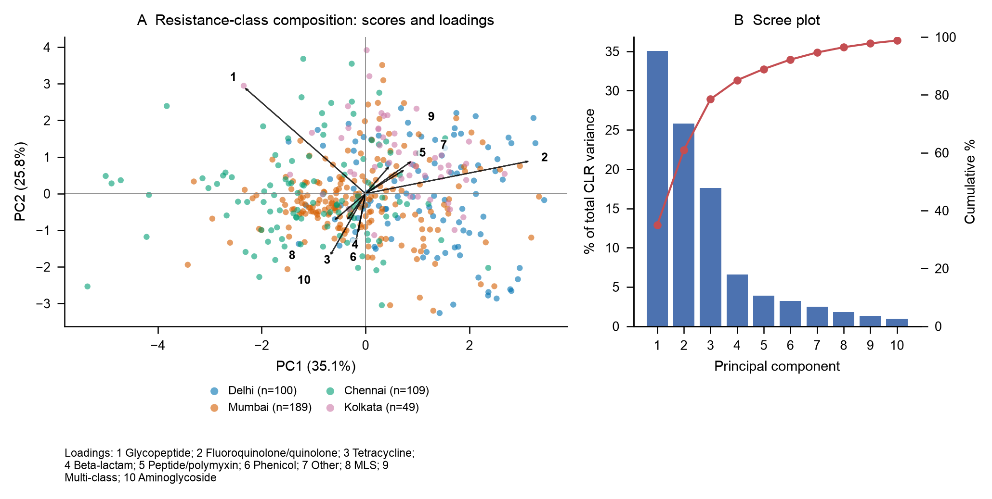
Fig. S8 CLR-PCA of resistance-class composition (13 class groups) in Indian open-drain wastewater: scores and loadings (A) and scree plot (B). n = 447.
CLR-PCA of 13 class groups: PC1 35.1%, PC2 25.8%, PC3 17.6%. PC1 is dominated by the genes of fluoroquinolone/quinolone (54.7%) and glycopeptide (29.8%), which together represent less than 1% of total RPKM; the ordination therefore emphasizes rare classes, and city overlap is extensive. Limitation: Caption statistic is sample-level; remove/replace with site-level test.
Source data: Table S32, Table S33.
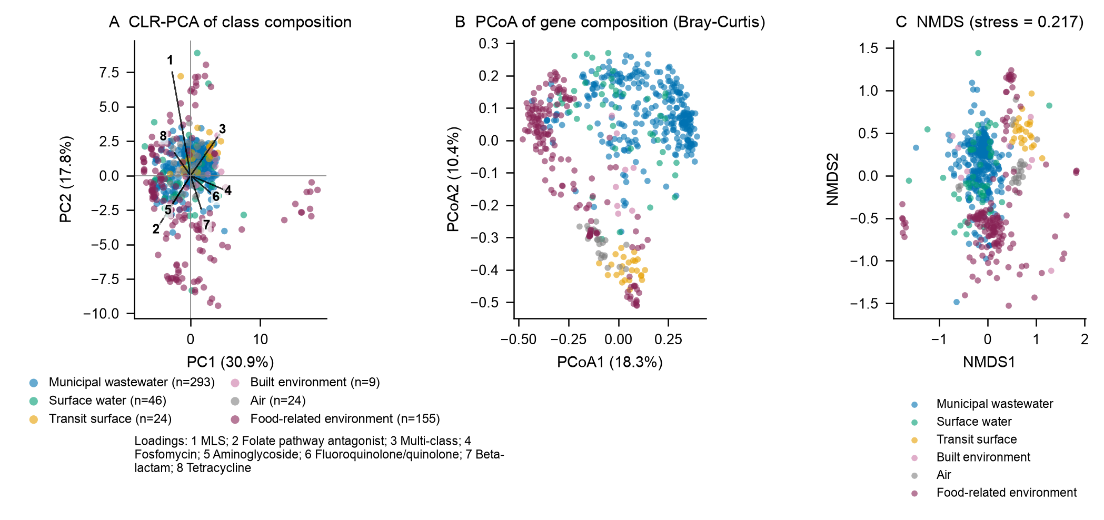
Fig. S9 Ordination of resistome composition across urban matrices in the ResFinder resource: CLR-PCA of class composition (A), principal coordinates analysis of Bray–Curtis gene composition (B), and non-metric multidimensional scaling (C; stress 0.217). n = 551 units.
Partially distinct regions (PCoA 18.3% and 10.4%) are occupied by matrix groups, and food-related units are separate from wastewater, but the project explains as much variation as the matrix (R² 0.22 versus 0.21), and NMDS stress (0.217) suggests poor fit in two dimensions. Limitation: Study-confounded; reduce to a single PCoA panel.
Source data: Table S51, Table S48.
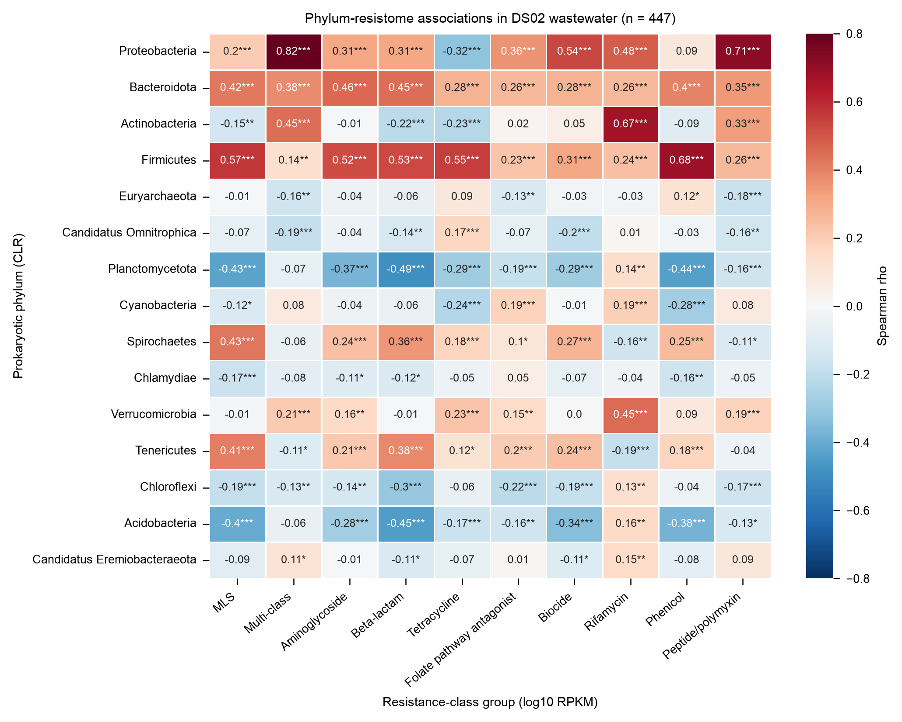
Fig. S10 Spearman correlations between abundances of phyla after CLR transformation and log10 resistance-class abundance (RPKM) in Indian open-drain wastewater (n = 447). Asterisks denote Benjamini–Hochberg q < 0.05, < 0.01, and < 0.001 across 150 tests.
Strong positive associations between the abundance of CLR phyla and the abundance of the class-group are found, such as Proteobacteria and multi-class (rho = 0.82) and peptide/polymyxin genes (rho = 0.71), and strong negative associations are found, such as Planctomycetota and beta-lactam genes (rho = −0.49); each of these pairs has BH q < 0.001 (correction over 150 tests). Limitation: Association of composition, not host assignments.
Source data: Table S31.
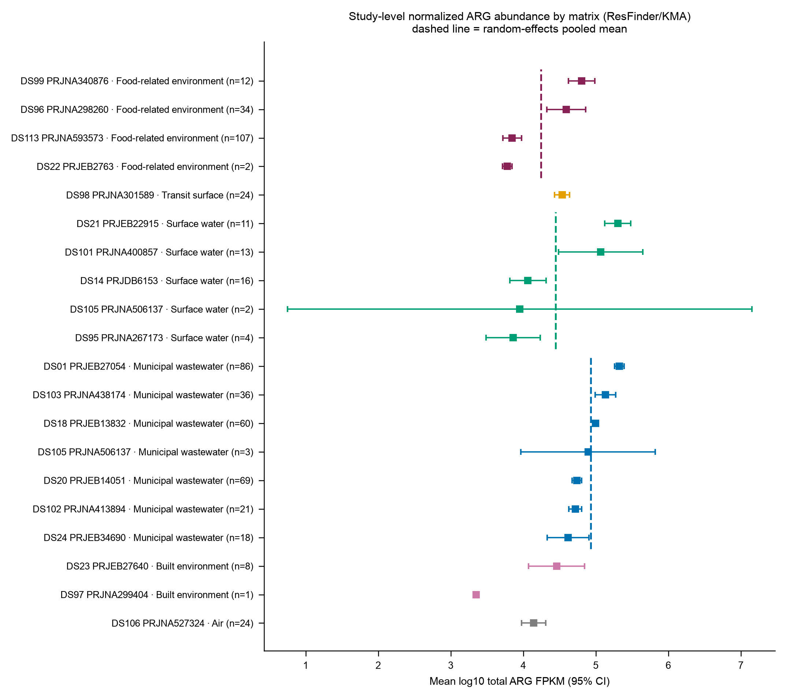
Fig. S11 Study-level mean log10 total ARG abundance (FPKM; 95% t-intervals) in the ResFinder resource by matrix. Random-effects (DerSimonian–Laird) pooled means are indicated by dashed lines.
Study means within a matrix spanned up to about 1.5 log10 units (e.g., surface water 3.9–5.3), similar to the spread between matrices, with I² ranging from 0.97 to 0.98 in each matrix containing at least four studies. This is the primary reason matrix contrasts are considered study-limited. Limitation: t-intervals for small studies are wide; the built environment includes a single-unit study.
Source data: Table S46, Table S47.

AMR gene presence
This section presents Figs. S12, S13, S14, S15 and S16.
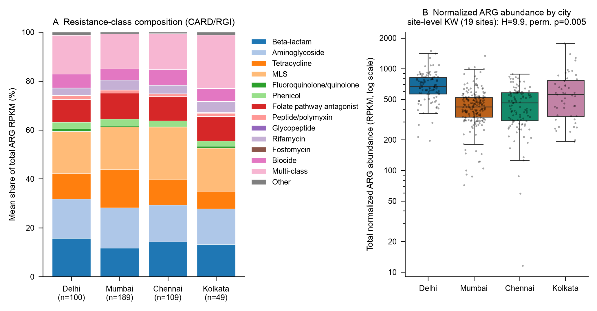
Fig. S12 Resistome of Indian open-drain wastewater (CARD/RGI, producer-processed): mean share of total ARG abundance by antibiotic-class group (A) and total normalized ARG abundance per sample (B; RPKM, logarithmic scale) with the site-level Kruskal–Wallis test (19 sites; whole-site permutation), n = 447 (Delhi 100, Mumbai 189, Chennai 109, Kolkata 49).
The resistomes are broad in all four cities, with the pooled resistomes, MLS, multi-class, aminoglycoside, beta-lactam, and tetracycline genes having the highest abundance (17.6% of total RPKM, 16.9%, 15.6%, 14.1%, and 11.7%, respectively). Median total abundance was highest in Delhi (666 RPKM; IQR 566–820) and lowest in Mumbai (421; 335–519). With sites as units, the city difference was supported (H = 9.9; permutation p = 0.005), and the mixed model gave fold changes relative to Delhi of 0.62 (95% CI 0.48–0.78) for Chennai, 0.62 (0.50–0.77) for Mumbai, and 0.81 (0.59–1.10) for Kolkata. The data cannot attribute the difference to antibiotic use, sewerage, or hydraulics, none of which were measured. Limitation: producer-processed CARD/RGI output with no reported CARD release; there are two sites in Kolkata.
Source data: Table S24, Table S25, Table S26, Table S27, Table S28.
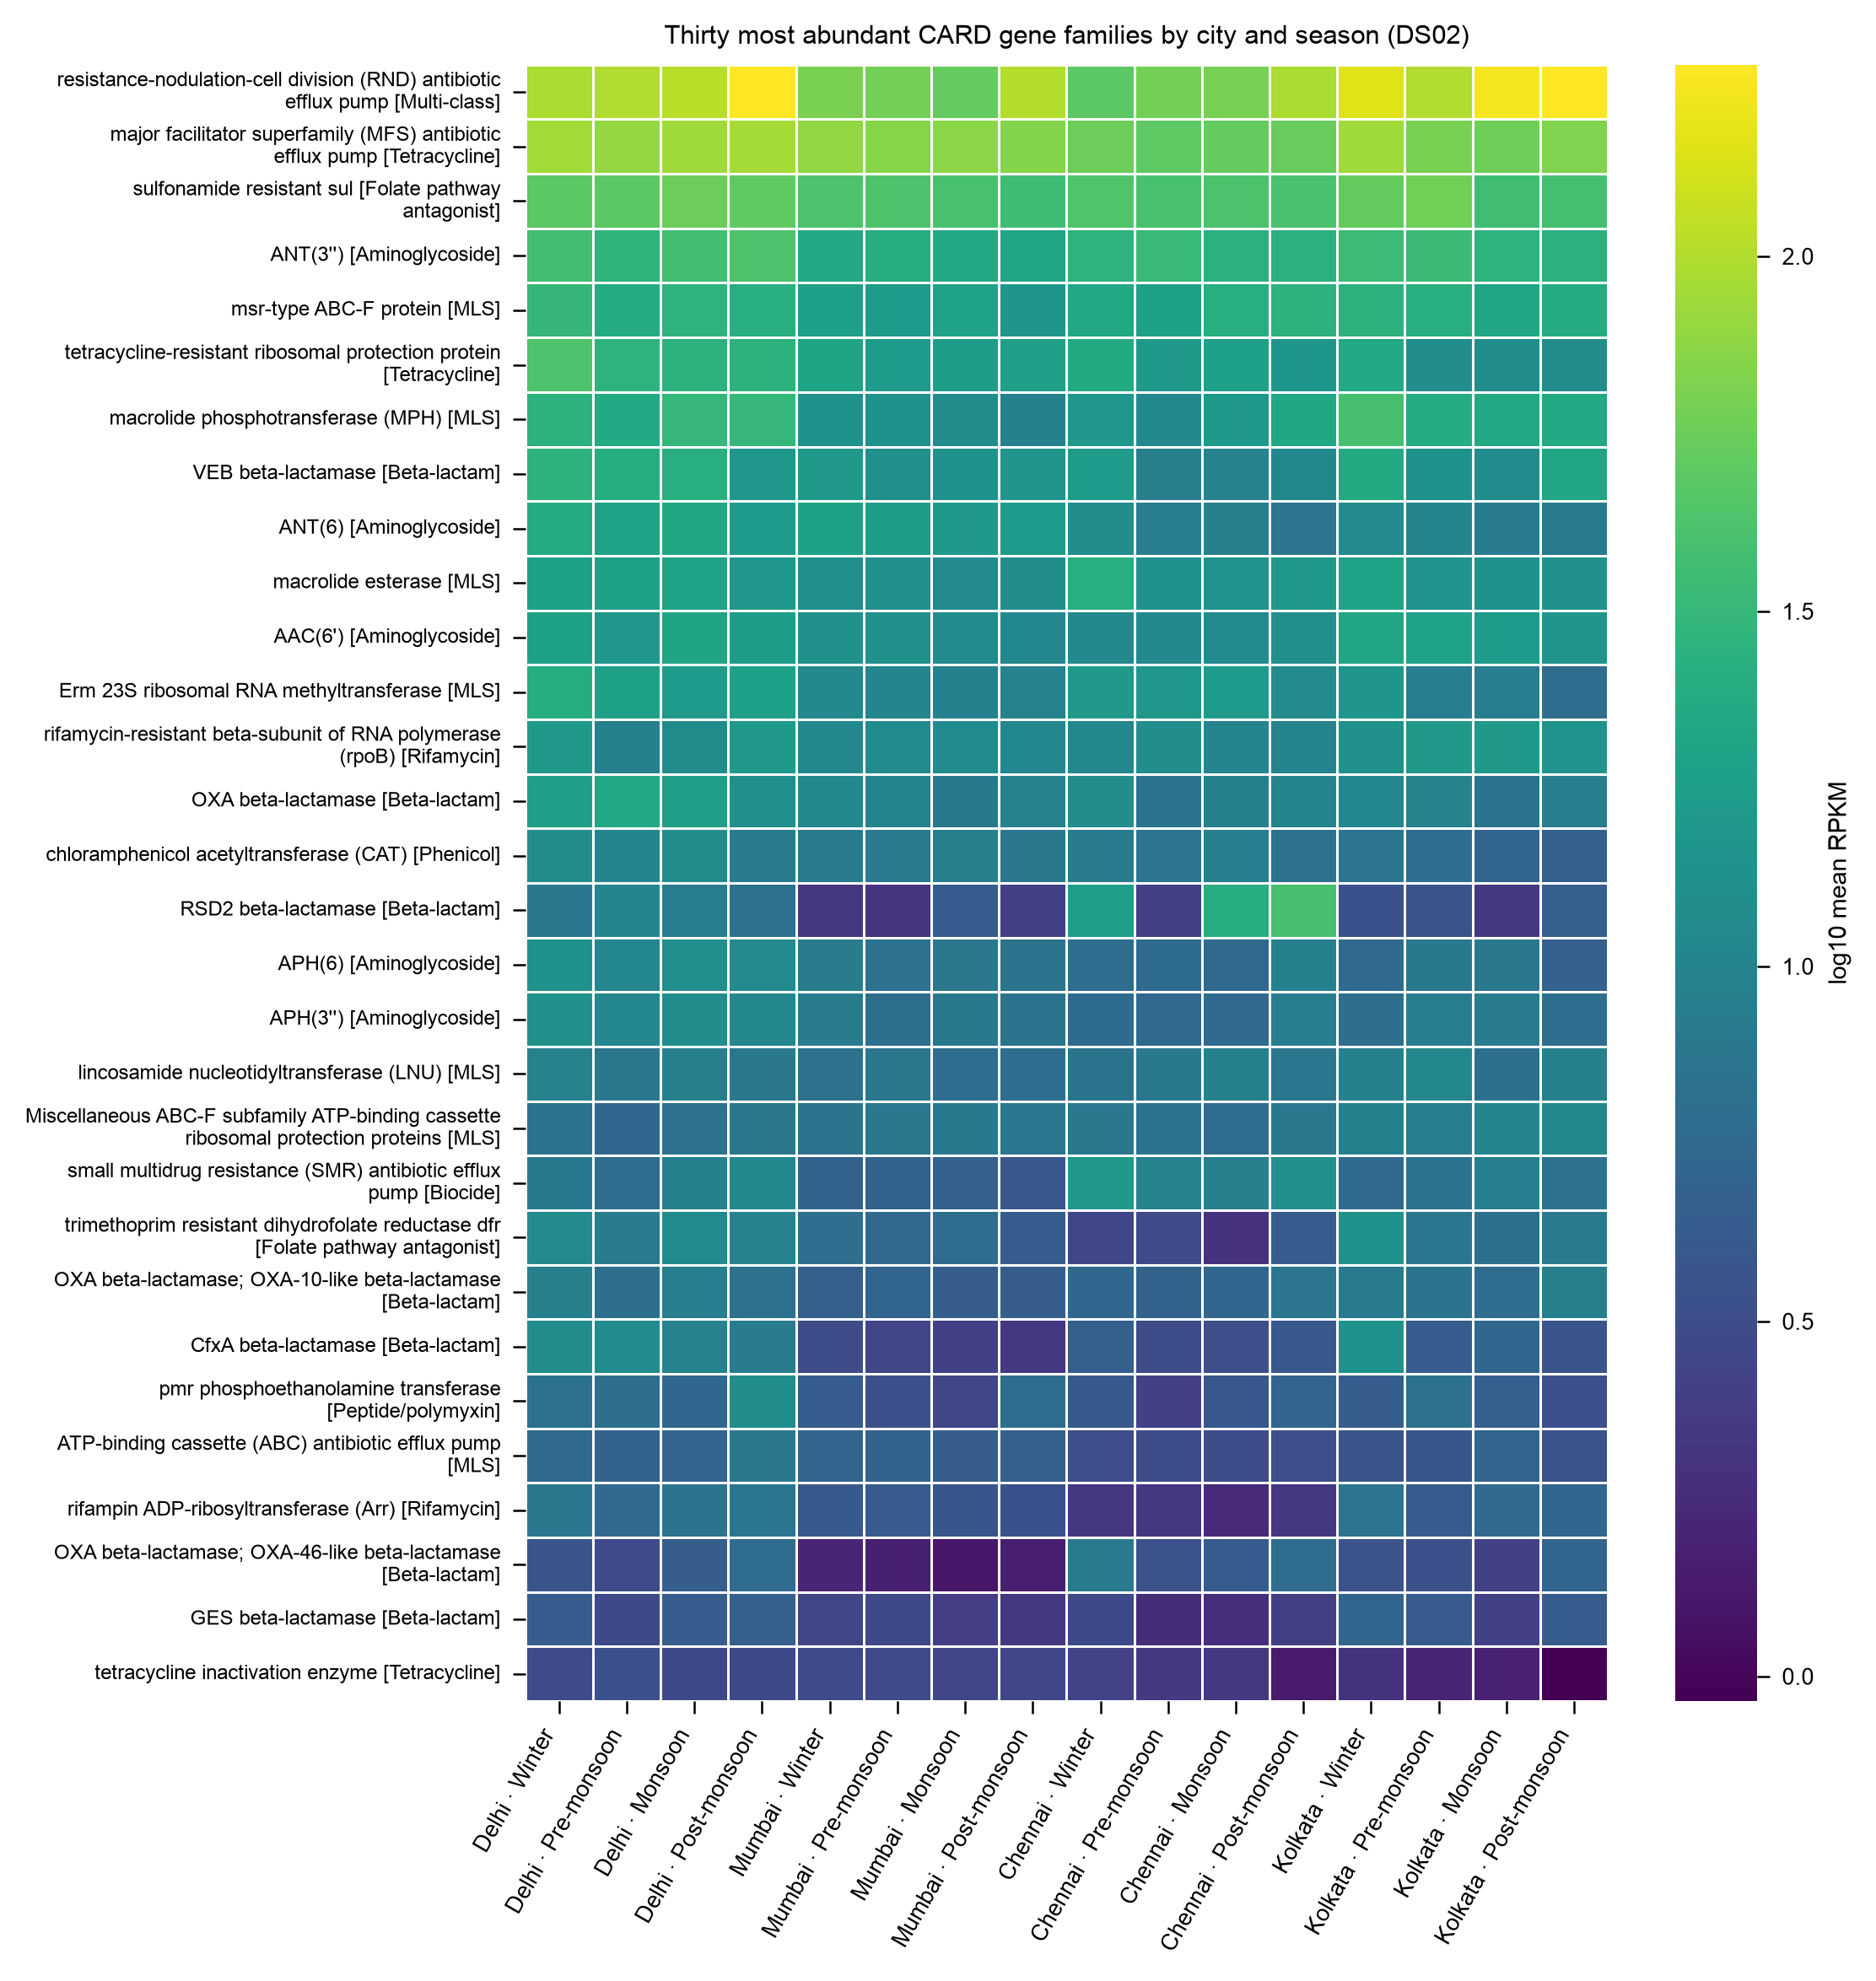
Fig. S13 Log10 mean abundance (RPKM) of the 30 most abundant CARD gene families by city and season in Indian open drain wastewater (n = 447).
The abundances of 30 CARD gene families are consistently ranked across seasons and are dominant in all city-season cells, including some with housekeeping functions, and efflux and multi-class families. Limitation: Abundance is not phenotype; Family harmonization affects ranking.
Source data: Table S23.
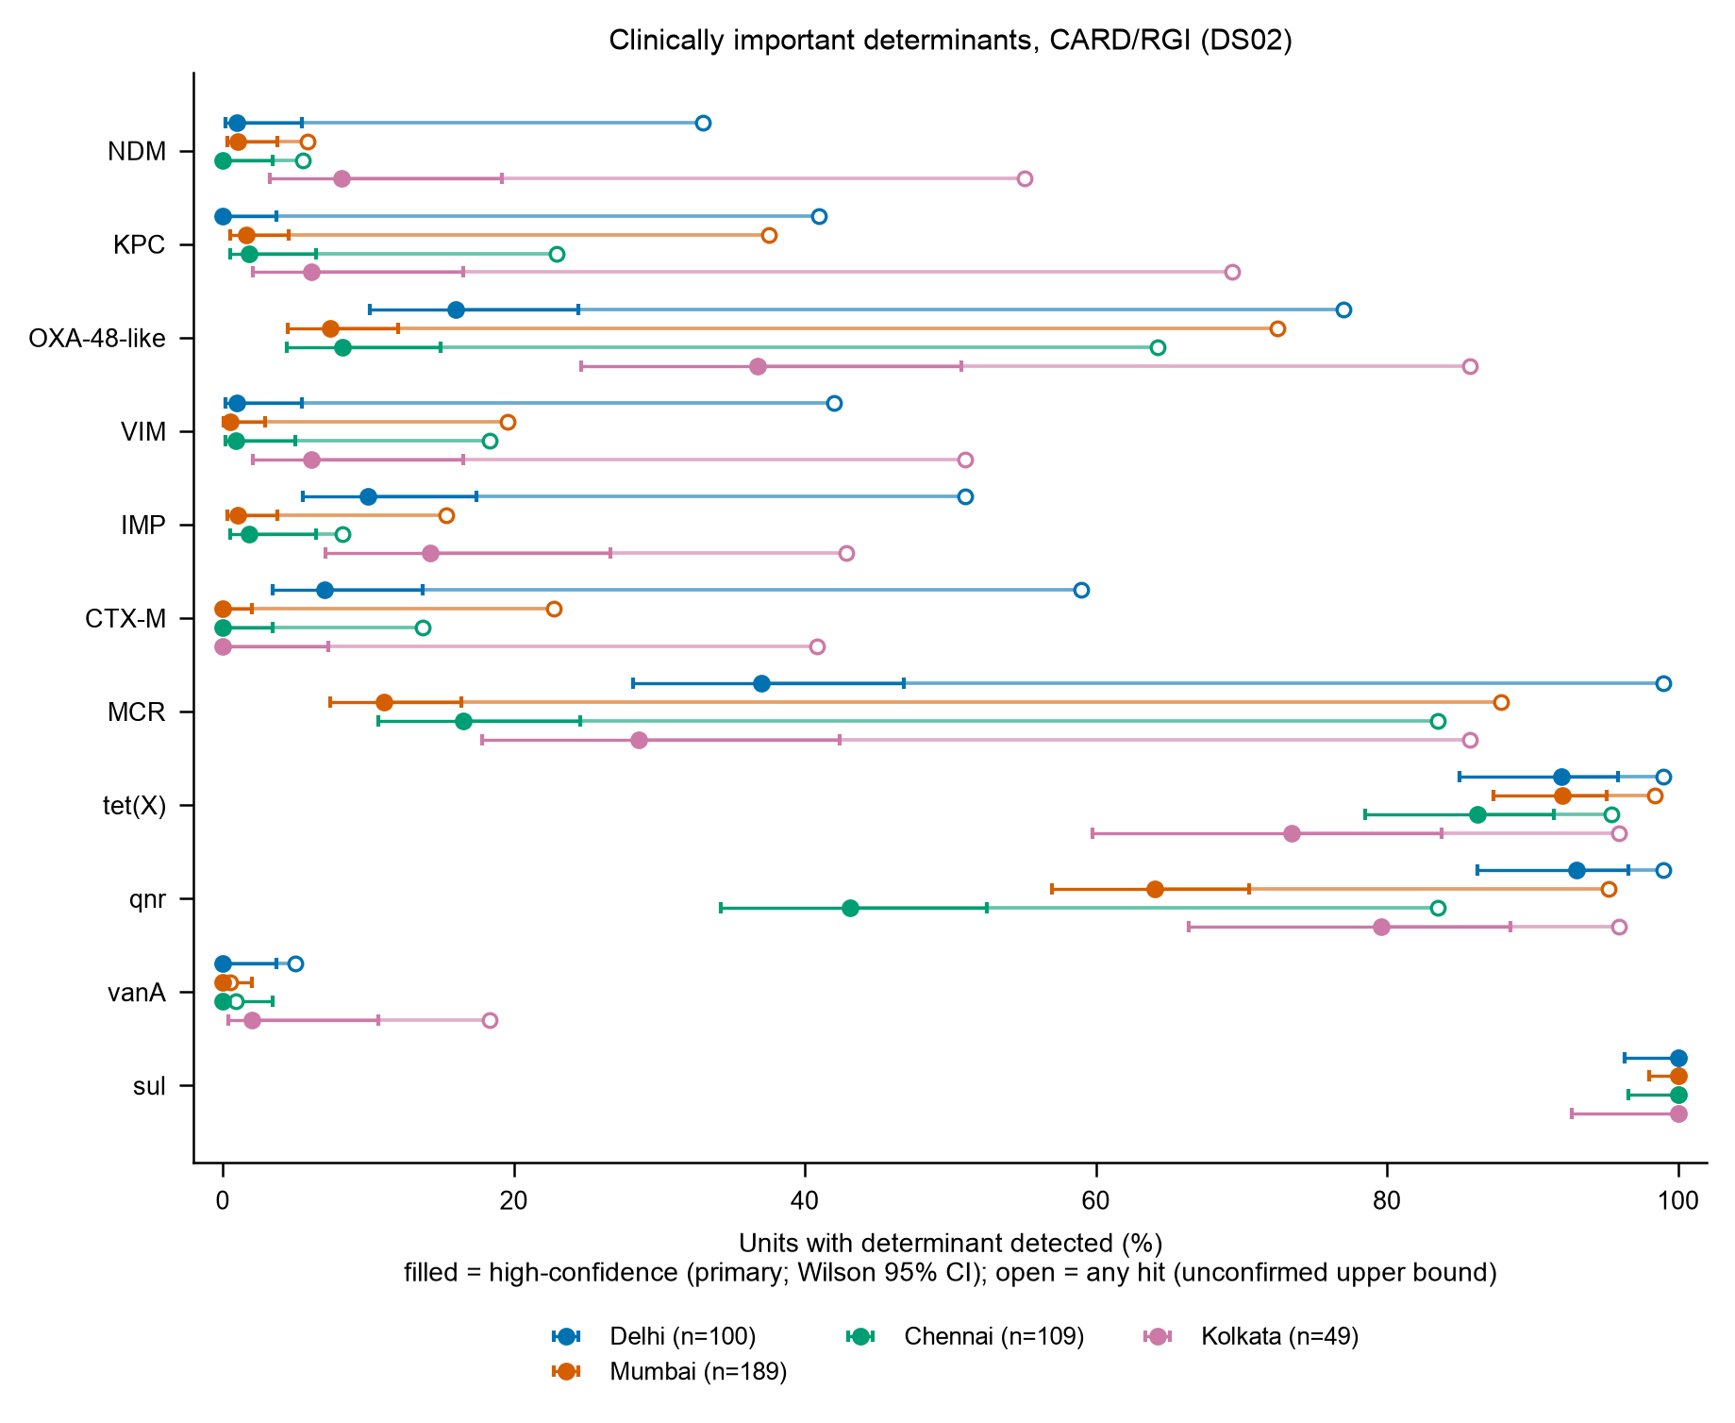
Fig. S14 Detection of clinically important resistance determinants by city in Indian open-drain wastewater (CARD/RGI). Filled symbols, high-confidence detection (with Wilson 95% CIs); open symbols, any hit (unconfirmed upper bound).
The distribution of the city-level detection is similar to that of Table 6.4: sul and tet(X) are ubiquitous; frequencies of carbapenemase genes are low at high confidence, with highest levels in Kolkata for NDM (8.2%) and OXA-48-like (36.7%) genes; any-hit bounds are much higher. Limitations: There are only two sites in Kolkata, so city differences were tested site-aware in Table S35.
Source data: Table S34, Table S35.
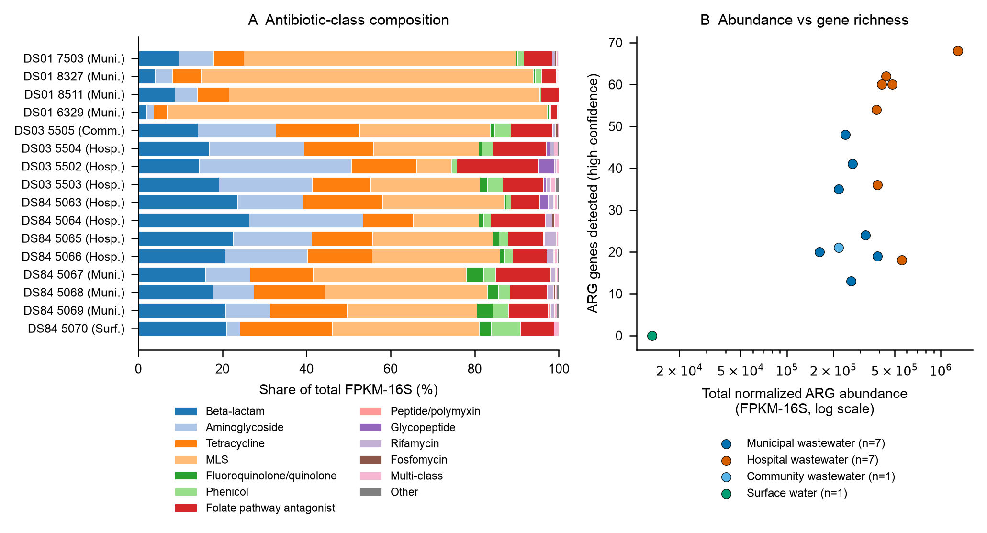
Fig. S15 Antibiotic-class composition (A; share of total FPKM-16S) and normalized ARG abundance against high-confidence gene richness (B) in the 16 Dhaka metagenomes, as a function of sample type.
The mean share of the MLS genes is 77.0% in DS01 samples, while DS03 and DS84 samples have mixed profiles. Hospital samples tend to carry more high-confidence genes, compared to the municipal samples at similar total abundance, and the pond sample is at the lowest end on both axes. The type of sample is confounded with the dataset.
Source data: Table S61, Table S63.
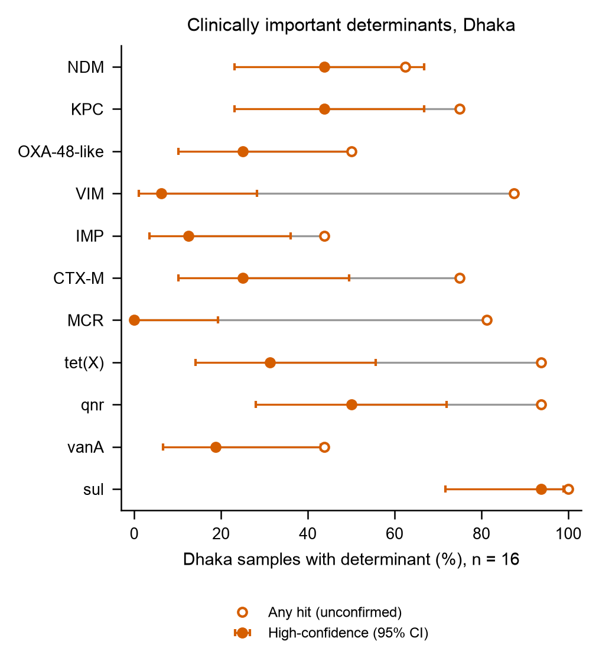
Fig. S16 Detection of clinically important resistance determinants in the 16 Dhaka metagenomes (ResFinder/KMA). Filled symbols, high-confidence detection (identity ≥ 90%, coverage ≥ 60%) with Wilson 95% CIs; open symbols, any hit.
NDM and KPC are each detected at high confidence in 7 of 16 samples (43.8%), qnr in 8, sul in 15, and MCR in none; any-hit bounds are higher, notably for VIM (14 of 16 versus 1) and MCR (13 versus 0). Limitation: n = 16; wide Wilson intervals (e.g., NDM 23.1–66.8%).
Source data: Table S64, Table S71.

Predictive modeling
This section presents Figs. S17 and S18.
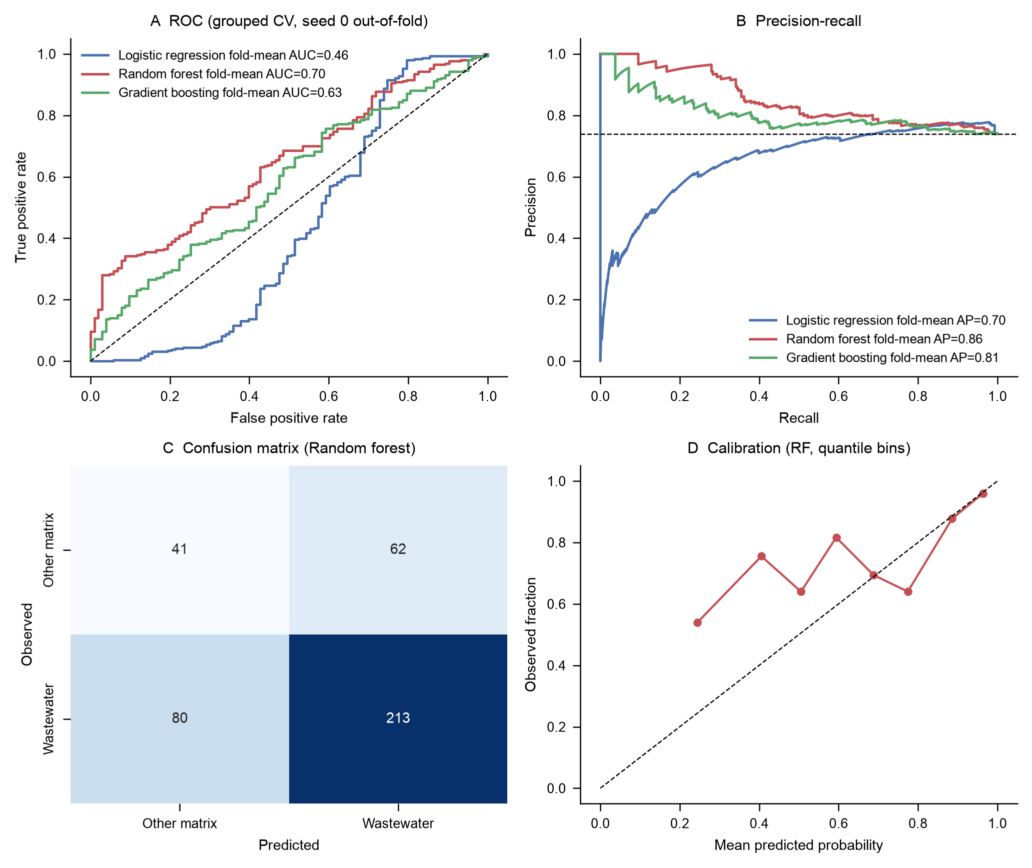
Fig. S17 Model A: exploratory classification of municipal wastewater against other urban matrices from CLR class composition, with 4-fold cross-validation holding out whole studies. ROC curves (A), precision – recall curves (B), confusion matrix (C), and calibration (D) for one repeat. 396 units, 15 studies.
With whole studies held out, the random forest had a mean ROC-AUC of 0.70 (SD 0.18; 2.5–97.5 percentile 0.23–0.85) and a balanced accuracy of 0.59, whereas the logistic regression was below chance (0.46). Allowing study leakage inflated the AUC to 0.93, indicating that the majority of apparent signal corresponds to study-specific information. Restriction: Only 15 studies; not stable across folds; only a matrix-signature test, not a health or food-safety prediction.
Source data: Table S76, Table S77, Table S78, Table S79.
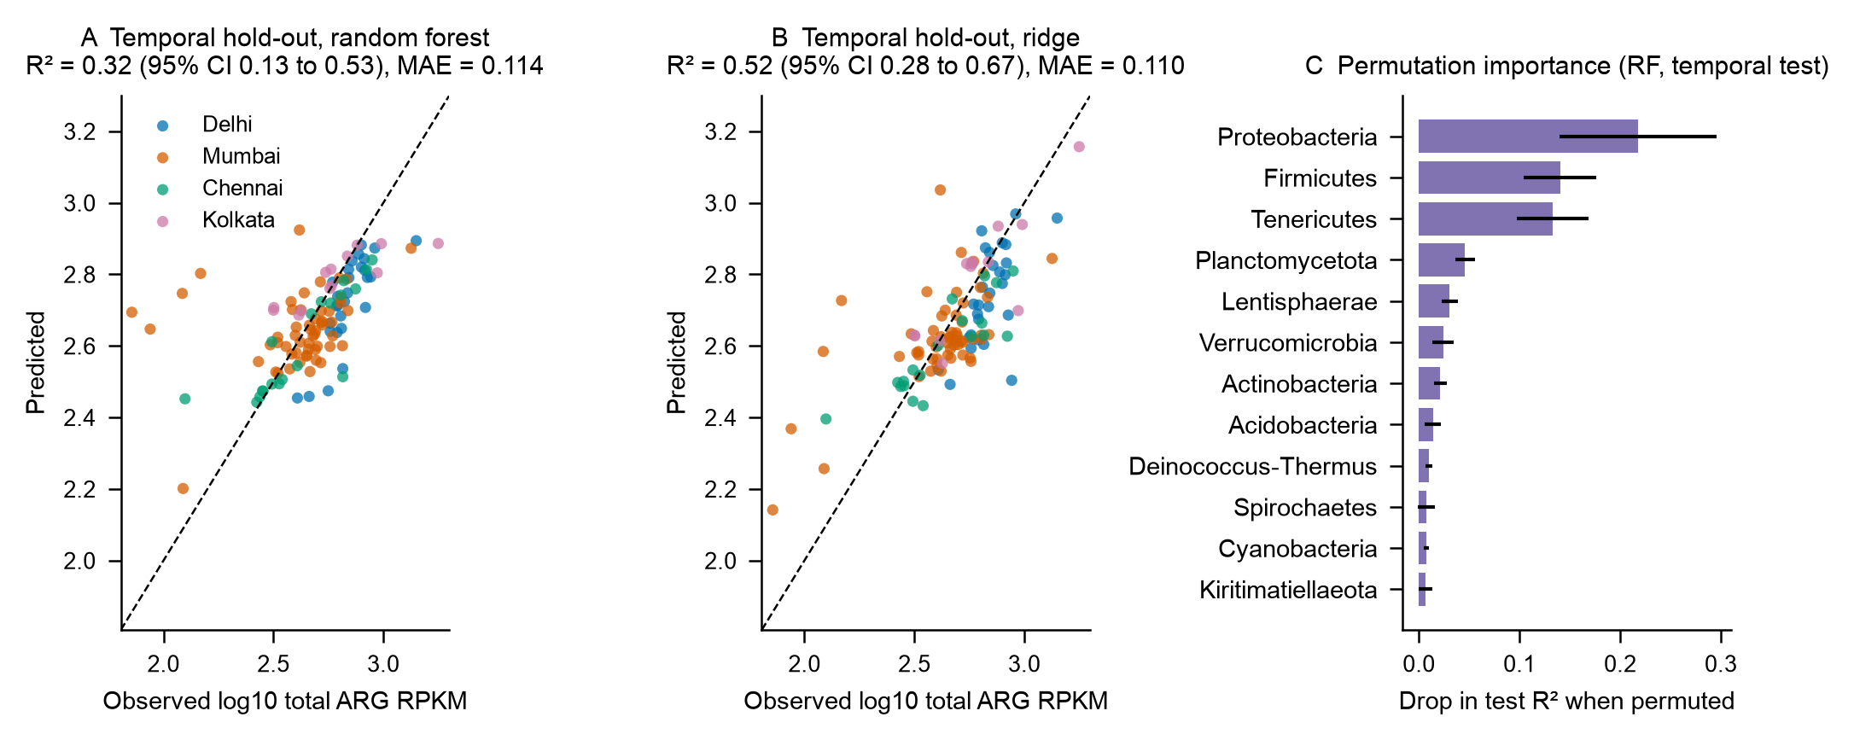
Fig. S18 Model B exploratory prediction of log10 total ARG abundance (RPKM) from CLR phylum composition in Indian wastewater samples, trained before September 2023 (n = 332) and tested on the remaining samples (n = 115) - A) random forest, B) ridge regression and C) permutation importance.
Ridge regression on CLR phylum composition had an R² of 0.52 (95% CI 0.28–0.67) compared to an R² of −0.02 (baseline); random forest R² was 0.32. Association was not consistent across cities, with held-out city R² ranging from −0.04 (Delhi) to 0.41 (Kolkata) for ridge. Limitation: Association – not prediction of health outcomes; 1 study; 1 pipeline.
Source data: Table S80, Table S81.

Environmental monitoring
This section presents Fig. S19.
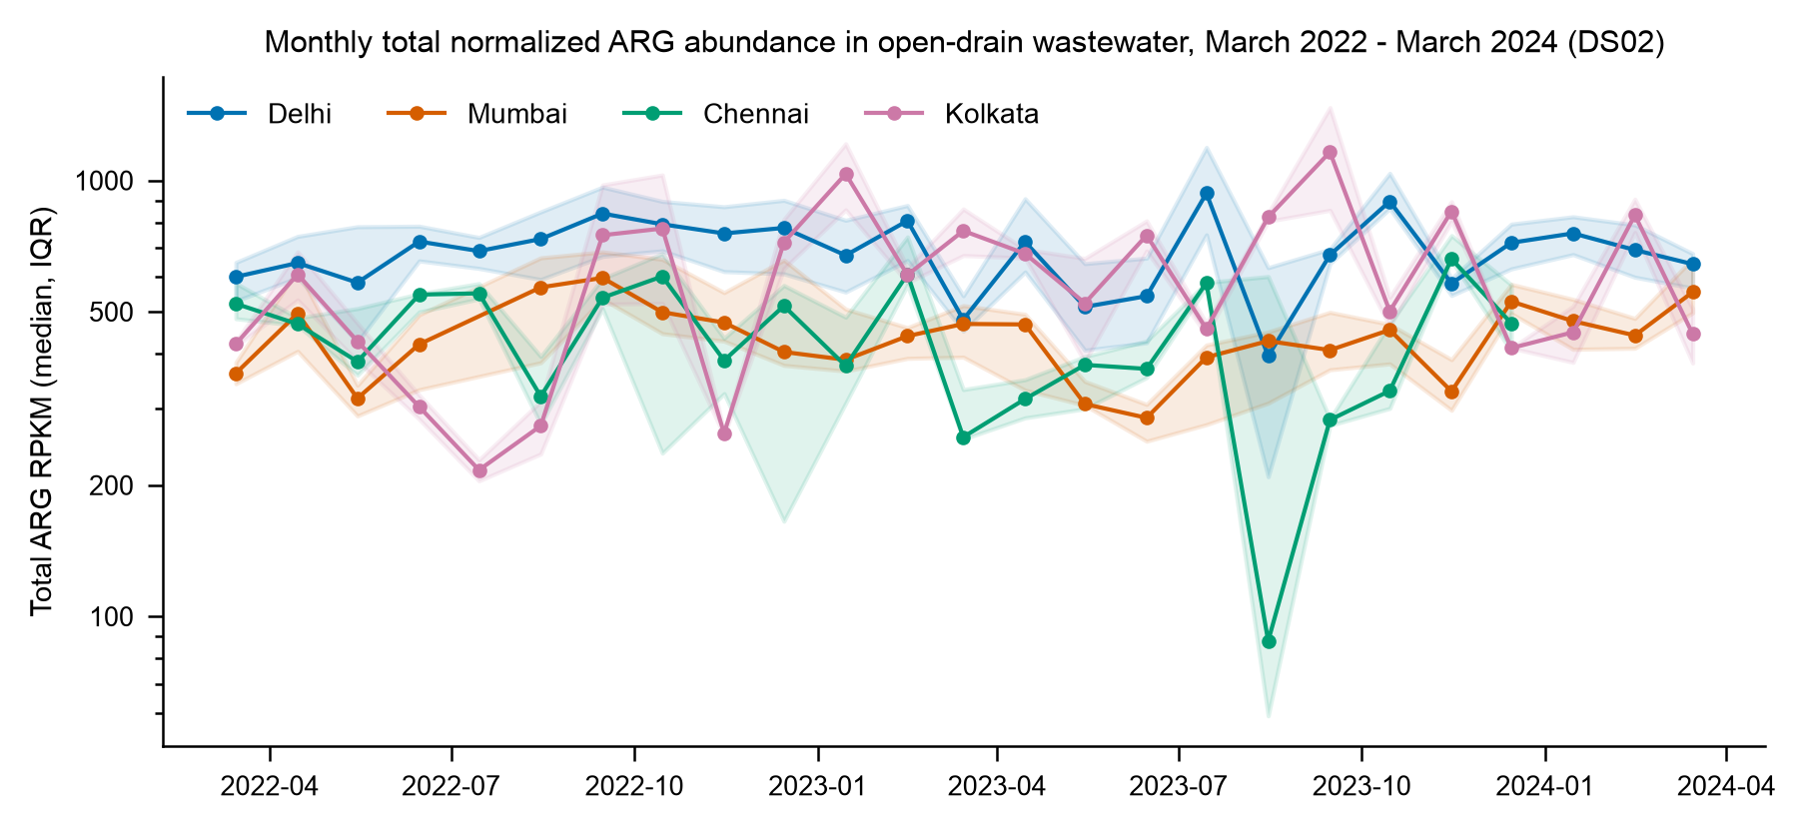
Fig. S19 Observed monthly median abundance of total normalized ARG (RPKM) ± interquartile range (IQR) (25 rounds; 1–8 samples/city/month) from Indian open-drain wastewater collected from March 2022 to March 2024. No values are modeled or forecast.
The monthly median of total RPKM was variable for different cities over 25 months, with Delhi being the top city in most months. Single-month excursions should not be treated as signals since the lowest point (Chennai, August 2023, 88 RPKM) is based on five samples with an IQR of 59–602. The following limitations are noted: Observed series, not modeled; site composition changes from month to month; no trend test performed.
Source data: Table S36.

Environmental monitoring and robustness
This section presents Figs. S20 and S21.
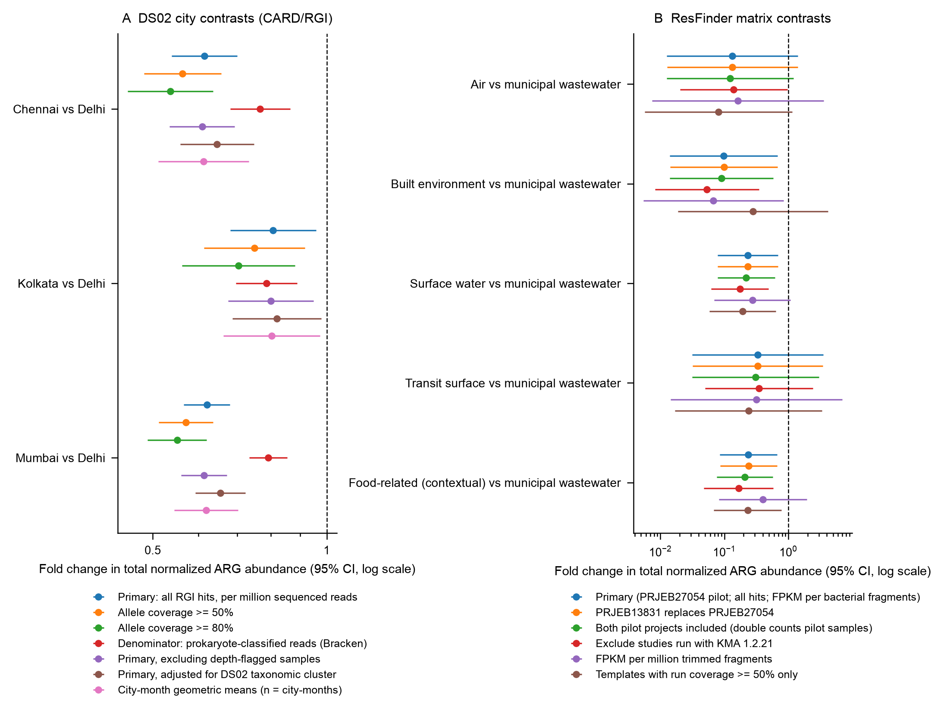
Fig. S20 Robustness of key contrasts relative to Delhi (A) and relative to municipal wastewater (B): fold changes (95% CI, log scale) for Indian city contrasts (A) and ResFinder matrix contrasts (B) with the alternatives to the basic specifications. City specifications for (A) are sample-level models, so only direction is informative.
Under alternative thresholds, denominators, outlier treatment, and alternative pilot projects and versions of the KMA, the direction of city contrasts (versus Delhi) and matrix contrasts (versus municipal wastewater) remain unchanged, and the confidence intervals grow larger, whereas some matrix contrasts are no longer significant under the trimmed-fragment denominator. Limitation: sensitivity, not validation; the seven DS02 specifications are sample-level models, so cite their direction, not their p-values.
Source data: Table S87, Table S89.
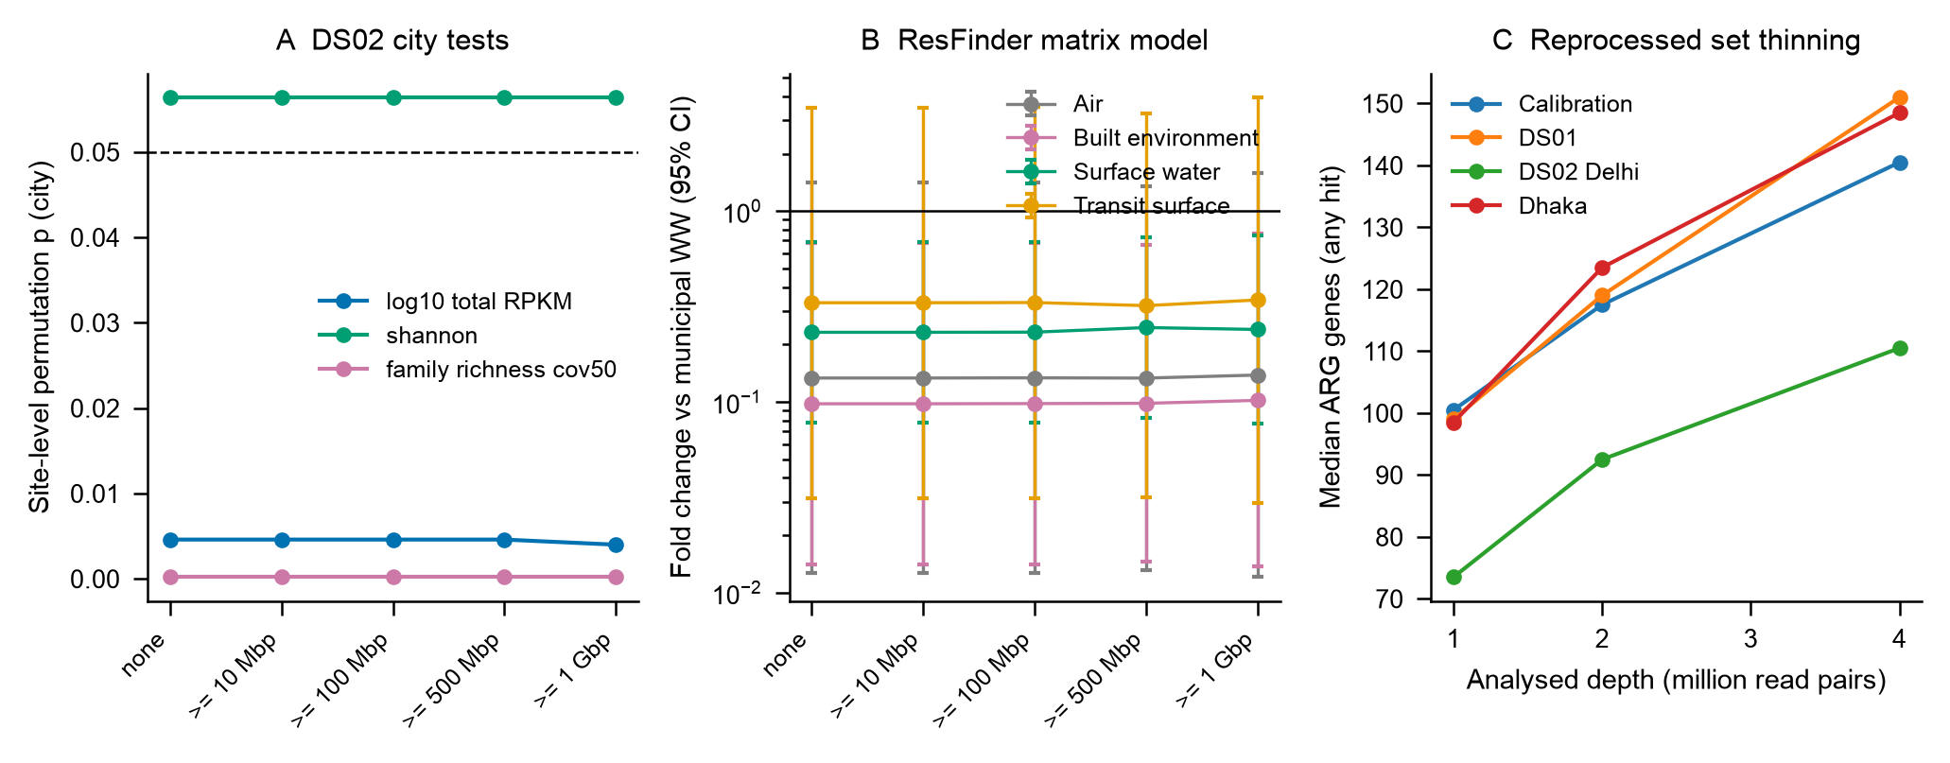
Fig. S21 Sensitivity to sequencing depth: site-level city tests in Indian open drains (A), ResFinder matrix fold changes across depth thresholds (B), and median ARG gene richness following binomial thinning of reprocessed runs (C).
Site-aware DS02 city tests remain significant for total RPKM and family richness across depth thresholds from 10 Mbp to 1 Gbp, although thresholds up to 500 Mbp removed no DS02 sample and 1 Gbp removed only one, so this is a weak test for DS02; ResFinder matrix fold changes keep their direction at every threshold; gene richness is reduced by binomial thinning of read pairs to 1–2 million, confirming that rare-gene detection is depth-limited. Limitation: Thresholds remove few samples in DS02.
Source data: Table S92, Table S93, Table S94, Table S95, Table S96.

Global microbial communities
This section presents Figs. S22, S23, S24, S25, S26 and S27.
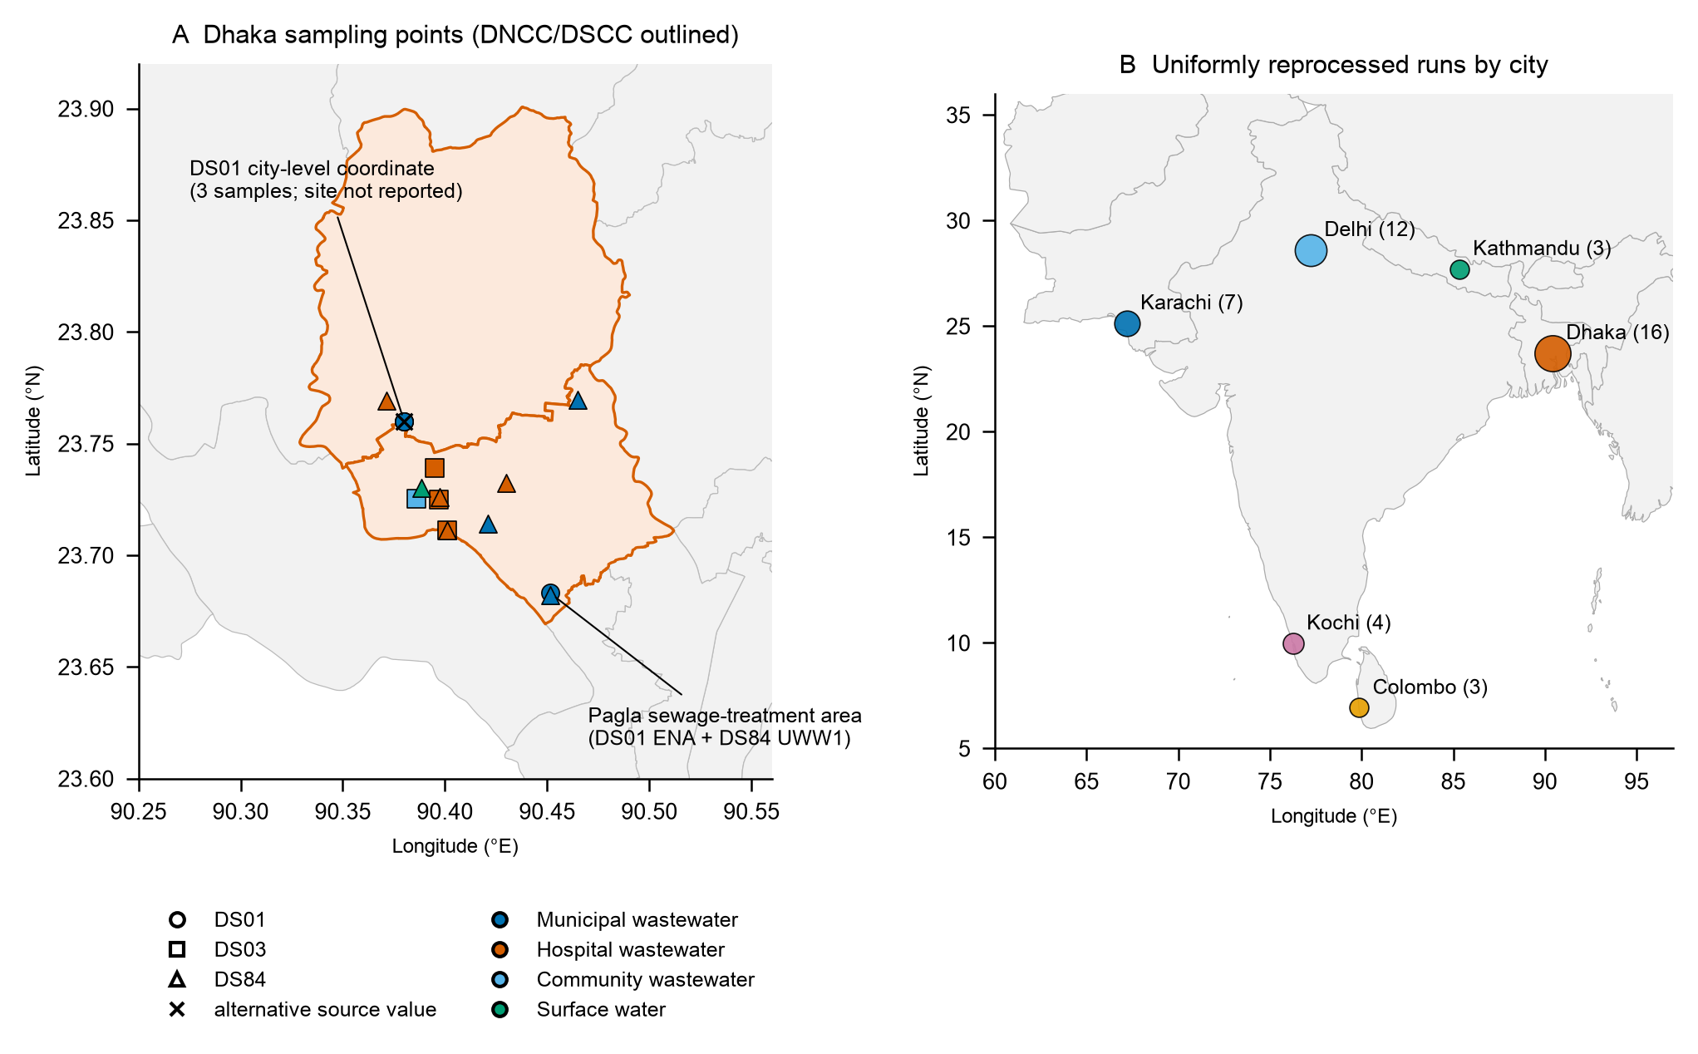
Fig. S22 Dhaka sampling locations plotted with respect to the map of Dhaka North and South City Corporation boundaries (A) and all uniformly reprocessed runs by city (B). Observed points only.
Reported coordinates for all 16 samples are within the Dhaka North/South City Corporations, but only 12 of the 16 samples can be confirmed (10 with sample-level and 2 with two-decimal coordinates); 3 samples have only a city-level publication coordinate, and 1 lies closer to the boundary than its coordinate precision; a DS84 inlet sample and a DS01 sample are located about 0.13 km apart near the Pagla treatment area. Limit: It is unknown if all DS01 rounds were sampled at Pagla (author decision).
Source data: Table S54, Table S55.
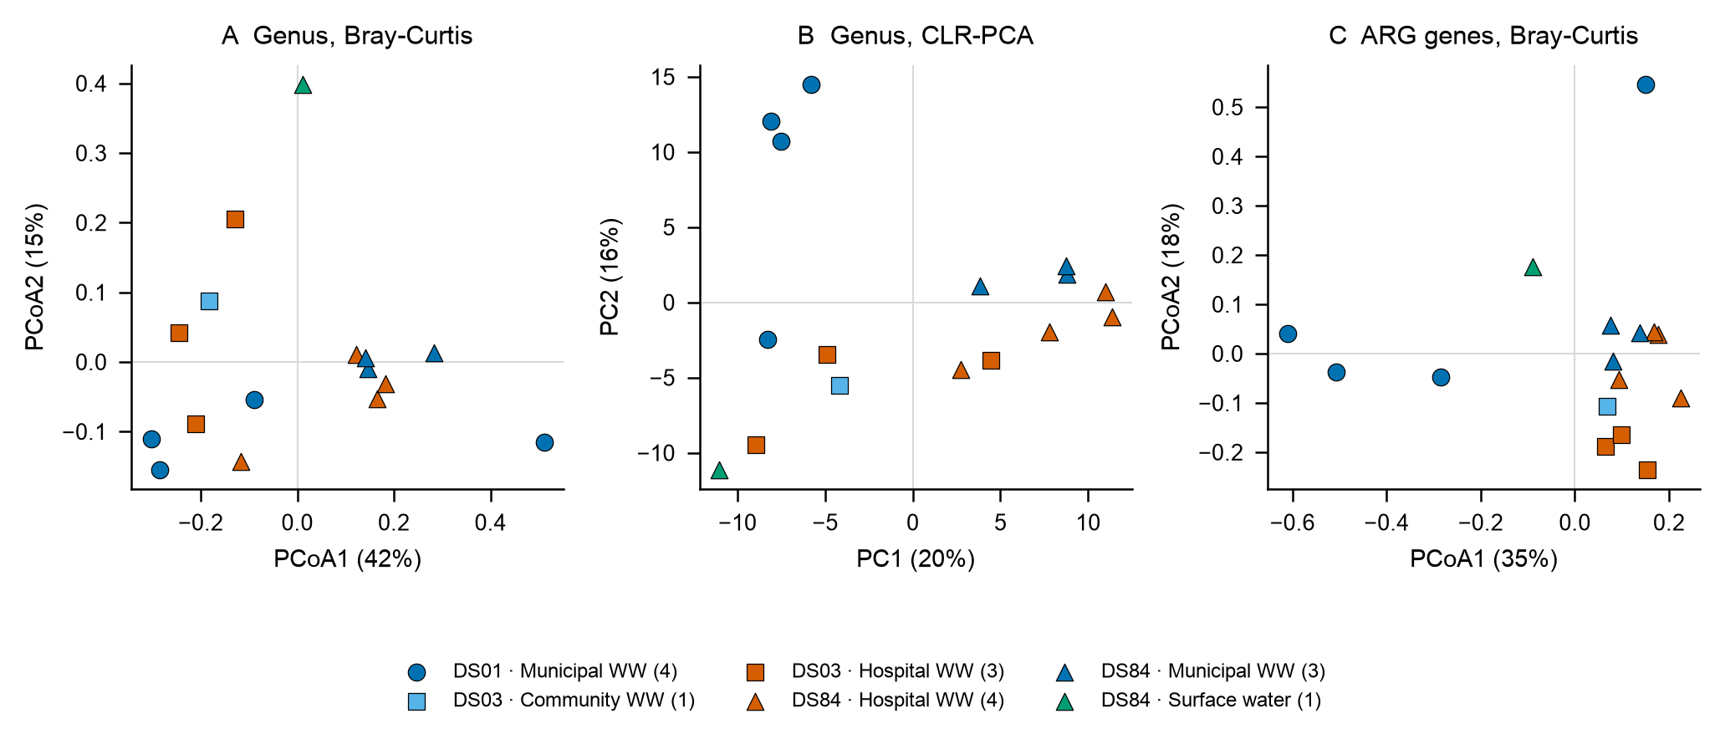
Fig. S23 Ordination of the 16 metagenomes from Dhaka by methods of genus Bray–Curtis PCoA (A), genus CLR-PCA (B), and ARG gene Bray–Curtis PCoA (C). There is confounding by dataset/year/instrument and sample type.
The ordination of genera and ARG was mostly separated by dataset for Dhaka samples, with R² of 0.30 and 0.36, respectively, but with no difference in dispersion (PERMDISP p = 0.49–0.90). There is a strong concordance between microbiome and resistome structure (Mantel r = 0.69). Limitation: Descriptive; dataset, year, instrument, and sample type confounded.
Source data: Table S65, Table S66.
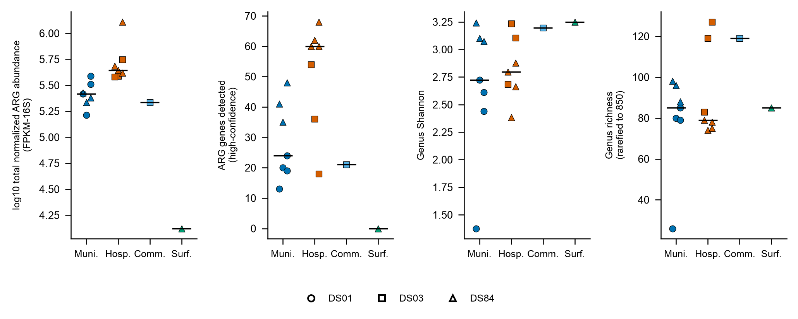
Fig. S24 Within-Dhaka comparison of normalized ARG abundance, high-confidence ARG genes, genus Shannon index, and rarefied genus richness by sample type and dataset; horizontal bars show medians.
In DS84, hospital wastewater exceeded STP inlets by 0.29 log10 FPKM-16S (Cliff's delta 1.00) and carried 20 more high-confidence genes, but the exact p-values (0.057 and 0.086, i.e., 2/35 and 3/35) are at or near the minimum attainable with 4 versus 3 samples. Limitation: Underpowered; other contrasts confound type with study.
Source data: Table S61, Table S60, Table S68.
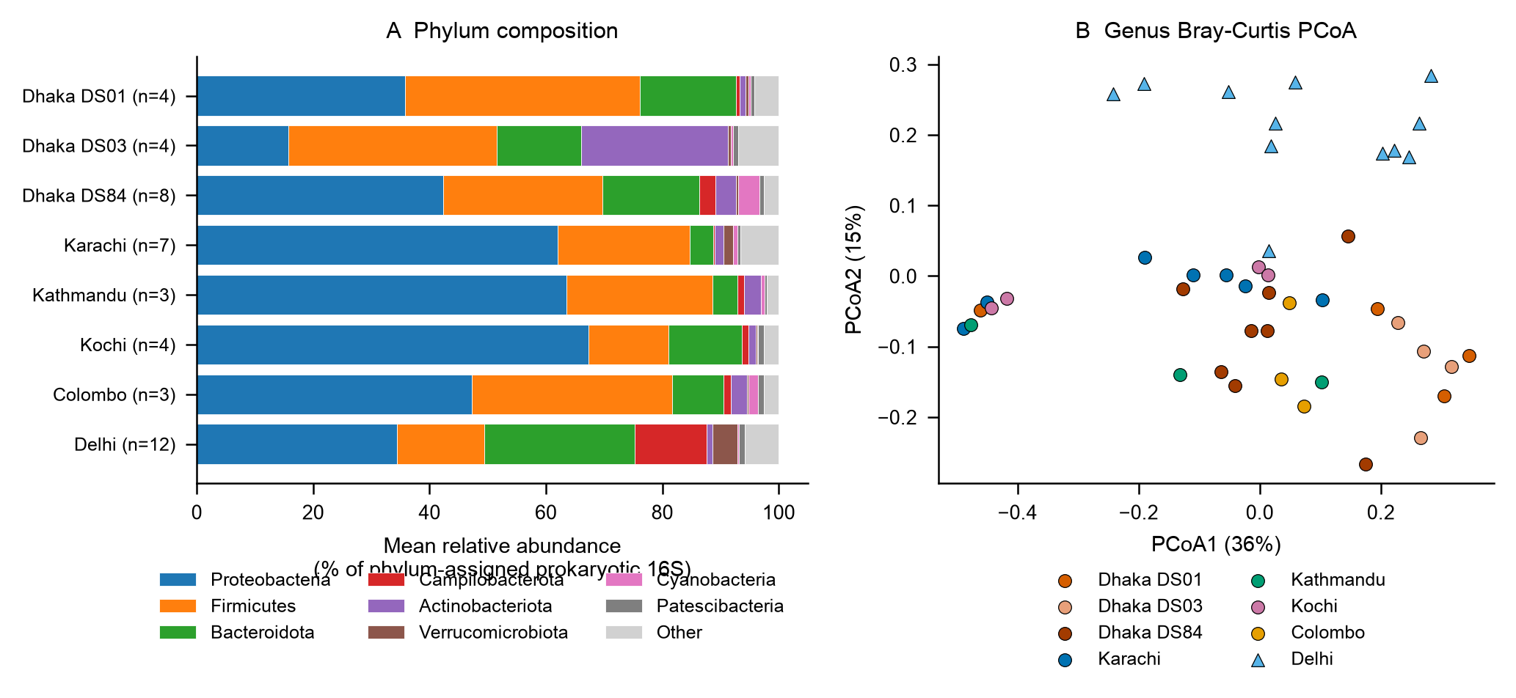
Fig. S25 Phylum composition (A) and genus Bray–Curtis PCoA (B) of Dhaka metagenomes compared with open drains in Delhi and municipal sewage from Karachi, Kathmandu, Kochi, and Colombo after uniform reprocessing.
The open drains in Delhi are separated from all sewage samples on PCoA2 (genus Bray-Curtis), with DS01 and DS03 being Firmicutes-rich and DS03 being Actinobacteriota-rich relative to the comparator cities. Limitations: Matrices, years, and studies vary.
Source data: Table S67, Table S68, Table S70.
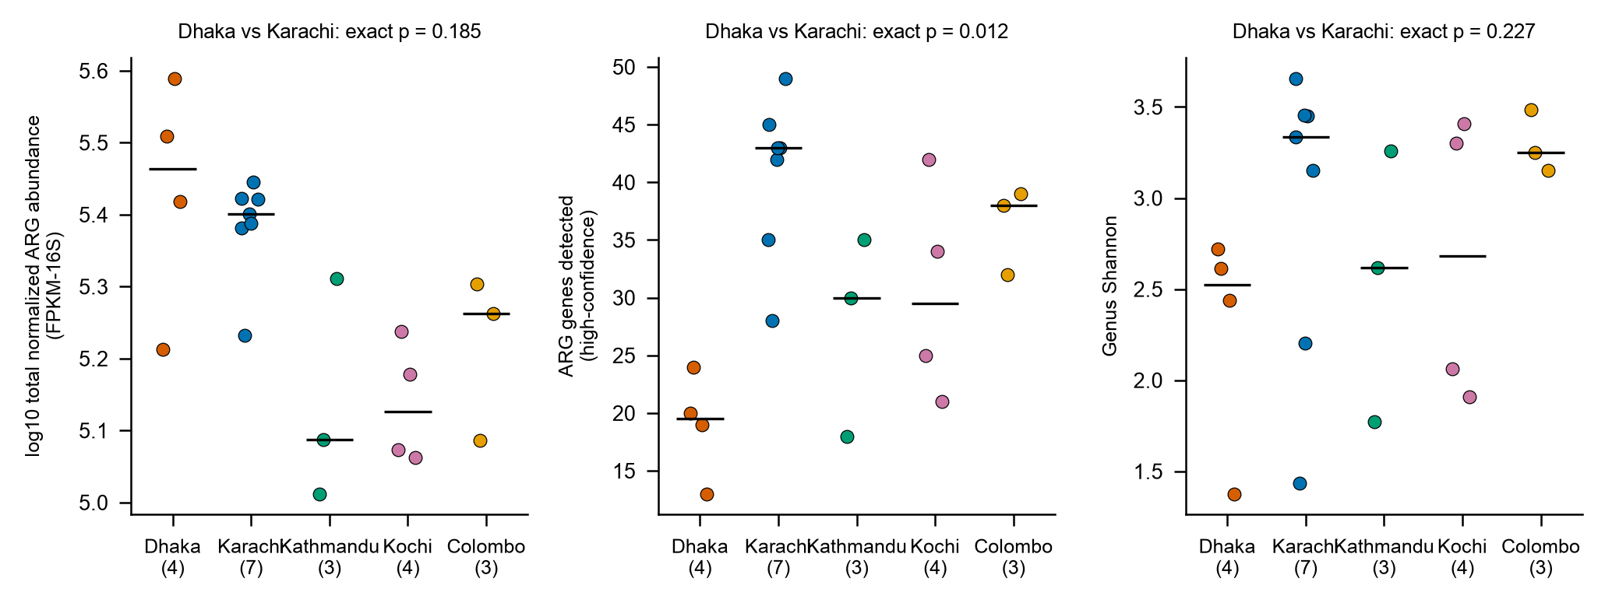
Fig. S26 Normalized ARG abundance, high-confidence ARG genes, and genus Shannon index for Dhaka compared with Karachi, Kathmandu, Kochi, and Colombo under a matched Global Sewage Surveillance protocol (2017–2019; Illumina NovaSeq 6000), with exact permutation p-values for Dhaka versus Karachi.
The abundance (median log10 5.46) of Dhaka overlaps with that of Karachi (5.40); however, the number of high-confidence genes is lower (19.5 versus 43.0; p = 0.012), and the genus Shannon is lower (2.53 versus 3.34; p = 0.227, not significant) in Dhaka compared to Karachi. Limitation: Four samples in Dhaka and seven in Karachi, city-rounds (not independent sites).
Source data: Table S67, Table S68.
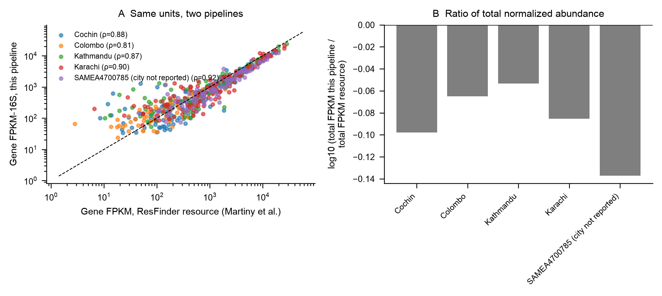
Fig. S27 Calibration of the uniform reprocessing pipeline against the ResFinder resource for the same sewage units: gene-level FPKM-16S versus resource FPKM with Spearman ρ (A) and the ratio of total normalized abundance (B).
The gene-level FPKM values from the Stream 3 workflow showed Spearman correlations of 0.81 to 0.92 with resource values, with presence Jaccard 0.42–0.64, and totals were slightly lower (log10 ratio −0.09 ± 0.03) for the five pilot sewage units. Limitation: Values are not interchangeable because the pipelines have different versions of KMA, ResFinder release, depth, and denominator.
Source data: Table S72, Table S73.

Risk mapping
This section presents Figs. S28, S29 and S30.
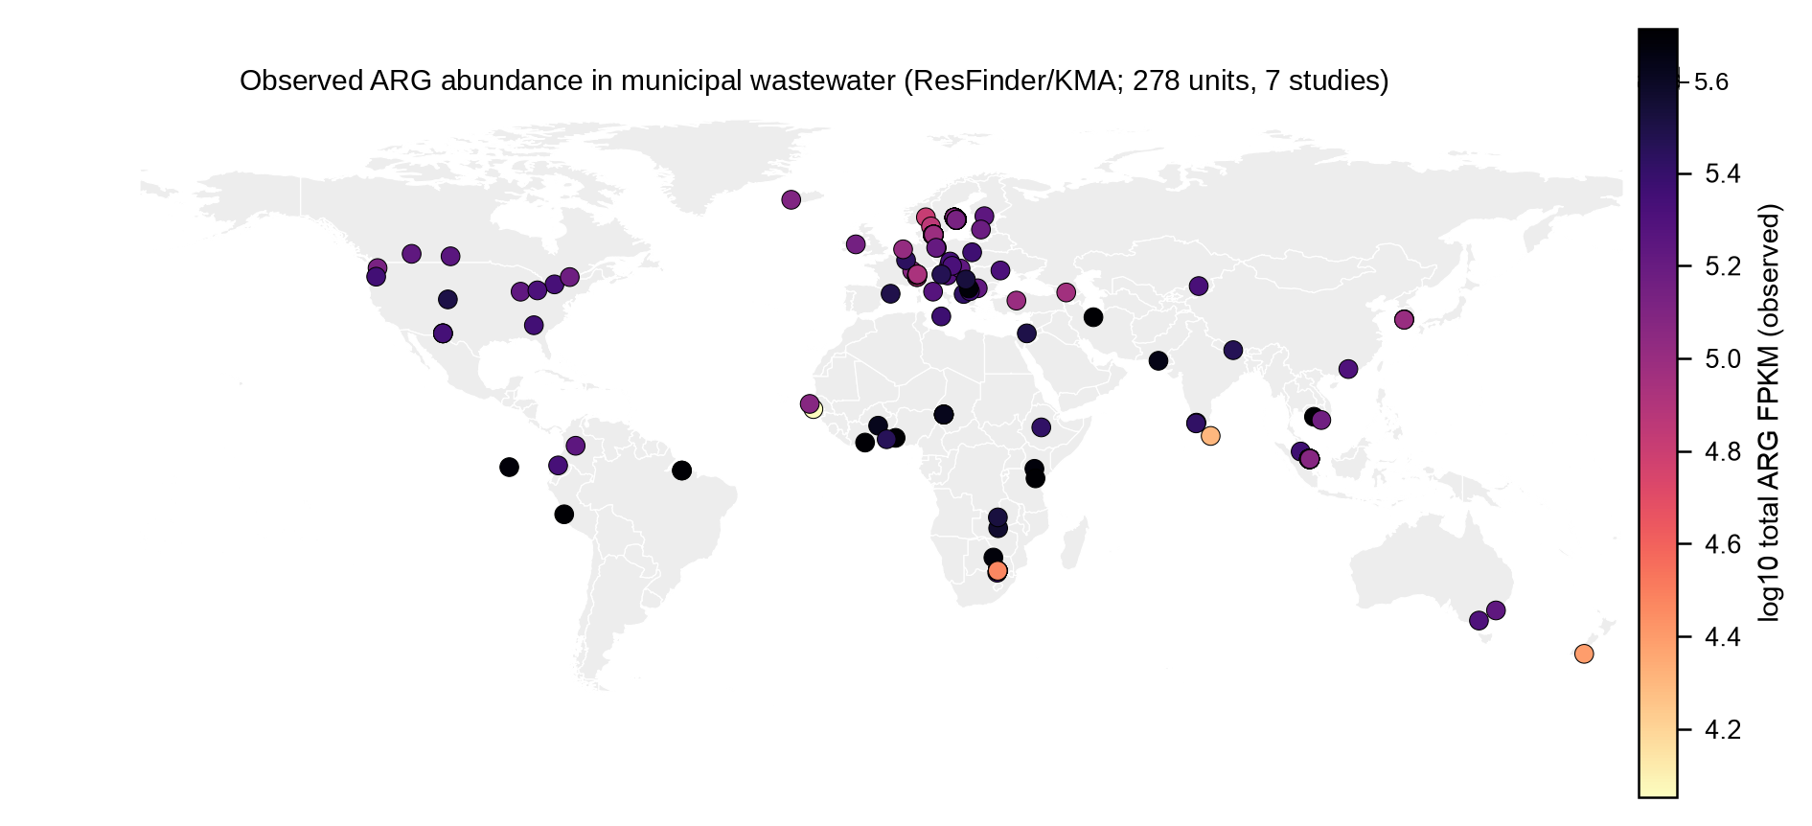
Fig. S28 Observed log10 total normalized abundance of ARG (FPKM) in the studied municipal wastewater at the reported sampling locations in the ResFinder resource (278 units, 7 studies). Only observed values, not an interpolated surface or risk map.
The abundance of municipal-wastewater observed units (278 units, 7 studies) is generally higher in Africa and some South American and Asian points than in European points and is similar to the pattern found on the continents in Figure S6.15. Limitation: Points are observations, not a surface; Color was clipped to the 2nd–98th percentile.
Source data: Table S37.
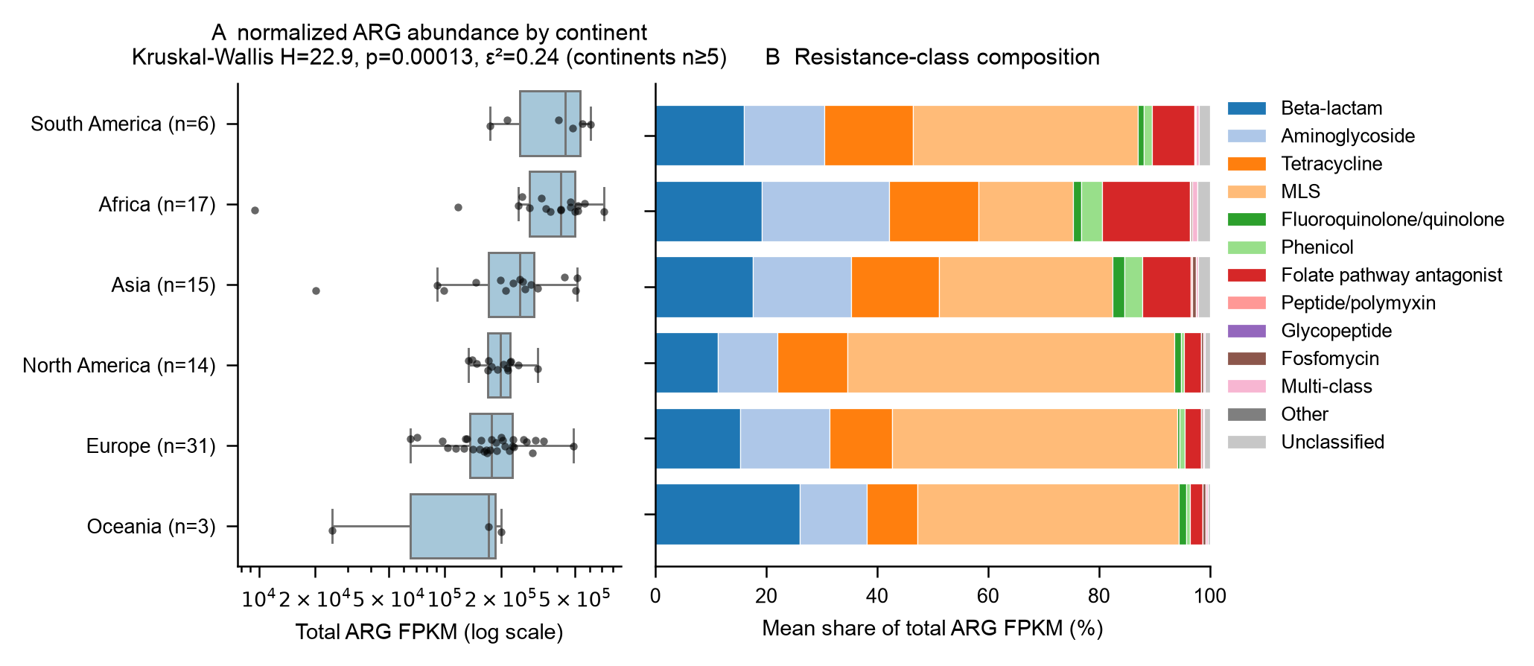
Fig. S29 Continental variation in the Global Sewage Surveillance 2016 pilot: total ARG FPKM over continents (A; Kruskal–Wallis over continents with ≥ 5 units) and mean resistance-class composition (B).
In the single-protocol 2016 pilot, South America and Africa had the highest median abundance, and Europe and Oceania the lowest (epsilon-squared 0.24); Europe and North America had larger MLS shares, and Africa larger folate-pathway-antagonist and aminoglycoside shares. Limitation: Continents (coarse), Oceania n = 3.
Source data: Table S83, Table S84.
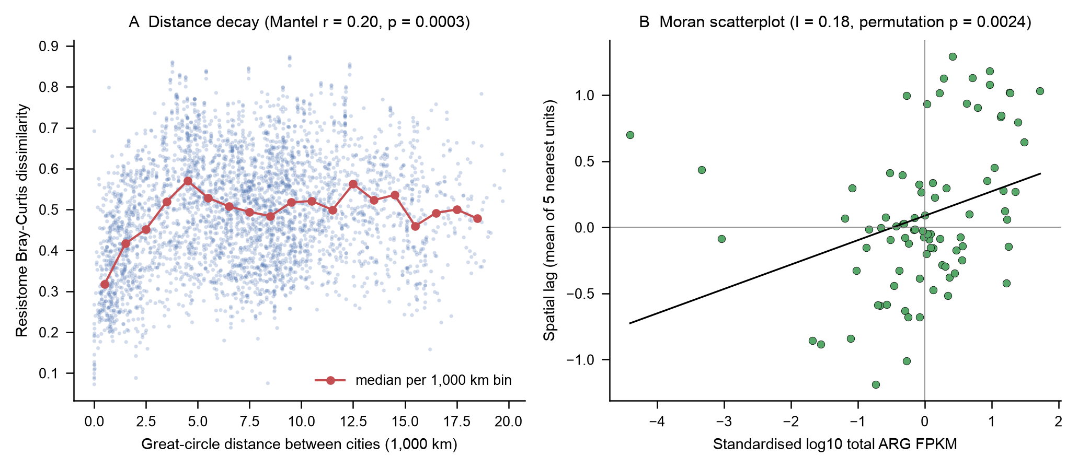
Fig. S30 Spatial structure of the sewage resistome among 86 units (mostly one per city) in the 2016 pilot: Bray–Curtis dissimilarity against great-circle distance with medians per 1,000-km bin and Mantel test (A), and Moran scatterplot of standardized log10 total FPKM against its five-nearest-neighbor spatial lag (B); 9,999 permutations each. Not a risk surface.
Resistome dissimilarity was higher with distance (Mantel r = 0.20; p = 0.0003), particularly in the first few thousand kilometers, and after that, bin medians plateaued, indicating regional and not global structuring. Weak to moderate positive spatial autocorrelation (Moran's I = 0.18, k = 5, permutation p = 0.0024) was found in total abundance, which was robust to k = 8 (I = 0.14). These patterns are compatible with shared regional drivers (antibiotic use and sanitation) which were not analyzed. Limitation: Results are from a single 2016 sampling round with mostly one sample per city and uneven spacing; results are specific to municipal sewage only and do not identify hotspots.
Source data: Table S85, Table S86.

Supplementary Tables

Evidence base and geographic coverage
This section presents Tables S1, S2, S3, S4, S5, S6, S7, S8, S9, S10, S11 and S12.
Table S1 Overview of the analyzable evidence base: included urban shotgun metagenomes and separately held food-related contextual samples
Quantity | Included urban environmental samples | Food-related contextual samples
Samples | 8053 | 840
Datasets | 112 | 16
Projects (accessions) | 122 | 16
Countries (reported) | 106 | 11
Source-labelled cities (City|Country) | 274 | 0
Continents | 7 | 4
Sample types | 8 | 2
Samples with coordinates | 6134 | 401
Samples with any AMR gene table | 1072 | 155
CARD/RGI | 447 | 0
ResFinder/KMA | 625 | 155
Samples with taxonomy table | 447 | 0
Samples with diversity indices | 625 | 155
Collection years (min-max) | 2011-2026 | 2009-2025
Samples with collection year | 7375 | 739
Samples = public shotgun metagenomes that were included. The number of cities refers to the number of distinct source-reported City|Country pairs. AMR and taxonomy tables are created by the producers. Food-related samples are never combined with urban samples and are contextual.
The evidence base consisted of 8,053 included urban environmental metagenomes from 112 datasets, 122 repository projects, 106 reported countries and 274 source-labeled cities, as well as 840 food-related contextual samples from 16 datasets. Availability dropped sharply with each layer of annotations: 6,134 urban samples had coordinates, 1,072 had any gene-level AMR table (447 CARD/RGI; 625 ResFinder/KMA), and only 447 had a taxonomic table, and the CARD/RGI profiles were a single dataset (Table S9). The 7,375 samples that reported a year were collected between 2011 and 2026. Of the food-related samples, there were 155 that contained ResFinder/KMA tables. The vast majority of samples thus only provided metadata. Counts are not intended to reflect intensity or representativeness of sampling, and the two AMR pipelines are not interchangeable.

Table S2 Included urban samples by sample type: dataset, country and city coverage, annotation availability, and repository-reported sequencing depth
Sample Type | Municipal wastewater | Transit surface | Built environment | Surface water | Community wastewater | Air | Urban soil | Hospital wastewater
samples | 2254 | 1911 | 1449 | 882 | 529 | 427 | 364 | 237
% of included | 28 | 23.70 | 18 | 11 | 6.60 | 5.30 | 4.50 | 2.90
datasets | 35 | 4 | 9 | 36 | 6 | 7 | 7 | 16
countries | 104 | 14 | 10 | 15 | 4 | 10 | 7 | 11
cities | 243 | 32 | 0 | 0 | 5 | 0 | 0 | 1
with coordinates | 1908 | 1180 | 1374 | 830 | 82 | 392 | 291 | 77
with AMR | 522 | 24 | 9 | 46 | 447 | 24 | 0 | 0
with taxonomy | 0 | 0 | 0 | 0 | 447 | 0 | 0 | 0
year min | 2012 | 2013 | 2011 | 2012 | 2014 | 2012 | 2013 | 2018
year max | 2024 | 2022 | 2024 | 2025 | 2025 | 2025 | 2024 | 2026
depth n | 2254 | 1911 | 1449 | 882 | 529 | 427 | 364 | 237
median Gbp | 10.51 | 1.23 | 1.29 | 2.59 | 5.45 | 1.56 | 10.71 | 0.221
Q1 Gbp | 3.41 | 0.820 | 0.569 | 0.038 | 4.39 | 1.23 | 3.07 | 0.051
Q3 Gbp | 13.92 | 1.85 | 3.87 | 14.86 | 6.68 | 4.18 | 16.32 | 4.03
mean log10 bases | 9.71 | 9.09 | 9.03 | 8.85 | 9.74 | 9.32 | 9.81 | 8.31
sd log10 bases | 0.707 | 0.488 | 0.730 | 1.60 | 0.151 | 0.353 | 0.552 | 1.54
pct = percentage of 8,053 samples included. Total sequenced bases from repository run records (Gbp, 10^9 bases); depth – not post-QC depth; quartiles – Q1/Q3. Displayed in Figs. S1 and S2.
Municipal wastewater had the largest number of samples (2,254, 28.0%) and also covered the largest spatial extent (35 datasets, 104 countries, 243 cities), followed by transit surfaces (1,911, 23.7%) from only 4 datasets and built environments (1,449, 18.0%). The smallest type (237, 2.9%) was hospital wastewater. Median depth ranged from 0.22 Gbp in hospital wastewater (IQR 0.05–4.03) to 10.51 Gbp in municipal wastewater and 10.71 Gbp in urban soil; surface water was the most heterogeneous (IQR 0.04–14.86 Gbp; SD of log10 bases 1.60), whereas community wastewater was uniform (SD 0.15). There were only taxonomic tables for community wastewater (447 out of 529). Such differences in depth can affect the detection of genes, apart from biological differences, which means that contrasts between samples of different types should be done after adjusting for depth.

Table S3 Included urban samples by reported country and continent, with numbers of types of samples, cities, datasets, and AMR-annotated samples
Continent | Country | samples | sample types | cities | datasets | with AMR
North America | United States | 1051 | 6 | 19 | 12 | 75
Asia | China | 1043 | 6 | 4 | 20 | 2
Europe | United Kingdom | 821 | 6 | 16 | 6 | 0
Asia | India | 642 | 6 | 8 | 13 | 451
Asia | Hong Kong | 497 | 3 | 1 | 3 | 0
Asia | Japan | 456 | 5 | 5 | 9 | 16
North America | Canada | 334 | 2 | 6 | 3 | 18
Africa | Kenya | 324 | 3 | 2 | 3 | 5
Europe | Denmark | 276 | 2 | 6 | 4 | 66
Asia | Singapore | 167 | 3 | 2 | 6 | 57
Africa | South Africa | 159 | 2 | 3 | 5 | 22
Europe | Sweden | 121 | 2 | 2 | 4 | 75
Europe | Italy | 115 | 3 | 4 | 6 | 10
South America | Brazil | 112 | 3 | 4 | 5 | 8
Europe | Norway | 108 | 2 | 1 | 4 | 28
Europe | Spain | 98 | 3 | 3 | 4 | 7
Africa | Zimbabwe | 92 | 1 | 0 | 1 | 0
Europe | Poland | 77 | 2 | 1 | 4 | 4
Oceania | New Zealand | 77 | 2 | 4 | 3 | 2
Europe | Germany | 73 | 3 | 2 | 3 | 11
Africa | Nigeria | 64 | 2 | 5 | 2 | 4
Asia | Thailand | 60 | 3 | 2 | 2 | 0
Europe | Finland | 58 | 2 | 3 | 2 | 4
Europe | Latvia | 56 | 1 | 2 | 2 | 5
Asia | Malaysia | 55 | 2 | 8 | 2 | 6
Oceania | Australia | 53 | 3 | 5 | 3 | 12
Asia | South Korea | 34 | 2 | 2 | 2 | 5
South America | Chile | 32 | 2 | 3 | 2 | 0
South America | Colombia | 31 | 3 | 3 | 3 | 13
Europe | Hungary | 29 | 2 | 2 | 3 | 2
Africa | Cameroon | 28 | 1 | 1 | 2 | 0
Europe | Czech Republic | 25 | 2 | 2 | 2 | 4
Africa | Tanzania | 24 | 1 | 3 | 1 | 2
Africa | Egypt | 20 | 1 | 0 | 1 | 0
Asia | Philippines | 20 | 2 | 2 | 2 | 0
Europe | Bulgaria | 19 | 2 | 1 | 2 | 5
South America | Ecuador | 19 | 1 | 4 | 1 | 5
North America | Costa Rica | 18 | 1 | 0 | 1 | 0
Asia | Bangladesh | 18 | 4 | 1 | 4 | 0
Africa | Cote d'Ivoire | 18 | 1 | 4 | 1 | 4
Africa | Ghana | 14 | 1 | 4 | 1 | 2
Europe | Portugal | 14 | 1 | 2 | 2 | 0
Asia | Israel | 13 | 1 | 2 | 2 | 4
South America | Paraguay | 13 | 2 | 3 | 2 | 0
Europe | Iceland | 13 | 2 | 1 | 2 | 4
Europe | Belgium | 13 | 1 | 8 | 1 | 0
Asia | Pakistan | 13 | 1 | 3 | 1 | 2
Europe | Netherlands | 12 | 1 | 3 | 1 | 6
Africa | Zambia | 12 | 1 | 2 | 1 | 12
Europe | Switzerland | 12 | 1 | 3 | 1 | 8
Africa | Malawi | 11 | 1 | 10 | 1 | 0
Africa | Burkina Faso | 11 | 1 | 2 | 2 | 0
Europe | Ireland | 11 | 2 | 3 | 2 | 4
Africa | Uganda | 10 | 1 | 1 | 2 | 0
Europe | Croatia | 10 | 1 | 1 | 1 | 6
Europe | Austria | 10 | 2 | 1 | 2 | 6
Asia | Iran | 10 | 1 | 2 | 1 | 4
Europe | Greece | 10 | 1 | 2 | 1 | 0
Africa | Chad | 9 | 1 | 1 | 1 | 5
Africa | Botswana | 9 | 1 | 2 | 1 | 5
Europe | Serbia | 9 | 1 | 1 | 1 | 4
Europe | Slovenia | 8 | 1 | 1 | 1 | 4
North America | Barbados | 8 | 1 | 2 | 1 | 0
Europe | Malta | 8 | 1 | 4 | 1 | 4
Europe | Macedonia | 8 | 1 | 1 | 1 | 5
Europe | France | 8 | 1 | 2 | 1 | 0
Europe | Estonia | 8 | 1 | 4 | 1 | 0
Africa | Democratic Republic of the Congo | 8 | 1 | 1 | 1 | 0
Asia | Turkey | 7 | 2 | 2 | 2 | 4
Europe | Slovakia | 7 | 1 | 1 | 1 | 3
Asia | Lebanon | 7 | 1 | 0 | 1 | 0
Asia | Sri Lanka | 7 | 1 | 3 | 1 | 2
Asia | Georgia | 6 | 1 | 2 | 1 | 5
Asia | Cambodia | 6 | 1 | 1 | 1 | 2
Africa | Togo | 6 | 1 | 1 | 1 | 2
Africa | Madagascar | 6 | 1 | 3 | 1 | 0
Africa | Senegal | 6 | 1 | 1 | 1 | 2
Asia | Nepal | 6 | 1 | 2 | 1 | 2
North America | Saint Lucia | 6 | 1 | 2 | 1 | 0
Europe | Albania | 6 | 1 | 1 | 1 | 4
Seven seas (open ocean) | Mauritius | 6 | 1 | 4 | 1 | 0
Asia | Viet Nam | 5 | 1 | 2 | 1 | 2
North America | Nicaragua | 5 | 1 | 5 | 1 | 0
Europe | Romania | 4 | 1 | 0 | 1 | 0
North America | Greenland | 4 | 1 | 1 | 1 | 0
Europe | Montenegro | 4 | 1 | 1 | 1 | 0
Europe | Luxembourg | 4 | 1 | 2 | 1 | 2
Africa | Ethiopia | 4 | 1 | 1 | 1 | 2
Africa | Morocco | 4 | 1 | 1 | 1 | 0
Asia | Saudi Arabia | 4 | 1 | 1 | 1 | 0
South America | Bolivia | 4 | 2 | 1 | 3 | 0
Asia | Taiwan | 4 | 1 | 1 | 1 | 0
Europe | Bosnia and Herzegovina | 4 | 1 | 1 | 1 | 0
Europe | Moldova | 4 | 1 | 1 | 1 | 4
Asia | Kazakhstan | 3 | 1 | 1 | 1 | 2
South America | Argentina | 3 | 1 | 1 | 1 | 0
Asia | United Arab Emirates | 3 | 1 | 1 | 1 | 0
North America | Guatemala | 3 | 1 | 2 | 1 | 0
South America | Peru | 3 | 1 | 2 | 1 | 2
South America | Uruguay | 3 | 1 | 1 | 1 | 0
Africa | Benin | 2 | 1 | 2 | 1 | 0
Africa | Gambia | 2 | 1 | 1 | 1 | 2
Asia | Kuwait | 2 | 1 | 1 | 1 | 0
Africa | Mozambique | 2 | 1 | 1 | 1 | 0
Europe | Kosovo | 2 | 1 | 1 | 1 | 2
Europe | Lithuania | 1 | 1 | 1 | 1 | 0
The country or continent the sample was collected from is indicated by the source (country/continent).
106 countries contributed samples; the United States (1,051), China (1,043), the United Kingdom (821), India (642), and Hong Kong (497) led with their contributions, with 15 countries contributing 100 or more and 48 countries contributing less than 10 samples. AMR-table availability was decoupled from sample numbers: India had 451 AMR-annotated samples; 2 samples were AMR-annotated in China and none in the United Kingdom; 42 countries had no AMR-annotated samples. Bangladesh was represented by 18 samples (4 sample types and 4 datasets), with no samples having an AMR table produced by a producer, and Pakistan had 13 samples (2 of which had AMR tables). The 269 samples without a reported continent (Table S4) are not listed. Counts are representative of deposition and project design, and cannot be used for country ranking.

Table S4 Cross-tabulation of included urban samples by continent and sample type
Continent | Air | Built environment | Community wastewater | Hospital wastewater | Municipal wastewater | Surface water | Transit surface | Urban soil | Total
Africa | 0 | 271 | 46 | 20 | 445 | 0 | 43 | 20 | 845
Asia | 164 | 1042 | 453 | 172 | 588 | 270 | 209 | 190 | 3088
Europe | 192 | 132 | 30 | 21 | 867 | 36 | 654 | 134 | 2066
North America | 59 | 1 | 0 | 0 | 165 | 529 | 655 | 20 | 1429
Not reported | 12 | 3 | 0 | 16 | 15 | 15 | 208 | 0 | 269
Oceania | 0 | 0 | 0 | 0 | 83 | 14 | 33 | 0 | 130
Seven seas (open ocean) | 0 | 0 | 0 | 0 | 6 | 0 | 0 | 0 | 6
South America | 0 | 0 | 0 | 8 | 85 | 18 | 109 | 0 | 220
Total | 427 | 1449 | 529 | 237 | 2254 | 882 | 1911 | 364 | 8053
Cells = numbers of samples included; continent as reported or derived from the source country. Displayed in Fig. S1.
There were 3,088 samples from Asia, 2,066 from Europe, 1,429 from North America, 845 from Africa, 220 from South America, 130 from Oceania, 6 from the open ocean, and 269 were not reported by continent. Sample-type composition differed strongly between continents. The biggest number of community-wastewater samples were from Asia (453 out of 529), the largest number of built-environment samples were from Asia (1,042 out of 1,449), and the largest number of surface-water samples were from North America (529 out of 882). The vast majority of the transit surfaces were from North America (655) and Europe (654). There were no air or surface-water samples in Africa, and no air or built-environment samples in Oceania or South America. Continent and sample type were jointly structured by a few projects, which means that there would be a “matrix effect” (that is, the effect of the matrix) and a “study effect” (that is, the effect of the study) compounded in any continental contrast.
Table S5 Included urban samples by source-labeled city, with sample types, contributing datasets, and AMR- and taxonomy-annotated samples
city label | samples | sample types | datasets | with AMR | with taxonomy
London, United Kingdom | 531 | Transit surface | DS04 | 0 | 0
New York City, United States | 423 | Transit surface | DS04 | 0 | 0
Mumbai, India | 189 | Community wastewater | DS02 | 189 | 189
Fairbanks, United States | 138 | Transit surface | DS04 | 0 | 0
Chennai, India | 109 | Community wastewater | DS02 | 109 | 109
Delhi, India | 100 | Community wastewater | DS02 | 100 | 100
Singapore, Singapore | 94 | Municipal wastewater; Transit surface | DS01; DS04 | 3 | 0
Rio De Janeiro, Brazil | 68 | Transit surface | DS04 | 0 | 0
Berlin, Germany | 62 | Municipal wastewater; Transit surface | DS01; DS04 | 4 | 0
Kolkata, India | 49 | Community wastewater | DS02 | 49 | 49
Tokyo, Japan | 35 | Transit surface | DS04 | 0 | 0
Santiago, Chile | 30 | Municipal wastewater; Transit surface | DS01; DS04 | 0 | 0
Denver, United States | 29 | Transit surface | DS04 | 0 | 0
Lyngby, Denmark | 27 | Municipal wastewater | DS01 | 0 | 0
Offa, Nigeria | 26 | Transit surface | DS04 | 0 | 0
El Paso, United States | 24 | Municipal wastewater | DS01 | 24 | 0
Ilorin, Nigeria | 23 | Municipal wastewater; Transit surface | DS01; DS04 | 0 | 0
Kuala Lumpur, Malaysia | 23 | Municipal wastewater | DS01 | 5 | 0
Melbourne, Australia | 22 | Municipal wastewater | DS01 | 5 | 0
Regina, Canada | 20 | Municipal wastewater | DS01 | 3 | 0
Guangzhou, China | 19 | Municipal wastewater | DS01 | 1 | 0
Seattle, United States | 19 | Municipal wastewater | DS01 | 4 | 0
Hamilton, New Zealand | 16 | Transit surface | DS04 | 0 | 0
Yaounde, Cameroon | 16 | Municipal wastewater | DS01 | 0 | 0
Sacramento, United States | 16 | Transit surface | DS04 | 0 | 0
Bogota, Colombia | 15 | Transit surface | DS04 | 0 | 0
Auckland, New Zealand | 15 | Transit surface | DS04 | 0 | 0
Moshi, Tanzania | 15 | Municipal wastewater | DS01 | 1 | 0
Baltimore, United States | 13 | Transit surface | DS04 | 0 | 0
Quito, Ecuador | 12 | Municipal wastewater | DS01 | 1 | 0
City = source-reported City|Country pair, not standardized; variations in spelling (e.g., Kochi/Cochin) are listed separately. with_AMR and with_taxonomy = samples with producer-processed tables. 5,069 samples without a City|Country pair are excluded (Table S6).
The single-project contributions of the 274 source-labeled cities included transit-surface samples from London (531) and New York City (423), and community-wastewater samples from Mumbai (189), Chennai (109), Delhi (100) and Kolkata (49); the latter had taxonomic tables. 237 of the remaining labels were from the sewage dataset from around the world (with 223 of those having 8 or fewer samples), and 67 cities had just one sample. There were 79 cities with any AMR-annotated sample and 6 cities spanning more than one sample type. Dhaka appeared with only 8 labeled samples because there was no source city label on the DS84 samples (Table S12). Labels are based on the sources indicated, subject to the spelling variations found in those sources, and occasionally with inconsistent country assignment, and counts are approximate but do not support city ranking.
Table S6 Summary of city coverage in evidence base included and implications for the chapter’s multi-city framing
Quantity | Value
Source-labelled cities | 274
Cities with >=10 samples | 33
Cities with >=30 samples | 12
Cities with 1 sample | 67
Median samples per city (IQR) | 3 (2-5)
Cities represented in >1 sample type | 6
Cities with >=1 AMR-annotated sample | 79
Cities with >=1 taxonomy-annotated sample | 4
Included samples without a City|Country pair (city missing, or country missing/unverified) | 5069
City = source-reported City|Country pair. AMR- and taxonomy-annotated = at least one producer-processed table. Samples that did not have a pair were missing a city or had a missing or unverified country. Descriptive Counts; IQR = Interquartile Range.
While 274 cities reported samples, coverage was light: 33 cities reported 10 or more samples; 12 reported 30 or more samples; 67 reported a single sample; and the median for cities with samples was 3 (IQR 2–5). Six cities had more than one sample type, 79 cities had at least one sample annotated with AMR, 4 cities had at least one sample annotated with taxonomy, and 5,069 included samples had no usable City|Country pair. The table suggests that the number of city labels was greater than the target of the chapter, but a similar multi-city analysis was not possible: City-level inference was limited to the cities in the DS02 collection and uniformly reprocessed South Asian runs. City and matrix effects are not separable, as most of the cities have been sampled in one matrix by one project.
Table S7 Distribution of samples across sequencing platform families by sample type for the included urban samples
Platform Family | Air | Built environment | Community wastewater | Hospital wastewater | Municipal wastewater | Surface water | Transit surface | Urban soil | Total
DNBSEQ/MGI/BGISEQ | 0 | 261 | 0 | 17 | 297 | 25 | 0 | 90 | 690
Illumina | 427 | 1188 | 529 | 188 | 1939 | 546 | 1911 | 274 | 7002
Ion Torrent | 0 | 0 | 0 | 0 | 12 | 0 | 0 | 0 | 12
Oxford Nanopore | 0 | 0 | 0 | 32 | 0 | 311 | 0 | 0 | 343
PacBio | 0 | 0 | 0 | 0 | 6 | 0 | 0 | 0 | 6
Total | 427 | 1449 | 529 | 237 | 2254 | 882 | 1911 | 364 | 8053
Platform family from repository run metadata. Number of included samples = cells. Displayed in Fig. S1.
A total of 7,002 samples were generated on Illumina platforms, followed by DNBSEQ/MGI/BGISEQ (690), Oxford Nanopore (343), Ion Torrent (12), and PacBio (6). All the samples of air, community-wastewater, and transit-surface were Illumina. Long-read data were limited to a small number of matrices: 311 of the 343 Nanopore samples were surface water, while 32 were hospital wastewater, and Ion Torrent and PacBio were only represented in municipal wastewater. The majority of DNBSEQ-family data was from municipal wastewater (297) and built environments (261). Therefore, platform was partially confounded with sample type, particularly for surface water where 311/882 samples were Nanopore. Any re-analysis of raw reads across matrices would need platform stratification or sensitivity analysis, as read length and error profiles influence gene detection using alignment.
Table S8 Availability of coordinates, AMR gene tables, taxonomic tables and diversity indices by sample type among included urban samples
Part 1 of 2
Sample Type | samples | has coords | has any AMR | has CARD RGI | has ResFinder KMA | has taxonomy | has diversity | has coords % | has any AMR %
Municipal wastewater | 2254 | 1908 | 522 | 0 | 522 | 0 | 522 | 84.60 | 23.20
Transit surface | 1911 | 1180 | 24 | 0 | 24 | 0 | 24 | 61.70 | 1.30
Built environment | 1449 | 1374 | 9 | 0 | 9 | 0 | 9 | 94.80 | 0.600
Surface water | 882 | 830 | 46 | 0 | 46 | 0 | 46 | 94.10 | 5.20
Community wastewater | 529 | 82 | 447 | 447 | 0 | 447 | 0 | 15.50 | 84.50
Air | 427 | 392 | 24 | 0 | 24 | 0 | 24 | 91.80 | 5.60
Urban soil | 364 | 291 | 0 | 0 | 0 | 0 | 0 | 79.90 | 0
Hospital wastewater | 237 | 77 | 0 | 0 | 0 | 0 | 0 | 32.50 | 0
Total | 8053 | 6134 | 1072 | 447 | 625 | 447 | 625 | 76.20 | 13.30
Part 2 of 2
Sample Type | has CARD RGI % | has ResFinder KMA % | has taxonomy % | has diversity %
Municipal wastewater | 0 | 23.20 | 0 | 23.20
Transit surface | 0 | 1.30 | 0 | 1.30
Built environment | 0 | 0.600 | 0 | 0.600
Surface water | 0 | 5.20 | 0 | 5.20
Community wastewater | 84.50 | 0 | 84.50 | 0
Air | 0 | 5.60 | 0 | 5.60
Urban soil | 0 | 0 | 0 | 0
Hospital wastewater | 0 | 0 | 0 | 0
Total | 5.60 | 7.80 | 5.60 | 7.80
Percentages are based on each type of sample. AMR = producer-processed CARD/RGI or ResFinder/KMA gene table; diversity = producer-provided diversity indices. Displayed in Fig. S2.
6,134 samples (76.2%) had coordinates, with 15.5% of community-wastewater samples and 32.5% of hospital-wastewater samples having coordinates, and 94.8% of built-environment samples having coordinates. Gene-level AMR tables covered only 13.3% of the samples (1,072/8,053) and were very matrix-specific: CARD/RGI tables were limited to community wastewater (447 samples, 84.5%); ResFinder/KMA tables were mainly limited to municipal wastewater (522 samples, 23.2%); no other matrix had more than 5.6% of samples with AMR tables. No AMR table was found for urban soil or hospital wastewater. Taxonomic tables were restricted to community wastewater (5.6% overall). The table shows that the database for annotations was aligned with the matrix, so that the results obtained with the two approaches (CARD and ResFinder) cannot be compared directly; this is why the results of the streams have been analyzed independently, and that of the hospital wastewater has been analyzed following reprocessing.
Table S9 Inventory of the 112 datasets containing urban samples: sample type, country, number of verified corrections, number of recovered site identifiers, AMR profiles and reprocessed runs
Dataset ID | Dataset Name | included samples | countries | sample types | sample type corrections | site ids recovered | CARD RGI profiles | ResFinder KMA profiles | uniformly reprocessed runs this update
DS04 | MetaSUB City Sampling Day 2016-2017 (SRA subset) | 1804 | Australia; Brazil; Chile; Colombia; Germany; Ireland; Japan; New Zealand; Nigeria; Not yet verified; Singapore; United Kingdom; United States | Transit surface 1804 | 0 | 0 | 0 | 0 | 0
DS01 | Global Sewage Surveillance Project (Munk et al. 2022; incl. 2016 pilot) | 1034 | Albania; Argentina; Australia; Austria; Bangladesh; Barbados; Belgium; Benin; Bolivia; Bosnia and Herzegovina; Botswana; Brazil; Bulgaria; Burkina Faso; Cambodia; Cameroon; Canada; Chad; Chile; China; | Municipal wastewater 1034 | 0 | 0 | 0 | 315 | 27
DS02 | Indian metropolitan open-drain wastewater (Singh et al. 2026) | 447 | India | Community wastewater 447 | 0 | 19 | 447 | 0 | 12
DS115 | Hong Kong outdoor built environment surface metagenomes | 415 | Hong Kong | Built environment 415 | 0 | 0 | 0 | 0 | 0
DS111 | Shotgun metagenomic sequencing of subway and urban air samples: gCSD17 | 294 | Hong Kong; Norway; Sweden; United Kingdom; United States | Air 294 | 0 | 0 | 0 | 0 | 0
DS78 | Examining the microbiome and resistome of an urban freshwater ecosystem of Manitoba | 279 | Canada | Surface water 279 | 0 | 0 | 0 | 0 | 0
DS62 | Metagenomic Insights into Microbial Communities from Environmental Samples in an Urban Informal Settlement in Nairobi, Kenya | 272 | Kenya | Built environment 272 | 0 | 0 | 0 | 0 | 0
DS06 | Urban microbiomes in Japan | 261 | Japan | Built environment 261 | 0 | 0 | 0 | 0 | 0
DS86 | Metagenomic sequencing of urban wastewater samples from a coastal metropolis | 252 | China | Municipal wastewater 252 | 0 | 0 | 0 | 0 | 0
DS76 | Hospital surface microbiome | 206 | China | Built environment 206 | 0 | 0 | 0 | 0 | 0
DS34 | Dynamics of Antimicrobial Resistance in the Urban Water Cycle in Europe | 162 | Denmark | Municipal wastewater 162 | 0 | 0 | 0 | 0 | 0
DS81 | Citywide metagenomic analysis of Liverpool outdoor urban environment | 124 | United Kingdom | Built environment 124 | 0 | 0 | 0 | 0 | 0
DS30 | Metagenomics analysis of sewage for surveillance of antimicrobial resistance in South Africa | 108 | South Africa | Municipal wastewater 108 | 0 | 0 | 0 | 0 | 0
DS127 | GLUSEEN global urban soils (MG-RAST) | 100 | Finland; Hungary; South Africa; United States | Urban soil 100 | 0 | 0 | 0 | 0 | 0
DS71 | Bacterial populations in Zimbabwe wastewater 2021 | 92 | Zimbabwe | Municipal wastewater 92 | 0 | 0 | 0 | 0 | 0
DS58 | Metagenomic data in Xiamen urban park in 2020 | 90 | China | Urban soil 90 | 0 | 0 | 0 | 0 | 0
DS43 | New Delhi House Microbiome | 90 | India | Built environment 90 | 0 | 0 | 0 | 0 | 0
DS112 | A metagenomics-enabled investigation of antimicrobial resistance in an urban watershed | 74 | United States | Surface water 74 | 0 | 0 | 0 | 0 | 0
DS16 | A spatiotemporal analysis of the microbial community on the surface of public places in urban areas of Xi'an | 72 | China | Built environment 72 | 0 | 0 | 0 | 0 | 0
DS90 | Metagenomic analysis of microbial diversity in urban ponds of Shenzhen, China | 72 | China | Surface water 72 | 0 | 0 | 0 | 0 | 0
DS20 | Metagenomic characterization of three Swedish sewage treatment plants | 70 | Sweden | Municipal wastewater 70 | 0 | 0 | 0 | 69 | 0
DS15 | Metagenomic survey and whole genome sequencing of antimicrobial resistant bacteria in Japanese hospital sewage | 69 | Japan | Hospital wastewater 69 | 0 | 0 | 0 | 0 | 0
DS18 | Local surveillance of infectious diseases and antimicrobial resistance from sewage | 64 | Denmark | Municipal wastewater 64 | 0 | 0 | 0 | 60 | 0
DS55 | Metagenome sequencing of soils from historical and recent urban parks and undisturbed natural ecosystems in Torino (Northern Italy) | 61 | Italy | Urban soil 61 | 0 | 0 | 0 | 0 | 0
DS73 | Microbial Metagenome of 30 Urban Forest Remnant Patches in Guiyang City. | 60 | China | Urban soil 60 | 0 | 0 | 0 | 0 | 0
DS54 | Chinese urban river metagenomic sequencing | 57 | China | Surface water 57 | 0 | 0 | 0 | 0 | 0
DS129 | Mobile antibiotic resistome in Polish WWTPs, Tychy/Olsztyn (MG-RAST series) | 56 | Poland | Municipal wastewater 56 | 0 | 0 | 0 | 0 | 0
DS41 | Metagenomic sequencing of urban stormwater runoff | 54 | United States | Surface water 54 | 0 | 0 | 0 | 0 | 0
DS38 | Shotgun metagenomics of subway environment | 54 | Thailand | Transit surface 36; Air 18 | 0 | 0 | 0 | 0 | 0
DS10 | Comparative evaluation of antibiotic resistome in hospital wastewater sources | 52 | Japan | Hospital wastewater 52 | 0 | 0 | 0 | 0 | 0
DS59 | Microbial communities on station and train surfaces in Chennai Metro: Insights into urban transit microbiome | 47 | India | Transit surface 47 | 0 | 0 | 0 | 0 | 0
DS19 | Surveillance of infectious diseases and antimicrobial resistance from sewage in Kibera (Nairobi, Kenya) | 46 | Kenya | Community wastewater 46 | 0 | 0 | 0 | 0 | 0
DS32 | Urban sewage metagenomic analysis of Latvian Cities | 45 | Latvia | Municipal wastewater 45 | 0 | 0 | 0 | 0 | 0
DS64 | Public air samples Metagenome | 44 | China | Air 44 | 0 | 0 | 0 | 0 | 0
DS121 | Wastewater Metagenomics and Isolate Sequencing | 39 | New Zealand | Municipal wastewater 39 | 0 | 0 | 0 | 0 | 0
DS122 | Metagenomic analysis of an Urban Superfund Site: the Gowanus Canal in Brooklyn, New York | 37 | United States | Surface water 37 | 0 | 0 | 0 | 0 | 0
DS103 | Antimicrobial resistance of wastewater samples | 36 | Singapore | Municipal wastewater 36 | 0 | 0 | 0 | 36 | 0
DS45 | Urban stormwater long read metagenomes | 32 | United States | Surface water 32 | 0 | 0 | 0 | 0 | 0
DS61 | Characterization of the wastewater resistome and mobilome at community scale | 30 | Spain | Community wastewater 30 | 0 | 0 | 0 | 0 | 0
DS74 | Microbial community and function in three urban wetlands | 30 | China | Surface water 30 | 0 | 0 | 0 | 0 | 0
DS56 | Mapping Antimicrobial Resistance Landscape at a city scale sewage network | 28 | Spain | Municipal wastewater 24; Hospital wastewater 4 | 0 | 0 | 0 | 0 | 0
DS72 | Metagenomic assessment of full-scale wastewater treatment plants identifies sentinel antibiotic resistance genes for monitoring reclaimed wastewater and sludge. | 27 | Spain | Municipal wastewater 27 | 0 | 0 | 0 | 0 | 0
DS105 | wastewater Metagenome | 27 | South Korea | Surface water 16; Municipal wastewater 11 | 0 | 0 | 0 | 5 | 0
DS47 | Unveiling China's Antibiotic Resistance Threat: Urban Sewage Metagenome Surveillance Exposes Tibet-East Disparities and Pathogen Risks | 25 | China | Municipal wastewater 25 | 0 | 0 | 0 | 0 | 0
DS36 | Airborne ARGs in Nordic Urban Homes | 25 | Denmark; Iceland; Norway; Sweden | Air 25 | 0 | 0 | 0 | 0 | 0
DS98 | Microbial communities within an urban mass transit system | 24 | United States | Transit surface 24 | 0 | 0 | 0 | 24 | 0
DS77 | Urban forest soil metagenomic data | 24 | China | Urban soil 24 | 0 | 0 | 0 | 0 | 0
DS106 | Aerosol microbiome characterization of a semi-urban/rural outdoor ambient environment in Norway | 24 | Norway | Air 24 | 0 | 0 | 0 | 24 | 0
DS35 | River_water_and_wastewater_short_read_metagenomics | 24 | United Kingdom | Surface water 24 | 0 | 0 | 0 | 0 | 0
DS27 | Metagenomic Analysis of Microbial Contamination in the U.S. Portion of the Tijuana River Watershed | 22 | United States | Surface water 22 | 0 | 0 | 0 | 0 | 0
DS102 | Resistome of effluents of wastewater treatment plants | 21 | Italy | Municipal wastewater 21 | 0 | 0 | 0 | 21 | 0
DS28 | Distinctive hospital and community resistomes in Scottish urban wastewater: metagenomics of a paired wastewater sampling design | 20 | United Kingdom | Municipal wastewater 15; Hospital wastewater 5 | 0 | 0 | 0 | 0 | 0
DS65 | Metagenomic Profiling of Microbial Communities and the Resistome within Egyptian Hospital Wastewater and Tap water. | 20 | Egypt | Hospital wastewater 20 | 0 | 0 | 0 | 0 | 0
DS42 | sewage metagenome-sequencing | 18 | China | Municipal wastewater 18 | 0 | 0 | 0 | 0 | 0
DS12 | Investigating the resistome, bacterial composition, and mobilome in hospital wastewaters in Metro Manila using a shotgun metagenomics approac | 18 | Philippines | Hospital wastewater 18 | 0 | 0 | 0 | 0 | 0
DS63 | Metagenomic analysis of water and sediment samples from a Urban River in Costa Rica | 18 | Costa Rica | Surface water 18 | 0 | 0 | 0 | 0 | 0
DS24 | Resistome risks of wastewaters and aquatic environments deciphered by shotgun metagenomic assembly | 18 | South Africa | Municipal wastewater 18 | 0 | 0 | 0 | 18 | 0
DS100 | wastewater metagenome Raw sequence reads | 18 | Burkina Faso; Cameroon | Municipal wastewater 18 | 0 | 0 | 0 | 0 | 0
DS85 | Seasonal microbial community and metagenomic functional potential in urban rivers of Changzhou, China | 16 | China | Surface water 16 | 0 | 0 | 0 | 0 | 0
DS09 | Metagenomic survey and whole genome sequencing of antimicrobial resistant bacteria in Japanese hospital sewage | 16 | Japan | Hospital wastewater 16 | 0 | 0 | 0 | 0 | 0
DS117 | Resistome in sewage surviellance | 16 | Singapore | Municipal wastewater 16 | 0 | 0 | 0 | 0 | 0
DS114 | Comparative microbial antibiotic resistome between urban and deep forest environments | 16 | China | Urban soil 16 | 0 | 0 | 0 | 0 | 0
DS14 | Metagenomic sequences of the Tama River 2015_9 - 2016_12 | 16 | Japan | Surface water 16 | 0 | 0 | 0 | 16 | 0
DS120 | Impact of wastewater disinfection on the antibiotic resistome in the intra- and extracellular DNA characterized by shotgun metagenomics | 16 | Italy | Municipal wastewater 16 | 0 | 0 | 0 | 0 | 0
DS13 | Metagenomic clean data of surface water samples from five urban lakes with different trophic levels in Nanchang (PRJCA051782) | 15 | – | Surface water 15 | 0 | 0 | 0 | 0 | 0
DS51 | Microbial communities and AMR in urban aquatic environment | 14 | Australia | Surface water 14 | 0 | 0 | 0 | 0 | 0
DS50 | Shotgun Metagenomics Unravels the Bacterial Diversity and Resistome Profile in a Tropical Urban Environment | 13 | India | Surface water 13 | 0 | 0 | 0 | 0 | 0
DS101 | Antimicrobial resistance of urban water samples | 13 | Singapore | Surface water 13 | 0 | 0 | 0 | 13 | 0
DS31 | Antibiotic-Resistance Genes: Playing Hide and Seek in the Soil of a European Capital | 13 | Czech Republic | Urban soil 13 | 0 | 0 | 0 | 0 | 0
DS80 | Metagenomic analysis of microbial communities and antibiotic resistant genes in the Tijuana river, and potential sources | 13 | United States | Surface water 13 | 0 | 0 | 0 | 0 | 0
DS118 | Waste water metagenomics | 12 | Italy | Municipal wastewater 12 | 0 | 0 | 0 | 0 | 0
DS89 | Hospital wastewater metagenome | 12 | Malaysia | Hospital wastewater 12 | 0 | 0 | 0 | 0 | 0
DS75 | Temporal metagenomic profiling of bacterial communities in wastewater over a 12-month period | 12 | Brazil | Municipal wastewater 12 | 0 | 0 | 0 | 0 | 0
DS52 | METAGENOMICS AND RESISTOME OF THE SEWAGE IN THE CITY OF BELEM, PARA, BRAZIL | 12 | Brazil | Municipal wastewater 12 | 0 | 0 | 0 | 0 | 0
DS46 | Metagenomic assessment of the WWTP effluents impact on the River Iskar | 12 | Bulgaria | Surface water 12 | 0 | 0 | 0 | 0 | 0
DS93 | Metagenomic sequencing of urban airborne microbiota in Changsha, China | 12 | China | Air 12 | 0 | 0 | 0 | 0 | 0
DS21 | Anthropic Effects on Aquatic Microbial Communities and their Resistomes | 11 | Colombia | Surface water 11 | 0 | 0 | 0 | 11 | 0
DS116 | Metagenomic sequencing of wastewater treatment plants | 11 | China | Municipal wastewater 11 | 0 | 0 | 0 | 0 | 0
DS68 | Public transit microbiome- India | 10 | India | Air 10 | 0 | 0 | 0 | 0 | 0
DS07 | Antibiotic resistome in river by dry and wet weather | 10 | Japan | Surface water 10 | 0 | 0 | 0 | 0 | 0
DS60 | Shifts in microbiome and antibiotic resistome due to the discharge of urban wastewater to rivers in the twin city, Odisha, India | 9 | India | Surface water 6; Community wastewater 3 | 0 | 0 | 0 | 0 | 0
DS88 | Metagenomic Taxa of Raw and Treated Wastewater from a Public Hospital in Paraguay | 8 | Paraguay | Hospital wastewater 8 | 0 | 0 | 0 | 0 | 0
DS84 | Shotgun Metagenomics of Hospital and Urban Wastewater in Dhaka, Bangladesh | 8 | Bangladesh | Hospital wastewater 4; Municipal wastewater 3; Surface water 1 | 4 | 0 | 0 | 0 | 8
DS126 | Hospital wastewater metagenome- the impact of wastewater disinfection on the wastewater microbiome and resistome | 8 | Poland | Hospital wastewater 8 | 0 | 0 | 0 | 0 | 0
DS23 | Comparative metagenomics of controlled and uncontrolled built environments. | 8 | Austria; Germany; Italy | Built environment 8 | 0 | 0 | 0 | 8 | 0
DS94 | Occurrence and Removal of Antibiotics, Antibiotic Resistance Genes, and Pathogens in Hospital Wastewater: A Multi-site Study in East China | 8 | China | Hospital wastewater 8 | 0 | 0 | 0 | 0 | 0
DS109 | Urban wastewater treatment plant | 6 | Portugal | Municipal wastewater 6 | 0 | 0 | 0 | 0 | 0
DS49 | Metagenomics insight into the microbial resistome and virulome composition of Kampala's wastewater | 6 | Uganda | Municipal wastewater 6 | 0 | 0 | 0 | 0 | 0
DS104 | Wastewater Metagenome | 5 | Canada | Municipal wastewater 5 | 0 | 0 | 0 | 0 | 0
DS08 | Kolkata sewage project | 5 | India | Municipal wastewater 5 | 0 | 0 | 0 | 0 | 0
DS70 | Temporal variations of resistomes in wastewater and river water | 5 | South Africa | Municipal wastewater 5 | 0 | 0 | 0 | 0 | 0
DS83 | Metagenomic characterization of microbial communities across treatment stages of a municipal wastewater treatment plant | 5 | Israel | Municipal wastewater 5 | 0 | 0 | 0 | 0 | 0
DS11 | Metagenomic sequencing of hospital wastewater samples from Chongqing, China (PRJCA041808) | 5 | – | Hospital wastewater 5 | 0 | 0 | 0 | 0 | 0
DS95 | Urban waterways sediment Metagenome | 4 | Singapore | Surface water 4 | 0 | 0 | 0 | 4 | 0
DS03 | Dhaka hospital and community wastewater (BCSIR) | 4 | Bangladesh | Hospital wastewater 3; Community wastewater 1 | 0 | 0 | 0 | 0 | 4
DS119 | Metagenomic responses to Cunha canal, a polluted urban river in Rio de janeiro, Brazil | 4 | Brazil | Surface water 4 | 0 | 0 | 0 | 0 | 0
DS48 | Metageonome of Hospital wastewater | 4 | Poland | Hospital wastewater 4 | 0 | 0 | 0 | 0 | 0
DS69 | Metagenomic profiling of microbial diversity and antibiotic resistance genes in a wastewater influent from Iasi, Romania | 4 | Romania | Municipal wastewater 4 | 0 | 0 | 0 | 0 | 0
DS92 | Shotgun metagenomics of microbial communities in an urban river receiving reclaimed water in Ningbo, China | 3 | China | Surface water 3 | 0 | 0 | 0 | 0 | 0
DS37 | Urban wastewater and it's receiving river Kathajodi, Cuttack Metagenome | 3 | India | Surface water 3 | 0 | 0 | 0 | 0 | 0
DS110 | metagenomic studies of the urban river sediments of Zhengzhou city, China | 3 | China | Surface water 3 | 0 | 0 | 0 | 0 | 0
DS40 | Urban-Rural Pond Shotgun Metagenome | 2 | Bangladesh | Surface water 2 | 0 | 0 | 0 | 0 | 0
DS39 | Unraveling the Functional role of Microbial Communities in Mangrove Habitats from Urban Locations, Using Shotgun Metagenomics Sequencing Approach | 2 | India | Surface water 2 | 0 | 0 | 0 | 0 | 0
DS25 | Metagenome of a polluted urban lake depicts pathogenic microbial diversity and bacterial antibiotic resistance and virulence | 2 | Bolivia | Surface water 2 | 0 | 0 | 0 | 0 | 0
DS57 | Metagenome Sequencing and Analysis of Wastewater Samples Collected from River Mahananda, Siliguri, West Bengal, India | 2 | India | Community wastewater 2 | 0 | 0 | 0 | 0 | 0
DS124 | Metagenomic profiling of antibiotic resistance genes and bacterial community along an urban river, the Kanda River in Japan | 1 | Japan | Surface water 1 | 0 | 0 | 0 | 0 | 0
DS108 | Sediment Metagenome of River Yamuna (Faizupur Khadar , New Delhi s3) | 1 | India | Surface water 1 | 0 | 0 | 0 | 0 | 0
DS107 | Sediment Metagenome of River Yamuna (Wazaribad , New Delhi s1) | 1 | India | Surface water 1 | 0 | 0 | 0 | 0 | 0
DS17 | Metagenomic analysis of hospital wastewater | 1 | Turkey | Hospital wastewater 1 | 0 | 0 | 0 | 0 | 0
DS26 | Metagenomes of a contaminated urban lake | 1 | Bolivia | Surface water 1 | 0 | 0 | 0 | 0 | 0
DS67 | Functional resistomes in municipal wastewater treatment plant posing challenges to public health | 1 | Hungary | Municipal wastewater 1 | 0 | 0 | 0 | 0 | 0
DS97 | hospital shower hose biofilms metagenomes | 1 | United States | Built environment 1 | 0 | 0 | 0 | 1 | 0
included samples are urban shotgun metagenomes that are included. The country list can be abbreviated in the source field; two datasets were missing a verified country. Profiles = producer-processed gene tables; reprocessed runs = runs with a uniform pipeline
The sizes of the datasets ranged from small to very large, with a total of 112 datasets. Three datasets contributed most samples: MetaSUB transit surfaces (DS04; 1,804), the global sewage program (DS01; 1,034), and DS02 Indian open drains (447), whereas 32 datasets had fewer than 10 samples and only 14 had 100 or more samples. CARD/RGI profiles were provided from DS02 only (447) and ResFinder/KMA profiles from 15 datasets, primarily DS01 (315), DS20 (69) and DS18 (60). Site identifiers were recovered only for DS02 (19 sites), and 4 samples for DS84 were corrected with respect to the type of samples. Runs reprocessed in this update came from DS01 (27), DS02 (12), DS84 (8), and DS03 (4). Seven datasets spanned more than one sample type. Thus, pooled sample counts overweight a few projects, and the dataset is the relevant unit for between-study heterogeneity.
Table S10 Coverage of the global sample map: included samples with and without source-reported coordinates, distinct locations, and coordinate-country mismatches
item | n
Included samples | 8053
with source-reported coordinates (mapped) | 6134
without coordinates (not mapped) | 1919
distinct coordinate pairs | 2557
flagged coordinate-country mismatch >25 km (mapped as reported) | 228
Place names not geocoded; coordinates reported by the source. Mismatch = coordinate more than 25 km from the reported country's territory. Displayed in Fig. S3.
There were 6,134 samples with source-reported coordinates that could be mapped, and 1,919 samples without coordinates were not mapped. The samples mapped were not unique; only 2,557 distinct coordinate pairs were shared, indicating repeated sampling at the same locations and that site- or city-level coordinates were mapped more often than unique sample coordinates. Another 228 samples were located more than 25 km off their reported country and were mapped as reported but flagged. The map thus reflects the locations reported for samples, not necessarily their precise location, and was not used to interpolate surfaces or to estimate prevalence. Point density is a measure of sampling effort and deposition in the repository and not of resistance risk.
Table S11 Country coverage by ISO code: included urban samples, number of sample types and samples with producer-processed AMR tables
ISO2 | samples | sample types | with AMR table
US | 1051 | 6 | 75
CN | 1043 | 6 | 2
GB | 821 | 6 | 0
IN | 642 | 6 | 451
HK | 497 | 3 | 0
JP | 456 | 5 | 16
CA | 334 | 2 | 18
KE | 324 | 3 | 5
DK | 276 | 2 | 66
SG | 167 | 3 | 57
ZA | 159 | 2 | 22
SE | 121 | 2 | 75
IT | 115 | 3 | 10
BR | 112 | 3 | 8
NO | 108 | 2 | 28
ES | 98 | 3 | 7
ZW | 92 | 1 | 0
NZ | 77 | 2 | 2
PL | 77 | 2 | 4
DE | 73 | 3 | 11
NG | 64 | 2 | 4
TH | 60 | 3 | 0
FI | 58 | 2 | 4
LV | 56 | 1 | 5
MY | 55 | 2 | 6
AU | 53 | 3 | 12
KR | 34 | 2 | 5
CL | 32 | 2 | 0
CO | 31 | 3 | 13
HU | 29 | 2 | 2
CM | 28 | 1 | 0
CZ | 25 | 2 | 4
TZ | 24 | 1 | 2
EG | 20 | 1 | 0
PH | 20 | 2 | 0
BG | 19 | 2 | 5
EC | 19 | 1 | 5
CI | 18 | 1 | 4
BD | 18 | 4 | 0
CR | 18 | 1 | 0
GH | 14 | 1 | 2
PT | 14 | 1 | 0
IL | 13 | 1 | 4
IS | 13 | 2 | 4
PK | 13 | 1 | 2
PY | 13 | 2 | 0
BE | 13 | 1 | 0
ZM | 12 | 1 | 12
NL | 12 | 1 | 6
CH | 12 | 1 | 8
MW | 11 | 1 | 0
IE | 11 | 2 | 4
BF | 11 | 1 | 0
GR | 10 | 1 | 0
AT | 10 | 2 | 6
HR | 10 | 1 | 6
IR | 10 | 1 | 4
UG | 10 | 1 | 0
TD | 9 | 1 | 5
RS | 9 | 1 | 4
BW | 9 | 1 | 5
MK | 8 | 1 | 5
MT | 8 | 1 | 4
CD | 8 | 1 | 0
FR | 8 | 1 | 0
SI | 8 | 1 | 4
EE | 8 | 1 | 0
BB | 8 | 1 | 0
LB | 7 | 1 | 0
SK | 7 | 1 | 3
LK | 7 | 1 | 2
TR | 7 | 2 | 4
GE | 6 | 1 | 5
AL | 6 | 1 | 4
KH | 6 | 1 | 2
TG | 6 | 1 | 2
MG | 6 | 1 | 0
MU | 6 | 1 | 0
SN | 6 | 1 | 2
LC | 6 | 1 | 0
NP | 6 | 1 | 2
NI | 5 | 1 | 0
VN | 5 | 1 | 2
BA | 4 | 1 | 0
RO | 4 | 1 | 0
SA | 4 | 1 | 0
MD | 4 | 1 | 4
ET | 4 | 1 | 2
BO | 4 | 2 | 0
GL | 4 | 1 | 0
TW | 4 | 1 | 0
LU | 4 | 1 | 2
ME | 4 | 1 | 0
MA | 4 | 1 | 0
AE | 3 | 1 | 0
PE | 3 | 1 | 2
GT | 3 | 1 | 0
AR | 3 | 1 | 0
UY | 3 | 1 | 0
KZ | 3 | 1 | 2
GM | 2 | 1 | 2
BJ | 2 | 1 | 0
KW | 2 | 1 | 0
MZ | 2 | 1 | 0
XK | 2 | 1 | 2
LT | 1 | 1 | 0
ISO2 = ISO 3166-1 alpha-2 code (XK = Kosovo, user-assigned; HK listed separately).
The table below shows 106 countries using the ISO code. Breadth of matrix coverage was limited: Only 4 countries (US, CN, GB and IN) contributed 6 sample types, and 68 contributed 1 sample type. Sample numbers were not followed by AMR-table availability. The number of AMR-annotated samples in the United States was 75 of 1,051, and none of 821 in the United Kingdom (GB), while India had 451 of 642, reflecting the single DS02 dataset. There were 106 countries, 42 of which did not have an AMR-annotated sample, and 4 small contributors (ZM, MD, GM and XK) where all samples were annotated with an AMR table. The mapped AMR coverage is therefore not a measure of geographic variations in resistance, but rather of the projects that submitted processed tables, and a country with no AMR tables is a data gap rather than evidence of absence.
Table S12 Chapter target cities (Delhi, Dhaka, Karachi): included datasets, producer-processed AMR and taxonomy coverage, and runs reprocessed uniformly in this update
Part 1 of 2
target city | Dataset ID | Dataset Name | Sample Type | Inclusion Status | samples | source labelled city | years | CARD RGI | ResFinder KMA
Dhaka | DS01 | Global Sewage Surveillance Project (Munk et al. 2022; incl. 2016 pilot) | Municipal wastewater | Included | 4 | 4 | 2017-2018 | 0 | 0
Dhaka | DS03 | Dhaka hospital and community wastewater (BCSIR) | Community wastewater | Included | 1 | 1 | 2025-2025 | 0 | 0
Dhaka | DS03 | Dhaka hospital and community wastewater (BCSIR) | Hospital wastewater | Included | 3 | 3 | 2025-2025 | 0 | 0
Dhaka | DS84 | Shotgun Metagenomics of Hospital and Urban Wastewater in Dhaka, Bangladesh | Hospital wastewater | Included | 4 | 0 | 2024-2024 | 0 | 0
Dhaka | DS84 | Shotgun Metagenomics of Hospital and Urban Wastewater in Dhaka, Bangladesh | Municipal wastewater | Included | 3 | 0 | 2024-2024 | 0 | 0
Dhaka | DS84 | Shotgun Metagenomics of Hospital and Urban Wastewater in Dhaka, Bangladesh | Surface water | Included | 1 | 0 | 2024-2024 | 0 | 0
Delhi | DS02 | Indian metropolitan open-drain wastewater (Singh et al. 2026) | Community wastewater | Included | 100 | 100 | 2022-2024 | 100 | 0
Delhi | DS107 | Sediment Metagenome of River Yamuna (Wazaribad , New Delhi s1) | Surface water | Included | 1 | 0 | 2017-2017 | 0 | 0
Delhi | DS108 | Sediment Metagenome of River Yamuna (Faizupur Khadar , New Delhi s3) | Surface water | Included | 1 | 0 | 2017-2017 | 0 | 0
Delhi | DS43 | New Delhi House Microbiome | Built environment | Included | 90 | 0 | 2021-2021 | 0 | 0
Delhi | DS68 | Public transit microbiome- India | Air | Included | 10 | 0 | 2023-2024 | 0 | 0
Karachi | DS01 | Global Sewage Surveillance Project (Munk et al. 2022; incl. 2016 pilot) | Municipal wastewater | Included | 8 | 8 | 2016-2018 | 0 | 1
Part 2 of 2
target city | taxonomy | reprocessed uniform pipeline runs | note
Dhaka | 0 | 4 | Uniformly reprocessed in this update (notebooks 12-16)
Dhaka | 0 | 4 | Uniformly reprocessed in this update (notebooks 12-16)
Dhaka | 0 | 4 | Uniformly reprocessed in this update (notebooks 12-16)
Dhaka | 0 | 8 | Uniformly reprocessed in this update (notebooks 12-16)
Dhaka | 0 | 8 | Uniformly reprocessed in this update (notebooks 12-16)
Dhaka | 0 | 8 | Uniformly reprocessed in this update (notebooks 12-16)
Delhi | 100 | 12 | Uniformly reprocessed in this update (notebooks 12-16)
Delhi | 0 | 0 | –
Delhi | 0 | 0 | –
Delhi | 0 | 0 | –
Delhi | 0 | 0 | –
Karachi | 0 | 7 | Uniformly reprocessed in this update (notebooks 12-16)
Samples are included per dataset and sample type; reprocessed runs are counted per dataset and repeated along each row of the dataset.
Delhi was the only target city with producer-processed resistome and taxonomic tables: 100 DS02 community-wastewater samples (2022–2024), of which 12 runs were also uniformly reprocessed. Delhi's other included samples (90 built-environment, 10 air, and two single river-sediment samples) did not contain AMR tables. There were no producer-processed AMR tables on any of the samples from Dhaka, which consisted of 4 samples of sewage from DS01, 4 samples of hospital and community wastewater from DS03, and 8 samples from DS84 (hospital, municipal, and surface water; no source city label). Karachi had 8 DS01 samples (2016–2018), one with a ResFinder/KMA table, and 7 reprocessed runs. Dhaka and Karachi were therefore only analyzable by reprocessing, with small samples and the Dhaka matrix confounded with dataset and year.

Stream 1 (Indian open drains): taxonomic composition, diversity and ordination
This section presents Tables S13, S14, S15, S16, S17, S18, S19, S20, S21 and S22.
Table S13 Bacterial, archaeal, eukaryotic and viral proportions of phylum-classified reads in Indian open drain wastewater at the domain level (mean and standard deviation per city)
Group | Archaea mean | Archaea std | Bacteria mean | Bacteria std | Eukaryota mean | Eukaryota std | Viruses mean | Viruses std
Chennai | 1.64 | 1.71 | 65.38 | 8.06 | 31.84 | 7.15 | 1.14 | 0.500
Delhi | 0.850 | 0.760 | 69.77 | 10.01 | 27.63 | 9.81 | 1.75 | 1.26
Kolkata | 0.850 | 1.29 | 72.23 | 10.69 | 25.57 | 9.82 | 1.35 | 0.940
Mumbai | 1.12 | 1.29 | 63.67 | 9.76 | 33.72 | 9.36 | 1.49 | 0.780
All samples | 1.16 | 1.34 | 66.39 | 10 | 31.01 | 9.50 | 1.44 | 0.900
Reads are classified at the phylum level (Kraken 2/Bracken), and unclassified reads are excluded. Std = standard deviation; ARG = antimicrobial resistance gene; RPKM = reads per kilobase per million sequenced reads (447 samples).
In all samples, the percentage of reads classified to the phylum level as bacteria was 66.4% (SD 10.0) and as eukaryotes was 31.0% (SD 9.5), with small percentages of reads classified as archaea (1.16%) or viruses (1.44%). The share of eukaryotes varied from 25.6% (Kolkata) to 33.7% (Mumbai), while the share of bacteria varied from 63.7% (Mumbai) to 72.2% (Kolkata). The size and variability of this eukaryotic fraction are important for normalization: RPKM normalizes read counts for a gene by the total number of reads in the sequenced library, and cities with higher eukaryotic DNA would have lower abundance of ARG per million reads even if they had the same resistome of bacteria. Therefore, the abundance contrasts between cities should be interpreted with this denominator effect in mind, and eukaryotic reads were excluded from prokaryote-based analyses. The shares are based on the classification database.

Table S14 Mean relative abundance of the ten most abundant prokaryotic phyla in Indian open-drain wastewater, by city
Phylum | Delhi | Mumbai | Chennai | Kolkata
Proteobacteria | 67.35 | 62.45 | 66.67 | 70.87
Bacteroidota | 12.65 | 14.00 | 8.66 | 9.98
Actinobacteria | 7.78 | 9.87 | 9.92 | 8.72
Firmicutes | 5.95 | 5.30 | 4.67 | 4.39
Euryarchaeota | 1.13 | 1.33 | 2.25 | 1.05
Candidatus Omnitrophica | 0.566 | 1.56 | 0.972 | 0.516
Planctomycetota | 0.429 | 0.785 | 0.934 | 0.619
Cyanobacteria | 0.419 | 0.595 | 0.752 | 0.508
Chlamydiae | 0.315 | 0.436 | 0.881 | 0.170
Spirochaetes | 0.626 | 0.316 | 0.706 | 0.330
Other phyla | 2.78 | 3.36 | 3.59 | 2.85
Prokaryotic reads (Kraken 2/Bracken) relative abundance (%). Number of samples per city: Chennai 109, Delhi 100, Kolkata 49, Mumbai 189.
The prokaryotic fraction was dominated by Proteobacteria in all the cities, with the mean relative abundance ranging from 62.5% (Mumbai) to 70.9% (Kolkata). The next most abundant phyla were Bacteroidota (8.7%–14.0%), Actinobacteria (7.8%–9.9%), and Firmicutes (4.4%–6.0%). The remaining six named phyla each contributed at most 2.2%, and all other phyla combined 2.8–3.6%. The four cities had a broadly similar phylum profile, with the differences primarily due to the relative abundance of Proteobacteria and Bacteroidota. These are unweighted sample means that give more weight to cities and sites that have more samples; city differences in composition are tested with sites as units in Table S29.
Table S15 Mean relative abundance of the top 10 prokaryotic phyla from Indian open-drain wastewater, by season
Phylum | Winter (Dec-Feb) | Pre-monsoon (Mar-May) | Monsoon (Jun-Sep) | Post-monsoon (Oct-Nov)
Proteobacteria | 65.03 | 65.25 | 65.15 | 67.21
Bacteroidota | 12.59 | 11.93 | 12.00 | 11.08
Actinobacteria | 9.07 | 9.30 | 9.69 | 8.82
Firmicutes | 5.88 | 4.80 | 5.12 | 5.07
Euryarchaeota | 1.38 | 1.68 | 1.36 | 1.49
Candidatus Omnitrophica | 1.13 | 1.17 | 0.979 | 1.03
Planctomycetota | 0.631 | 0.776 | 0.748 | 0.713
Cyanobacteria | 0.484 | 0.644 | 0.629 | 0.533
Chlamydiae | 0.359 | 0.499 | 0.527 | 0.571
Spirochaetes | 0.400 | 0.590 | 0.506 | 0.364
Other phyla | 3.04 | 3.37 | 3.29 | 3.11
Seasons: Winter (December-February), Pre-monsoon (March-May), Monsoon (June–September), Post-monsoon (October–November). Relative abundance (%) of prokaryotic reads; means over samples per season.
The seasonal phylum profiles were virtually indistinguishable. Proteobacteria were 65.0% in the winter and 67.2% after the monsoon, Bacteroidota 11.1% to 12.6%, Actinobacteria 8.8% to 9.7%, and Firmicutes 4.8% to 5.9%. The changes in the proportion of the various named phyla were no more than approximately 2 percentage points for each phylum between seasons, and minor phyla such as Chlamydiae (0.36–0.57%) and Cyanobacteria (0.48–0.64%) varied within narrow ranges. This stability is consistent with the absence of a season effect on Bray–Curtis phylum composition within sites (Table S29; p = 0.474). Seasonal means pool cities and years unevenly, because collection months differed between years, so the table describes rather than tests seasonal variation.
Table S16 Phylum-level alpha diversity of prokaryotic communities in Indian open-drain wastewater: observed and rarefied richness, Shannon, Gini–Simpson and Pielou evenness by city
City | Delhi | Mumbai | Chennai | Kolkata
observed richness median | 97 | 98 | 98 | 99
observed richness Q1 | 96 | 97 | 97 | 97
observed richness Q3 | 99 | 100 | 99 | 100
observed richness mean | 97.49 | 98.45 | 98.38 | 98.27
observed richness std | 1.55 | 1.71 | 1.68 | 2.76
rarefied richness median | 94 | 96 | 96 | 94
rarefied richness Q1 | 92 | 94 | 94 | 92
rarefied richness Q3 | 95 | 97 | 97 | 96
rarefied richness mean | 92.50 | 95.13 | 95.11 | 92.04
rarefied richness std | 4.59 | 4.26 | 2.93 | 6.75
shannon median | 1.17 | 1.43 | 1.29 | 1.18
shannon Q1 | 0.942 | 1.11 | 1.02 | 0.841
shannon Q3 | 1.38 | 1.57 | 1.61 | 1.26
shannon mean | 1.15 | 1.33 | 1.29 | 1.07
shannon std | 0.314 | 0.325 | 0.355 | 0.324
gini simpson median | 0.514 | 0.601 | 0.533 | 0.501
gini simpson Q1 | 0.388 | 0.483 | 0.397 | 0.354
gini simpson Q3 | 0.614 | 0.652 | 0.642 | 0.547
gini simpson mean | 0.493 | 0.556 | 0.515 | 0.455
gini simpson std | 0.142 | 0.132 | 0.147 | 0.146
pielou evenness median | 0.256 | 0.311 | 0.282 | 0.257
pielou evenness Q1 | 0.205 | 0.242 | 0.224 | 0.182
pielou evenness Q3 | 0.301 | 0.342 | 0.349 | 0.275
pielou evenness mean | 0.251 | 0.291 | 0.281 | 0.233
pielou evenness std | 0.068 | 0.070 | 0.077 | 0.070
Median, Q1- Q3, mean, and SD per city (Chennai 109 samples, Delhi 100 samples, Kolkata 49 samples, Mumbai 189 samples). Rarefied richness at a common read depth; Shannon in natural-log units; prokaryotic phyla (Kraken 2/Bracken). Displayed in Fig. S5.
The diversity of phyla was low and similar between cities. Dominance of Proteobacteria was reflected by median Shannon diversity of 1.17 for Delhi, 1.18 for Kolkata, 1.29 for Chennai, and 1.43 for Mumbai, and median Pielou evenness of 0.26 to 0.31 (Table S14). The median rarefied richness was 94 phyla in Delhi and Kolkata and 96 in Chennai and Mumbai, with observed richness medians of 97–99 phyla, which are close to saturation. The median Gini–Simpson values were between 0.50 and 0.60. These are summary statistics at the sample level; at the site level, whether or not there are differences between cities is assessed in Tables S17 and Table S18. Because phylum resolution is coarse, genus- or species-level diversity may vary in pattern.
Table S17 Site-aware tests of city, season and year differences in phylum-level alpha diversity of prokaryotic communities in Indian open-drain wastewater.
Part 1 of 2
index | factor | analysis | n units | samples | H | df | p | p perm | epsilon2
rarefied_richness | City | Site-level Kruskal-Wallis (site medians; whole-site permutation) | 19 | 447 | 11.11 | 3 | 0.011 | 0.002 | 0.540
rarefied_richness | C(City) | Mixed model, site random intercept; ML likelihood-ratio test | 19 | 447 | – | 3 | 7.6e-04 | – | –
rarefied_richness | C(Season) | Mixed model, site random intercept; ML likelihood-ratio test | 19 | 447 | – | 3 | 0.057 | – | –
rarefied_richness | C(year) | Mixed model, site random intercept; ML likelihood-ratio test | 19 | 447 | – | 2 | 0.028 | – | –
shannon | City | Site-level Kruskal-Wallis (site medians; whole-site permutation) | 19 | 447 | 6.97 | 3 | 0.073 | 0.054 | 0.265
shannon | C(City) | Mixed model, site random intercept; ML likelihood-ratio test | 19 | 447 | – | 3 | 0.026 | – | –
shannon | C(Season) | Mixed model, site random intercept; ML likelihood-ratio test | 19 | 447 | – | 3 | 0.274 | – | –
shannon | C(year) | Mixed model, site random intercept; ML likelihood-ratio test | 19 | 447 | – | 2 | 0.202 | – | –
gini_simpson | City | Site-level Kruskal-Wallis (site medians; whole-site permutation) | 19 | 447 | 6.76 | 3 | 0.080 | 0.060 | 0.251
gini_simpson | C(City) | Mixed model, site random intercept; ML likelihood-ratio test | 19 | 447 | – | 3 | 0.054 | – | –
gini_simpson | C(Season) | Mixed model, site random intercept; ML likelihood-ratio test | 19 | 447 | – | 3 | 0.343 | – | –
gini_simpson | C(year) | Mixed model, site random intercept; ML likelihood-ratio test | 19 | 447 | – | 2 | 0.547 | – | –
pielou_evenness | City | Site-level Kruskal-Wallis (site medians; whole-site permutation) | 19 | 447 | 6.97 | 3 | 0.073 | 0.054 | 0.265
pielou_evenness | C(City) | Mixed model, site random intercept; ML likelihood-ratio test | 19 | 447 | – | 3 | 0.026 | – | –
pielou_evenness | C(Season) | Mixed model, site random intercept; ML likelihood-ratio test | 19 | 447 | – | 3 | 0.271 | – | –
pielou_evenness | C(year) | Mixed model, site random intercept; ML likelihood-ratio test | 19 | 447 | – | 2 | 0.210 | – | –
Part 2 of 2
index | LR | ICC site | sites per city | p primary | p primary BH
rarefied_richness | – | – | Chennai=5; Delhi=4; Kolkata=2; Mumbai=8 | 0.002 | 0.018
rarefied_richness | 16.83 | 0.038 | – | 7.6e-04 | 0.012
rarefied_richness | 7.53 | 0.038 | – | 0.057 | 0.097
rarefied_richness | 7.17 | 0.038 | – | 0.028 | 0.089
shannon | – | – | Chennai=5; Delhi=4; Kolkata=2; Mumbai=8 | 0.054 | 0.097
shannon | 9.30 | 0.126 | – | 0.026 | 0.089
shannon | 3.89 | 0.126 | – | 0.274 | 0.313
shannon | 3.20 | 0.126 | – | 0.202 | 0.281
gini_simpson | – | – | Chennai=5; Delhi=4; Kolkata=2; Mumbai=8 | 0.060 | 0.097
gini_simpson | 7.64 | 0.114 | – | 0.054 | 0.097
gini_simpson | 3.33 | 0.114 | – | 0.343 | 0.366
gini_simpson | 1.21 | 0.114 | – | 0.547 | 0.547
pielou_evenness | – | – | Chennai=5; Delhi=4; Kolkata=2; Mumbai=8 | 0.054 | 0.097
pielou_evenness | 9.24 | 0.126 | – | 0.026 | 0.089
pielou_evenness | 3.91 | 0.126 | – | 0.271 | 0.313
pielou_evenness | 3.12 | 0.126 | – | 0.210 | 0.281
H, Kruskal–Wallis on 19 site medians, whole-site permutation p; LR, likelihood ratio of ML mixed models with site random intercept (447 samples); ε², epsilon-squared; BH, Benjamini–Hochberg; ICC, site intraclass correlation. Displayed in Fig. S5.
With sites as units, rarefied phylum richness differed between cities (site-level H = 11.1; whole-site permutation p = 0.0023; BH q = 0.018; mixed-model p = 0.00076; q = 0.012). City differences in Shannon diversity were not supported after adjustment (permutation p = 0.054, q = 0.097; mixed-model p = 0.026, q = 0.089), and the same was true for Gini–Simpson (p = 0.060) and Pielou evenness (p = 0.054). There was no association with season for any index within sites (p = 0.057 to 0.34; all q ≥ 0.097), and the year association with richness (p = 0.028) was not maintained after adjustment (q = 0.089). The intraclass correlations for richness and Shannon were 0.04 and 0.13, respectively, in the sites. Inference is based on 19 sites (Chennai 5, Delhi 4, Kolkata 2, Mumbai 8) with limited power.
Table S18 Mixed-effects model of phylum-level Shannon diversity of prokaryotic communities in Indian open-drain wastewater from city, season and year with site random intercept
term | estimate | SE | ci low | ci high | p value
Intercept | 1.11 | 0.077 | 0.960 | 1.26 | 6.8e-47
C(City, Treatment('Delhi'))[T.Chennai] | 0.137 | 0.091 | -0.040 | 0.315 | 0.129
C(City, Treatment('Delhi'))[T.Kolkata] | -0.082 | 0.116 | -0.310 | 0.145 | 0.478
C(City, Treatment('Delhi'))[T.Mumbai] | 0.185 | 0.082 | 0.024 | 0.346 | 0.024
C(Season, Treatment('Winter (Dec-Feb)'))[T.Monsoon (Jun-Sep)] | 0.019 | 0.044 | -0.067 | 0.104 | 0.672
C(Season, Treatment('Winter (Dec-Feb)'))[T.Post-monsoon (Oct-Nov)] | -0.046 | 0.050 | -0.145 | 0.053 | 0.365
C(Season, Treatment('Winter (Dec-Feb)'))[T.Pre-monsoon (Mar-May)] | 0.041 | 0.043 | -0.043 | 0.126 | 0.339
C(year)[T.2023] | 0.054 | 0.032 | -7.63e-03 | 0.117 | 0.086
C(year)[T.2024] | 0.010 | 0.059 | -0.106 | 0.126 | 0.861
Site variance (random intercept) | 0.014 | – | – | – | –
Residual variance | 0.097 | – | – | – | –
ICC (site) | 0.126 | – | – | – | –
Linear mixed model, REML, 447 samples in 19 sites, references Delhi, winter (December–February) and 2022. Estimates of Shannon units (natural log) with 95% CI. ICC = intraclass correlation for site. Displayed in Fig. S5.
Relative to Delhi (intercept 1.11), Shannon diversity was 0.19 units higher in Mumbai (95% CI 0.02–0.35; p = 0.024), whereas the Chennai (0.14; −0.04 to 0.31; p = 0.13) and Kolkata contrasts (−0.08; −0.31 to 0.15; p = 0.48) included zero. No season contrast with winter was supported (p = 0.34 to 0.67), and Shannon diversity in 2023 (0.054; p = 0.086) and 2024 (0.010; p = 0.86) did not differ from the first collection year. The ratio of between-site variance to residual variance was small (0.014/0.097), resulting in an intraclass correlation of 0.13. The impact of the single Mumbai contrast should be interpreted with caution, as the overall effect of the city on Shannon diversity was not supported after multiple testing adjustment (q = 0.089; Table S17).
Table S19 Explained variance of principal components of centered log-ratio PCA of prevalent prokaryotic phyla in Indian open-drain wastewater.
PC | eigenvalue | explained variance % | cumulative % | % of total CLR variance
PC1 | 6.45 | 36.40 | 36.40 | 36.40
PC2 | 3.58 | 20.24 | 56.64 | 20.24
PC3 | 1.69 | 9.56 | 66.20 | 9.56
PC4 | 1.25 | 7.08 | 73.28 | 7.08
PC5 | 1.05 | 5.95 | 79.23 | 5.95
PC6 | 0.872 | 4.92 | 84.16 | 4.92
PC7 | 0.640 | 3.62 | 87.77 | 3.62
PC8 | 0.458 | 2.58 | 90.36 | 2.58
PC9 | 0.393 | 2.22 | 92.58 | 2.22
PC10 | 0.234 | 1.32 | 93.89 | 1.32
PCA, principal component analysis; CLR, centered log-ratio transformation; PC, principal component. Input: 447 samples and the 21 phyla that had a prevalence ≥ 90% and a mean relative abundance ≥ 0.1% (Table S20). Displayed in Fig. S7.
The first principal component accounted for 36.4 % of the variance in CLR phylum composition, the second 20.2%, so the first two components captured 56.6% and the first three 66.2%. There were five components with eigenvalues > 1 (PC1 6.45 to PC5 1.05), and ten components accounted for 93.9% of the total variance. The high percentage of variance on a few axes suggests that a few compositional contrasts organized the phylum profiles. Low-abundance phyla drove these axes, as indicated by the loadings (Table S20), and a high percentage of explained variance does not necessarily mean a large change in the dominant community. The analysis is sample-level and descriptive.
Table S20 Loadings and percentage contributions of the prevalent prokaryotic phyla to the first three principal components of the centered log-ratio PCA of Indian open-drain wastewater
Phylum | PC1 | PC2 | PC3 | PC1 contribution % | PC2 contribution % | PC3 contribution %
Candidatus Omnitrophica | 0.872 | -0.031 | 0.357 | 76.04 | 0.096 | 12.77
Chlamydiae | -0.375 | -0.654 | 0.496 | 14.04 | 42.74 | 24.60
Candidatus Eremiobacteraeota | -0.274 | 0.664 | 0.632 | 7.49 | 44.15 | 39.91
Thermotogae | -0.081 | 0.042 | -0.116 | 0.648 | 0.178 | 1.34
Proteobacteria | -0.080 | 0.136 | -0.253 | 0.648 | 1.86 | 6.42
Spirochaetes | -0.057 | 0.054 | -0.184 | 0.319 | 0.294 | 3.39
Tenericutes | -0.047 | 0.123 | -0.143 | 0.218 | 1.52 | 2.04
Verrucomicrobia | 0.034 | -0.021 | -0.076 | 0.113 | 0.046 | 0.578
Bacteroidota | -0.033 | 0.184 | -0.127 | 0.108 | 3.38 | 1.62
Kiritimatiellaeota | 0.027 | -0.092 | -0.144 | 0.075 | 0.850 | 2.06
Euryarchaeota | -0.025 | -0.057 | -6.17e-03 | 0.061 | 0.326 | 3.81e-03
Nitrospirae | -0.022 | -0.085 | 2.52e-03 | 0.049 | 0.720 | 6.33e-04
Firmicutes | -0.021 | 0.084 | -0.152 | 0.045 | 0.709 | 2.30
Acidobacteria | 0.019 | -0.057 | -0.012 | 0.035 | 0.325 | 0.014
Lentisphaerae | 0.019 | -0.011 | 0.019 | 0.035 | 0.012 | 0.035
Candidatus Thermoplasmatota | 0.017 | -0.149 | 3.58e-03 | 0.028 | 2.21 | 1.28e-03
Planctomycetota | 0.015 | -0.055 | -0.032 | 0.022 | 0.306 | 0.101
Cyanobacteria | -0.011 | -5.36e-04 | -0.073 | 0.012 | 2.87e-05 | 0.532
Chloroflexi | 9.47e-03 | -0.043 | -2.01e-06 | 8.98e-03 | 0.182 | 4.02e-10
Deinococcus-Thermus | 7.08e-03 | -0.029 | -0.050 | 5.01e-03 | 0.084 | 0.252
Actinobacteria | 6.06e-03 | -4.53e-03 | -0.142 | 3.67e-03 | 2.05e-03 | 2.03
PC, principal component; CLR, centered log-ratio. The contribution was calculated as the squared loading as a percentage of the component total, for each of the 21 phyla. Displayed in Fig. S7.
One to three minor phyla dominated each of the first three components. Candidatus Omnitrophica contributed 76.0% of PC1 (loading 0.87), while Chlamydiae accounted for 14.0%. The Candidatus Eremiobacteraeota (loading 0.66; 44.2%) and Chlamydiae (−0.65; 42.7%) were the most important groups in PC2, while Candidatus Eremiobacteraeota (39.9%), Chlamydiae (24.6%), and Candidatus Omnitrophica (12.8%) were the most important groups in PC3. The dominant phyla contributed little: Proteobacteria (0.65% of PC1 and 6.4% of PC3) and Bacteroidota (3.4% of PC2). The CLR transformation weights all phyla equally, which means that the ordination is sensitive to the classification and detection limits of minor phyla, and can be dominated by occasional fluctuations in low-abundance phyla.
Table S21 Discrete prokaryotic taxonomic clusters in Indian open-drain wastewater obtained from k-means clustering on the first three principal components: size, city composition, and median phylum abundance
taxonomic cluster | T1 | T2 | T3 | T4
n | 31 | 92 | 98 | 226
Chennai | 2 | 42 | 20 | 45
Delhi | 22 | 16 | 27 | 35
Kolkata | 1 | 5 | 27 | 16
Mumbai | 6 | 29 | 24 | 130
Candidatus Omnitrophica | 0.010 | 0.038 | 0.010 | 2.14
Chlamydiae | 0.017 | 2.37 | 0.016 | 0.030
Candidatus Eremiobacteraeota | 1.79 | 5.00e-03 | 2.00e-03 | 4.00e-03
Thermotogae | 0.055 | 0.060 | 0.027 | 0.048
Proteobacteria | 67.68 | 64.45 | 70.53 | 61.63
Spirochaetes | 0.224 | 0.307 | 0.136 | 0.263
Clusters based on k-means (k = 4) on CLR-PCA scores PC1–PC3; n, number of samples per cluster; city columns, number of samples; phylum columns, median relative abundance (%). 447 samples; descriptive. Table transposed for layout (statistics as rows). Displayed in Fig. S7.
The four clusters were of different sizes and different in the minor phyla which they represented. Cluster T4 (n = 226) was characterized by Candidatus Omnitrophica (median 2.14%) and comprised 130 Mumbai samples; T2 (n = 92) by Chlamydiae (2.37%), with 42 Chennai samples; and T1 (n = 31) by Candidatus Eremiobacteraeota (1.79%), with 22 Delhi samples. T3 (n = 98) showed very low levels of all three phyla of markers, and samples were taken from all four cities (20–27 from each city). Median Proteobacteria abundance was similar across clusters (61.6–70.5%). The clusters are therefore not defined by the dominant community, but by the minor phyla with medians of no more than 2.37%, and a correlation with the sites or the processing batches was not tested.
Table S22 Associations of discrete prokaryotic taxonomic clusters in Indian open-drain wastewater with city, season, year, sequencing depth and total normalized resistance gene abundance
covariate | statistic | df | p value | effect (Cramer's V or epsilon-squared)
City | 121.4 | 9 | 6.8e-22 | 0.301
Season | 10.92 | 9 | 0.282 | 0.090
year | 12.41 | 6 | 0.053 | 0.118
log10 sequenced reads (Kruskal-Wallis) | 3.80 | 3 | 0.284 | 1.81e-03
log10 total ARG RPKM (Kruskal-Wallis) | 46.81 | 3 | 3.8e-10 | 0.099
For categorical covariates, a chi-squared test was used, and Cramér's V was used for the result; for log10 sequenced reads and log10 total ARG RPKM, a Kruskal–Wallis H test was used, and the result was given as epsilon-squared (ε²). ARG, antimicrobial resistance gene. Sample-level (447 samples). Displayed in Fig. S7.
Cluster membership was associated with city (chi-squared = 121.4; df = 9; Cramér's V = 0.30; p < 0.0001), a moderate association, but not with season (V = 0.09; p = 0.28), and only weakly with year (V = 0.12; p = 0.053). There was no significant difference in sequencing depth among clusters (ε² = 0.0018, p = 0.28), suggesting that sequencing depth is not the primary source of clustering. The abundance of total ARG was significantly different between clusters (H = 46.8; ε² = 0.099; p < 0.0001), but the effect size was small. These tests assume that samples are independent even if they are collected from the same site each month, which may lead to an optimistic p-value and possibly some city association is due to the site membership; other technical factors (e.g., processing batch) were not evaluated.

Stream 1 (Indian open drains): resistome composition, abundance and determinants
This section presents Tables S23, S24, S25, S26, S27, S28, S29, S30, S31, S32, S33, S34, S35 and S36.
Table S23 Antimicrobial resistance gene families identified in Indian open drain wastewater (mean and median abundance, % of total abundance, and coverage-qualified prevalence)
AMR Gene Family | Class Group | mean RPKM | median RPKM | sd RPKM | share of total % | detected any hit n | detected cov50 n | prevalence cov50 % | prev cov50 ci low | prev cov50 ci high
resistance-nodulation-cell division (RND) antibiotic efflux pump | Multi-class | 85.09 | 46.11 | 123.3 | 16.43 | 447 | 446 | 99.78 | 98.74 | 99.96
major facilitator superfamily (MFS) antibiotic efflux pump | Tetracycline | 70.45 | 69.06 | 34.52 | 13.60 | 447 | 447 | 100 | 99.15 | 100
sulfonamide resistant sul | Folate pathway antagonist | 43.84 | 41.02 | 21.44 | 8.46 | 447 | 447 | 100 | 99.15 | 100
ANT(3'') | Aminoglycoside | 28.22 | 26.85 | 15.00 | 5.45 | 447 | 446 | 99.78 | 98.74 | 99.96
msr-type ABC-F protein | MLS | 22.21 | 20.05 | 12.66 | 4.29 | 447 | 445 | 99.55 | 98.38 | 99.88
tetracycline-resistant ribosomal protection protein | Tetracycline | 20.66 | 17.09 | 16.73 | 3.99 | 447 | 433 | 96.87 | 94.81 | 98.13
macrolide phosphotransferase (MPH) | MLS | 18.26 | 12.20 | 16.63 | 3.53 | 447 | 447 | 100 | 99.15 | 100
VEB beta-lactamase | Beta-lactam | 15.92 | 13.77 | 12.19 | 3.07 | 447 | 422 | 94.41 | 91.87 | 96.18
ANT(6) | Aminoglycoside | 15.34 | 13.21 | 11.38 | 2.96 | 447 | 440 | 98.43 | 96.80 | 99.24
macrolide esterase | MLS | 15.11 | 13.38 | 10.50 | 2.92 | 447 | 442 | 98.88 | 97.41 | 99.52
AAC(6') | Aminoglycoside | 14.13 | 12.54 | 9.09 | 2.73 | 447 | 422 | 94.41 | 91.87 | 96.18
Erm 23S ribosomal RNA methyltransferase | MLS | 13.38 | 11.25 | 10.50 | 2.58 | 446 | 443 | 99.11 | 97.72 | 99.65
rifamycin-resistant beta-subunit of RNA polymerase (rpoB) | Rifamycin | 11.94 | 10.31 | 6.27 | 2.31 | 447 | 405 | 90.60 | 87.54 | 92.97
OXA beta-lactamase | Beta-lactam | 11.42 | 9.04 | 9.13 | 2.21 | 445 | 438 | 97.99 | 96.22 | 98.94
chloramphenicol acetyltransferase (CAT) | Phenicol | 8.49 | 7.65 | 5.53 | 1.64 | 445 | 435 | 97.32 | 95.37 | 98.46
RSD2 beta-lactamase | Beta-lactam | 8.35 | 2.26 | 22.53 | 1.61 | 430 | 373 | 83.45 | 79.72 | 86.60
APH(6) | Aminoglycoside | 8.13 | 6.87 | 5.74 | 1.57 | 447 | 444 | 99.33 | 98.05 | 99.77
APH(3'') | Aminoglycoside | 8.07 | 6.93 | 5.72 | 1.56 | 447 | 444 | 99.33 | 98.05 | 99.77
lincosamide nucleotidyltransferase (LNU) | MLS | 7.65 | 7.27 | 4.58 | 1.48 | 447 | 437 | 97.76 | 95.93 | 98.78
Miscellaneous ABC-F subfamily ATP-binding cassette ribosomal protection proteins | MLS | 7.33 | 6.06 | 4.69 | 1.42 | 447 | – | – | – | –
small multidrug resistance (SMR) antibiotic efflux pump | Biocide | 7.31 | 5.43 | 7.35 | 1.41 | 447 | 443 | 99.11 | 97.72 | 99.65
trimethoprim resistant dihydrofolate reductase dfr | Folate pathway antagonist | 6.33 | 4.74 | 6.14 | 1.22 | 440 | 426 | 95.30 | 92.93 | 96.91
OXA beta-lactamase; OXA-10-like beta-lactamase | Beta-lactam | 5.83 | 4.82 | 4.27 | 1.13 | 446 | 422 | 94.41 | 91.87 | 96.18
CfxA beta-lactamase | Beta-lactam | 5.12 | 2.70 | 7.97 | 0.990 | 423 | 379 | 84.79 | 81.16 | 87.82
pmr phosphoethanolamine transferase | Peptide/polymyxin | 4.68 | 2.67 | 6.14 | 0.904 | 445 | 150 | 33.56 | 29.34 | 38.06
ATP-binding cassette (ABC) antibiotic efflux pump | MLS | 4.45 | 3.75 | 3.12 | 0.859 | 447 | 180 | 40.27 | 35.82 | 44.88
rifampin ADP-ribosyltransferase (Arr) | Rifamycin | 4.27 | 3.54 | 3.63 | 0.824 | 445 | 432 | 96.64 | 94.54 | 97.96
OXA beta-lactamase; OXA-46-like beta-lactamase | Beta-lactam | 3.13 | 1.69 | 4.96 | 0.604 | 438 | 393 | 87.92 | 84.57 | 90.62
GES beta-lactamase | Beta-lactam | 2.94 | 2.28 | 2.42 | 0.569 | 444 | 336 | 75.17 | 70.96 | 78.95
tetracycline inactivation enzyme | Tetracycline | 2.61 | 1.80 | 2.67 | 0.504 | 439 | 400 | 89.49 | 86.30 | 92.00
RPKM, reads per kilobase per million sequenced reads; RND, resistance-nodulation-cell division; MFS, major facilitator superfamily; MPH, macrolide phosphotransferase. Prevalence denominator: 447 samples (sample-level, descriptive); Wilson 95% CI. Blank prevalence cells: No coverage-based estimate reported. Displayed in Fig. S13.
The table shows 315 gene families of the CARD family that were found in the open-drain metagenomes. The abundance was concentrated in a few families: RND efflux pumps (16.4% of total RPKM), MFS efflux pumps (13.6% of total RPKM), and sul genes (8.5% of total RPKM). Prevalence was 100% (95% CI 99.1–100) for MFS pumps, sul, and MPH, and 22 families had prevalence >90%. Beta-lactamase families formed 217 of the 315 rows, but most were detected sporadically; NDM (1.6%), CTX-M (1.6%), KPC (1.8%), and VIM (1.3%) were detected with coverage of at least 50% in few samples, whereas any-hit detection of NDM reached 77 samples. The Wilson intervals treat monthly repeats at the same sites as independent and are therefore narrower than site-aware intervals; detection only represents the presence of DNA, not phenotypic resistance.
Table S24 Resistance-class composition of Indian open-drain wastewater resistomes: share of total CARD abundance by class group, overall and mean share by city
Class Group | share of total RPKM % | median RPKM | mean RPKM | mean share % Chennai | mean share % Delhi | mean share % Kolkata | mean share % Mumbai
MLS | 17.57 | 84.40 | 90.99 | 21.45 | 17.16 | 17.57 | 17.40
Multi-class | 16.93 | 48.76 | 87.66 | 14.64 | 15.84 | 21.84 | 14.29
Aminoglycoside | 15.57 | 76.29 | 80.65 | 14.95 | 16.07 | 14.58 | 16.43
Beta-lactam | 14.10 | 59.62 | 73.00 | 14.35 | 15.70 | 13.23 | 11.76
Tetracycline | 11.67 | 59.09 | 60.45 | 10.40 | 10.52 | 7.15 | 15.66
Folate pathway antagonist | 9.69 | 46.58 | 50.16 | 9.95 | 9.33 | 10.03 | 10.67
Biocide | 5.51 | 23.85 | 28.52 | 6.47 | 5.60 | 5.26 | 4.56
Rifamycin | 3.24 | 15.20 | 16.79 | 3.39 | 3.05 | 4.52 | 4.05
Phenicol | 2.61 | 12.41 | 13.51 | 2.41 | 2.72 | 2.12 | 2.79
Peptide/polymyxin | 1.29 | 3.75 | 6.67 | 0.996 | 1.50 | 1.34 | 1.12
Other | 0.913 | 2.65 | 4.73 | 0.540 | 1.27 | 1.11 | 0.693
Fluoroquinolone/quinolone | 0.695 | 1.33 | 3.60 | 0.204 | 1.02 | 0.882 | 0.425
Glycopeptide | 0.142 | 0.468 | 0.735 | 0.223 | 0.102 | 0.269 | 0.117
Fosfomycin | 0.082 | 0.055 | 0.425 | 0.034 | 0.121 | 0.094 | 0.034
RPKM, reads per kilobase per million sequenced reads. Overall share = class RPKM summed over 447 samples/total RPKM; city columns = mean of per-sample shares. Multi-class is a grouping of genes for several classes. Displayed in Fig. S12.
The genes for macrolide–lincosamide–streptogramin (MLS) and multi-class were found in the largest proportion of the resistome, with 17.6% and 16.9% of total RPKM, respectively, while aminoglycoside, beta-lactam, and tetracycline genes contributed 15.6%, 14.1%, and 11.7% of the total RPKM, respectively. A small percentage of fluoroquinolone/quinolone (0.69%), glycopeptide (0.14%), and fosfomycin (0.08%) genes were present. The mean city shares were also broadly similar, and the most noticeable differences were for tetracycline (7.1% in Kolkata, 15.7% in Mumbai) and multi-class genes (14.3% in Mumbai, 21.8% in Kolkata). A small abundance share does not mean that the gene is rare: quinolone genes were present at 0.69% of RPKM, but qnr met the high-confidence criterion in 67.1% of samples (Table S34). City shares are sample-level descriptive means, and Kolkata is based on two sites.

Table S25 Resistance mechanisms in Indian open-drain wastewater resistomes: percentage of total CARD abundance by resistance mechanism, total and mean percentage per city
Mechanism | share of total RPKM % | mean share % Chennai | mean share % Delhi | mean share % Kolkata | mean share % Mumbai
antibiotic inactivation | 40.31 | 40.62 | 42.68 | 38.66 | 38.31
antibiotic efflux | 32.85 | 30.13 | 30.18 | 35.02 | 32.93
antibiotic target protection | 10.44 | 11.40 | 10.77 | 9.49 | 11.10
antibiotic target replacement | 9.69 | 9.95 | 9.33 | 10.04 | 10.67
antibiotic target alteration | 3.64 | 4.48 | 4.31 | 2.66 | 3.17
multiple mechanisms | 2.90 | 3.37 | 2.49 | 3.97 | 3.66
reduced permeability to antibiotic | 0.182 | 0.043 | 0.227 | 0.164 | 0.173
resistance by host-dependent nutrient acquisition | 1.87e-04 | 0 | 4.20e-04 | 5.11e-04 | 0
RPKM = reads per kilobase per million sequenced reads; Ontology of the mechanisms is based on the CARD Antibiotic Resistance Ontology. Overall shares are pooled over 447 samples, and city columns are means of per-sample shares. Displayed in Fig. S12.
The mechanism profile was dominated by antibiotic inactivation (40.3% of total RPKM) and antibiotic efflux (32.9%), with target protection (10.4%), target replacement (9.7%), target alteration (3.6%), and reduced permeability (0.18%) contributing. The city profiles were comparable, with inactivation between 38.3% (Mumbai) and 42.7% (Delhi) and efflux between 30.1% (Chennai) and 35.0% (Kolkata). The target-replacement share was similar to the folate-pathway class share (9.7%; Table S24), consistent with both being carried primarily by the sul and dfr genes. Mechanisms are not measured, but rather derived from reference annotations; efflux families include widespread chromosomal pumps and whose role in clinically relevant resistance is not known from read counts; city means are descriptive.
Table S26 Total normalized antimicrobial resistance gene abundance and gene-family richness and diversity in Indian open-drain wastewater, per city
City | n | median total RPKM | Q1 | Q3 | median family richness cov50 | median family shannon | median CI95
Chennai | 109 | 460.8 | 308.3 | 580.1 | 39 | 3.06 | (383.0, 515.3)
Delhi | 100 | 666.3 | 565.7 | 820.0 | 53.50 | 3.23 | (629.2, 736.0)
Kolkata | 49 | 558.2 | 342.0 | 762.7 | 48 | 3.10 | (428.7, 655.9)
Mumbai | 189 | 421.4 | 335.3 | 519.4 | 43 | 3.08 | (397.6, 449.0)
ARG, antimicrobial resistance gene; RPKM, reads per kilobase per million sequenced reads; IQR, Q1 – Q3. Richness includes CARD families that have a coverage rate of 50% or more. 95% Confidence interval for the sample median. Displayed in Fig. S12.
Median total ARG abundance was 666 RPKM in Delhi (bootstrap 95% CI 629–736; n = 100), 558 RPKM in Kolkata (429–656; n = 49), 461 RPKM in Chennai (383–515; n = 109), and 421 RPKM in Mumbai (398–449; n = 189). Interquartile ranges overlapped widely, such as 308–580 RPKM in Chennai and 342–763 RPKM in Kolkata. Median gene-family richness varied from 39 (Chennai) to 53.5 (Delhi) families, and median family Shannon diversity varied from 3.06 to 3.23. These are sample-level summaries; the bootstrap intervals that resample repeated monthly samples are optimistic, and the site-aware tests are reported separately (Table S27 and Table S28). RPKM is based on total sequenced reads (including eukaryotic reads).

Table S27 Site-aware tests of city and season/year differences in total normalized resistance gene abundance, gene-family richness and diversity in Indian open-drain wastewater
Part 1 of 2
variable | factor | analysis | n units | samples | H | df | p | p perm | epsilon2
log10_total_RPKM | City | Site-level Kruskal-Wallis (site medians; whole-site permutation) | 19 | 447 | 9.87 | 3 | 0.020 | 0.005 | 0.458
log10_total_RPKM | C(City) | Mixed model, site random intercept; ML likelihood-ratio test | 19 | 447 | – | 3 | 6.5e-04 | – | –
log10_total_RPKM | C(Season) | Mixed model, site random intercept; ML likelihood-ratio test | 19 | 447 | – | 3 | 0.024 | – | –
log10_total_RPKM | C(year) | Mixed model, site random intercept; ML likelihood-ratio test | 19 | 447 | – | 2 | 0.031 | – | –
family_richness_cov50 | City | Site-level Kruskal-Wallis (site medians; whole-site permutation) | 19 | 447 | 13.65 | 3 | 0.003 | 1.0e-04 | 0.710
family_richness_cov50 | C(City) | Mixed model, site random intercept; ML likelihood-ratio test | 19 | 447 | – | 3 | 7.5e-07 | – | –
family_richness_cov50 | C(Season) | Mixed model, site random intercept; ML likelihood-ratio test | 19 | 447 | – | 3 | 0.002 | – | –
family_richness_cov50 | C(year) | Mixed model, site random intercept; ML likelihood-ratio test | 19 | 447 | – | 2 | 0.057 | – | –
family_shannon | City | Site-level Kruskal-Wallis (site medians; whole-site permutation) | 19 | 447 | 9.97 | 3 | 0.019 | 0.007 | 0.464
family_shannon | C(City) | Mixed model, site random intercept; ML likelihood-ratio test | 19 | 447 | – | 3 | 0.007 | – | –
family_shannon | C(Season) | Mixed model, site random intercept; ML likelihood-ratio test | 19 | 447 | – | 3 | 0.060 | – | –
family_shannon | C(year) | Mixed model, site random intercept; ML likelihood-ratio test | 19 | 447 | – | 2 | 0.084 | – | –
Part 2 of 2
variable | LR | ICC site | p primary | p primary BH
log10_total_RPKM | – | – | 0.005 | 0.011
log10_total_RPKM | 17.17 | 0.114 | 6.5e-04 | 0.003
log10_total_RPKM | 9.48 | 0.114 | 0.024 | 0.035
log10_total_RPKM | 6.96 | 0.114 | 0.031 | 0.041
family_richness_cov50 | – | – | 1.0e-04 | 6.0e-04
family_richness_cov50 | 31.27 | 0.065 | 7.5e-07 | 9.0e-06
family_richness_cov50 | 15.34 | 0.065 | 0.002 | 0.005
family_richness_cov50 | 5.72 | 0.065 | 0.057 | 0.066
family_shannon | – | – | 0.007 | 0.012
family_shannon | 12.26 | 0.024 | 0.007 | 0.012
family_shannon | 7.40 | 0.024 | 0.060 | 0.066
family_shannon | 4.96 | 0.024 | 0.084 | 0.084
ARG, antimicrobial resistance gene; RPKM, reads per kilobase per million reads; ε², epsilon-squared; LR, likelihood ratio; BH, Benjamini–Hochberg; ICC, site intraclass correlation. The data consisted of 19 site medians (Kruskal–Wallis) or 447 samples with a site random intercept (ML LRT). Primary inference. Displayed in Fig. S12.
The differences in total ARG abundance among cities were confirmed by the site-level Kruskal–Wallis test (H = 9.87, whole-site permutation p = 0.0047, ε² = 0.46) and by the mixed model (LR = 17.2, p = 0.00065, BH q = 0.0026). Family richness also differed more strongly (H = 13.6; permutation p = 0.0001; ε² = 0.71; mixed-model p < 0.0001), and family Shannon diversity also differed (permutation p = 0.007). Season (p = 0.024; q = 0.035) and year (p = 0.031; q = 0.041) were significant for total abundance within sites, but not for Shannon diversity within sites (q = 0.066 and 0.084). Estimates from 19 units (two of which are in Kolkata) are not precise and not causal.
Table S28 Mixed-effects model of total normalized resistance gene abundance in Indian open-drain wastewater by city, season and year, with a site random intercept; fold changes are relative to Delhi
term | estimate | SE | ci low | ci high | p value | fold change | fc ci low | fc ci high
Intercept | 2.88 | 0.047 | 2.79 | 2.97 | 0.0e+00 | – | – | –
C(City, Treatment('Delhi'))[T.Chennai] | -0.211 | 0.054 | -0.317 | -0.105 | 9.2e-05 | 0.615 | 0.482 | 0.785
C(City, Treatment('Delhi'))[T.Kolkata] | -0.092 | 0.069 | -0.228 | 0.043 | 0.182 | 0.809 | 0.592 | 1.10
C(City, Treatment('Delhi'))[T.Mumbai] | -0.207 | 0.049 | -0.303 | -0.111 | 2.3e-05 | 0.621 | 0.498 | 0.774
C(Season, Treatment('Winter (Dec-Feb)'))[T.Monsoon (Jun-Sep)] | -0.066 | 0.027 | -0.119 | -0.013 | 0.015 | 0.859 | 0.760 | 0.971
C(Season, Treatment('Winter (Dec-Feb)'))[T.Post-monsoon (Oct-Nov)] | -9.70e-03 | 0.031 | -0.071 | 0.052 | 0.757 | 0.978 | 0.849 | 1.13
C(Season, Treatment('Winter (Dec-Feb)'))[T.Pre-monsoon (Mar-May)] | -0.061 | 0.027 | -0.113 | -8.02e-03 | 0.024 | 0.870 | 0.771 | 0.982
C(year)[T.2023] | -0.051 | 0.020 | -0.089 | -0.012 | 0.010 | 0.889 | 0.814 | 0.972
C(year)[T.2024] | -0.016 | 0.037 | -0.088 | 0.056 | 0.665 | 0.964 | 0.816 | 1.14
Site variance (random intercept) | 4.84e-03 | – | – | – | – | – | – | –
Residual variance | 0.038 | – | – | – | – | – | – | –
ICC (site) | 0.114 | – | – | – | – | – | – | –
ARG, antimicrobial resistance gene; ICC, intraclass correlation. Outcome: log10 total RPKM; fold change = 10^estimate. Linear mixed model, REML, 447 samples nested in 19 sites, reference: Delhi, winter (Dec–Feb) 2022. Displayed in Fig. S12.
Relative to Delhi, total ARG abundance was 0.62-fold in Chennai (95% CI 0.48–0.78; p < 0.0001) and 0.62-fold in Mumbai (0.50–0.77), whereas the Kolkata estimate (0.81; 0.59–1.10; p = 0.18) was compatible with no difference. Relative to winter, monsoon (0.86; 0.76–0.97) and pre-monsoon samples (0.87; 0.77–0.98) had lower abundance, while post-monsoon samples did not differ (0.98; 0.85–1.13). Relative to the first collection year, samples from 2023 had 0.89-fold abundance (0.81–0.97), and 2024 did not differ (0.96; 0.82–1.14). The ICC of 0.11 indicated that there was little between-site variance compared to residual variance (0.0048 vs. 0.038). Partly, the sampling calendar is mixed up with season and year; Kolkata provides two sites; the estimates are associations and not causal effects.
Table S29 Sequential PERMANOVA and dispersion tests of prokaryotic phylum and resistance gene-family composition in Indian open-drain wastewater by city, season and year.
Part 1 of 2
features | distance | term | covariates | n | df term | df resid | pseudo F | R2 partial | p value
Prokaryotic phyla | Bray-Curtis | City | (none; free permutation, descriptive) | 447 | 3 | 443 | 11.66 | 0.073 | 0.001
Prokaryotic phyla | Bray-Curtis | City | (none) | 447 | 3 | 443 | 11.66 | 0.073 | 0.014
Prokaryotic phyla | Bray-Curtis | Season | City | 447 | 3 | 440 | 0.825 | 5.18e-03 | 0.474
Prokaryotic phyla | Bray-Curtis | year | City;Season | 447 | 2 | 438 | 1.81 | 7.56e-03 | 0.080
Prokaryotic phyla | Bray-Curtis | City | (PERMDISP) | 447 | 3 | 443 | 2.04 | – | 0.093
Prokaryotic phyla | Bray-Curtis | Season | (PERMDISP) | 447 | 3 | 443 | 0.822 | – | 0.482
Prokaryotic phyla | Aitchison (CLR) | City | (none; free permutation, descriptive) | 447 | 3 | 443 | 11.60 | 0.073 | 0.001
Prokaryotic phyla | Aitchison (CLR) | City | (none) | 447 | 3 | 443 | 11.60 | 0.073 | 0.001
Prokaryotic phyla | Aitchison (CLR) | Season | City | 447 | 3 | 440 | 1.74 | 0.011 | 0.001
Prokaryotic phyla | Aitchison (CLR) | year | City;Season | 447 | 2 | 438 | 2.24 | 9.30e-03 | 0.001
Prokaryotic phyla | Aitchison (CLR) | City | (PERMDISP) | 447 | 3 | 443 | 0.806 | – | 0.502
Prokaryotic phyla | Aitchison (CLR) | Season | (PERMDISP) | 447 | 3 | 443 | 1.34 | – | 0.251
ARG gene families | Bray-Curtis (relative RPKM) | City | (none; free permutation, descriptive) | 447 | 3 | 443 | 13.81 | 0.086 | 0.001
ARG gene families | Bray-Curtis (relative RPKM) | City | (none) | 447 | 3 | 443 | 13.81 | 0.086 | 0.001
ARG gene families | Bray-Curtis (relative RPKM) | Season | City | 447 | 3 | 440 | 2.25 | 0.014 | 0.009
ARG gene families | Bray-Curtis (relative RPKM) | year | City;Season | 447 | 2 | 438 | 2.30 | 9.38e-03 | 0.012
ARG gene families | Bray-Curtis (relative RPKM) | City | (PERMDISP) | 447 | 3 | 443 | 8.85 | – | 0.001
ARG gene families | Bray-Curtis (relative RPKM) | Season | (PERMDISP) | 447 | 3 | 443 | 2.60 | – | 0.043
ARG gene families | Jaccard (presence, cov>=50%) | City | (none; free permutation, descriptive) | 447 | 3 | 443 | 19.68 | 0.118 | 0.001
ARG gene families | Jaccard (presence, cov>=50%) | City | (none) | 447 | 3 | 443 | 19.68 | 0.118 | 0.001
ARG gene families | Jaccard (presence, cov>=50%) | Season | City | 447 | 3 | 440 | 2.43 | 0.014 | 0.001
ARG gene families | Jaccard (presence, cov>=50%) | year | City;Season | 447 | 2 | 438 | 2.37 | 9.29e-03 | 0.002
ARG gene families | Jaccard (presence, cov>=50%) | City | (PERMDISP) | 447 | 3 | 443 | 6.65 | – | 0.001
ARG gene families | Jaccard (presence, cov>=50%) | Season | (PERMDISP) | 447 | 3 | 443 | 0.225 | – | 0.882
Part 2 of 2
features | permutations | permutation scheme
Prokaryotic phyla | 999 | free
Prokaryotic phyla | 999 | blocks: Site
Prokaryotic phyla | 999 | within Site
Prokaryotic phyla | 999 | within Site
Prokaryotic phyla | 999 | PERMDISP (distance to centroid)
Prokaryotic phyla | 999 | PERMDISP (distance to centroid)
Prokaryotic phyla | 999 | free
Prokaryotic phyla | 999 | blocks: Site
Prokaryotic phyla | 999 | within Site
Prokaryotic phyla | 999 | within Site
Prokaryotic phyla | 999 | PERMDISP (distance to centroid)
Prokaryotic phyla | 999 | PERMDISP (distance to centroid)
ARG gene families | 999 | free
ARG gene families | 999 | blocks: Site
ARG gene families | 999 | within Site
ARG gene families | 999 | within Site
ARG gene families | 999 | PERMDISP (distance to centroid)
ARG gene families | 999 | PERMDISP (distance to centroid)
ARG gene families | 999 | free
ARG gene families | 999 | blocks: Site
ARG gene families | 999 | within Site
ARG gene families | 999 | within Site
ARG gene families | 999 | PERMDISP (distance to centroid)
ARG gene families | 999 | PERMDISP (distance to centroid)
PERMANOVA, permutational multivariate analysis of variance (sequential terms: city, then season, then year); PERMDISP, distance-to-centroid dispersion test; ARG, antimicrobial resistance gene; R², partial. 447 samples, 999 permutations; city permuted among whole sites, season and year within sites.
With whole sites permuted, city explained 7.3% of Bray–Curtis variation in phylum composition (pseudo-F = 11.66; p = 0.014), and there were no significant differences in dispersion among the cities (PERMDISP p = 0.093); season (p = 0.474) and year (p = 0.08) were not supported for this distance. For ARG-family composition, city explained 8.6% (Bray–Curtis) and 11.8% (Jaccard) of variation (both p = 0.001), and smaller within-site effects of season (1.4%; p = 0.009) and year (0.9%; p = 0.012) were present. Dispersion, however, was also different between cities for both resistome distances (PERMDISP F = 8.85 and 6.65; p = 0.001), indicating that a portion of the city effect was due to unequal dispersion and not to shifted centroids. Free-permutation rows give the same R², but are descriptive and assume repeated samples are independent.
Table S30 Concordance between prokaryotic community structure and resistome structure in Indian open-drain wastewater: Mantel and Procrustes tests
test | statistic | p value | n | permutations | procrustes correlation r
Mantel (Spearman): taxonomy Aitchison vs ARG Bray-Curtis | 0.306 | 0.001 | 447 | 999 | –
Mantel (Spearman): taxonomy Bray-Curtis vs ARG Bray-Curtis | 0.488 | 0.001 | 447 | 999 | –
Procrustes m2 (PCoA 5 axes; lower = more concordant) | 0.847 | 0.001 | 447 | 999 | 0.391
Mantel test, Spearman correlation between distance matrices; Procrustes m², sum of squared residuals after superimposition (lower = more concordant); PCoA, principal coordinates analysis.
The dissimilarities of the prokaryotic community and resistome were moderately concordant. The Spearman Mantel correlation between taxonomic Aitchison distance and resistome Bray–Curtis distance was 0.31, rising to 0.49 when taxonomic Bray–Curtis distance was used. The first five principal coordinates were subjected to a Procrustes analysis with m² = 0.85 (correlation 0.39). The p-value for all three statistics was 0.001, which is the lowest possible value using 999 permutations. Due to the repeated sampling of the same sites each month, these p-values are descriptive and are likely to be optimistic. The samples with similar phylum composition also tended to have similar resistomes, suggesting that the structure of the sites or cities might influence the resistome, but not indicating the bacterial hosts of the resistance genes.
Table S31 Spearman correlations between centered log-ratio abundances of phyla and log-transformed abundances of resistance class-groups in Indian open-drain wastewater, with Benjamini–Hochberg adjustment
phylum | class group | rho | p | n | ci low | ci high | p BH
Proteobacteria | Multi-class | 0.822 | 5.2e-111 | 447 | 0.784 | 0.854 | 7.8e-109
Proteobacteria | Peptide/polymyxin | 0.715 | 4.3e-71 | 447 | 0.660 | 0.762 | 3.3e-69
Firmicutes | Phenicol | 0.684 | 6.3e-63 | 447 | 0.625 | 0.735 | 3.1e-61
Actinobacteria | Rifamycin | 0.673 | 2.8e-60 | 447 | 0.613 | 0.726 | 1.0e-58
Firmicutes | MLS | 0.571 | 4.5e-40 | 447 | 0.500 | 0.635 | 1.4e-38
Firmicutes | Tetracycline | 0.554 | 3.0e-37 | 447 | 0.480 | 0.619 | 7.6e-36
Proteobacteria | Biocide | 0.535 | 1.6e-34 | 447 | 0.461 | 0.603 | 3.5e-33
Firmicutes | Beta-lactam | 0.529 | 1.4e-33 | 447 | 0.454 | 0.597 | 2.6e-32
Firmicutes | Aminoglycoside | 0.522 | 1.4e-32 | 447 | 0.446 | 0.590 | 2.4e-31
Planctomycetota | Beta-lactam | -0.489 | 3.3e-28 | 447 | -0.560 | -0.410 | 4.9e-27
Proteobacteria | Rifamycin | 0.484 | 1.4e-27 | 447 | 0.405 | 0.555 | 1.9e-26
Bacteroidota | Aminoglycoside | 0.462 | 5.6e-25 | 447 | 0.381 | 0.535 | 7.0e-24
Verrucomicrobia | Rifamycin | 0.450 | 1.0e-23 | 447 | 0.369 | 0.525 | 1.2e-22
Bacteroidota | Beta-lactam | 0.449 | 1.4e-23 | 447 | 0.368 | 0.524 | 1.5e-22
Actinobacteria | Multi-class | 0.448 | 1.9e-23 | 447 | 0.367 | 0.522 | 1.9e-22
Acidobacteria | Beta-lactam | -0.446 | 3.1e-23 | 447 | -0.521 | -0.365 | 2.9e-22
Planctomycetota | Phenicol | -0.443 | 6.5e-23 | 447 | -0.518 | -0.361 | 5.7e-22
Spirochaetes | MLS | 0.431 | 1.2e-21 | 447 | 0.349 | 0.507 | 9.8e-21
Planctomycetota | MLS | -0.430 | 1.6e-21 | 447 | -0.506 | -0.347 | 1.3e-20
Bacteroidota | MLS | 0.419 | 2.0e-20 | 447 | 0.336 | 0.496 | 1.5e-19
Tenericutes | MLS | 0.411 | 1.1e-19 | 447 | 0.328 | 0.488 | 8.1e-19
Acidobacteria | MLS | -0.404 | 5.6e-19 | 447 | -0.482 | -0.320 | 3.8e-18
Bacteroidota | Phenicol | 0.396 | 3.4e-18 | 447 | 0.311 | 0.474 | 2.2e-17
Tenericutes | Beta-lactam | 0.383 | 4.4e-17 | 447 | 0.298 | 0.462 | 2.8e-16
Acidobacteria | Phenicol | -0.380 | 9.1e-17 | 447 | -0.459 | -0.294 | 5.5e-16
Bacteroidota | Multi-class | 0.379 | 1.0e-16 | 447 | 0.294 | 0.458 | 5.9e-16
Planctomycetota | Aminoglycoside | -0.374 | 2.9e-16 | 447 | -0.453 | -0.288 | 1.6e-15
Proteobacteria | Folate pathway antagonist | 0.362 | 2.8e-15 | 447 | 0.276 | 0.442 | 1.5e-14
Spirochaetes | Beta-lactam | 0.355 | 9.6e-15 | 447 | 0.269 | 0.436 | 4.9e-14
Bacteroidota | Peptide/polymyxin | 0.347 | 4.7e-14 | 447 | 0.260 | 0.428 | 2.3e-13
CLR, centered log-ratio; MLS, macrolide–lincosamide–streptogramin; BH, Benjamini–Hochberg; rho, Spearman correlation with 95% CI. Class abundance (log10 RPKM). Sample-level (447 samples); descriptive and exploratory, 150 tests Displayed in Fig. S10.
Of 150 pairs of phylum-class (15 phyla, 10 class groups), 107 pairs had BH-adjusted p-values < 0.05, and 10 pairs had an absolute correlation coefficient ≥ 0.5. Proteobacteria was most strongly associated with multi-class genes (rho = 0.82; 95% CI 0.78–0.85) and peptide/polymyxin genes (0.71); Firmicutes were most strongly associated with phenicol (0.68) and MLS genes (0.57); and Actinobacteria were most strongly associated with rifamycin genes (0.67). The genes for beta-lactams correlated negatively with Planctomycetota (rho = −0.49) and Acidobacteria (−0.45), while tetracycline genes were negatively correlated with Proteobacteria (−0.32). Small correlations are significant with 447 samples, and repeated sampling of the same sites yields optimistic p-values. Correlations of compositional phylum abundance with gene abundance are consistent with, but do not prove, carriage of these genes by the correlated phyla.
Table S32 Explained variance of principal components from centered log-ratio PCA of resistance class-group composition in Indian open-drain wastewater
PC | eigenvalue | explained variance % | cumulative % | % of total CLR variance
PC1 | 2.05 | 35.07 | 35.07 | 35.07
PC2 | 1.51 | 25.84 | 60.91 | 25.84
PC3 | 1.03 | 17.60 | 78.51 | 17.60
PC4 | 0.383 | 6.56 | 85.07 | 6.56
PC5 | 0.226 | 3.87 | 88.94 | 3.87
PC6 | 0.189 | 3.24 | 92.19 | 3.24
PC7 | 0.144 | 2.46 | 94.65 | 2.46
PC8 | 0.106 | 1.82 | 96.47 | 1.82
PC9 | 0.078 | 1.33 | 97.80 | 1.33
PC10 | 0.057 | 0.978 | 98.78 | 0.978
PCA, principal component analysis; CLR, centered log-ratio; PC, principal component; MLS, macrolide–lincosamide–streptogramin. Input: 13 class groups (CARD/RGI RPKM), 447 samples. Displayed in Fig. S8.
The first three components accounted for 35.1%, 25.8%, and 17.6% of the variance in CLR, for a total of 78.5%, and the three had eigenvalues greater than 1 (2.05, 1.51, and 1.03). The fourth component accounted for 6.6%, and ten components accounted for 98.8%. The composition of the resistome at the class level was thus low-dimensional, and the first three axes accounted for most of the variation between the samples. The loadings (Table S33) indicate that these axes were influenced primarily by the small abundance share classes, rather than the classes with the highest abundance such as the MLS, aminoglycoside, and beta-lactam genes. Analysis is at the sample level and descriptive.
Table S33 Loadings and percentage contributions of resistance class groups to the first three principal components of the centered log-ratio PCA of Indian open-drain wastewater
Class Group | PC1 | PC2 | PC3 | PC1 contribution % | PC2 contribution % | PC3 contribution %
Aminoglycoside | -0.082 | -0.165 | 0.045 | 0.671 | 2.71 | 0.206
Beta-lactam | -0.043 | -0.303 | 0.073 | 0.187 | 9.15 | 0.527
Biocide | -0.041 | -0.129 | -0.224 | 0.165 | 1.66 | 5.01
Fluoroquinolone/quinolone | 0.739 | 0.208 | 0.523 | 54.68 | 4.32 | 27.39
Folate pathway antagonist | -0.108 | -0.123 | -0.038 | 1.18 | 1.51 | 0.148
Glycopeptide | -0.546 | 0.678 | 0.340 | 29.81 | 46.03 | 11.55
MLS | -0.138 | -0.167 | 0.048 | 1.92 | 2.78 | 0.226
Multi-class | 0.104 | 0.171 | -0.498 | 1.09 | 2.93 | 24.80
Other | 0.173 | 0.150 | -0.109 | 2.98 | 2.25 | 1.19
Peptide/polymyxin | 0.205 | 0.205 | -0.437 | 4.20 | 4.20 | 19.07
Phenicol | -0.033 | -0.242 | 0.093 | 0.109 | 5.87 | 0.869
Rifamycin | -0.071 | 0.108 | -0.099 | 0.498 | 1.17 | 0.988
Tetracycline | -0.159 | -0.392 | 0.283 | 2.52 | 15.40 | 8.03
PC, principal component; CLR, centered log-ratio; MLS, macrolide–lincosamide–streptogramin; RPKM, reads per kilobase per million reads. Contribution = squared loading as a percentage of the component total. 13 class groups, 447 samples. Displayed in Fig. S8.
PC1 contrasted the fluoroquinolone/quinolone genes (loading 0.74; 54.7% of the component) with the glycopeptide genes (−0.55; 29.8% of the component). The glycopeptide genes (PC2; 0.68; 46.0%) were the major genes in PC2, and fluoroquinolone/quinolone genes (PC3; 27.4%), multi-class (PC3; 24.8%), and peptide/polymyxin genes (PC3; 19.1%) were the major genes in PC3. The most abundant classes contributed little to PC1: MLS (1.9%), aminoglycoside (0.67%), and beta-lactam (0.19%). Fluoroquinolone/quinolone and glycopeptide genes only accounted for 0.69% and 0.14% of total RPKM (Table S24), meaning the top axes represent log-ratio variation in rare classes, which can be affected by zero handling and detection limits, rather than the bulk of the resistome.
Table S34 Detection of clinically important resistance determinants in Indian open-drain wastewater by city: high-confidence, stricter-coverage and any-hit detection with Wilson confidence intervals
Part 1 of 2
pipeline | determinant | group | n | detected high confidence | % high confidence | hc ci low | hc ci high | detected any hit unconfirmed | % any hit unconfirmed
CARD/RGI (DS02) | NDM | All | 447 | 7 | 1.57 | 0.761 | 3.20 | 77 | 17.23
CARD/RGI (DS02) | NDM | Chennai | 109 | 0 | 0 | 3.47e-16 | 3.40 | 6 | 5.50
CARD/RGI (DS02) | NDM | Delhi | 100 | 1 | 1 | 0.177 | 5.45 | 33 | 33
CARD/RGI (DS02) | NDM | Kolkata | 49 | 4 | 8.16 | 3.22 | 19.19 | 27 | 55.10
CARD/RGI (DS02) | NDM | Mumbai | 189 | 2 | 1.06 | 0.291 | 3.78 | 11 | 5.82
CARD/RGI (DS02) | KPC | All | 447 | 8 | 1.79 | 0.910 | 3.49 | 171 | 38.26
CARD/RGI (DS02) | KPC | Chennai | 109 | 2 | 1.83 | 0.505 | 6.44 | 25 | 22.94
CARD/RGI (DS02) | KPC | Delhi | 100 | 0 | 0 | 0 | 3.70 | 41 | 41
CARD/RGI (DS02) | KPC | Kolkata | 49 | 3 | 6.12 | 2.10 | 16.52 | 34 | 69.39
CARD/RGI (DS02) | KPC | Mumbai | 189 | 3 | 1.59 | 0.541 | 4.56 | 71 | 37.57
CARD/RGI (DS02) | OXA-48-like | All | 447 | 57 | 12.75 | 9.97 | 16.16 | 326 | 72.93
CARD/RGI (DS02) | OXA-48-like | Chennai | 109 | 9 | 8.26 | 4.41 | 14.95 | 70 | 64.22
CARD/RGI (DS02) | OXA-48-like | Delhi | 100 | 16 | 16 | 10.10 | 24.42 | 77 | 77
CARD/RGI (DS02) | OXA-48-like | Kolkata | 49 | 18 | 36.73 | 24.67 | 50.73 | 42 | 85.71
CARD/RGI (DS02) | OXA-48-like | Mumbai | 189 | 14 | 7.41 | 4.46 | 12.05 | 137 | 72.49
CARD/RGI (DS02) | VIM | All | 447 | 6 | 1.34 | 0.617 | 2.90 | 124 | 27.74
CARD/RGI (DS02) | VIM | Chennai | 109 | 1 | 0.917 | 0.162 | 5.01 | 20 | 18.35
CARD/RGI (DS02) | VIM | Delhi | 100 | 1 | 1 | 0.177 | 5.45 | 42 | 42
CARD/RGI (DS02) | VIM | Kolkata | 49 | 3 | 6.12 | 2.10 | 16.52 | 25 | 51.02
CARD/RGI (DS02) | VIM | Mumbai | 189 | 1 | 0.529 | 0.093 | 2.94 | 37 | 19.58
CARD/RGI (DS02) | IMP | All | 447 | 21 | 4.70 | 3.09 | 7.08 | 110 | 24.61
CARD/RGI (DS02) | IMP | Chennai | 109 | 2 | 1.83 | 0.505 | 6.44 | 9 | 8.26
CARD/RGI (DS02) | IMP | Delhi | 100 | 10 | 10 | 5.52 | 17.44 | 51 | 51
CARD/RGI (DS02) | IMP | Kolkata | 49 | 7 | 14.29 | 7.10 | 26.67 | 21 | 42.86
CARD/RGI (DS02) | IMP | Mumbai | 189 | 2 | 1.06 | 0.291 | 3.78 | 29 | 15.34
CARD/RGI (DS02) | CTX-M | All | 447 | 7 | 1.57 | 0.761 | 3.20 | 137 | 30.65
CARD/RGI (DS02) | CTX-M | Chennai | 109 | 0 | 0 | 3.47e-16 | 3.40 | 15 | 13.76
CARD/RGI (DS02) | CTX-M | Delhi | 100 | 7 | 7 | 3.43 | 13.75 | 59 | 59
CARD/RGI (DS02) | CTX-M | Kolkata | 49 | 0 | 0 | 0 | 7.27 | 20 | 40.82
CARD/RGI (DS02) | CTX-M | Mumbai | 189 | 0 | 0 | 0 | 1.99 | 43 | 22.75
CARD/RGI (DS02) | MCR | All | 447 | 90 | 20.13 | 16.68 | 24.10 | 398 | 89.04
CARD/RGI (DS02) | MCR | Chennai | 109 | 18 | 16.51 | 10.71 | 24.60 | 91 | 83.49
CARD/RGI (DS02) | MCR | Delhi | 100 | 37 | 37 | 28.18 | 46.78 | 99 | 99
CARD/RGI (DS02) | MCR | Kolkata | 49 | 14 | 28.57 | 17.85 | 42.41 | 42 | 85.71
CARD/RGI (DS02) | MCR | Mumbai | 189 | 21 | 11.11 | 7.38 | 16.39 | 166 | 87.83
CARD/RGI (DS02) | tet(X) | All | 447 | 396 | 88.59 | 85.31 | 91.21 | 436 | 97.54
CARD/RGI (DS02) | tet(X) | Chennai | 109 | 94 | 86.24 | 78.53 | 91.48 | 104 | 95.41
CARD/RGI (DS02) | tet(X) | Delhi | 100 | 92 | 92 | 85 | 95.89 | 99 | 99
CARD/RGI (DS02) | tet(X) | Kolkata | 49 | 36 | 73.47 | 59.74 | 83.79 | 47 | 95.92
CARD/RGI (DS02) | tet(X) | Mumbai | 189 | 174 | 92.06 | 87.32 | 95.13 | 186 | 98.41
CARD/RGI (DS02) | qnr | All | 447 | 300 | 67.11 | 62.63 | 71.31 | 417 | 93.29
CARD/RGI (DS02) | qnr | Chennai | 109 | 47 | 43.12 | 34.21 | 52.49 | 91 | 83.49
CARD/RGI (DS02) | qnr | Delhi | 100 | 93 | 93 | 86.25 | 96.57 | 99 | 99
CARD/RGI (DS02) | qnr | Kolkata | 49 | 39 | 79.59 | 66.36 | 88.52 | 47 | 95.92
CARD/RGI (DS02) | qnr | Mumbai | 189 | 121 | 64.02 | 56.96 | 70.52 | 180 | 95.24
CARD/RGI (DS02) | vanA | All | 447 | 1 | 0.224 | 0.040 | 1.26 | 16 | 3.58
CARD/RGI (DS02) | vanA | Chennai | 109 | 0 | 0 | 3.47e-16 | 3.40 | 1 | 0.917
CARD/RGI (DS02) | vanA | Delhi | 100 | 0 | 0 | 0 | 3.70 | 5 | 5
CARD/RGI (DS02) | vanA | Kolkata | 49 | 1 | 2.04 | 0.361 | 10.69 | 9 | 18.37
CARD/RGI (DS02) | vanA | Mumbai | 189 | 0 | 0 | 0 | 1.99 | 1 | 0.529
CARD/RGI (DS02) | sul | All | 447 | 447 | 100 | 99.15 | 100 | 447 | 100
CARD/RGI (DS02) | sul | Chennai | 109 | 109 | 100 | 96.60 | 100 | 109 | 100
CARD/RGI (DS02) | sul | Delhi | 100 | 100 | 100 | 96.30 | 100 | 100 | 100
CARD/RGI (DS02) | sul | Kolkata | 49 | 49 | 100 | 92.73 | 100 | 49 | 100
CARD/RGI (DS02) | sul | Mumbai | 189 | 189 | 100 | 98.01 | 100 | 189 | 100
Part 2 of 2
pipeline | detected cov80 | % cov80 | uncertainty range pp
CARD/RGI (DS02) | 2 | 0.447 | 15.66
CARD/RGI (DS02) | 0 | 0 | 5.50
CARD/RGI (DS02) | 0 | 0 | 32
CARD/RGI (DS02) | 2 | 4.08 | 46.94
CARD/RGI (DS02) | 0 | 0 | 4.76
CARD/RGI (DS02) | 1 | 0.224 | 36.47
CARD/RGI (DS02) | 0 | 0 | 21.10
CARD/RGI (DS02) | 0 | 0 | 41
CARD/RGI (DS02) | 0 | 0 | 63.27
CARD/RGI (DS02) | 1 | 0.529 | 35.98
CARD/RGI (DS02) | 20 | 4.47 | 60.18
CARD/RGI (DS02) | 3 | 2.75 | 55.96
CARD/RGI (DS02) | 7 | 7 | 61
CARD/RGI (DS02) | 8 | 16.33 | 48.98
CARD/RGI (DS02) | 2 | 1.06 | 65.08
CARD/RGI (DS02) | 3 | 0.671 | 26.40
CARD/RGI (DS02) | 0 | 0 | 17.43
CARD/RGI (DS02) | 1 | 1 | 41
CARD/RGI (DS02) | 2 | 4.08 | 44.90
CARD/RGI (DS02) | 0 | 0 | 19.05
CARD/RGI (DS02) | 6 | 1.34 | 19.91
CARD/RGI (DS02) | 0 | 0 | 6.42
CARD/RGI (DS02) | 2 | 2 | 41
CARD/RGI (DS02) | 3 | 6.12 | 28.57
CARD/RGI (DS02) | 1 | 0.529 | 14.29
CARD/RGI (DS02) | 1 | 0.224 | 29.08
CARD/RGI (DS02) | 0 | 0 | 13.76
CARD/RGI (DS02) | 1 | 1 | 52
CARD/RGI (DS02) | 0 | 0 | 40.82
CARD/RGI (DS02) | 0 | 0 | 22.75
CARD/RGI (DS02) | 23 | 5.14 | 68.90
CARD/RGI (DS02) | 7 | 6.42 | 66.97
CARD/RGI (DS02) | 5 | 5 | 62
CARD/RGI (DS02) | 5 | 10.20 | 57.14
CARD/RGI (DS02) | 6 | 3.17 | 76.72
CARD/RGI (DS02) | 330 | 73.83 | 8.95
CARD/RGI (DS02) | 73 | 66.97 | 9.17
CARD/RGI (DS02) | 82 | 82 | 7
CARD/RGI (DS02) | 24 | 48.98 | 22.45
CARD/RGI (DS02) | 151 | 79.89 | 6.35
CARD/RGI (DS02) | 209 | 46.76 | 26.17
CARD/RGI (DS02) | 24 | 22.02 | 40.37
CARD/RGI (DS02) | 83 | 83 | 6
CARD/RGI (DS02) | 30 | 61.22 | 16.33
CARD/RGI (DS02) | 72 | 38.10 | 31.22
CARD/RGI (DS02) | 1 | 0.224 | 3.36
CARD/RGI (DS02) | 0 | 0 | 0.917
CARD/RGI (DS02) | 0 | 0 | 5
CARD/RGI (DS02) | 1 | 2.04 | 16.33
CARD/RGI (DS02) | 0 | 0 | 0.529
CARD/RGI (DS02) | 447 | 100 | 0
CARD/RGI (DS02) | 109 | 100 | 0
CARD/RGI (DS02) | 100 | 100 | 0
CARD/RGI (DS02) | 49 | 100 | 0
CARD/RGI (DS02) | 189 | 100 | 0
High confidence: Allele coverage ≥ 50% and ≥ 2 completely mapped reads (CARD/RGI). Any hit: Unconfirmed upper bound. Uncertainty range = any-hit - high confidence (in percentage points). Denominators: number of samples per city (447 total); Wilson 95% CI; sample level, descriptive. The layout is divided into 2 parts, with the first part being repeated. Displayed in Fig. S14.
Under the primary high-confidence rule, sul genes were detected in all 447 samples, tet(X) in 88.6% (95% CI 85.3–91.2), and qnr in 67.1% (62.6–71.3). MCR genes were detected in 20.1% (16.7–24.1) and OXA-48-like genes in 12.8% (10.0–16.2), whereas IMP (4.7%), KPC (1.8%), NDM (1.6%), CTX-M (1.6%), VIM (1.3%), and vanA (0.2%) were uncommon. Any-hit detection was far higher for several determinants (MCR 89.0%, OXA-48-like 72.9%, KPC 38.3%), giving uncertainty ranges of up to 68.9 percentage points, and a tighter 80% coverage tier lowered the MCR to 5.1%. Sample-level city percentages, such as OXA-48-like in 36.7% of the samples from Kolkata, are descriptive (Table S35). Detection reflects presence of DNA, not phenotypic resistance, host or expression.
Table S35 Site-aware city comparisons of high-confidence detection of clinically important resistance determinants in Indian open-drain wastewater, prevalence at site level by city
determinant | detection rule | samples | sites | detected samples | chi2 | p perm whole sites | site prevalence by city | p BH
NDM | high-confidence (cov >= 50% and >= 2 completely mapped reads) | 447 | 19 | 7 | 16.09 | 0.016 | Chennai: median 0% (range 0-0%); Delhi: median 0% (range 0-4%); Kolkata: median 8% (range 4-12%); Mumbai: median 0% (range 0-4%) | 0.027
KPC | high-confidence (cov >= 50% and >= 2 completely mapped reads) | 447 | 19 | 8 | 7.10 | 0.030 | Chennai: median 0% (range 0-5%); Delhi: median 0% (range 0-0%); Kolkata: median 6% (range 4-8%); Mumbai: median 0% (range 0-4%) | 0.037
OXA-48-like | high-confidence (cov >= 50% and >= 2 completely mapped reads) | 447 | 19 | 57 | 33.11 | 0.005 | Chennai: median 9% (range 0-19%); Delhi: median 16% (range 4-28%); Kolkata: median 36% (range 25-48%); Mumbai: median 6% (range 0-17%) | 0.014
VIM | high-confidence (cov >= 50% and >= 2 completely mapped reads) | 447 | 19 | 6 | 9.64 | 0.028 | Chennai: median 0% (range 0-5%); Delhi: median 0% (range 0-4%); Kolkata: median 6% (range 4-8%); Mumbai: median 0% (range 0-4%) | 0.037
IMP | high-confidence (cov >= 50% and >= 2 completely mapped reads) | 447 | 19 | 21 | 23.93 | 0.009 | Chennai: median 0% (range 0-5%); Delhi: median 8% (range 4-20%); Kolkata: median 14% (range 8-20%); Mumbai: median 0% (range 0-8%) | 0.018
CTX-M | high-confidence (cov >= 50% and >= 2 completely mapped reads) | 447 | 19 | 7 | 24.68 | 0.005 | Chennai: median 0% (range 0-0%); Delhi: median 6% (range 4-12%); Kolkata: median 0% (range 0-0%); Mumbai: median 0% (range 0-0%) | 0.014
MCR | high-confidence (cov >= 50% and >= 2 completely mapped reads) | 447 | 19 | 90 | 30.32 | 0.004 | Chennai: median 14% (range 14-23%); Delhi: median 34% (range 20-60%); Kolkata: median 29% (range 28-29%); Mumbai: median 11% (range 0-29%) | 0.014
tet(X) | high-confidence (cov >= 50% and >= 2 completely mapped reads) | 447 | 19 | 396 | 15.09 | 0.151 | Chennai: median 86% (range 77-91%); Delhi: median 94% (range 84-96%); Kolkata: median 74% (range 68-79%); Mumbai: median 96% (range 58-100%) | 0.151
qnr | high-confidence (cov >= 50% and >= 2 completely mapped reads) | 447 | 19 | 300 | 63.07 | 2.0e-04 | Chennai: median 41% (range 36-50%); Delhi: median 92% (range 92-96%); Kolkata: median 80% (range 76-83%); Mumbai: median 64% (range 46-88%) | 0.002
vanA | high-confidence (cov >= 50% and >= 2 completely mapped reads) | 447 | 19 | 1 | 8.14 | 0.079 | Chennai: median 0% (range 0-0%); Delhi: median 0% (range 0-0%); Kolkata: median 2% (range 0-4%); Mumbai: median 0% (range 0-0%) | 0.088
sul | high-confidence (cov >= 50% and >= 2 completely mapped reads) | 447 | 19 | 447 | – | – | constant (all or none detected) | –
BH, Benjamini–Hochberg. High-confidence rule: ≥ 50% of coverage and ≥ 2 completely mapped reads. Chi-squared statistic on 447 samples; p from permuting city labels among 19 whole sites (primary). Site prevalence is the percentage of samples that are detected per site. Displayed in Fig. S14.
When city labels were permuted among 19 whole sites, city differences in detection were supported after BH adjustment for qnr (permutation p = 0.0002; q = 0.002), MCR (p = 0.0045), OXA-48-like (p = 0.005), CTX-M (p = 0.0055; all q = 0.014), IMP (q = 0.018), NDM (q = 0.027), KPC and VIM (both q = 0.037). The differences in tet(X) (p = 0.151) and vanA (q = 0.088) were not supported, and sul was found in all samples. The pattern is illustrated by the site-level medians: qnr in 41% of samples per Chennai site against 92% per Delhi site; CTX-M was detected only at Delhi sites (median 6%). NDM, KPC and VIM were based on 6 to 8 positive samples and Kolkata on two sites, so these contrasts are fragile.
Table S36 Monthly median total normalized resistance gene abundance in Indian open-drain wastewater by city, with interquartile ranges and samples per city-month
City | Month | median RPKM | Q1 | Q3 | n
Chennai | 2022-03 | 521.4 | 481.8 | 580.9 | 5
Chennai | 2022-04 | 468.2 | 464.9 | 483.7 | 5
Chennai | 2022-05 | 384.0 | 357.6 | 508.4 | 5
Chennai | 2022-06 | 547.1 | 499.3 | 549.7 | 5
Chennai | 2022-07 | 550.8 | 534.9 | 580.1 | 5
Chennai | 2022-08 | 319.6 | 275.6 | 394.7 | 5
Chennai | 2022-09 | 538.2 | 507.6 | 595.6 | 5
Chennai | 2022-10 | 602.4 | 236.8 | 679.4 | 5
Chennai | 2022-11 | 386.5 | 324.4 | 434.6 | 5
Chennai | 2022-12 | 515.4 | 165.3 | 574.4 | 5
Chennai | 2023-01 | 375.4 | 308.3 | 485.7 | 5
Chennai | 2023-02 | 609.1 | 575.6 | 742.1 | 5
Chennai | 2023-03 | 257.8 | 255.0 | 331.4 | 5
Chennai | 2023-04 | 315.2 | 285.4 | 349.0 | 5
Chennai | 2023-05 | 377.5 | 299.4 | 394.3 | 5
Chennai | 2023-06 | 369.6 | 353.1 | 428.1 | 5
Chennai | 2023-07 | 582.0 | 570.1 | 583.3 | 5
Chennai | 2023-08 | 87.80 | 59.14 | 602.1 | 5
Chennai | 2023-09 | 282.3 | 274.2 | 283.7 | 5
Chennai | 2023-10 | 329.1 | 300.0 | 469.4 | 4
Chennai | 2023-11 | 660.2 | 654.0 | 747.3 | 5
Chennai | 2023-12 | 470.2 | 405.8 | 576.2 | 5
Delhi | 2022-03 | 601.0 | 529.1 | 648.6 | 4
Delhi | 2022-04 | 646.6 | 598.4 | 744.2 | 4
Delhi | 2022-05 | 582.8 | 426.2 | 783.2 | 4
Delhi | 2022-06 | 724.1 | 653.8 | 785.3 | 4
Delhi | 2022-07 | 688.6 | 628.4 | 740.1 | 4
Delhi | 2022-08 | 733.8 | 592.6 | 847.2 | 4
Delhi | 2022-09 | 839.5 | 669.6 | 965.2 | 4
Delhi | 2022-10 | 793.2 | 689.6 | 895.3 | 4
Delhi | 2022-11 | 755.8 | 617.9 | 870.4 | 4
Delhi | 2022-12 | 778.2 | 610.6 | 900.4 | 4
Delhi | 2023-01 | 673.2 | 554.6 | 810.4 | 4
Delhi | 2023-02 | 808 | 654.9 | 876.2 | 4
Delhi | 2023-03 | 479.5 | 451.1 | 543.9 | 4
Delhi | 2023-04 | 723.1 | 616.6 | 908.0 | 4
Delhi | 2023-05 | 512.9 | 407.9 | 644.5 | 4
Delhi | 2023-06 | 542.8 | 424.4 | 663.5 | 4
Delhi | 2023-07 | 934.4 | 750.2 | 1190.5 | 4
Delhi | 2023-08 | 395.5 | 209.1 | 630.8 | 4
Delhi | 2023-09 | 674.6 | 644.6 | 695.6 | 4
Delhi | 2023-10 | 895.2 | 861.8 | 1038.4 | 4
Delhi | 2023-11 | 580.5 | 544.6 | 595.9 | 4
Delhi | 2023-12 | 719.5 | 626.9 | 794.1 | 4
Delhi | 2024-01 | 756.1 | 676.0 | 825.5 | 4
Delhi | 2024-02 | 692.6 | 599.9 | 790.7 | 4
Delhi | 2024-03 | 642.7 | 566.5 | 679.4 | 4
Kolkata | 2022-03 | 421.7 | 416.8 | 426.6 | 2
Kolkata | 2022-04 | 608.9 | 531.9 | 685.8 | 2
Kolkata | 2022-05 | 427.6 | 384.8 | 470.4 | 2
Kolkata | 2022-06 | 302.6 | 283.3 | 321.8 | 2
Kolkata | 2022-07 | 216.6 | 204.6 | 228.7 | 2
Kolkata | 2022-08 | 273.6 | 235.8 | 311.4 | 2
Kolkata | 2022-09 | 748.7 | 520.7 | 976.7 | 2
Kolkata | 2022-10 | 775.7 | 522.1 | 1029.3 | 2
Kolkata | 2022-11 | 262.9 | 260.0 | 265.8 | 2
Kolkata | 2022-12 | 721.1 | 627.9 | 814.3 | 2
Kolkata | 2023-01 | 1035 | 856.2 | 1213.8 | 2
Kolkata | 2023-02 | 607.1 | 582.7 | 631.5 | 2
Kolkata | 2023-03 | 766.2 | 672.6 | 859.9 | 2
Kolkata | 2023-04 | 679.4 | 663.8 | 694.9 | 2
Kolkata | 2023-05 | 522.9 | 383.4 | 662.4 | 2
Kolkata | 2023-06 | 748.3 | 689.0 | 807.6 | 2
Kolkata | 2023-07 | 456.3 | 442.5 | 470.1 | 2
Kolkata | 2023-08 | 823.6 | 806.1 | 841.1 | 2
Kolkata | 2023-09 | 1161.7 | 854.1 | 1469.3 | 2
Kolkata | 2023-10 | 501.0 | 462.5 | 539.6 | 2
Kolkata | 2023-11 | 849.5 | 805.1 | 893.8 | 2
Kolkata | 2023-12 | 412.5 | 412.5 | 412.5 | 1
Kolkata | 2024-01 | 448.5 | 382.6 | 514.5 | 2
Kolkata | 2024-02 | 832.6 | 759.6 | 905.7 | 2
Kolkata | 2024-03 | 444.6 | 381.2 | 507.9 | 2
Mumbai | 2022-03 | 361.2 | 341.7 | 382.6 | 8
Mumbai | 2022-04 | 495.4 | 405.6 | 623.7 | 8
Mumbai | 2022-05 | 316.3 | 288.3 | 339.1 | 8
Mumbai | 2022-06 | 420.9 | 331.1 | 491.8 | 8
Mumbai | 2022-08 | 568.5 | 381.9 | 664.5 | 8
Mumbai | 2022-09 | 597.7 | 534.4 | 685.6 | 8
Mumbai | 2022-10 | 498.5 | 445.2 | 659.2 | 8
Mumbai | 2022-11 | 472.0 | 428.0 | 553.0 | 8
Mumbai | 2022-12 | 404.1 | 376.6 | 656.7 | 7
Mumbai | 2023-01 | 387.7 | 365.3 | 506.9 | 8
Mumbai | 2023-02 | 439.4 | 390.8 | 459.5 | 8
Mumbai | 2023-03 | 468.6 | 393.3 | 516.4 | 8
Mumbai | 2023-04 | 467.4 | 330.3 | 493.1 | 8
Mumbai | 2023-05 | 307.0 | 304.8 | 345.9 | 7
Mumbai | 2023-06 | 285.3 | 252.3 | 306.3 | 8
Mumbai | 2023-07 | 392.9 | 275.3 | 419.3 | 8
Mumbai | 2023-08 | 428.2 | 308.5 | 449.2 | 8
Mumbai | 2023-09 | 408.1 | 367.9 | 498.3 | 8
Mumbai | 2023-10 | 454 | 379.6 | 467.6 | 8
Mumbai | 2023-11 | 328.2 | 297 | 388.1 | 8
Mumbai | 2023-12 | 527.6 | 495.1 | 577.6 | 7
Mumbai | 2024-01 | 475.6 | 409.9 | 533.6 | 8
Mumbai | 2024-02 | 441.0 | 412.2 | 482.5 | 8
Mumbai | 2024-03 | 554.3 | 497.0 | 661.1 | 8
RPKM, reads per kilobase per million sequenced reads; IQR, interquartile range (Q1–Q3); n, number of samples per city-month (1 to 8). Medians are descriptive and are for each month, and each month's samples are from different sites within the same city. Displayed in Fig. S19.
There are 96 city-month summaries in the table. Delhi and Kolkata each had 25 monthly rounds between March 2022 and March 2024, followed by Mumbai with 24 monthly rounds (excluding July 2022) and Chennai with 22 monthly rounds, with the last round in December 2023. The monthly medians also varied within all the cities: 395–934 RPKM in Delhi, 217–1162 RPKM in Kolkata, 285–598 RPKM in Mumbai, and 88–660 RPKM in Chennai. The minimum value (88 RPKM; Chennai; August 2023) was based on five samples, and the interquartile range was 59–602 RPKM, suggesting that the reduction was not consistent across the sites. The medians for Kolkata were based on 1 or 2 samples per month. There is no trend or seasonality test reported here; the site-aware model of season and year is reported in Table S28.

Stream 2 (curated global resource): urban matrices and food-related contextual units
This section presents Tables S37, S38, S39, S40, S41, S42, S43, S44, S45, S46, S47, S48, S49, S50 and S51.
Table S37 Total ARG abundance (FPKM) and ARG gene richness by urban matrix and food-related contextual stratum in the curated ResFinder/KMA resource
Stratum | Food-related (contextual) | Urban environmental | Urban environmental | Urban environmental | Urban environmental | Urban environmental
Sample Type | Food-related environment | Air | Built environment | Municipal wastewater | Surface water | Transit surface
units | 155 | 24 | 9 | 293 | 46 | 24
studies | 4 | 1 | 2 | 7 | 5 | 1
countries | 4 | 1 | 4 | 63 | 4 | 1
median total FPKM | 12,882 | 17,004 | 16,071 | 105,480 | 31,579 | 34,310
Q1 | 6913.4 | 12,596 | 8574.2 | 67,379 | 12,822 | 27,361
Q3 | 33,362 | 24,150 | 72,634 | 189,060 | 229,590 | 40,175
mean log10 FPKM | 4.08 | 4.14 | 4.34 | 5.01 | 4.62 | 4.54
sd log10 FPKM | 0.762 | 0.395 | 0.569 | 0.396 | 0.832 | 0.244
median gene richness | 20 | 53.50 | 60 | 89 | 60 | 58.50
median bacterial fragments | 7201 | 23,014 | 68,197 | 38,336 | 4814 | 15,359
median CI95 | (11027.0, 16495.0) | (14881.0, 22010.0) | (8461.0, 88963.0) | (96717.0, 115653.0) | (15152.0, 95207.0) | (28157.0, 38103.0)
FPKM, fragments per kilobase of ResFinder template per million rRNA-aligned bacterial fragments (relative measure); IQR, Q1–Q3; CI, bootstrap 95% interval of the median. The analytic unit (biological sample) is the unit of analysis. Displayed in Fig. S28.
The total abundance of ARG was highest in municipal wastewater (293 units; 7 studies; median 105,480 FPKM, IQR 67,379–189,060, bootstrap 95% CI of the median 96,717–115,653), and the median gene richness was highest in municipal wastewater (89 genes). Medians of the other urban matrices ranged from 16,071 FPKM (built environment, 9 units) to 34,310 FPKM (transit surfaces, 24 units) and median richness of 53.5–60 genes. The food-related contextual stratum (155 units, 4 studies) had a median of 20 genes and 12,882 FPKM. The most dispersed matrix was surface water (SD 0.83 log10 units; CI of the median 15,152–95,207), and median bacterial fragment counts ranged from 4,814 to 68,197. These are unadjusted descriptive summaries; air and transit surfaces each came from a single study, so their values cannot be separated from study effects (Table S43).
Table S38 Mean abundance (FPKM) and prevalence (any hit) of individual ResFinder genes (allele-collapsed for bla and mcr families) in all units and by matrix
Part 1 of 2
gene | Class Group | mean FPKM all units | prevalence any hit % | prev % Air | mean FPKM Air | prev % Built environment | mean FPKM Built environment | prev % Food-related environment | mean FPKM Food-related environment
blaOXA | Beta-lactam | 9730.1 | 78.77 | 50 | 62.20 | 88.89 | 9310 | 41.29 | 585.7
mph(E) | MLS | 5707.3 | 60.44 | 16.67 | 8.17 | 66.67 | 623.9 | 5.16 | 16.85
msr(E) | MLS | 5518.2 | 64.25 | 29.17 | 12.76 | 77.78 | 661.7 | 10.32 | 19.07
sul1 | Folate pathway antagonist | 5269.4 | 89.47 | 79.17 | 310.7 | 88.89 | 322.9 | 77.42 | 1552.9
erm(B) | MLS | 4647.2 | 62.61 | 33.33 | 70.64 | 88.89 | 1445.4 | 13.55 | 47.13
mef(A) | MLS | 3479.2 | 71.69 | 83.33 | 79.41 | 33.33 | 118.6 | 39.35 | 2146.6
tet(Q) | Tetracycline | 2666.8 | 68.97 | 100 | 520.2 | 33.33 | 192.3 | 21.93 | 3258.9
aph(6)-Id | Aminoglycoside | 2502 | 88.20 | 100 | 1115.4 | 88.89 | 4033.5 | 73.55 | 1290.5
aph(3'')-Ib | Aminoglycoside | 2445.5 | 87.48 | 95.83 | 1142.3 | 88.89 | 3923.2 | 70.97 | 1161
msr(D) | MLS | 2352.5 | 66.97 | 29.17 | 22.45 | 33.33 | 121.4 | 28.39 | 86.54
aadA6 | Aminoglycoside | 2311.2 | 84.57 | 75 | 80.55 | 88.89 | 243.0 | 69.68 | 1137.2
tet(39) | Tetracycline | 2233.3 | 60.07 | 29.17 | 27.28 | 66.67 | 290.7 | 9.03 | 69.29
sul2 | Folate pathway antagonist | 2224.8 | 85.84 | 83.33 | 681.3 | 77.78 | 169.8 | 76.77 | 1448.7
erm(F) | MLS | 2070.2 | 63.88 | 25 | 27.89 | 33.33 | 120.2 | 19.36 | 137.4
tet(W) | Tetracycline | 1889.4 | 66.06 | 100 | 2427.4 | 66.67 | 72.41 | 20.64 | 1470.8
ant(3'')-Ia | Aminoglycoside | 1659.6 | 80.40 | 66.67 | 132.6 | 44.44 | 112 | 60 | 355.9
mef(C) | MLS | 1507 | 56.62 | 0 | 0 | 22.22 | 7.55 | 17.42 | 44.95
tet(C) | Tetracycline | 1397.3 | 78.77 | 100 | 809.0 | 55.56 | 63.08 | 55.48 | 177.8
mph(G) | MLS | 1353.1 | 52.81 | 0 | 0 | 11.11 | 4.83 | 13.55 | 32.82
ere(D) | MLS | 1317.7 | 50.27 | 4.17 | 1.16 | 0 | 0 | 2.58 | 2.90
aadA2 | Aminoglycoside | 1315.3 | 51.18 | 20.83 | 31.23 | 33.33 | 141.4 | 27.74 | 197.2
tet(A) | Tetracycline | 1158.3 | 66.97 | 25 | 13.23 | 33.33 | 6.73 | 42.58 | 464.0
tet(X) | Tetracycline | 1032.4 | 62.80 | 45.83 | 44.69 | 22.22 | 94.81 | 34.84 | 207.2
tet(M) | Tetracycline | 972.4 | 72.23 | 75 | 90.74 | 88.89 | 289.3 | 37.42 | 444.8
blaGES | Beta-lactam | 949.4 | 48.64 | 0 | 0 | 11.11 | 4.19 | 0 | 0
lnu(B) | MLS | 901.2 | 49.37 | 20.83 | 10.46 | 11.11 | 2.75 | 10.97 | 93.95
tet(O/32/O) | Tetracycline | 881.1 | 55.72 | 75 | 194.5 | 44.44 | 43.37 | 20.64 | 466.1
lnu(C) | MLS | 866.6 | 50.09 | 75 | 199.2 | 11.11 | 7.14 | 19.36 | 1291
lsa(E) | MLS | 863.7 | 53.36 | 33.33 | 18.65 | 11.11 | 1.11 | 16.77 | 103.3
blaKPC | Beta-lactam | 846.9 | 6.90 | 0 | 0 | 0 | 0 | 0 | 0
Part 2 of 2
gene | prev % Municipal wastewater | mean FPKM Municipal wastewater | prev % Surface water | mean FPKM Surface water | prev % Transit surface | mean FPKM Transit surface
blaOXA | 99.66 | 14,776 | 84.78 | 18,437 | 79.17 | 320.6
mph(E) | 91.81 | 9656.9 | 78.26 | 6635.7 | 41.67 | 66.48
msr(E) | 93.52 | 9345 | 78.26 | 6331.6 | 58.33 | 81.78
sul1 | 97.95 | 6912.8 | 89.13 | 13,490 | 75 | 265.6
erm(B) | 90.44 | 8228.7 | 52.17 | 2577 | 79.17 | 378.1
mef(A) | 87.71 | 5058.1 | 65.22 | 1261.1 | 100 | 1721.1
tet(Q) | 89.08 | 2219.8 | 73.91 | 6213.6 | 100 | 577.7
aph(6)-Id | 97.95 | 3119.9 | 67.39 | 3854.2 | 91.67 | 1002.9
aph(3'')-Ib | 97.95 | 3112.2 | 71.74 | 3826.3 | 87.50 | 705.2
msr(D) | 88.74 | 4108.4 | 67.39 | 927.5 | 100 | 1448.4
aadA6 | 95.22 | 3554.6 | 78.26 | 1006 | 70.83 | 222.2
tet(39) | 88.40 | 3728.2 | 69.56 | 2670.1 | 54.17 | 57.30
sul2 | 94.88 | 2880.2 | 84.78 | 2978.8 | 41.67 | 104.4
erm(F) | 89.76 | 3351.6 | 73.91 | 2862.3 | 66.67 | 164.8
tet(W) | 87.37 | 2050.1 | 54.35 | 3070.8 | 87.50 | 511.1
ant(3'')-Ia | 97.95 | 2202.4 | 78.26 | 4545.6 | 29.17 | 29.45
mef(C) | 85.67 | 2707.4 | 65.22 | 652.6 | 8.33 | 1.98
tet(C) | 95.56 | 2252.6 | 78.26 | 1352.5 | 12.50 | 5.55
mph(G) | 82.59 | 2428.9 | 54.35 | 618.2 | 8.33 | 13.91
ere(D) | 83.62 | 2382 | 58.70 | 601.2 | 0 | 0
aadA2 | 68.94 | 2036.5 | 63.04 | 2075.1 | 0 | 0
tet(A) | 90.10 | 1598 | 63.04 | 2123.8 | 4.17 | 1.66
tet(X) | 84.64 | 1666.1 | 56.52 | 998.4 | 20.83 | 29.54
tet(M) | 90.78 | 1321.1 | 52.17 | 947.0 | 100 | 1308
blaGES | 79.52 | 985.1 | 73.91 | 5096.3 | 0 | 0
lnu(B) | 78.84 | 1590.9 | 39.13 | 339.4 | 0 | 0
tet(O/32/O) | 75.08 | 942.9 | 41.30 | 2768.5 | 58.33 | 189.2
lnu(C) | 68.26 | 610.4 | 43.48 | 1980.4 | 29.17 | 108.6
lsa(E) | 81.91 | 1531 | 36.96 | 234.4 | 8.33 | 2.48
blaKPC | 8.53 | 8.11 | 28.26 | 10,092 | 0 | 0
FPKM, fragments per kilobase per million rRNA-aligned bacterial fragments; means include zeros. Prevalence: Percentage of analytic units that had at least one hit (551 units total; 155 units were contextual units related to food). MLS, macrolide-lincosamide-streptogramin.
After collapsing the genes in the bla and mcr families, the resource had 651 genes in ResFinder. blaOXA had the highest mean abundance in all units (9,730 FPKM) and was found in 78.8% of all units and 99.7% of municipal-wastewater units. The macrolide genes mph(E) and msr(E) were next (5,707 and 5,518 FPKM), followed by sul1 (5,269 FPKM), which was the most common gene (89.5% of all units). Means were sensitive to a few high-abundance units: blaKPC averaged 846.9 FPKM overall but was detected in only 6.9% of units, with a surface-water mean of 10,092 FPKM and a prevalence of 28.3%. erm(X) and erm(C) were present at 100% prevalence in transit-surface units. Prevalence indicates any-hit alignment (upper bound); gene detection does not mean phenotypic resistance, expression, or viable hosts; matrix columns are confounded with study.
Table S39 Mean share (%) of total ResFinder ARG abundance by antibiotic-class group in each urban matrix and the food-related contextual stratum
Class Group | Air | Built environment | Food-related environment | Municipal wastewater | Surface water | Transit surface
Aminoglycoside | 35.32 | 22.73 | 32.09 | 17.73 | 21.13 | 12.65
Beta-lactam | 4.44 | 30.43 | 11.30 | 16.08 | 15.99 | 6.97
Fluoroquinolone/quinolone | 0.252 | 0.252 | 0.994 | 1.21 | 2.47 | 0.200
Folate pathway antagonist | 5.99 | 2.49 | 18.20 | 9.78 | 15.96 | 1.79
Fosfomycin | 0.912 | 1.79 | 2.47 | 0.247 | 0.154 | 2.61
Glycopeptide | 0.235 | 0.044 | 0.324 | 0.081 | 0.026 | 0.036
MLS | 8.71 | 25.00 | 9.84 | 37.20 | 22.77 | 56.27
Multi-class | 0.511 | 1.48 | 3.42 | 0.272 | 0.655 | 0.150
Other | 0 | 0.310 | 0 | 5.94e-04 | 0 | 0.112
Peptide/polymyxin | 2.42e-03 | 0 | 0.083 | 0.243 | 0.333 | 0.024
Phenicol | 1.59 | 3.04 | 2.17 | 1.53 | 2.55 | 2.48
Tetracycline | 40.85 | 12.22 | 18.74 | 14.31 | 15.66 | 14.88
Unclassified | 1.18 | 0.202 | 0.358 | 1.31 | 2.30 | 1.82
Values are unit-level percentages of total ResFinder FPKM averaged within each matrix (columns sum to approximately 100%). MLS, macrolide-lincosamide-streptogramin. Food-related environment is a contextual stratum, not an urban matrix.
Class composition varied widely by matrix. The highest mean percentage (37.2%) was for MLS genes, followed by aminoglycoside (17.7%), beta-lactam (16.1%), and tetracycline (14.3%) genes in municipal wastewater. MLS genes were even more dominant on transit surfaces (56.3%), whereas air units were dominated by tetracycline (40.9%) and aminoglycoside (35.3%) genes, with only 4.4% beta-lactam. The largest proportion of beta-lactam genes was found in built-environment units (30.4%), and the most prevalent genes in food-related contextual units were aminoglycoside (32.1%), tetracycline (18.7%), and folate-pathway-antagonist (18.2%). Fluoroquinolone/quinolone genes contributed at most 2.5% (surface water), and peptide/polymyxin genes at most 0.33%. The shares are compositional and descriptive; as air and transit surfaces each originated from one study, the shares may reflect study-specific protocols more than matrix.
Table S40 Bacterial genus-level diversity (SILVA rRNA alignments) and sequencing depth by urban matrix and food-related contextual stratum in the ResFinder resource
Stratum | Sample Type | units | studies | genus shannon median | genus shannon Q1 | genus shannon Q3 | genus richness median | genus richness Q1 | genus richness Q3 | total fragments median
Food-related (contextual) | Food-related environment | 155 | 4 | 4.06 | 3.49 | 4.61 | 511 | 407.5 | 621.5 | 7,348,700
Urban environmental | Air | 24 | 1 | 4.88 | 4.71 | 5.03 | 1454 | 1287.2 | 1644.2 | 12,028,000
Urban environmental | Built environment | 9 | 2 | 3.95 | 3.81 | 4.13 | 1191 | 1141 | 1431 | 40,846,000
Urban environmental | Municipal wastewater | 293 | 7 | 4.06 | 3.79 | 4.36 | 609 | 362 | 871 | 28,706,000
Urban environmental | Surface water | 46 | 5 | 4.24 | 3.60 | 4.89 | 411 | 306 | 696 | 2,499,100
Urban environmental | Transit surface | 24 | 1 | 4.88 | 4.62 | 5.39 | 900 | 567.5 | 1486.8 | 13,072,000
Medians with Q1–Q3, Genus Shannon and richness from SILVA rRNA alignments (KMA). Total fragments, median per unit. Analytic unit is the unit of analysis. Displayed in Fig. S6.
Median genus Shannon diversity was highest in the air (4.88) and transit surfaces (4.88), intermediate in surface water (4.24), and similar in municipal wastewater (4.06), food-related units (4.06), and the built environment (3.95). Median genus richness was different, being 1,454 in air, 1,191 in the built environment, 609 in municipal wastewater, 511 in food-related units, and 411 in surface water. The median number of total fragments was 2,499,100 in surface water and 40,846,000 in the built environment, with richness partly following this trend. These represent uncorrected descriptive data; air and transit surfaces each came from a single study, and after adjustment for depth and study no matrix contrast in Shannon diversity was supported (Table S41).
Table S41 Linear mixed model of genus Shannon diversity by urban matrix, adjusting for log10 mapped fragments, with a study random intercept
term | estimate | SE | ci low | ci high | p value
Intercept | 4.09 | 0.820 | 2.49 | 5.70 | 6.0e-07
C(Sample_Type, Treatment('Municipal wastewater'))[T.Air] | 0.961 | 0.708 | -0.427 | 2.35 | 0.175
C(Sample_Type, Treatment('Municipal wastewater'))[T.Built environment] | -0.826 | 0.607 | -2.01 | 0.363 | 0.173
C(Sample_Type, Treatment('Municipal wastewater'))[T.Surface water] | 0.120 | 0.345 | -0.555 | 0.796 | 0.727
C(Sample_Type, Treatment('Municipal wastewater'))[T.Transit surface] | 1.05 | 0.708 | -0.342 | 2.43 | 0.140
log10_total_fragments | -0.025 | 0.110 | -0.240 | 0.191 | 0.822
Study random-effect variance | 0.429 | – | – | – | –
Residual variance | 0.332 | – | – | – | –
ICC (study) | 0.563 | – | – | – | –
Genus Shannon diversity based on SILVA rRNA alignment. 396 urban units, 15 studies, municipal wastewater reference matrix, Wald p-values, ICC, study intraclass correlation. Displayed in Fig. S6.
No urban matrix was significantly different from municipal wastewater in terms of genus Shannon diversity after accounting for sequencing depth and study. Point estimates were higher for transit surfaces (+1.05; p = 0.14) and air (+0.96; p = 0.17) and lower for the built environment (−0.83; p = 0.17), with surface water close to the reference (+0.12; p = 0.73); all 95% CIs spanned zero. There was no significant relationship between Shannon diversity and depth (−0.025 per log10 fragment; p = 0.82). The study intraclass correlation was 0.56, with study variance (0.43) higher than residual variance (0.33). The apparent differences in the matrices in Table S40 are therefore largely study differences. Since air and transit surfaces are single-study matrices, the model is unable to separate their matrix effects from study effects.
Table S42 Linear mixed model of log10 total ARG abundance (FPKM), with municipal wastewater as reference, and a study random intercept
term | estimate | SE | ci low | ci high | p value | fold change vs MW | single study matrix | studies for matrix
Intercept | 5.02 | 0.176 | 4.67 | 5.36 | 4.4e-178 | – | – | –
C(Sample_Type, Treatment('Municipal wastewater'))[T.Air] | -0.875 | 0.522 | -1.90 | 0.149 | 0.094 | 0.133 | Yes | 1
C(Sample_Type, Treatment('Municipal wastewater'))[T.Built environment] | -1.01 | 0.429 | -1.85 | -0.170 | 0.018 | 0.098 | No | 2
C(Sample_Type, Treatment('Municipal wastewater'))[T.Surface water] | -0.635 | 0.241 | -1.11 | -0.163 | 0.008 | 0.232 | No | 5
C(Sample_Type, Treatment('Municipal wastewater'))[T.Transit surface] | -0.480 | 0.522 | -1.50 | 0.543 | 0.358 | 0.331 | Yes | 1
Study variance | 0.236 | – | – | – | – | – | – | –
Residual variance | 0.128 | – | – | – | – | – | – | –
ICC (study) | 0.648 | – | – | – | – | – | – | –
LRT chi2 (matrix term, ML) | 13.07 | – | – | – | – | – | – | –
LRT p-value | 0.011 | – | – | – | – | – | – | –
FPKM, fragments per kilobase per million rRNA-aligned bacterial fragments. Fold change = 10^estimate. Model applied to 396 urban units across 15 studies, likelihood ratio test (maximum likelihood), ICC = study variance / total variance.
The estimated mean of the municipal-wastewater reference was 5.02 log10 FPKM with a study random intercept. All other matrices had lower estimates: built environment −1.01 log10 units (fold change 0.10; 95% CI −1.85 to −0.17; p = 0.018), surface water −0.64 (fold change 0.23; −1.11 to −0.16; p = 0.008), air −0.88 (fold change 0.13; −1.90 to 0.15; p = 0.094) and transit surfaces −0.48 (fold change 0.33; −1.50 to 0.54; p = 0.36). Support for the matrix term overall was found (likelihood-ratio χ² 13.07, p = 0.011). The study intraclass correlation was 0.65 (study variance = 0.24 and residual variance = 0.13). Air and transit surfaces were each represented by one study, so their contrasts are study contrasts; the other contrasts are study-limited, with two to five studies.
Table S43 Study composition of each urban matrix in the ResFinder resource and the resulting identifiability of matrix effects from study effects
Sample Type | units | studies | study list | largest study share % | matrix effect identifiable from study effect
Air | 24 | 1 | PRJNA527324 (24) | 100 | No - single-study matrix: matrix and study effects are not separable
Built environment | 9 | 2 | PRJEB27640 (8); PRJNA299404 (1) | 88.89 | Weakly (2 studies)
Municipal wastewater | 293 | 7 | PRJEB27054 (86); PRJEB14051 (69); PRJEB13832 (60); PRJNA438174 (36); PRJNA413894 (21); PRJEB34690 (18); PRJNA506137 (3) | 29.35 | Partly (>= 3 studies; still study-limited)
Surface water | 46 | 5 | PRJDB6153 (16); PRJNA400857 (13); PRJEB22915 (11); PRJNA267173 (4); PRJNA506137 (2) | 34.78 | Partly (>= 3 studies; still study-limited)
Transit surface | 24 | 1 | PRJNA301589 (24) | 100 | No - single-study matrix: matrix and study effects are not separable
Units are analytical units (biological samples). Largest study share is the proportion of the units of the matrix that are supplied by the largest study.
The table illustrates the reasons matrix contrasts were considered to be study-limited. Air (24 units) and transit surfaces (24 units) were each sampled by a single study (100% of units), so matrix and study effects are not separable. The built environment consisted of 9 units from 2 studies, with 88.9% of units from one of the studies, resulting in weak identifiability. Partly identifiable municipal wastewater (293 units, 7 studies) and surface water (46 units, 5 studies) had their largest study contributing 29.4% and 34.8% of units, respectively, with the sewage pilot study in 2016 representing 86 wastewater units. Only one study contributed to two matrices (3 wastewater and 2 surface-water units), so there is not enough data to perform a within-study matrix contrast. The differences in the matrices in Tables S42, Table S44 and Table S50 therefore cannot be attributed to matrix alone.
Table S44 Linear mixed model of ARG gene richness by urban matrix, after controlling for the log10 number of bacterial fragments, with a study random intercept
term | estimate | SE | ci low | ci high | p value
Intercept | -131.8 | 18.57 | -168.2 | -95.39 | 1.3e-12
C(Sample_Type, Treatment('Municipal wastewater'))[T.Air] | -29.66 | 30.51 | -89.47 | 30.14 | 0.331
C(Sample_Type, Treatment('Municipal wastewater'))[T.Built environment] | -68.32 | 25.69 | -118.7 | -17.96 | 0.008
C(Sample_Type, Treatment('Municipal wastewater'))[T.Surface water] | -8.04 | 14.98 | -37.40 | 21.33 | 0.592
C(Sample_Type, Treatment('Municipal wastewater'))[T.Transit surface] | -19.80 | 30.52 | -79.61 | 40.02 | 0.517
log10_bacterial_fragments | 49.92 | 3.54 | 42.97 | 56.86 | 4.4e-45
Study variance | 797.8 | – | – | – | –
Residual variance | 570.3 | – | – | – | –
ICC (study) | 0.583 | – | – | – | –
LRT chi2 (matrix term, ML) | 8.75 | – | – | – | –
LRT p-value | 0.068 | – | – | – | –
Number of unique ResFinder genes found per unit, gene richness. The model was applied to 396 urban units, 15 studies; likelihood-ratio test of the matrix term using maximum likelihood; ICC, study intraclass correlation.
The overall matrix term was not supported after adjusting for sequencing depth and study (likelihood-ratio χ² 8.75, p = 0.068). Only the built environment had a clear reduction in richness (−68.3 genes; 95% CI −118.7 to −18.0; p = 0.008), relative to municipal wastewater, a contrast resting on only two studies. Estimates for air (−29.7; p = 0.33), transit surfaces (−19.8; p = 0.52) and surface water (−8.0; p = 0.59) had intervals spanning zero. Richness was significantly depth-dependent, with a slope of 49.9 genes per log10 unit of bacterial fragments (95% CI 43.0–56.9; p < 0.001). The study intraclass correlation was 0.58. The negative intercept corresponds to zero log10 fragments and is not interpretable. The unadjusted richness differences between matrices (Table S37) are thus mainly due to depth and study, and not to matrix.
Table S45 Linear mixed model comparing food-related contextual environments with municipal wastewater in log10 total ARG abundance (FPKM) with a study random intercept
term | estimate | SE | ci low | ci high | p value | fold change
Intercept | 4.92 | 0.134 | 4.66 | 5.19 | 6.1e-297 | –
C(Stratum, Treatment('Urban environmental'))[T.Food-related (contextual)] | -0.624 | 0.228 | -1.07 | -0.177 | 0.006 | 0.238
Study variance | 0.112 | – | – | – | – | –
Residual variance | 0.217 | – | – | – | – | –
ICC (study) | 0.341 | – | – | – | – | –
LRT chi2 (matrix term, ML) | 6.79 | – | – | – | – | –
LRT p-value | 9.15e-03 | – | – | – | – | –
FPKM, fragments per kilobase per million rRNA-aligned bacterial fragments; fold change = 10^estimate. Model fitted to 448 units (293 wastewater, 155 food-related) from 11 studies; likelihood-ratio test by maximum likelihood; ICC, study intraclass correlation.
The total abundance of ARG in food-related contextual units was lower than that in municipal wastewater (by −0.62 log10 units, or a fold change of 0.24; 95% CI −1.07 to −0.18; p = 0.006) and supported by the likelihood-ratio test (χ² 6.79, p = 0.009). The mean wastewater estimate was 4.92 log10 FPKM. The study variance (0.11) was less than the residual variance (0.22) and resulted in a study intraclass correlation of 0.34, which was lower than that of the urban matrix model. This contrast was not strong when normalized by total trimmed fragments (fold change 0.40; Table S89), suggesting sensitivity to the denominator. Food-related units are processing and production units from four studies and do not reflect urban food systems, food contamination, exposure, or food safety risks.
Table S46 Study-level mean log10 total ARG abundance (FPKM) with 95% t-intervals for each study and matrix in the ResFinder resource
Project Accession | Dataset ID | Sample Type | Stratum | mean | std | count | se | ci low | ci high
PRJDB6153 | DS14 | Surface water | Urban environmental | 4.06 | 0.467 | 16 | 0.117 | 3.82 | 4.31
PRJEB13832 | DS18 | Municipal wastewater | Urban environmental | 5.00 | 0.140 | 60 | 0.018 | 4.96 | 5.03
PRJEB14051 | DS20 | Municipal wastewater | Urban environmental | 4.74 | 0.270 | 69 | 0.032 | 4.67 | 4.80
PRJEB22915 | DS21 | Surface water | Urban environmental | 5.30 | 0.265 | 11 | 0.080 | 5.12 | 5.48
PRJEB27054 | DS01 | Municipal wastewater | Urban environmental | 5.33 | 0.308 | 86 | 0.033 | 5.26 | 5.39
PRJEB2763 | DS22 | Food-related environment | Food-related (contextual) | 3.78 | 7.42e-03 | 2 | 5.24e-03 | 3.71 | 3.85
PRJEB27640 | DS23 | Built environment | Urban environmental | 4.46 | 0.462 | 8 | 0.164 | 4.07 | 4.85
PRJEB34690 | DS24 | Municipal wastewater | Urban environmental | 4.62 | 0.580 | 18 | 0.137 | 4.33 | 4.91
PRJNA267173 | DS95 | Surface water | Urban environmental | 3.86 | 0.234 | 4 | 0.117 | 3.49 | 4.23
PRJNA298260 | DS96 | Food-related environment | Food-related (contextual) | 4.59 | 0.766 | 34 | 0.131 | 4.32 | 4.86
PRJNA299404 | DS97 | Built environment | Urban environmental | 3.35 | – | 1 | – | – | –
PRJNA301589 | DS98 | Transit surface | Urban environmental | 4.54 | 0.244 | 24 | 0.050 | 4.43 | 4.64
PRJNA340876 | DS99 | Food-related environment | Food-related (contextual) | 4.80 | 0.288 | 12 | 0.083 | 4.62 | 4.99
PRJNA400857 | DS101 | Surface water | Urban environmental | 5.07 | 0.958 | 13 | 0.266 | 4.49 | 5.65
PRJNA413894 | DS102 | Municipal wastewater | Urban environmental | 4.72 | 0.192 | 21 | 0.042 | 4.63 | 4.80
PRJNA438174 | DS103 | Municipal wastewater | Urban environmental | 5.13 | 0.414 | 36 | 0.069 | 4.99 | 5.27
PRJNA506137 | DS105 | Municipal wastewater | Urban environmental | 4.89 | 0.373 | 3 | 0.215 | 3.97 | 5.82
PRJNA506137 | DS105 | Surface water | Urban environmental | 3.95 | 0.356 | 2 | 0.252 | 0.748 | 7.15
PRJNA527324 | DS106 | Air | Urban environmental | 4.14 | 0.395 | 24 | 0.081 | 3.97 | 4.31
PRJNA593573 | DS113 | Food-related environment | Food-related (contextual) | 3.84 | 0.672 | 107 | 0.065 | 3.72 | 3.97
Values are means of log10 total FPKM per study and matrix; std, standard deviation; count, analytic units; se, standard error; 95% t-intervals. Displayed in Fig. S11.
The 20 study-by-matrix rows show that variation between studies within a matrix was comparable to variation between matrices. The range of municipal-wastewater studies was 4.62 to 5.33 log10 FPKM, with the sewage pilot from 2016 having the highest. The surface-water study range is 3.86 to 5.30, and the food-related study range is 3.78 to 4.80. The built environment comprised one study of 8 units (mean 4.46) and a single-unit study (3.35) without an interval. The interval for surface water (0.75–7.15) was uninformative; wastewater (3 units; 4.89) was higher than surface water (2 units; 3.95) in the only study that sampled two matrices. The intervals for small studies were large, and the study means are a combination of matrix, protocol, KMA version, and depth, and should not be interpreted as matrix-specific values.
Table S47 Pooled mean log10 total ARG abundance and between-study heterogeneity using the random-effects (DerSimonian-Laird) model for matrices for which at least four studies were available
k | pooled | ci low | ci high | tau2 | Q | Q df | Q p | I2 | Sample Type
5 | 4.45 | 3.73 | 5.16 | 0.636 | 147.689 | 4 | 6.4e-31 | 0.973 | Surface water
7 | 4.93 | 4.74 | 5.12 | 0.055 | 215.982 | 6 | 7.5e-44 | 0.972 | Municipal wastewater
4 | 4.25 | 3.79 | 4.71 | 0.214 | 189.737 | 3 | 7.0e-41 | 0.984 | Food-related environment
k, number of studies (with at least 2 units); τ², between-study variance; Q, Cochran's heterogeneity statistic (df = k − 1); I², proportion of total variation due to heterogeneity (0–1 scale). The units are log10 FPKM. Displayed in Fig. S11.
The level of between-study heterogeneity was very high in all matrices that could be pooled. Municipal wastewater (k = 7) had a pooled mean of 4.93 log10 FPKM (95% CI 4.74–5.12; τ² 0.055; I² 0.97; Q 216.0, p < 0.001). Surface water (k = 5) had a lower pooled mean of 4.45 (3.73–5.16), but much larger between-study variance (τ² 0.64; I² 0.97), and food-related contextual units (k = 4) had a pooled mean of 4.25 (3.79–4.71; τ² 0.21; I² 0.98). The wastewater pooled mean was part of the surface-water interval. The I² values were 0.97–0.98, indicating that nearly all of the differences in the study means were likely due to differences between studies and not sampling error, supporting the treatment of matrix contrasts as study-limited. Estimates of τ² from four to seven studies are imprecise.
Table S48 PERMANOVA of ResFinder gene composition (Bray-Curtis, relative FPKM) by matrix with study-block permutation, study-within-matrix test and dispersion test (PERMDISP)
set | term | covariates | n | df term | df resid | pseudo F | R2 partial | p value | permutation scheme
Urban units | Sample_Type | (none) | 396 | 4 | 391 | 26.27 | 0.212 | 0.036 | blocks: block
Urban units | Project_Accession | Sample_Type | 396 | 14 | 377 | 10.57 | 0.222 | 0.001 | within Sample_Type
Urban + food-related contextual | Sample_Type | (none) | 551 | 5 | 545 | 32.55 | 0.230 | 0.068 | blocks: block
Urban units | Sample_Type | (PERMDISP) | 396 | 4 | 391 | 28.97 | – | 0.001 | PERMDISP
Bray-Curtis dissimilarity for relative gene FPKM. Partial proportion of variation explained, R². Permutations limited to study blocks (matrix term) or within matrix (study term). Test of homogeneity of multivariate dispersion (PERMDISP). Displayed in Fig. S9.
Under the partial R² of Bray-Curtis variation in gene composition, matrix accounted for 0.21 of the variation in 396 urban units (pseudo-F 26.27; p = 0.036 after permutation of whole study blocks). A similar proportion (R² 0.22; p = 0.001) was explained by study nested within matrix. The matrix-or-stratum term was not supported under block permutation (p = 0.068) and had R² 0.23 when the food-related contextual units were added (551 units). Multivariate dispersion differed between matrices (PERMDISP F 28.97, p = 0.001), so part of the apparent location difference may be due to unequal within-matrix dispersion. Few studies per matrix and comparable R² values for matrix and study suggest that differences in composition cannot be attributed to matrix alone.
Table S49 Spearman correlations between bacterial genus diversity and ARG diversity and total ARG abundance, overall and within each matrix, with Benjamini-Hochberg adjustment
group | x | y | rho | p | n | ci low | ci high | p BH
All urban units | genus_shannon | gene_shannon_fragments | 0.111 | 0.028 | 396 | 0.012 | 0.207 | 0.053
All urban units | genus_richness | gene_richness | 0.297 | 1.7e-09 | 396 | 0.202 | 0.386 | 1.2e-08
All urban units | genus_shannon | log10_total_FPKM | -0.274 | 3.0e-08 | 396 | -0.364 | -0.178 | 1.6e-07
Food-related (contextual) | genus_shannon | gene_shannon_fragments | 0.296 | 1.8e-04 | 155 | 0.142 | 0.436 | 4.8e-04
Food-related (contextual) | genus_richness | gene_richness | 0.578 | 3.5e-15 | 155 | 0.452 | 0.681 | 3.7e-14
Food-related (contextual) | genus_shannon | log10_total_FPKM | 0.045 | 0.577 | 155 | -0.113 | 0.201 | 0.638
Air | genus_shannon | gene_shannon_fragments | 0.318 | 0.130 | 24 | -0.108 | 0.646 | 0.227
Air | genus_richness | gene_richness | -0.225 | 0.291 | 24 | -0.580 | 0.202 | 0.436
Air | genus_shannon | log10_total_FPKM | 0.707 | 1.1e-04 | 24 | 0.382 | 0.876 | 3.4e-04
Built environment | genus_shannon | gene_shannon_fragments | 0.750 | 0.020 | 9 | 0.067 | 0.954 | 0.042
Built environment | genus_richness | gene_richness | 0.293 | 0.444 | 9 | -0.474 | 0.807 | 0.583
Built environment | genus_shannon | log10_total_FPKM | 0.017 | 0.966 | 9 | -0.655 | 0.673 | 0.966
Municipal wastewater | genus_shannon | gene_shannon_fragments | 0.156 | 0.008 | 293 | 0.041 | 0.266 | 0.018
Municipal wastewater | genus_richness | gene_richness | 0.576 | 2.8e-27 | 293 | 0.487 | 0.653 | 5.9e-26
Municipal wastewater | genus_shannon | log10_total_FPKM | -0.054 | 0.361 | 293 | -0.167 | 0.061 | 0.505
Surface water | genus_shannon | gene_shannon_fragments | 0.064 | 0.672 | 46 | -0.231 | 0.348 | 0.705
Surface water | genus_richness | gene_richness | 0.089 | 0.557 | 46 | -0.207 | 0.370 | 0.638
Surface water | genus_shannon | log10_total_FPKM | -0.207 | 0.167 | 46 | -0.472 | 0.092 | 0.270
Transit surface | genus_shannon | gene_shannon_fragments | 0.799 | 2.8e-06 | 24 | 0.541 | 0.920 | 9.9e-06
Transit surface | genus_richness | gene_richness | 0.864 | 5.3e-08 | 24 | 0.668 | 0.948 | 2.2e-07
Transit surface | genus_shannon | log10_total_FPKM | 0.138 | 0.519 | 24 | -0.283 | 0.515 | 0.638
ρ, Spearman rank correlation with 95% CI; q, Benjamini-Hochberg-adjusted p (p_BH). The analytic unit is the unit of analysis; correlations are not adjusted for the clustering of the studies. Air and transit surfaces are single-study matrices.
The genus richness was positively correlated with ARG gene richness (ρ = 0.30; q < 0.001), genus Shannon diversity was weakly correlated with gene Shannon diversity (ρ = 0.11; q = 0.053), and genus Shannon was negatively correlated with log10 total FPKM (ρ = −0.27; q < 0.001) across all 396 urban units. The negative pooled association was not replicated in matrices: there was no association in municipal wastewater (ρ = −0.05; q = 0.51), and a positive association in air (ρ = 0.71; q < 0.001), indicating the negative association was likely due to differences between matrices and studies. Strong richness-richness correlations were found in municipal wastewater (0.58), food-related units (0.58), and transit surfaces (0.86), while no surface-water correlation was supported (q ≥ 0.27). Richness correlations are partially due to shared dependence on depth, and unit-level correlations do not account for study clustering.
Table S50 Linear mixed model of ARG gene Shannon diversity on genus Shannon diversity, urban matrix and log10 bacterial fragments, with a study random intercept
term | estimate | SE | ci low | ci high | p value
Intercept | 0.582 | 0.392 | -0.186 | 1.35 | 0.137
C(Sample_Type, Treatment('Municipal wastewater'))[T.Air] | -0.119 | 0.380 | -0.864 | 0.627 | 0.755
C(Sample_Type, Treatment('Municipal wastewater'))[T.Built environment] | -0.683 | 0.351 | -1.37 | 3.66e-03 | 0.051
C(Sample_Type, Treatment('Municipal wastewater'))[T.Surface water] | 0.118 | 0.208 | -0.290 | 0.525 | 0.571
C(Sample_Type, Treatment('Municipal wastewater'))[T.Transit surface] | 0.061 | 0.381 | -0.685 | 0.807 | 0.873
genus_shannon | 0.224 | 0.041 | 0.144 | 0.304 | 4.2e-08
log10_bacterial_fragments | 0.360 | 0.067 | 0.228 | 0.491 | 8.1e-08
Gene Shannon diversity (based on ResFinder fragment counts) and genus Shannon (based on SILVA rRNA alignments). Model fitted to 396 urban units, 15 studies; Wald p-values; variance components not reported in this table.
Among urban units, ARG gene Shannon diversity increased by 0.22 per unit of genus Shannon diversity (95% CI 0.14–0.30; p < 0.001) after adjustment for matrix, sequencing depth, and study. ARG diversity was independently associated with depth (0.36 per log10 unit of bacterial fragments; 95% CI 0.23–0.49; p < 0.001). No matrix contrast relative to municipal wastewater was supported: the built environment was closest (−0.68; 95% CI −1.37 to 0.004; p = 0.051), while estimates for the air, surface-water and transit were near zero (p = 0.57–0.87). The association, positive within the model and not apparent in the pooled correlation in Table S49, is consistent with a covariance of community diversity and resistome diversity within studies, and does not indicate a causal relationship between bacterial diversity and ARG diversity.
Table S51 Percentage of variation accounted for by the first ten axes of the Principal Coordinates Analysis (PCoA) and the two-dimensional NMDS stress for Bray-Curtis ResFinder gene composition
axis | proportion explained %
PCoA1 | 18.34
PCoA2 | 10.37
PCoA3 | 5.75
PCoA4 | 4.75
PCoA5 | 4.53
PCoA6 | 3.69
PCoA7 | 3.28
PCoA8 | 2.67
PCoA9 | 2.45
PCoA10 | 2.17
NMDS (2D) stress (normalised Stress-1) | 0.217
Negative PCoA eigenvalues (count) | 0
PCoA, principal coordinates analysis; NMDS, non-metric multidimensional scaling (normalized Stress-1). Relative ResFinder gene FPKM Bray-Curtis dissimilarity. Proportions are percentages of total inertia. Displayed in Fig. S9.
The first two principal coordinates accounted for 18.3% and 10.4% of Bray-Curtis variation in gene composition, respectively, while the third accounted for 5.8% and subsequent ones accounted for 4.8% or less, to 2.2% for the tenth axis. Variation was therefore distributed over many dimensions, and two-dimensional plots only show a small part of the compositional structure. The two-dimensional NMDS solution had a normalized stress of 0.217, which is above the conventional threshold of 0.2 for an acceptable representation, so distances in NMDS plots should be interpreted with caution. No negative eigenvalues were generated, so no correction of the PCoA was necessary. These ordinations are visual, and the separation of matrices is confounded with study (Table S48).

Stream 3 (uniform reprocessing): Dhaka and South Asian comparisons
This section presents Tables S52, S53, S54, S55, S56, S57, S58, S59, S60, S61, S62, S63, S64, S65, S66, S67, S68, S69, S70, S71, S72, S73, S74 and S75.
Table S52 Dhaka metagenome inventory by dataset: BioProjects, sequencing platform, collection period, sequencing depth and sample-type composition (3 datasets, 16 samples)
Dataset ID | samples | projects | platform | first date | last date | median Gbp | min Gbp | max Gbp | sample types
DS01 | 4 | PRJEB27621; PRJEB40798; PRJEB40815; PRJEB40816 | Illumina NovaSeq 6000 | 2017-06-14 | 2018-12-31 | 13.45 | 12.85 | 13.74 | Municipal wastewater 4
DS03 | 4 | PRJNA1399457 | NextSeq 2000 | 2025-06-18 | 2025-06-18 | 7.07 | 6.01 | 7.99 | Hospital wastewater 3; Community wastewater 1
DS84 | 8 | PRJNA1475805 | NextSeq 500 | 2024-06-04 | 2024-11-01 | 2.43 | 1.16 | 4.87 | Hospital wastewater 4; Municipal wastewater 3; Surface water 1
Gbp, gigabase pairs of the full public library (ENA); the sample types are the verified types after reclassification (Table S53). Only inventory, no statistical test. The uniform analysis was performed using a constant subsample per run (Table S56).
The 16 Dhaka metagenomes (Table S53) were derived from three datasets that varied concurrently with respect to period, platform, depth, and matrix. DS01 comprised 4 municipal wastewater samples from four BioProjects (Illumina NovaSeq 6000, 2017-06-14 to 2018-12-31; median 13.4 Gbp, range 12.9–13.7). DS03 comprised 4 wastewater samples collected on 2025-06-18 (NextSeq 2000; median 7.1 Gbp, 6.0–8.0) and comprised 3 hospital and 1 community wastewater samples. DS84 comprised 4 hospital, 3 municipal wastewater, and 1 surface-water sample (NextSeq 500, 2024-06-04 to 2024-11-01; median 2.4 Gbp, 1.2–4.9). No difference in the datasets can be attributed to time, setting, or hospital influence because they are covarying. The DS84 collection year is also not consistent across source records (here 2024, in another record 2025) and must be verified by the author.
Table S53 Dhaka sample-level metadata: verified sample type, reclassification record, collection date, coordinates and coordinate precision of the 16 Dhaka-labeled metagenomes
Part 1 of 2
Sample ID | Dataset ID | Sample Type Original Harmonized | Sample Type | Sample Type Correction | Sample Subtype | Collection Date | Latitude | Longitude | Coordinate Precision
SAMEA4777503 | DS01 | Municipal wastewater | Municipal wastewater | No correction | wastewater | 2017-06-14 | 23.68 | 90.45 | Exact (source-reported, >=3 decimals)
SAMEA7428327 | DS01 | Municipal wastewater | Municipal wastewater | No correction | wastewater | 2017-11-25 | 23.76 | 90.38 | Approximate (source-reported, <=2 decimals)
SAMEA7428511 | DS01 | Municipal wastewater | Municipal wastewater | No correction | wastewater | 2018-07-03 | 23.76 | 90.38 | Approximate (source-reported, <=2 decimals)
SAMEA7426329 | DS01 | Municipal wastewater | Municipal wastewater | No correction | wastewater | 2018-12-31 | 23.76 | 90.38 | Approximate (source-reported, <=2 decimals)
SAMN54495504 | DS03 | Hospital wastewater | Hospital wastewater | No correction | Hospital wastewater | 2025-06-18 | 23.71 | 90.40 | Exact (source-reported, >=3 decimals)
SAMN54495502 | DS03 | Hospital wastewater | Hospital wastewater | No correction | Hospital wastewater | 2025-06-18 | 23.74 | 90.39 | Exact (source-reported, >=3 decimals)
SAMN54495503 | DS03 | Hospital wastewater | Hospital wastewater | No correction | Hospital wastewater | 2025-06-18 | 23.72 | 90.40 | Exact (source-reported, >=3 decimals)
SAMN54495505 | DS03 | Community wastewater | Community wastewater | No correction | Community sewar | 2025-06-18 | 23.73 | 90.39 | Exact (source-reported, >=3 decimals)
SAMN60675063 | DS84 | Hospital wastewater | Hospital wastewater | No correction | Hospital wastewater | 2024-06-04 | 23.77 | 90.37 | Exact (source-reported, >=3 decimals)
SAMN60675064 | DS84 | Hospital wastewater | Hospital wastewater | No correction | Hospital wastewater | 2024-06-09 | 23.73 | 90.40 | Exact (source-reported, >=3 decimals)
SAMN60675065 | DS84 | Hospital wastewater | Hospital wastewater | No correction | Hospital wastewater | 2024-08-27 | 23.71 | 90.40 | Exact (source-reported, >=3 decimals)
SAMN60675066 | DS84 | Hospital wastewater | Hospital wastewater | No correction | Hospital wastewater | 2024-09-04 | 23.73 | 90.43 | Approximate (source-reported, <=2 decimals)
SAMN60675067 | DS84 | Hospital wastewater | Municipal wastewater | AUD-04: Hospital wastewater (study-level default) -> Municipal wastewater | Urban sewage treatment plant inlet (source isolation_source: "Urban wastewater"; BioSample name UWW1) | 2024-09-17 | 23.68 | 90.45 | Exact (source-reported, >=3 decimals)
SAMN60675068 | DS84 | Hospital wastewater | Municipal wastewater | AUD-04: Hospital wastewater (study-level default) -> Municipal wastewater | Urban sewage treatment plant inlet (source isolation_source: "Urban wastewater"; BioSample name UWW2) | 2024-10-20 | 23.77 | 90.46 | Exact (source-reported, >=3 decimals)
SAMN60675069 | DS84 | Hospital wastewater | Municipal wastewater | AUD-04: Hospital wastewater (study-level default) -> Municipal wastewater | Urban sewage treatment plant inlet (source isolation_source: "Urban wastewater"; BioSample name UWW3) | 2024-10-23 | 23.71 | 90.42 | Exact (source-reported, >=3 decimals)
SAMN60675070 | DS84 | Hospital wastewater | Surface water | AUD-04: Hospital wastewater (study-level default) -> Surface water | Pond water, environmental comparator (source isolation_source: "Pond"; BioSample name Control) | 2024-11-01 | 23.73 | 90.39 | Approximate (source-reported, <=2 decimals)
Part 2 of 2
Sample ID | Locality As Reported | City
SAMEA4777503 | Not reported | Dhaka
SAMEA7428327 | Not reported | Dhaka
SAMEA7428511 | Not reported | Dhaka
SAMEA7426329 | Not reported | Dhaka
SAMN54495504 | Dhaka | Dhaka
SAMN54495502 | Dhaka | Dhaka
SAMN54495503 | Dhaka | Dhaka
SAMN54495505 | Dhaka | Dhaka
SAMN60675063 | Dhaka | Not reported
SAMN60675064 | Dhaka | Not reported
SAMN60675065 | Dhaka | Not reported
SAMN60675066 | Dhaka | Not reported
SAMN60675067 | Dhaka | Not reported
SAMN60675068 | Dhaka | Not reported
SAMN60675069 | Dhaka | Not reported
SAMN60675070 | Dhaka | Not reported
Each BioSample is listed on a single row. The reason for each change is provided for Original versus Verified sample type. No coordinates were imputed, and the precision of the coordinates is as reported by the source. No test, descriptive metadata. The columns are split into 2 parts for layout, the first being repeated.
Checking each record against the BioSample isolation source and BioProject description changed the sample type of 4 of the 16 samples, all in DS84, where a study-level hospital-wastewater default had been applied: three urban sewage-treatment-plant inlets (UWW1-UWW3) were changed to municipal wastewater, and the pond control was changed to surface water. There were 7 hospital and 7 municipal samples, as well as 1 community and 1 surface-water sample, which were verified. Hospital and municipal contrasts are based on small groups from different data sets. Coordinates were reported to at least 3 decimal places for 11 samples and to 2 decimal places or fewer for 5; three DS01 samples shared one city-level coordinate (23.76, 90.38), and no DS01 locality was reported. The year is unverified, as DS84 dates in these records are 2024; another source record is 2025.
Table S54 Geographic verification of Dhaka-labeled samples: coordinate provenance and precision, point-in-polygon test against official city-corporation boundaries, distance to boundary and classification
Part 1 of 2
Sample ID | Dataset ID | Sample Type | Dhaka labelled | latitude | longitude | coordinate precision | coordinate source | admin2 district | admin3 unit
SAMEA4777503 | DS01 | Municipal wastewater | True | 23.68 | 90.45 | Exact (source-reported, >=3 decimals) | Two source values retained, not averaged: primary Latitude/Longitude = ENA sample record SAMEA4777503 (23.68340 N, 90.45135 E; sample-level; Pagla sewage-treatment area); Latitude_Alternative/Longitude_Alternative = Munk et al. 2022 Suppl. Data 1 city-level coordinate (23.76, 90.38; 2 decimals) | Dhaka | Dhaka South City Corporation
SAMEA7426329 | DS01 | Municipal wastewater | True | 23.76 | 90.38 | Approximate (source-reported, <=2 decimals) | Publication city-level coordinate (Munk et al. 2022 Suppl. Data 1; 2 decimals); no sample-level coordinate in the ENA record | Dhaka | Dhaka North City Corporation
SAMEA7428327 | DS01 | Municipal wastewater | True | 23.76 | 90.38 | Approximate (source-reported, <=2 decimals) | Publication city-level coordinate (Munk et al. 2022 Suppl. Data 1; 2 decimals); no sample-level coordinate in the ENA record | Dhaka | Dhaka North City Corporation
SAMEA7428511 | DS01 | Municipal wastewater | True | 23.76 | 90.38 | Approximate (source-reported, <=2 decimals) | Publication city-level coordinate (Munk et al. 2022 Suppl. Data 1; 2 decimals); no sample-level coordinate in the ENA record | Dhaka | Dhaka North City Corporation
SAMN54495502 | DS03 | Hospital wastewater | True | 23.74 | 90.39 | Exact (source-reported, >=3 decimals) | NCBI BioSample lat_lon (sample-level) | Dhaka | Dhaka South City Corporation
SAMN54495503 | DS03 | Hospital wastewater | True | 23.72 | 90.40 | Exact (source-reported, >=3 decimals) | NCBI BioSample lat_lon (sample-level) | Dhaka | Dhaka South City Corporation
SAMN54495504 | DS03 | Hospital wastewater | True | 23.71 | 90.40 | Exact (source-reported, >=3 decimals) | NCBI BioSample lat_lon (sample-level) | Dhaka | Dhaka South City Corporation
SAMN54495505 | DS03 | Community wastewater | True | 23.73 | 90.39 | Exact (source-reported, >=3 decimals) | NCBI BioSample lat_lon (sample-level) | Dhaka | Dhaka South City Corporation
SAMN60675063 | DS84 | Hospital wastewater | True | 23.77 | 90.37 | Exact (source-reported, >=3 decimals) | NCBI BioSample lat_lon (sample-level) | Dhaka | Dhaka North City Corporation
SAMN60675064 | DS84 | Hospital wastewater | True | 23.73 | 90.40 | Exact (source-reported, >=3 decimals) | NCBI BioSample lat_lon (sample-level) | Dhaka | Dhaka South City Corporation
SAMN60675065 | DS84 | Hospital wastewater | True | 23.71 | 90.40 | Exact (source-reported, >=3 decimals) | NCBI BioSample lat_lon (sample-level) | Dhaka | Dhaka South City Corporation
SAMN60675066 | DS84 | Hospital wastewater | True | 23.73 | 90.43 | Approximate (source-reported, <=2 decimals) | NCBI BioSample lat_lon (sample-level) | Dhaka | Dhaka South City Corporation
SAMN60675067 | DS84 | Municipal wastewater | True | 23.68 | 90.45 | Exact (source-reported, >=3 decimals) | NCBI BioSample lat_lon (sample-level) | Dhaka | Dhaka South City Corporation
SAMN60675068 | DS84 | Municipal wastewater | True | 23.77 | 90.46 | Exact (source-reported, >=3 decimals) | NCBI BioSample lat_lon (sample-level) | Dhaka | Dhaka South City Corporation
SAMN60675069 | DS84 | Municipal wastewater | True | 23.71 | 90.42 | Exact (source-reported, >=3 decimals) | NCBI BioSample lat_lon (sample-level) | Dhaka | Dhaka South City Corporation
SAMN60675070 | DS84 | Surface water | True | 23.73 | 90.39 | Approximate (source-reported, <=2 decimals) | NCBI BioSample lat_lon (sample-level) | Dhaka | Dhaka South City Corporation
Part 2 of 2
Sample ID | within DNCC DSCC | distance to city boundary km | alternative coordinate | geographic status
SAMEA4777503 | True | 0.810 | 23.76, 90.38 -> Dhaka North City Corporation | Confirmed within Dhaka City (DNCC/DSCC), sample-level coordinate
SAMEA7426329 | True | 0.180 | none | Dhaka-labelled; location uncertain (publication city-level coordinate; sampling site not reported)
SAMEA7428327 | True | 0.180 | none | Dhaka-labelled; location uncertain (publication city-level coordinate; sampling site not reported)
SAMEA7428511 | True | 0.180 | none | Dhaka-labelled; location uncertain (publication city-level coordinate; sampling site not reported)
SAMN54495502 | True | 0.750 | none | Confirmed within Dhaka City (DNCC/DSCC), sample-level coordinate
SAMN54495503 | True | 1.48 | none | Confirmed within Dhaka City (DNCC/DSCC), sample-level coordinate
SAMN54495504 | True | 0.060 | none | Within DNCC/DSCC but closer to the boundary than the coordinate precision - uncertain
SAMN54495505 | True | 1.67 | none | Confirmed within Dhaka City (DNCC/DSCC), sample-level coordinate
SAMN60675063 | True | 1.23 | none | Confirmed within Dhaka City (DNCC/DSCC), sample-level coordinate
SAMN60675064 | True | 1.62 | none | Confirmed within Dhaka City (DNCC/DSCC), sample-level coordinate
SAMN60675065 | True | 0.080 | none | Confirmed within Dhaka City (DNCC/DSCC), sample-level coordinate
SAMN60675066 | True | 2.10 | none | Within Dhaka City (DNCC/DSCC); approximate (2-decimal) coordinate
SAMN60675067 | True | 0.760 | none | Confirmed within Dhaka City (DNCC/DSCC), sample-level coordinate
SAMN60675068 | True | 0.360 | none | Confirmed within Dhaka City (DNCC/DSCC), sample-level coordinate
SAMN60675069 | True | 1.44 | none | Confirmed within Dhaka City (DNCC/DSCC), sample-level coordinate
SAMN60675070 | True | 1.86 | none | Within Dhaka City (DNCC/DSCC); approximate (2-decimal) coordinate
Point-in-polygon to BBS/OCHA administrative level-3 boundaries; distance to nearest city boundary (km) - Precision: exact (>= 3 decimals) or approximate (<= 2 decimals). Displayed in Fig. S22.
16 of the 16 coordinates labeled Dhaka were within the Dhaka North City Corporation or Dhaka South City Corporation polygons, 12 in the south and 4 in the north, at ranges of 0.06–2.1 km away from the city boundary. However, confirmation was weaker than containment implies: three DS01 samples carry only the publication's city-level coordinate (23.76, 90.38); two DS84 samples have 2-decimal coordinates; one DS03 hospital site is within 0.06 km of the boundary, which is within coordinate precision. The sample-level ENA coordinate (Pagla sewage-treatment area, 0.81 km inside the south boundary) and the city-level publication coordinate were both kept for the first DS01 sample, and not averaged. Containment shows that sampling points lie within the city, not that the wastewater originated there, as catchments may be trans-boundary.
Table S55 Number of Dhaka-labeled samples by geographic verification status (16 samples)
geographic status | samples
Confirmed within Dhaka City (DNCC/DSCC), sample-level coordinate | 10
Dhaka-labelled; location uncertain (publication city-level coordinate; sampling site not reported) | 3
Within Dhaka City (DNCC/DSCC); approximate (2-decimal) coordinate | 2
Within DNCC/DSCC but closer to the boundary than the coordinate precision - uncertain | 1
Sample counts by status obtained from the verification in Table S54. City corporations: Dhaka North (DNCC) and Dhaka South (DSCC). Displayed in Fig. S22.
The Dhaka-labeled samples were confirmed in Dhaka City with sample-level coordinates (10 samples), within the city corporations with approximate 2-decimal coordinates (2 samples), within Dhaka City but closer to the border than its coordinate precision (1 sample), and with only a publication city-level coordinate, but the sampling site was not reported (3 samples). All samples may therefore be considered as Dhaka observations, but only the 10 confirmed samples can be used for the sample-level spatial statements. The three samples with location uncertainty are all from DS01, the dataset that is used for the matched-protocol comparisons, and should therefore be indicated as approximate points on any map of Dhaka points rather than as measured points.
Table S56 Read-level quality control and sequencing-depth assessment for each Dhaka metagenome after uniform subsampling of 4,000,000 read pairs per run
Part 1 of 4
run accession | Sample ID | analysis group | City group | Dataset ID | Sample Type | Collection Date | instrument model | processing status | acquired pairs
ERR2683246 | SAMEA4777503 | Dhaka | Dhaka | DS01 | Municipal wastewater | 2017-06-14 | Illumina NovaSeq 6000 | completed | 4,000,000
ERR4682420 | SAMEA7428327 | Dhaka | Dhaka | DS01 | Municipal wastewater | 2017-11-25 | Illumina NovaSeq 6000 | completed | 4,000,000
ERR4682869 | SAMEA7428511 | Dhaka | Dhaka | DS01 | Municipal wastewater | 2018-07-03 | Illumina NovaSeq 6000 | completed | 4,000,000
ERR4678629 | SAMEA7426329 | Dhaka | Dhaka | DS01 | Municipal wastewater | 2018-12-31 | Illumina NovaSeq 6000 | completed | 4,000,000
SRR36711354 | SAMN54495504 | Dhaka | Dhaka | DS03 | Hospital wastewater | 2025-06-18 | NextSeq 2000 | completed | 4,000,000
SRR36711356 | SAMN54495502 | Dhaka | Dhaka | DS03 | Hospital wastewater | 2025-06-18 | NextSeq 2000 | completed | 4,000,000
SRR36711355 | SAMN54495503 | Dhaka | Dhaka | DS03 | Hospital wastewater | 2025-06-18 | NextSeq 2000 | completed | 4,000,000
SRR36711353 | SAMN54495505 | Dhaka | Dhaka | DS03 | Community wastewater | 2025-06-18 | NextSeq 2000 | completed | 4,000,000
SRR39037540 | SAMN60675063 | Dhaka | Dhaka | DS84 | Hospital wastewater | 2024-06-04 | NextSeq 500 | completed | 4,000,000
SRR39037539 | SAMN60675064 | Dhaka | Dhaka | DS84 | Hospital wastewater | 2024-06-09 | NextSeq 500 | completed | 4,000,000
SRR39037538 | SAMN60675065 | Dhaka | Dhaka | DS84 | Hospital wastewater | 2024-08-27 | NextSeq 500 | completed | 4,000,000
SRR39037537 | SAMN60675066 | Dhaka | Dhaka | DS84 | Hospital wastewater | 2024-09-04 | NextSeq 500 | completed | 4,000,000
SRR39037536 | SAMN60675067 | Dhaka | Dhaka | DS84 | Municipal wastewater | 2024-09-17 | NextSeq 500 | completed | 4,000,000
SRR39037535 | SAMN60675068 | Dhaka | Dhaka | DS84 | Municipal wastewater | 2024-10-20 | NextSeq 500 | completed | 4,000,000
SRR39037534 | SAMN60675069 | Dhaka | Dhaka | DS84 | Municipal wastewater | 2024-10-23 | NextSeq 500 | completed | 4,000,000
SRR39037533 | SAMN60675070 | Dhaka | Dhaka | DS84 | Surface water | 2024-11-01 | NextSeq 500 | completed | 4,000,000
Part 2 of 4
run accession | qc pairs | % reads passed | q30 rate raw | q30 rate qc | read1 mean length raw | read1 mean length qc | gc content raw | duplication rate | insert size peak
ERR2683246 | 3,977,863 | 99.45 | 0.963 | 0.966 | 150 | 148 | 0.478 | 0.061 | 251
ERR4682420 | 3,943,430 | 98.59 | 0.906 | 0.912 | 151 | 149 | 0.495 | 0.046 | 255
ERR4682869 | 3,965,875 | 99.15 | 0.936 | 0.939 | 148 | 149 | 0.453 | 0.097 | 243
ERR4678629 | 3,962,208 | 99.06 | 0.940 | 0.944 | 151 | 149 | 0.474 | 0.098 | 227
SRR36711354 | 3,767,323 | 94.18 | 0.862 | 0.872 | 130 | 134 | 0.571 | 0.014 | 115
SRR36711356 | 3,729,642 | 93.24 | 0.843 | 0.861 | 131 | 135 | 0.660 | 0.011 | 126
SRR36711355 | 3,759,368 | 93.98 | 0.866 | 0.879 | 131 | 135 | 0.538 | 0.017 | 105
SRR36711353 | 3,743,433 | 93.59 | 0.852 | 0.865 | 129 | 133 | 0.597 | 0.011 | 105
SRR39037540 | 3,726,584 | 93.16 | 0.849 | 0.867 | 137 | 139 | 0.469 | 0.015 | 253
SRR39037539 | 3,697,052 | 92.43 | 0.823 | 0.848 | 144 | 144 | 0.604 | 8.07e-03 | 252
SRR39037538 | 3,667,256 | 91.68 | 0.862 | 0.880 | 122 | 126 | 0.457 | 0.017 | 148
SRR39037537 | 3,719,456 | 92.99 | 0.856 | 0.874 | 132 | 135 | 0.467 | 0.014 | 148
SRR39037536 | 3,717,487 | 92.94 | 0.851 | 0.871 | 134 | 136 | 0.499 | 0.012 | 148
SRR39037535 | 3,754,322 | 93.86 | 0.852 | 0.868 | 136 | 138 | 0.438 | 0.012 | 148
SRR39037534 | 3,733,826 | 93.35 | 0.859 | 0.877 | 133 | 135 | 0.470 | 0.013 | 148
SRR39037533 | 3,778,949 | 94.47 | 0.836 | 0.855 | 144 | 144 | 0.511 | 8.56e-03 | 251
Part 3 of 4
run accession | adapter trimmed reads | low quality reads | too short reads | kraken classified pairs | % pairs rRNA classified | bacteria 16S fragments | archaea 16S fragments | eukaryota 18S fragments | resfinder aligned fragments
ERR2683246 | 478,642 | 24,924 | 18,108 | 12,758 | 0.321 | 12,547 | 34 | 97 | 1942
ERR4682420 | 524,708 | 87,638 | 19,966 | 11,663 | 0.296 | 11,339 | 149 | 94 | 3442
ERR4682869 | 7868 | 51,940 | 15,616 | 33,718 | 0.850 | 33,560 | 6 | 97 | 9843
ERR4678629 | 596,900 | 50,658 | 13,254 | 15,653 | 0.395 | 15,479 | 72 | 31 | 5303
SRR36711354 | 102,310 | 101,470 | 363,750 | 6534 | 0.173 | 6199 | 162 | 127 | 2606
SRR36711356 | 133,116 | 195,548 | 344,772 | 3664 | 0.098 | 3563 | 21 | 47 | 2031
SRR36711355 | 99,374 | 124,742 | 356,274 | 12,716 | 0.338 | 12,437 | 72 | 152 | 4893
SRR36711353 | 127,854 | 127,720 | 385,254 | 6847 | 0.183 | 6539 | 61 | 197 | 1547
SRR39037540 | 42,654 | 318,078 | 226,040 | 16,121 | 0.433 | 16,016 | 14 | 50 | 7894
SRR39037539 | 32,926 | 538,166 | 64,848 | 6059 | 0.164 | 5999 | 4 | 38 | 7496
SRR39037538 | 94,544 | 267,720 | 395,128 | 16,223 | 0.442 | 16,144 | 12 | 36 | 8039
SRR39037537 | 65,812 | 288,750 | 269,828 | 15,753 | 0.424 | 15,695 | 4 | 31 | 6761
SRR39037536 | 68,692 | 349,002 | 212,816 | 11,910 | 0.320 | 11,655 | 22 | 194 | 2648
SRR39037535 | 50,040 | 284,488 | 203,750 | 15,990 | 0.426 | 15,902 | 17 | 24 | 4074
SRR39037534 | 68,958 | 298,052 | 231,502 | 13,413 | 0.359 | 13,305 | 19 | 52 | 3805
SRR39037533 | 40,954 | 383,952 | 55,218 | 4919 | 0.130 | 4114 | 2 | 652 | 61
Part 4 of 4
run accession | resfinder templates any | ENA Gbp | fraction of library analysed % | prokaryotic 16S fragments | QC flags
ERR2683246 | 172 | 13.42 | 8.94 | 12,581 | none
ERR4682420 | 166 | 12.85 | 4.69 | 11,488 | none
ERR4682869 | 101 | 13.74 | 4.34 | 33,566 | none
ERR4678629 | 149 | 13.47 | 4.48 | 15,551 | none
SRR36711354 | 200 | 6.97 | 14.96 | 6361 | none
SRR36711356 | 142 | 7.16 | 14.65 | 3584 | none
SRR36711355 | 249 | 7.99 | 13.09 | 12,509 | none
SRR36711353 | 177 | 6.01 | 17.20 | 6600 | none
SRR39037540 | 284 | 1.71 | 64.49 | 16,030 | none
SRR39037539 | 283 | 1.49 | 77.88 | 6003 | none
SRR39037538 | 289 | 2.63 | 37.39 | 16,156 | none
SRR39037537 | 289 | 4.87 | 21.80 | 15,699 | none
SRR39037536 | 203 | 2.72 | 39.64 | 11,677 | none
SRR39037535 | 236 | 2.24 | 48.88 | 15,919 | none
SRR39037534 | 226 | 4.16 | 25.71 | 13,324 | none
SRR39037533 | 36 | 1.16 | 99.24 | 4116 | none
Q30, percentage of bases in the sequence that have a Phred quality score of at least 30; FPKM-16S: number of fragments per kilobase of template per million prokaryotic 16S fragments.
4,000,000 read pairs were acquired, and no QC flag was raised for any of the 16 runs completed. In the fastp filtering, between 91.7% and 99.4% of pairs passed, while post-QC Q30 ranged from 0.848 to 0.966, with a higher number of too-short pairs for NextSeq runs (DS03, DS84) compared to NovaSeq runs (DS01). Sampling effort was equal per run, but not per library, with the subsample representing 4.3%–8.9% of each DS01 library and up to 99.2% of the smallest DS84 library. Prokaryotic 16S fragments (denominator for FPKM-16S) ranged from 3,584 to 33,566, and ResFinder-aligned fragments ranged from 61 (pond water) to 9,843. Low 16S and alignment counts broaden the uncertainty of normalized abundances, and instrument differences are still mixed up with the dataset.
Table S57 Relative abundance (mean, median, maximum) and prevalence of each prokaryotic phylum, class, order, family and genus in all 16 metagenomes from Dhaka, overall and by dataset.
rank | taxon | mean RA % | median RA % | max RA % | prevalence n | prevalence % | mean RA % DS01 | mean RA % DS03 | mean RA % DS84
Phylum | Proteobacteria | 34.09 | 29.11 | 85.88 | 16 | 100 | 35.80 | 15.76 | 42.41
Class | Gammaproteobacteria | 34.00 | 27.13 | 87.40 | 16 | 100 | 36.70 | 14.61 | 42.35
Phylum | Firmicutes | 32.71 | 30.03 | 65.81 | 16 | 100 | 40.40 | 35.77 | 27.34
Genus | Streptococcus | 29.81 | 24.86 | 52.36 | 16 | 100 | 34.69 | 34.97 | 24.79
Family | Streptococcaceae | 25.93 | 21.78 | 50.31 | 16 | 100 | 32.72 | 28.98 | 21.02
Order | Lactobacillales | 22.61 | 19.78 | 43.49 | 16 | 100 | 27.73 | 26.49 | 18.12
Class | Bacilli | 22.36 | 19.56 | 41.03 | 16 | 100 | 27.85 | 25.21 | 18.20
Class | Bacteroidia | 16.85 | 17.84 | 33.51 | 16 | 100 | 17.39 | 15.28 | 17.36
Phylum | Bacteroidota | 16.05 | 16.88 | 32.12 | 16 | 100 | 16.41 | 14.46 | 16.66
Order | Enterobacterales | 12.20 | 9.51 | 32.96 | 16 | 100 | 12.32 | 5.90 | 15.29
Genus | Klebsiella | 11.54 | 8.75 | 31.01 | 16 | 100 | 11.80 | 5.83 | 14.27
Family | Enterobacteriaceae | 11.54 | 9.56 | 28.98 | 16 | 100 | 11.38 | 5.52 | 14.63
Order | Bacteroidales | 10.90 | 11.53 | 27.51 | 16 | 100 | 14.07 | 10.81 | 9.36
Order | Pseudomonadales | 10.74 | 6.67 | 52.40 | 16 | 100 | 15.57 | 2.26 | 12.57
Genus | Acinetobacter | 8.98 | 4.78 | 53.94 | 16 | 100 | 15.40 | 0.636 | 9.93
Family | Moraxellaceae | 8.76 | 4.46 | 55.95 | 16 | 100 | 15.98 | 0.573 | 9.24
Phylum | Actinobacteriota | 8.33 | 1.74 | 45.58 | 16 | 100 | 1.02 | 25.15 | 3.58
Class | Actinobacteria | 7.28 | 1.33 | 43.33 | 16 | 100 | 0.615 | 23.32 | 2.59
Order | Burkholderiales | 7.02 | 6.43 | 19.98 | 16 | 100 | 2.00 | 5.12 | 10.47
Class | Clostridia | 6.31 | 5.26 | 21.06 | 16 | 100 | 8.98 | 7.69 | 4.29
Order | Flavobacteriales | 6.14 | 4.89 | 13.13 | 16 | 100 | 4.45 | 4.40 | 7.86
Genus | Myroides | 5.62 | 5.65 | 10.43 | 16 | 100 | 5.60 | 5.18 | 5.86
Family | Flavobacteriaceae | 4.94 | 5.00 | 9.73 | 16 | 100 | 5.19 | 4.37 | 5.10
Genus | Pseudomonas | 4.21 | 2.92 | 23.60 | 16 | 100 | 1.51 | 2.45 | 6.44
Family | Pseudomonadaceae | 3.65 | 2.50 | 20.53 | 16 | 100 | 1.42 | 2.02 | 5.59
Genus | uncultured | 3.48 | 2.24 | 10.24 | 16 | 100 | 3.69 | 5.64 | 2.30
Family | Propionibacteriaceae | 3.42 | 0.230 | 31.37 | 14 | 87.50 | 0.087 | 13.17 | 0.205
Family | Prevotellaceae | 3.20 | 2.19 | 9.33 | 15 | 93.75 | 0.515 | 3.58 | 4.35
Order | Propionibacteriales | 3.18 | 0.206 | 29.21 | 14 | 87.50 | 0.079 | 12.25 | 0.200
Genus | Neisseria | 2.40 | 1.85 | 5.69 | 16 | 100 | 0.734 | 1.22 | 3.82
Relative abundance, % of prokaryotic 16S fragments assigned at that rank (Kraken 2 clade counts, SILVA 138); prevalence: samples that contain the taxon (of 16). Taxa with no prevalence are kept for completeness. Displayed in Fig. S4.
There are 1,849 taxa (62 phyla, 145 classes, 298 orders, 434 families, 910 genera); 678 genera were found in at least one sample and 14 genera in all 16 samples. At the phylum level, Proteobacteria (mean 34.1%, median 29.1%, max 85.9%), Firmicutes (32.7%), Bacteroidota (16.0%) and Actinobacteriota (8.3%) were the most abundant phyla. The most abundant genus was Streptococcus (mean 29.8%, all 16 samples), followed by Klebsiella (11.5%) and Acinetobacter (9.0%, maximum 53.9%). The taxa that diverged in the dataset were Actinobacteriota (25.2% in DS03, 1.0% in DS01, 3.6% in DS84), Propioniciclava (8.8% in DS03), and Acinetobacter (15.4% in DS01, 0.6% in DS03). These differences are compositional and are confounded with dataset, year, and platform, and genus labels from 16S fragments do not identify pathogenic species.
Table S58 Five most abundant phyla and genera in each Dhaka metagenome, by dataset and verified sample type, showing relative abundance
run accession | Sample ID | Dataset ID | Sample Type | rank | dominant taxa
ERR2683246 | SAMEA4777503 | DS01 | Municipal wastewater | Phylum | Firmicutes 32.3%; Bacteroidota 32.1%; Proteobacteria 27.4%; Campilobacterota 1.6%; Fusobacteriota 1.3%
ERR2683246 | SAMEA4777503 | DS01 | Municipal wastewater | Genus | Streptococcus 33.2%; Paludibacter 10.9%; Myroides 10.4%; Klebsiella 8.9%; Acinetobacter 6.8%
ERR4682420 | SAMEA7428327 | DS01 | Municipal wastewater | Phylum | Firmicutes 52.1%; Bacteroidota 19.2%; Proteobacteria 16.7%; Actinobacteriota 1.9%; Halobacterota 1.5%
ERR4682420 | SAMEA7428327 | DS01 | Municipal wastewater | Genus | Streptococcus 48.3%; Myroides 7.1%; uncultured 6.4%; Paludibacter 4.9%; Erysipelothrix 3.4%
ERR4682869 | SAMEA7428511 | DS01 | Municipal wastewater | Phylum | Proteobacteria 85.9%; Firmicutes 11.4%; Elusimicrobiota 0.7%; Bacteroidota 0.5%; Synergistota 0.3%
ERR4682869 | SAMEA7428511 | DS01 | Municipal wastewater | Genus | Acinetobacter 53.9%; Klebsiella 31.0%; Streptococcus 4.8%; Exiguobacterium 1.6%; Arsenophonus 1.3%
ERR4678629 | SAMEA7426329 | DS01 | Municipal wastewater | Phylum | Firmicutes 65.8%; Bacteroidota 13.8%; Proteobacteria 13.3%; Actinobacteriota 1.5%; Elusimicrobiota 0.8%
ERR4678629 | SAMEA7426329 | DS01 | Municipal wastewater | Genus | Streptococcus 52.4%; Erysipelothrix 4.9%; Myroides 4.6%; Paludibacter 4.3%; Klebsiella 4.2%
SRR36711353 | SAMN54495505 | DS03 | Community wastewater | Phylum | Firmicutes 33.9%; Actinobacteriota 25.7%; Proteobacteria 18.0%; Bacteroidota 13.1%; Patescibacteria 1.6%
SRR36711353 | SAMN54495505 | DS03 | Community wastewater | Genus | Streptococcus 33.6%; uncultured 8.6%; Klebsiella 7.9%; Myroides 5.7%; Propioniciclava 3.6%
SRR36711354 | SAMN54495504 | DS03 | Hospital wastewater | Phylum | Firmicutes 39.1%; Actinobacteriota 19.2%; Bacteroidota 17.1%; Proteobacteria 10.6%; Chloroflexi 2.8%
SRR36711354 | SAMN54495504 | DS03 | Hospital wastewater | Genus | Streptococcus 35.2%; Propioniciclava 7.7%; uncultured 6.3%; Myroides 5.9%; Klebsiella 3.4%
SRR36711356 | SAMN54495502 | DS03 | Hospital wastewater | Phylum | Actinobacteriota 45.6%; Firmicutes 20.1%; Proteobacteria 18.2%; Bacteroidota 7.9%; Chloroflexi 2.7%
SRR36711356 | SAMN54495502 | DS03 | Hospital wastewater | Genus | Streptococcus 23.6%; Propioniciclava 22.4%; Klebsiella 6.9%; Myroides 5.2%; uncultured 5.1%
SRR36711355 | SAMN54495503 | DS03 | Hospital wastewater | Phylum | Firmicutes 49.9%; Bacteroidota 19.7%; Proteobacteria 16.2%; Actinobacteriota 10.1%; Elusimicrobiota 0.5%
SRR36711355 | SAMN54495503 | DS03 | Hospital wastewater | Genus | Streptococcus 47.4%; Prevotella 5.9%; Klebsiella 5.1%; Bifidobacterium 4.2%; Myroides 3.9%
SRR39037540 | SAMN60675063 | DS84 | Hospital wastewater | Phylum | Firmicutes 55.5%; Proteobacteria 22.4%; Bacteroidota 16.9%; Actinobacteriota 1.9%; Patescibacteria 1.4%
SRR39037540 | SAMN60675063 | DS84 | Hospital wastewater | Genus | Streptococcus 50.6%; Klebsiella 7.7%; Acinetobacter 4.8%; Myroides 4.7%; Prevotella 3.9%
SRR39037539 | SAMN60675064 | DS84 | Hospital wastewater | Phylum | Proteobacteria 52.1%; Firmicutes 29.9%; Bacteroidota 8.5%; Actinobacteriota 7.1%; Campilobacterota 0.4%
SRR39037539 | SAMN60675064 | DS84 | Hospital wastewater | Genus | Streptococcus 24.0%; Pseudomonas 23.6%; Klebsiella 12.1%; Acinetobacter 9.2%; Bifidobacterium 5.2%
SRR39037538 | SAMN60675065 | DS84 | Hospital wastewater | Phylum | Proteobacteria 46.2%; Firmicutes 28.5%; Bacteroidota 19.3%; Campilobacterota 1.6%; Elusimicrobiota 1.2%
SRR39037538 | SAMN60675065 | DS84 | Hospital wastewater | Genus | Streptococcus 25.7%; Acinetobacter 17.3%; Klebsiella 14.4%; Pseudomonas 6.3%; Myroides 6.3%
SRR39037537 | SAMN60675066 | DS84 | Hospital wastewater | Phylum | Proteobacteria 48.1%; Firmicutes 30.1%; Bacteroidota 16.9%; Campilobacterota 1.1%; Elusimicrobiota 1.0%
SRR39037537 | SAMN60675066 | DS84 | Hospital wastewater | Genus | Streptococcus 23.5%; Klebsiella 17.5%; Acinetobacter 15.1%; Myroides 5.6%; Pseudomonas 5.4%
SRR39037536 | SAMN60675067 | DS84 | Municipal wastewater | Phylum | Proteobacteria 56.5%; Bacteroidota 16.7%; Firmicutes 16.7%; Campilobacterota 3.1%; Actinobacteriota 1.3%
SRR39037536 | SAMN60675067 | DS84 | Municipal wastewater | Genus | Klebsiella 19.0%; Acinetobacter 15.9%; Streptococcus 13.4%; Myroides 7.9%; Neisseria 5.7%
SRR39037535 | SAMN60675068 | DS84 | Municipal wastewater | Phylum | Proteobacteria 39.7%; Firmicutes 23.7%; Bacteroidota 22.0%; Campilobacterota 9.8%; Elusimicrobiota 1.1%
SRR39037535 | SAMN60675068 | DS84 | Municipal wastewater | Genus | Streptococcus 23.5%; Klebsiella 16.5%; Acinetobacter 11.0%; Myroides 7.8%; Neisseria 3.9%
SRR39037534 | SAMN60675069 | DS84 | Municipal wastewater | Phylum | Proteobacteria 43.4%; Firmicutes 23.2%; Bacteroidota 22.9%; Campilobacterota 4.5%; Actinobacteriota 1.6%
SRR39037534 | SAMN60675069 | DS84 | Municipal wastewater | Genus | Streptococcus 19.7%; Klebsiella 18.4%; Myroides 8.7%; Acinetobacter 4.8%; Prevotella 4.4%
SRR39037533 | SAMN60675070 | DS84 | Surface water | Phylum | Proteobacteria 30.8%; Cyanobacteria 26.3%; Actinobacteriota 13.8%; Firmicutes 11.1%; Bacteroidota 10.0%
SRR39037533 | SAMN60675070 | DS84 | Surface water | Genus | Streptococcus 17.9%; uncultured 10.2%; Klebsiella 8.6%; hgcI clade 7.6%; CL500-29 marine group 6.7%
Values: % of prokaryotic 16S fragments assigned at the given rank in that sample (Kraken 2, SILVA 138). Unit: sample; descriptive. A SILVA placeholder that is not named to genus is Uncultured. Displayed in Fig. S4.
Streptococcus was one of the five dominant genera in all 16 samples and was the most abundant genus in 14 of the 16 samples (4.8–52.4%). The two exceptions were a DS01 municipal sample dominated by Acinetobacter (53.9%) and Klebsiella (31.0%), with Proteobacteria at 85.9%, and the first DS84 sewage-treatment-plant inlet with Klebsiella (19.0%) and Acinetobacter (15.9%), with Streptococcus third (13.4%). The most abundant phylum was Proteobacteria in 8 samples, Firmicutes in 7, and Actinobacteriota in 1 DS03 hospital sample (45.6%), which also contained Propioniciclava (22.4%). The pond sample was different in kind and included Cyanobacteria (26.3%) as well as freshwater lineages including the hgcI clade (7.6%). The single sample, rank-based summaries should not be interpreted as differences between groups, as these will be influenced by uncultured fragments.
Table S59 Taxonomic resolution of Dhaka metagenomes: Prokaryotic 16S fragments not resolved at phylum, family, and genus level; 16S fragments resolved at genus level
run accession | Sample ID | % 16S unassigned below phylum | % 16S unassigned below family | % 16S unassigned below genus | genus assigned fragments | prokaryotic 16S fragments
ERR2683246 | SAMEA4777503 | 33.43 | 63.33 | 66.31 | 4239 | 12,581
ERR4682420 | SAMEA7428327 | 34.76 | 62.16 | 66.45 | 3854 | 11,488
ERR4682869 | SAMEA7428511 | 46.42 | 60.31 | 63.06 | 12,398 | 33,566
ERR4678629 | SAMEA7426329 | 35.91 | 61.07 | 64.26 | 5558 | 15,551
SRR36711353 | SAMN54495505 | 39.79 | 61.64 | 68.15 | 2102 | 6600
SRR36711354 | SAMN54495504 | 37.65 | 58.73 | 66.01 | 2162 | 6361
SRR36711356 | SAMN54495502 | 39.09 | 60.60 | 70.01 | 1075 | 3584
SRR36711355 | SAMN54495503 | 34.43 | 51.74 | 58.81 | 5153 | 12,509
SRR39037540 | SAMN60675063 | 42.00 | 58.79 | 63.25 | 5891 | 16,030
SRR39037539 | SAMN60675064 | 40.11 | 56.59 | 62.59 | 2246 | 6003
SRR39037538 | SAMN60675065 | 39.94 | 55.70 | 61.49 | 6221 | 16,156
SRR39037537 | SAMN60675066 | 40.00 | 56.13 | 62.25 | 5927 | 15,699
SRR39037536 | SAMN60675067 | 40.16 | 62.52 | 69.87 | 3518 | 11,677
SRR39037535 | SAMN60675068 | 41.03 | 60.59 | 69.29 | 4889 | 15,919
SRR39037534 | SAMN60675069 | 41.21 | 61.47 | 68.75 | 4164 | 13,324
SRR39037533 | SAMN60675070 | 37.83 | 72.35 | 79.35 | 850 | 4116
All prokaryotic 16S fragments of the sample are used as the denominator in the percentages; Kraken 2 lowest-common-ancestor assignment against the SILVA 138 16S index. Displayed in Fig. S4.
A large proportion of 16S fragments were not resolved in the Lowest-common-ancestor assignment: 33.4%–46.4% below phylum, 51.7%–72.4% below family, and 58.8%–79.3% below genus. The number of fragments assigned to Genus ranged from 850 in the pond sample to 12,398 in one DS01 sample, compared to 3,584 to 33,566 fragments of prokaryotic 16S. The dataset contrasts cannot be attributed entirely to the differences in resolution: excluding the pond, the percentages of unresolved shares below genus were fairly uniform across the datasets (DS01 63.1%–66.5%; DS03 58.8%–70.0%; DS84 61.5%–69.9%). The pond minimum set the rarefaction depth for genus diversity (Table S60). Genus-level abundance and diversity estimates only reflect the resolvable minority of fragments and may under-represent poorly characterized lineages.
Table S60 Genus alpha diversity (rarefied to 850 genus-assigned 16S fragments; richness, Shannon, Gini-Simpson, Pielou) and ARG diversity per Dhaka metagenome
Part 1 of 2
run accession | genus fragments | observed genera | rarefied genus richness | genus shannon | genus gini simpson | rarefied genus shannon | genus pielou | genes high confidence | gene shannon FPKM
ERR2683246 | 4239 | 169 | 80 | 2.72 | 0.849 | 2.69 | 0.531 | 20 | 3.23
ERR4682420 | 3854 | 185 | 90 | 2.61 | 0.751 | 2.52 | 0.500 | 24 | 2.41
ERR4682869 | 12,398 | 83 | 26 | 1.38 | 0.610 | 1.33 | 0.311 | 13 | 1.71
ERR4678629 | 5558 | 181 | 82 | 2.44 | 0.714 | 2.25 | 0.469 | 19 | 1.54
SRR36711353 | 2102 | 174 | 102 | 3.20 | 0.865 | 3.04 | 0.620 | 21 | 4.07
SRR36711354 | 2162 | 184 | 123 | 3.24 | 0.858 | 3.12 | 0.621 | 36 | 4.11
SRR36711356 | 1075 | 142 | 115 | 3.11 | 0.880 | 3.04 | 0.627 | 18 | 3.51
SRR36711355 | 5153 | 207 | 89 | 2.69 | 0.763 | 2.62 | 0.504 | 54 | 4.18
SRR39037540 | 5891 | 163 | 63 | 2.38 | 0.729 | 2.31 | 0.468 | 62 | 3.94
SRR39037539 | 2246 | 113 | 76 | 2.67 | 0.858 | 2.58 | 0.564 | 68 | 4.00
SRR39037538 | 6221 | 198 | 69 | 2.80 | 0.871 | 2.73 | 0.529 | 60 | 4.00
SRR39037537 | 5927 | 182 | 80 | 2.88 | 0.880 | 2.79 | 0.553 | 60 | 4.06
SRR39037536 | 3518 | 187 | 97 | 3.10 | 0.905 | 3.06 | 0.593 | 35 | 3.96
SRR39037535 | 4889 | 203 | 87 | 3.07 | 0.893 | 3.03 | 0.579 | 48 | 4.04
SRR39037534 | 4164 | 203 | 104 | 3.24 | 0.908 | 3.19 | 0.610 | 41 | 4.04
SRR39037533 | 850 | 85 | 85 | 3.25 | 0.929 | 3.25 | 0.732 | 0 | 3.35
Part 2 of 2
run accession | gene simpson FPKM | total FPKM 16S | Sample ID | Dataset ID | Sample Type | Collection Date | Period
ERR2683246 | 0.899 | 163,203 | SAMEA4777503 | DS01 | Municipal wastewater | 2017-06-14 | 2017-2018
ERR4682420 | 0.724 | 323,198 | SAMEA7428327 | DS01 | Municipal wastewater | 2017-11-25 | 2017-2018
ERR4682869 | 0.726 | 262,074 | SAMEA7428511 | DS01 | Municipal wastewater | 2018-07-03 | 2017-2018
ERR4678629 | 0.508 | 388,456 | SAMEA7426329 | DS01 | Municipal wastewater | 2018-12-31 | 2017-2018
SRR36711353 | 0.972 | 216,270 | SAMN54495505 | DS03 | Community wastewater | 2025-06-18 | 2025
SRR36711354 | 0.972 | 386,078 | SAMN54495504 | DS03 | Hospital wastewater | 2025-06-18 | 2025
SRR36711356 | 0.940 | 558,929 | SAMN54495502 | DS03 | Hospital wastewater | 2025-06-18 | 2025
SRR36711355 | 0.975 | 381,477 | SAMN54495503 | DS03 | Hospital wastewater | 2025-06-18 | 2025
SRR39037540 | 0.964 | 441,572 | SAMN60675063 | DS84 | Hospital wastewater | 2024-06-04 | 2024
SRR39037539 | 0.968 | 1,286,400 | SAMN60675064 | DS84 | Hospital wastewater | 2024-06-09 | 2024
SRR39037538 | 0.967 | 483,503 | SAMN60675065 | DS84 | Hospital wastewater | 2024-08-27 | 2024
SRR39037537 | 0.969 | 413,739 | SAMN60675066 | DS84 | Hospital wastewater | 2024-09-04 | 2024
SRR39037536 | 0.968 | 216,074 | SAMN60675067 | DS84 | Municipal wastewater | 2024-09-17 | 2024
SRR39037535 | 0.971 | 239,063 | SAMN60675068 | DS84 | Municipal wastewater | 2024-10-20 | 2024
SRR39037534 | 0.972 | 267,446 | SAMN60675069 | DS84 | Municipal wastewater | 2024-10-23 | 2024
SRR39037533 | 0.958 | 13,248 | SAMN60675070 | DS84 | Surface water | 2024-11-01 | 2024
Rarefied metrics are based on 850 genus-assigned 16S fragments; unrarefied observed genera and Shannon are also presented. ARG diversity is based on high-confidence richness and Shannon of gene FPKM-16S. Displayed in Fig. S24.
After rarefaction to 850 genus-assigned fragments, genus richness ranged from 26 to 123 and rarefied Shannon diversity from 1.33 to 3.25. The DS01 sample of 2018-07-03 had the lowest values (richness 26, Shannon 1.33, Pielou 0.31), consistent with its dominance by two genera (Table S58), whereas the pond sample had the highest evenness (Pielou 0.73) but no high-confidence ARG. High-confidence gene richness ranged from 0 to 68 and gene Shannon diversity from 1.54 to 4.18. Taxonomic and resistome diversity did not track each other uniformly, as the pond and the DS01 samples illustrate. Values describe single samples; the low rarefaction depth, set by the pond sample, limits resolution of rare genera, and dataset contrasts are confounded.
Table S61 Per-sample normalized ARG abundance, high-confidence gene, allele and class richness and ARG diversity in 16 Dhaka metagenomes.
Part 1 of 2
run accession | total FPKM 16S | total RPKM depth | total FPKM 16S high conf | aligned fragments | genes any hit | genes high confidence | alleles high confidence | classes high confidence | gene shannon FPKM
ERR2683246 | 163,203 | 516.2 | 111,403 | 1942 | 132 | 20 | 23 | 5 | 3.23
ERR4682420 | 323,198 | 941.5 | 237,037 | 3442 | 121 | 24 | 26 | 6 | 2.41
ERR4682869 | 262,074 | 2218.1 | 252,225 | 9843 | 78 | 13 | 14 | 5 | 1.71
ERR4678629 | 388,456 | 1524.6 | 305,354 | 5303 | 113 | 19 | 22 | 6 | 1.54
SRR36711353 | 216,270 | 381.3 | 110,361 | 1547 | 135 | 21 | 22 | 6 | 4.07
SRR36711354 | 386,078 | 651.9 | 245,217 | 2606 | 150 | 36 | 39 | 8 | 4.11
SRR36711356 | 558,929 | 537.1 | 292,293 | 2031 | 110 | 18 | 19 | 5 | 3.51
SRR36711355 | 381,477 | 1269.3 | 285,412 | 4893 | 173 | 54 | 63 | 9 | 4.18
SRR39037540 | 441,572 | 1899.4 | 352,903 | 7894 | 195 | 62 | 73 | 11 | 3.94
SRR39037539 | 1,286,400 | 2088.8 | 1,046,900 | 7496 | 189 | 68 | 76 | 10 | 4.00
SRR39037538 | 483,503 | 2130.1 | 391,928 | 8039 | 203 | 60 | 69 | 9 | 4.00
SRR39037537 | 413,739 | 1746.3 | 332,142 | 6761 | 190 | 60 | 70 | 8 | 4.06
SRR39037536 | 216,074 | 678.7 | 156,185 | 2648 | 147 | 35 | 36 | 8 | 3.96
SRR39037535 | 239,063 | 1013.7 | 189,761 | 4074 | 168 | 48 | 54 | 9 | 4.04
SRR39037534 | 267,446 | 954.4 | 196,173 | 3805 | 163 | 41 | 43 | 9 | 4.04
SRR39037533 | 13,248 | 14.43 | 0 | 61 | 34 | 0 | 0 | 0 | 3.35
Part 2 of 2
run accession | gene simpson FPKM | Sample ID | Dataset ID | Sample Type | Collection Date
ERR2683246 | 0.899 | SAMEA4777503 | DS01 | Municipal wastewater | 2017-06-14
ERR4682420 | 0.724 | SAMEA7428327 | DS01 | Municipal wastewater | 2017-11-25
ERR4682869 | 0.726 | SAMEA7428511 | DS01 | Municipal wastewater | 2018-07-03
ERR4678629 | 0.508 | SAMEA7426329 | DS01 | Municipal wastewater | 2018-12-31
SRR36711353 | 0.972 | SAMN54495505 | DS03 | Community wastewater | 2025-06-18
SRR36711354 | 0.972 | SAMN54495504 | DS03 | Hospital wastewater | 2025-06-18
SRR36711356 | 0.940 | SAMN54495502 | DS03 | Hospital wastewater | 2025-06-18
SRR36711355 | 0.975 | SAMN54495503 | DS03 | Hospital wastewater | 2025-06-18
SRR39037540 | 0.964 | SAMN60675063 | DS84 | Hospital wastewater | 2024-06-04
SRR39037539 | 0.968 | SAMN60675064 | DS84 | Hospital wastewater | 2024-06-09
SRR39037538 | 0.967 | SAMN60675065 | DS84 | Hospital wastewater | 2024-08-27
SRR39037537 | 0.969 | SAMN60675066 | DS84 | Hospital wastewater | 2024-09-04
SRR39037536 | 0.968 | SAMN60675067 | DS84 | Municipal wastewater | 2024-09-17
SRR39037535 | 0.971 | SAMN60675068 | DS84 | Municipal wastewater | 2024-10-20
SRR39037534 | 0.972 | SAMN60675069 | DS84 | Municipal wastewater | 2024-10-23
SRR39037533 | 0.958 | SAMN60675070 | DS84 | Surface water | 2024-11-01
FPKM-16S, fragments per kilobase of template per million prokaryotic 16S fragments; RPKM-depth, per million analyzed read pairs. High confidence: identity >= 90%, coverage >= 60%; any hit, unconfirmed upper bound. Displayed in Figs. S15 and S24.
The abundance of ARGs ranged from 13,248 FPKM-16S in the pond sample to 1,286,400 in one DS84 hospital sample, with the other samples ranging from 163,203 to 558,929. Up to 11 antibiotic classes were detected, with high-confidence gene richness of 13–24 in DS01, 18–54 in DS03, and 35–68 in the seven DS84 wastewater samples. The gene-level Shannon diversity of the other wastewater samples ranged from 3.51 to 4.18, while that of DS01 ranged from 1.54 to 3.23. The pond sample had 61 aligned fragments and 34 any-hit genes but no high-confidence gene, so its abundance consisted entirely of unconfirmed alignments. The contrast is descriptive, since higher DS84 richness is correlated with a different study, year, instrument, and higher hospital representation, as well as lower library depth.
Table S62 All ResFinder genes aligned in Dhaka metagenomes: class, mechanism, mean and median FPKM-16S, percent of total and any-hit and high-confidence detection overall and by dataset.
Part 1 of 2
gene | Class Group | Mechanism | mean FPKM 16S | median FPKM 16S | share of total % | detected any hit n | detected high conf n | detected high conf DS01 | detected high conf DS03
erm(B) | MLS | Target modification | 33,363 | 4761.4 | 8.84 | 15 | 11 | 3 | 3
sul1 | Folate pathway antagonist | Purine blend | 25,135 | 15,394 | 6.66 | 16 | 15 | 4 | 4
blaOXA | Beta-lactam | Enzymatic inactivation | 22,965 | 18,480 | 6.08 | 16 | 14 | 3 | 4
mph(E) | MLS | Enzymatic inactivation | 21,121 | 12,018 | 5.59 | 16 | 15 | 4 | 4
msr(E) | MLS | Target protection | 20,516 | 12,685 | 5.43 | 16 | 15 | 4 | 4
erm(F) | MLS | Target modification | 13,249 | 10,719 | 3.51 | 15 | 13 | 3 | 3
msr(D) | MLS | Target protection | 9755.7 | 8509.7 | 2.58 | 16 | 13 | 4 | 3
ant(3'')-Ia | Aminoglycoside | Enzymatic modification | 9598.2 | 7968.2 | 2.54 | 16 | 9 | 0 | 3
mef(A) | MLS | Efflux | 8546.3 | 8183.2 | 2.26 | 16 | 13 | 3 | 3
tet(Q) | Tetracycline | Target protection | 7550.8 | 5951.1 | 2.00 | 15 | 10 | 0 | 3
aph(3'')-Ib | Aminoglycoside | Enzymatic modification | 7356.3 | 5068.9 | 1.95 | 15 | 14 | 3 | 4
blaKPC | Beta-lactam | Enzymatic inactivation | 7076.3 | 242.5 | 1.87 | 12 | 7 | 0 | 3
aph(6)-Id | Aminoglycoside | Enzymatic modification | 6585.6 | 5004.5 | 1.74 | 15 | 15 | 4 | 4
blaNDM | Beta-lactam | Enzymatic inactivation | 6468.2 | 660.2 | 1.71 | 10 | 7 | 0 | 2
blaVEB | Beta-lactam | Enzymatic inactivation | 6415.9 | 6177.8 | 1.70 | 16 | 13 | 3 | 3
sul2 | Folate pathway antagonist | Purine blend | 6369.4 | 5000.3 | 1.69 | 15 | 15 | 4 | 4
aadA2 | Aminoglycoside | Enzymatic modification | 5928.2 | 3106.6 | 1.57 | 15 | 11 | 0 | 4
ant(3'')-Ii-aac(6')-IId | Aminoglycoside | Enzymatic modification | 5835.7 | 1431.6 | 1.55 | 15 | 0 | 0 | 0
cfxA6 | Beta-lactam | Enzymatic inactivation | 5642.4 | 2447.8 | 1.49 | 14 | 9 | 0 | 2
blaGES | Beta-lactam | Enzymatic inactivation | 5384.0 | 2183.1 | 1.43 | 15 | 9 | 0 | 3
tet(A) | Tetracycline | Efflux | 5286.4 | 4366.6 | 1.40 | 16 | 14 | 3 | 4
aph(3')-VI | Aminoglycoside | Enzymatic modification | 5096.6 | 714.4 | 1.35 | 10 | 6 | 0 | 1
tet(39) | Tetracycline | Efflux | 4724.3 | 1807.5 | 1.25 | 15 | 8 | 1 | 0
aac(6')-Il | Aminoglycoside | Enzymatic modification | 4692.8 | 300.4 | 1.24 | 9 | 6 | 0 | 2
tet(33) | Tetracycline | Efflux | 4545.0 | 270.5 | 1.20 | 13 | 3 | 0 | 3
mph(A) | MLS | Enzymatic inactivation | 4096.8 | 2474.5 | 1.09 | 15 | 9 | 1 | 1
tet(W) | Tetracycline | Target protection | 4032.8 | 4056.1 | 1.07 | 15 | 13 | 2 | 4
tet(M) | Tetracycline | Target protection | 3662.5 | 2608.3 | 0.970 | 14 | 9 | 1 | 2
aac(6')-aph(2'') | Aminoglycoside | Enzymatic modification | 3367.7 | 362.2 | 0.892 | 9 | 7 | 0 | 2
ant(2'')-Ia | Aminoglycoside | Enzymatic modification | 3334.7 | 1824.3 | 0.883 | 14 | 8 | 0 | 1
Part 2 of 2
gene | detected high conf DS84 | prevalence high conf % | prev ci low | prev ci high
erm(B) | 5 | 68.75 | 44.40 | 85.84
sul1 | 7 | 93.75 | 71.67 | 98.89
blaOXA | 7 | 87.50 | 63.98 | 96.50
mph(E) | 7 | 93.75 | 71.67 | 98.89
msr(E) | 7 | 93.75 | 71.67 | 98.89
erm(F) | 7 | 81.25 | 56.99 | 93.41
msr(D) | 6 | 81.25 | 56.99 | 93.41
ant(3'')-Ia | 6 | 56.25 | 33.18 | 76.90
mef(A) | 7 | 81.25 | 56.99 | 93.41
tet(Q) | 7 | 62.50 | 38.64 | 81.52
aph(3'')-Ib | 7 | 87.50 | 63.98 | 96.50
blaKPC | 4 | 43.75 | 23.10 | 66.82
aph(6)-Id | 7 | 93.75 | 71.67 | 98.89
blaNDM | 5 | 43.75 | 23.10 | 66.82
blaVEB | 7 | 81.25 | 56.99 | 93.41
sul2 | 7 | 93.75 | 71.67 | 98.89
aadA2 | 7 | 68.75 | 44.40 | 85.84
ant(3'')-Ii-aac(6')-IId | 0 | 0 | 0 | 19.36
cfxA6 | 7 | 56.25 | 33.18 | 76.90
blaGES | 6 | 56.25 | 33.18 | 76.90
tet(A) | 7 | 87.50 | 63.98 | 96.50
aph(3')-VI | 5 | 37.50 | 18.48 | 61.36
tet(39) | 7 | 50 | 28.00 | 72.00
aac(6')-Il | 4 | 37.50 | 18.48 | 61.36
tet(33) | 0 | 18.75 | 6.59 | 43.01
mph(A) | 7 | 56.25 | 33.18 | 76.90
tet(W) | 7 | 81.25 | 56.99 | 93.41
tet(M) | 6 | 56.25 | 33.18 | 76.90
aac(6')-aph(2'') | 5 | 43.75 | 23.10 | 66.82
ant(2'')-Ia | 7 | 50 | 28.00 | 72.00
Gene names collapse alleles, detection counts are samples (of 16), and Wilson 95% CI for high-confidence prevalence. FPKM-16S: fragments per kilobase per million prokaryotic 16S fragments.
Of 550 genes with aligned fragments, 394 met the any-hit criterion and 114 the high-confidence criterion in at least one sample. erm(B) contributed the largest share of total FPKM-16S (8.8%, mean 33,362.7, median 4,761.5), followed by sul1 (6.7%), blaOXA (6.1%), mph(E) (5.6%), and msr(E) (5.4%). Six genes (sul1, mph(E), msr(E), aph(6)-Id, sul2, tet(C)) were high-confidence in 15 of 16 samples (93.8%; 95% CI 71.7%–98.9%). blaKPC and blaNDM were each high-confidence in 7 samples, none from DS01. For some abundant entries, there was no high-confidence call, such as ant(3'')-Ii-aac(6')-IId (mean 5,835.7; any hit in 15 samples), so shares partly reflect unconfirmed alignments. Detection is only for the presence of DNA, and the means are skewed by a few samples.
Table S63 Antibiotic-class composition of the Dhaka resistome: Share of total FPKM-16S and mean per-sample share by class group.
Class Group | share of total FPKM % | mean sample share % | median FPKM 16S | mean share % DS01 | mean share % DS03 | mean share % DS84 | mean share % Community wastewater | mean share % Hospital wastewater | mean share % Municipal wastewater | mean share % Surface water
MLS | 34.19 | 40.18 | 102,290 | 77.02 | 22.60 | 30.56 | 31.11 | 23.23 | 59.17 | 35.01
Aminoglycoside | 18.65 | 14.65 | 34,387 | 4.86 | 24.88 | 14.43 | 18.61 | 23.13 | 7.24 | 3.20
Beta-lactam | 17.84 | 16.03 | 48,680 | 6.01 | 16.13 | 20.99 | 14.10 | 20.47 | 11.17 | 20.89
Tetracycline | 13.39 | 13.96 | 45,986 | 6.18 | 16.45 | 16.60 | 19.84 | 15.25 | 10.69 | 21.97
Folate pathway antagonist | 9.96 | 8.94 | 26,854 | 3.95 | 12.90 | 9.45 | 9.82 | 11.16 | 6.73 | 7.96
Phenicol | 1.96 | 2.41 | 6380.6 | 0.978 | 2.82 | 2.92 | 3.88 | 2.06 | 1.89 | 7.01
Fluoroquinolone/quinolone | 1.16 | 1.39 | 2522.8 | 0.284 | 0.930 | 2.18 | 1.01 | 0.990 | 1.65 | 2.79
Rifamycin | 1.06 | 0.879 | 2337.2 | 0.257 | 0.705 | 1.28 | 0.645 | 1.30 | 0.618 | 0
Glycopeptide | 0.651 | 0.494 | 132.3 | 7.70e-03 | 1.36 | 0.306 | 0.026 | 1.11 | 0.016 | 0
Multi-class | 0.605 | 0.544 | 1167.1 | 0.186 | 0.671 | 0.659 | 0.212 | 0.751 | 0.295 | 1.16
Fosfomycin | 0.275 | 0.222 | 577.9 | 0.157 | 0.234 | 0.248 | 0.667 | 0.213 | 0.198 | 0
Other | 0.215 | 0.226 | 646.7 | 0.069 | 0.285 | 0.275 | 0 | 0.310 | 0.207 | 0
Peptide/polymyxin | 0.053 | 0.071 | 71.99 | 0.030 | 0.043 | 0.105 | 0.085 | 0.019 | 0.131 | 0
Class groups are annotated with ResFinder phenotypes; the shares are compositional and sum to approximately 100% per column. Samples are equally weighted when calculating the mean per-sample share. Displayed in Fig. S15.
The genes of the macrolide-lincosamide-streptogramin (MLS) group accounted for 34.2% of the pooled FPKM-16S (mean per-sample share 40.2%), followed by the genes of aminoglycoside (18.6%), beta-lactam (17.8%), tetracycline (13.4%), and folate pathway antagonist genes (10.0%). The composition of classes varied widely across the three datasets: the average proportion of MLS genes in the resistome was 77.0% in the DS01 dataset, 22.6% in the DS03 dataset, and 30.6% in the DS84 dataset; the average proportions of aminoglycoside genes were 4.9%, 24.9%, and 14.4% in the three datasets, respectively. Municipal wastewater had a mean of 59.2% MLS compared to 23.2% for hospital wastewater, and a mean of 0.016% glycopeptide genes compared to 1.11% for hospital wastewater. The municipal group includes both the DS01 and three DS84 inlets, and type and dataset effects cannot be separated; community and surface-water values are based on only one sample.
Table S64 Clinically important resistance determinants in Dhaka metagenomes: high-confidence and any-hit detection, overall, by dataset and by sample type, with Wilson 95% CI and detected alleles
determinant | group | n | detected high confidence | % high confidence | ci low | ci high | detected any hit unconfirmed | % any hit unconfirmed | genes high confidence
NDM | All Dhaka | 16 | 7 | 43.75 | 23.10 | 66.82 | 10 | 62.50 | blaNDM-1; blaNDM-18
NDM | DS01 | 4 | 0 | 0 | 0 | 48.99 | 1 | 25 | -
NDM | DS03 | 4 | 2 | 50 | 15 | 85 | 3 | 75 | blaNDM-1; blaNDM-18
NDM | DS84 | 8 | 5 | 62.50 | 30.57 | 86.32 | 6 | 75 | blaNDM-1
NDM | Community wastewater | 1 | 0 | 0 | 0 | 79.35 | 0 | 0 | -
NDM | Hospital wastewater | 7 | 6 | 85.71 | 48.69 | 97.43 | 7 | 100 | blaNDM-1; blaNDM-18
NDM | Municipal wastewater | 7 | 1 | 14.29 | 2.57 | 51.31 | 3 | 42.86 | blaNDM-1
NDM | Surface water | 1 | 0 | 0 | 0 | 79.35 | 0 | 0 | -
KPC | All Dhaka | 16 | 7 | 43.75 | 23.10 | 66.82 | 12 | 75 | blaKPC-2; blaKPC-34
KPC | DS01 | 4 | 0 | 0 | 0 | 48.99 | 1 | 25 | -
KPC | DS03 | 4 | 3 | 75 | 30.06 | 95.44 | 4 | 100 | blaKPC-2; blaKPC-34
KPC | DS84 | 8 | 4 | 50 | 21.52 | 78.48 | 7 | 87.50 | blaKPC-2; blaKPC-34
KPC | Community wastewater | 1 | 0 | 0 | 0 | 79.35 | 1 | 100 | -
KPC | Hospital wastewater | 7 | 7 | 100 | 64.57 | 100 | 7 | 100 | blaKPC-2; blaKPC-34
KPC | Municipal wastewater | 7 | 0 | 0 | 2.78e-15 | 35.43 | 4 | 57.14 | -
KPC | Surface water | 1 | 0 | 0 | 0 | 79.35 | 0 | 0 | -
OXA-48-like | All Dhaka | 16 | 4 | 25 | 10.18 | 49.50 | 8 | 50 | blaOXA-181
OXA-48-like | DS01 | 4 | 0 | 0 | 0 | 48.99 | 0 | 0 | -
OXA-48-like | DS03 | 4 | 1 | 25 | 4.56 | 69.94 | 3 | 75 | blaOXA-181
OXA-48-like | DS84 | 8 | 3 | 37.50 | 13.68 | 69.43 | 5 | 62.50 | blaOXA-181
OXA-48-like | Community wastewater | 1 | 0 | 0 | 0 | 79.35 | 0 | 0 | -
OXA-48-like | Hospital wastewater | 7 | 4 | 57.14 | 25.05 | 84.18 | 7 | 100 | blaOXA-181
OXA-48-like | Municipal wastewater | 7 | 0 | 0 | 2.78e-15 | 35.43 | 1 | 14.29 | -
OXA-48-like | Surface water | 1 | 0 | 0 | 0 | 79.35 | 0 | 0 | -
VIM | All Dhaka | 16 | 1 | 6.25 | 1.11 | 28.33 | 14 | 87.50 | blaVIM-4
VIM | DS01 | 4 | 0 | 0 | 0 | 48.99 | 3 | 75 | -
VIM | DS03 | 4 | 0 | 0 | 0 | 48.99 | 4 | 100 | -
VIM | DS84 | 8 | 1 | 12.50 | 2.24 | 47.09 | 7 | 87.50 | blaVIM-4
VIM | Community wastewater | 1 | 0 | 0 | 0 | 79.35 | 1 | 100 | -
VIM | Hospital wastewater | 7 | 1 | 14.29 | 2.57 | 51.31 | 7 | 100 | blaVIM-4
VIM | Municipal wastewater | 7 | 0 | 0 | 2.78e-15 | 35.43 | 6 | 85.71 | -
VIM | Surface water | 1 | 0 | 0 | 0 | 79.35 | 0 | 0 | -
IMP | All Dhaka | 16 | 2 | 12.50 | 3.50 | 36.02 | 7 | 43.75 | blaIMP-15; blaIMP-26
IMP | DS01 | 4 | 0 | 0 | 0 | 48.99 | 1 | 25 | -
IMP | DS03 | 4 | 0 | 0 | 0 | 48.99 | 2 | 50 | -
IMP | DS84 | 8 | 2 | 25 | 7.15 | 59.07 | 4 | 50 | blaIMP-15; blaIMP-26
IMP | Community wastewater | 1 | 0 | 0 | 0 | 79.35 | 0 | 0 | -
IMP | Hospital wastewater | 7 | 2 | 28.57 | 8.22 | 64.11 | 6 | 85.71 | blaIMP-15; blaIMP-26
IMP | Municipal wastewater | 7 | 0 | 0 | 2.78e-15 | 35.43 | 1 | 14.29 | -
IMP | Surface water | 1 | 0 | 0 | 0 | 79.35 | 0 | 0 | -
CTX-M | All Dhaka | 16 | 4 | 25 | 10.18 | 49.50 | 12 | 75 | blaCTX-M-15; blaCTX-M-180
CTX-M | DS01 | 4 | 0 | 0 | 0 | 48.99 | 3 | 75 | -
CTX-M | DS03 | 4 | 1 | 25 | 4.56 | 69.94 | 2 | 50 | blaCTX-M-180
CTX-M | DS84 | 8 | 3 | 37.50 | 13.68 | 69.43 | 7 | 87.50 | blaCTX-M-15
CTX-M | Community wastewater | 1 | 0 | 0 | 0 | 79.35 | 0 | 0 | -
CTX-M | Hospital wastewater | 7 | 4 | 57.14 | 25.05 | 84.18 | 6 | 85.71 | blaCTX-M-15; blaCTX-M-180
CTX-M | Municipal wastewater | 7 | 0 | 0 | 2.78e-15 | 35.43 | 6 | 85.71 | -
CTX-M | Surface water | 1 | 0 | 0 | 0 | 79.35 | 0 | 0 | -
MCR | All Dhaka | 16 | 0 | 0 | 0 | 19.36 | 13 | 81.25 | -
MCR | DS01 | 4 | 0 | 0 | 0 | 48.99 | 3 | 75 | -
MCR | DS03 | 4 | 0 | 0 | 0 | 48.99 | 3 | 75 | -
MCR | DS84 | 8 | 0 | 0 | 0 | 32.44 | 7 | 87.50 | -
MCR | Community wastewater | 1 | 0 | 0 | 0 | 79.35 | 1 | 100 | -
MCR | Hospital wastewater | 7 | 0 | 0 | 2.78e-15 | 35.43 | 6 | 85.71 | -
MCR | Municipal wastewater | 7 | 0 | 0 | 2.78e-15 | 35.43 | 6 | 85.71 | -
MCR | Surface water | 1 | 0 | 0 | 0 | 79.35 | 0 | 0 | -
tet(X) | All Dhaka | 16 | 5 | 31.25 | 14.16 | 55.60 | 15 | 93.75 | tet(X)
tet(X) | DS01 | 4 | 0 | 0 | 0 | 48.99 | 3 | 75 | -
tet(X) | DS03 | 4 | 1 | 25 | 4.56 | 69.94 | 4 | 100 | tet(X)
tet(X) | DS84 | 8 | 4 | 50 | 21.52 | 78.48 | 8 | 100 | tet(X)
tet(X) | Community wastewater | 1 | 0 | 0 | 0 | 79.35 | 1 | 100 | -
tet(X) | Hospital wastewater | 7 | 4 | 57.14 | 25.05 | 84.18 | 7 | 100 | tet(X)
tet(X) | Municipal wastewater | 7 | 1 | 14.29 | 2.57 | 51.31 | 6 | 85.71 | tet(X)
tet(X) | Surface water | 1 | 0 | 0 | 0 | 79.35 | 1 | 100 | -
qnr | All Dhaka | 16 | 8 | 50 | 28 | 72 | 15 | 93.75 | qnrB4; qnrS1; qnrS2; qnrVC1; qnrVC4
qnr | DS01 | 4 | 0 | 0 | 0 | 48.99 | 3 | 75 | -
qnr | DS03 | 4 | 1 | 25 | 4.56 | 69.94 | 4 | 100 | qnrS2; qnrVC4
qnr | DS84 | 8 | 7 | 87.50 | 52.91 | 97.76 | 8 | 100 | qnrB4; qnrS1; qnrS2; qnrVC1; qnrVC4
qnr | Community wastewater | 1 | 0 | 0 | 0 | 79.35 | 1 | 100 | -
qnr | Hospital wastewater | 7 | 5 | 71.43 | 35.89 | 91.78 | 7 | 100 | qnrB4; qnrS1; qnrS2; qnrVC1; qnrVC4
qnr | Municipal wastewater | 7 | 3 | 42.86 | 15.82 | 74.95 | 6 | 85.71 | qnrS1; qnrS2; qnrVC1; qnrVC4
qnr | Surface water | 1 | 0 | 0 | 0 | 79.35 | 1 | 100 | -
vanA | All Dhaka | 16 | 3 | 18.75 | 6.59 | 43.01 | 7 | 43.75 | VanHAX
vanA | DS01 | 4 | 0 | 0 | 0 | 48.99 | 0 | 0 | -
vanA | DS03 | 4 | 1 | 25 | 4.56 | 69.94 | 3 | 75 | VanHAX
vanA | DS84 | 8 | 2 | 25 | 7.15 | 59.07 | 4 | 50 | VanHAX
vanA | Community wastewater | 1 | 0 | 0 | 0 | 79.35 | 0 | 0 | -
vanA | Hospital wastewater | 7 | 3 | 42.86 | 15.82 | 74.95 | 7 | 100 | VanHAX
vanA | Municipal wastewater | 7 | 0 | 0 | 2.78e-15 | 35.43 | 0 | 0 | -
vanA | Surface water | 1 | 0 | 0 | 0 | 79.35 | 0 | 0 | -
sul | All Dhaka | 16 | 15 | 93.75 | 71.67 | 98.89 | 16 | 100 | sul1; sul2; sul4
sul | DS01 | 4 | 4 | 100 | 51.01 | 100 | 4 | 100 | sul1; sul2; sul4
sul | DS03 | 4 | 4 | 100 | 51.01 | 100 | 4 | 100 | sul1; sul2; sul4
sul | DS84 | 8 | 7 | 87.50 | 52.91 | 97.76 | 8 | 100 | sul1; sul2; sul4
sul | Community wastewater | 1 | 1 | 100 | 20.65 | 100 | 1 | 100 | sul1; sul2
sul | Hospital wastewater | 7 | 7 | 100 | 64.57 | 100 | 7 | 100 | sul1; sul2; sul4
sul | Municipal wastewater | 7 | 7 | 100 | 64.57 | 100 | 7 | 100 | sul1; sul2; sul4
sul | Surface water | 1 | 0 | 0 | 0 | 79.35 | 1 | 100 | -
High confidence (primary): identity >= 90% and coverage >= 60%. Any hit: unconfirmed upper bound. The counts in the table are samples, and the 95% Wilson score CI are provided. Displayed in Fig. S16.
Across 16 samples, high-confidence calls were made for sul in 15 (93.8%), qnr in 8 (50.0%), NDM and KPC in 7 each (43.8%; 95% CI 23.1%–66.8%), tet(X) in 5, OXA-48-like (blaOXA-181) and CTX-M in 4, vanA (VanHAX) in 3, IMP in 2 and VIM in 1; MCR had no high-confidence call despite any hits in 13 samples. The proportions of high-confidence detection of NDM and KPC in hospital wastewater were 6/7 (85.7%) and 7/7 (95% CI 64.6%–100%), respectively, compared to 1/7 and 0/7 in municipal wastewater. The carbapenemase, CTX-M, and vanA call were not detected with high confidence in DS01. Hospital samples were collected only from DS03 and DS84, and therefore, the results are confounded by dataset and period; also, detection does not confirm phenotypic resistance.
Table S65 PERMANOVA and PERMDISP of Dhaka genus and ARG composition by dataset and by sample type
distance | term | covariates | n | df term | df resid | pseudo F | R2 partial | p value | permutation scheme | status
Genus Bray-Curtis | Dataset_ID | (none) | 16 | 2 | 13 | 2.83 | 0.303 | 0.005 | free | Descriptive (n = 16; dataset, sample type, year and platform confounded)
Genus Bray-Curtis | Dataset_ID | (PERMDISP) | 16 | 2 | 13 | 0.386 | – | 0.668 | PERMDISP | Descriptive
Genus Bray-Curtis | Sample_Type | (none) | 16 | 3 | 12 | 1.39 | 0.257 | 0.184 | free | Descriptive (n = 16; dataset, sample type, year and platform confounded)
Genus Bray-Curtis | Sample_Type | (PERMDISP) | 16 | 3 | 12 | 3.48 | – | 0.481 | PERMDISP | Descriptive
Genus Aitchison (CLR) | Dataset_ID | (none) | 16 | 2 | 13 | 2.65 | 0.290 | 1.0e-04 | free | Descriptive (n = 16; dataset, sample type, year and platform confounded)
Genus Aitchison (CLR) | Dataset_ID | (PERMDISP) | 16 | 2 | 13 | 0.080 | – | 0.897 | PERMDISP | Descriptive
Genus Aitchison (CLR) | Sample_Type | (none) | 16 | 3 | 12 | 1.59 | 0.284 | 0.003 | free | Descriptive (n = 16; dataset, sample type, year and platform confounded)
Genus Aitchison (CLR) | Sample_Type | (PERMDISP) | 16 | 3 | 12 | 6.71 | – | 0.707 | PERMDISP | Descriptive
ARG gene Bray-Curtis (relative FPKM-16S) | Dataset_ID | (none) | 16 | 2 | 13 | 3.67 | 0.361 | 2.0e-04 | free | Descriptive (n = 16; dataset, sample type, year and platform confounded)
ARG gene Bray-Curtis (relative FPKM-16S) | Dataset_ID | (PERMDISP) | 16 | 2 | 13 | 0.620 | – | 0.487 | PERMDISP | Descriptive
ARG gene Bray-Curtis (relative FPKM-16S) | Sample_Type | (none) | 16 | 3 | 12 | 1.86 | 0.317 | 0.056 | free | Descriptive (n = 16; dataset, sample type, year and platform confounded)
ARG gene Bray-Curtis (relative FPKM-16S) | Sample_Type | (PERMDISP) | 16 | 3 | 12 | 3.62 | – | 0.191 | PERMDISP | Descriptive
PERMANOVA (R2, free permutation of samples) and PERMDISP on Bray-Curtis (relative abundance) and Aitchison (centered log-ratio) distances; unit: sample (n = 16). Displayed in Fig. S23.
The dataset explained 30.3% of the variation in genus Bray-Curtis distances (pseudo-F 2.83, p = 0.0048), 29.0% in genus Aitchison distances (p = 0.0001), and 36.1% in ARG Bray-Curtis distances (p = 0.0002); there was no significant difference in dispersion (PERMDISP p = 0.49–0.90). Sample type explained 25.7%–31.7% of variation, reaching p = 0.0029 only for genus Aitchison distances (ARG Bray-Curtis p = 0.056; genus Bray-Curtis p = 0.18). Dataset therefore aligned more consistently with composition than sample type did. These results are descriptive, as dataset, sample type, year, and platform are confounded, and samples were permuted freely.
Table S66 Concordance of microbiome and resistome structure in metagenomes from Dhaka: Mantel test of genus Aitchison distances against ARG Bray-Curtis distances
test | r | p value | n | permutations
Mantel (Spearman): genus Aitchison vs ARG Bray-Curtis (Dhaka) | 0.694 | 1.0e-04 | 16 | 9999
Mantel test, Spearman correlation between distance matrices; 9,999 permutations. Displayed in Fig. S23.
Pairwise genus Aitchison distance between samples had a high Mantel-Spearman correlation with pairwise ARG Bray-Curtis distance (r = 0.69, p = 0.0001, 9,999 permutations) across the 16 samples from Dhaka. The taxonomic differences of samples are also reflected in resistome differences. This concordance is expected if both profiles have a common structure, and a large portion of both profiles was accounted for by the same dataset grouping (Table S65), so much of the correlation may be due to study, year, and platform rather than to the carrying of specific genes by particular taxa. Metagenomic co-variation does not assign genes to hosts, and the Mantel statistic is not a test of dependence between microbial taxa and resistance determinants.
Table S67 Matched-protocol (Global Sewage Surveillance, uniform reprocessing) ARG and genus diversity summary for municipal sewage collected from Dhaka and 4 South Asian cities
City group | Dhaka | Karachi | Kathmandu | Kochi | Colombo
log10 total FPKM 16S median | 5.46 | 5.40 | 5.09 | 5.13 | 5.26
log10 total FPKM 16S min | 5.21 | 5.23 | 5.01 | 5.06 | 5.09
log10 total FPKM 16S max | 5.59 | 5.45 | 5.31 | 5.24 | 5.30
log10 total FPKM 16S count | 4 | 7 | 3 | 4 | 3
ARG genes high conf median | 19.50 | 43 | 30 | 29.50 | 38
ARG genes high conf min | 13 | 28 | 18 | 21 | 32
ARG genes high conf max | 24 | 49 | 35 | 42 | 39
ARG genes high conf count | 4 | 7 | 3 | 4 | 3
ARG gene shannon median | 2.06 | 4.03 | 3.64 | 3.60 | 4.14
ARG gene shannon min | 1.54 | 3.13 | 3.02 | 3.10 | 4.04
ARG gene shannon max | 3.23 | 4.13 | 4.09 | 4.08 | 4.28
ARG gene shannon count | 4 | 7 | 3 | 4 | 3
genus richness rarefied median | 79.50 | 103 | 73 | 69 | 99
genus richness rarefied min | 26 | 32 | 27 | 31 | 87
genus richness rarefied max | 85 | 138 | 96 | 115 | 114
genus richness rarefied count | 4 | 7 | 3 | 4 | 3
genus shannon median | 2.53 | 3.33 | 2.62 | 2.68 | 3.25
genus shannon min | 1.38 | 1.43 | 1.77 | 1.91 | 3.15
genus shannon max | 2.72 | 3.66 | 3.26 | 3.41 | 3.48
genus shannon count | 4 | 7 | 3 | 4 | 3
Medians (min-max) per city; log10 total FPKM-16S; high-confidence genes (identity >= 90%, coverage >= 60%); Shannon of gene FPKM-16S; genus richness rarefied to a common depth. Displayed in Figs. S25 and S26.
In one sewage-surveillance protocol, the median log10 value of total abundance (5.46 FPKM-16S) for Dhaka (n = 4) was similar to that of Karachi (5.40 FPKM-16S), and higher than the medians of Colombo (5.26), Kochi (5.13), and Kathmandu (5.09). The number of high-confidence genes (median 19.5, range 13–24) was lower in Dhaka than in each comparator (medians 29.5–43.0), and the ARG Shannon diversity was lower in Dhaka (2.06) than in each comparator (3.60–4.14). Rarefied genus richness overlapped among the cities (Dhaka median 79.5; others 69.0–103.0). Groups contain 3–7 samples, one for each city-round, so these summaries are descriptive; formal contrasts with independent units appear in Table S68.
Table S68 Dhaka comparative analysis: all tests with independent units, group sizes, statistic, p-value, Benjamini-Hochberg adjustment within comparison level, effect size and inferential status
Part 1 of 2
level | comparison | metric | independent unit | n group a | n group b | statistic name | statistic | p value | p method
Within Dhaka | DS01 vs DS03 vs DS84 | log10_total_FPKM_16S | sample (datasets confounded with year, instrument, sites, sample type) | 16 | – | Kruskal-Wallis H | 0.767 | 0.682 | asymptotic
Within Dhaka | DS01 vs DS03 vs DS84 | ARG_genes_high_conf | sample (datasets confounded with year, instrument, sites, sample type) | 16 | – | Kruskal-Wallis H | 5.21 | 0.074 | asymptotic
Within Dhaka | DS01 vs DS03 vs DS84 | ARG_gene_shannon | sample (datasets confounded with year, instrument, sites, sample type) | 16 | – | Kruskal-Wallis H | 9.81 | 0.007 | asymptotic
Within Dhaka | DS01 vs DS03 vs DS84 | genus_richness_rarefied | sample (datasets confounded with year, instrument, sites, sample type) | 16 | – | Kruskal-Wallis H | 5.69 | 0.058 | asymptotic
Within Dhaka | DS01 vs DS03 vs DS84 | genus_shannon | sample (datasets confounded with year, instrument, sites, sample type) | 16 | – | Kruskal-Wallis H | 5.67 | 0.059 | asymptotic
Within Dhaka | DS84 hospital wastewater vs urban sewage (STP inlet), same study | log10_total_FPKM_16S | sample (distinct sites within one study) | 4 | 3 | median difference (hospital - urban) | 0.286 | 0.057 | exact permutation (35 arrangements)
Within Dhaka | DS84 hospital wastewater vs urban sewage (STP inlet), same study | ARG_genes_high_conf | sample (distinct sites within one study) | 4 | 3 | median difference (hospital - urban) | 20 | 0.086 | exact permutation (35 arrangements)
Within Dhaka | DS84 hospital wastewater vs urban sewage (STP inlet), same study | ARG_gene_shannon | sample (distinct sites within one study) | 4 | 3 | median difference (hospital - urban) | -0.036 | 0.571 | exact permutation (35 arrangements)
Within Dhaka | DS84 hospital wastewater vs urban sewage (STP inlet), same study | genus_richness_rarefied | sample (distinct sites within one study) | 4 | 3 | median difference (hospital - urban) | -19.50 | 0.057 | exact permutation (35 arrangements)
Within Dhaka | DS84 hospital wastewater vs urban sewage (STP inlet), same study | genus_shannon | sample (distinct sites within one study) | 4 | 3 | median difference (hospital - urban) | -0.372 | 0.114 | exact permutation (35 arrangements)
Within Dhaka | DS84 hospital vs urban sewage: composition | Genus Bray-Curtis | sample (DS84, pond excluded) | 4 | 3 | pseudo-F | 2.27 | 0.058 | permutation (35 distinct arrangements; p >= 1/35)
Within Dhaka | DS84 hospital vs urban sewage: composition | ARG Bray-Curtis | sample (DS84, pond excluded) | 4 | 3 | pseudo-F | 3.33 | 0.031 | permutation (35 distinct arrangements; p >= 1/35)
Dhaka vs South Asian sewage (DS01) | Five cities | log10_total_FPKM_16S | sewage sample (one per city-round; Colombo: 3 sites, 1 round; same protocol) | 21 | – | Kruskal-Wallis H | 11.54 | 0.021 | asymptotic
Dhaka vs South Asian sewage (DS01) | Dhaka vs Karachi | log10_total_FPKM_16S | sewage sample (one per city-round; Colombo: 3 sites, 1 round; same protocol) | 4 | 7 | median difference (Dhaka - comparator) | 0.063 | 0.185 | exact permutation
Dhaka vs South Asian sewage (DS01) | Dhaka vs Kathmandu | log10_total_FPKM_16S | sewage sample (one per city-round; Colombo: 3 sites, 1 round; same protocol) | 4 | 3 | median difference (Dhaka - comparator) | 0.377 | 0.057 | exact permutation
Dhaka vs South Asian sewage (DS01) | Dhaka vs Kochi | log10_total_FPKM_16S | sewage sample (one per city-round; Colombo: 3 sites, 1 round; same protocol) | 4 | 4 | median difference (Dhaka - comparator) | 0.338 | 0.057 | exact permutation
Dhaka vs South Asian sewage (DS01) | Dhaka vs Colombo | log10_total_FPKM_16S | sewage sample (one per city-round; Colombo: 3 sites, 1 round; same protocol) | 4 | 3 | median difference (Dhaka - comparator) | 0.201 | 0.257 | exact permutation
Dhaka vs South Asian sewage (DS01) | Five cities | ARG_genes_high_conf | sewage sample (one per city-round; Colombo: 3 sites, 1 round; same protocol) | 21 | – | Kruskal-Wallis H | 12.45 | 0.014 | asymptotic
Dhaka vs South Asian sewage (DS01) | Dhaka vs Karachi | ARG_genes_high_conf | sewage sample (one per city-round; Colombo: 3 sites, 1 round; same protocol) | 4 | 7 | median difference (Dhaka - comparator) | -23.50 | 0.012 | exact permutation
Dhaka vs South Asian sewage (DS01) | Dhaka vs Kathmandu | ARG_genes_high_conf | sewage sample (one per city-round; Colombo: 3 sites, 1 round; same protocol) | 4 | 3 | median difference (Dhaka - comparator) | -10.50 | 0.143 | exact permutation
Dhaka vs South Asian sewage (DS01) | Dhaka vs Kochi | ARG_genes_high_conf | sewage sample (one per city-round; Colombo: 3 sites, 1 round; same protocol) | 4 | 4 | median difference (Dhaka - comparator) | -10 | 0.057 | exact permutation
Dhaka vs South Asian sewage (DS01) | Dhaka vs Colombo | ARG_genes_high_conf | sewage sample (one per city-round; Colombo: 3 sites, 1 round; same protocol) | 4 | 3 | median difference (Dhaka - comparator) | -18.50 | 0.057 | exact permutation
Dhaka vs South Asian sewage (DS01) | Five cities | ARG_gene_shannon | sewage sample (one per city-round; Colombo: 3 sites, 1 round; same protocol) | 21 | – | Kruskal-Wallis H | 10.63 | 0.031 | asymptotic
Dhaka vs South Asian sewage (DS01) | Dhaka vs Karachi | ARG_gene_shannon | sewage sample (one per city-round; Colombo: 3 sites, 1 round; same protocol) | 4 | 7 | median difference (Dhaka - comparator) | -1.97 | 0.012 | exact permutation
Dhaka vs South Asian sewage (DS01) | Dhaka vs Kathmandu | ARG_gene_shannon | sewage sample (one per city-round; Colombo: 3 sites, 1 round; same protocol) | 4 | 3 | median difference (Dhaka - comparator) | -1.58 | 0.143 | exact permutation
Dhaka vs South Asian sewage (DS01) | Dhaka vs Kochi | ARG_gene_shannon | sewage sample (one per city-round; Colombo: 3 sites, 1 round; same protocol) | 4 | 4 | median difference (Dhaka - comparator) | -1.54 | 0.086 | exact permutation
Dhaka vs South Asian sewage (DS01) | Dhaka vs Colombo | ARG_gene_shannon | sewage sample (one per city-round; Colombo: 3 sites, 1 round; same protocol) | 4 | 3 | median difference (Dhaka - comparator) | -2.08 | 0.114 | exact permutation
Dhaka vs South Asian sewage (DS01) | Five cities | genus_richness_rarefied | sewage sample (one per city-round; Colombo: 3 sites, 1 round; same protocol) | 21 | – | Kruskal-Wallis H | 4.99 | 0.288 | asymptotic
Dhaka vs South Asian sewage (DS01) | Dhaka vs Karachi | genus_richness_rarefied | sewage sample (one per city-round; Colombo: 3 sites, 1 round; same protocol) | 4 | 7 | median difference (Dhaka - comparator) | -23.50 | 0.282 | exact permutation
Dhaka vs South Asian sewage (DS01) | Dhaka vs Kathmandu | genus_richness_rarefied | sewage sample (one per city-round; Colombo: 3 sites, 1 round; same protocol) | 4 | 3 | median difference (Dhaka - comparator) | 6.50 | 0.714 | exact permutation
Dhaka vs South Asian sewage (DS01) | Dhaka vs Kochi | genus_richness_rarefied | sewage sample (one per city-round; Colombo: 3 sites, 1 round; same protocol) | 4 | 4 | median difference (Dhaka - comparator) | 10.50 | 1.000 | exact permutation
Dhaka vs South Asian sewage (DS01) | Dhaka vs Colombo | genus_richness_rarefied | sewage sample (one per city-round; Colombo: 3 sites, 1 round; same protocol) | 4 | 3 | median difference (Dhaka - comparator) | -19.50 | 0.057 | exact permutation
Dhaka vs South Asian sewage (DS01) | Five cities | genus_shannon | sewage sample (one per city-round; Colombo: 3 sites, 1 round; same protocol) | 21 | – | Kruskal-Wallis H | 4.78 | 0.310 | asymptotic
Dhaka vs South Asian sewage (DS01) | Dhaka vs Karachi | genus_shannon | sewage sample (one per city-round; Colombo: 3 sites, 1 round; same protocol) | 4 | 7 | median difference (Dhaka - comparator) | -0.809 | 0.227 | exact permutation
Dhaka vs South Asian sewage (DS01) | Dhaka vs Kathmandu | genus_shannon | sewage sample (one per city-round; Colombo: 3 sites, 1 round; same protocol) | 4 | 3 | median difference (Dhaka - comparator) | -0.094 | 0.829 | exact permutation
Dhaka vs South Asian sewage (DS01) | Dhaka vs Kochi | genus_shannon | sewage sample (one per city-round; Colombo: 3 sites, 1 round; same protocol) | 4 | 4 | median difference (Dhaka - comparator) | -0.158 | 0.857 | exact permutation
Dhaka vs South Asian sewage (DS01) | Dhaka vs Colombo | genus_shannon | sewage sample (one per city-round; Colombo: 3 sites, 1 round; same protocol) | 4 | 3 | median difference (Dhaka - comparator) | -0.722 | 0.114 | exact permutation
Dhaka vs South Asian sewage (DS01) | Five cities: composition | Genus Bray-Curtis | sewage sample (one per city-round; Colombo: 3 sites, 1 round) | 21 | – | pseudo-F | 2.07 | 0.040 | permutation (9,999)
Dhaka vs Karachi (DS01) | Dhaka vs Karachi: composition | Genus Bray-Curtis | sewage sample (one per city-round; Colombo: 3 sites, 1 round) | 4 | 7 | pseudo-F | 3.71 | 0.031 | permutation (330 distinct arrangements)
Dhaka vs South Asian sewage (DS01) | Five cities: composition | ARG Bray-Curtis | sewage sample (one per city-round; Colombo: 3 sites, 1 round) | 21 | – | pseudo-F | 2.53 | 0.002 | permutation (9,999)
Dhaka vs Karachi (DS01) | Dhaka vs Karachi: composition | ARG Bray-Curtis | sewage sample (one per city-round; Colombo: 3 sites, 1 round) | 4 | 7 | pseudo-F | 5.34 | 0.003 | permutation (330 distinct arrangements)
Dhaka vs Delhi | Dhaka sewage/community wastewater vs Delhi open drains | log10_total_FPKM_16S | sampling unit (Dhaka 5 units; Delhi 4 sites) | 5 | 4 | median difference of unit medians (Dhaka - Delhi) | 0.087 | 0.048 | exact permutation of units
Dhaka vs Delhi | All Dhaka samples vs Delhi open drains (sample level) | log10_total_FPKM_16S | sample (Delhi samples repeated within 4 sites; descriptive) | 16 | 12 | Mann-Whitney U | 160 | 0.003 | asymptotic
Dhaka vs Delhi | Dhaka sewage/community wastewater vs Delhi open drains | ARG_genes_high_conf | sampling unit (Dhaka 5 units; Delhi 4 sites) | 5 | 4 | median difference of unit medians (Dhaka - Delhi) | 10 | 0.333 | exact permutation of units
Dhaka vs Delhi | All Dhaka samples vs Delhi open drains (sample level) | ARG_genes_high_conf | sample (Delhi samples repeated within 4 sites; descriptive) | 16 | 12 | Mann-Whitney U | 125 | 0.186 | asymptotic
Dhaka vs Delhi | Dhaka sewage/community wastewater vs Delhi open drains | ARG_gene_shannon | sampling unit (Dhaka 5 units; Delhi 4 sites) | 5 | 4 | median difference of unit medians (Dhaka - Delhi) | 0.311 | 0.095 | exact permutation of units
Dhaka vs Delhi | All Dhaka samples vs Delhi open drains (sample level) | ARG_gene_shannon | sample (Delhi samples repeated within 4 sites; descriptive) | 16 | 12 | Mann-Whitney U | 111 | 0.501 | asymptotic
Dhaka vs Delhi | Dhaka sewage/community wastewater vs Delhi open drains | genus_richness_rarefied | sampling unit (Dhaka 5 units; Delhi 4 sites) | 5 | 4 | median difference of unit medians (Dhaka - Delhi) | 14 | 0.079 | exact permutation of units
Dhaka vs Delhi | All Dhaka samples vs Delhi open drains (sample level) | genus_richness_rarefied | sample (Delhi samples repeated within 4 sites; descriptive) | 16 | 12 | Mann-Whitney U | 119.5 | 0.285 | asymptotic
Dhaka vs Delhi | Dhaka sewage/community wastewater vs Delhi open drains | genus_shannon | sampling unit (Dhaka 5 units; Delhi 4 sites) | 5 | 4 | median difference of unit medians (Dhaka - Delhi) | 0.186 | 0.238 | exact permutation of units
Dhaka vs Delhi | All Dhaka samples vs Delhi open drains (sample level) | genus_shannon | sample (Delhi samples repeated within 4 sites; descriptive) | 16 | 12 | Mann-Whitney U | 85 | 0.626 | asymptotic
Dhaka vs Delhi | Dhaka sewage vs Delhi open drains: composition | Genus Bray-Curtis | sampling unit (whole-unit permutation) | 8 | 12 | pseudo-F | 3.71 | 0.008 | permutation of whole units (126 arrangements)
Dhaka vs Delhi | Dhaka sewage vs Delhi open drains: composition | ARG Bray-Curtis | sampling unit (whole-unit permutation) | 8 | 12 | pseudo-F | 4.28 | 0.015 | permutation of whole units (126 arrangements)
Part 2 of 2
level | effect size name | effect size | detail | status | p BH within level
Within Dhaka | epsilon-squared | -0.095 | DS01: median 5.46; DS03: median 5.58; DS84: median 5.52 | Descriptive (confounded) | –
Within Dhaka | epsilon-squared | 0.247 | DS01: median 19.5; DS03: median 28.5; DS84: median 54 | Descriptive (confounded) | –
Within Dhaka | epsilon-squared | 0.601 | DS01: median 2.06; DS03: median 4.09; DS84: median 4 | Descriptive (confounded) | –
Within Dhaka | epsilon-squared | 0.284 | DS01: median 79.5; DS03: median 119; DS84: median 82 | Descriptive (confounded) | –
Within Dhaka | epsilon-squared | 0.282 | DS01: median 2.53; DS03: median 3.15; DS84: median 2.98 | Descriptive (confounded) | –
Within Dhaka | Cliff's delta | 1 | ratio of medians (FPKM) = 1.93 | Inferential (design-appropriate) | 0.102
Within Dhaka | Cliff's delta | 1 | – | Inferential (design-appropriate) | 0.120
Within Dhaka | Cliff's delta | -0.167 | – | Inferential (design-appropriate) | 0.571
Within Dhaka | Cliff's delta | -1 | – | Inferential (design-appropriate) | 0.102
Within Dhaka | Cliff's delta | -1 | – | Inferential (design-appropriate) | 0.133
Within Dhaka | R2 | 0.312 | – | Inferential (design-appropriate) | 0.102
Within Dhaka | R2 | 0.400 | – | Inferential (design-appropriate) | 0.102
Dhaka vs South Asian sewage (DS01) | epsilon-squared | 0.472 | – | Inferential (design-appropriate) | 0.114
Dhaka vs South Asian sewage (DS01) | Cliff's delta | 0.286 | ratio of medians Dhaka/Karachi = 1.16 (bootstrap 95% CI 0.65-1.54) | Inferential (design-appropriate) | 0.277
Dhaka vs South Asian sewage (DS01) | Cliff's delta | 0.833 | ratio of medians Dhaka/Kathmandu = 2.39 (bootstrap 95% CI 1.04-3.46) | Inferential (design-appropriate) | 0.129
Dhaka vs South Asian sewage (DS01) | Cliff's delta | 0.875 | ratio of medians Dhaka/Kochi = 2.17 (bootstrap 95% CI 1.21-3.04) | Inferential (design-appropriate) | 0.129
Dhaka vs South Asian sewage (DS01) | Cliff's delta | 0.667 | ratio of medians Dhaka/Colombo = 1.60 (bootstrap 95% CI 0.89-2.92) | Inferential (design-appropriate) | 0.347
Dhaka vs South Asian sewage (DS01) | epsilon-squared | 0.528 | – | Inferential (design-appropriate) | 0.096
Dhaka vs South Asian sewage (DS01) | Cliff's delta | -1 | – | Inferential (design-appropriate) | 0.096
Dhaka vs South Asian sewage (DS01) | Cliff's delta | -0.500 | – | Inferential (design-appropriate) | 0.227
Dhaka vs South Asian sewage (DS01) | Cliff's delta | -0.875 | – | Inferential (design-appropriate) | 0.129
Dhaka vs South Asian sewage (DS01) | Cliff's delta | -1 | – | Inferential (design-appropriate) | 0.129
Dhaka vs South Asian sewage (DS01) | epsilon-squared | 0.415 | – | Inferential (design-appropriate) | 0.129
Dhaka vs South Asian sewage (DS01) | Cliff's delta | -0.929 | – | Inferential (design-appropriate) | 0.096
Dhaka vs South Asian sewage (DS01) | Cliff's delta | -0.833 | – | Inferential (design-appropriate) | 0.227
Dhaka vs South Asian sewage (DS01) | Cliff's delta | -0.750 | – | Inferential (design-appropriate) | 0.178
Dhaka vs South Asian sewage (DS01) | Cliff's delta | -1 | – | Inferential (design-appropriate) | 0.206
Dhaka vs South Asian sewage (DS01) | epsilon-squared | 0.062 | – | Inferential (design-appropriate) | 0.353
Dhaka vs South Asian sewage (DS01) | Cliff's delta | -0.571 | – | Inferential (design-appropriate) | 0.353
Dhaka vs South Asian sewage (DS01) | Cliff's delta | 0 | – | Inferential (design-appropriate) | 0.804
Dhaka vs South Asian sewage (DS01) | Cliff's delta | -0.250 | – | Inferential (design-appropriate) | 1.000
Dhaka vs South Asian sewage (DS01) | Cliff's delta | -1 | – | Inferential (design-appropriate) | 0.129
Dhaka vs South Asian sewage (DS01) | epsilon-squared | 0.049 | – | Inferential (design-appropriate) | 0.364
Dhaka vs South Asian sewage (DS01) | Cliff's delta | -0.571 | – | Inferential (design-appropriate) | 0.323
Dhaka vs South Asian sewage (DS01) | Cliff's delta | -0.333 | – | Inferential (design-appropriate) | 0.890
Dhaka vs South Asian sewage (DS01) | Cliff's delta | -0.250 | – | Inferential (design-appropriate) | 0.890
Dhaka vs South Asian sewage (DS01) | Cliff's delta | -1 | – | Inferential (design-appropriate) | 0.206
Dhaka vs South Asian sewage (DS01) | R2 | 0.341 | PERMDISP F = 0.47, p = 0.513 | Inferential (design-appropriate) | 0.129
Dhaka vs Karachi (DS01) | R2 | 0.292 | – | Inferential (design-appropriate) | 0.031
Dhaka vs South Asian sewage (DS01) | R2 | 0.387 | PERMDISP F = 0.74, p = 0.459 | Inferential (design-appropriate) | 0.041
Dhaka vs Karachi (DS01) | R2 | 0.372 | – | Inferential (design-appropriate) | 0.005
Dhaka vs Delhi | Cliff's delta (units) | 0.800 | sample-level ratio of medians Dhaka/Delhi = 1.28 (bootstrap 95% CI 0.99-1.78; descriptive) | Inferential (design-appropriate) | 0.111
Dhaka vs Delhi | Cliff's delta | 0.667 | – | Descriptive (pseudo-replicated; mixed matrices) | –
Dhaka vs Delhi | Cliff's delta (units) | 0.300 | – | Inferential (design-appropriate) | 0.333
Dhaka vs Delhi | Cliff's delta | 0.302 | – | Descriptive (pseudo-replicated; mixed matrices) | –
Dhaka vs Delhi | Cliff's delta (units) | 0.600 | – | Inferential (design-appropriate) | 0.133
Dhaka vs Delhi | Cliff's delta | 0.156 | – | Descriptive (pseudo-replicated; mixed matrices) | –
Dhaka vs Delhi | Cliff's delta (units) | 0.700 | – | Inferential (design-appropriate) | 0.133
Dhaka vs Delhi | Cliff's delta | 0.245 | – | Descriptive (pseudo-replicated; mixed matrices) | –
Dhaka vs Delhi | Cliff's delta (units) | 0.600 | – | Inferential (design-appropriate) | 0.278
Dhaka vs Delhi | Cliff's delta | -0.115 | – | Descriptive (pseudo-replicated; mixed matrices) | –
Dhaka vs Delhi | R2 | 0.171 | PERMDISP F = 0.25, p = 0.612 (sample level) | Inferential (design-appropriate) | 0.053
Dhaka vs Delhi | R2 | 0.192 | PERMDISP F = 6.12, p = 0.029 (sample level) | Inferential (design-appropriate) | 0.053
Exact or 9,999-permutation p-values; Kruskal-Wallis and Mann-Whitney asymptotic. q, Benjamini-Hochberg within comparison level. Cliff's delta, epsilon-squared, and R2 are effect sizes. Status separates design-appropriate and descriptive tests. Displayed in Figs. S24, S25 and S26.
The 53 tests distinguish between the design-appropriate and the confounded contrasts at the sample level for the Dhaka datasets. In total abundance, hospital wastewater had the higher abundance (ratio of medians 1.93; Cliff's delta 1.0; exact p = 0.057; q = 0.10) compared to sewage-treatment-plant inlets within DS84, and there was a difference in ARG composition (R2 = 0.40, p = 0.031). Under the matched sewage approach, Dhaka had fewer high-confidence genes than Karachi (median difference −23.5; p = 0.012; q = 0.096), and there was no detectable abundance difference (ratio 1.16; 95% CI 0.65–1.54), while ARG composition differed (R2 = 0.37, q = 0.005). Against Delhi open drains, the unit-level abundance difference was 0.087 log10 (p = 0.048; q = 0.11). After adjustment, only the contrasts in composition are significant; small groups reduce power, and contrasts between Dhaka and Delhi are descriptive of different matrices and periods.
Table S69 Sensitivity of Dhaka versus Delhi exact permutation tests to four definitions of the Dhaka sampling unit (unreported DS01 sites; DS84 inlet co-located with the Pagla treatment area)
unit definition | metric | n dhaka units | n delhi sites | median difference Dhaka minus Delhi | p exact | p method
Primary: DS01 rounds pooled as one unit; DS84 UWW1 separate | log10_total_FPKM_16S | 5 | 4 | 0.087 | 0.048 | exact permutation of units
Primary: DS01 rounds pooled as one unit; DS84 UWW1 separate | ARG_genes_high_conf | 5 | 4 | 10 | 0.333 | exact permutation of units
Primary: DS01 rounds pooled as one unit; DS84 UWW1 separate | ARG_gene_shannon | 5 | 4 | 0.311 | 0.095 | exact permutation of units
Primary: DS01 rounds pooled as one unit; DS84 UWW1 separate | genus_richness_rarefied | 5 | 4 | 14 | 0.079 | exact permutation of units
Primary: DS01 rounds pooled as one unit; DS84 UWW1 separate | genus_shannon | 5 | 4 | 0.186 | 0.238 | exact permutation of units
Pagla merged: DS84 UWW1 pooled with the DS01 unit | log10_total_FPKM_16S | 4 | 4 | 0.107 | 0.057 | exact permutation of units
Pagla merged: DS84 UWW1 pooled with the DS01 unit | ARG_genes_high_conf | 4 | 4 | 6 | 0.629 | exact permutation of units
Pagla merged: DS84 UWW1 pooled with the DS01 unit | ARG_gene_shannon | 4 | 4 | 0.313 | 0.143 | exact permutation of units
Pagla merged: DS84 UWW1 pooled with the DS01 unit | genus_richness_rarefied | 4 | 4 | 11 | 0.143 | exact permutation of units
Pagla merged: DS84 UWW1 pooled with the DS01 unit | genus_shannon | 4 | 4 | 0.218 | 0.200 | exact permutation of units
DS01 rounds as separate units (treats repeated rounds as independent) | log10_total_FPKM_16S | 8 | 4 | 0.107 | 0.101 | exact permutation of units
DS01 rounds as separate units (treats repeated rounds as independent) | ARG_genes_high_conf | 8 | 4 | -2.50 | 0.840 | exact permutation of units
DS01 rounds as separate units (treats repeated rounds as independent) | ARG_gene_shannon | 8 | 4 | -0.134 | 0.723 | exact permutation of units
DS01 rounds as separate units (treats repeated rounds as independent) | genus_richness_rarefied | 8 | 4 | 4.50 | 0.632 | exact permutation of units
DS01 rounds as separate units (treats repeated rounds as independent) | genus_shannon | 8 | 4 | -0.020 | 0.935 | exact permutation of units
Pagla split: SAMEA4777503 + UWW1 as one unit; other DS01 rounds as a second unit | log10_total_FPKM_16S | 5 | 4 | 0.087 | 0.167 | exact permutation of units
Pagla split: SAMEA4777503 + UWW1 as one unit; other DS01 rounds as a second unit | ARG_genes_high_conf | 5 | 4 | 2.50 | 0.921 | exact permutation of units
Pagla split: SAMEA4777503 + UWW1 as one unit; other DS01 rounds as a second unit | ARG_gene_shannon | 5 | 4 | 0.311 | 0.167 | exact permutation of units
Pagla split: SAMEA4777503 + UWW1 as one unit; other DS01 rounds as a second unit | genus_richness_rarefied | 5 | 4 | 6 | 0.317 | exact permutation of units
Pagla split: SAMEA4777503 + UWW1 as one unit; other DS01 rounds as a second unit | genus_shannon | 5 | 4 | 0.157 | 0.183 | exact permutation of units
Whole sampling units are permuted (n_dhaka_units and n_delhi_sites provide the units permuted). There are four open-drain sites in Delhi. Median difference = Unit median of Dhaka - Unit median of Delhi.
Under the four definitions of the unit, the difference in log10 total abundance between Dhaka sewage and Delhi open drain was positive (0.087–0.107), but the exact p-value was 0.048 under the primary definition (5 Dhaka units versus 4 Delhi sites) and 0.057, 0.10, and 0.17 under the alternatives. None of the other metrics achieved p < 0.05 for any definition; for high-confidence gene richness, the p-values ranged from 0.33 to 0.92, and the median difference became negative (−2.5) when the DS01 rounds were considered as separate entities. The nominal abundance contrast is thus sensitive to the treatment of unreported DS01 sites and to the treatment of the co-located Pagla inlet. There is also a difference between the cities with regard to matrix, study, and period, which makes it a descriptive comparison.
Table S70 Mean percentage of total FPKM-16S by antibiotic-class group in three datasets from Dhaka and seven comparator groups following uniform reprocessing
Class Group | Colombo | Delhi | Dhaka DS01 | Dhaka DS03 | Dhaka DS84 | Karachi | Kathmandu | Kochi
Aminoglycoside | 14.20 | 16.20 | 4.86 | 24.88 | 14.43 | 22.28 | 12.00 | 12.29
Beta-lactam | 20.97 | 17.99 | 6.01 | 16.13 | 20.99 | 18.56 | 17.72 | 17.89
Fluoroquinolone/quinolone | 1.84 | 0.686 | 0.284 | 0.930 | 2.18 | 2.57 | 1.06 | 1.40
Folate pathway antagonist | 11.60 | 14.00 | 3.95 | 12.90 | 9.45 | 13.41 | 6.57 | 9.65
Fosfomycin | 1.03 | 0.098 | 0.157 | 0.234 | 0.248 | 1.56 | 7.09 | 1.06
Glycopeptide | 0.012 | 4.56e-03 | 7.70e-03 | 1.36 | 0.306 | 0.034 | 0 | 5.35e-03
MLS | 25.32 | 26.54 | 77.02 | 22.60 | 30.56 | 18.85 | 25.61 | 32.24
Multi-class | 1.09 | 0.153 | 0.186 | 0.671 | 0.659 | 1.56 | 7.43 | 1.45
Other | 0.141 | 0.199 | 0.069 | 0.285 | 0.275 | 0.249 | 0.109 | 0.341
Peptide/polymyxin | 0.126 | 0.075 | 0.030 | 0.043 | 0.105 | 0.102 | 0.239 | 0.487
Phenicol | 2.95 | 3.52 | 0.978 | 2.82 | 2.92 | 2.50 | 3.52 | 2.81
Rifamycin | 0.340 | 1.47 | 0.257 | 0.705 | 1.28 | 0.188 | 0.390 | 0.895
Tetracycline | 20.38 | 19.07 | 6.18 | 16.45 | 16.60 | 18.13 | 18.27 | 19.48
Mean per-sample shares (%) of total FPKM-16S; ResFinder/KMA. Group sizes: Dhaka DS01 4, DS03 4, DS84 8; Karachi 7; Kochi 4; Colombo 3; Kathmandu 3; Delhi 12 (Table S71). Displayed in Fig. S25.
On average, 77.0% of the resistome of DS01 Dhaka was composed of MLS genes, compared to 18.8%–32.2% for all other groups: DS03 (22.6%), DS84 (30.6%), and the matched-protocol sewage from Karachi, Kochi, Colombo, and Kathmandu. Similarly, the aminoglycoside percentage was low in DS01 (4.9%) compared to 12.0%–24.9% in other areas. Kathmandu had higher percentages of fosfomycin (7.1%) and multi-class (7.4%) than any other group (at most 1.6%), and DS03 a higher percentage of glycopeptides (1.36% vs. at most 0.31%). Outside DS01, beta-lactam and tetracycline shares were quite similar. The shares are compositional; a high MLS fraction reduces the other fractions; groups also differ in matrix, study and period, and the profile does not rank cities.

Table S71 High-confidence and any-hit detection of clinically important determinants by the Dhaka dataset and comparator city after uniform reprocessing, with Wilson 95% CI
determinant | group | n | detected high confidence | % high confidence | ci low | ci high | detected any hit unconfirmed
NDM | Colombo | 3 | 0 | 0 | 0 | 56.15 | 2
NDM | Delhi | 12 | 0 | 0 | 0 | 24.25 | 0
NDM | Dhaka DS01 | 4 | 0 | 0 | 0 | 48.99 | 1
NDM | Dhaka DS03 | 4 | 2 | 50 | 15 | 85 | 3
NDM | Dhaka DS84 | 8 | 5 | 62.50 | 30.57 | 86.32 | 6
NDM | Karachi | 7 | 0 | 0 | 2.78e-15 | 35.43 | 3
NDM | Kathmandu | 3 | 0 | 0 | 0 | 56.15 | 0
NDM | Kochi | 4 | 0 | 0 | 0 | 48.99 | 2
KPC | Colombo | 3 | 0 | 0 | 0 | 56.15 | 0
KPC | Delhi | 12 | 0 | 0 | 0 | 24.25 | 0
KPC | Dhaka DS01 | 4 | 0 | 0 | 0 | 48.99 | 1
KPC | Dhaka DS03 | 4 | 3 | 75 | 30.06 | 95.44 | 4
KPC | Dhaka DS84 | 8 | 4 | 50 | 21.52 | 78.48 | 7
KPC | Karachi | 7 | 0 | 0 | 2.78e-15 | 35.43 | 1
KPC | Kathmandu | 3 | 0 | 0 | 0 | 56.15 | 0
KPC | Kochi | 4 | 0 | 0 | 0 | 48.99 | 1
OXA-48-like | Colombo | 3 | 1 | 33.33 | 6.15 | 79.23 | 2
OXA-48-like | Delhi | 12 | 0 | 0 | 0 | 24.25 | 1
OXA-48-like | Dhaka DS01 | 4 | 0 | 0 | 0 | 48.99 | 0
OXA-48-like | Dhaka DS03 | 4 | 1 | 25 | 4.56 | 69.94 | 3
OXA-48-like | Dhaka DS84 | 8 | 3 | 37.50 | 13.68 | 69.43 | 5
OXA-48-like | Karachi | 7 | 0 | 0 | 2.78e-15 | 35.43 | 2
OXA-48-like | Kathmandu | 3 | 0 | 0 | 0 | 56.15 | 1
OXA-48-like | Kochi | 4 | 0 | 0 | 0 | 48.99 | 1
VIM | Colombo | 3 | 0 | 0 | 0 | 56.15 | 3
VIM | Delhi | 12 | 1 | 8.33 | 1.49 | 35.39 | 11
VIM | Dhaka DS01 | 4 | 0 | 0 | 0 | 48.99 | 3
VIM | Dhaka DS03 | 4 | 0 | 0 | 0 | 48.99 | 4
VIM | Dhaka DS84 | 8 | 1 | 12.50 | 2.24 | 47.09 | 7
VIM | Karachi | 7 | 0 | 0 | 2.78e-15 | 35.43 | 7
VIM | Kathmandu | 3 | 0 | 0 | 0 | 56.15 | 2
VIM | Kochi | 4 | 0 | 0 | 0 | 48.99 | 4
IMP | Colombo | 3 | 0 | 0 | 0 | 56.15 | 2
IMP | Delhi | 12 | 0 | 0 | 0 | 24.25 | 5
IMP | Dhaka DS01 | 4 | 0 | 0 | 0 | 48.99 | 1
IMP | Dhaka DS03 | 4 | 0 | 0 | 0 | 48.99 | 2
IMP | Dhaka DS84 | 8 | 2 | 25 | 7.15 | 59.07 | 4
IMP | Karachi | 7 | 0 | 0 | 2.78e-15 | 35.43 | 2
IMP | Kathmandu | 3 | 0 | 0 | 0 | 56.15 | 0
IMP | Kochi | 4 | 0 | 0 | 0 | 48.99 | 2
CTX-M | Colombo | 3 | 1 | 33.33 | 6.15 | 79.23 | 2
CTX-M | Delhi | 12 | 0 | 0 | 0 | 24.25 | 1
CTX-M | Dhaka DS01 | 4 | 0 | 0 | 0 | 48.99 | 3
CTX-M | Dhaka DS03 | 4 | 1 | 25 | 4.56 | 69.94 | 2
CTX-M | Dhaka DS84 | 8 | 3 | 37.50 | 13.68 | 69.43 | 7
CTX-M | Karachi | 7 | 4 | 57.14 | 25.05 | 84.18 | 7
CTX-M | Kathmandu | 3 | 0 | 0 | 0 | 56.15 | 2
CTX-M | Kochi | 4 | 0 | 0 | 0 | 48.99 | 2
MCR | Colombo | 3 | 0 | 0 | 0 | 56.15 | 3
MCR | Delhi | 12 | 0 | 0 | 0 | 24.25 | 9
MCR | Dhaka DS01 | 4 | 0 | 0 | 0 | 48.99 | 3
MCR | Dhaka DS03 | 4 | 0 | 0 | 0 | 48.99 | 3
MCR | Dhaka DS84 | 8 | 0 | 0 | 0 | 32.44 | 7
MCR | Karachi | 7 | 1 | 14.29 | 2.57 | 51.31 | 7
MCR | Kathmandu | 3 | 0 | 0 | 0 | 56.15 | 3
MCR | Kochi | 4 | 1 | 25 | 4.56 | 69.94 | 4
tet(X) | Colombo | 3 | 1 | 33.33 | 6.15 | 79.23 | 3
tet(X) | Delhi | 12 | 1 | 8.33 | 1.49 | 35.39 | 11
tet(X) | Dhaka DS01 | 4 | 0 | 0 | 0 | 48.99 | 3
tet(X) | Dhaka DS03 | 4 | 1 | 25 | 4.56 | 69.94 | 4
tet(X) | Dhaka DS84 | 8 | 4 | 50 | 21.52 | 78.48 | 8
tet(X) | Karachi | 7 | 0 | 0 | 2.78e-15 | 35.43 | 7
tet(X) | Kathmandu | 3 | 2 | 66.67 | 20.77 | 93.85 | 3
tet(X) | Kochi | 4 | 2 | 50 | 15 | 85 | 4
qnr | Colombo | 3 | 2 | 66.67 | 20.77 | 93.85 | 3
qnr | Delhi | 12 | 2 | 16.67 | 4.70 | 44.80 | 12
qnr | Dhaka DS01 | 4 | 0 | 0 | 0 | 48.99 | 3
qnr | Dhaka DS03 | 4 | 1 | 25 | 4.56 | 69.94 | 4
qnr | Dhaka DS84 | 8 | 7 | 87.50 | 52.91 | 97.76 | 8
qnr | Karachi | 7 | 4 | 57.14 | 25.05 | 84.18 | 7
qnr | Kathmandu | 3 | 1 | 33.33 | 6.15 | 79.23 | 3
qnr | Kochi | 4 | 2 | 50 | 15 | 85 | 4
vanA | Colombo | 3 | 0 | 0 | 0 | 56.15 | 0
vanA | Delhi | 12 | 0 | 0 | 0 | 24.25 | 0
vanA | Dhaka DS01 | 4 | 0 | 0 | 0 | 48.99 | 0
vanA | Dhaka DS03 | 4 | 1 | 25 | 4.56 | 69.94 | 3
vanA | Dhaka DS84 | 8 | 2 | 25 | 7.15 | 59.07 | 4
vanA | Karachi | 7 | 0 | 0 | 2.78e-15 | 35.43 | 0
vanA | Kathmandu | 3 | 0 | 0 | 0 | 56.15 | 0
vanA | Kochi | 4 | 0 | 0 | 0 | 48.99 | 0
sul | Colombo | 3 | 3 | 100 | 43.85 | 100 | 3
sul | Delhi | 12 | 12 | 100 | 75.75 | 100 | 12
sul | Dhaka DS01 | 4 | 4 | 100 | 51.01 | 100 | 4
sul | Dhaka DS03 | 4 | 4 | 100 | 51.01 | 100 | 4
sul | Dhaka DS84 | 8 | 7 | 87.50 | 52.91 | 97.76 | 8
sul | Karachi | 7 | 7 | 100 | 64.57 | 100 | 7
sul | Kathmandu | 3 | 3 | 100 | 43.85 | 100 | 3
sul | Kochi | 4 | 4 | 100 | 51.01 | 100 | 4
High confidence: identity >= 90%, coverage >= 60% (primary); any hit: unconfirmed upper bound. Counts indicate the number of samples per group, with Wilson score 95% CI. Detection is not based on phenotype, but on the presence of DNA. Displayed in Fig. S16.
High-confidence NDM and KPC calls occurred only in Dhaka DS03 (2 and 3 of 4) and DS84 (5 and 4 of 8); none were made in DS01, Karachi (0 of 7), Kochi, Colombo, Kathmandu, or Delhi (0 of 12; 95% CI 0%–24.3%). This was the same for vanA (DS03 1, DS84 2). sul was detected with high confidence in 87.5%–100% of samples in every group, while MCR had high-confidence calls in only 1 sample from Kochi and 1 sample from Karachi, despite frequent hits, such as 9 of 12 in Delhi. CTX-M was detected at high confidence in 4 of 7 Karachi samples (57.1%) and qnr in 7 of 8 DS84 samples (87.5%). DS03 and DS84 include hospital wastewater and were sampled later than the sewage comparators, so these contrasts reflect matrix and period as much as place.
Table S72 Gene-level agreement and total-abundance ratio for the five 2016 pilot sewage units between the uniform reprocessing pipeline and the Martiny et al. ResFinder resource
unit id | BIO:2016_pil_ind_01 | BIO:2016_pil_lka_01 | BIO:2016_pil_npl_01 | BIO:2016_pil_pak_01 | SAMEA4700785
runs | ERR2607465;ERR2607466 | ERR2607486 | ERR2607518 | ERR2607520 | ERR2607464
City | Cochin | Colombo | Kathmandu | Karachi | Not reported
genes resource | 165 | 132 | 155 | 188 | 113
genes ours | 199 | 93 | 133 | 161 | 137
genes both | 133 | 66 | 102 | 125 | 98
jaccard presence | 0.576 | 0.415 | 0.548 | 0.558 | 0.645
spearman log FPKM shared genes | 0.881 | 0.807 | 0.869 | 0.904 | 0.922
spearman top50 resource genes | 0.928 | 0.682 | 0.931 | 0.942 | 0.909
total FPKM resource | 253,875 | 20,136 | 290,078 | 440,826 | 262,349
total FPKM ours | 202,624 | 17,337 | 256,625 | 362,147 | 191,285
log10 ratio total ours vs resource | -0.098 | -0.065 | -0.053 | -0.085 | -0.137
share of resource FPKM in shared genes | 96.02 | 82.73 | 97.44 | 97.43 | 96.88
FPKM, as listed in each source; log10 ratio = uniform pipeline versus resource. For gene presence, Jaccard was used, and for the log FPKM of shared genes, Spearman was used. Displayed in Fig. S27.
The presence of genes was moderately similar (Jaccard 0.42–0.64) between the uniform pipeline and the resource, while relative abundances of common genes were very similar (Spearman 0.81–0.92; 0.68–0.94 for the top 50 genes in the resource). Because shared genes carried 82.7%–97.4% of resource FPKM, discordant presence calls were primarily for low-abundance genes. There was a lower total abundance in the uniform pipeline for all units (log10 ratio −0.053 to −0.137). The agreement was lowest for the Colombo unit (Jaccard 0.42; 82.7% of FPKM in common genes). The pipelines rank the genes consistently, but are not interchangeable for the presence counts or absolute totals, which is why it is recommended that Streams 2 and 3 remain separate; limited calibration is available from five units.
Table S73 Gene-level FPKM from the uniform reprocessing pipeline and from the Martiny et al. ResFinder resource for each of the five calibration sewage units
unit id | gene | FPKM ours | FPKM resource
BIO:2016_pil_npl_01 | mef(A) | 23,798 | 28,492
BIO:2016_pil_pak_01 | blaOXA | 20,925 | 25,718
BIO:2016_pil_pak_01 | erm(F) | 17,253 | 25,241
BIO:2016_pil_npl_01 | msr(D) | 19,925 | 19,705
SAMEA4700785 | sul1 | 12,316 | 19,610
BIO:2016_pil_npl_01 | erm(B) | 14,567 | 19,599
BIO:2016_pil_npl_01 | tet(M) | 13,991 | 17,736
BIO:2016_pil_pak_01 | tet(M) | 13,440 | 17,630
BIO:2016_pil_pak_01 | sul1 | 14,195 | 17,600
SAMEA4700785 | tet(C) | 12,103 | 17,524
BIO:2016_pil_ind_01 | sul1 | 12,781 | 16,868
BIO:2016_pil_pak_01 | mef(A) | 14,804 | 16,425
BIO:2016_pil_ind_01 | tet(C) | 12,597 | 15,470
BIO:2016_pil_pak_01 | tet(W) | 9672.1 | 14,338
BIO:2016_pil_pak_01 | lnu(B) | 10,206 | 13,800
BIO:2016_pil_ind_01 | blaOXA | 11,005 | 12,953
BIO:2016_pil_pak_01 | tet(Q) | 11,322 | 12,869
SAMEA4700785 | blaOXA | 10,138 | 12,600
BIO:2016_pil_pak_01 | mph(E) | 11,102 | 12,537
BIO:2016_pil_pak_01 | lsa(E) | 9379.0 | 12,524
SAMEA4700785 | blaVEB | 7464.0 | 11,936
BIO:2016_pil_ind_01 | blaVEB | 9377.0 | 11,773
BIO:2016_pil_pak_01 | msr(E) | 9436.2 | 11,474
BIO:2016_pil_pak_01 | aph(6)-Id | 8126.6 | 11,118
BIO:2016_pil_pak_01 | aph(3'')-Ib | 9534.5 | 11,082
BIO:2016_pil_npl_01 | cfxA6 | 9546.2 | 10,989
SAMEA4700785 | mef(A) | 7779.4 | 10,764
BIO:2016_pil_pak_01 | cfxA6 | 8997.3 | 10,562
BIO:2016_pil_pak_01 | lnu(C) | 7197.9 | 10,378
BIO:2016_pil_pak_01 | msr(D) | 11,505 | 10,272
FPKM_ours represents the uniform pipeline (ResFinder 4.7.2, KMA), and FPKM_resource represents values reported in the resource. Displayed in Fig. S27.
There are 952 gene-unit pairs in the table, with 199 of these genes identified only through the uniform pipeline and 229 genes identified only in the resource. There was good consensus among abundant genes, such as msr(D) in the Kathmandu unit (19,925.0 versus 19,704.9; city labels from Table S72) and blaOXA in the Cochin unit (11,005.2 versus 12,952.7). Some of the disagreement is not biological; OqxA and OqxB only exist in the pipeline output, while oqxA and oqxB only exist in the resource, mdf(A) only in the resource, and tmexC and tmexD only in the newer release of the database. The FPKM for most other one-sided calls was low. Before cross-source comparison, gene names should be harmonized, and a zero in one source does not mean the gene is not present, but rather that it was not detected.
Table S74 Cross-pipeline check for 12 Delhi samples: samples with each clinically important determinant by tier and by pipeline, and agreement of ResFinder high-confidence calls with each CARD tier
determinant | n | ResFinder high conf | ResFinder any hit | CARD high conf | CARD any hit | agree RFhc CARDhc | agree RFhc CARDany
NDM | 12 | 0 | 0 | 0 | 2 | 1 | 0.833
KPC | 12 | 0 | 0 | 0 | 3 | 1 | 0.750
OXA-48-like | 12 | 0 | 1 | 0 | 8 | 1 | 0.333
VIM | 12 | 1 | 11 | 1 | 5 | 1 | 0.667
IMP | 12 | 0 | 5 | 2 | 5 | 0.833 | 0.583
CTX-M | 12 | 0 | 1 | 0 | 3 | 1 | 0.750
MCR | 12 | 0 | 9 | 2 | 12 | 0.833 | 0
tet(X) | 12 | 1 | 11 | 10 | 12 | 0.250 | 0.083
qnr | 12 | 2 | 12 | 10 | 12 | 0.333 | 0.167
vanA | 12 | 0 | 0 | 0 | 1 | 1 | 0.917
sul | 12 | 12 | 12 | 12 | 12 | 1 | 1
Counts are samples (of 12) with the determinant; agreement is the proportion of samples with the same presence calls. CARD/RGI tiers as given by the data producer; ResFinder high confidence: identity >= 90%, coverage >= 60%.
Both pipelines detected sul in all 12 Delhi samples in all tiers (agreement 1.0); neither detected a high-confidence NDM, KPC, OXA-48-like, or vanA call, although CARD any hits flagged OXA-48-like in 8 samples. The pipelines differed for tet(X) and qnr, which the CARD high-confidence tier called in 10 samples each against 1 and 2 ResFinder high-confidence calls (agreement 0.25 and 0.33); and for MCR and IMP (CARD 2 each, ResFinder 0). ResFinder high-confidence calls were thus the more conservative, and agreement fell further against CARD any hits (0.0 for MCR). The prevalences will vary based on the database and threshold, so the prevalence for Stream 1 (CARD) should not be compared directly with the prevalence for Stream 3 (ResFinder).
Table S75 Total normalized ARG abundance in 12 Delhi samples: producer CARD/RGI RPKM versus independent ResFinder/KMA totals (Spearman rho 0.68 for CARD versus ResFinder RPKM)
Sample ID | CARD total RPKM | ResFinder total RPKM depth | ResFinder total FPKM 16S
SAMN54918424 | 735.3 | 492.1 | 166,704
SAMN54918436 | 655.8 | 433.9 | 114,280
SAMN54918448 | 720.6 | 593.2 | 224,710
SAMN54918449 | 582.3 | 548.1 | 245,856
SAMN54918461 | 447.2 | 269.9 | 149,700
SAMN54918473 | 619.8 | 497.9 | 231,946
SAMN54918474 | 619.6 | 518.1 | 231,215
SAMN54918486 | 452.4 | 304.3 | 164,041
SAMN54918498 | 406.6 | 379.6 | 206,898
SAMN54918499 | 369.6 | 353.0 | 185,336
SAMN54918511 | 506.5 | 187.8 | 83,449
SAMN54918523 | 665.6 | 585.6 | 218,224
RPKM, reads per kilobase per million sequenced reads (CARD) or analyzed read pairs (ResFinder); FPKM-16S, per million prokaryotic 16S fragments. Spearman rho was calculated for CARD RPKM vs ResFinder RPKM-depth.
Producer CARD/RGI totals ranged from 369.6 to 735.3 RPKM, ResFinder totals from 187.8 to 593.2 RPKM-depth, and from 83,448.7 to 245,856 FPKM-16S. The ResFinder RPKM-depth was lower for all 12 samples than the CARD total, which was consistent with the acquired-gene ResFinder reference, which was smaller in size. Only moderate correlations were obtained for the ordering of the samples (Spearman rho 0.68; see title), and one sample (SAMN54918511) showed a mid-range CARD total (506.5) but a low ResFinder total (187.8 RPKM-depth). Hence, absolute values from the two pipelines cannot be combined or exchanged, and the moderate rank agreement, based on 12 samples repeated within four sites, is highly uncertain.

Predictive modeling
This section presents Tables S76, S77, S78, S79, S80, S81 and S82.
Table S76 Design of exploratory Model A, classification of municipal wastewater against other urban matrices from resistome class composition
item | value
Unit of analysis | Analytic unit (biological sample)
Units | 396
Positive class (municipal wastewater) | 293
Negative class (surface water, air, built environment, transit) | 103
Studies (groups) | 15
Features | CLR of 12 class-group shares of total FPKM
Pre-processing (AUD-17 fix) | Multiplicative zero-replacement constant (0.65 x smallest non-zero share) and CLR estimated on the training fold only, inside each model pipeline; test folds never inform pre-processing
Validation | Stratified group 4-fold CV (whole studies held out), 10 repeats; per-fold metrics averaged (leave-one-study-out used for per-study accuracy, Table M03)
Comparison validation (leakage illustration) | Stratified 4-fold ignoring study, 10 repeats
CLR, centered log-ratio transformation. The analytic unit (biological sample) is the unit of analysis, and study is the grouping variable. Performance is in Table S77, per-study accuracy is in Table S78, and feature importance is in Table S79. Displayed in Fig. S17.
Model A was a matrix-signature test, not a health or risk model. Its 396 units were urban, with 293 being municipal-wastewater units (positive class) and 103 surface-water, air, built-environment, and transit-surface units from 15 studies; the classes were not well balanced, so that a trivial classifier achieves a high accuracy. The centered log-ratios of 12 class-group shares of total FPKM were used as features. The pre-processing was estimated in each training fold, with the result that test folds were never used to inform pre-processing. The primary validation was done by four-fold group stratified cross-validation repeated 10 times with leave-one-study-out runs for per-study accuracy. A four-fold study-ignorant scheme was conducted solely to measure the leakage. There are 15 studies, and few studies are in the held-out folds, reducing the stability.
Table S77 Classification performance of Model A when using study-grouped and study-ignorant cross-validation, and a prior-only baseline
model | Baseline (prior) | Baseline (prior) | Logistic regression (L2) | Logistic regression (L2) | Random forest | Random forest | Gradient boosting (HistGB) | Gradient boosting (HistGB)
validation | Stratified group 4-fold (studies held out), 10 repeats | Stratified 4-fold ignoring study (leakage-prone), 10 repeats | Stratified group 4-fold (studies held out), 10 repeats | Stratified 4-fold ignoring study (leakage-prone), 10 repeats | Stratified group 4-fold (studies held out), 10 repeats | Stratified 4-fold ignoring study (leakage-prone), 10 repeats | Stratified group 4-fold (studies held out), 10 repeats | Stratified 4-fold ignoring study (leakage-prone), 10 repeats
n | 396 | 396 | 396 | 396 | 396 | 396 | 396 | 396
folds evaluated | 40 | 40 | 40 | 40 | 40 | 40 | 40 | 40
roc auc mean | 0.500 | 0.500 | 0.465 | 0.717 | 0.703 | 0.926 | 0.634 | 0.908
roc auc sd | 0 | 0 | 0.146 | 0.058 | 0.184 | 0.022 | 0.129 | 0.025
roc auc p2 5 | 0.500 | 0.500 | 0.257 | 0.596 | 0.232 | 0.883 | 0.310 | 0.857
roc auc p97 5 | 0.500 | 0.500 | 0.625 | 0.800 | 0.854 | 0.959 | 0.733 | 0.946
pr auc mean | 0.737 | 0.740 | 0.702 | 0.815 | 0.861 | 0.970 | 0.812 | 0.963
balanced accuracy mean | 0.500 | 0.500 | 0.589 | 0.667 | 0.594 | 0.853 | 0.581 | 0.781
pooled seed0 accuracy | 0.740 | 0.740 | 0.740 | 0.811 | 0.641 | 0.879 | 0.662 | 0.841
pooled seed0 balanced accuracy | 0.500 | 0.500 | 0.576 | 0.661 | 0.563 | 0.843 | 0.560 | 0.757
pooled seed0 precision | 0.740 | 0.740 | 0.773 | 0.810 | 0.775 | 0.918 | 0.771 | 0.864
pooled seed0 recall | 1 | 1 | 0.918 | 0.973 | 0.727 | 0.918 | 0.771 | 0.932
pooled seed0 f1 | 0.851 | 0.851 | 0.839 | 0.884 | 0.750 | 0.918 | 0.771 | 0.897
pooled seed0 brier | 0.193 | 0.192 | 0.217 | 0.154 | 0.211 | 0.108 | 0.270 | 0.114
ROC-AUC, area under the receiver operating characteristic curve; PR-AUC, area under the precision-recall curve; Brier, mean squared error of predicted probabilities. Threshold metrics were pooled together from seed 0, and metrics were averaged over 40 folds (4 folds × 10 repeats). Displayed in Fig. S17.
The random forest gave a mean ROC-AUC of 0.70 (SD 0.18; 2.5th–97.5th percentile of fold values 0.23–0.85) and a balanced accuracy of 0.59; gradient boosting performed with a mean ROC-AUC of 0.63, and logistic regression performed below chance (0.46). The prior-only baseline had a PR-AUC of 0.74, while the random forest had a PR-AUC of 0.86. The accuracy of the random forest (0.64) and its Brier score (0.21) were worse than the baseline's (0.74 and 0.19) at the default threshold. The ROC-AUC improved to 0.93 (random forest), 0.91 (gradient boosting), and 0.72 (logistic regression) when studies were permitted to spill over folds. The resistome class profile is a weak and inconsistent indicator of municipal wastewater between studies, with most apparent discrimination being study-specific signal.
Table S78 Accuracy of Model A on each held-out study when applying leave-one-study-out validation: by model and study matrix
model | held out study | sample type | n | true positive share | accuracy | mean predicted prob
Logistic regression (L2) | PRJDB6153 | Surface water | 16 | 0 | 0.250 | 0.736
Logistic regression (L2) | PRJEB13832 | Municipal wastewater | 60 | 1 | 0.800 | 0.645
Logistic regression (L2) | PRJEB14051 | Municipal wastewater | 69 | 1 | 0.855 | 0.671
Logistic regression (L2) | PRJEB22915 | Surface water | 11 | 0 | 0 | 0.928
Logistic regression (L2) | PRJEB27054 | Municipal wastewater | 86 | 1 | 0.942 | 0.683
Logistic regression (L2) | PRJEB27640 | Built environment | 8 | 0 | 0.750 | 0.249
Logistic regression (L2) | PRJEB34690 | Municipal wastewater | 18 | 1 | 0.944 | 0.723
Logistic regression (L2) | PRJNA267173 | Surface water | 4 | 0 | 0 | 0.868
Logistic regression (L2) | PRJNA299404 | Built environment | 1 | 0 | 0 | 0.648
Logistic regression (L2) | PRJNA301589 | Transit surface | 24 | 0 | 0.333 | 0.625
Logistic regression (L2) | PRJNA400857 | Surface water | 13 | 0 | 0 | 0.899
Logistic regression (L2) | PRJNA413894 | Municipal wastewater | 21 | 1 | 0.952 | 0.796
Logistic regression (L2) | PRJNA438174 | Municipal wastewater | 36 | 1 | 0.917 | 0.760
Logistic regression (L2) | PRJNA506137 | Municipal wastewater | 5 | 0.600 | 0.600 | 0.732
Logistic regression (L2) | PRJNA527324 | Air | 24 | 0 | 0.083 | 0.796
Random forest | PRJDB6153 | Surface water | 16 | 0 | 0.375 | 0.493
Random forest | PRJEB13832 | Municipal wastewater | 60 | 1 | 0.867 | 0.637
Random forest | PRJEB14051 | Municipal wastewater | 69 | 1 | 0.826 | 0.701
Random forest | PRJEB22915 | Surface water | 11 | 0 | 0 | 0.792
Random forest | PRJEB27054 | Municipal wastewater | 86 | 1 | 0.837 | 0.733
Random forest | PRJEB27640 | Built environment | 8 | 0 | 0.875 | 0.338
Random forest | PRJEB34690 | Municipal wastewater | 18 | 1 | 0.667 | 0.579
Random forest | PRJNA267173 | Surface water | 4 | 0 | 0 | 0.777
Random forest | PRJNA299404 | Built environment | 1 | 0 | 1 | 0.397
Random forest | PRJNA301589 | Transit surface | 24 | 0 | 0.417 | 0.547
Random forest | PRJNA400857 | Surface water | 13 | 0 | 0.231 | 0.673
Random forest | PRJNA413894 | Municipal wastewater | 21 | 1 | 0.619 | 0.553
Random forest | PRJNA438174 | Municipal wastewater | 36 | 1 | 0.806 | 0.578
Random forest | PRJNA506137 | Municipal wastewater | 5 | 0.600 | 0.600 | 0.630
Random forest | PRJNA527324 | Air | 24 | 0 | 0.500 | 0.434
One held-out study in each row (15 studies per model). True positive share, proportion of the study's units that are municipal wastewater; mean predicted prob, mean predicted probability of wastewater. Displayed in Fig. S17.
The accuracy of the unseen studies was highly dependent on the matrix, suggesting that both models tended to predict wastewater by default. The accuracy of logistic regression was 0.80–0.95 for studies with only municipal wastewater, while the random forest yielded 0.62–0.87 accuracy. It was much lower for other matrices: surface-water studies were classified with 0–0.25 (logistic regression) and 0–0.375 (random forest); and logistic regression gave mean wastewater probabilities up to 0.93 to surface-water units. Air (0.083 and 0.50) and transit surfaces (0.33 and 0.42) were also less well recognized, while the 8-unit built-environment study was classified more accurately (0.75 and 0.875). The single mixed study (5 units, true-positive share 0.6) had both models yield a score of 0.60. Accuracies are extremely volatile per study for small studies, including a one-unit study.
Table S79 Feature importance in Model A: held-out permutation importance and impurity importance (random forest) and standardized logistic coefficients
feature (CLR class share) | mean accuracy drop | impurity importance full fit | logistic coefficient standardised
Fosfomycin | 0.028 | 0.153 | -0.319
Multi-class | 0.025 | 0.102 | 0.172
Fluoroquinolone/quinolone | 8.71e-03 | 0.077 | 0.029
Peptide/polymyxin | 7.32e-03 | 0.064 | 0.229
Glycopeptide | 4.29e-03 | 0.035 | -0.071
Other | -2.53e-04 | 0.090 | -0.903
Aminoglycoside | -1.01e-03 | 0.063 | -0.172
Folate pathway antagonist | -1.14e-03 | 0.056 | 0.169
MLS | -1.39e-03 | 0.079 | 0.452
Tetracycline | -2.53e-03 | 0.111 | -0.191
Beta-lactam | -4.42e-03 | 0.086 | 0.581
Phenicol | -0.017 | 0.084 | -0.028
CLR, centered log-ratio of class share. Mean accuracy drop, held-out permutation importance (random forest); impurity importance, mean decrease in impurity on the full fit; logistic coefficients standardized. MLS, macrolide-lincosamide-streptogramin. Displayed in Fig. S17.
The feature importance was very low and varied from one method to another. Only fosfomycin (mean accuracy drop 0.028) and multi-class (0.025) shares had a drop greater than 0.01, followed by fluoroquinolone/quinolone (0.0087). Seven of 12 class features had negative values, meaning that permuting them did not reduce held-out accuracy, the largest being phenicol (−0.017). Impurity importance from the complete fit also ranked fosfomycin first (0.15), followed by tetracycline (0.11) and multi-class (0.10). Different features were highlighted by the standardized logistic coefficients: Other (−0.90), beta-lactam (+0.58), MLS (+0.45), and fosfomycin (−0.32). The classifiers' signal is thus overwhelmed by low-abundance classes. These importances are descriptive, as the models discriminated weakly across studies (Table S77) and CLR features are mutually dependent.
Table S80 Performance of exploratory Model B predicting log10 total ARG abundance (RPKM) in Indian open-drain wastewater from CLR prokaryotic phylum composition
model | validation | n test | R2 | MAE | RMSE | spearman rho | R2 ci low | R2 ci high
Baseline (training mean) | Temporal hold-out (train < Sep 2023, n=332; test >= Sep 2023, n=115) | 115 | -0.023 | 0.160 | 0.219 | – | -0.145 | -7.52e-05
Baseline (training mean) | Leave-one-city-out (pooled out-of-fold) | 447 | -0.140 | 0.177 | 0.238 | -0.406 | -0.180 | -0.112
Baseline (training mean) | Leave-one-city-out: held-out Mumbai | 189 | -0.265 | 0.150 | 0.215 | – | – | –
Baseline (training mean) | Leave-one-city-out: held-out Delhi | 100 | -1.67 | 0.216 | 0.245 | – | – | –
Baseline (training mean) | Leave-one-city-out: held-out Chennai | 109 | -0.115 | 0.177 | 0.268 | – | – | –
Baseline (training mean) | Leave-one-city-out: held-out Kolkata | 49 | -0.080 | 0.198 | 0.237 | – | – | –
Ridge regression (CV alpha) | Temporal hold-out (train < Sep 2023, n=332; test >= Sep 2023, n=115) | 115 | 0.517 | 0.110 | 0.151 | 0.706 | 0.281 | 0.669
Ridge regression (CV alpha) | Leave-one-city-out (pooled out-of-fold) | 447 | 0.281 | 0.124 | 0.189 | 0.635 | 0.170 | 0.401
Ridge regression (CV alpha) | Leave-one-city-out: held-out Mumbai | 189 | 0.089 | 0.115 | 0.183 | 0.629 | – | –
Ridge regression (CV alpha) | Leave-one-city-out: held-out Delhi | 100 | -0.037 | 0.129 | 0.153 | 0.664 | – | –
Ridge regression (CV alpha) | Leave-one-city-out: held-out Chennai | 109 | 0.169 | 0.128 | 0.232 | 0.680 | – | –
Ridge regression (CV alpha) | Leave-one-city-out: held-out Kolkata | 49 | 0.405 | 0.137 | 0.176 | 0.673 | – | –
Random forest | Temporal hold-out (train < Sep 2023, n=332; test >= Sep 2023, n=115) | 115 | 0.321 | 0.114 | 0.179 | 0.675 | 0.127 | 0.529
Random forest | Leave-one-city-out (pooled out-of-fold) | 447 | 0.238 | 0.125 | 0.195 | 0.619 | 0.131 | 0.359
Random forest | Leave-one-city-out: held-out Mumbai | 189 | 0.036 | 0.118 | 0.188 | 0.632 | – | –
Random forest | Leave-one-city-out: held-out Delhi | 100 | -0.531 | 0.154 | 0.186 | 0.640 | – | –
Random forest | Leave-one-city-out: held-out Chennai | 109 | 0.159 | 0.120 | 0.233 | 0.684 | – | –
Random forest | Leave-one-city-out: held-out Kolkata | 49 | 0.635 | 0.101 | 0.138 | 0.844 | – | –
RPKM, reads per kilobase per million sequenced reads; CLR, centered log-ratio of 21 phyla; MAE, mean absolute error; RMSE, root-mean-square error. R² 95% CI (bootstrap). The unit is the sample (447 samples, 19 sites, 4 cities); samples are repeated site measurements. Displayed in Fig. S18.
Under the temporal hold-out (training before September 2023, n = 332; testing thereafter, n = 115), ridge regression predicted later-month abundance with R² 0.52 (95% CI 0.28–0.67; MAE 0.110 log10 units; Spearman ρ 0.71), against a training-mean baseline R² of −0.023; the random forest reached R² 0.32 (0.13–0.53). Transfer to unseen cities was weaker and inconsistent. Pooled leave-one-city-out R2 for ridge regression was 0.28, and for the random forest 0.24, while for the ridge regression, the hold-out-city R2 ranged from −0.037 (Delhi) to 0.41 (Kolkata), and for the random forest, the hold-out-city R2 ranged from −0.53 (Delhi) to 0.63 (Kolkata). Rank correlations within held-out cities were largely unchanged at 0.63–0.68 for ridge, indicating city-level offsets. The model reflects association rather than prediction of health outcomes, as training and test samples are at the same sites and use the same pipeline.
Table S81 Model B random forest permutation importance for CLR phylum features on the temporal test set
phylum | permutation importance R2 drop | sd
Proteobacteria | 0.217 | 0.078
Firmicutes | 0.140 | 0.036
Tenericutes | 0.133 | 0.036
Planctomycetota | 0.046 | 9.95e-03
Lentisphaerae | 0.030 | 8.13e-03
Verrucomicrobia | 0.024 | 0.011
Actinobacteria | 0.021 | 6.50e-03
Acidobacteria | 0.014 | 7.87e-03
Deinococcus-Thermus | 9.97e-03 | 3.69e-03
Spirochaetes | 7.31e-03 | 8.62e-03
Cyanobacteria | 7.00e-03 | 2.49e-03
Kiritimatiellaeota | 6.65e-03 | 6.70e-03
Candidatus Omnitrophica | 5.75e-03 | 3.60e-03
Chlamydiae | 5.11e-03 | 2.28e-03
Thermotogae | 4.64e-03 | 1.57e-03
Candidatus Eremiobacteraeota | 4.21e-03 | 2.08e-03
Chloroflexi | 1.01e-03 | 2.52e-03
Candidatus Thermoplasmatota | 8.19e-04 | 7.16e-03
Euryarchaeota | -2.35e-03 | 6.03e-03
Nitrospirae | -2.78e-03 | 3.05e-03
Bacteroidota | -0.013 | 9.67e-03
Permutation importance: mean decrease in test-set R² when a phylum's CLR value is permuted, with SD across permutations. Temporal test set: samples taken from September 2023 (n = 115). CLR, centered log-ratio; 21 phyla. Displayed in Fig. S18.
Most of the predictive information in the random forest on the temporal test set was lost by permuting Proteobacteria (R² reduced by 0.22, SD 0.078), Firmicutes (by 0.14), and Tenericutes (by 0.13). Planctomycetota (0.046) and Lentisphaerae (0.030) contributed less, and the remaining phyla each decreased R² by 0.024 or less. Bacteroidota (−0.013) had a small negative value, which indicates that permuting the phylum did not negatively impact the predictions. These importances refer to a random forest with reduced performance compared to ridge regression (Table S80: R² 0.32 vs 0.52). Because features in CLR are dependent on each other and importance reflects predictive association, ranking does not indicate ARG hosts or mechanisms, and abundance prediction using taxonomy remains exploratory.
Table S82 Feasibility of predictive modeling targets based on available data – requirements, data availability and decisions taken
target | required data | available | decision
Disease incidence / outbreak prediction | Clinical or epidemiological outcomes matched to samples by place and time | None linked | Not feasible
Clinical AMR prevalence (e.g., GLASS indicators) | Country/city-year surveillance indicators with matching denominators | Not downloaded; country-level only; temporal mismatch with 2016 pilot | Not feasible in this analysis; future work
Food-safety or food-business impact | Food-chain contamination, recall, trade or economic outcome data | No such data available | Not feasible
Environmental matrix from resistome (Model A) | Matrix labels, resistome profiles, >= 2 studies per class | 396 units, 15 studies | Performed (exploratory)
normalized ARG abundance from taxonomy (Model B) | Paired taxonomy and resistome from one pipeline; temporal or spatial hold-out | DS02: 447 samples, 4 cities, 25 months | Performed (exploratory)
Temporal forecasting of normalized ARG abundance | Long, regularly spaced series per site with site identifiers | 25 monthly points per city; sites unidentified | Not performed beyond the temporal hold-out; insufficient series length per site
Design and feasibility table; statistics not available. WHO Global Antimicrobial Resistance and Use Surveillance System (GLASS). The performed models are reported in Tables S76 to S81.
Two of the six candidate targets were modeled as exploratory analyses, and four were not. Environmental matrix labels and resistome profiles were available for 396 units across 15 studies, making Model A (classifying environmental matrix from resistome composition) feasible. Model B, which used paired data from one pipeline (447 samples, 4 cities, 25 months) to predict normalized ARG abundance from taxonomy, was tested. No clinical or epidemiological outcomes were associated with samples, and disease or outbreak prediction was not possible. Clinical AMR prevalence was not modeled as surveillance indicators were not downloaded and were country-level only and not temporally matched with the 2016 pilot. Food-safety or food-business impact could not be modeled without food-chain or economic outcome data. No attempt was made to forecast beyond the hold-out as series per site were short and sites were unidentified.

Spatial analysis (2016 Global Sewage Surveillance pilot)
This section presents Tables S83, S84, S85 and S86.
Table S83 Total ARG abundance (FPKM) and gene richness by continent in the 2016 Global Sewage Surveillance pilot (single protocol, mostly one unit per city)
Continent | units | median FPKM | Q1 | Q3 | median gene richness
South America | 6 | 446,400 | 264,500 | 533,000 | 135.5
Africa | 17 | 419,900 | 284,700 | 500,600 | 162
Asia | 15 | 253,900 | 172,900 | 302,300 | 155
North America | 14 | 199,200 | 170,600 | 223,300 | 151.5
Europe | 31 | 177,600 | 136,700 | 231,400 | 137
Oceania | 3 | 172,000 | 98,400 | 186,400 | 130
FPKM, fragments per kilobase per million rRNA-aligned bacterial fragments; Q1–Q3, interquartile range. Units are samples collected from the sewer in the city during one round in 2016. No test is reported in this table; it is descriptive. Displayed in Fig. S29.
Among the pilot units, median total ARG abundance was highest in South America (446,400 FPKM; 6 units) and Africa (419,900; 17 units), intermediate in Asia (253,900; 15 units) and North America (199,200; 14 units), and lowest in Europe (177,600; 31 units) and Oceania (172,000; 3 units). Interquartile ranges overlapped for some continents such as North America (170,600–223,300) and Europe (136,700–231,400). Median gene richness was less variable, ranging from 130 genes (Oceania) to 162 genes (Africa). The differences are not confounded by pipeline, as all units were from one study and protocol, but continents were coarse aggregates of heterogeneous cities; Oceania and South America were sampled sparsely, and the data are from one sampling round. FPKM is not an exposure or health risk measurement.
Table S84 Mean resistance-class share (%) of total ARG abundance by continent in the 2016 Global Sewage Surveillance pilot
Continent | Africa | Asia | Europe | North America | Oceania | South America
Aminoglycoside | 22.89 | 17.67 | 16.13 | 10.69 | 12.09 | 14.44
Beta-lactam | 19.24 | 17.63 | 15.29 | 11.25 | 26.07 | 16.01
Fluoroquinolone/quinolone | 1.48 | 2.02 | 0.427 | 1.23 | 1.38 | 1.10
Folate pathway antagonist | 15.89 | 8.78 | 2.90 | 3.02 | 2.30 | 7.72
Fosfomycin | 0.280 | 0.659 | 0.203 | 0.324 | 0.555 | 0.174
Glycopeptide | 6.67e-03 | 2.57e-03 | 0.055 | 0.036 | 0.013 | 1.23e-03
MLS | 16.95 | 31.34 | 51.39 | 58.85 | 47.09 | 40.57
Multi-class | 0.994 | 0.445 | 0.312 | 0.322 | 0.299 | 0.516
Other | 0 | 0 | 0 | 1.30e-04 | 0 | 0
Peptide/polymyxin | 0.026 | 0.232 | 0.029 | 0.040 | 0.063 | 0.024
Phenicol | 3.84 | 3.23 | 1.02 | 0.625 | 0.586 | 1.47
Tetracycline | 16.18 | 15.86 | 11.23 | 12.74 | 9.15 | 15.94
Unclassified | 2.23 | 2.13 | 1.01 | 0.876 | 0.417 | 2.02
Values are unit-level percentages of total ResFinder FPKM averaged within continents (rows sum to about 100%). MLS, macrolide-lincosamide-streptogramin. Displayed in Fig. S29.
The sewage resistome was found to be systematically different across continents in terms of class composition. MLS genes formed the largest mean share in North America (58.9%), Europe (51.4%), Oceania (47.1%), and South America (40.6%), but smaller shares in Asia (31.3%) and Africa (17.0%). African units instead had more even profiles, with aminoglycoside (22.9%), beta-lactam (19.2%), tetracycline (16.2%), and folate-pathway-antagonist (15.9%) genes; folate-pathway-antagonist shares were much lower in Europe (2.9%) and North America (3.0%). The highest beta-lactam percentage (26.1%) was found in Oceania, with 3 units. The fluoroquinolone/quinolone genes contributed at most 2.0% on any continent. Shares are compositional; a lower share of one class necessarily increases another class, and there is also variation between cities, which is not reflected in the continental averages; the profiles indicate gene composition, not phenotypic resistance.
Table S85 Global spatial autocorrelation (Moran's I) of resistome measures and Mantel distance decay among 86 city sewage units in the 2016 Global Sewage Surveillance pilot
variable | weights | n | morans I | expected I | null mean | null sd | z | p value two sided | permutations | mantel r
log10 total ARG FPKM | k-nearest neighbours (k=5), row-standardised | 86 | 0.184 | -0.012 | -0.012 | 0.058 | 3.37 | 0.002 | 9999 | –
log10 total ARG FPKM | k-nearest neighbours (k=8), row-standardised | 86 | 0.138 | -0.012 | -0.012 | 0.045 | 3.32 | 0.003 | 9999 | –
ARG gene richness | k-nearest neighbours (k=5), row-standardised | 86 | 0.211 | -0.012 | -0.012 | 0.060 | 3.69 | 9.0e-04 | 9999 | –
ARG gene richness | k-nearest neighbours (k=8), row-standardised | 86 | 0.088 | -0.012 | -0.012 | 0.046 | 2.16 | 0.033 | 9999 | –
Beta-lactam share of FPKM | k-nearest neighbours (k=5), row-standardised | 86 | 0.143 | -0.012 | -0.012 | 0.059 | 2.62 | 0.015 | 9999 | –
Beta-lactam share of FPKM | k-nearest neighbours (k=8), row-standardised | 86 | 0.102 | -0.012 | -0.011 | 0.045 | 2.50 | 0.018 | 9999 | –
Resistome Bray-Curtis vs great-circle distance | Mantel (Spearman) | 86 | – | – | – | – | – | 3.0e-04 | 9999 | 0.204
Moran's I with row-standardized k-nearest-neighbor weights; two-sided permutation p-values (9,999 permutations); z relative to the permutation null. Mantel test, Spearman correlation of Bray-Curtis dissimilarity and great-circle distance. Displayed in Fig. S30.
All three resistome measures showed positive global spatial autocorrelation. With five-nearest-neighbor weights, Moran's I was 0.18 for log10 total ARG FPKM (z = 3.37; p = 0.0024), 0.21 for gene richness (p = 0.0009) and 0.14 for the beta-lactam share (p = 0.015), against an expectation of −0.012. Results were similar with eight neighbors for total abundance (0.14; p = 0.0033) and beta-lactam share (0.10; p = 0.018), but weaker for richness (0.088; p = 0.033). The dissimilarity of resistomes was found to be positively associated with great-circle distance (Mantel r = 0.20, p = 0.0003). The global statistics suggest that in 2016, the resistomes of nearby cities were more similar, but they do not identify hotspots, are based primarily on one sample per city from one round, and may be influenced by regional differences in sanitation or sampling.
Table S86 Feasibility of spatial analyses based on the data available: requirements, data availability and decisions made
method | data requirement | available | decision
Point maps of observed values | Producer-reported coordinates | 6,134 included samples; 278 wastewater ARG units | Performed (Figures 22, 24)
Country-level choropleth | Country per sample | 106 countries | Performed (Figure 23)
Global Moran's I / Mantel distance decay | Comparable measurements at >=30 locations from one protocol | 86 cities in the 2016 pilot (one study) | Performed for the pilot only (Figure 26)
Local hotspot statistics (LISA, Getis-Ord Gi*) | Dense, comparable sampling within regions; multiple-testing control | One sample per city; sparse in Africa, South America, Oceania | Not performed: density insufficient, hotspots would be artefacts of sampling gaps
Interpolated surfaces (kriging, IDW) / risk maps | Dense sampling, validated variogram, outcome data defining 'risk' | No such data available | Not performed: would imply measurements where none exist
City-level mapping of DS02 Indian cities | Site coordinates | City labels only (19 sites unidentified) | City used as unit (bar/box plots); site coordinates require Singh et al. Supplementary Data S7
Design and feasibility table without statistics. LISA, local indicators of spatial association; Getis-Ord Gi*: local hotspot statistic; IDW: inverse-distance weighting. Maps showing "observed" conditions are NOT risk maps. Displayed in Fig. S30.
Of the six spatial methods that were discussed, three were carried out (one of which was carried out only in the pilot), two were not carried out, and one was adapted. Sixty-one hundred and thirty-four samples (including 278 wastewater ARG units) were included in observed-value point maps, and 106 countries were included in a country-level choropleth. Global Moran's I and Mantel tests required comparable measurements at 30 or more locations from one protocol, and were therefore limited to the 2016 pilot (86 cities). Local hotspot statistics were not calculated as sampling (one sample per city; sparse in Africa, South America and Oceania) would mean that hotspots would be artifacts of sampling gaps. No interpolated surfaces or risk maps were generated as there was no dense sampling nor outcome data defining risk. The feasibility record for the Indian open drain data does not contain site identifiers; site labels for the 19 sites were subsequently recovered from repository records, and the city was kept as the mapping unit as site coordinates were not found in the recovered records.

Robustness and sequencing-depth sensitivity
This section presents Tables S87, S88, S89, S90, S91, S92, S93, S94, S95 and S96.
Table S87 Sensitivity of the city fold changes for total normalized ARG abundance to model specification at the sample level for DS02
specification | contrast | n | fold change | ci low | ci high | p value
Primary: all RGI hits, per million sequenced reads | Chennai vs Delhi | 447 | 0.614 | 0.539 | 0.700 | 2.6e-13
Primary: all RGI hits, per million sequenced reads | Kolkata vs Delhi | 447 | 0.807 | 0.680 | 0.958 | 0.014
Primary: all RGI hits, per million sequenced reads | Mumbai vs Delhi | 447 | 0.621 | 0.566 | 0.680 | 2.3e-24
Allele coverage >= 50% | Chennai vs Delhi | 447 | 0.563 | 0.483 | 0.656 | 2.1e-13
Allele coverage >= 50% | Kolkata vs Delhi | 447 | 0.750 | 0.613 | 0.917 | 0.005
Allele coverage >= 50% | Mumbai vs Delhi | 447 | 0.571 | 0.512 | 0.636 | 3.7e-24
Allele coverage >= 80% | Chennai vs Delhi | 447 | 0.536 | 0.453 | 0.636 | 7.0e-13
Allele coverage >= 80% | Kolkata vs Delhi | 447 | 0.704 | 0.561 | 0.881 | 0.002
Allele coverage >= 80% | Mumbai vs Delhi | 447 | 0.551 | 0.490 | 0.620 | 4.9e-23
Denominator: prokaryote-classified reads (Bracken) | Chennai vs Delhi | 447 | 0.767 | 0.681 | 0.864 | 1.3e-05
Denominator: prokaryote-classified reads (Bracken) | Kolkata vs Delhi | 447 | 0.787 | 0.696 | 0.889 | 1.2e-04
Denominator: prokaryote-classified reads (Bracken) | Mumbai vs Delhi | 447 | 0.792 | 0.734 | 0.854 | 1.5e-09
Primary, excluding depth-flagged samples | Chennai vs Delhi | 443 | 0.609 | 0.535 | 0.693 | 5.5e-14
Primary, excluding depth-flagged samples | Kolkata vs Delhi | 443 | 0.800 | 0.675 | 0.949 | 0.010
Primary, excluding depth-flagged samples | Mumbai vs Delhi | 443 | 0.613 | 0.560 | 0.672 | 7.1e-26
Primary, adjusted for DS02 taxonomic cluster | Chennai vs Delhi | 447 | 0.646 | 0.558 | 0.749 | 6.3e-09
Primary, adjusted for DS02 taxonomic cluster | Kolkata vs Delhi | 447 | 0.820 | 0.687 | 0.979 | 0.028
Primary, adjusted for DS02 taxonomic cluster | Mumbai vs Delhi | 447 | 0.655 | 0.593 | 0.723 | 7.1e-17
City-month geometric means (n = city-months) | Chennai vs Delhi | 96 | 0.613 | 0.511 | 0.734 | 1.0e-07
City-month geometric means (n = city-months) | Kolkata vs Delhi | 96 | 0.803 | 0.663 | 0.973 | 0.025
City-month geometric means (n = city-months) | Mumbai vs Delhi | 96 | 0.619 | 0.545 | 0.703 | 1.2e-13
Fold change, back-transformed OLS coefficient of log total abundance versus Delhi, season and year adjusted, robust errors. RPKM = reads per kilobase per million sequenced reads (primary); n = samples or city-months. Displayed in Fig. S20.
The results in the primary specification showed a decrease in total normalized ARG abundance in Chennai (fold change 0.61), Mumbai (fold change 0.62), and Kolkata (fold change 0.81) compared to Delhi. In all 21 estimates, the values were below 1 for the seven specifications. Normalizing by prokaryote-classified reads attenuated the Chennai and Mumbai contrasts with Delhi to 0.77 and 0.79, respectively, whereas limiting hits to allele coverage of at least 80% lowered the ratios (Chennai 0.54, Mumbai 0.55, Kolkata 0.70). Excluding depth-flagged samples (n = 443), adjusting for taxonomic cluster, or using 96 city-month geometric means had little impact on estimates (e.g., Chennai 0.61, Mumbai 0.62, Kolkata 0.80 for city-month means). These are sample-level models of repeated monthly samples from a few sites, and the confidence intervals and p-values are too narrow; only the direction of effects is informative.
Table S88 Sensitivity of the city effect on total normalized ARG abundance (epsilon-squared) for six sample-level specifications
specification | n | H | p | epsilon2
Primary: all RGI hits, per million sequenced reads | 447 | 91.89 | 8.6e-20 | 0.201
Allele coverage >= 50% | 447 | 96.40 | 9.2e-21 | 0.211
Allele coverage >= 80% | 447 | 93.49 | 3.9e-20 | 0.204
Denominator: prokaryote-classified reads (Bracken) | 447 | 31.19 | 7.8e-07 | 0.064
Primary, excluding depth-flagged samples | 443 | 93.90 | 3.2e-20 | 0.207
City-month geometric means (n = city-months) | 96 | 33.67 | 2.3e-07 | 0.333
Total normalized ARG abundance across four cities (Kruskal-Wallis test); epsilon-squared = H-based effect size. Unit = sample (or city-month). Reads per kilobase per million sequenced reads (RPKM).
In the primary specification (H = 91.9, n = 447, epsilon-squared = 0.20), the sample-level city effect was moderate and was almost the same when hits were limited to at least 50% (0.21) or 80% (0.20) allele coverage, or when depth-flagged samples were excluded (0.21; n = 443). Normalizing by prokaryote-classified reads reduced the effect to 0.06 (H = 31.2), indicating that part of the apparent city difference in RPKM may reflect differences in the prokaryotic fraction of sequenced reads. Aggregating to 96 city-month geometric means gave an epsilon-squared of 0.33. The city effect was observed with all specifications, although its size was dependent on the denominator. The p-values are descriptive, as samples were repeated monthly at the same sites, and they only give information about the direction of effects.
Table S89 Sensitivity of ResFinder matrix and food-related contrasts in total normalized ARG abundance to project duplication, KMA version, denominator, and template coverage.
specification | contrast | n units | n studies | fold change | ci low | ci high | p value
Primary (PRJEB27054 pilot; all hits; FPKM per bacterial fragments) | Air vs municipal wastewater | 396 | 15 | 0.133 | 0.013 | 1.41 | 0.094
Primary (PRJEB27054 pilot; all hits; FPKM per bacterial fragments) | Built environment vs municipal wastewater | 396 | 15 | 0.098 | 0.014 | 0.676 | 0.018
Primary (PRJEB27054 pilot; all hits; FPKM per bacterial fragments) | Surface water vs municipal wastewater | 396 | 15 | 0.232 | 0.078 | 0.687 | 0.008
Primary (PRJEB27054 pilot; all hits; FPKM per bacterial fragments) | Transit surface vs municipal wastewater | 396 | 15 | 0.331 | 0.031 | 3.49 | 0.358
Primary (PRJEB27054 pilot; all hits; FPKM per bacterial fragments) | Food-related (contextual) vs municipal wastewater | 448 | 11 | 0.238 | 0.085 | 0.665 | 0.006
PRJEB13831 replaces PRJEB27054 | Air vs municipal wastewater | 391 | 15 | 0.134 | 0.013 | 1.41 | 0.094
PRJEB13831 replaces PRJEB27054 | Built environment vs municipal wastewater | 391 | 15 | 0.099 | 0.014 | 0.680 | 0.019
PRJEB13831 replaces PRJEB27054 | Surface water vs municipal wastewater | 391 | 15 | 0.233 | 0.079 | 0.692 | 0.009
PRJEB13831 replaces PRJEB27054 | Transit surface vs municipal wastewater | 391 | 15 | 0.333 | 0.032 | 3.49 | 0.359
PRJEB13831 replaces PRJEB27054 | Food-related (contextual) vs municipal wastewater | 443 | 11 | 0.239 | 0.086 | 0.665 | 0.006
Both pilot projects included (double counts pilot samples) | Air vs municipal wastewater | 477 | 16 | 0.124 | 0.013 | 1.21 | 0.072
Both pilot projects included (double counts pilot samples) | Built environment vs municipal wastewater | 477 | 16 | 0.091 | 0.014 | 0.585 | 0.012
Both pilot projects included (double counts pilot samples) | Surface water vs municipal wastewater | 477 | 16 | 0.220 | 0.078 | 0.620 | 0.004
Both pilot projects included (double counts pilot samples) | Transit surface vs municipal wastewater | 477 | 16 | 0.307 | 0.031 | 3.00 | 0.310
Both pilot projects included (double counts pilot samples) | Food-related (contextual) vs municipal wastewater | 529 | 12 | 0.210 | 0.077 | 0.576 | 0.002
Exclude studies run with KMA 1.2.21 | Air vs municipal wastewater | 309 | 13 | 0.140 | 0.020 | 0.973 | 0.047
Exclude studies run with KMA 1.2.21 | Built environment vs municipal wastewater | 309 | 13 | 0.053 | 8.23e-03 | 0.347 | 0.002
Exclude studies run with KMA 1.2.21 | Surface water vs municipal wastewater | 309 | 13 | 0.175 | 0.062 | 0.492 | 9.5e-04
Exclude studies run with KMA 1.2.21 | Transit surface vs municipal wastewater | 309 | 13 | 0.348 | 0.050 | 2.41 | 0.286
Exclude studies run with KMA 1.2.21 | Food-related (contextual) vs municipal wastewater | 345 | 9 | 0.167 | 0.048 | 0.582 | 0.005
FPKM per million trimmed fragments | Air vs municipal wastewater | 396 | 15 | 0.163 | 7.39e-03 | 3.58 | 0.249
FPKM per million trimmed fragments | Built environment vs municipal wastewater | 396 | 15 | 0.068 | 5.42e-03 | 0.841 | 0.036
FPKM per million trimmed fragments | Surface water vs municipal wastewater | 396 | 15 | 0.276 | 0.070 | 1.09 | 0.066
FPKM per million trimmed fragments | Transit surface vs municipal wastewater | 396 | 15 | 0.316 | 0.014 | 6.96 | 0.466
FPKM per million trimmed fragments | Food-related (contextual) vs municipal wastewater | 448 | 11 | 0.404 | 0.083 | 1.97 | 0.261
Templates with run coverage >= 50% only | Air vs municipal wastewater | 388 | 14 | 0.081 | 5.73e-03 | 1.14 | 0.063
Templates with run coverage >= 50% only | Built environment vs municipal wastewater | 388 | 14 | 0.281 | 0.019 | 4.16 | 0.356
Templates with run coverage >= 50% only | Surface water vs municipal wastewater | 388 | 14 | 0.194 | 0.059 | 0.636 | 0.007
Templates with run coverage >= 50% only | Transit surface vs municipal wastewater | 388 | 14 | 0.239 | 0.017 | 3.38 | 0.289
Templates with run coverage >= 50% only | Food-related (contextual) vs municipal wastewater | 439 | 11 | 0.232 | 0.068 | 0.787 | 0.019
Linear mixed model of log total FPKM with a study random intercept, fold change vs municipal wastewater. FPKM= fragments per kilobase per million rRNA-aligned bacterial fragments (primary). Displayed in Fig. S20.
In the primary mixed model (396 units, 15 studies), abundance relative to municipal wastewater was lower in built environments (fold change 0.10; 95% CI 0.01–0.68) and surface water (0.23; 0.08–0.69), with wide intervals including 1 for air (0.13; 0.01–1.41) and transit surfaces (0.33; 0.03–3.49); food-related contextual units had 0.24 (0.08–0.67). All 30 estimates remained below 1. The estimates were only slightly affected by the pilot projects being swapped or double-counted. Excluding studies conducted using KMA 1.2.21 (309 units, 13 studies) reinforced several contrasts, such as air (0.14, 0.02–0.97). Normalizing by total trimmed fragments left only built environments with an interval excluding 1 (0.07; 0.005–0.84), and the food-related contrast lost support (0.40; 0.08–1.97). Direction was robust; statistical support was dependent on specification, and matrix remains confounded with study.
Table S90 Sensitivity analysis of ResFinder matrix differences in total normalized ARG abundance (study-level medians used as the unit of analysis)
specification | H | df | p | epsilon2 | n | k
Study-level medians (unit = study x matrix) | 5.42 | 4 | 0.247 | 0.129 | 16 | 5
Unit = study x matrix median of total FPKM (fragments per kilobase per million fragments aligned to rRNA of bacteria); k = number of matrices; n = study-matrix units. The Kruskal-Wallis test and an effect size, epsilon-squared (H), are used.
The Kruskal-Wallis test across 5 matrices was used when each study-by-matrix combination was reduced to its median, so that studies, rather than samples, became the unit of analysis, and did not support a matrix difference (H = 5.42, df = 4, p = 0.25; n = 16 study-matrix units). The effect size (epsilon-squared 0.13) was not small, but the power of the test was low due to the fact that only one to a few studies represented most matrices. This result is consistent with the confounding of matrix with study in the ResFinder resource: the sample-level and mixed-model matrix contrasts (Table S89) rest heavily on differences between studies. The results here are not significant and do not imply that the abundance of resistomes in matrices is the same.
Table S91 Additional robustness checks: phylum richness with and without rarefaction, resistome composition under Aitchison distance, and random-forest stability across seeds
check | n | statistic | p value | effect | effect name
DS02 phylum observed_richness by city (Kruskal-Wallis) | 447 | 24.02 | 2.5e-05 | 0.047 | epsilon-squared
DS02 phylum rarefied_richness by city (Kruskal-Wallis) | 447 | 61.79 | 2.4e-13 | 0.133 | epsilon-squared
DS02 resistome Aitchison distance (families in >= 50% of samples) ~ City (PERMANOVA) | 447 | 18.83 | 0.001 | 0.113 | R2
Model A random forest ROC-AUC across 5 random seeds (LOGO) | 396 | 0.656 | – | 6.59e-03 | SD across seeds; range 0.646-0.667
Richness, Kruskal-Wallis epsilon-squared; Composition, PERMANOVA R-squared (unit = sample). The area under the receiver operating characteristic curve (ROC-AUC), leave-one-group (study)-out validation (LOGO), and standard deviation (SD) across seeds.
Phylum richness in DS02 differed between cities whether observed (H = 24.0; epsilon-squared 0.05) or rarefied (H = 61.8; 0.13), so the city signal was not explained by unequal depth; rarefaction strengthened rather than removed it. The composition of resistomes was also found to be different between cities by Aitchison distance on gene families present in at least 50% of samples (PERMANOVA R-squared 0.11, p = 0.001; n = 447). Model A, a random forest that classifies municipal wastewater from other matrices, achieved a mean leave-one-study-out ROC-AUC of 0.66 (SD 0.007, range 0.646–0.667), which suggests stable but weak discrimination. The p-values for the DS02 checks are descriptive, as they are sample-level analyses of repeated samples from a site.
Table S92 Included urban samples retained at each repository sequencing-depth threshold, used as sensitivity denominators
Sample Type | none | >= 10 Mbp | >= 100 Mbp | >= 500 Mbp | >= 1 Gbp | lost at 100Mbp
ALL | 8053 | 7822 | 7411 | 6701 | 5840 | 642
Air | 427 | 420 | 420 | 409 | 389 | 7
Built environment | 1449 | 1442 | 1278 | 1097 | 910 | 171
Community wastewater | 529 | 528 | 528 | 528 | 527 | 1
Hospital wastewater | 237 | 198 | 150 | 103 | 78 | 87
Municipal wastewater | 2254 | 2243 | 2220 | 1926 | 1829 | 34
Surface water | 882 | 719 | 622 | 589 | 561 | 260
Transit surface | 1911 | 1909 | 1832 | 1695 | 1214 | 79
Urban soil | 364 | 363 | 361 | 354 | 332 | 3
Numbers in the columns indicate the numbers of samples that were included with the total number of bases sequenced at or above each threshold; lost_at_100Mbp indicates the number of samples with less than 100 Mbp. No samples were taken out of the main analysis. Displayed in Fig. S21.
Of 8,053 included samples, 7,822 met a 10 Mbp threshold, 7,411 met 100 Mbp, 6,701 met 500 Mbp, and 5,840 met 1 Gbp; 642 samples fell below 100 Mbp. Losses were focused in specific matrices. At 100 Mbp, surface water lost 260 samples (882 to 622); built environments 171; and hospital wastewater 87 (237 to 150, falling to 78 at 1 Gbp); community wastewater lost 1, and urban soil 3. Transit surfaces were mostly held to 500 Mbp (1,695) but dropped to 1,214 at 1 Gbp. Thresholds were not used as exclusions but applied only in sensitivity analyses to not exclude hospital wastewater and surface water in an unfair manner. This depth is not post-QC depth, but total repository bases.
Table S93 DS02 Site-aware tests for differences in resistome metrics between cities at each sequencing-depth threshold (site-level Kruskal-Wallis and mixed-model likelihood-ratio tests)
threshold | variable | samples | sites | site KW H | site perm p | mixed LRT p city | ICC site
none | log10_total_RPKM | 447 | 19 | 9.87 | 0.005 | 6.5e-04 | 0.114
none | shannon | 447 | 19 | 6.97 | 0.056 | 0.026 | 0.126
none | family_richness_cov50 | 447 | 19 | 13.65 | 2.0e-04 | 7.5e-07 | 0.065
>= 10 Mbp | log10_total_RPKM | 447 | 19 | 9.87 | 0.005 | 6.5e-04 | 0.114
>= 10 Mbp | shannon | 447 | 19 | 6.97 | 0.056 | 0.026 | 0.126
>= 10 Mbp | family_richness_cov50 | 447 | 19 | 13.65 | 2.0e-04 | 7.5e-07 | 0.065
>= 100 Mbp | log10_total_RPKM | 447 | 19 | 9.87 | 0.005 | 6.5e-04 | 0.114
>= 100 Mbp | shannon | 447 | 19 | 6.97 | 0.056 | 0.026 | 0.126
>= 100 Mbp | family_richness_cov50 | 447 | 19 | 13.65 | 2.0e-04 | 7.5e-07 | 0.065
>= 500 Mbp | log10_total_RPKM | 447 | 19 | 9.87 | 0.005 | 6.5e-04 | 0.114
>= 500 Mbp | shannon | 447 | 19 | 6.97 | 0.056 | 0.026 | 0.126
>= 500 Mbp | family_richness_cov50 | 447 | 19 | 13.65 | 2.0e-04 | 7.5e-07 | 0.065
>= 1 Gbp | log10_total_RPKM | 446 | 19 | 10.00 | 0.004 | 6.5e-04 | 0.114
>= 1 Gbp | shannon | 446 | 19 | 6.97 | 0.056 | 0.026 | 0.126
>= 1 Gbp | family_richness_cov50 | 446 | 19 | 13.65 | 2.0e-04 | 9.2e-07 | 0.067
19 site medians, site-level Kruskal-Wallis test with whole-site permutation p-values; city with site random intercept: mixed-model LRT; ICC_site = intraclass correlation for site. RPKM = reads per kilobase per million sequenced reads. Displayed in Fig. S21.
Site-aware results were identical from no threshold through 500 Mbp because no DS02 sample was removed (447 samples, 19 sites). Total normalized ARG abundance differed between cities (site-level H = 9.87, permutation p = 0.0046; mixed-model LRT p = 0.0007; site ICC 0.11), as did gene-family richness at 50% coverage (H = 13.65, permutation p = 0.0002; LRT p < 0.001). Shannon diversity was not supported by the site-level test (H = 6.97, p = 0.056), although the mixed-model LRT gave p = 0.026. At 1 Gbp, one sample was removed (446), and results were similar (abundance H = 10.00, p = 0.004). The analysis reveals that the conclusions of DS02 are insensitive to depth filtering, but it is not a general test of depth robustness, as DS02 was uniformly deep.
Table S94 ResFinder study-random-intercept model of total normalized ARG abundance, by matrix, at each sequencing-depth threshold, as fold change compared to municipal wastewater
threshold | units | studies | matrix | fold change vs MW | ci low | ci high | units in matrix | same direction as primary | CI excludes 1
none | 396 | 15 | Air | 0.133 | 0.013 | 1.41 | 24 | True | False
none | 396 | 15 | Built environment | 0.098 | 0.014 | 0.676 | 9 | True | True
none | 396 | 15 | Surface water | 0.232 | 0.078 | 0.687 | 46 | True | True
none | 396 | 15 | Transit surface | 0.331 | 0.031 | 3.49 | 24 | True | False
>= 10 Mbp | 396 | 15 | Air | 0.133 | 0.013 | 1.41 | 24 | True | False
>= 10 Mbp | 396 | 15 | Built environment | 0.098 | 0.014 | 0.676 | 9 | True | True
>= 10 Mbp | 396 | 15 | Surface water | 0.232 | 0.078 | 0.687 | 46 | True | True
>= 10 Mbp | 396 | 15 | Transit surface | 0.331 | 0.031 | 3.49 | 24 | True | False
>= 100 Mbp | 395 | 15 | Air | 0.134 | 0.013 | 1.41 | 24 | True | False
>= 100 Mbp | 395 | 15 | Built environment | 0.098 | 0.014 | 0.679 | 9 | True | True
>= 100 Mbp | 395 | 15 | Surface water | 0.232 | 0.078 | 0.688 | 46 | True | True
>= 100 Mbp | 395 | 15 | Transit surface | 0.332 | 0.031 | 3.51 | 24 | True | False
>= 500 Mbp | 380 | 15 | Air | 0.133 | 0.013 | 1.35 | 24 | True | False
>= 500 Mbp | 380 | 15 | Built environment | 0.098 | 0.015 | 0.661 | 9 | True | True
>= 500 Mbp | 380 | 15 | Surface water | 0.245 | 0.083 | 0.726 | 40 | True | True
>= 500 Mbp | 380 | 15 | Transit surface | 0.319 | 0.032 | 3.23 | 22 | True | False
>= 1 Gbp | 327 | 15 | Air | 0.138 | 0.012 | 1.58 | 24 | True | False
>= 1 Gbp | 327 | 15 | Built environment | 0.102 | 0.014 | 0.758 | 9 | True | True
>= 1 Gbp | 327 | 15 | Surface water | 0.240 | 0.077 | 0.746 | 30 | True | True
>= 1 Gbp | 327 | 15 | Transit surface | 0.342 | 0.030 | 3.95 | 19 | True | False
Log total FPKM linear mixed model with study random intercept, fold change versus municipal wastewater (MW). FPKM = Fragments per kilobase per million fragments aligned to rRNA of bacteria. Units = samples; units_in_matrix = units of the matrix that are retained. Displayed in Fig. S21.
Applying depth thresholds reduced the analyzed units from 396 to 395 at 100 Mbp, 380 at 500 Mbp, and 327 at 1 Gbp, while all 15 studies were retained. The direction of the primary model was maintained in all 20 matrix estimates. Built environments (0.10 without a threshold; 0.10 at 1 Gbp, 95% CI 0.01–0.76) and surface water (0.23; 0.24 at 1 Gbp, 0.08–0.75) had intervals excluding 1 at every threshold, whereas the intervals for air (0.13–0.14) and transit surfaces (0.32–0.34) included 1 throughout. Surface-water units dropped from 46 to 30 and transit-surface units from 24 to 19 at 1 Gbp. Matrix estimates were thus insensitive to depth filtering, but they remain confounded with study, and built environments contributed only 9 units.
Table S95 Median genus Shannon diversity, ARG gene richness and total normalized ARG abundance at each sequencing-depth threshold
threshold | Sample Type | units | median genus shannon | median gene richness | median total FPKM
none | Air | 24 | 4.88 | 53.50 | 17,004
none | Built environment | 9 | 3.95 | 60 | 16,071
none | Municipal wastewater | 293 | 4.06 | 89 | 105,480
none | Surface water | 46 | 4.24 | 60 | 31,579
none | Transit surface | 24 | 4.88 | 58.50 | 34,310
>= 10 Mbp | Air | 24 | 4.88 | 53.50 | 17,004
>= 10 Mbp | Built environment | 9 | 3.95 | 60 | 16,071
>= 10 Mbp | Municipal wastewater | 293 | 4.06 | 89 | 105,480
>= 10 Mbp | Surface water | 46 | 4.24 | 60 | 31,579
>= 10 Mbp | Transit surface | 24 | 4.88 | 58.50 | 34,310
>= 100 Mbp | Air | 24 | 4.88 | 53.50 | 17,004
>= 100 Mbp | Built environment | 9 | 3.95 | 60 | 16,071
>= 100 Mbp | Municipal wastewater | 292 | 4.06 | 89 | 105,494
>= 100 Mbp | Surface water | 46 | 4.24 | 60 | 31,579
>= 100 Mbp | Transit surface | 24 | 4.88 | 58.50 | 34,310
>= 500 Mbp | Air | 24 | 4.88 | 53.50 | 17,004
>= 500 Mbp | Built environment | 9 | 3.95 | 60 | 16,071
>= 500 Mbp | Municipal wastewater | 285 | 4.07 | 90 | 105,013
>= 500 Mbp | Surface water | 40 | 4.27 | 69 | 41,096
>= 500 Mbp | Transit surface | 22 | 4.98 | 60.50 | 34,310
>= 1 Gbp | Air | 24 | 4.88 | 53.50 | 17,004
>= 1 Gbp | Built environment | 9 | 3.95 | 60 | 16,071
>= 1 Gbp | Municipal wastewater | 245 | 4.13 | 104 | 103,028
>= 1 Gbp | Surface water | 30 | 4.17 | 69 | 23,448
>= 1 Gbp | Transit surface | 19 | 5.12 | 61 | 34,817
Medians per matrix of retained units at each threshold. FPKM: fragments per kilobase per million (rRNA-aligned bacterial fragments); gene richness: number of ResFinder genes detected; genus Shannon from rRNA-mapped reads. Displayed in Fig. S21.
Without a threshold, municipal wastewater (293 units) had a median genus Shannon of 4.06, ARG gene richness of 89, and total abundance of 105,480 FPKM, compared with Shannon 4.88 and richness 53.5 in air, and 3.95 and 60 in built environments. The air and built environment medians remained the same at each threshold, as all the units were kept. Municipal wastewater had a median richness of 104 (Shannon 4.13) at 1 Gbp, which was consistent with the gene detection that increased with depth, and abundance was stable (103,028). Surface-water abundance changed in a somewhat irregular fashion as units were subtracted (31,579, 41,096 at 500 Mbp and 23,449 at 1 Gbp). These are unadjusted medians, and changes in the medians are partly due to the removal of studies, and so do not reflect matrix effects.
Table S96 Uniformly reprocessed runs: median ARG gene richness by analysis group at successive fractions of the analyzed sequencing depth
analysis group | depth fraction | genes any hit | genes ge2 fragments
Calibration (2016 pilot unit in ResFinder resource) | 0.250 | 100.5 | 67.50
Calibration (2016 pilot unit in ResFinder resource) | 0.500 | 117.5 | 91.50
Calibration (2016 pilot unit in ResFinder resource) | 1 | 140.5 | 107.5
DS01 comparator | 0.250 | 99 | 62
DS01 comparator | 0.500 | 119 | 85
DS01 comparator | 1 | 151 | 111
DS02 Delhi comparator | 0.250 | 73.50 | 49
DS02 Delhi comparator | 0.500 | 92.50 | 61.50
DS02 Delhi comparator | 1 | 110.5 | 82
Dhaka | 0.250 | 98.50 | 66
Dhaka | 0.500 | 123.5 | 87
Dhaka | 1 | 148.5 | 109
Binomial thinning of the uniformly subsampled read pairs; depth_fraction 1.0 = full analyzed subsample; genes_any_hit = ResFinder genes with any KMA hit (unconfirmed upper bound); genes_ge2_fragments = genes supported by at least two fragments. Displayed in Fig. S21.
Median ARG gene richness increased with each increase in analyzed depth in all the groups, and there was no plateau. The medians for Dhaka increased from 98.5 at a quarter of the analyzed depth to 123.5 at half depth and 148.5 at full depth. The DS01 comparator increased from 99.0 to 151.0, the calibration unit from 100.5 to 140.5, and the DS02 Delhi open-drain comparator from 73.5 to 110.5. The same trend was seen in genes with at least two fragments (Dhaka 66.0 to 109.0; Delhi 49.0 to 82.0). Richness at the analyzed depth was therefore not saturated, and gene counts are therefore comparable only at the same depth, as guaranteed by the uniform subsampling, and rare genes are likely under-detected. Groups differ in matrix, study, and period.

