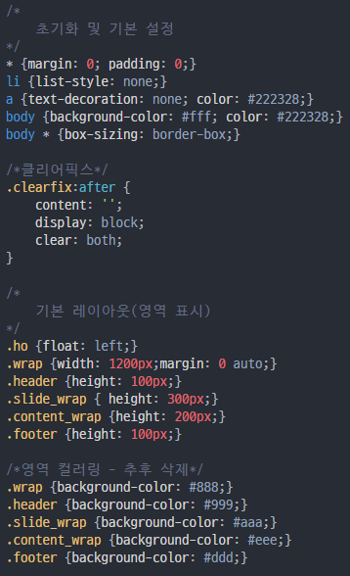

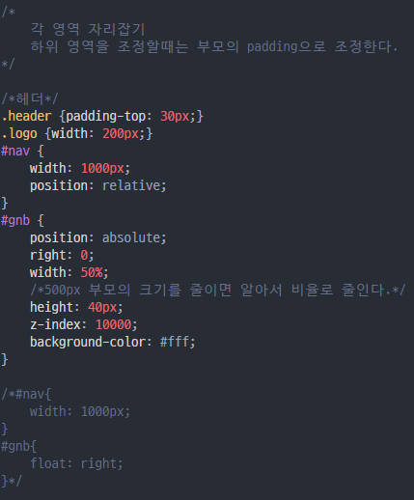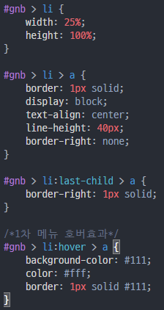

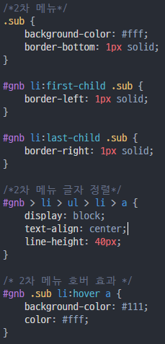

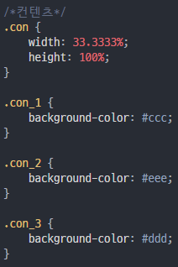

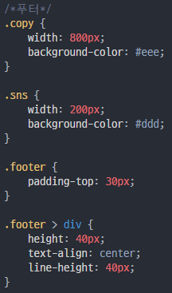

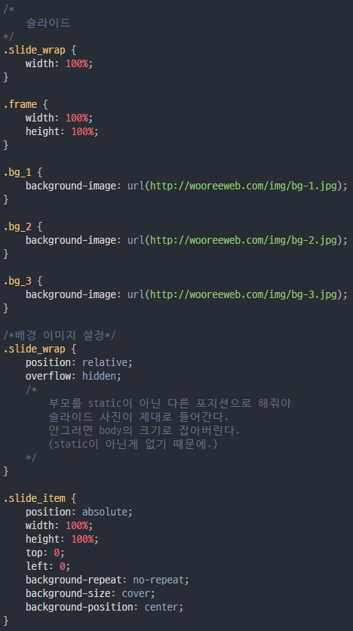

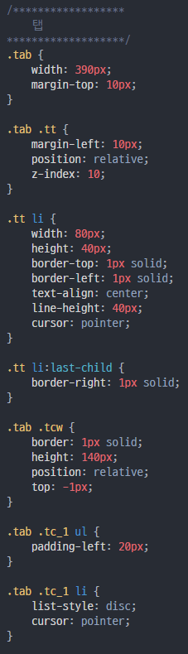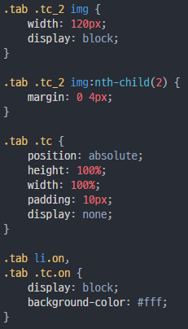

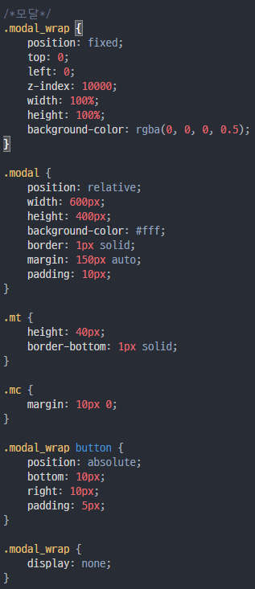

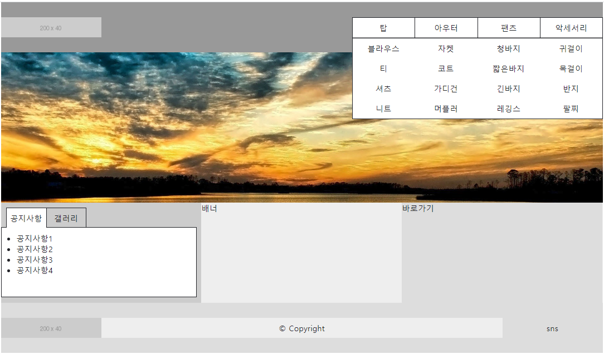

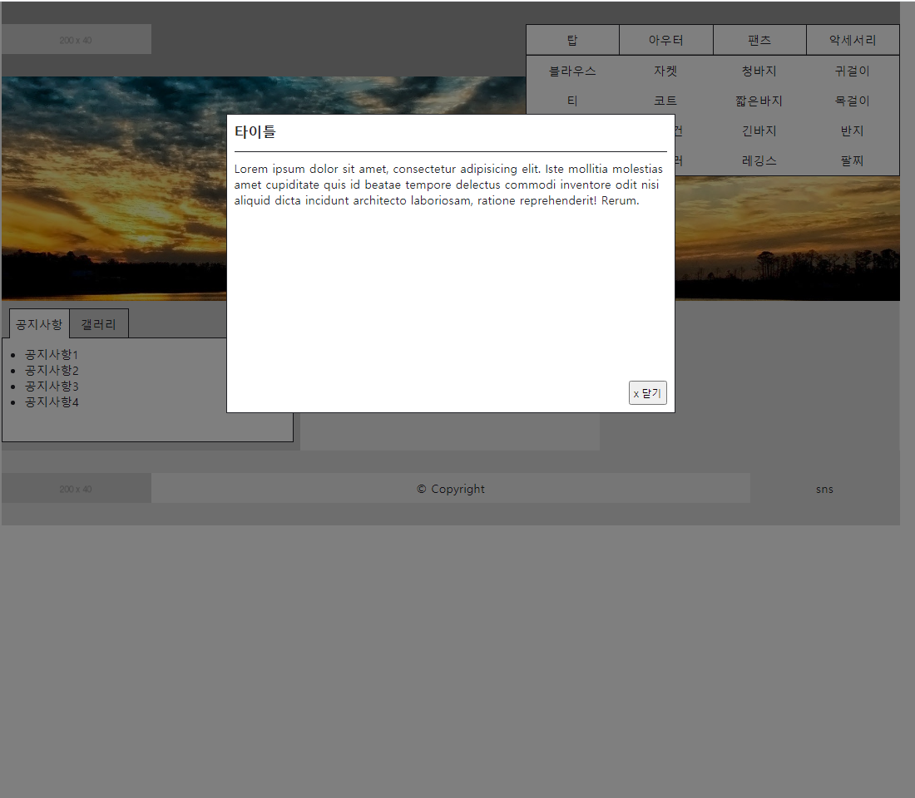

/*

초기화 및 기본 설정

*/

* {margin: 0; padding: 0;}

li {list-style: none;}

a {text-decoration: none; color: #222328;}

body {background-color: #fff; color: #222328;}

body * {box-sizing: border-box;}

/*클리어픽스*/

.clearfix:after {

content: '';

display: block;

clear: both;

}

/*

기본 레이아웃(영역 표시)

*/

.ho {float: left;}

.wrap {width: 1200px;margin: 0 auto;}

.header {height: 100px;}

.slide_wrap { height: 300px;}

.content_wrap {height: 200px;}

.footer {height: 100px;}

/*영역 컬러링 - 추후 삭제*/

.wrap {background-color: #888;}

.header {background-color: #999;}

.slide_wrap {background-color: #aaa;}

.content_wrap {background-color: #eee;}

.footer {background-color: #ddd;}

/*

각 영역 자리잡기

하위 영역을 조정할때는 부모의 padding으로 조정한다.

*/

/*헤더*/

.header {padding-top: 30px;}

.logo {width: 200px;}

#nav {

width: 1000px;

position: relative;

}

#gnb {

position: absolute;

right: 0;

width: 50%;

/*500px 부모의 크기를 줄이면 알아서 비율로 줄인다.*/

height: 40px;

z-index: 10000;

background-color: #fff;

}

/*#nav{

width: 1000px;

}

#gnb{

float: right;

}*/

#gnb > li {

width: 25%;

height: 100%;

}

#gnb > li > a {

border: 1px solid;

display: block;

text-align: center;

line-height: 40px;

border-right: none;

}

#gnb > li:last-child > a {

border-right: 1px solid;

}

/*1차 메뉴 호버효과*/

#gnb > li:hover > a {

background-color: #111;

color: #fff;

border: 1px solid #111;

}

/*2차 메뉴*/

.sub {

background-color: #fff;

border-bottom: 1px solid;

}

#gnb li:first-child .sub {

border-left: 1px solid;

}

#gnb li:last-child .sub {

border-right: 1px solid;

}

/*2차 메뉴 글자 정렬*/

#gnb > li > ul > li > a {

display: block;

text-align: center;

line-height: 40px;

}

/* 2차 메뉴 호버 효과 */

#gnb .sub li:hover a {

background-color: #111;

color: #fff;

}

/*컨텐츠*/

.con {

width: 33.3333%;

height: 100%;

}

.con_1 {

background-color: #ccc;

}

.con_2 {

background-color: #eee;

}

.con_3 {

background-color: #ddd;

}

/*푸터*/

.copy {

width: 800px;

background-color: #eee;

}

.sns {

width: 200px;

background-color: #ddd;

}

.footer {padding-top: 30px;}

.footer > div {

height: 40px;

text-align: center;

line-height: 40px;

}

/*

슬라이드

*/

.slide_wrap {

width: 100%;

}

.frame {

width: 100%;

height: 100%;

}

.bg_1 {

background-image: url(http://wooreeweb.com/img/bg-1.jpg);

}

.bg_2 {

background-image: url(http://wooreeweb.com/img/bg-2.jpg);

}

.bg_3 {

background-image: url(http://wooreeweb.com/img/bg-3.jpg);

}

/*배경 이미지 설정*/

.slide_wrap {

position: relative;

overflow: hidden;

/*

부모를 static이 아닌 다른 포지션으로 해줘야

슬라이드 사진이 제대로 들어간다.

안그러면 body의 크기로 잡아버린다.

(static이 아닌게 없기 때문에.)

*/

}

.slide_item {

position: absolute;

width: 100%;

height: 100%;

top: 0;

left: 0;

background-repeat: no-repeat;

background-size: cover;

background-position: center;

}

/******************

탭

*******************/

.tab {

width: 390px;

margin-top: 10px;

}

.tab .tt {

margin-left: 10px;

position: relative;

z-index: 10;

}

.tt li {

width: 80px;

height: 40px;

border-top: 1px solid;

border-left: 1px solid;

text-align: center;

line-height: 40px;

cursor: pointer;

}

.tt li:last-child {

border-right: 1px solid;

}

.tab .tcw {

border: 1px solid;

height: 140px;

position: relative;

top: -1px;

}

.tab .tc_1 ul {

padding-left: 20px;

}

.tab .tc_1 li {

list-style: disc;

cursor: pointer;

}

.tab .tc_2 img {

width: 120px;

display: block;

}

.tab .tc_2 img:nth-child(2) {

margin: 0 4px;

}

.tab .tc {

position: absolute;

height: 100%;

width: 100%;

padding: 10px;

display: none;

}

.tab li.on,

.tab .tc.on {

display: block;

background-color: #fff;

}

/*모달*/

.modal_wrap {

position: fixed;

top: 0;

left: 0;

z-index: 10000;

width: 100%;

height: 100%;

background-color: rgba(0, 0, 0, 0.5);

}

.modal {

position: relative;

width: 600px;

height: 400px;

background-color: #fff;

border: 1px solid;

margin: 150px auto;

padding: 10px;

}

.mt {

height: 40px;

border-bottom: 1px solid;

}

.mc {margin: 10px 0;}

.modal_wrap button {

position: absolute;

bottom: 10px;

right: 10px;

padding: 5px;

}

.modal_wrap {

display: none;

}

<!DOCTYPE html>

<html lang="ko">

<head>

<meta charset="UTF-8">

<title>JUST 쇼핑몰</title>

<link rel="stylesheet" href="css/layout.css">

</head>

<body>

<!--전체(1200px)-->

<div class="wrap">

<!--A. header-->

<div class="header clearfix">

<!--A-1. logo-->

<div class="logo ho">

<img src="http://placehold.it/200x40" alt="메인페이지도 이동">

</div>

<!--A-2. nav-->

<div id="nav" class="ho">

<ul id="gnb" class="clearfix">

<!--(li[class=ho]>a[href=#])*4-->

<li class="ho"><a href="#">탑</a>

<!--ul.sub>(li>a[href=#])*4-->

<ul class="sub">

<li><a href="#">블라우스</a></li>

<li><a href="#">티</a></li>

<li><a href="#">셔츠</a></li>

<li><a href="#">니트</a></li>

</ul>

</li>

<li class="ho"><a href="#">아우터</a>

<ul class="sub">

<li><a href="#">자켓</a></li>

<li><a href="#">코트</a></li>

<li><a href="#">가디건</a></li>

<li><a href="#">머플러</a></li>

</ul>

</li>

<li class="ho"><a href="#">팬츠</a>

<ul class="sub">

<li><a href="#">청바지</a></li>

<li><a href="#">짧은바지</a></li>

<li><a href="#">긴바지</a></li>

<li><a href="#">레깅스</a></li>

</ul>

</li>

<li class="ho"><a href="#">악세서리</a>

<ul class="sub">

<li><a href="#">귀걸이</a></li>

<li><a href="#">목걸이</a></li>

<li><a href="#">반지</a></li>

<li><a href="#">팔찌</a></li>

</ul>

</li>

</ul>

</div>

</div>

<!--B. slide-->

<div class="slide_wrap">

<div class="frame clearfix">

<!--.slide_item.bg_$*3-->

<div class="slide_item bg_1"></div>

<div class="slide_item bg_2"></div>

<div class="slide_item bg_3"></div>

</div>

</div>

<!--C. content-->

<div class="content_wrap clearfix">

<!--.con.ho.con_$*3-->

<div class="con ho con_1">

<!--탭 (전체)-->

<div class="tab">

<!--(1) 탭 메뉴-->

<ul class="tt clearfix">

<li class="ho on">공지사항</li>

<li class="ho">갤러리</li>

</ul>

<!--(2) 탭 컨텐츠-->

<div class="tcw">

<div class="tc tc_1 on">

<ul>

<li>공지사항1</li>

<li>공지사항2</li>

<li>공지사항3</li>

<li>공지사항4</li>

</ul>

</div>

<div class="tc tc_2 clearfix">

<img src="http://placehold.it/100X100" alt="" class="ho">

<img src="http://placehold.it/100X100" alt="" class="ho">

<img src="http://placehold.it/100X100" alt="" class="ho">

</div>

</div>

</div>

</div>

<div class="con ho con_2">배너</div>

<div class="con ho con_3">바로가기</div>

</div>

<!--D. footer-->

<div class="footer clearfix">

<div class="logo ho">

<a href="index.html">

<img src="http://placehold.it/200x40" alt="메인페이지로 이동"></a>

</div>

<div class="copy ho">

&copy; Copyright

</div>

<div class="sns ho">

sns

</div>

</div>

</div>

<!--팝업(모달) 레이어-->

<div class="modal_wrap">

<div class="modal">

<div class="mt"><h3>타이틀</h3></div>

<div class="mc">Lorem ipsum dolor sit amet, consectetur adipisicing elit. Iste mollitia molestias amet cupiditate quis id beatae tempore delectus commodi inventore odit nisi aliquid dicta incidunt architecto laboriosam, ratione reprehenderit! Rerum.</div>

<button>x 닫기</button>

</div>

</div>

</body>

</html>