Kevin Hoser

Alex Schendel

Spring 2020

23 March 2020

**CS 324 HW 6: Dynamic Programming & Greedy Algorithms**

**Part A (20 points): can be done individually or in pairs, pairs preferred**

1. (15 points) Upload your code file to the separate moodle submission link. If you worked with a partner, put both names above and in the code comments.
2. (2 points) What are the returned values for the test arrays above for the recursive solution? Include a screenshot of your results below.
   1. True/False
   2. True/False
   3. True/False
   4. True/False

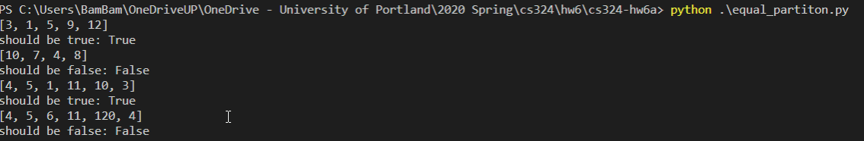

1. (1 point) Do your answers with the dynamic programming version match that of the recursive version?
   1. Yes/No

Yes

1. (2 points) Copy and paste your table from test case 3 {4, 5, 1, 11, 10, 3} below.

[True, True, True, True, True, True, True]

[False, False, False, True, True, True, True]

[False, False, False, False, False, False, False]

[False, False, False, False, False, False, True]

[False, True, True, True, True, True, True]

[False, False, True, True, True, True, True]

[False, False, False, True, True, True, True]

[False, False, False, False, False, False, True]

[False, False, False, False, False, False, True]

[False, False, True, True, True, True, True]

[False, False, False, True, True, True, True]

[False, False, False, False, True, True, True]

[False, False, False, False, True, True, True]

[False, False, False, False, False, False, True]

[False, False, False, False, False, True, True]

[False, False, False, False, True, True, True]

[False, False, False, False, True, True, True]

[False, False, False, False, True, True, True]