Computer Networks
HOMEWORK #1
Due date: 2026-03-30
NOTE: WRITE YOUR ANSWERS IN ENGLISH.
ID#:2021310314 Name: (Kor.)강호승 (Eng.)KangHoseung

Problem #1. (20pts) Explore future trends in technology and select a minimum of four (4) new cutting-edge technological inventions or innovations, one each from the following application areas: Wearable, Fixed, Mobile, and Flying things. Present each idea in half a page, preferably in bullet points, and underline key sentences. Each product should be accompanied by a link to a related video or documentation. Ensure that your list does not include any products or devices mentioned in Lecture #1 Explore the Future.
You may refer to the following Technology Events and Exhibitions for some new ideas:
- CES (Consumer Electronics Show): https://www.ces.tech/
- MWC (Mobile World Congress): https://www.mwcbarcelona.com/
- IFA Berlin: https://b2b.ifa-berlin.com/en/
- Tech Web
***Note***: Do not write lengthy paragraphs. The bullet point style is more efficient.

1. Wearable - Looki
• A wearable AI device that continuously records and analyzes the user’s daily life through camera and audio
• Designed to be worn on clothing or around the neck as a lightweight AI companion
• Uses multimodal AI to understand context and answer user questions based on recorded data
• Functions as a “second brain” by summarizing events, conversations, and activities
• Equipped with camera, microphone, and sensors to capture real-world interactions
• Focuses on memory assistance and life logging rather than replacing smartphones
• Connects to AI systems to generate insights, summaries, and personalized responses
• Represents a shift toward passive AI assistance instead of active app-based interaction
• Highlighted in CES/MWC as a practical next-generation AI wearable
Link : https://www.looki.ai/looki-l1

2. Fixed - FaceHeart CardioMirror
- An AI-powered smart mirror that analyzes cardiovascular health and vital signs using non-contact sensing
- Allows users to check their health simply by standing in front of the mirror
- Recognized in the CES 2025 Innovation Awards, indicating technological credibility
- Measures multiple health indicators such as heart rate, blood pressure, respiratory rate, and oxygen saturation
- Provides a convenient and continuous health monitoring solution without wearable devices
- Suitable for deployment in homes, hospitals, and healthcare kiosks due to its fixed installation
- Uses advanced imaging and AI algorithms to extract physiological signals from facial data
- Enables early detection of potential health issues through regular monitoring
- Can be integrated with telemedicine systems for remote healthcare services
Link : https://www.ces.tech/ces-innovation-awards/2025/faceheart-cardiomirror/

3. Mobile – Motorola Adaptive Display / Rollable Concept
- A next-generation mobile device concept featuring a flexible and adaptive display
- Introduced by Lenovo/Motorola at major tech events such as Tech World and MWC
- Can be used like a regular smartphone or transformed into different form factors depending on user needs
- Demonstrates both portability and screen expandability in a single device
- Showcases the future direction of mobile devices beyond traditional fixed-screen smartphones
- Utilizes flexible OLED display technology to enable bending and reshaping
- Allows dynamic user experiences, such as wearable mode or stand mode
- Enhances multitasking and content consumption through adjustable screen configurations
- Represents innovation in both hardware design and user interaction
Links : https://news.lenovo.com/pressroom/press-releases/motorola-redefines-possible-ai-adaptive-display-tech-world-2023/

4. Flying – EHang EH216-S
- An autonomous eVTOL (electric vertical takeoff and landing) aircraft designed for urban air mobility
- Operates without a pilot, enabling fully autonomous passenger transportation
- Demonstrated through real passenger test flights and urban trial operations
- Represents a practical step toward future air taxi services in smart cities
- Highlights the transition from traditional ground transportation to aerial mobility solutions
- Powered by electric propulsion, making it environmentally friendly
- Equipped with intelligent flight control systems for navigation and safety
- Capable of vertical takeoff and landing, eliminating the need for runways
- Supported by official videos and company announcements, ensuring credibility
Links : https://www.ehang.com/video/videolist?id=6

Problem #2. (10pts)
- (3pts) What is the difference between hubs, switches, bridges, routers, and repeaters?

A hub forwards incoming data to all connected ports without any filtering, which creates a single collision domain and leads to frequent collisions and inefficient network usage; it operates at the physical layer of the OSI model.
A switch forwards data only to the intended port by learning and using MAC addresses, allowing each port to function independently with minimal collisions; it operates at the data link layer of the OSI model.
A bridge filters frames based on MAC addresses and divides a network into smaller segments to reduce collisions, serving as an early version of a switch; it also operates at the data link layer of the OSI model.
A router connects different networks and determines the best path for data using IP addresses, enabling communication across multiple networks including the internet; it operates at the network layer of the OSI model.
A repeater simply amplifies or regenerates signals to extend transmission distance without interpreting the data, and it operates at the physical layer of the OSI model.
- (7pts) In a scenario where we need to provide WiFi access to approximately 50 to 70 people using services such as VR/AR/XR inside a building, which device would you recommend? Please provide comprehensive but concise details, including vendor name, product name/ID, available channels, channel capacity, availability in Korea, price, and website. (Hint: You may refer to the same vendors asked in Problem 6)

Recommended Device: Huawei AirEngine 8771-X1T
1. Basic Information
The Huawei AirEngine 8771-X1T is an indoor enterprise access point that supports Wi-Fi 7 (802.11be) and operates on tri-band frequencies of 2.4 GHz, 5 GHz, and 6 GHz. It is designed to provide high performance and reliable wireless connectivity.
2. Performance & Channels
The device delivers a maximum data rate of up to 18.67 Gbps and supports 12 spatial streams (4×4 MIMO per band). It supports up to 40 MHz in the 2.4 GHz band, up to 160 MHz in the 5 GHz band, and up to 320 MHz in the 6 GHz band, enabling high throughput and reduced interference.
3. Capacity & Deployment
Assuming around 50 VR/AR/XR users are connected simultaneously, the total bandwidth of 18.67 Gbps provides approximately 370 Mbps per user. Since typical VR/AR/XR applications require about 50-150 Mbps, this configuration offers sufficient capacity and ensures stable performance even under high load.
4. Availability & Price
The device is available in Korea through enterprise distribution channels, with a price of approximately $800-$900 (about 1,000,000-1,200,000 won). When divided among 50 users, the cost per user is roughly $16-$24, making it a cost-effective solution for high-performance wireless deployments.
Website: https://e.huawei.com/en/products/wlan/airengine-8771-x1t
Price: https://www.router-switch.com/airengine-8771-x1t.html

Problem #3. (5pts) What does the term protocol-layering mean? Why is it a good idea?
1. Definition of Protocol-Layering
- Protocol-layering is a design approach that divides network communication into multiple layers, each with specific functions.
- Each layer communicates with others using defined rules (protocols).

2. Why is it a good idea?
- Reduces complexity: Breaking the system into layers makes it easier to understand and manage.
- Modularity: Each layer can be developed and modified independently.
- Easier troubleshooting: Problems can be isolated to a specific layer, simplifying debugging.
Conclusion
Protocol-layering improves efficiency and simplifies network design and maintenance.

Problem #4. (5pts) How many point-to-point WANs are needed to connect n LANs if each LAN should be able to directly communicate with any other LAN?
If each LAN must be able to directly communicate with every other LAN, every pair of LANs needs one point-to-point WAN link. Therefore, the total number of required WANs is:
$$\frac{n(n-1)}{2}$$

Problem #5. (5pts) Assume we want to connect two isolated hosts together to let each host communicate with the other. Do we need a link-layer switch between the two? Explain.

No, a link-layer switch is not necessary to connect two isolated hosts. If there are only two hosts, they can be directly connected using a communication link, which is sufficient to enable communication between them. A switch is primarily used when multiple devices need to be interconnected within a network, so for just two hosts, a direct connection is enough.

Problem #6. (5pts) Answer the following questions based on your knowledge.
- "WiFi" is abbreviated for Wireless Fidelity, whereas LiFi is for Light Fidelity.
- WiFi uses radio waves, whereas LiFi uses light for data transmission.
- Between WiFi and LiFi, LiFi has higher transmission rate and WiFi has higher coverage.
- Vendors like Cisco, Huawei, and TP-Link have captured the international market as the manufacturers of WiFi devices.
- For everyday internet browsing and checking emails, a 2.4 GHz WiFi connection is generally sufficient. However, for activities that require high bandwidth and low latency, like online gaming and video conferencing, a 5 GHz connection is preferred.
- An application-layer process sends messages into, and receives messages from, the network through a software interface called a socket. This is also referred to as an API which stands for Application Programming Interface.
- In Microsoft Magentic-One, the Orchestrator is responsible for task planning, inter-agent collaboration, coordination, progress tracking, and error recovery.
- In networking, a stateful protocol maintains information between requests, while a stateless protocol treats each request independently without retaining any previous interaction data. Given this definition, determine which of the two following protocols is stateful or stateless? HTTP is a stateless protocol. FTP is a stateful protocol.
- In a client-server architecture, there is an always-on host, called the server, which services requests from many other hosts, called clients.
- In the HTTP protocol, a basic URL has two components: the host that houses the object and the object’s path. For example, the URL ‘http://monet.skku.edu/course/homeworkcomnet2021.doc’ has monet.skku.edu for a host and /course/ homeworkcomnet2021.doc for a path

Problem #7. (10pts) Search for Network LLMs. Networking standards from the 3rd Generation Partnership Project (3GPP) provide the basis for real cellular networks. Engineers track Key Performance Indicators (KPIs) such as delay, throughput, handover success, and packet loss to evaluate performance, while mobility traces show how user movement affects the network. By analyzing both, the system can detect an anomaly, meaning unusual behavior that may indicate congestion, faults, or service degradation. In 6G, intelligent orchestration can then respond automatically by adjusting resources or policies. To support such tasks, researchers are exploring Large Language Models (LLMs) for networking applications such as log understanding and decision support. However, general-purpose LLMs often lack training on network data and standards, so network LLMs, which are LLMs trained for networking tasks, are a promising direction. You are tasked to:
- Search and provide:
- Two examples of fine-tuned Network LLMs
Fine-tuned Network LLMs: Example 1
Paper: Fine-tuning Llama3 for Integrated Analysis of Network Packet and System Log Data
DOI: https://doi.org/10.23919/APCC64555.2025.11279921
Technique
- Llama-3-8B fine-tuning
- Joint analysis of pcap + syslog
- Instruction tuning
- Self-Instruct data generation
- Q&A and code generation tasks
Description
This paper proposes Llama-PcapLog, a fine-tuned Llama-3 model for integrated cybersecurity analysis. It combines network packet data and system logs to detect threats and analyze attack scenarios more effectively than treating them separately.

Fine-tuned Network LLMs: Example 2.
Paper: Large language model-based optical network log analysis using LLaMA2 with instruction tuning
DOI: https://doi.org/10.1364/JOCN.527874
Technique
- LLaMA2 fine-tuning
- Instruction tuning
- Optical network log analysis
- Log parsing, anomaly detection, and report generation
- Real-world field log dataset
Description
This paper proposes an LLaMA2-based log analysis framework for optical networks. It uses instruction tuning on real network logs to improve log parsing, anomaly detection/classification, anomaly analysis, and report generation, while also supporting data privacy through open-source LLM deployment.

- Two examples of generic LLM + RAG systems for networking
LLM + RAG systems for networking : Example 1
Paper: Telco-RAG: Navigating the Challenges of Retrieval-Augmented Language Models for Telecommunications
DOI: https://doi.org/10.1109/GLOBECOM52923.2024.10901158
Technique
- Retrieval-Augmented Generation (RAG)
- 3GPP document retrieval
- Telecom-domain question answering
- Open-source framework
Description
This system uses a general LLM with RAG to answer questions about telecommunications standards, especially 3GPP documents. It is designed to improve factual accuracy and handle highly technical telecom content without relying only on the model’s internal knowledge.

LLM + RAG systems for networking : Example 2
Paper: TeleOracle: Fine-Tuned Retrieval-Augmented Generation With Long-Context Support for Networks
DOI: https://doi.org/10.1109/JIOT.2025.3553161
Technique
- Retrieval-Augmented Generation (RAG)
- Phi-2 based telecom-specialized SLM
- Two-stage retriever
- Semantic chunking
- LoRA fine-tuning
Description
TeleOracle is a telecom-specialized LLM + RAG system for network question answering. It improves retrieval with a two-stage retriever and supports long-context reasoning, achieving better accuracy and faithfulness than the base Phi-2 model.
- Decide which of the Network LLM (Fine-tuned or RAG-based) is more suitable and why, for each of the following 3 tasks.
  - Task 1: Root-cause analysis for modem or network device error logs
  - Task 2: Question answering for 3GPP specifications
  - Task 3: 6G network orchestration using policies, KPI trends, mobility traces, and anomaly history
For Task 1, a fine-tuned LLM is more suitable because modem and network device error logs are relatively structured and contain recurring patterns that can be learned effectively. Fine-tuning enables fast and accurate root-cause analysis without relying on external retrieval.
For Task 2, a RAG-based LLM is preferred since 3GPP specifications are extensive and continuously updated. Retrieval allows the model to access the most relevant and up-to-date sections, ensuring accurate and grounded answers.
For Task 3, a hybrid approach with RAG at the core is most appropriate, as 6G orchestration requires integrating dynamic data such as policies, KPI trends, and anomaly history. At the same time, fine-tuning helps incorporate domain-specific reasoning for better decision-making.
Problem #8. (40pts) Client-Server File Transfer Service with TCP and UDP
In a Client-Server communication, Transmission Control Protocol (TCP) and User Datagram Protocol (UDP) are the two primary transport layer protocols. TCP ensures reliable, connection-oriented communication, while UDP is faster but connectionless, making it suitable for low-latency applications. To facilitate communication between the client and server, a port number directs network traffic to specific services, allowing multiple applications to run simultaneously on a device. In addition to the choice of TCP or UDP and the use of port numbers, several parameters, such as chunk size, send delay, processing delay, buffer size, and timeout, can affect how data is transmitted between the client and the server. Particularly, chunk size is the amount of data sent each time. Send delay is the waiting time between sending chunks; without it, data may be sent too fast and cause packet loss or unstable results. Processing delay is the waiting time before the server handles data, which helps simulate a busy server. Buffer size is the temporary space for incoming data. Timeout is the maximum waiting time for data, especially important in UDP when packets may be lost. To evaluate the transfer performance, this experiment measures transfer time, total received bytes, and throughput. Transfer time is the total time needed to send and receive the file. Total received bytes shows how much data the server received. Throughput means the data transfer speed, usually calculated as the total received bytes divided by the transfer time. These parameters help show how TCP and UDP behave under different conditions.

Requirements: Implement two separate file transfer systems, as shown in Table 1.
Table 1. Experimental settings and performance for TCP and UDP file transfer
Protocol |  | Component | Setting 1 | Setting 2
TCP | Client |  | Send delay: 0.005 (s) | Send delay: 0.0 (s)
 | Server |  | Chunk size: 512 (bytes)  Processing delay: 0.0 (s)  Receive buffer size: 65536 (bytes) | Chunk size: 256  Processing delay: 0.002 (s)  Receive buffer size: 8192 (bytes)
 | Result |  | Result: Complete  Transfer time: 30.716787s  Total received bytes: 3145728bytes  Throughput: 102410.71bytes/s | Result: Complete  Transfer time: 3.506152s  Total received bytes: 3145728bytes  Throughput: 897202.30bytes/s
 | Conclusion |  | In Setting 1, the 0.005-second send delay increased the transfer time compared to Setting 2, despite having a larger receive buffer and no processing delay. In Setting 2, removing the send delay enabled faster transfer and higher throughput, and TCP handled the smaller buffer and added processing delay without packet loss.
UDP | Client |  | Send delay: 0.005 (s) | Send delay: 0.0 (s)
 | Server |  | Chunk size: 512 (bytes)  Processing delay: 0.0 (s)  Receive buffer size: 65536 (bytes)  Timeout: 2.0 (s) | Chunk size: 256 (bytes)  Processing delay: 0.002 (s)  Receive buffer size: 8192 (bytes)  Timeout: 2.0 (s)
 | Result |  | Result: Complete  Transfer time: 30.715039s  total received bytes: 3145728 bytes  throughput: 102416.54 bytes/s | Result: Incomplete  Transfer time: 6.455444s  total received bytes: 444672 bytes  throughput: 68883.26 bytes/s
 | Conclusion |  | In Setting 1, the transfer was completed without data loss because the send delay and larger receive buffer helped prevent buffer overflow. In Setting 2, the lack of send delay and smaller buffer led to packet loss, resulting in an incomplete transfer.
TCP consistently achieved complete file transfer in both settings due to its flow control and retransmission mechanisms. In contrast, UDP suffered significant packet loss in Setting 2 when the receiver became overloaded. Overall, TCP maintained reliable performance under heavy load, while UDP was prone to data loss without rate control.

Network Configuration
- Port number: 5000
- Client IP address: 10.10.10.1
- Server IP address: 10.10.10.2
- Here are the guidelines for parameter setting in Python that you can refer to.
  - Receive buffer size = w (bytes)
    - recv_buffer_size = w
    - data = sock.recv(recv_buffer_size)
  - Processing delay = x (s)
    - processing_delay = x
    - time.sleep(processing_delay)
  - Chunk size = y (bytes)
    - chunk_size = y
    - data = f.read(chunk_size)
  - Send delay = z (s)
    - send_delay = z
    - time.sleep(send_delay)
- Parameter setting 2 for TCP and UDP
File Transfer Task
- Step 1: The client must generate a text file of 3MB (approximately 5000 lines), such as sample.txt
- Step 2: The client (virtual machine 1) sends the txt file to the server (virtual machine 2)
- Steps 3-4: The server receives the file, analyzes the transfer, and returns the following results to the client:
  - Transfer time (seconds)
  - Total received bytes
  - Throughput (bytes/second)
- Step 5: The client saves the returned results in a file named result.txt.
You can refer to Fig. 1 for a better understanding.

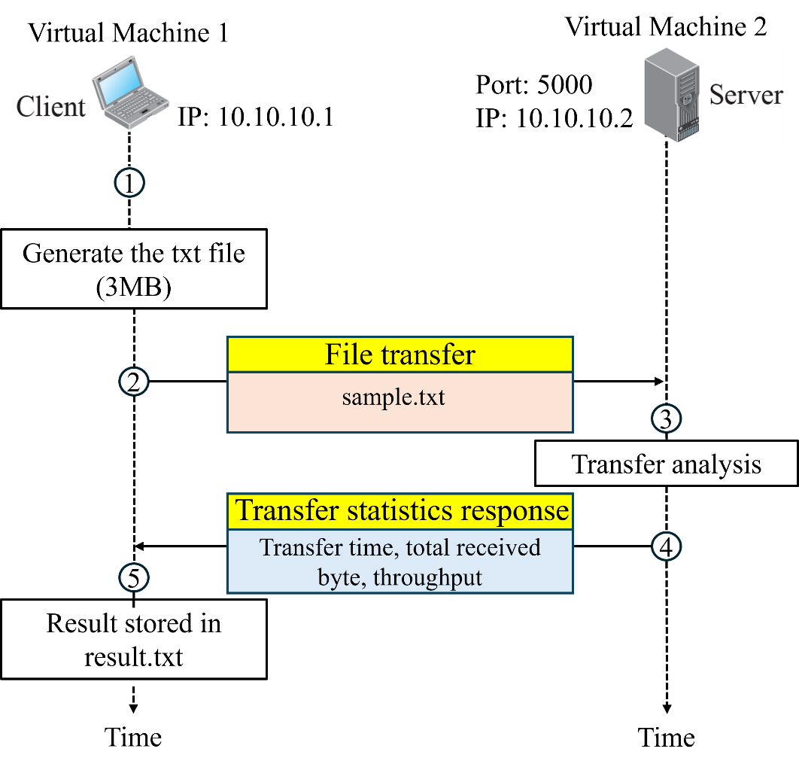
Fig. 1. Scenario of the problem

TCP server and client (using Setting 1)

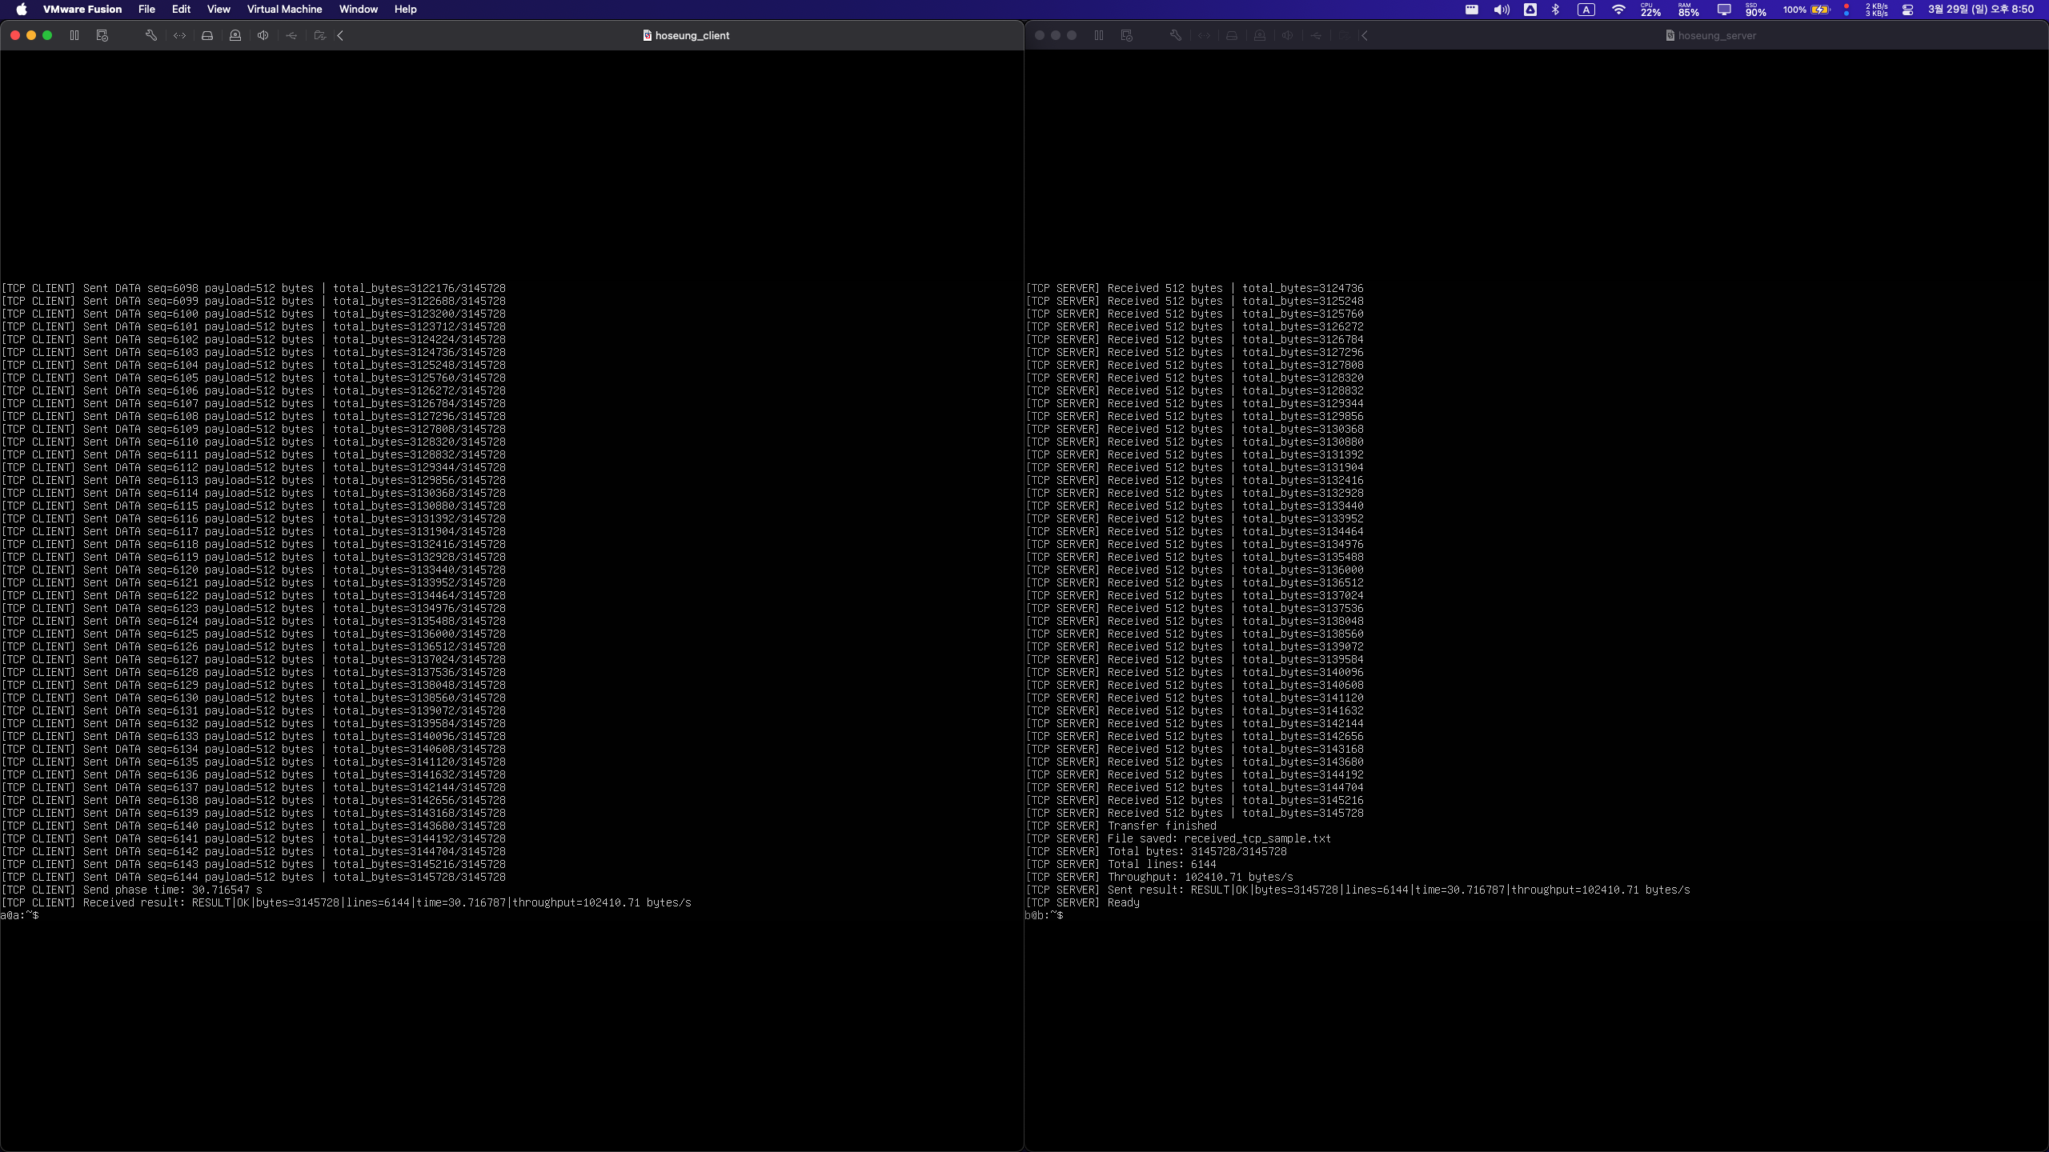
TCP server and client (using Setting 2)

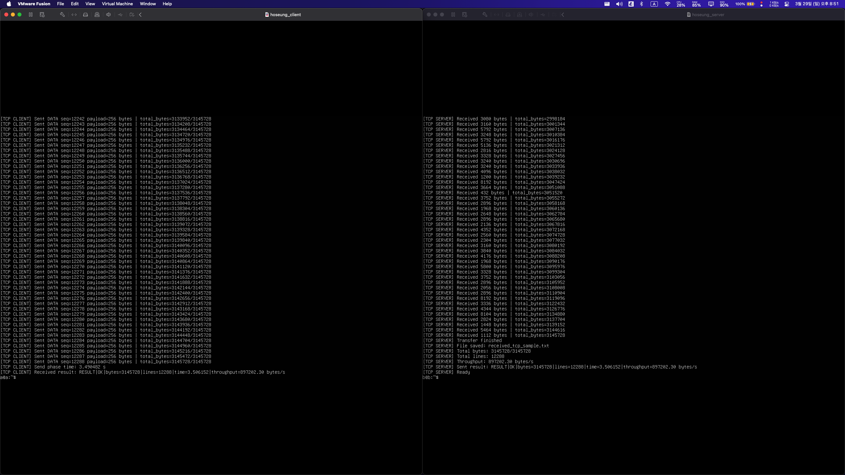
UDP server and client (using Setting 1)

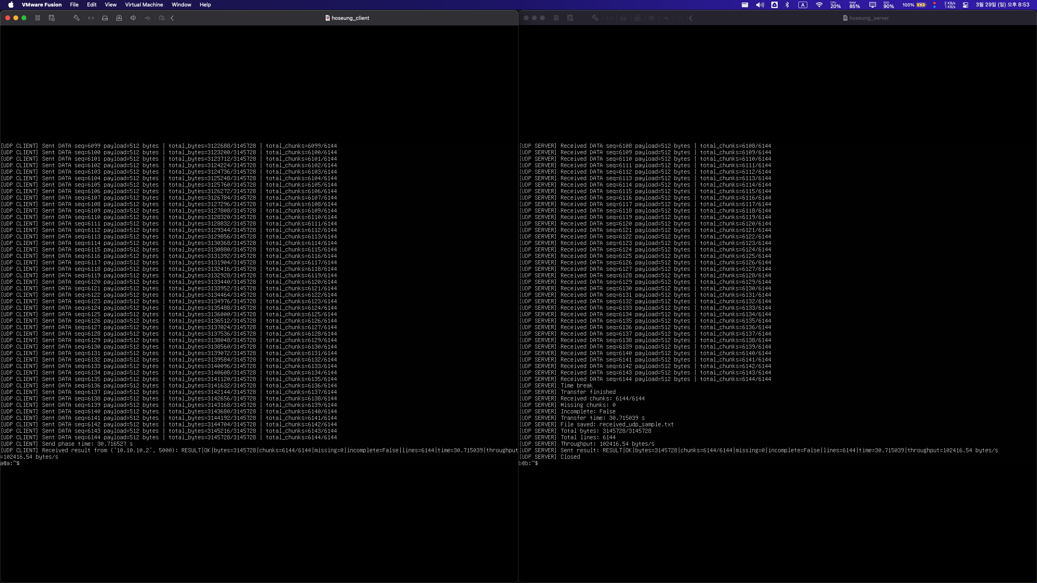

UDP server and client (using Setting 2)

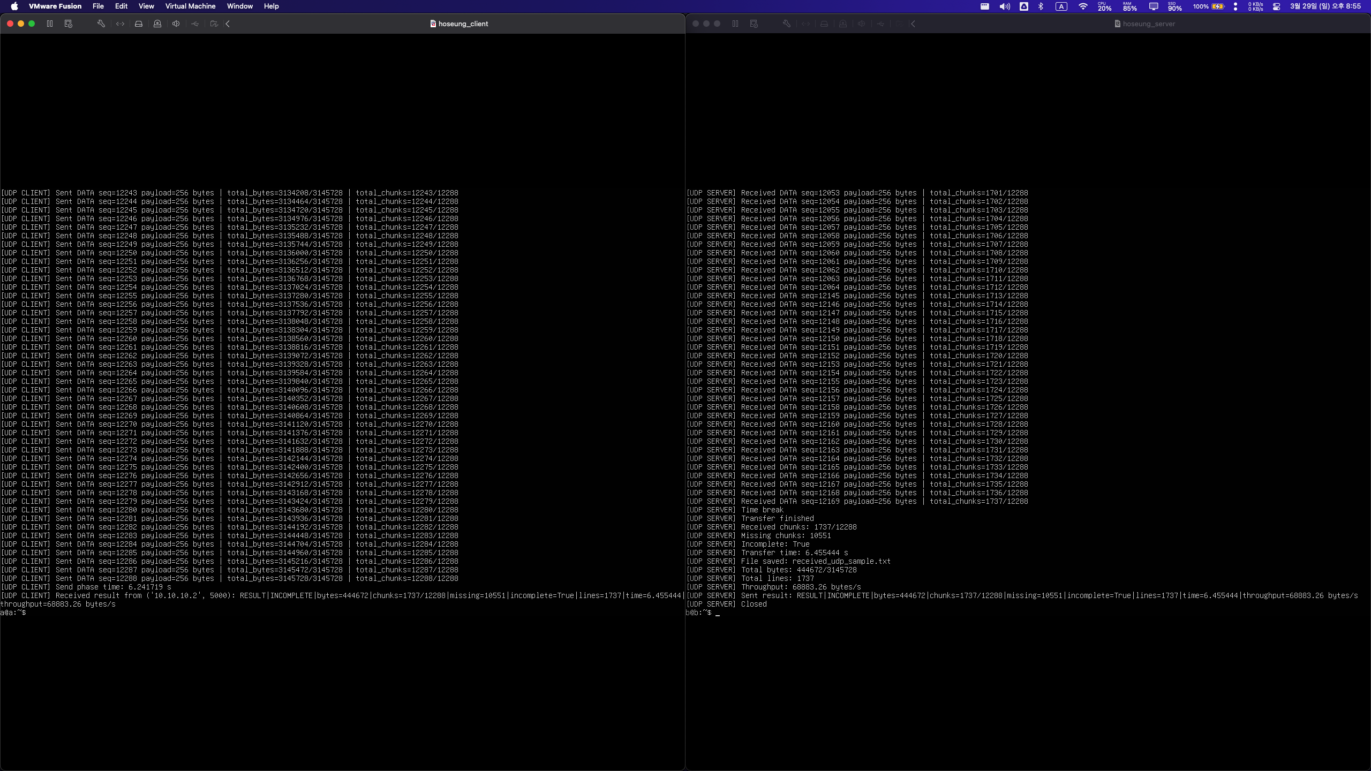

What to hand in:
- Submit a report containing the completed Table 1 and screenshots of the results generated on your own machine after executing your source code. The screenshots must be organized into two folders, TCP and UDP, and each folder must include results for the two settings listed in Table 1. All screenshots must be clear and must include your PC username or other proof that the execution was performed by you.
- Submit all source code files in executable form. The code must run without any modification, and the IP addresses and port numbers must be predefined so that the TAs can test it immediately without manual input.
Submission guidelines:
- You must submit a compressed file named CN26-HW1-ID-NAME.zip through i-Campus.
For example: CN26-HW1-2024970211-Park Chaeyoung.zip where 2024970211 is the student ID and Park Chaeyoung is student NAME
- Your solution must be written in ENGLISH. Solution written in Korean will NOT be graded.
- You must use the .doc template provided on i-Campus.
There will be a serious penalty for students who copy each other.

AI Usage Statement
Used AI tools for English translation and grammar correction
Used AI tools to debug and identify errors in the implemented code
Used AI tools to review and verify correctness of written answers
Used AI tools to improve clarity and structure of explanations

