Homework 1 Report

The goal of homework 1 was to learn the basics of loading in different kinds of data and outputting them in a specific order. We had to output our name and date of birth in the format “First Last Month/Day”. This is a slightly more complex “Hello World” program.

My approach to this problem was written in MIPS Assembly and compiled and tested with the MARS IDE. My strategy involved saving my name and a ‘/’ character as a string, and the date and day as an integer. I would then load in and output the Name, then the month, then a slash, then the day.

There are no special requirements or settings to build and run this program. I have only tested it through the MARS IDE with default settings.

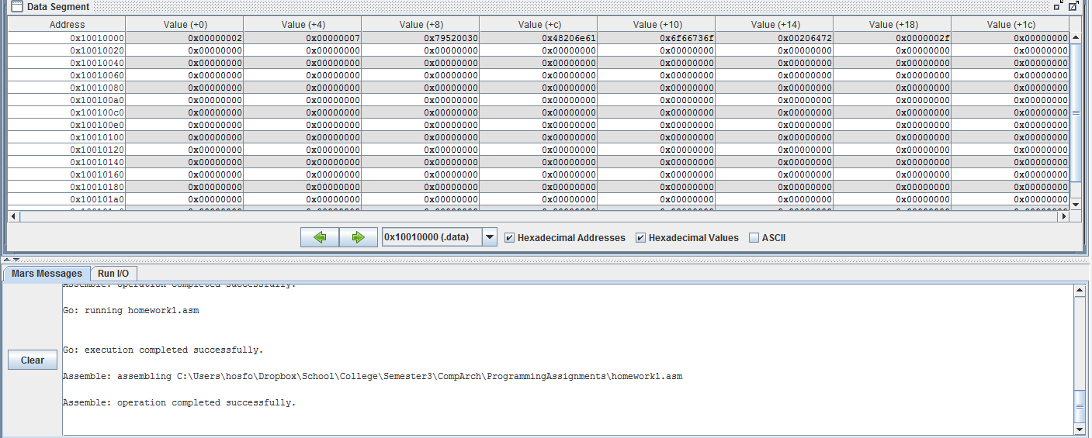

This screenshot shows that the program builds successfully without any errors or warnings.

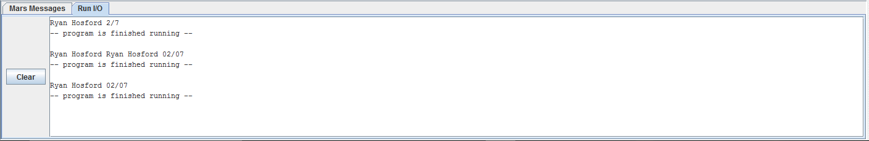

This screenshot shows that the program runs without errors and that the output is correct. The output should be “Ryan Hosford 02/07”.