Programming Assignment 2 Report

The problem that I had to solve was to take an input from the user in which they specified the name of an input file (maximum of 20 characters long) which contained to integers that needed to be multiplied. The importance of this assignment is to learn how different forms of input are handled as well as converting a string into integers which arithmetic can be done on.

To solve this problem, I had to get the filename from the user, then I had to parse over it to make sure it was in the correct format. After reading the file and getting the numbers in the form of a string, I had to parse over the string and split it into two separate numbers. After I had the integers, I had to do the multiplication on them. I did this in the MIPS assembly language, written in the MARS IDE.

There are no special requirements to build and execute this program. The maximum size of the integers and their results have to be under 32 bits of storage, and the filename has to be under 21 characters long Use the default settings in the MARS IDE.

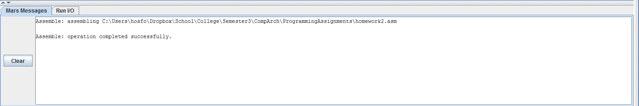

Here is a screenshot showing that the program successfully builds.

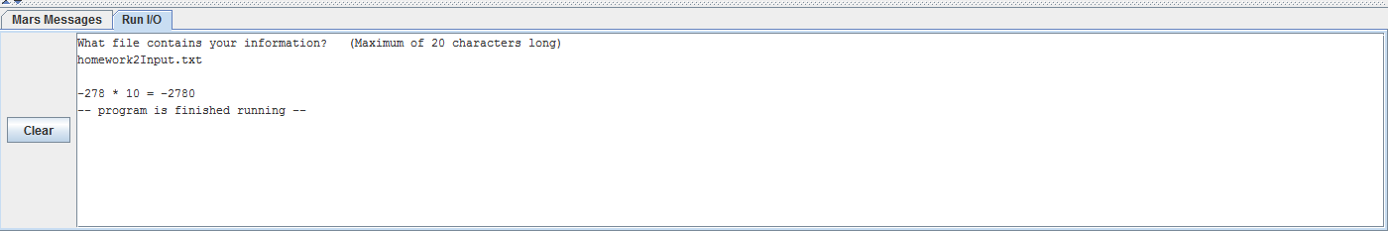

Here is a screenshot showing the execution of the program. It asks for the filename and then outputs the integers in the file along with the result of the multiplication.