Programming Assignment 3 Report

Reading from a file can be much more difficult when there in an unknown number of lines of data in the file. When there is an arbitrary number of lines of input, it forces the programmer to make the program dynamic and not hard-code anything. This programming assignment required me to take a solution I designed for a previous assignment and adapt it to work with an unknown number of lines of inputs. This assignment called for the program to take in an unknown number of pairs of integers from a user specified file, and add their products.

My approach to solving this problem was to put most of my solution to the previous assignment in a loop and add some logic to figure out when it has reached the end of the input file. Similar to a while-loop in a high level language. This worked because the previous assignment handled reading the integer pairs and multiplying them. So, if you just repeat this for every pair and add the products, you have your solution. I did this program in MIPS Assembly Language in the MARS IDE.

There are no special requirements to build and execute this program. The maximum size of the integers and the result of the summation of products has to be under 32 bits of storage, and there has to be an even number of integers in the file (due to the requirement of pairs of integers) The user defined filename can be up to a length of 100 characters. Use the default settings in MARS IDE for building and execution.

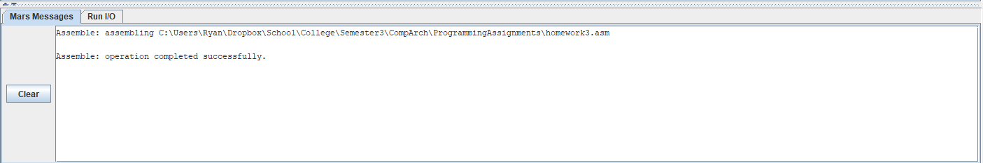

Here is a screenshot showing that the program builds successfully

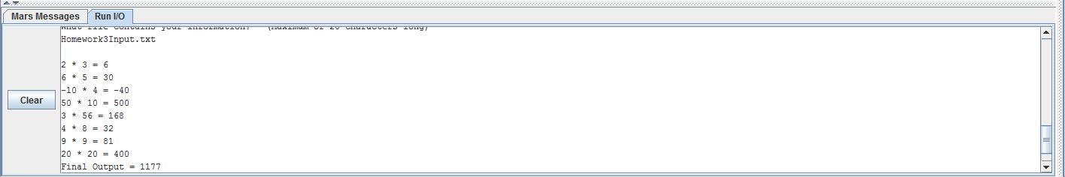

Here you can see the execution of the program. The user is prompted for a file containing the input, then outputs the integers found in the file along with the appropriate mathematical operations. It then outputs the summation of the products of integer pairs as the “Final Output”