Programming Assignment 4 Report

For this program, I was tasked with counting the occurrence of each digit 0-9 present in a user given file. Essentially creating a histogram of the file. This is important because it reinforces concept of reading a file of an unknown length and performing operations on the data in the file.

The approach I used to complete this assignment was to re-use the code I created in a previous assignment for getting the filename from the user, and reading all the data from the user given file. After that, I parsed through the input and counted the occurrence of each digit 0-9. The language used was MIPS Assembly and was programmed in Mars IDE.

As in my previous programs, there is no special requirements to build or execute this program except that the filename given by the user can’t be greater than 100 characters long and the file itself can’t be greater than 100000 bytes long. Use the default settings in Mars IDE for building and executing.

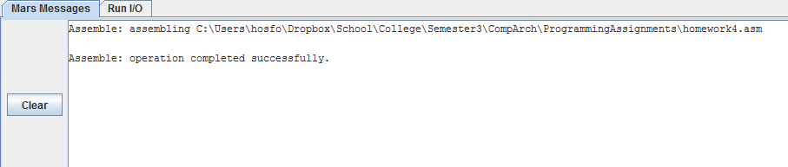

Here is a screenshot showing that the program builds successfully

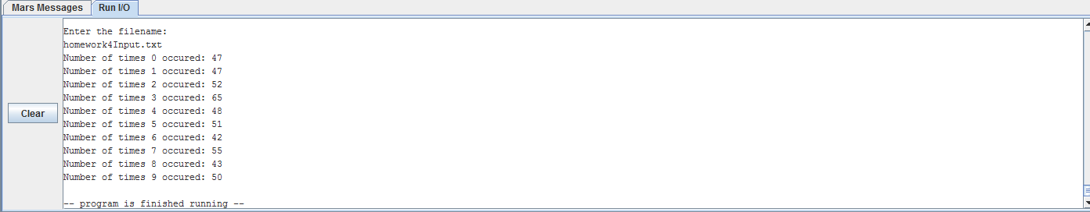

Here you can see the execution of the program. The user is prompted for the name of the file to read, then the program outputs the number of times each digit 0-9 occur in the file.