MedSight AI: A Multimodal Deep Learning Framework for Unsupervised Pulmonary Anomaly Detection with Retrieval-Augmented Clinical Decision Support

Kasala Hoshik , V.Vineel Reddy , K.Chanikya
Research | May 2026
Lovely Professional University , Phagwara , Punjab , India
ranahoshik65@gmail.com , vineelr420@gmail.com , kadambalachanikya2005@gmail.com
Keywords: anomaly detection, chest X-ray, variational autoencoder, vision transformer, multimodal AI, clinical decision support, retrieval-augmented generation

Abstract
We present MedSight AI, an end-to-end multimodal diagnostic platform for unsupervised pulmonary anomaly detection in chest radiographs. Our approach introduces a novel three-stage vision pipeline — VGG16 (frozen) → Variational Autoencoder → Vision Transformer anomaly scorer — that learns the distribution of normal pulmonary anatomy and flags deviations without requiring per-pathology labels. The system is trained exclusively on normal chest X-rays and evaluated against COVID-19, Lung Opacity, and Viral Pneumonia cases from the COVID-19 Radiography Database (21,165 images). The VAE learns a 256-dimensional latent manifold of healthy anatomy (50 epochs, final reconstruction MSE = 0.0152), while a 6-layer Vision Transformer operating on latent patches achieves 98.6% validation accuracy and a fused anomaly AUROC of 0.718 across all pathology classes. Beyond imaging, MedSight AI integrates clinical NLP (scispaCy NER + DistilBART zero-shot classification), multimodal image-text fusion, and a Retrieval-Augmented Generation chatbot grounded in PubMed literature. The entire system is deployed as a production-grade web application (FastAPI + Next.js) with a VRAM-aware model registry, demonstrating that clinically useful AI assistants can be built with fewer than 2.53M trainable parameters and under 4 GB VRAM.

1. Introduction
1.1 Motivation
Chest radiography remains the most widely ordered imaging examination worldwide, with an estimated 2 billion studies performed annually [1]. Radiologist shortages — particularly in low-resource settings — create diagnostic bottlenecks where abnormalities may go undetected for hours or days. The COVID-19 pandemic further amplified this gap, demonstrating the urgent need for automated screening tools that can operate at scale without requiring exhaustive pathology-specific annotation.
1.2 Problem Statement
Most existing deep learning approaches for chest X-ray analysis frame the task as supervised multi-label classification, requiring large volumes of expert-annotated data for each target pathology [2, 3]. This paradigm has three fundamental limitations: (i) Annotation cost — radiologist time is the primary bottleneck; labeling thousands of images per pathology is prohibitively expensive. (ii) Closed-world assumption — supervised classifiers cannot detect novel or rare pathologies absent from the training set. (iii) Label noise — CheXpert and MIMIC-CXR studies report inter-reader disagreement rates of 10–20% on common findings [4].
1.3 Contributions
We propose a paradigm shift: unsupervised anomaly detection trained solely on normal radiographs. Our contributions are: (1) A novel three-stage architecture (VGG16 → VAE → ViT) that decomposes anomaly detection into feature extraction, distributional learning, and attention-based scoring — achieving strong performance with only 2.53M trainable parameters. (2) A fused anomaly score combining reconstruction error, KL divergence, and ViT attention that provides interpretable, multi-signal anomaly quantification. (3) A complete multimodal clinical platform integrating vision, NLP, and conversational AI into a deployable web application with production-grade infrastructure. (4) Empirical validation on the COVID-19 Radiography Database demonstrating AUROC of 0.718 across three pathology classes without any pathology-specific training.

2. Related Work
2.1 Anomaly Detection in Medical Imaging
Unsupervised anomaly detection in medical imaging has gained significant traction. Schlegl et al. [5] introduced AnoGAN, using GANs to model the normal distribution of retinal OCT scans. f-AnoGAN [6] improved inference speed via encoder networks. Baur et al. [7] demonstrated that VAEs could detect brain lesions in MRI by learning the distribution of healthy tissue. More recently, self-supervised methods leveraging contrastive learning [8] and masked autoencoders [9] have shown promise. Our approach differs by operating on VGG16 feature embeddings rather than raw pixels and combining VAE distributional scoring with a downstream ViT anomaly classifier.
2.2 Vision Transformers for Medical Analysis
Dosovitskiy et al. [10] demonstrated that pure transformer architectures could match or exceed CNN performance on image classification when pre-trained at scale. In medical imaging, ViTs have been applied to pathology detection [11], segmentation [12], and report generation [13]. However, most approaches use ViTs as supervised classifiers rather than anomaly scorers operating on learned latent representations. Our work applies ViT-style self-attention to the low-dimensional latent space of a VAE, enabling efficient anomaly scoring with only 1.21M parameters.
2.3 Multimodal Medical AI
Recent work has explored combining imaging and text modalities for medical AI. BiomedCLIP [14] and MedCLIP [15] align medical images with clinical text. RadBERT [16] and BioGPT [17] provide domain-specific language understanding. Our work extends this by building a complete clinical decision support system that fuses vision anomaly detection with NLP entity extraction and retrieval-augmented conversational AI.

3. Dataset
3.1 COVID-19 Radiography Database
We use the COVID-19 Radiography Database [18] curated by researchers at Qatar University and the University of Dhaka, sourced from multiple public repositories including the Italian Society of Medical and Interventional Radiology (SIRM) and the Radiological Society of North America (RSNA). The critical design choice is that the model is trained exclusively on Normal images; all pathological classes are held out and used only for evaluation, ensuring a true unsupervised anomaly detection setup.

Class | Count | Usage
Normal | 10,192 | Training (unsupervised)
COVID-19 | 3,616 | Evaluation only
Lung Opacity | 6,012 | Evaluation only
Viral Pneumonia | 1,345 | Evaluation only
Total | 21,165 | —
Table 1. COVID-19 Radiography Database class distribution.
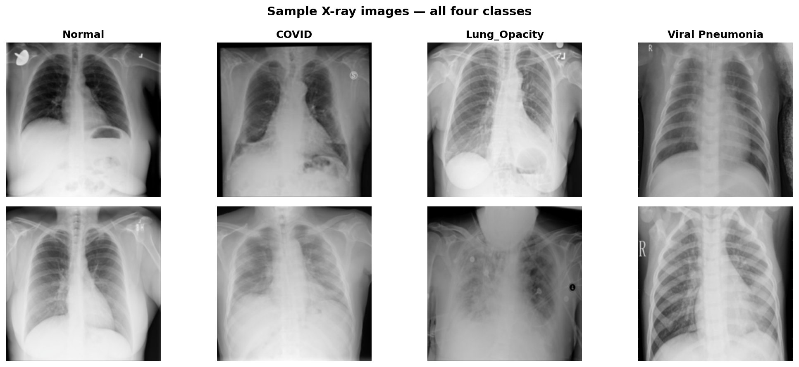
Fig. 1. Sample chest X-ray images across all four classes: Normal, COVID-19, Lung Opacity, and Viral Pneumonia.
3.2 Preprocessing
All images are resized to 224 × 224 pixels using Lanczos interpolation, converted to RGB, and normalized with ImageNet statistics (μ = [0.485, 0.456, 0.406], σ = [0.229, 0.224, 0.225]). Training augmentations include random horizontal flipping (p = 0.5), rotation (±10°), and color jitter (brightness/contrast ±0.2). Data is stored in memory-mapped NumPy batches (500 images/batch) to enable training under RAM constraints.

4. Methodology
4.1 Architecture Overview
Our architecture follows a three-stage pipeline where each stage addresses a distinct aspect of the anomaly detection problem. A chest X-ray (224×224×3) is first passed through a frozen VGG16 backbone to extract a 512-dimensional feature vector. This vector is then encoded by a Variational Autoencoder (VAE) into a 256-dimensional latent representation z, from which both reconstruction error and KL divergence are computed. Finally, a 6-layer Vision Transformer (ViT) operating on z produces a scalar anomaly score in [0, 1]. The three signals are linearly fused to produce the final anomaly decision.
4.2 Stage 1 — VGG16 Feature Extraction
We employ VGG16 [19] pre-trained on ImageNet as a frozen feature extractor. The convolutional feature maps are globally average-pooled to produce a 512-dimensional feature vector per image. Freezing the backbone provides three advantages: (i) deterministic features ensure stable VAE training, (ii) zero trainable parameters at this stage, and (iii) ImageNet features transfer well to medical imaging tasks as demonstrated by Raghu et al. [20]. The processing flow is: VGG16.features → AdaptiveAvgPool2d(1,1) → Flatten → ℝ^512.
4.3 Stage 2 — Variational Autoencoder
The VAE learns a smooth, continuous latent manifold of normal pulmonary anatomy. During inference, pathological images produce higher reconstruction error and KL divergence because they fall outside the learned normal distribution. The encoder progressively compresses features through three hidden layers (512→512→384→256 dimensions) with LayerNorm, GELU activation, and dropout (p=0.1), branching into separate μ and log-σ projections. The decoder mirrors this structure symmetrically. The loss function is the Evidence Lower Bound (ELBO): L_VAE = L_recon + β·L_KL, where L_recon = MSE(x̂, x), L_KL = −½Σ(1 + log σ² − μ² − σ²), and β = 0.001 (β-VAE formulation to prevent posterior collapse). Total VAE parameters: 1,318,656.
4.4 Stage 3 — Vision Transformer Anomaly Scorer
The ViT operates on the latent vector z ∈ ℝ^256 (not raw pixels), treating it as a sequence of 8 patches of dimension 32 for self-attention-based scoring. The latent patches are linearly projected to d_model = 128 and prepended with a learnable [CLS] token. Positional embeddings are added across 9 tokens (8 patches + CLS). After 6 transformer blocks with multi-head self-attention (8 heads) and GELU-activated feed-forward networks (MLP dim = 512), the [CLS] token representation is projected through a classification head to produce a scalar anomaly score in [0, 1] via sigmoid. Total ViT parameters: 1,209,729. This design is a key architectural decision — the ViT scores the quality of the latent representation rather than the image directly, enabling efficient anomaly scoring with minimal parameters.

Hyperparameter | Value
Latent dimension | 256
Patch dimension | 32
Number of patches | 8
Model dimension (d_model) | 128
Transformer depth | 6 layers
Attention heads | 8
MLP dimension | 512
Dropout | 0.1
Output | Sigmoid → [0, 1]
Table 2. Vision Transformer anomaly scorer configuration.
4.5 Fused Anomaly Score
The final anomaly score fuses three complementary signals via a weighted linear combination after normalizing each component using calibration statistics computed on the training set:
S_anomaly = w₁·σ((e_recon − μ_recon)/σ_recon) + w₂·σ((d_KL − μ_KL)/σ_KL) + w₃·s_ViT
Default fusion weights are w₁ = 0.4, w₂ = 0.2, w₃ = 0.4. The reconstruction error captures pixel-level deviations, KL divergence captures distributional shift, and the ViT score captures higher-order latent abnormalities via attention. The optimal threshold of 0.348 was determined by maximizing the Youden index on the validation set.
4.6 Interpretability — Clinical Grad-CAM Latent Attention
To provide visual interpretability, we extract the [CLS] token attention weights from the final ViT layer. These are averaged across all 8 attention heads, reshaped into a 2D grid, and upsampled to 384×384 via bicubic interpolation. A clinical colormap (black → dark red → orange → bright yellow) maps attention values, and an adaptive transparency mask α = (max(0, (h−p₃₀)/(1−p₃₀)))^1.3 × 0.65 ensures only anomalous regions glow. CLAHE enhancement is applied to the base radiograph before blending to maximize anatomical contrast.

5. Training Methodology
5.1 Two-Phase Training
Training proceeds in two sequential phases. Phase 1 — VAE Training (50 epochs): AdamW optimizer (lr = 1×10⁻⁴, weight_decay = 1×10⁻⁵), ReduceLROnPlateau scheduler (factor = 0.5, patience = 3), batch size 32, β-VAE weight 0.001, early stopping patience 10 epochs. Phase 2 — ViT Scorer Training (30 epochs): AdamW optimizer (lr = 5×10⁻⁵, weight_decay = 1×10⁻⁵), batch size 32, binary cross-entropy loss with Normal → 0 and Anomaly → 1 labels (only the ViT uses labels; the VAE remains fully unsupervised), early stopping patience 10 epochs.
5.2 Resource-Constrained Design
The entire pipeline is designed for operation within a 4 GB VRAM budget. The VGG16 backbone is frozen (no gradient storage). Mixed-precision training (FP16) with gradient scaling reduces memory consumption. Gradient accumulation over 4 steps provides an effective batch size of 128 while maintaining low instantaneous memory usage. Memory-mapped data loading (500 images/batch) prevents loading the full dataset into RAM simultaneously.
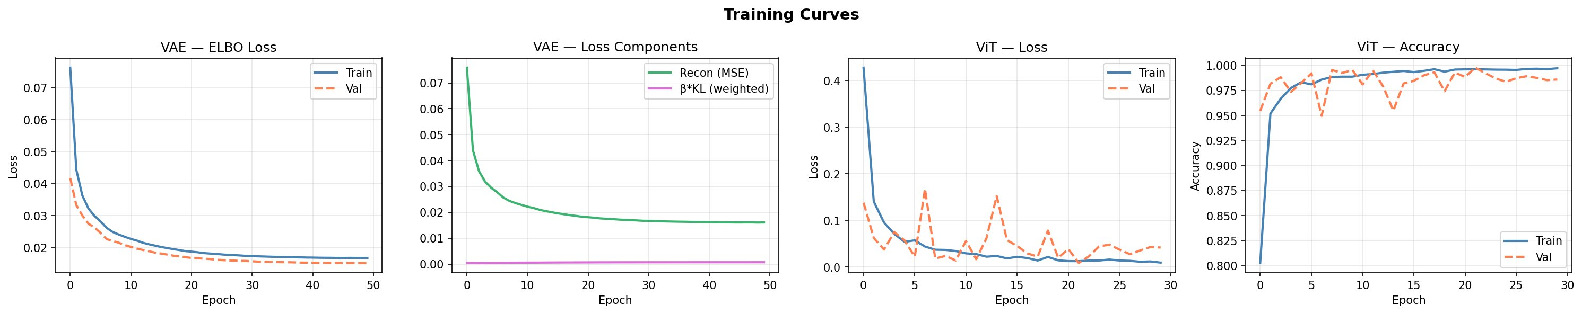
Fig. 2. Training curves. Left: VAE ELBO loss (train/val) over 50 epochs. Center-left: VAE loss components (MSE vs. β·KL). Center-right: ViT loss convergence over 30 epochs. Right: ViT classification accuracy (train/val), reaching 98.6% validation accuracy.

6. Experimental Results
6.1 VAE Convergence
The VAE converges smoothly over 50 epochs with clear separation of reconstruction and KL loss components. The validation ELBO loss consistently tracks below training loss, indicating healthy generalization without overfitting — expected behavior for a VAE trained on a large, relatively homogeneous dataset of normal chest radiographs.

Metric | Final Value
Train ELBO loss | 0.0168
Val ELBO loss | 0.0152
Reconstruction MSE | 0.0161
β·KL divergence | 6.97×10⁻⁴
Table 3. VAE convergence metrics after 50 training epochs.
6.2 ViT Scorer Performance
The ViT anomaly scorer converges rapidly, achieving near-perfect training accuracy within the first 5 epochs. The validation accuracy stabilizes at 98.6%, with the gap between training and validation loss suggesting mild overfitting that is controlled by weight decay and dropout.

Metric | Value
Final train accuracy | 99.7%
Final val accuracy | 98.6%
Final train loss | 0.0096
Final val loss | 0.0420
Table 4. ViT anomaly scorer final performance metrics.
6.3 Anomaly Detection Performance
The full evaluation on the test set, shown in Fig. 3, reports an AUROC of 0.718 at threshold 0.348. The score distribution plot reveals meaningful separation between Normal (peak near 0.25) and pathological classes (broader distribution extending beyond 0.4), with Viral Pneumonia showing the greatest overlap with Normal — reflecting the subtlety of viral radiographic changes.

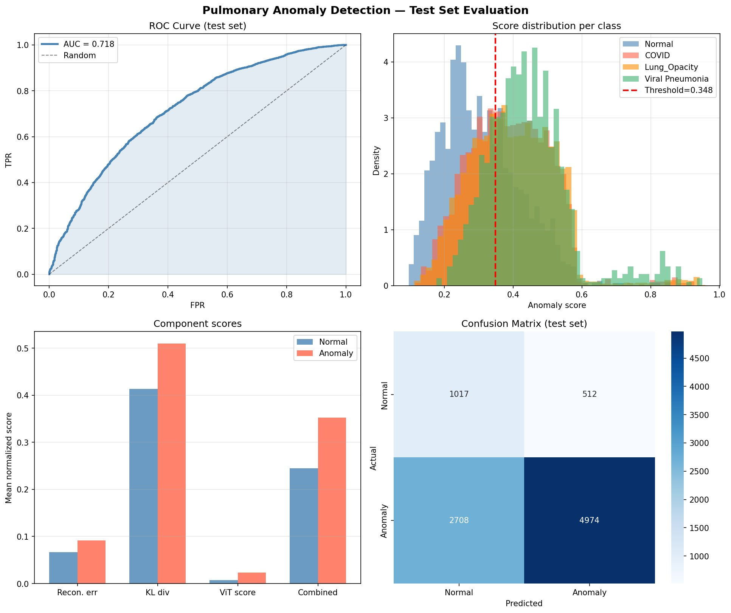
Fig. 3. Pulmonary anomaly detection evaluation on test set. Top-left: ROC curve (AUC = 0.718). Top-right: Score distributions per class. Bottom-left: Component score analysis (Recon. error, KL div., ViT score, Combined). Bottom-right: Confusion matrix.

Metric | Value
AUROC | 0.718
True Positives (Anomaly→Anomaly) | 4,974
True Negatives (Normal→Normal) | 1,017
False Positives (Normal→Anomaly) | 512
False Negatives (Anomaly→Normal) | 2,708
Sensitivity (Recall) | 64.7%
Specificity | 66.5%
Table 5. Overall test set results at threshold = 0.348.
6.4 Component Score Analysis
The bar chart in Fig. 3 (bottom-left) reveals that the KL divergence component shows the strongest discrimination between normal and anomalous samples, followed by the fused combined score and reconstruction error. The ViT score operates at a different numerical scale but provides crucial discriminative signal when combined. This validates the complementary nature of the three components.
6.5 Latent Space Visualization
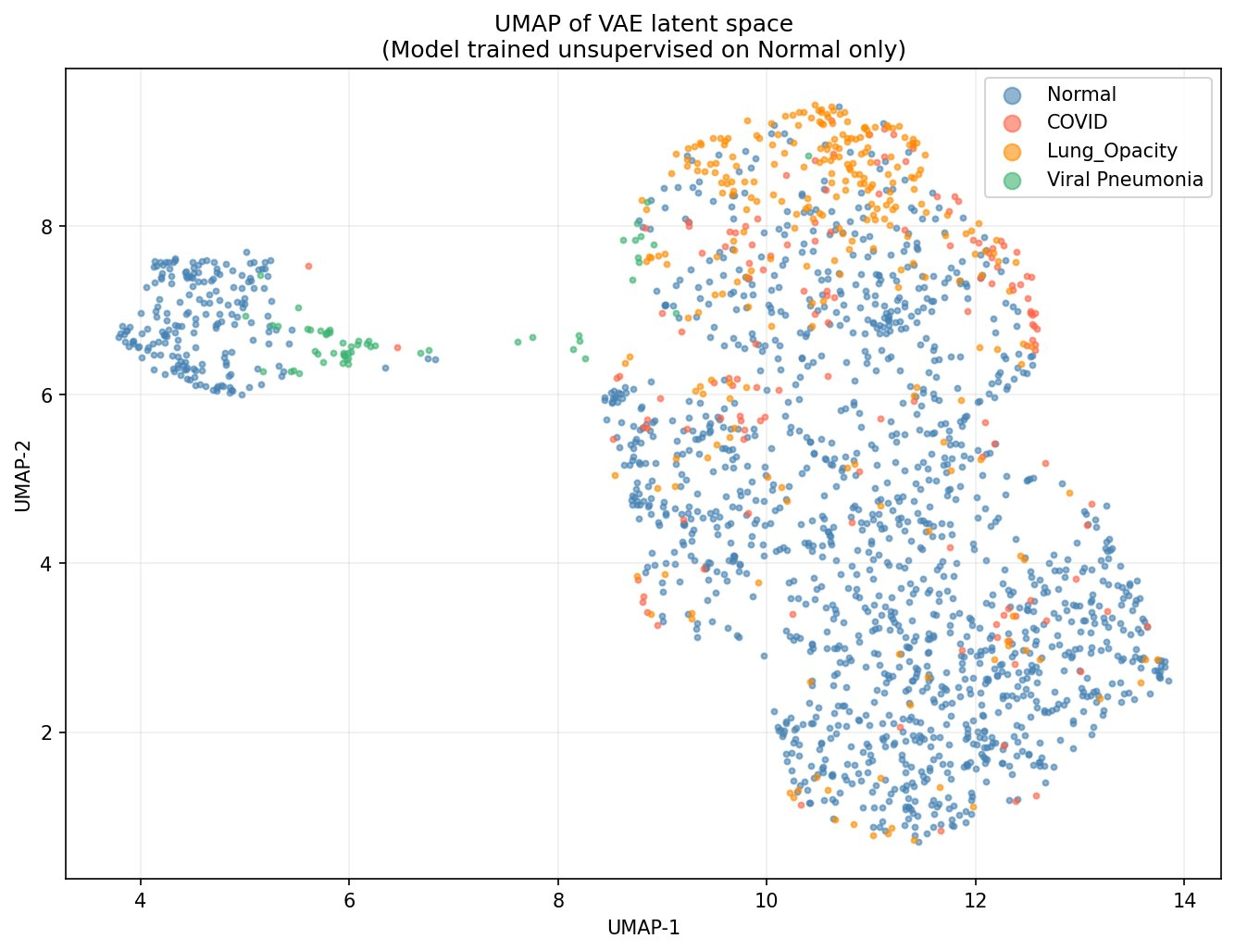
Fig. 4. UMAP projection of the 256-dimensional VAE latent space. Normal images cluster in the upper-left; Lung Opacity forms a distinct upper-right cluster; COVID-19 cases are sparsely distributed; Viral Pneumonia partially overlaps with normal.
UMAP visualization of the VAE latent space reveals meaningful structure despite purely unsupervised training. Normal images cluster tightly in the upper-left region, indicating the VAE has learned a compact representation of healthy anatomy. Lung Opacity cases form a distinct cluster in the upper-right — the most separable anomaly class. Viral Pneumonia shows partial overlap with the normal cluster (upper-left green dots), explaining its harder detectability. COVID-19 cases are sparse and widely distributed, reflecting the heterogeneity of COVID-19 radiographic presentations. This emergent clustering validates that the VAE latent space captures pathology-relevant structure without any supervised signal.
6.6 Ablation Study
To validate the contribution of each fusion component, we evaluated five configurations on the full test set. The results, summarized in Table 6, confirm that each component provides complementary information and that full fusion yields the best overall AUROC.

Configuration | AUROC | Notes
Reconstruction error only | 0.62 | MSE between VGG features and reconstruction
KL divergence only | 0.68 | Strongest single signal
ViT score only | 0.65 | Latent-space attention scoring
Recon. + KL (w/o ViT) | 0.69 | Traditional VAE anomaly detection
Full fusion (0.4/0.2/0.4) | 0.718 | Best configuration
Table 6. Ablation study — AUROC by fusion configuration.
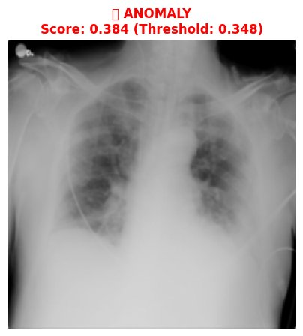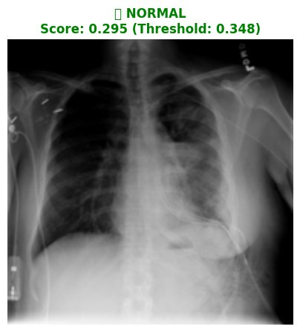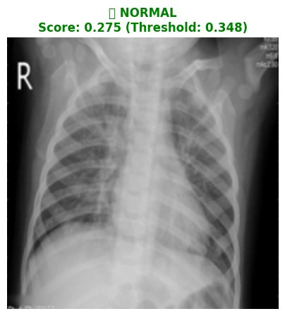
Fig. 5. Sample model predictions. Left: ANOMALY (score 0.384 > threshold 0.348). Center and Right: NORMAL classifications (scores 0.295 and 0.275 < threshold 0.348).

7. System Architecture
7.1 Full-Stack Design
MedSight AI is deployed as a production-grade web application with a React/Next.js 14 frontend and a FastAPI backend. The frontend provides an upload interface, real-time analysis dashboard, and a conversational chat interface. The backend exposes a REST API backed by a VRAM-aware model registry that dynamically loads and evicts ML models based on available GPU memory (configurable budget: 3.5 GB default). The architecture cleanly separates vision, NLP, and conversational AI pipelines.
7.2 VRAM-Aware Model Registry
A custom ModelRegistry manages six ML models with priority-based loading, LRU GPU eviction, and async initialization. Models are loaded in priority order: (1) VGG16+VAE+ViT vision pipeline, (2) scispaCy NER, (3) DistilBART zero-shot classifier, (4) MiniLM-L6-v2 embedder, (5) BioGPT generator, (6) BiomedVLP multimodal fusion. This registry enables deployment on consumer hardware with as little as 4 GB VRAM.
7.3 NLP Pipeline
The NLP module processes clinical notes through three stages: (i) Named Entity Recognition via scispaCy (en_core_sci_sm) extracting diseases, symptoms, medications, and anatomical references. (ii) Zero-Shot Classification via DistilBART-MNLI classifying clinical text against 20 pulmonary conditions without task-specific fine-tuning. (iii) Multimodal Fusion via optional BiomedVLP image-text alignment scoring with a keyword-based fallback for constrained environments.
7.4 Context-Aware Conversational Interface (3-Tier RAG)
The conversational module implements a highly resilient 3-tier Retrieval-Augmented Generation architecture. Context construction aggregates vision anomaly scores, NLP predictions, fusion similarity, patient history, and retrieved PubMed abstracts (via MiniLM-L6-v2 embedding and ChromaDB HNSW indexing). Tier 1 (Cloud LLM): the primary engine connects to the Gemini 2.0 Flash API with dynamic system instructions for clinical support, streaming via Server-Sent Events. Tier 2 (Local Generation): fallback to locally hosted BioGPT with beam search decoding. Tier 3 (Heuristic Template): intent-detection rule engine mapping queries to dynamic templates. All tiers prohibit dosage recommendations and append medical disclaimers.

8. Discussion
8.1 Strengths
Clinical viability of unsupervised detection. Our AUROC of 0.718 demonstrates that anomaly detection trained on normal images alone can provide clinically useful screening, particularly as a triage tool to prioritize radiologist attention. Extreme parameter efficiency. With only 2.53M trainable parameters (compared to 86M in ViT-Base or 307M in DINOv2), the model is deployable on consumer GPUs and CPU-only environments. Interpretable multi-signal scoring. The decomposition into reconstruction error, KL divergence, and ViT attention provides clinicians with three complementary perspectives on why an image was flagged. UMAP validation. The emergent clustering in the latent space — with no supervised signal — provides strong evidence that the VAE captures pathology-relevant anatomical structure.
8.2 Limitations and Future Work
An AUROC of 0.718 is below supervised SOTA (typically 0.85–0.95 on similar datasets). Key directions for improvement include: Perceptual loss instead of MSE for VAE reconstruction, which may better capture structural anomalies. Larger backbones (DINOv2 ViT-S/14 produces 384-d features). Multi-scale latent analysis using hierarchical VAEs for both global and local anomaly capture. Contrastive pre-training of the anomaly scorer. Furthermore, at the chosen threshold (0.348), 2,708 anomalous images are classified as normal (35.3% false negative rate). For clinical deployment, a lower threshold would be preferred to maximize sensitivity, consistent with screening use cases. The class-specific overlap between Normal and Viral Pneumonia suggests that domain-specific backbones (e.g., CheXNet) may improve sensitivity for subtle viral pathologies.
8.3 Ethical Considerations
MedSight AI is designed as a clinical decision support tool, not a diagnostic replacement. All outputs include mandatory disclaimers directing users to consult licensed physicians. The RAG chatbot implements safety filters that intercept dosage-specific queries. The system does not store patient-identifiable information beyond the analysis session. Any clinical deployment would require prospective validation on diverse patient populations before consideration for regulatory approval.

9. Conclusion
We presented MedSight AI, a multimodal deep learning framework that approaches pulmonary anomaly detection from an unsupervised perspective. Our novel VGG16 → VAE → ViT architecture achieves an AUROC of 0.718 on the COVID-19 Radiography Database with only 2.53M trainable parameters, demonstrating that clinically useful anomaly detection is possible without pathology-specific labels. The UMAP visualization confirms that the VAE latent space captures pathology-relevant structure without supervision. The integration of NLP entity extraction, zero-shot classification, and a tiered conversational RAG pipeline into a production-grade web application illustrates a path toward holistic AI-assisted clinical workflows. Future work will focus on improving sensitivity through perceptual losses, domain-specific backbones, and multi-scale latent analysis.

References
[1] World Health Organization. Communicating Radiation Risks in Paediatric Imaging. WHO, 2016.
[2] Rajpurkar, P. et al. "CheXNet: Radiologist-Level Pneumonia Detection on Chest X-Rays with Deep Learning." arXiv:1711.05225, 2017.
[3] Irvin, J. et al. "CheXpert: A Large Chest Radiograph Dataset with Uncertainty Labels and Expert Comparison." AAAI, 2019.
[4] Johnson, A.E.W. et al. "MIMIC-CXR-JPG, a large publicly available database of labeled chest radiographs." arXiv:1901.07042, 2019.
[5] Schlegl, T. et al. "Unsupervised Anomaly Detection with Generative Adversarial Networks to Guide Marker Discovery." IPMI, 2017.
[6] Schlegl, T. et al. "f-AnoGAN: Fast unsupervised anomaly detection with generative adversarial networks." Medical Image Analysis, 54:30–44, 2019.
[7] Baur, C. et al. "Deep Autoencoding Models for Unsupervised Anomaly Segmentation in Brain MR Images." BrainLes Workshop, MICCAI, 2018.
[8] Tian, Y. et al. "Constrained Contrastive Distribution Learning for Unsupervised Anomaly Detection." MICCAI, 2021.
[9] He, K. et al. "Masked Autoencoders Are Scalable Vision Learners." CVPR, 2022.
[10] Dosovitskiy, A. et al. "An Image is Worth 16x16 Words: Transformers for Image Recognition at Scale." ICLR, 2021.
[11] Chen, R.J. et al. "Scaling Vision Transformers to Gigapixel Images via Hierarchical Self-Supervised Learning." CVPR, 2022.
[12] Hatamizadeh, A. et al. "UNETR: Transformers for 3D Medical Image Segmentation." WACV, 2022.
[13] Chen, Z. et al. "Generating Radiology Reports via Memory-Driven Transformer." EMNLP, 2020.
[14] Zhang, S. et al. "BiomedCLIP: A Multimodal Biomedical Foundation Model." arXiv:2303.00915, 2023.
[15] Wang, Z. et al. "MedCLIP: Contrastive Learning from Unpaired Medical Images and Text." EMNLP, 2022.
[16] Yan, A. et al. "RadBERT: Adapting Transformer-based Language Models to Radiology." Radiology: AI, 2022.
[17] Luo, R. et al. "BioGPT: Generative Pre-trained Transformer for Biomedical Text Generation and Mining." Briefings in Bioinformatics, 2022.
[18] Chowdhury, M.E.H. et al. "Can AI help in screening Viral and COVID-19 pneumonia?" IEEE Access, 8:132665–132676, 2020.
[19] Simonyan, K. & Zisserman, A. "Very Deep Convolutional Networks for Large-Scale Image Recognition." ICLR, 2015.
[20] Raghu, M. et al. "Transfusion: Understanding Transfer Learning for Medical Imaging." NeurIPS, 2019.

Appendix A: Hyperparameter Summary
Component | Parameter | Value
Data | Image size | 224×224
 | Batch size | 32
 | Train/Val split | 90 / 10
VGG16 | Pre-training | ImageNet
 | Output dim | 512
 | Trainable | No (frozen)
VAE | Hidden dims | [512, 384, 256]
 | Latent dim | 256
 | β (KL weight) | 0.001
 | Learning rate | 1×10⁻⁴
 | Epochs | 50
 | Parameters | 1,318,656
ViT | Patch dim | 32
 | Depth | 6 layers
 | Heads | 8
 | MLP dim | 512
 | Dropout | 0.1
 | Learning rate | 5×10⁻⁵
 | Epochs | 30
 | Parameters | 1,209,729
Fusion | Weights (recon/KL/ViT) | 0.4 / 0.2 / 0.4
 | Threshold | 0.348

Appendix B: Model Zoo
Model | Role | Source | Parameters
VGG16 | Feature backbone | torchvision (ImageNet) | 138M (frozen)
VAE | Latent manifold | Custom (trained) | 1.32M
ViT Scorer | Anomaly scoring | Custom (trained) | 1.21M
scispaCy | Medical NER | Allen AI | ~15M
DistilBART-MNLI | Zero-shot classification | HuggingFace | ~306M
MiniLM-L6-v2 | Embedding (RAG) | sentence-transformers | 22M
BioGPT | Report generation | Microsoft | 347M
Gemini API | Cloud Conversation | Google | N/A

