

**Records Management Information System of Commission on**

**Higher Education - 10**

**VON FRANCIS LA VICTORIA**

**TIPSY BLESS T. LAGROSAS**

**JEMRY CAIN C. MAGDUA**

**DECEMBER 2023**

**PLANNING PHASE**

In the planning phase for the Commission on Higher Education (CHED) records management system, the team will begin by conducting a comprehensive needs assessment to identify specific requirements and challenges unique to CHED's record-keeping processes. This will involve engaging stakeholders, including CHED officials, staff, and end-users, to gather insights and ensure the system aligns with organizational goals. The team will establish clear objectives, defining the scope, functionalities, and key performance indicators for the system. Additionally, a thorough analysis of existing workflows and data structures will be conducted to streamline processes and enhance efficiency.

The planning phase will culminate in the development of a detailed project plan, outlining timelines, resource allocations, and risk management strategies to guide the subsequent stages of system design and implementation.

**ANALYSIS PHASE**

In the analysis phase of developing the Commission on Higher Education (CHED) records management system, the team will delve into a detailed examination of the information gathered during the planning phase. This involves a comprehensive review of the current state of CHED's record management practices, including document types, data sources, and regulatory requirements. The team will collaborate closely with CHED stakeholders to identify specific system requirements, ensuring that the solution addresses their unique needs.

Data migration strategies and considerations for integrating with existing systems will be explored. Furthermore, the analysis phase will involve a risk assessment to identify potential challenges and mitigate them proactively.

**DESIGN PHASE**

In this phase, the team now concentrates on creating the web application's user interface and user experience. Developing an easy-to-use interface that is in line with project objectives is one of the objectives. The design process is iterated, enabling ongoing improvement in both utility and appearance. The group develops a prototype, tests it to get feedback, and adjusts it as needed to satisfy the clients.

**IMPLEMENT PHASE**

In the implementation phase of developing the Commission on Higher Education (CHED) records management system, the team will focus on both outgoing and ingoing record processes. For outgoing records, the development team will implement features that facilitate the efficient creation, categorization, and secure transmission of documents from CHED to external entities. This may include functionalities for document approval workflows, digital signatures, and tracking mechanisms.

Throughout the implementation phase, rigorous testing will be conducted to ensure the seamless functioning of both outgoing and ingoing record processes. Stakeholder feedback will be actively sought and incorporated to address specific requirements and to enhance user experience. The goal is to create a robust and user-friendly records management system that effectively manages the flow of records both within and outside CHED

**PROPOSED SYSTEM**

The study added a database, this supports good data access because large volumes of data can be stored in one place. Multiple users can read and modify the data at the same time. Databases are used to store, maintain and access all kinds of data. Collect information about people, places, and things. This information is collected in one place for observation and analysis. A database can be viewed as an organized collection of information.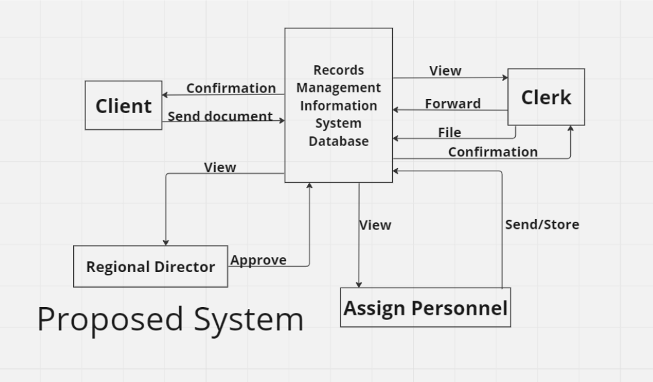

**CURRENT SYSTEM**

CHED10 employees manually search documents on their Spreadsheet. It will take their time searching documents due to unsorted files. The researchers proposed an improved system that will give them categorized documents, simplify the way of finding archived documents and show pending files that are needed to be signed.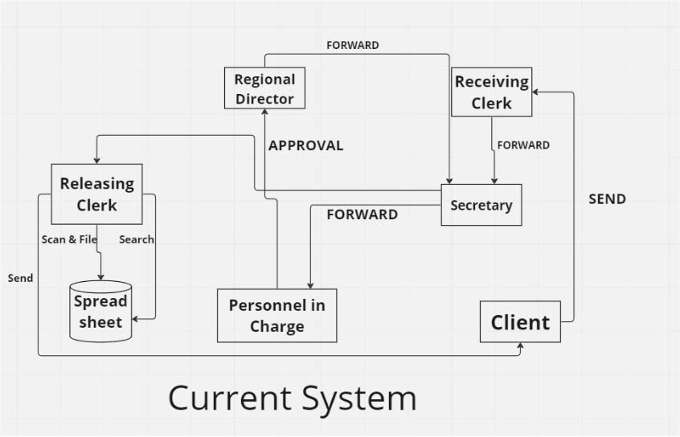

**ENTITY RELATIONAL DIAGRAM**

The figure shown depicts the entity-relationship diagram for the proposed records management system composed of 18 entities. Starting from the Document_source table, the Document table stores the file names and the type of the document. The Admin table holds the admin’s full name, contact number and other information. The DocSour_Detail table extends to the Document_Source table, which stores the details like date and time of the source of the document. The Document_Source table extends to the Document table, storing the origin of the document. The Doc_Detail table extends to the Document table, which stores the details of the document. The User table stores the full name and other information of the users. The Transaction table stores the information of the transactions.

The figure shown depicts the entity-relationship diagram for the proposed records management system composed of 18 entities. Starting from the Document_source table, the Document table stores the file names and the type of the document. The Admin table holds the admin’s full name, contact number and other information. The DocSour_Detail table extends to the Document_Source table, which stores the details like date and time of the source of the document. The Document_Source table extends to the Document table, storing the origin of the document. The Doc_Detail table extends to the Document table, which stores the details of the document. The User table stores the full name and other information of the users. The Transaction table stores the information of the transactions.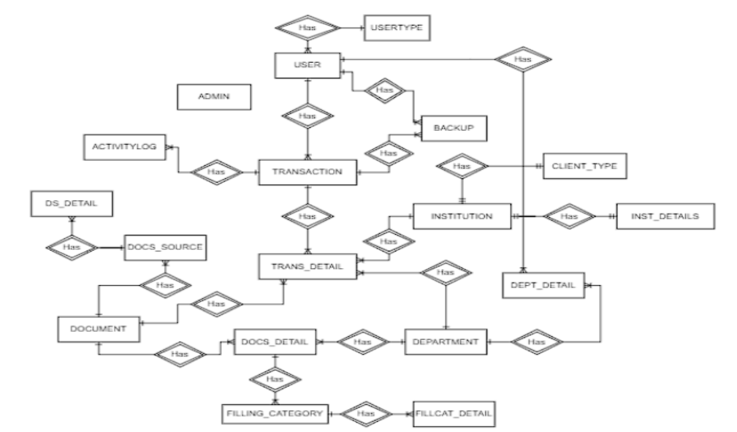

**DATA DICTIONARY**

**Table 1**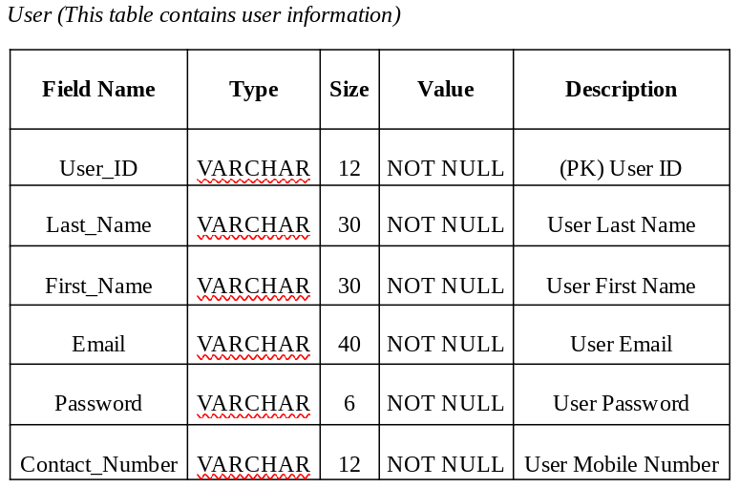

**Table 2**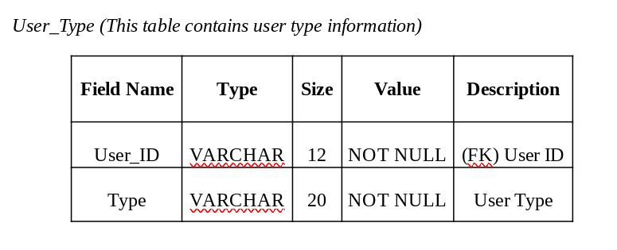

**Table 3**

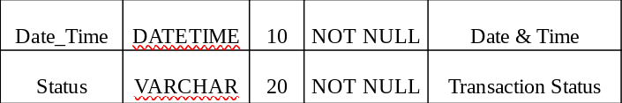

**Table 4**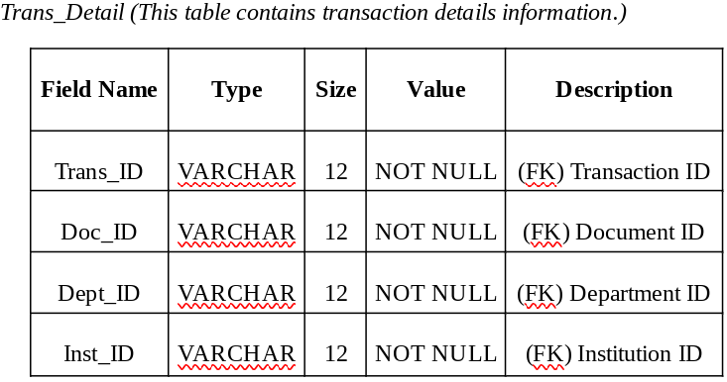

**Table 5**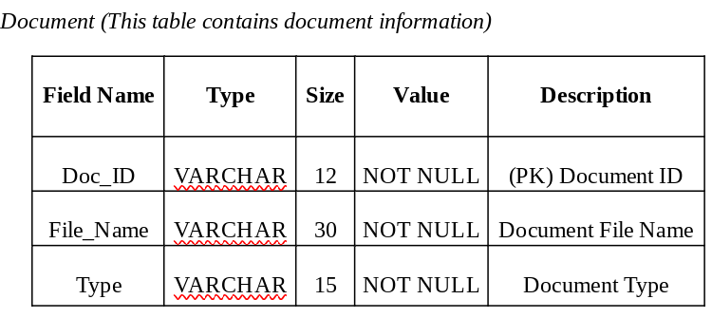

**Table 6**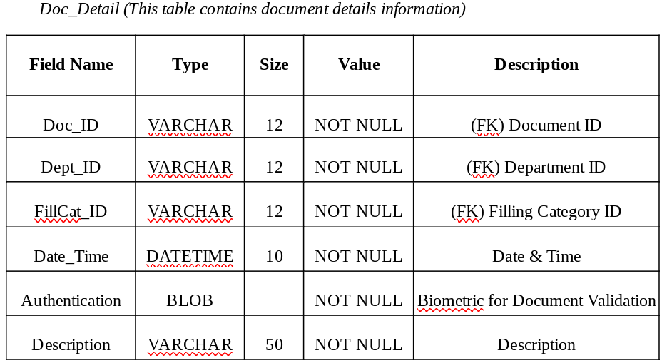

**Table 7**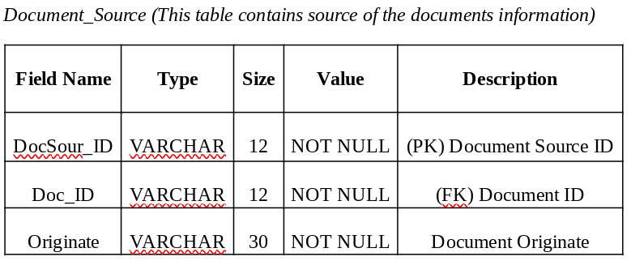

**Table 8**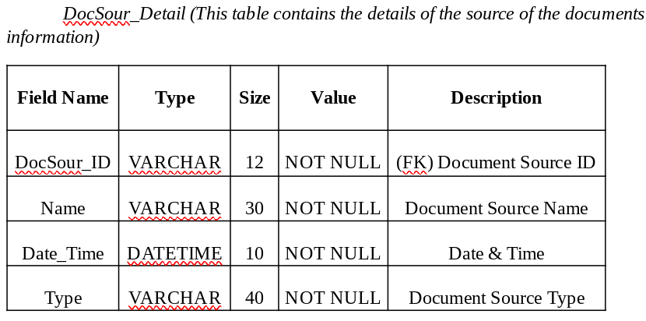

**Table 9**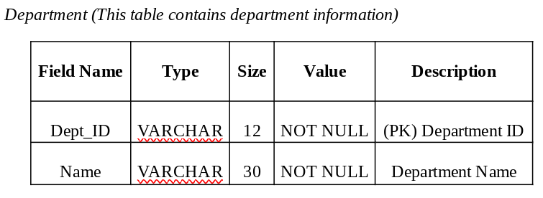

**Table 10**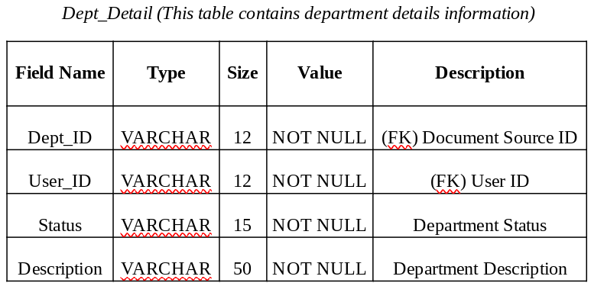

**Table 11**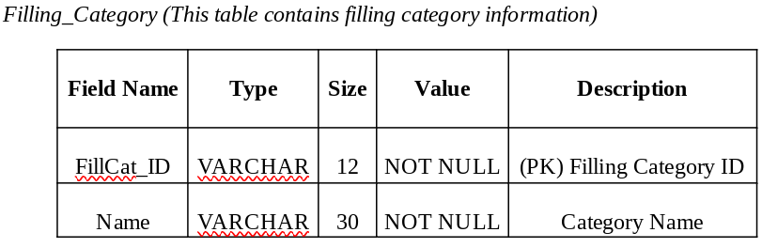

**Table 12**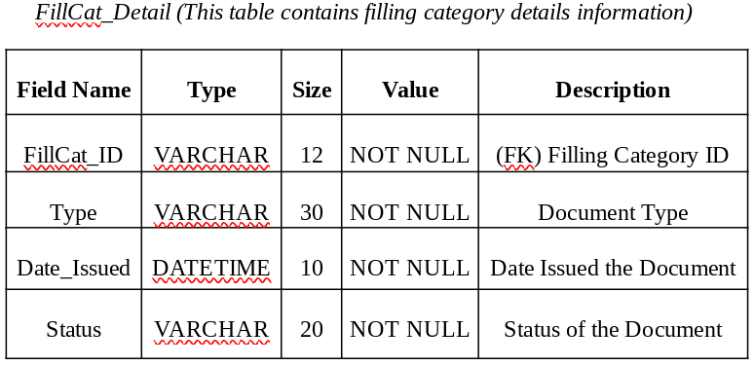

**Table 13**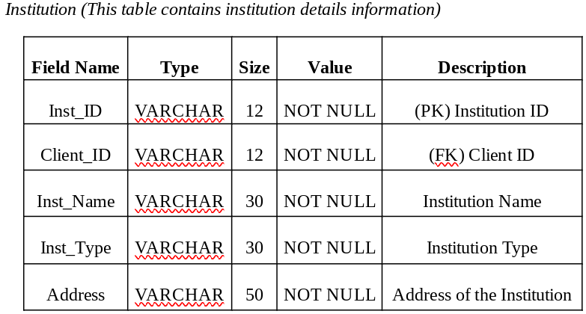

**Table 14**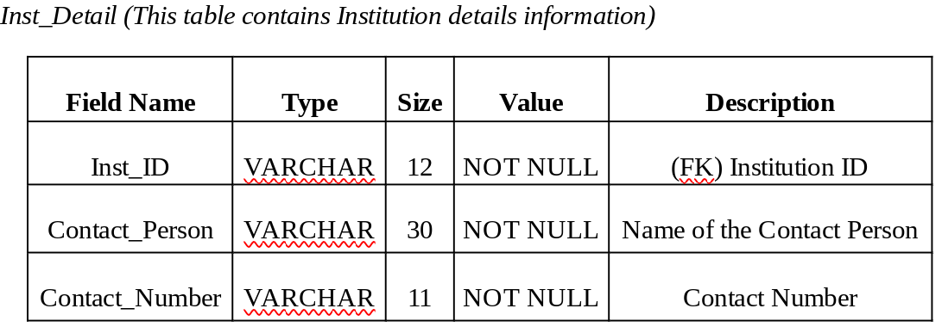

**Table 18**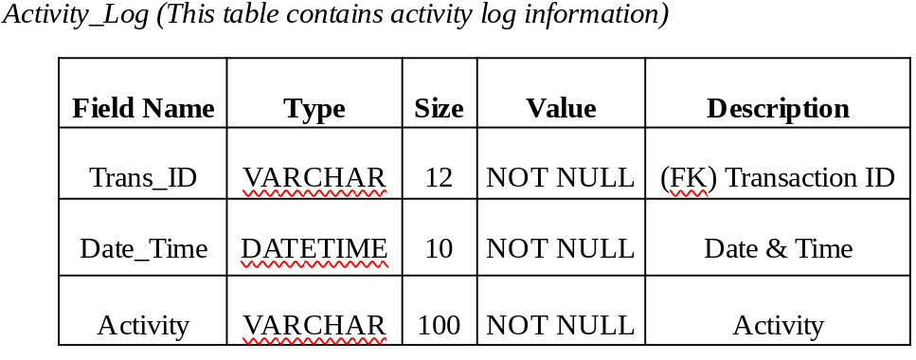

**Table 19**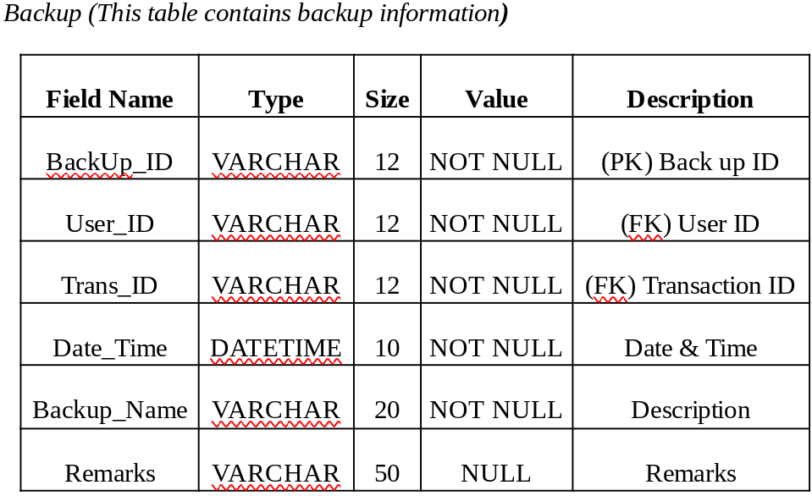

**Table 20**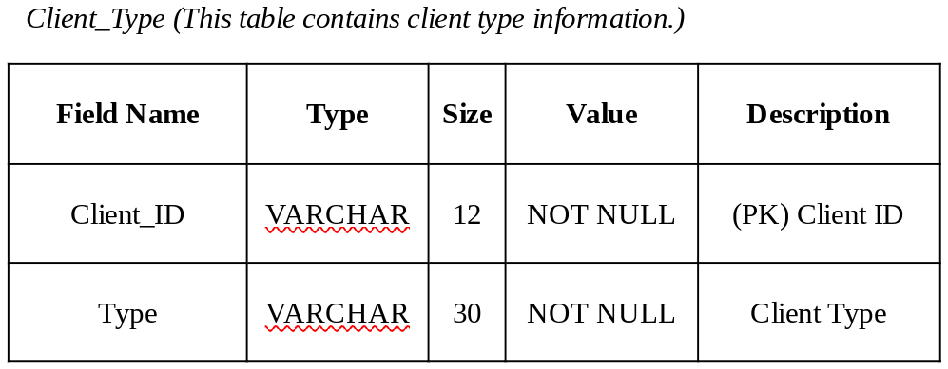

**Table 21**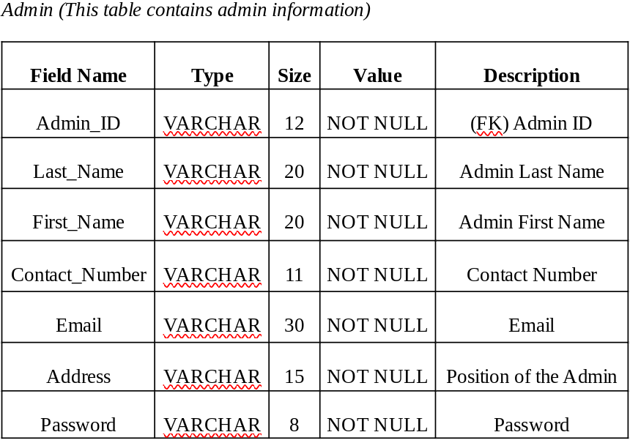

**GRAPHICAL USER INTERFACE**

**GUI 1**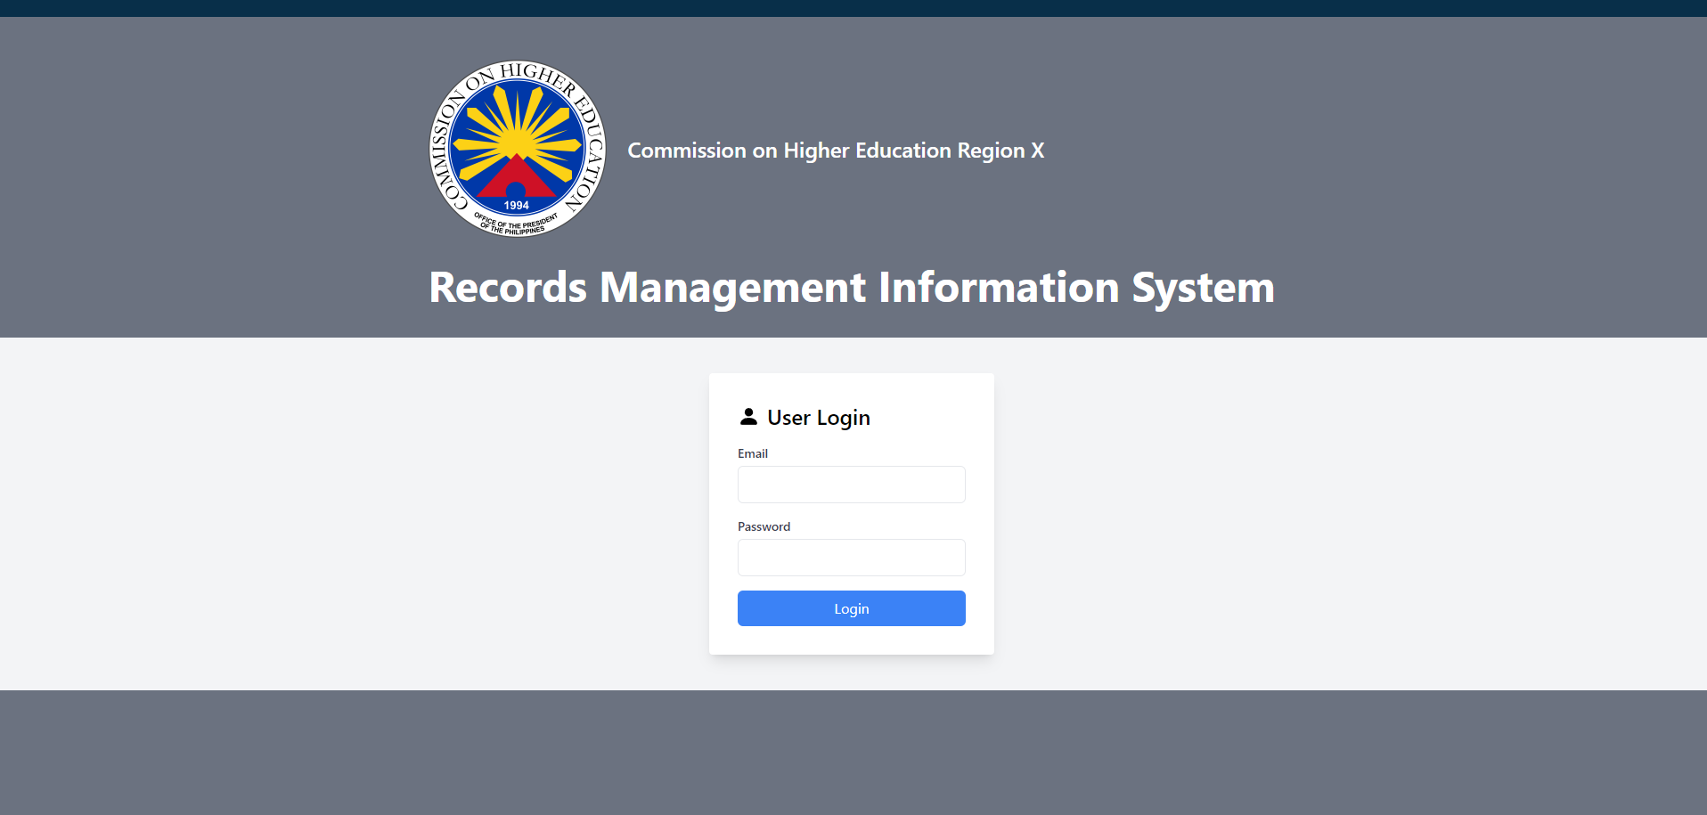

**GUI 2**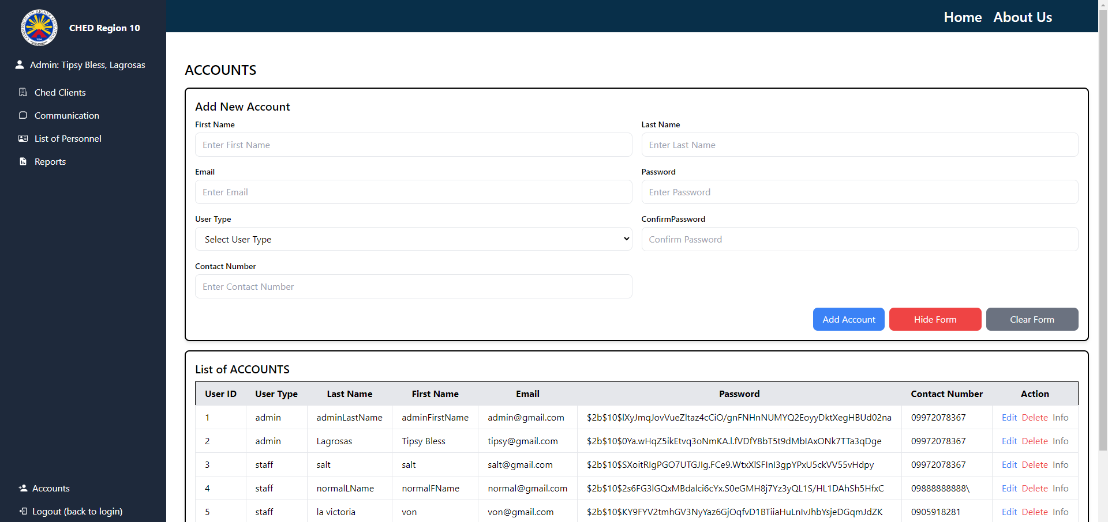

**GUI 3**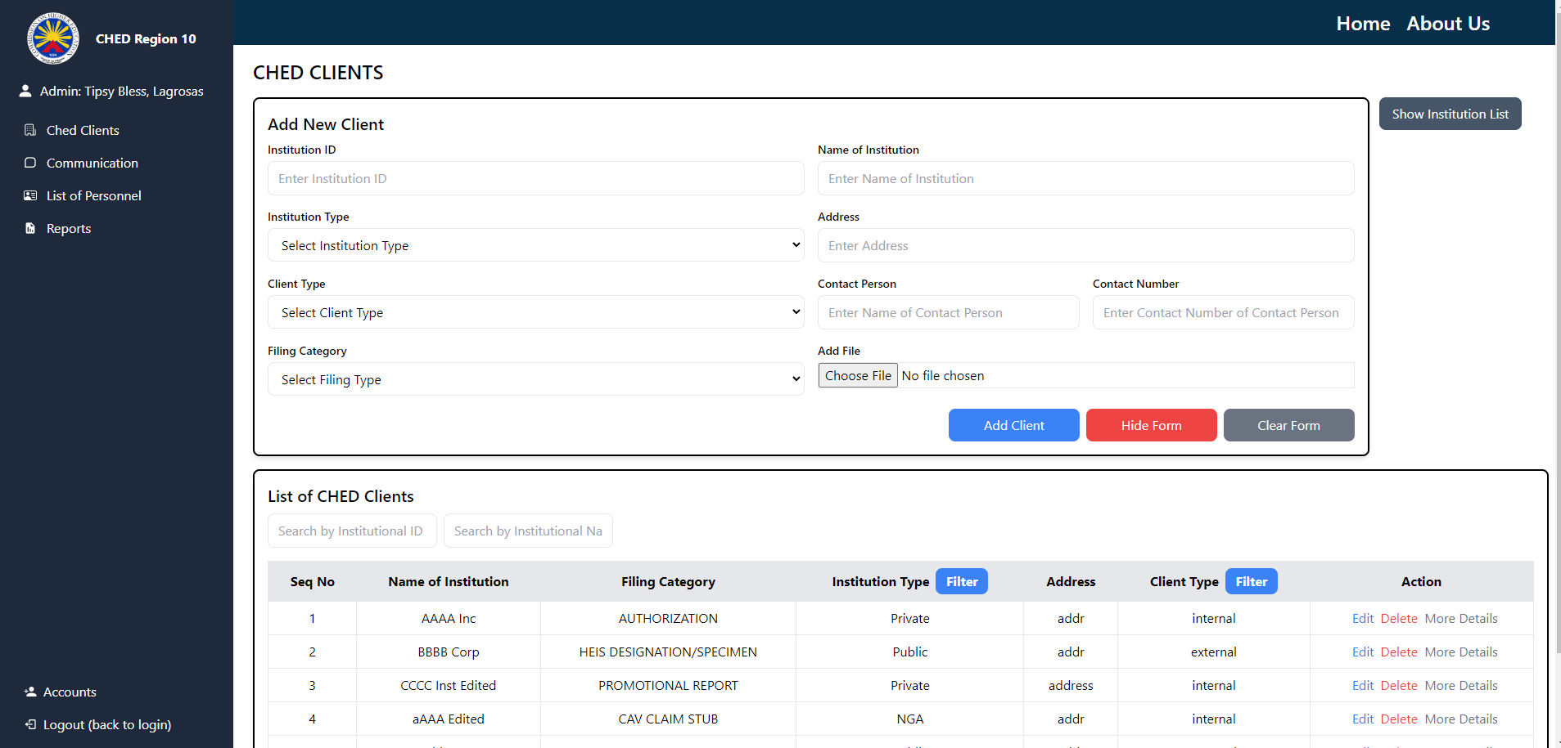

**GUI 4**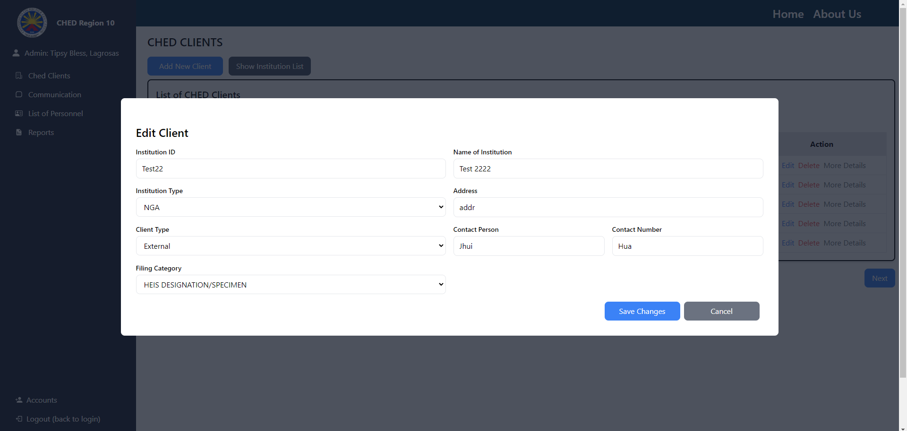

**GUI 5**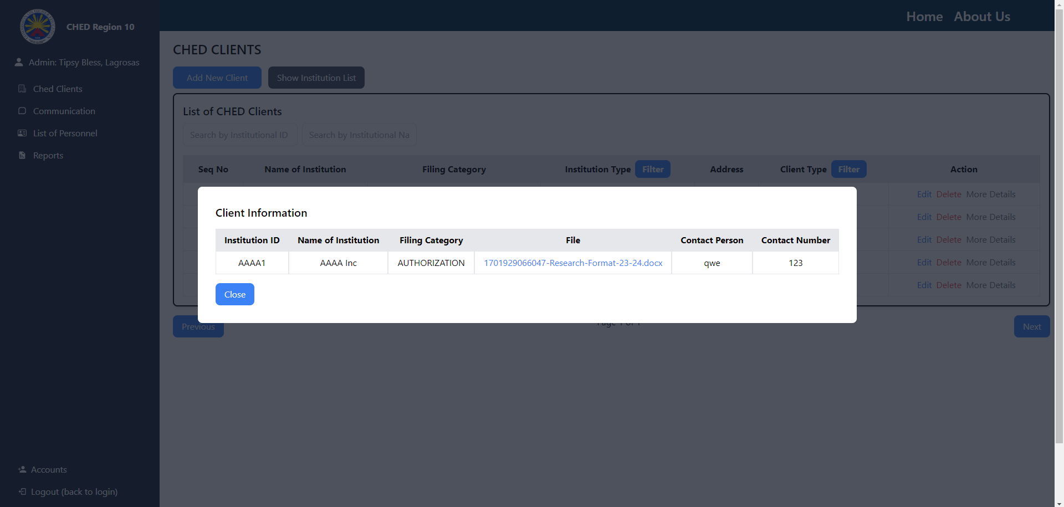

**GUI 6**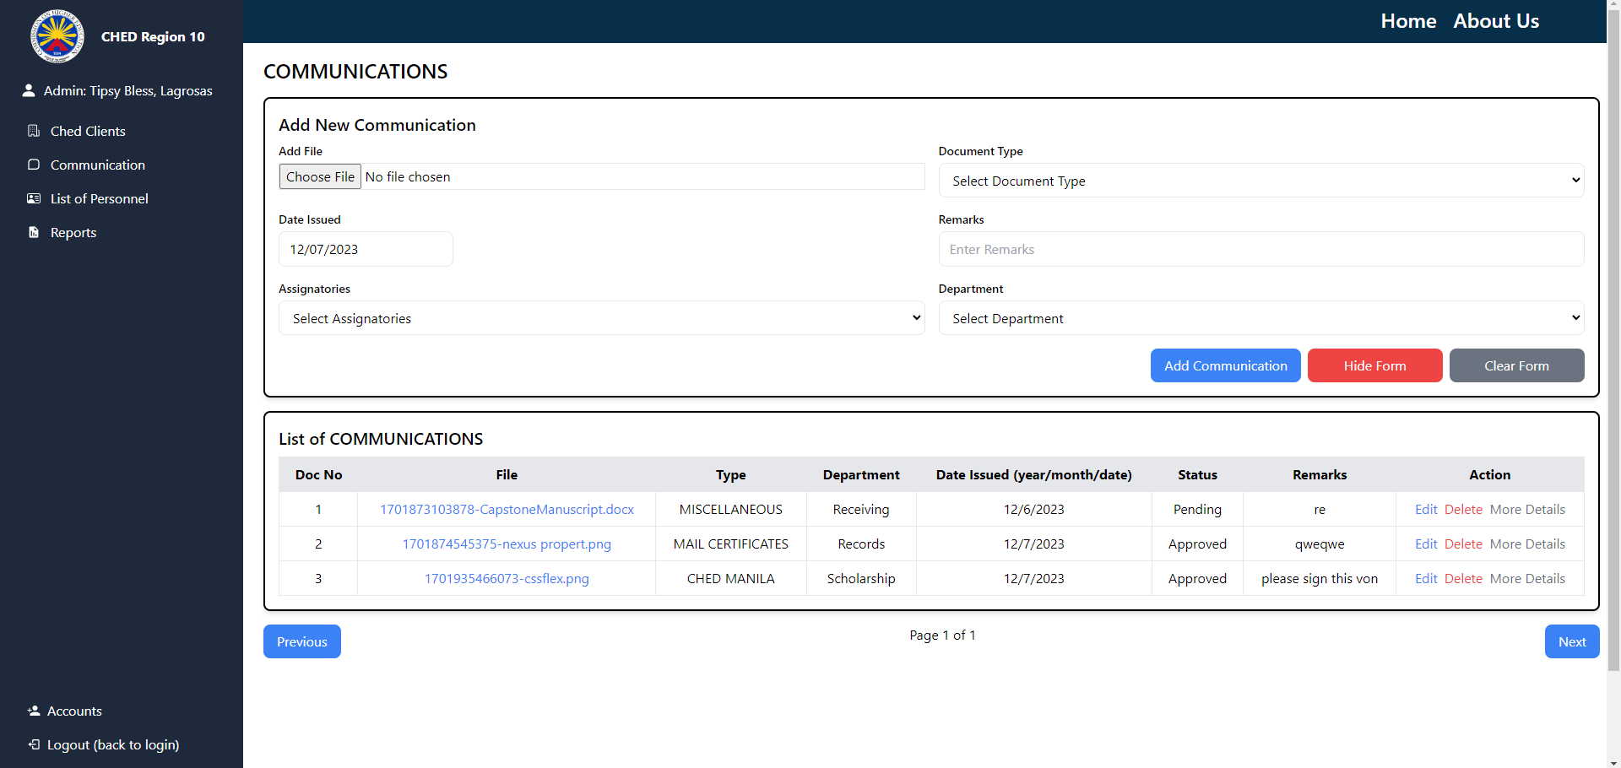

**GUI 7**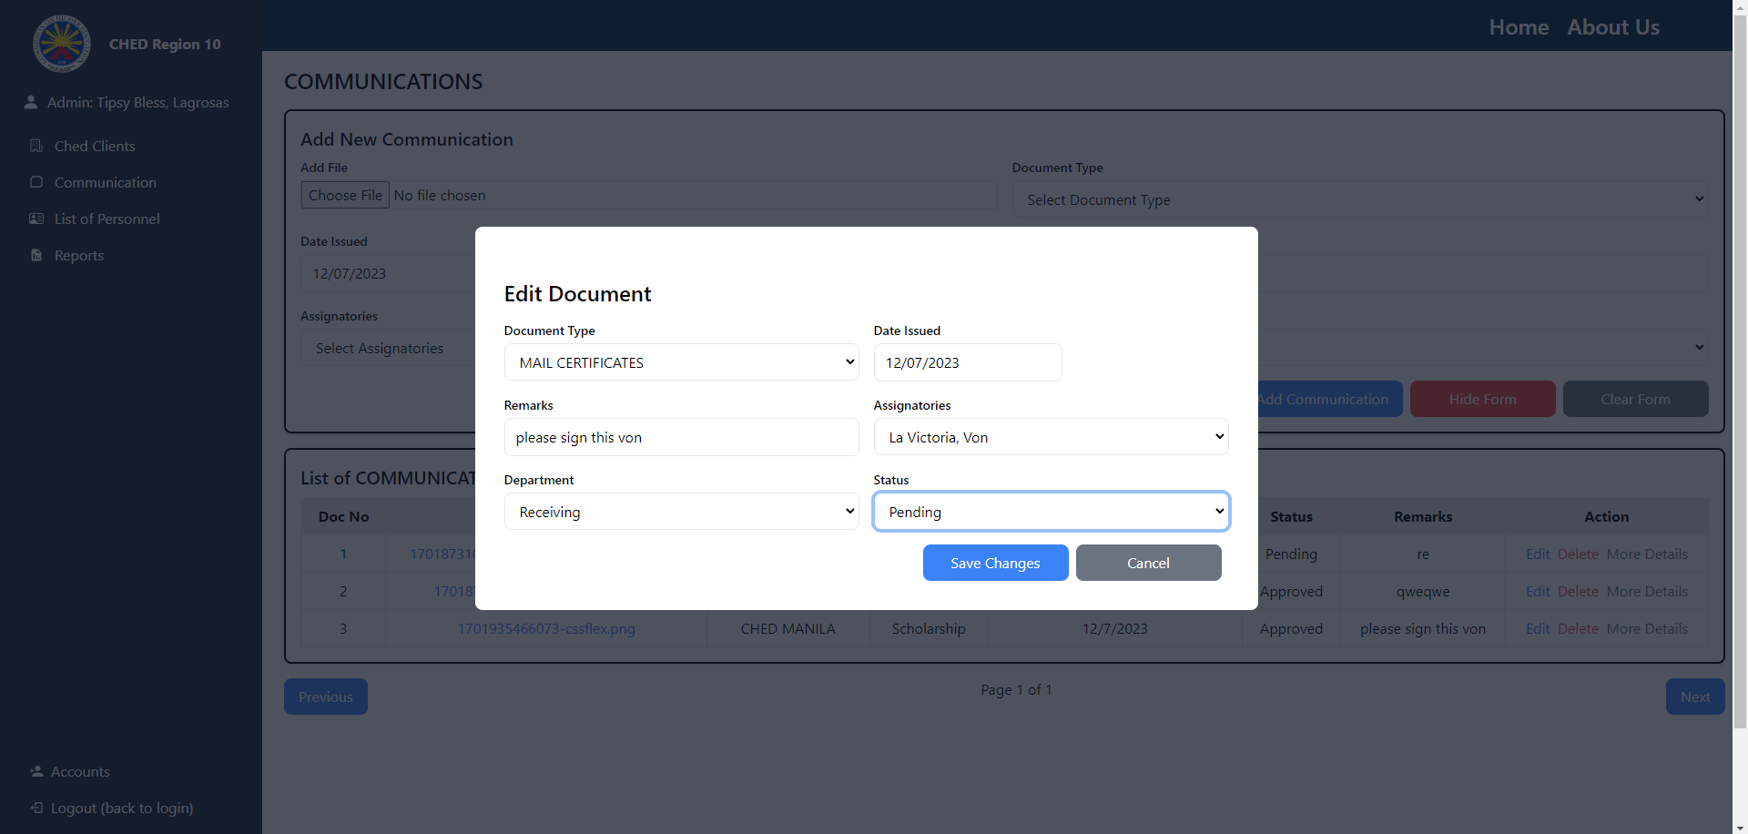

**GUI 8**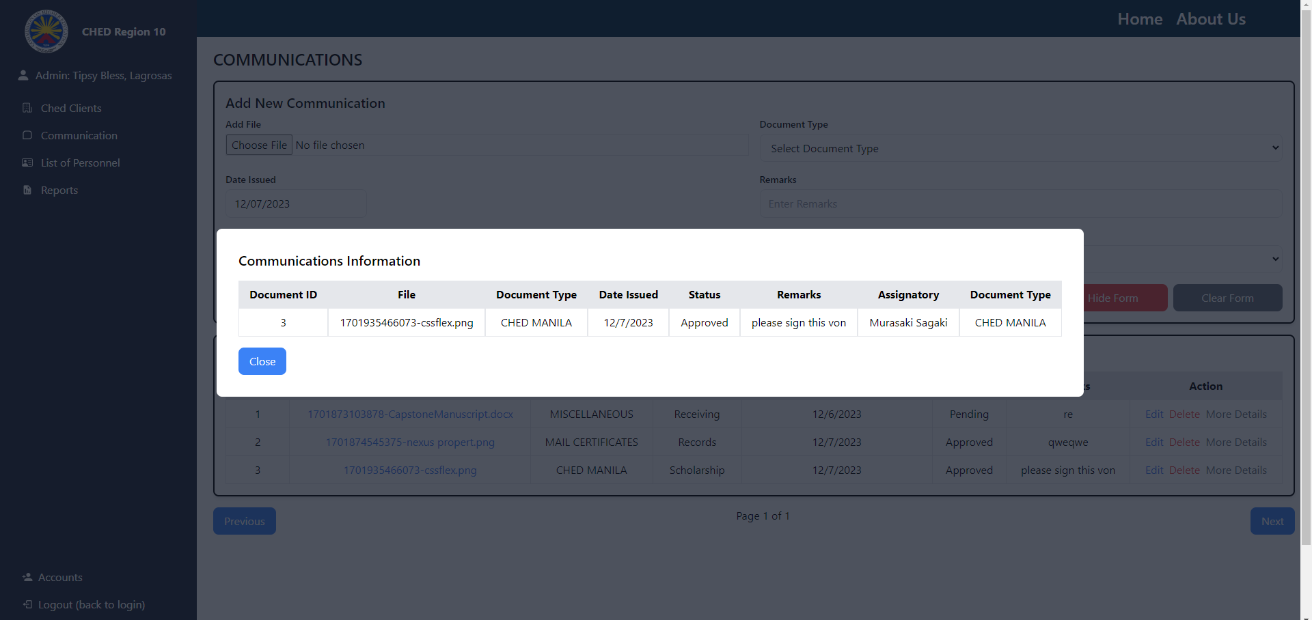

**GUI 9**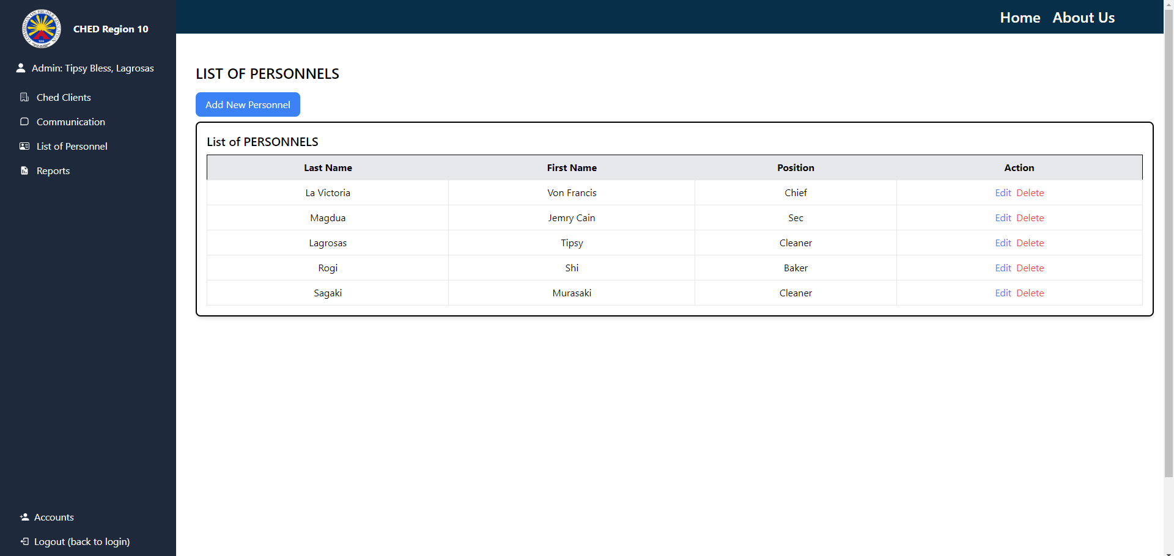

**CONCLUSION**

In conclusion, the development of the Commission on Higher Education (CHED) records management system involves a systematic and collaborative process, starting with a thorough planning phase to identify needs and set objectives. The analysis phase refines these requirements, considering existing workflows and potential challenges. The design phase transforms these insights into a detailed blueprint, encompassing system architecture, UI/UX design, and security measures. The implementation phase brings the design to life, focusing on both outgoing and ingoing record processes, with a commitment to iterative testing and stakeholder feedback. Through these phases, the goal is to create a comprehensive and user-friendly system that aligns with CHED's record-keeping requirements, ultimately enhancing efficiency and accountability in managing records.