

**RECORDS MANAGEMENT INFORMATION SYSTEM OF**

**COMMISSION ON HIGHER EDUCATION - REGION 10**

**VON FRANCIS A. LA VICTORIA**

**TIPSY BLESS T. LAGROSAS**

**JERMY CAIN C. MAGDUA**

**MAY 2023**

**RECORDS MANAGEMENT INFORMATION SYSTEM OF**

**COMMISSION ON HIGHER EDUCATION - REGION 10**

**-------------------------------------------------------------------------------**

A **Capstone Project** Presented to the

College of Information Technology

Liceo de Cagayan University

Cagayan de Oro City

**-------------------------------------------------------------------------------**

In Partial Fulfillment

of the Requirements for the Degree

**Bachelor of Science in Information Technology**

**-------------------------------------------------------------------------------**

**VON FRANCIS A. LA VICTORIA**

**TIPSY BLESS T. LAGROSAS**

**JERMY CAIN C. MAGDUA**

 **Liceo de Cagayan University College of Information Technology**

**APPROVAL SHEET**

 **Liceo de Cagayan University College of Information Technology**

**TABLE OF CONTENT**

**Chapter Page**

**1 THE PROBLEM AND ITS SCOPE 1**

Introduction 1

Framework 3

Statement of the Problem 4

Objectives of the Study 5

Scope and Delimitation of the Study 6

Significance of the Study 7

Output of the Study 8

Definition of Terms 9

**2 REVIEW OF THE RELATED LITERATURE AND STUDIES 10**

**3 METHOD AND MATERIALS 30**

Research Design 30

Research Setting 33

Research Instruments 33

Data Gathering 33

System Design 34

Entity Relationship Diagram 36

Data Structure 49

Data Dictionary 49

References 60

 **Liceo de Cagayan University College of Information Technology**

**CHAPTER 1**

**THE PROBLEM AND ITS SCOPE**

**Introduction**

The Commission on Higher Education (CHED) is responsible for the supervision and regulation of higher education institutions in the Philippines. As part of its mandate, CHED is required to maintain accurate and up-to-date records of its operations and activities. However, the CHED still doesn’t have a complete automated Records Management System. This study aims to create a Records Management System to be used by CHED and provide recommendations for its improvement. Organizations may utilize the RMIS to increase the accuracy, availability, and security of their records, allowing them to more effectively satisfy legal and regulatory requirements, reduce the risk of data breaches, and make more informed decisions.

Information dedicated to electronic media has been experiencing an exponential growth and in turn, modern technology has brought about change in the way governments, organizations and individuals carry out their business. This leads to the transformation of the nature of dealing with records.(Mukred & Yusof, 2017)

 **Liceo de Cagayan University College of Information Technology** **Page**

**2**

An online information and monitoring system is complex and flexible and is designed to meet distinct needs. In developing the proposed system, the researchers used the Prototyping Life Cycle Model These applications improved the traditional transaction processing systems(Tubongbanua, et al.,  2017)

We the researchers focus on the CHED Records Management System, examining its features, functionalities, and the benefits it provides to the organization. This project will also explore the challenges in implementing and maintaining the system, as well as potential areas for improvement. Ultimately, this project aims to contribute to the ongoing development and improvement of the CHED10 Records Management System, as well as to advance the field of records management more broadly.

 **Liceo de Cagayan University College of Information Technology** **Page**

**3**

**Framework**

  The researchers will use the Input-Process-Output (IPO) conceptual framework for this study. The IPO framework is rooted in classic systems theory and posits that the overall  composition of a system is crucial for understanding its effective operation as a single entity. According to the American Psychological Association Dictionary (2022), the Input-Process Output model is "an analysis of performance and processing systems that considers how raw  materials (inputs) are transformed through internal processes to produce results (outputs)."

**Figure 1:**

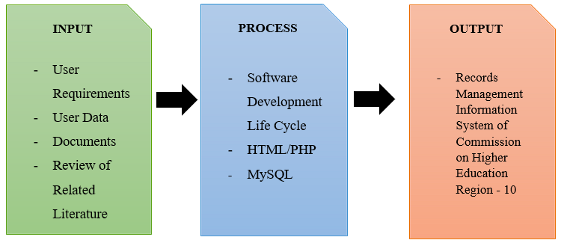*I.P.O Model Conceptual Framework*

 **Liceo de Cagayan University College of Information Technology** **Page**

**4**

**Statement of the Problem**

This research study aims to organize, store, retrieve, and archive of records. It can reduce the cost of managing documents, reduce manual labor and minimize the need for physical storage space.

* Unorganized recording keeping system resulted to misplaced of the documents.
* Difficulty in organizing and searching of records.
* Ineffective document tracking system.
* It takes time to generate reports due to traditional transaction.

 **Liceo de Cagayan University College of Information Technology** **Page**

**5**

**Objectives of the Study**

Provides a centralize platform for CHED10, enabling them to store, organize and manage their records securely and efficiently. The Primary objective of this study is to make it easier to handle documents effectively throughout their entire lifecycle. The goal is to ensure that they are produced, recorded, and retained in a way that supports all the daily operations of CHED10 and legal and regulatory compliance.

* Develop a centralize and digitize record management system to minimize the reliance on paper-based documentation and maintain accurate records;
* Develop an user friendly search engine of the system.
* Create a mechanism for tracking documents.
* Generate reports by category and status of documents.

 **Liceo de Cagayan University College of Information Technology** **Page**

**6**

**Scope and Delimitations of the Study**

The scope of this study is to assess and enhance the CHED Records Management System in terms of its features, functionalities, and benefits to the organization. This study will cover the processes involved in generating reports and managing records, such as document creation, retrieval, archiving documents, and storage. For more secured storage, we will be using CHED's storage. It will examine the system's access control and security measures to ensure the integrity and confidentiality of records, also we're planning to change from traditional way of paper-based records into a modern paperless record.

The study is delimited only on the CHED Records Management System and its implementation within the organization. It will not cover other records management systems used by other government agencies or private organizations. Additionally, this is a stand-alone system. The study will focus on the user experience and the effectiveness of the system in meeting CHED's record-keeping needs. Finally, this study will not cover the policy or legal framework that governs records management in the Philippines.

 **Liceo de Cagayan University College of Information Technology Page**

**7**

**Significance of the Study**

**Stakeholders –** This study will help the institution/agency to be more efficient on accessing the information.

**CHED10 -** This study will help the organization to process the records efficiently.

**CHED10 Staff -** This study will help them to ease the workload of the staff.

**Department Heads -** This study will help to generate reports and find past documents.

**Regional Director -** This study will help the Regional Director of CHED to easily monitor documents.

**Researcher** – This study will help the researcher to develop and improve their skills.

**Future Researcher -** This study would help the student researchers to be aware and knowledgeable of the CHED RMS . It would help them to be a better analyst and it can be a help as a future reference for more studies in the future.

 **Liceo de Cagayan University College of Information Technology** **Page**

**8**

**Output of the Study**

Creating Records Management System for Commission on Higher Education (CHED) is the main objective of this study. Records management systems help CHED to manage their records efficiently. By using a centralized system, employees can easily access and update records, reducing the time and effort required to manage them. Creating a records management system can help CHED mitigate risks associated with lost or misplaced records, document tampering, or unauthorized access. By implementing appropriate security measures, organizations can ensure that their records are secure and protected. Accurate and accessible records can help CHED make informed decisions. By having a comprehensive view of historical records, organizations can identify trends and make data-driven decisions.

 **Liceo de Cagayan University College of Information Technology** **Page**

**9**

**Definition of Terms**

**CHED.** The Commission on Higher Education is the Philippine government’s agency in charged with promoting relevant and quality higher education, ensuring access to quality higher education, and guaranteeing and protecting academic freedom for continuing intellectual growth, advancement of learning and research, development of responsible and effective leadership, education of high level professionals, and enrichment of historical and cultural heritages.  
**Database.** A structured set of data held in a computer, especially one that is accessible in various ways.

**Coding.** A process of telling the machine on how to do something and complete it using a machine.

**Programming.** The act of writing, testing, debugging, and maintaining the source code for computer programs.

**Records.** To keep information for the future, by writing it down or storing it on a computer.

**Information System.** A group of elements which work together to gather, process, store, and disseminate data or information within an organization.

 **Liceo de Cagayan University College of Information Technology**

**CHAPTER II**

**REVIEW OF RELATED LITERATURE AND STUDIES**

**Management**

To assess the efficacy of EDMS in accessibility and use of records at Sokoine University of Agriculture. Specifically, the study was geared to find out the way EDMS is used in accessing and using documents at Sokoine University of Agriculture. The study used a cross section research design whereby the data were collected at one time based on two approaches which are qualitative and quantitative. (Malekani, A.W and Alphonce, A. B , 2020)

Public Institutions need information systems that facilitate management of generated documents during business processes on a digital platform. Development of information and communication technologies facilitated the transfer of documents to digital platforms which caused the emergence of the Electronic Document Management System (EDMS). Institutions are utilizing EDMS in order to keep records securely and improve business processes. (Ayaz, A. & Yanartas, M., 2020)

The records management strategies of the administrative staff at Laguna State Polytechnic University with their professional performance. The descriptive quantitative research involved 59 administrative staff through the researcher-made survey questionnaire distributed through Google forms.

 **Liceo de Cagayan University College of Information Technology** **Page**

**11**

The results of the study proved that there is a significant difference in the records management strategies when grouped according to age, gender, job tenure, and job position in the department. (Gesmundo, J.L., et al, 2022)

Prior studies have identified a need for engaging researchers in providing and curating their identity data. This article reports findings from a qualitative study exploring how researchers use and participate in online research information management (RIM) systems and their requirements for information quality in RIM systems (Wu, S. Stvilia, B. Lee, D.J., 2017).

In this project, it is designed a "Document Management System (DMS)" to make web-based and systematic management and follow-up of documents in the General Directorate of Personnel of Ministry of National Education. This project aims to ensure that the decrees prepared as a result of the appointments made by the General Directorate of Personnel are kept in a safe way in electronic environment, monitored, managed and delivered to the related units. Also this application; it is designed to be used as a document management system in public institutions and universities. Web-based applications make access to content easier, reducing storage and printing costs. (AKÇAY, M., ARDIÇ, I., and ŞEN S., 2019)

Effective records management programs are a major element of the governance of any organization. Based on the surveys, the Northwest Samar State University was not fully aware of what to do about the implementation of this act, National Archives of the Philippines Act of 2007 (R.A 9470). The university was still relying on the university code for the records management provisions.

 **Liceo de Cagayan University College of Information Technology** **Page**

**12**

This was undertaken to develop and validate the acceptability of the developed University Electronic Records Management System (UeRMS) for Northwest Samar State University as perceived by the computer experts, school officials, teaching personnel and non- teaching personnel. Thus, the idea and assessment of the respondents towards the design of the system is very critical. Upon validating the developed system, they observed that it was much faster to search records compared to manual processes. (Patimo, D. Maribojoc , R.P., 2021)

Although the electronic records management system (ERMS) is important in bringing about the productivity of organizations, the majority of them refuse to implement it, while a few embark on  implementing it blindly, without guidance, which often results in failure. This paper, therefore,  proposed a model for the ERMS adoption to support the productivity and performance of higher professional education (HPE) institutions in the Yemeni context. This paper used the unified  theory of acceptance and use of technology (UTAUT) and a mixed explanatory approach to gather quantitative and qualitative data. Data was then analyzed through the use of SPSS 21, with SEM and SmartPLS V3 software used to test the proposed model. The model was also confirmed by five experts who were interviewed to obtain qualitative data. Based on the analysis results, all the fit indices met the recommended values range that assumed the acceptability of the developed model. The model was found to be of a good fit, and the theory upon which the  model was developed was stable. (Mukred, M., Yusof, Z.M., & Alotaibi, F.M., 2019).

 **Liceo de Cagayan University College of Information Technology** **Page**

**13**

The purpose of the study was to examine the impact of Electronic Records Management System on Organizational Performance in Iganga district local Government. The specific objectives of the study were; to establish the benefits of electronic records management System in Iganga District Local Government, To determine the challenges facing the effective management of Electronic Records Management System in Iganga District Local Government and to determine the solutions to the challenges facing the effective management of Electronic Records Management System in Iganga District Local Government. The researcher used a descriptive research design with quantitative methods and sampled 25 respondents purposively using the sample size determination Table of Krejcie and Morgan. The researcher used self administered questionnaires of both open ended and close ended questionnaires. The study finding revealed that majority of the respondents answered that improvement of Efficiency and Productivity was the major benefit of ERMS, on the Challenges Facing the Effective Management of Electronic Records Management System, the study findings revealed that most of the respondents answered that access and security was the major challenge facing ERMS and on the Solutions to the Challenges Facing the Effective Management of Electronic Records Management System, the study findings revealed that most respondents answered that human resource training was the best solution to the Challenges facing the Effective Management of Electronic Records Management Systems in Iganga District Local Government. Lastly the researcher recommended; Construct ERMS facilities, Improve ERMS Security, Encourage Corroborations, Government Support and Maximum Training as better solutions for the topic under study. (Racheal, N., 2018)

 **Liceo de Cagayan University College of Information Technology** **Page**

**14**

Records are documentary evidence of routine transactions made or received by an organization in pursuit of its legal obligations irrespective of the physical form or characteristics. They are categories of information identified by the particular functions they perform in support of business, accountability and cultural heritage. They confirm who did what, where, and when. Therefore, records management is making and maintaining complete, accurate and reliable evidence of official business in the form of recorded information. Records are important to the administration of government institutions, because they contain the necessary information that helps government programmes function effectively. Records give government grounds for making decisions, administering programmes and providing administrative continuity with past operations. Records help to make the government and its officials accountable. It is therefore worth noting that for the purpose of transparency and accountability, government institutions should create and preserve reliable and usable records. (Prof. Alegbeleye G.O., & Chilaka, O.C.,  2019)

The implementation of the records management system of Cotabato Regional Medical Center Health Information Department. It utilized the quantitative-qualitative design in data gathering that was conducted in Cotabato Regional Medical Center, a tertiary hospital located in Cotabato City, to the 100 respondents composed of CRMC staff and personnel and clients. The study made use of mean as statistical tools in the analysis of data gathered. The findings of the study revealed the types of services provided, the practice of filing and processing and records management on guidelines on procedures were very extensive. The seminars and trainings for human resource and upgrading of resources and facilities were very extensive.

 **Liceo de Cagayan University College of Information Technology** **Page**

**15**

The attainment of quality service outcome in terms of retrieval of information, preserving records life cycle and quality service in promptness and accuracy were very extensive. The common minor problems encountered included miscommunication and some unavoidable delay due to technological problems that sometimes occur. The common interventions formulated as verbalized by the informants revealed they often conduct meeting and planning regularly to address problems encountered. The study concludes that the records department of Cotabato Regional Medical Center efficiently provides quality services to the clients. The prompt and accurate records released, and the preservation of documents was highly maintained since facilities and equipment were provided. Likewise, trainings and seminars were also provided to develop the competency of the personnel which is a factor in improving the quality of services of the department. The study generally recommends continuing and intensifying the compliance of the personnel in practicing standards and protocols for records management system. (Delosa, S.A., Delosa Jr, R.A., 2020)

**Records**

The Document management system is an essential approach that should be managed well to ensure an effective and faster overall working process in an organization. Hardcopy documents has been one of the items that most organizations need to manage in a safe and secure manner due to the high dependency on most of their working procedure especially in government organizations. Hence, we proposed a new framework to improve the weaknesses of the existing document management procedures in government organizations.

 **Liceo de Cagayan University College of Information Technology** **Page**

**16**

Our proposed framework integrates the implementation of an NFC system in this research due to its secure short - range communication, and the peer-to-peer communication capability in most mobile devices. Besides that, most existing government organizations within Malaysia could easily implement such technology for their internal usage as this technology is cost effective due to its availability on existing mobile devices on most Android based devices. (Abidin, S.S.Z. and Husin, M.H., 2018)

Government agencies like the Bureau of Fire Protection in the municipality of Hinunangan wanted to improve their records keeping and retrieval, including disaster risk response and monitoring. Southern Leyte State University-Hinunangan responded positively to the request and developed a system purposely to properly handle records and efficiently monitor establishments for business and building compliance. The integration particularly of a geographic information system aimed at determining, locating, and monitoring establishments particularly when responding to fire or disaster risk-related incidents. The System Development Life Cycle (SDLC Framework), which employs the entire iterative waterfall approach, was used in the development process. Upon deployment, the agency conducted a month-long series of user tests utilizing test scripts to determine the system's usability and functionalities. A systems evaluation was also supplied patterned from the ISO 9126-1 software quality model standard. According to the users from the Bureau of Fire Protection, the developed system is significant and relevant for their operations. It assists in the provision of enhanced records management operations and helps improve disaster risk response and monitoring services, all of which were highly accepted by users. (Manun-og M.B., Manun-og M.R., et al., 2022).

 **Liceo de Cagayan University College of Information Technology** **Page**

**17**

The rapid pace with which technology is changing continues to pose a perpetual threat to digital preservation. Although initiatives in digital preservation in Europe, North America, Asia and sporadic attempts in Africa appear to have yielded some level of progress, permanent access to information and longevity of digital records continue to be a problem. Whilst Africa’s contribution to the growth of digital records may be insignificant, it is growing and Ghana cannot be insulated from this threat of digital growth. This paper examines the current challenges of digital preservation in sub-Saharan Africa with particular reference to Ghana. It identified funding, level of security and privacy, skills training and technological obsolescence as factors that pose key threats to digital preservation. The paper recommends that the ministries and agencies can address many of the digital preservation challenges if they adopt backup, refreshing, metadata and migration strategies. (Adu, K.K. & Ngulube, P., 2017)

The Philippines is frequently visited by many catastrophic storms and other natural calamities due to its geographical location. Likewise, the country is faced with issues of man-made disasters such as theft, acts of terrorism, civil disorder, and the like. The occurrence of any of these events may result in interruption of the operations of the Electric Cooperative (EC) as well as the destruction of its facilities, vital documents, and records. Thus, it is essential to develop or adopt records management systems to protect its important records and ensure the continuous operation of the Electric Cooperative. To mitigate the risk of losing data, the EC must provide a back-up for storage and retention of vital documents and records. (Masongsong, E.R., 2021)

 **Liceo de Cagayan University College of Information Technology** **Page**

**18**

The main aim of developing this technique is to provide blood to the people that are in need of The number of persons who are in need of blood are increasing in sizable amount day by Using this technique user can search blood type available within the city and he also can get contact number of the donor who has an equivalent blood type he needs. In order to help people who are in need of blood, this application is often used effectively for getting the small print of obtainable blood groups and users also can get contact numbers of the blood donors having an equivalent blood type and within an equivalent city. So if the blood group isn't available in the blood bank, the user can request the donor to donate the blood to him and save someone life. Using this application people can register who want to donate blood. To register in the system they've to enter their information like address, mobile number etc. This blood warrior is an online website so it's easily available to everyone. When an individual wants to donate blood he need to register to the system. (Shravani, B.S. Raghavendra, R., 2022)

Life records are created in every event. From birth to death, records are necessary and vital to man. Needless to say, records management is necessary to an individual, to companies, agencies, whether public or private. It calls for efficient and effective handling. So, it is obvious that piles of papers are accumulated. This pile of papers serves as the base of a sturdy business to avoid chaos and confusion and brings about smooth transactions. With the event of technology, records management has taken a new turn. Records management has become faster, smoother, and just as expected to serve clientele in the best manner possible. (Bongon, A.M. 2019)

 **Liceo de Cagayan University College of Information Technology** **Page**

**19**

Thus, the study recommends that the KMC should improve its records management programme by establishing legal frameworks, training staff and prioritizing the records management unit. (Rutta, M. & Ndenje-Sichalwe, E., 2021)

Storage of records has always been a fundamental objective of information systems. However, in the past decade managing sensitive information throughout its lifecycle from creation to destruction or archival has become of significant importance. She is increasing awareness of the impact of technology on privacy has added momentum to the need to have better enforcement of records retention policies. organizations today not only have to comply with regulations but also must maintain a balance between operational record keeping requirements minimizing liability of storing private information and customer privacy preferences. This word will not attempt to define the term record in the broad content, instead the term will be treated in all its generality and then applied to the world of relational databases without attempting to differentiate terms such as data knowledge, information, and record! it is recommended that the reader maintain a simple but consistent definition of a record throughout this thesis. (Okey, K., 2019)

The researchers aimed to elicit information among selected faculty members and staﬀ of the Mindanao State University Main Campus about their records management practices and their perspective on digitization as a solution to records preservation. In selecting the 363 participants, purposive sampling was utilized. e results showed that the participants were open to the idea of digitization of the records of the Main Campus and that the staﬀ were willing to digitize records in order to improve records management, although they believe that seminars, workshops, and orientations are needed for them to be aware of digitization and thus improve their skills.

 **Liceo de Cagayan University College of Information Technology** **Page**

**20**

They also believe that administrative support is badly needed by using suﬃcient budget in managing records in the campus. (Prado, N., Pangcatan, L., 2020)

The report provides an overview of the basic concepts of internationalisms in international information management. Systematization of the conceptual and categorical apparatus that is disclosed on the example of the use of information systems in management according to their hierarchy is proposed. The creation of a unified conceptual and categorical apparatus of information management, summarized in a logically connected international system, which will enable the manager to navigate the numerous international abbreviations.  (Eroshkin, S.Yu. N.A. Kameneva, et al 2017)

In an organization, records constitute corporate memory which supplement human memory and serve as guides to decision making and effective planning. Records are valuable to organizations because resorting to human memory is not a method of producing the picture of what actually took place. This point is readily apparent when we ask a number of persons to observe a scene and report their observations individually. The result is most likely to reveal that each person's memory of the event is different. Given a time lag before the question is repeated, each individual's recollection of the scene may differ still, from their earlier report. The prospect of relying on human memory is even more dismal when we consider the point that the value of information obtained from such a source diminishes as it is transmitted from person to person and from generation to generation. To take advantage of past experiences, accurate records and good records keeping are a necessary prologue to planning for the future.

 **Liceo de Cagayan University College of Information Technology** **Page**

**21**

Records therefore constitute an essential tool of administration without which operational processes and functions cannot be performed in organizations. The importance of records is underscored by the fact that a significant percentage of organizations' budgets are spent directly or  indirectly on the resource. Despite the indispensable value of records, however, proper management of records that will lead to economy and efficiency in their creation, use and maintenance is seldom considered by many organizations.This paper therefore discusses the processes and essence of keeping records (Ezekwe, F., 2019).

The study Assessment of the Records Management System (RMS) of Local Government Units in the Local Government of Laguna, aimed at the assessment of RMS that is being practiced by the province on its Phase 1. This will become a basis for the Standardization of the Records Management System in the Local Government Units in Laguna. It dealt with the parameters of RMS as to; IRMS, Record management program, Regulatory Environment Functionality and components of record system, Record management processes and control, ARMA, Filing Methods, Filing Procedures, and Indexing Rules and as being practice currently by the Local Government of Laguna. (Romero, E.R., 2021)

 **Liceo de Cagayan University College of Information Technology** **Page**

**22**

Good record-keeping makes better reports and contributes to exceptional planning for the future. During the Covid-19 pandemic, most offices were operating from home. Having such a system would help to keep track of important documents and events. A small office may find such a system a lifesaver where it can provide a CRUD (create-read-update-delete) function, generate reports, serve as activity logs, and provide feedback. The prototype was developed as a web-based system, combining document and event management records. PHP and MySQL databases were the backbones of the system. A case study consisting of the ABC Department was used to illustrate the usage of the prototype. The prototype could be customized to client requirements. (Adamn, N.L., Mansor, M.A.H, et al 2022)

 **Liceo de Cagayan University College of Information Technology** **Page**

**23**

**Monitoring**

Computerized Record Management System was designed to provide efficient and accurate recording of records, to maintain and secure the student's records and easy retrieval of student records, to lessen the workload of the staff. In this study, entitled: “Computerized Record Management System '' was developed. To handle the storage, maintenance and retrieval of information of students. The processes involved in the current student Record Management of Quetegan National High School include the following: Registration process, Sectioning and Grade Generation. The problems encountered in the current Record Management include the following: Unorganized and difficulty in searching and Updating Records and Unsecured Files. The features of the proposed Computerized Record Management System are Registration, Computerized filing of Records and Automated Report Generation. The Security measures would be appropriate in the proposed Computerized Record Management System would be password security for the server and client in accessing the system. (Danlog, K.P., Rebujio, E., et al, 2017)

It is generally believed that the ability of an organization or institution in managing its records could be a prerequisite to effective administration. held the view that proper records management could help institutions to manage their information efficiently, fulfill their mandate, protect them from litigation, preserve their corporate memory and foster accountability and good governance. Records management is the effective storage and retrieval mechanism of information that aids an organization in making decisions. Records are essentially the basic principles for the development of any institution. The manufacturing of computers and the advent of Internet connectivity have revolutionized work activities and have created new avenues for work and work practices.

**Liceo de Cagayan University College of Information Technology** **Page**

**24**

Thus the role of records and records management personnel has changed significantly in terms of information retrieval, creating, storing and dissemination of information. (Touray, R. 2021).

School records refer to official documents, books, and files containing information that is highly crucial about actions and events that take place in schools. The school office keeps and preserves these records for use and retrieval of information as needed. The head of school, principal, teachers, counselors, or administrative staff is in charge of this responsibility at various levels. The purpose of recordkeeping and management is to ensure accurate and up-to-date records of students’ achievements and growth. (Umeri, V., 2022)

More than a decade of conflict has disrupted all sectors across Syria, including the higher education (HE) sector, depriving much of a generation of Syrian youth of access to HE in areas to which they have been displaced. This research sought to evaluate the effectiveness of student-record systems in facilitating student transition and mobility both inside Syria and beyond, focusing on two universities in the conflict-affected northwest to which the greatest number have been displaced. A mixed-method approach was adopted, combining a student survey (370 respondents), two student focus groups, and six interviews with staff (academic and administrative) from the two study universities. Results revealed a total absence of mobility opportunities due primarily to the universities’ lack of international recognition, as well as financial limitations. The adoption of hardcopy student-record systems due the lack of finance and skills to support digitisation, coupled with a lack of standardised practices across universities in the northwest, whether study-related or other, clearly constrained student transition.

 **Liceo de Cagayan University College of Information Technology** **Page**

**25**

Most respondents had little knowledge of transition processes or of alternative integrated-institution-wide-record systems. (Assaf, M., Lakmes, A., et al 2022). skills to support digitisation, coupled with a lack of standardised practices across universities in the northwest, whether study-related or other, clearly constrained student transition. Most respondents had little knowledge of transition processes or of alternative integrated-institution-wide-record systems. (Assaf, M., Lakmes, A., et al 2022).

**Documents**

Document management systems in AEC projects manage important project documents such as schedules, RFIs, and change orders. Hence, security concerns in document management systems especially involving data integrity of documents and records may have a severe effect on a project in terms of money and the reputations of project participants. Therefore, in this research blockchain technology is leveraged to facilitate data integrity in document management for construction applications through - irreversible and irrevocable approval workflow logic via smart contract technology, irreversible recording of document changes via blockchain ledger technology, and document version history integrity via a blockchain-based data structure. A prototype of the proposed smart contract framework was developed using Hyperledger fabric and evaluated. The scalability of the proposed framework to support document version integrity was also evaluated and discussed. A formulation based on existing literature is developed to evaluate the cost viability of the proposed framework. (Moumita Das, etal., 2022)

 **Liceo de Cagayan University College of Information Technology** **Page**

**26**

Barangay is where the initial planning and implementation of projects and undertakings in the community take place but ironically it has the least amount of available information that serves as a baseline for planning and policy implementation. The Barangay Management System or e - barangay is a web – based management system which shall reinvent barangay management from a traditional and centrally dependent unit towards a more inclusive and citizens-oriented scheme. It essentially aims to streamline existing administrative processes in terms of requesting documents, filing complaints and generating apt and accurate local statistics. (Carpio, C.O., 2020)

The primary purpose was to provide a new way of keeping and retrieving documents in a digital form available in the Records Office and a computerized leave management system modified for the employees of Northern Iloilo Polytechnic State College Estancia, Iloilo. Specifically, this paper sought to design and develop the Record Management System with Document Control and evaluated its level of usability and performance as perceived by the target users. A total of 165 respondents of the said institution participated in the study which includes the five experts for School Year 2016-2017. (Pagayonan, S.M., 2021)

**Organization**

Electronic document and records management system (EDRMS) is designed to enable organizations to manage their documents and records throughout their life cycle. This would help organizations particularly businesses protect their information, the valuable assets, effectively and efficiently according to the best current practice. (Aziz, A. et al., 2017)

The purpose of this study is to give a review of the literature on the issues and challenges of the adoption of electronic record management system in an organization. In this review paper,

 **Liceo de Cagayan University College of Information Technology** **Page**

**27**

the existing literature on the acceptance of an electronic record management system in organizations is reviewed. Based on the review, this study concluded that both technological and human are the main challenges that need to be concerned on. Human factors include employee’s readiness, raining and resistance to change while technological factors involve the challenges from the technological infrastructure and the integration of new technologies. The evaluation will provide future researchers with a comprehensive understanding of the electronic record management system idea and will aid in identifying research gaps. This study will be benefit to the managers or organization in identifying the hindrance factors in ERMS implementation, thus preparing for future strategies in ERMS will be more practical. (Bahri, A.N.B., Aris, M.H.B., et al 2022).

This chapter examines the record management and its contemporary trends. It discusses the concept of record not only as evidence but also a proof of important transactions carried out in an organization. Records ensure effective and efficient updates to organizations if properly managed, organized, and monitored. However, most records in organizations, especially libraries, lack monitoring and enforcement , inappropriate vintage and governance. It is against this background that record managers should create a system of organizing records storage where essential records can be reduced to microform in order to conserve, space, and speed-up preservation and retrieval of information. (Yusof, S.K., & Adekoya, O.M., 2021).

 **Liceo de Cagayan University College of Information Technology** **Page**

**28**

Business records management plays a vital role in enabling organizations to maintain accountability, curb corruption, and prevent mismanagement, while promoting efficient running of daily activities and effective decision-making. It is important for business organization to efficiently manage both digital and manually created recorded business information. In the digital and networked environment, and within the global economy, records are created as consequences of business transaction. Even though many companies have been processing network-generated business information and digital business records, many companies have not been able to manage their business process using the capabilities of information technology infrastructure. This article presented a simplify models using service oriented (software) design to assist companies especially the small and medium enterprises (SMEs) to manage their business intelligence (business records) in a networked environment. (Ajibade, P., & Mutula, S.M., 2019)

With the advancement of technology, it is imperative to exalt all the systems into a user-friendly manner. The Library Management system (LMS) acts as a tool to transform traditional libraries into digital libraries. In traditional libraries, the students/user has to search for books which are hassle process and there is no proper maintenance of database about issues/fines. The overall progress of work is slow and it is impossible to generate a fast report. The librarians have to work allotted for arranging, sorting books in the book sells. At the same time, they have to check and monitor the lend/borrow book details with its fine. It is a tedious process to work simultaneously in different sectors. LMS will assist the librarians to work easily. The LMS supports the librarians to encounter all the issues concurrently. The users need not stand in a queue for a long period to return/borrow a book from the library. The single PC contains all the data's in it.

 **Liceo de Cagayan University College of Information Technology** **Page**

**29**

The librarians have to assess the system and provide an entry in it. Through LMS the librarian can find the book in the bookshelves. The LMS is designed with the basic features such as librarian can add/view/update/delete books and students' details in it. (Shanmugam P, S Ganeshan, et al 2020)

As organizations grow, so does the volume of records they produce when conducting their business with the resulting large customer base. Studies have established that all forms of organizations that do not have a well-coordinated records management system face a variety of risks and challenges that can collapse the business operations of these organizations. (Msosa, W.H, Chawinga, W.D. and Chipeta. G., 2022)

In the modern world, the amount of information stored in modern technology has been exponentially increasing. Access to vast amounts of information has changed how governments, institutions, organizations, and individuals conduct their business and record keeping. The increased use of cloud computing in conjunction with information and communication technologies (ICT), office automation, and digitalization has altered how electronic records are generated. Organizations should embrace this emerging environment to ensure competent operations and regulatory compliance well into the future. The absence of a framework makes it difficult to implement the Electronic Records Management System (ERMS). (Mukred, M., Yusof, Z.M., et al., 2021)

 **Liceo de Cagayan University College of Information Technology**

**CHAPTER III**

**METHOD AND MATERIALS**

**Research Design**

The selected software development method helped organize and standardize the system. It ensured a consistent and efficient approach to creating the automation system that was previously approved and presented to Glarigen Baja Fernandez, an employee of CHED.

 **Liceo de Cagayan University College of Information Technology** **Page**

**31**

**Figure 2:**

*Agile Software Development Life Cycle (SDLC)*

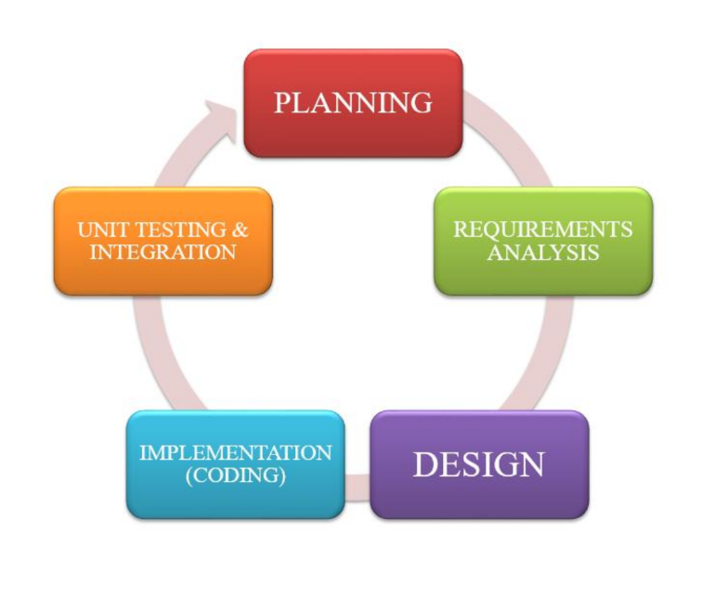

The Agile SDLC model has a flexible team approach that can adapt to changing requirements. It welcomes changes, especially if they happen late in development. The team delivers working software frequently and prioritizes customer satisfaction by creating simple software promptly and consistently. This ability to adapt to changing project needs is a good benefit of the Agile approach. The cycle lasts from one to three weeks, with cross-functional teams working on planning, requirements analysis, design, implementation, unit testing and acceptance testing during each cycle.

 **Liceo de Cagayan University College of Information Technology** **Page**

**32**

The following phases for the study:

* **Planning** - The planning phase is crucial in constructing a general overview of the project and proposed system. It helps align the perspectives of all team members by outlining how to organize data collection, link operations across various system functions, and handle and view expected results.
* **Requirements Analysis** - After gathering all data, the researchers will study each piece of information to plan how to build the system.
* **Design** - During this process, the researchers will use the results from data analysis to design the best build for the proposed automation system. They will also consider possible problems, project limitations, technology integration, budget, and time restrictions, and their abilities as factors that could limit the project.
* **Implementation** - After finishing the design phase, the team will start coding the proposed automation system. The developers will begin by building the entire system using the Visual Studio Code.
* **Unit Testing & Integration** - The dry run of the system testing will initiate after the developers have finished coding the records system.

 **Liceo de Cagayan University College of Information Technology** **Page**

**33**

**Research Setting**

This research study will take place at CHED, The Commission on Higher Education is the Philippine government’s agency in charged with promoting relevant and quality higher education, ensuring access to quality higher education, and guaranteeing and protecting academic freedom for continuing intellectual growth, advancement of learning and research, development of responsible and effective leadership, education of high-level professionals, and enrichment of historical and cultural heritages.

**Figure 3:**

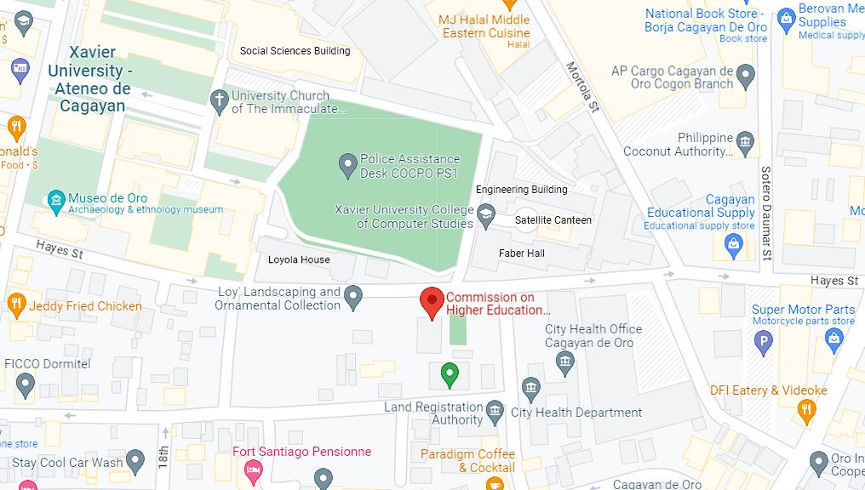*Commission on Higher Education Region-10 location using Google Maps.*

 **Liceo de Cagayan University College of Information Technology** **Page**

**34**

**Figure 4:**

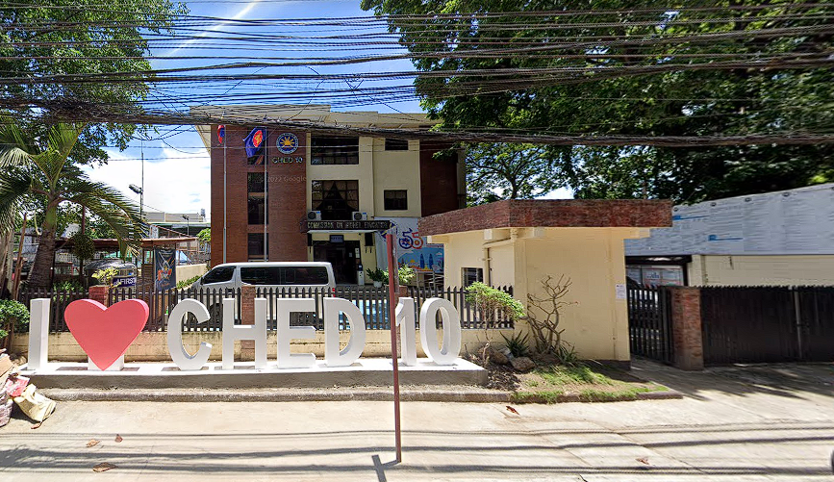*Commission on Higher Education Region – 10 front building.*

**Research Instruments**

The study used a review of related literature as its primary source of information. The

researchers also interviewed Glarigen Baja Fernandez, an employee of CHED. The project used the latest hardware and software for the study.

 **Liceo de Cagayan University College of Information Technology** **Page**

**35**

**Data Gathering**

The researchers spoke to an employee of CHED, Glarigen Baja Fernandez to gather information for our study. They discovered that CHED still doesn’t have a complete Records Management System. The researchers suggested adding a database storage. The study will benefit CHED and its employees.

**System Design**

The system design consist of as follows;

**Current** **System**

**Figure 5:**

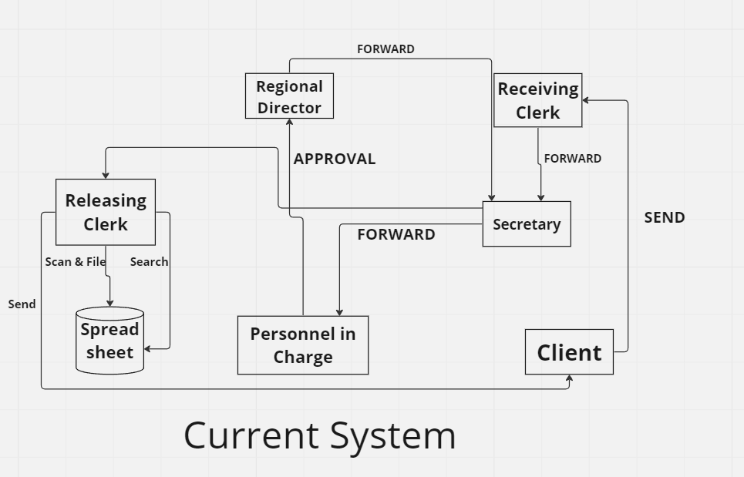*Current system of CHED10*

 **Liceo de Cagayan University College of Information Technology** **Page**

**36**

CHED10 employees manually search documents on their Spreadsheet. It will take their time searching documents due to unsorted files. The researchers proposed an improved system that will give them categorized documents, simplify the way of finding archived documents and show pending files that are needed to be signed.

**Proposed System**

**Figure 6:**

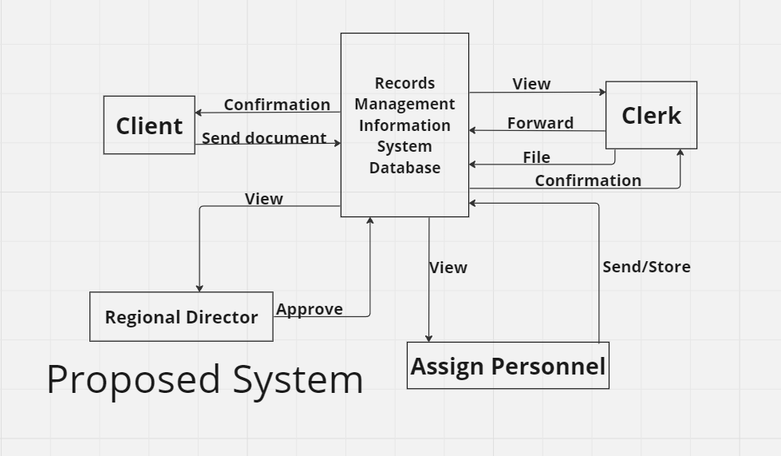*Proposed System for CHED10*

The study added a database, this supports good data access because large volumes of data can be stored in one place. Multiple users can read and modify the data at the same time. Database are used to store, maintain and access all kinds of data. Collect information about people, places, and things. This information is collected in one place for observation and analysis. A database can be viewed as an organized collection of information.

 **Liceo de Cagayan University College of Information Technology** **Page**

**37**

**Entity Relationship Diagram**

**Figure 7 :**

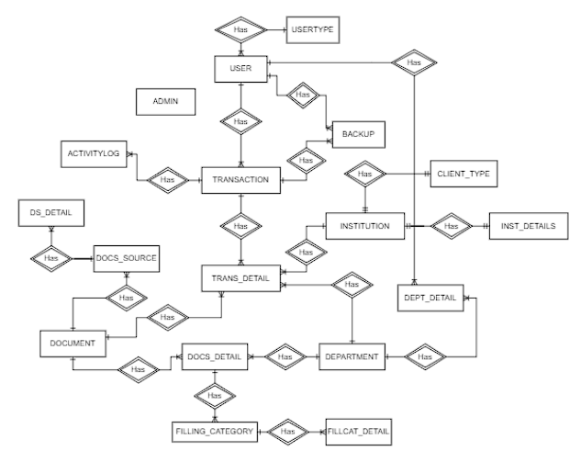*Entity Relationship Diagram of Proposed System. It has 18 entities or tables.*

The figure shown depicts the entity-relationship diagram for the proposed records management system compose of 18 entities.  Starting from the Document_source table, the Document table stores the file names and the type of the document. The Admin table holds the admin’s full name, contact number and other information. The DocSour_Detail table extends to the Document_Source table, which stores the details like date and time of the source of the document. The Document_Source table extends to the Document table, storing the origin of the document. The Doc_Detail table extends to the Document table, which stores the details of the document. The User table stores the full name and other information of the users. The Transaction table stores the information of the transactions.

 **Liceo de Cagayan University College of Information Technology** **Page**

**38**

The Trans_Detail table extends to the Transaction table, which stores the details of the transactions. The Department table stores the name of the department. The Filling_Category table stores the name of the name of the filling category. The FillCat_Detail table extends to the Filling Category table, which stores the status, and states the date issued of the filling category. The User_Type table extends to the User table, which stores the type of the user. The Activity_Log table extends to the Transaction table, which will store the date, time, and the activity of the transaction. The Backup, which will create backup documents. The Institution table stores the type of the institution. The Dept_Detail table, which will store the details like status and description of the department. The Inst_Details extends to the Institution table, which will store the contact person and its contact number of the institution. The Client_Type table extends to the Institution table, which store the Client type.

 **Liceo de Cagayan University College of Information Technology** **Page**

**39**

**Figure 8:**

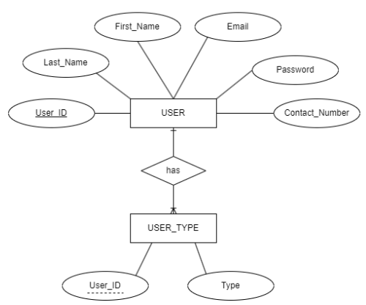*User and User_Type Relationship*

**Figure 9:**

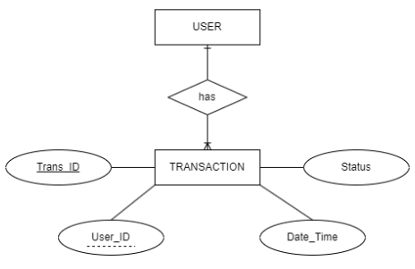*User and Transaction Relationship*

 **Liceo de Cagayan University College of Information Technology** **Page**

**40**

**Figure 10:**

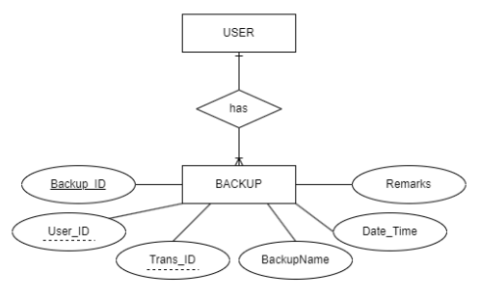*User and Backup Relationship*

**Figure 11:**

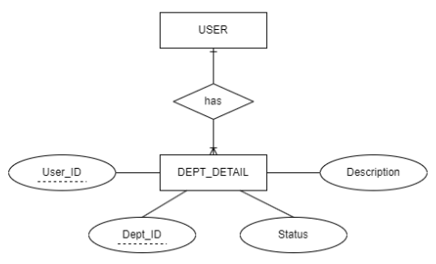*User and Dept_Detail Relationship*

 **Liceo de Cagayan University College of Information Technology** **Page**

**41**

**Figure 12:**

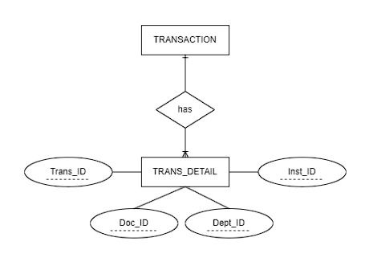*Transaction and Trans_detail Relationship*

**Figure 13:**

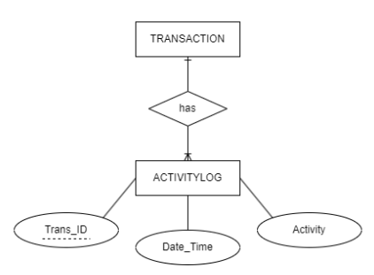*Transaction and ActivityLog Relationship*

 **Liceo de Cagayan University College of Information Technology** **Page**

**42**

**Figure 14:**

*Transaction and backup Relationship*

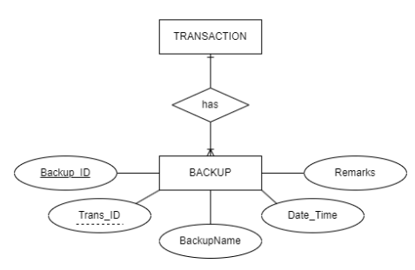

**Figure 15:**

*Department and Dept_Detail Relationship*

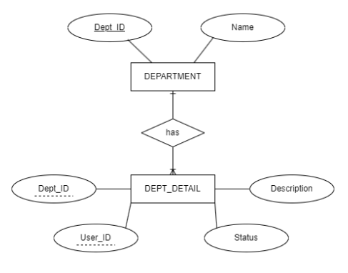

 **Liceo de Cagayan University College of Information Technology** **Page**

**43**

**Figure 16:**

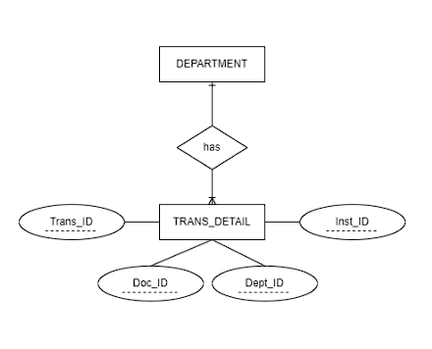*Department and trans_detail Relationship*

**Figure 17:**

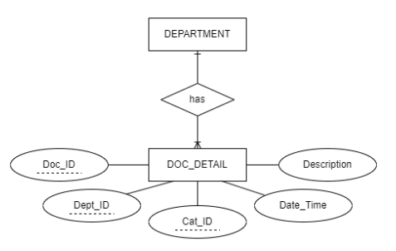*Department and doc_Detail Relationship*

 **Liceo de Cagayan University College of Information Technology** **Page**

**44**

**Figure 18:**

*Document and Doc_Detail Relationship*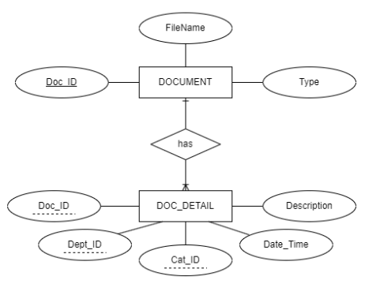

**Figure 19:**

*Document and Trans_Detail Relationship*

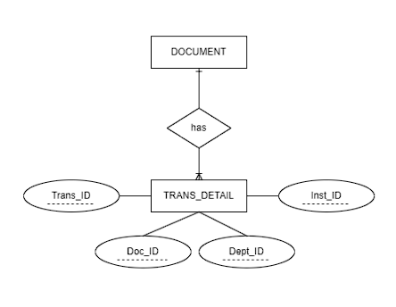

 **Liceo de Cagayan University College of Information Technology** **Page**

**45**

**Figure 20:**

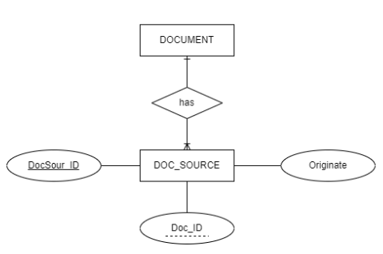*Document and Doc_Source Relationship*

**Figure 21:**

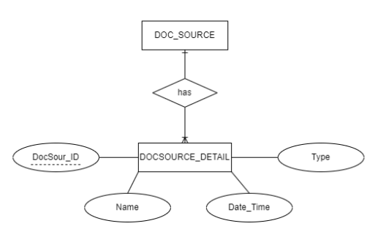*Doc_Source to DocSource_Detail*

 **Liceo de Cagayan University College of Information Technology** **Page**

**46**

**Figure 22:**

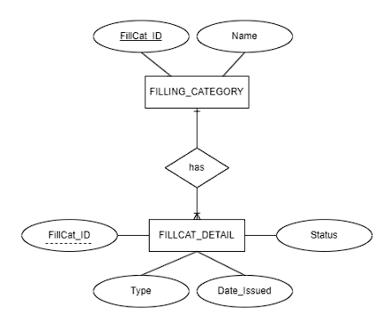*Filling_Category and FillCat_Detail Relationship*

**Figure 23:**

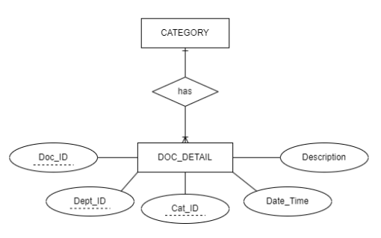*Filling_Category and Doc_Detail Relationship*



 **Liceo de Cagayan University College of Information Technology** **Page**

**47**

**Figure 24:**

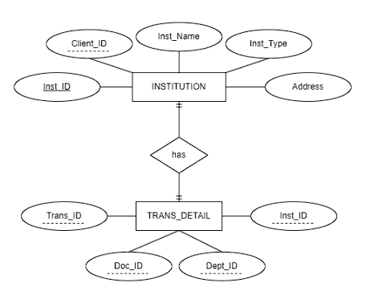*Institution and Trans_Detail Relationship*

**Figure 25:**

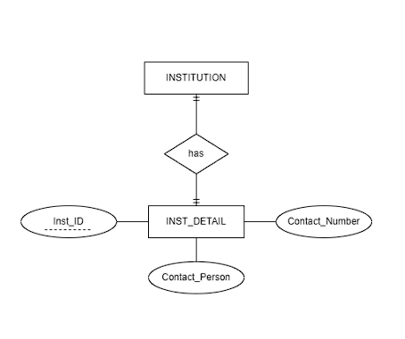 *Inst_Detail and Institution Relationship*

 **Liceo de Cagayan University College of Information Technology** **Page**

**48**

**Figure 26:**

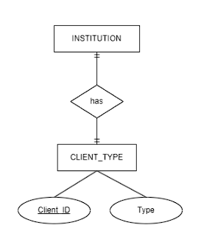*Institution and Client_Type Relationship*

**Figure 27**:

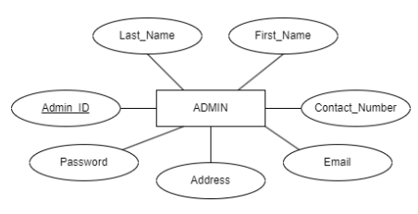*Admin Entity*

**Database Structure**

The database contains Eighteen entities or tables, each with its unique set of data attributes. The name of this database is Records Management Information System Database.

 **Liceo de Cagayan University College of Information Technology** **Page**

**49**

**Data Dictionary**

**Table 1:**

*User (This table contains user information)*

|  |  |  |  |  |
| --- | --- | --- | --- | --- |
| **Field Name** | **Type** | **Size** | **Value** | **Description** |
| User_ID | VARCHAR | 12 | NOT NULL | (PK) User ID |
| Last_Name | VARCHAR | 30 | NOT NULL | User Last Name |
| First_Name | VARCHAR | 30 | NOT NULL | User First Name |
| Email | VARCHAR | 40 | NOT NULL | User Email |
| Password | VARCHAR | 6 | NOT NULL | User Password |
| Contact_Number | VARCHAR | 12 | NOT NULL | User Mobile Number |

 **Liceo de Cagayan University College of Information Technology** **Page**

**50**

**Table 2:**

*User_Type (This table contains user type information)*

|  |  |  |  |  |
| --- | --- | --- | --- | --- |
| **Field Name** | **Type** | **Size** | **Value** | **Description** |
| User_ID | VARCHAR | 12 | NOT NULL | (FK) User ID |
| Type | VARCHAR | 20 | NOT NULL | User Type |

**Table 3:**

*Transaction (This table contains transaction information)*

|  |  |  |  |  |
| --- | --- | --- | --- | --- |
| **Field Name** | **Type** | **Size** | **Value** | **Description** |
| Trans_ID | VARCHAR | 12 | NOT NULL | (PK) Transaction ID |
| User_ID | VARCHAR | 12 | NOT NULL | (FK)User ID |
| Date_Time | DATETIME | 10 | NOT NULL | Date & Time |
| Status | VARCHAR | 20 | NOT NULL | Transaction Status |

 **Liceo de Cagayan University College of Information Technology** **Page**

**51**

**Table 4:**

*Trans_Detail (This table contains transaction details information.)*

|  |  |  |  |  |
| --- | --- | --- | --- | --- |
| **Field Name** | **Type** | **Size** | **Value** | **Description** |
| Trans_ID | VARCHAR | 12 | NOT NULL | (FK) Transaction ID |
| Doc_ID | VARCHAR | 12 | NOT NULL | (FK) Document ID |
| Dept_ID | VARCHAR | 12 | NOT NULL | (FK) Department ID |
| Inst_ID | VARCHAR | 12 | NOT NULL | (FK) Institution ID |

**Table 5:**

*Document (This table contains document information)*

|  |  |  |  |  |
| --- | --- | --- | --- | --- |
| **Field Name** | **Type** | **Size** | **Value** | **Description** |
| Doc_ID | VARCHAR | 12 | NOT NULL | (PK) Document ID |
| File_Name | VARCHAR | 30 | NOT NULL | Document File Name |
| Type | VARCHAR | 15 | NOT NULL | Document Type |

 **Liceo de Cagayan University College of Information Technology** **Page**

**52**

**Table 6:**

*Doc_Detail (This table contains document details information)*

|  |  |  |  |  |
| --- | --- | --- | --- | --- |
| **Field Name** | **Type** | **Size** | **Value** | **Description** |
| Doc_ID | VARCHAR | 12 | NOT NULL | (FK) Document ID |
| Dept_ID | VARCHAR | 12 | NOT NULL | (FK) Department ID |
| FillCat_ID | VARCHAR | 12 | NOT NULL | (FK) Filling Category ID |
| Date_Time | DATETIME | 10 | NOT NULL | Date & Time |
| Authentication | BLOB |  | NOT NULL | Biometric for Document Validation |
| Description | VARCHAR | 50 | NOT NULL | Description |

**Table 7:**

*Document_Source (This table contains source of the documents information)*

|  |  |  |  |  |
| --- | --- | --- | --- | --- |
| **Field Name** | **Type** | **Size** | **Value** | **Description** |
| DocSour_ID | VARCHAR | 12 | NOT NULL | (PK) Document Source ID |
| Doc_ID | VARCHAR | 12 | NOT NULL | (FK) Document ID |
| Originate | VARCHAR | 30 | NOT NULL | Document Originate |

 **Liceo de Cagayan University College of Information Technology** **Page**

**53**

**Table 8:**

*DocSour_Detail (This table contains the details of the source of the documents information)*

|  |  |  |  |  |
| --- | --- | --- | --- | --- |
| **Field Name** | **Type** | **Size** | **Value** | **Description** |
| DocSour_ID | VARCHAR | 12 | NOT NULL | (FK) Document Source ID |
| Name | VARCHAR | 30 | NOT NULL | Document Source Name |
| Date_Time | DATETIME | 10 | NOT NULL | Date & Time |
| Type | VARCHAR | 40 | NOT NULL | Document Source Type |

**Table 9:**

*Department (This table contains department information)*

|  |  |  |  |  |
| --- | --- | --- | --- | --- |
| **Field Name** | **Type** | **Size** | **Value** | **Description** |
| Dept_ID | VARCHAR | 12 | NOT NULL | (PK) Department ID |
| Name | VARCHAR | 30 | NOT NULL | Department Name |

 **Liceo de Cagayan University College of Information Technology** **Page**

**54**

**Table 10:**

*Dept_Detail (This table contains department details information)*

|  |  |  |  |  |
| --- | --- | --- | --- | --- |
| **Field Name** | **Type** | **Size** | **Value** | **Description** |
| Dept_ID | VARCHAR | 12 | NOT NULL | (FK) Document Source ID |
| User_ID | VARCHAR | 12 | NOT NULL | (FK) User ID |
| Status | VARCHAR | 15 | NOT NULL | Department Status |
| Description | VARCHAR | 50 | NOT NULL | Department Description |

**Table 11:**

*Filling_Category (This table contains filling category information)*

|  |  |  |  |  |
| --- | --- | --- | --- | --- |
| **Field Name** | **Type** | **Size** | **Value** | **Description** |
| FillCat_ID | VARCHAR | 12 | NOT NULL | (PK) Filling Category ID |
| Name | VARCHAR | 30 | NOT NULL | Category Name |

 **Liceo de Cagayan University College of Information Technology** **Page**

**55**

**Table 12:**

*FillCat_Detail (This table contains filling category details information)*

|  |  |  |  |  |
| --- | --- | --- | --- | --- |
| **Field Name** | **Type** | **Size** | **Value** | **Description** |
| FillCat_ID | VARCHAR | 12 | NOT NULL | (FK) Filling Category ID |
| Type | VARCHAR | 30 | NOT NULL | Document Type |
| Date_Issued | DATETIME | 10 | NOT NULL | Date Issued the Document |
| Status | VARCHAR | 20 | NOT NULL | Status of the Document |

**Table 13:**

*Institution (This table contains institution details information)*

|  |  |  |  |  |
| --- | --- | --- | --- | --- |
| **Field Name** | **Type** | **Size** | **Value** | **Description** |
| Inst_ID | VARCHAR | 12 | NOT NULL | (PK) Institution ID |
| Client_ID | VARCHAR | 12 | NOT NULL | (FK) Client ID |
| Inst_Name | VARCHAR | 30 | NOT NULL | Institution Name |
| Inst_Type | VARCHAR | 30 | NOT NULL | Institution Type |
| Address | VARCHAR | 50 | NOT NULL | Address of the Institution |

 **Liceo de Cagayan University College of Information Technology** **Page**

**56**

**Table 14:**

*Inst_Detail (This table contains Institution details information)*

|  |  |  |  |  |
| --- | --- | --- | --- | --- |
| **Field Name** | **Type** | **Size** | **Value** | **Description** |
| Inst_ID | VARCHAR | 12 | NOT NULL | (FK) Institution ID |
| Contact_Person | VARCHAR | 30 | NOT NULL | Name of the Contact Person |
| Contact_Number | VARCHAR | 11 | NOT NULL | Contact Number |

**Table 18:**

*Activity_Log (This table contains activity log information)*

|  |  |  |  |  |
| --- | --- | --- | --- | --- |
| **Field Name** | **Type** | **Size** | **Value** | **Description** |
| Trans_ID | VARCHAR | 12 | NOT NULL | (FK) Transaction ID |
| Date_Time | DATETIME | 10 | NOT NULL | Date & Time |
| Activity | VARCHAR | 100 | NOT NULL | Activity |

 **Liceo de Cagayan University College of Information Technology** **Page**

**57**

**Table 19:**

*Backup (This table contains backup information****)***

|  |  |  |  |  |
| --- | --- | --- | --- | --- |
| **Field Name** | **Type** | **Size** | **Value** | **Description** |
| BackUp_ID | VARCHAR | 12 | NOT NULL | (PK) Back up ID |
| User_ID | VARCHAR | 12 | NOT NULL | (FK) User ID |
| Trans_ID | VARCHAR | 12 | NOT NULL | (FK) Transaction ID |
| Date_Time | DATETIME | 10 | NOT NULL | Date & Time |
| Backup_Name | VARCHAR | 20 | NOT NULL | Description |
| Remarks | VARCHAR | 50 | NULL | Remarks |

**Table 20:**

*Client_Type (This table contains client type information.)*

|  |  |  |  |  |
| --- | --- | --- | --- | --- |
| **Field Name** | **Type** | **Size** | **Value** | **Description** |
| Client_ID | VARCHAR | 12 | NOT NULL | (PK) Client ID |
| Type | VARCHAR | 30 | NOT NULL | Client Type |

 **Liceo de Cagayan University College of Information Technology** **Page**

**58**

**Table 21:**

*Admin (This table contains admin information)*

|  |  |  |  |  |
| --- | --- | --- | --- | --- |
| **Field Name** | **Type** | **Size** | **Value** | **Description** |
| Admin_ID | VARCHAR | 12 | NOT NULL | (FK) Admin ID |
| Last_Name | VARCHAR | 20 | NOT NULL | Admin Last Name |
| First_Name | VARCHAR | 20 | NOT NULL | Admin First Name |
| Contact_Number | VARCHAR | 11 | NOT NULL | Contact Number |
| Email | VARCHAR | 30 | NOT NULL | Email |
| Address | VARCHAR | 15 | NOT NULL | Position of the Admin |
| Password | VARCHAR | 8 | NOT NULL | Password |

 **Liceo de Cagayan University College of Information Technology** **Page**

**59**

**References:**

Racheal, N., (2018). The Impact Of Electronic Records Management System On Organizational Performance. Information Management of Management Training and Advisory Center (MTAC) in Uganda.

Rutta, M. & Ndenje-Sichalwe, E., (2021). The State of Records Management Practices in Public Offices: A Case of Kinondoni Municipal Council in Dar es Salaam, Tanzania. University of Dar es Salaam Library Journal.

Patimo, D. (2021). University Electronic Records Management System for Northwest Samar State University, Calbayog City. [http://dx.doi.org/10.31940/logic.v21i1.2145](https://dx.doi.org/10.31940/logic.v21i1.2145)

Bongon, A.M., (2019). The Records Management System of Department of Education City Divisions, Region V (Bicol),Vol. 3 No. 2J (2019): Ascendens Asia Journal of Multidisciplinary Research Abstracts.

Msosa, W.H, Chawinga, W.D. and Chipeta. G., (2023) Analysis of a Records Management Systems at the Northern Region Water Board in Malawi. Okey, K., (2019). Records Management, page 27 - 28.

Mukred, M., Yusof, Z.M., et al., (2021). Electronic records management systems and the competency of educational institutions: Evidence from Yemen. <https://doi.org/10.1177/0266666920980829>

 **Liceo de Cagayan University College of Information Technology** **Page**

**60**

Touray, R., (2021). A Review of Records Management in Organisations, 10.4236/oalib.1108107

Abidin, S.S.Z, Husin M.H., (2018). Improving accessibility and security on document management system: A Malaysian case study

Masongsong, E.R., (2021). Safekeeping Of Electric Cooperative's Vital Documents And Records Thru Electronic Data Files. National Electrification Administration.

Manun-og, M.B., Manun-og, M.R., et al (2022). Development of a records management system with GIS integration: enabling tools for disaster risk management. Southern Leyte, Philippines.

Prof. Delosa, S.A. & Delosa Jr. R.A., (2020). Implementation Of Records Management System In Cotabato Regional Medical Center Health Information Management Department. International Journal of Social Science and Humanities Research.

Prof. Alegbeleye, G.O., & Chilaka, U.C., (2019). Evaluation of Records Management Practices at the Ministry of Health, Abia State, Nigeria. University of Nebraska - Lincoln.

Mukred, M., Yusof, Z.M., & Alotaibi, F.M., (2019). Ensuring The Productivity Of Higher Learning Institutions Through Electronic Records Management System (ERMS) Faculty of Information Science and Technology, Universiti Kebangsaan Malaysia.

 **Liceo de Cagayan University College of Information Technology** **Page**

**61**

Wu, S. Stvilia, B. Lee, D.J., (2017). Exploring researchers participation in online research identity management systems  <https://doi.org/10.1002/pra2.2016.14505301105>

Gesmundo, J.L., et al, (2022). Records Management Strategies and Professional Performance of Administrative Staff. International Journal of Academe and Industry Research.

Ayaz, A., & Yanartas, M., (2020) Acceptance of electronic document management system (EDMS) Computers in Human Behavior Reports. <https://doi.org/10.1016/j.chbr.2020.100032>

Malekani, A.W and Alphonce, A. B., (2022) Assessing the efficacy of electronic document management systems in records management at Sokoine University of Agriculture.

Moumita Das, etal., (2022). A blockchain-based integrated document management framework for construction applications <https://doi.org/10.1016/j.autcon.2021.104001>

Umeri, V., (2022). School Records Management. FlexiSAF Edusoft Ltd.

Danlog, K.P., Rebujio, E., et al, (2017). Computerized Record Management System of one National High School in the Philippines.

Romeo, E.R., (2021). Standardization Of Records Management System In Local Government Units. <https://doi.org/10.47119/IJRP1008711020212366>

 **Liceo de Cagayan University College of Information Technology** **Page**

**62**

Eroshkin, S.Yu. N.A. Kameneva, et al (2017). Conceptual System in the Modern Information Management <https://doi.org/10.1016/j.procs.2017.01.079>

Ezekwe, F., (2019). Prospects And Methods Of Records Management In Nigeria

Prado, N., Pangcatan, L., (2020) A Solution to the Preservation of Records at the Mindanao State University Main-Campus. Liceo Journal of Higher Education Research. Liceo de Cagayan University.

Shravani BS, Raghavendra. R (2022). Research Paper on Blood Bank Donation and Management using Danjgo. <https://doi.org/10.22214/ijraset.2022.41763>

Adu, K.K. & Ngulube, P., (2017) Key threats and challenges to the preservation of digital records of public institutions in Ghana.

Shanmugam P, S Ganeshan, et al (2020). Library Management System Xi'an Jianzhu Keji Daxue Xuebao/Journal of Xi'an University of Architecture & Technology <https://dx.doi.org/10.37896/JXAT12.11/29777>

Aziz, A. et al., (2017). Establishing Policy for the Implementation of Electronic Document and Records Management System in Public Sector in Malaysia. American Scientific Publishers <https://doi.org/10.1166/asl.2017.10141>

Pagayunan, S.M.S., (2021). Record Management System with Document Control. Institute of Information and Computer Studies, Northern Iloilo Polytechnic State College, Estancia, Iloilo. <https://doi.org/10.47191/ijmra/v4-i12-23>

 **Liceo de Cagayan University College of Information Technology** **Page**

**632**

Carpio, C.O., (2020) Barangay Management. System International Journal of Multidisciplinary Research and Publications

Akçay, M., Ardiç, I., And Şen S., (2019). Document Management System. 2019 3rd International Symposium on Multidisciplinary Studies and Innovative Technologies (ISMSIT).

Yusof, S.K., & Adekoya, O.M., (2021). Trends-in-Contemporary-Record-Management Handbook of Research on Information and Records Management in the Fourth Industrial Revolution (pp.326-343). IGI global Publisher

Ajibade, P., & Mutula, S.M., (2019). Integrated Records Management. New Review of Information Networking (pp. 178-192)

Assaf, M., Lakmes, A., et al, (2022). Evaluating the effectiveness of student-record systems in conflict-affected universities in northwest Syria relative to student transition and mobility. International Journal of Educational Research Open. <https://doi.org/10.1016/j.ijedro.2022.100128>

Adamn, N.L., Mansor, M.A.H, et al, (2022). Document and Event Record Management System 2022 IEEE 12th Symposium on Computer Applications & Industrial Electronics (ISCAIE).

Bahri, A.N.B., Aris, M.H.B., et al (2022). Issues And Challenges In Record Management: The Adoption Of Erms. International Journal of Accounting, Finance and Business. Special Issues (pp. 214 - 219).