**Danphe DB Documentation and Understanding**

Contents

Version 1

Introduction 1

Common Fields 1

Higher level DB understanding 2

Patient , Appointment and Visit 2

Department, Category, Item and Price Category 3

Employee vs User 3

Employee and Role 3

User table, Role, Permission and Application 4

Test category, lab test and test components 4

Imaging Item, Imaging Type and Film Type. 5

Generic, Category, Item and Stock 5

Category, Item, Stock and Store Stock 6

Ledger, Ledger Group, Chart of Accounts and Mapping 6

Admin DB 7

CORE_CFG 7

FiscalYears 7

## Version

|  |  |  |
| --- | --- | --- |
| Version No | Modified by | Description |
| 1.1 | Dinesh , Shiv and Vrushali | Created an Initial document with higher level understanding. |
|  |  |  |

## Introduction

This document will help you understand Danphe DB database structure. Any queries please email to [questpond@questpond.com](mailto:questpond@questpond.com) or you can also CC at [shiv_koirala@yahoo.com](mailto:shiv_koirala@yahoo.com)

## Common Fields

All the tables in Danphe EMR have common fields like Id , IsActive and so on. So rather than repeating the documentation individually we are putting down the same in this section.

Please note in some tables some fields will not be present.

|  |  |
| --- | --- |
| **FieldName** | **Description** |
| ID | It is primary key with identity (Auto-increment) and mandatory in every table. |
| IsActive | IsActive will be true if the record is active or else its inactive. **There is no hard delete in Danphe , everything is a soft delete.** |
| CreatedBy | User who created the record. Please note this UserId is linked with the User Table. |
| CreatedOn | This has the date and time when the record was created. |
| ModifiedBy | User who Modiefied the record. Please note this UserId is linked with the User Table. |
| ModifiedOn | This has the date and time when the record was modified. |

## Higher level DB understanding

This section will focus on important relationship. It will avoid getting in to field level understanding.

### Patient , Appointment and Visit

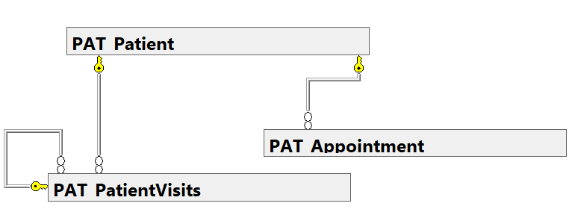

* “PAT_Patient” has patient details.
* Every patient can book multiple appointments and the appointment data is in the “PAT_Appointment” table.
* Patient can visit multiple time the visit information is stored in the “PAT_PatientVisits”

### Department, Category, Item and Price Category

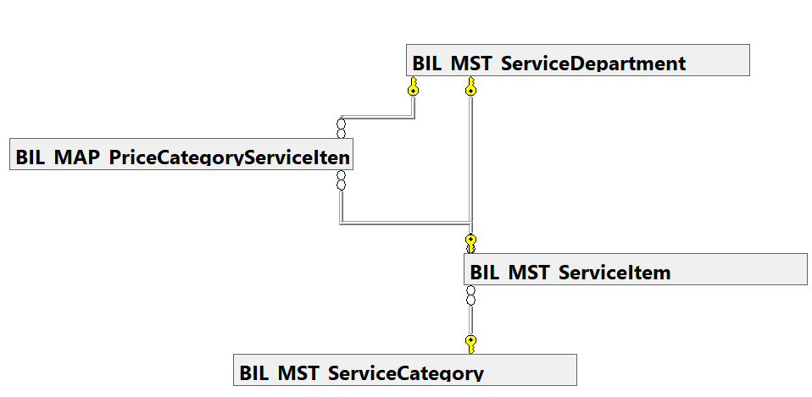

* "BIL_MST_ServiceDepartment" contains department information. One department has many service items.
* The item data is stored in the "BIL_MST_ServiceItem" database, which contains billing item details.
* The service item table is also linked to the "BIL_MST_ServiceCategory" table, which stores billing categories. Each service category contains numerous service items.
* "BIL_MAP_PriceCategoryServiceItem" stores the prices of billing items, and each billing item has numerous prices and price categories associated with a service department.

### Employee vs User

Employee tables represents the employee of the hospital while User table represents User who uses the software.

### Employee and Role

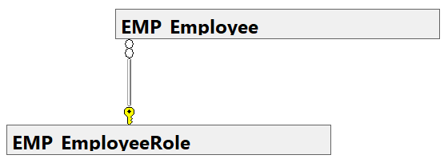

* The "EMP_Employee" table contains the details of all employees, and the roles of those employees are stored in the "EMP_EmployeeRole" table.

### User table, Role, Permission and Application

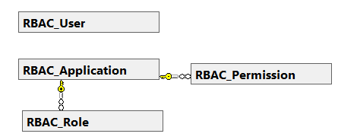

* “RBAC_User” it stores the user name, password and other details of the user and it connect with most of the tables.
* “RBAC_Role” it stores the different types of role. Which we will assignee to user in mapping table.
* “RBAC_Permission” it stores the permission of users, it connect with user in user mapping table each user has multiple permission.
* “RBAC_Application” it stores the different fields of application, it connect with role and permission.

### Test category, lab test and test components

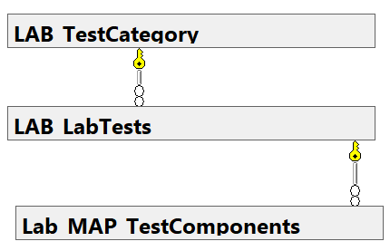

* "LAB_TestCategory" contains information on numerous test categories that are relevant to lab tests, and each test category has multiple lab tests, with test specifics stored in the "LAB_LabTest" database.
* The "LAB_MAP_TestComponent" table stores the relationship between the test and the component.

### Imaging Item, Imaging Type and Film Type.

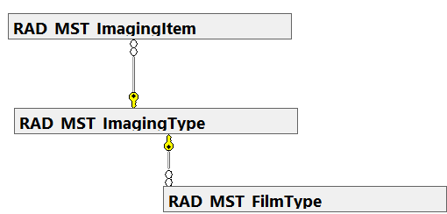

* "RAD_MST_ImagingItem" stores all imaging items that are relevant to the imaging type.
* "RAD_MST_ImagingType" table stores the type of imaging, and each imaging type contains numerous imaging items.
* The imaging type is tied to the "RAD_MST_FilmType" table. The film type table stores the size of the film.

### Generic, Category, Item and Stock

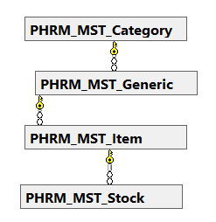

* “PHRM_MST_Category” table stores the category of medicine**.** Each category has multiple generic name and it’s connected with generic table.
* “PHRM_MST_Generic” table stores the generic name of medicine and it is connect with Item table .
* “PHRM_MST_Item” table stores the item of medicine and each category has multiple item. Item table connect with stock table.
* ”PHRM_MST_Stock” table stores the stock of medicine, price and expiry date of medicine. Each item has multiple price and expiry date.

### Category, Item, Stock and Store Stock

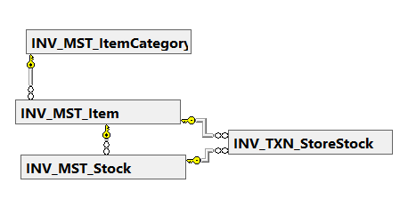

* “INV_MST_ItemCategory” table stores the different category of item it connect with item table.
* “INV_MST_Item” table stores the item, each category has multiple item.
* “INV_MST_Stock” table stores the stock of item and it also sores price and expiry date of item. Each item has multiple price and expiry date.
* “INV_TXN_StoreStock” table stores the stock of different store, it stores price and expiry date also and it connect with item table and stock table.

### Ledger, Ledger Group, Chart of Accounts and Mapping

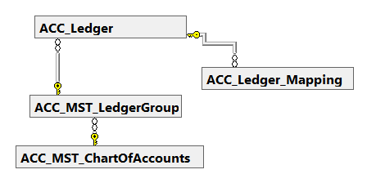

* “ACC_Ledger” table stores the accounting ledger it connect with ledger group table.
* “ACC_MST_LedgerGroup” table stores the ledger group each ledger group has multiple ledger.
* “ACC_MST_ChartOfAccount” stores the chart of account name it connect with ledger group table and each chart of account has multiple ledger group.
* “ACC_Ledger_Mapping” table stores the different type of ledger and it connect with ledger, each ledger has multiple ledger mapping.

## Admin DB

* “DanpheAudit” table stores any activity done in Danphe Database. Right from login to any kind of new/edit or update in database.
* “DanpheLogInInformation” any kind of login or logout activity all user. It also shows the login and logout timing.
* “SysAdmin_DBLog” any backup taken reflect in this table and recorded with time and folder path. Along with action, status and message details.
* “tbl_AuditTableDisplayName” whichever table we add in this table will be shown in Danphe Audit table. We need to add any table manually.

## CORE_CFG

* “CORE_CFG_LookUps” In this table we can see all the laboratory related test. Data can be added from UI and it has multiple value like: urine colour = Light Yellow","Yellow","Red","Deep Yellow","Milky","Straw","Whitish","Greenish","Greyish.
* “CORE_CFG_Parameters” Information in this table is regarding parameter setting of Danphe. For various kind of changes, this table can give us lot of information.

## FiscalYears

* “MST_FiscalYear” this table is the master table in database for fiscal year. All other fiscal years are connected to this master table. E.g. ACC_MST_FiscalYears, BIL_CFG_FiscalYears, INV_CFG_FiscalYears and PHRM_CFG_FiscalYears.
* So when the year closes first the billing , inventory and pharmacy fiscal year is closed and then the main fiscal year.