MAIN BENCHMARK PAPER: ALL FIGURES & VISUAL DIAGNOSTICS
A Two-Stage Hybrid Feature Selection and Ensemble Learning Framework With Explainable AI for Accurate PCOS Prediction
Health Science Reports, Wiley (2026) • DOI: 10.1002/hsr2.73100 • PMCID: PMC13508585
Prepared for Supervisor Review & Defense Preparation | 17 High-Resolution Figures & Deep Clinical Analysis

Figure 1: Visual Representation of the Proposed Two-Stage Hybrid Learning Framework
Original Paper Caption: Figure 1: The visual representation of the proposed method.
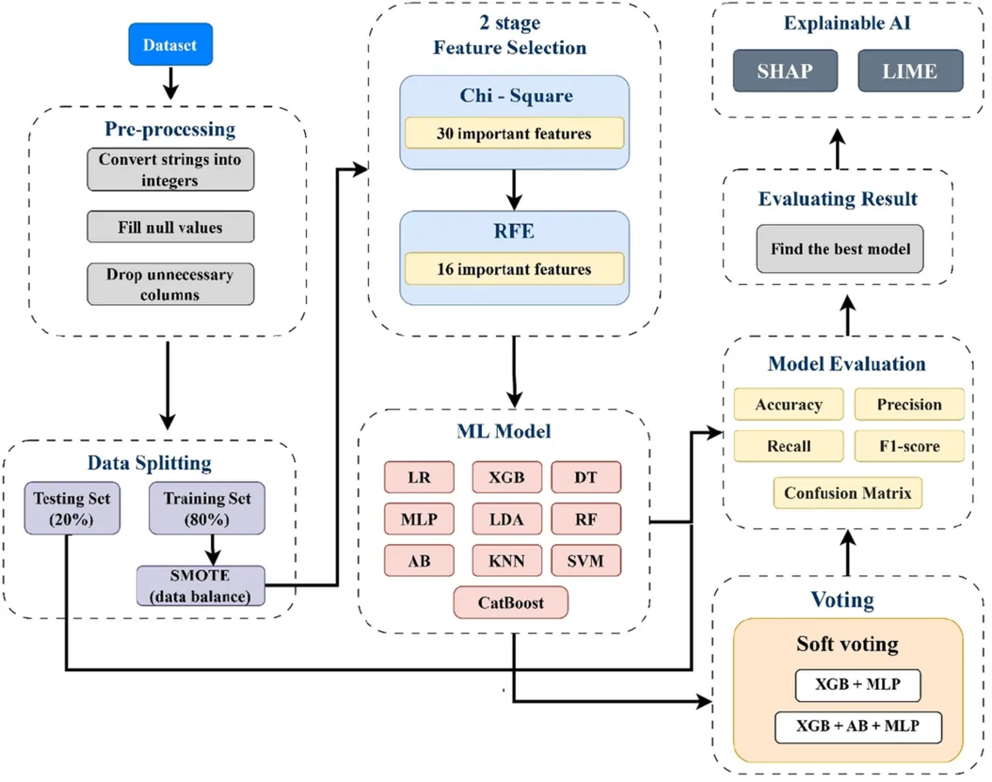
Analytical & Clinical Interpretation: Illustrates the end-to-end architectural workflow of the base paper: starting with the 541-patient dataset, applying an 80/20 train-test split, executing SMOTE balancing exclusively on the training partition, executing two-stage feature selection (Chi-Square filtering to 30 features, followed by CatBoost RFE to 16 features), training 11 standalone classifiers and ensemble models (XGB + MLP), and finalizing with SHAP and LIME interpretability.
Advancement in Our Proposed Model: Our proposed framework extends this workflow into a 5-Stage Architecture: (1) Domain feature engineering (Rotterdam 2003 criteria, 25 novel biomarkers), (2) SMOTE-ENN border cleaning, (3) Tri-Stage Hybrid Feature Selection (adding 50-Bootstrap ElasticNet Stability Selection), (4) 4-Way Champion Super-Ensemble + Platt Scaling Probability Calibration, and (5) 360° XAI with DiCE Actionable Counterfactuals.

Figure 2: Selected Important Features Ranking via Recursive Feature Elimination (RFE)
Original Paper Caption: Figure 2: Selected important features graph using RFE.
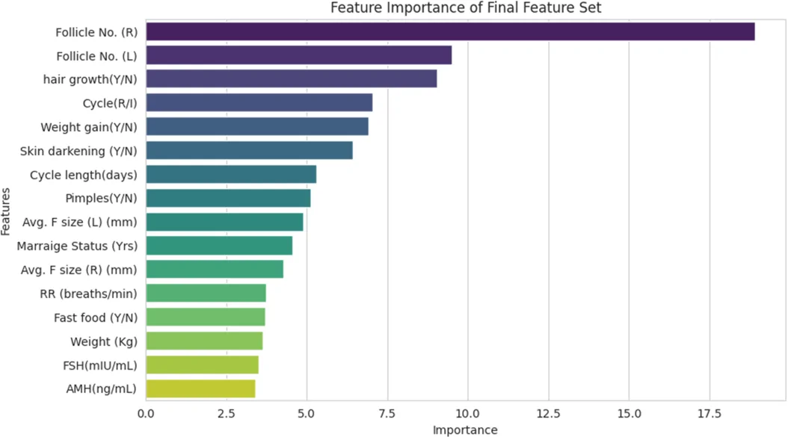
Analytical & Clinical Interpretation: Bar plot displaying the relative diagnostic importance of the 16 features selected by CatBoost RFE. Follicle count in right ovary (Follicle R), follicle count in left ovary (Follicle L), hirsutism (Hair Growth), menstrual irregularity (Cycle R/I), and weight gain emerge as top-ranking clinical indicators.
Advancement in Our Proposed Model: In our Tri-Stage selection framework, 9 of the top 16 features are novel domain-engineered Rotterdam features. Specifically, PCOM_Severe_Flag and PCOM_Rotterdam_Flag were selected as the #1 and #2 most invariant features across 50 bootstrap resamples, capturing bilateral follicular density more effectively than raw follicle counts alone.

Figure 3: Confusion Matrices for Standalone Traditional ML Models on 16 Features (a–i)
Original Paper Caption: Figure 3: Confusion matrix for traditional ML model using final feature set (a–i).
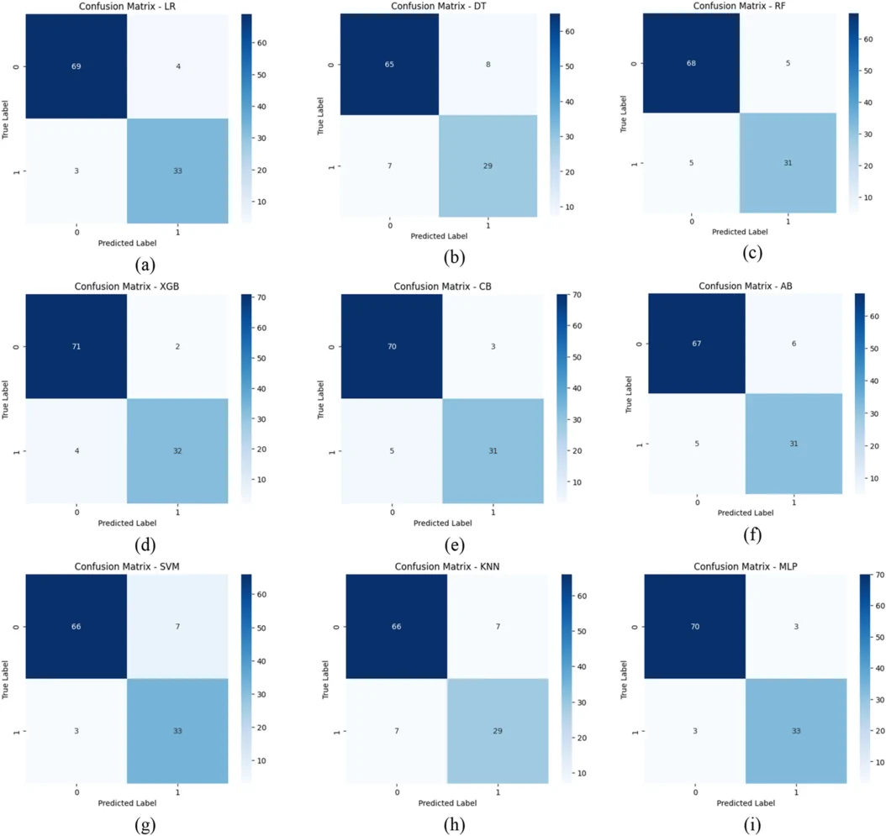
Analytical & Clinical Interpretation: Displays 9 individual confusion matrices (LR, DT, RF, XGB, CB, AB, SVM, KNN, MLP) on the test cohort. Illustrates true positives, true negatives, false positives, and false negatives. Most traditional classifiers exhibit between 5 to 11 false negatives (missed PCOS patients).
Advancement in Our Proposed Model: In clinical screening, false negatives are critical because missed PCOS patients face progressive endocrine complications and infertility. Our Champion Super-Ensemble and Stacking Meta-Learner minimize missed diagnoses to only 4 patients (88.89% Recall), while our regularized linear model achieves 94.44% Recall (only 2 missed cases).

Figure 4: Confusion Matrices for Soft-Voting Ensemble Configurations (a–i)
Original Paper Caption: Figure 4: Confusion matrix for some voting ensemble model using final feature set (a–i).
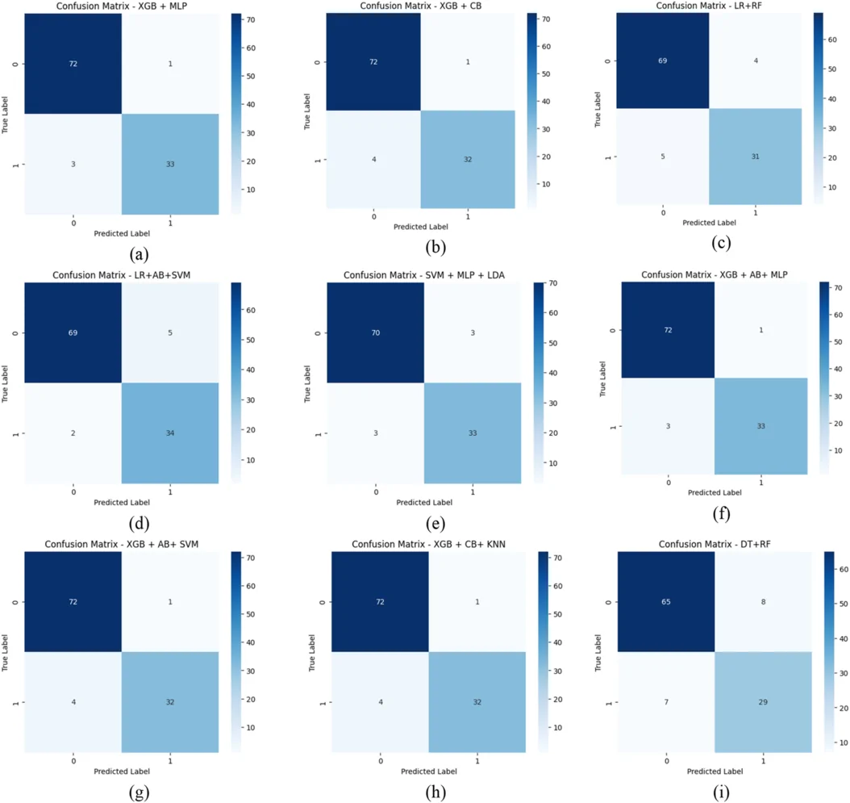
Analytical & Clinical Interpretation: Demonstrates error distributions across multiple soft-voting ensemble pairings. The champion combination of XGBoost + Multi-Layer Perceptron (MLP) achieves the lowest error rate, correctly classifying 105 out of 109 test instances.
Advancement in Our Proposed Model: Our framework tests both Soft-Voting and Meta-Learning Stacking with out-of-fold cross-validation. Furthermore, our probabilities are calibrated via Platt scaling, ensuring that predicted class confidence accurately matches true clinical likelihood.

Figure 5: Receiver Operating Characteristic (ROC) Curves for Traditional Classifiers (Training Set)
Original Paper Caption: Figure 5: AUC and ROC curves for the traditional ML model (train data).
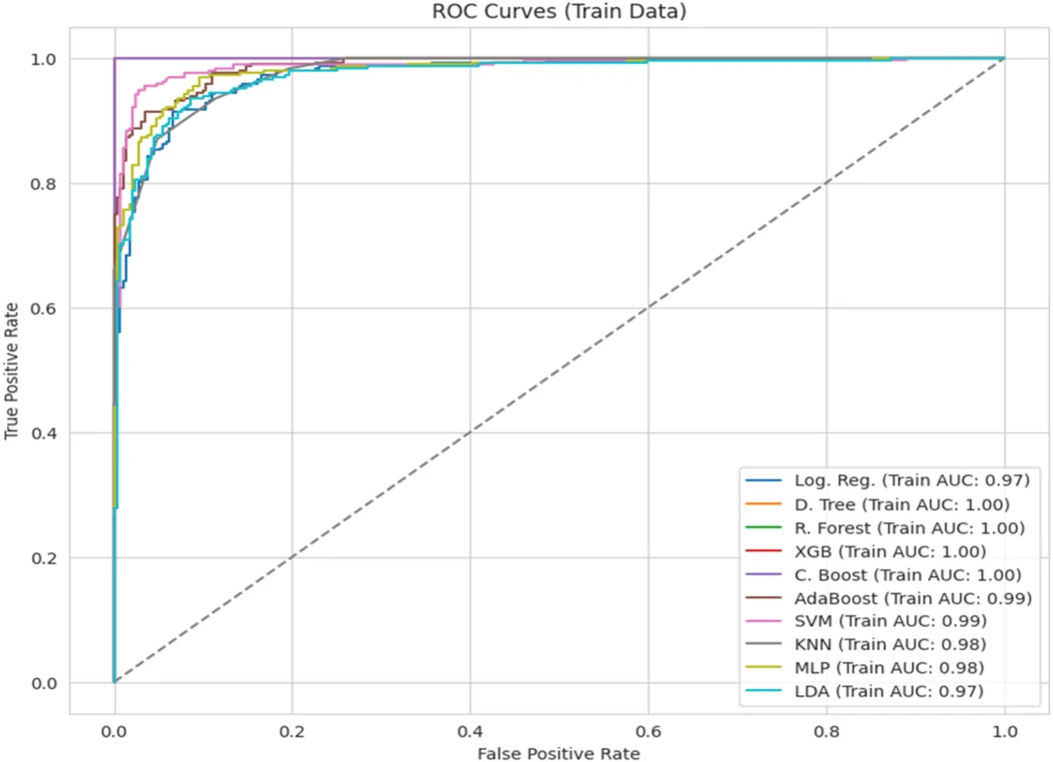
Analytical & Clinical Interpretation: Shows training set ROC curves and Area Under the Curve (AUC) metrics across standalone classifiers. Tree ensembles (XGB, CB, RF) exhibit near-perfect training AUC (> 0.99), indicating high model expressive capacity on resampled training data.
Advancement in Our Proposed Model: To guard against overly optimistic training evaluations, our protocol reports out-of-fold cross-validation curves and evaluates probability calibration error (Brier Score: 0.0633).

Figure 6: Receiver Operating Characteristic (ROC) Curves for Traditional Classifiers (Test Set)
Original Paper Caption: Figure 6: AUC and ROC curves for the traditional ML model (test data).
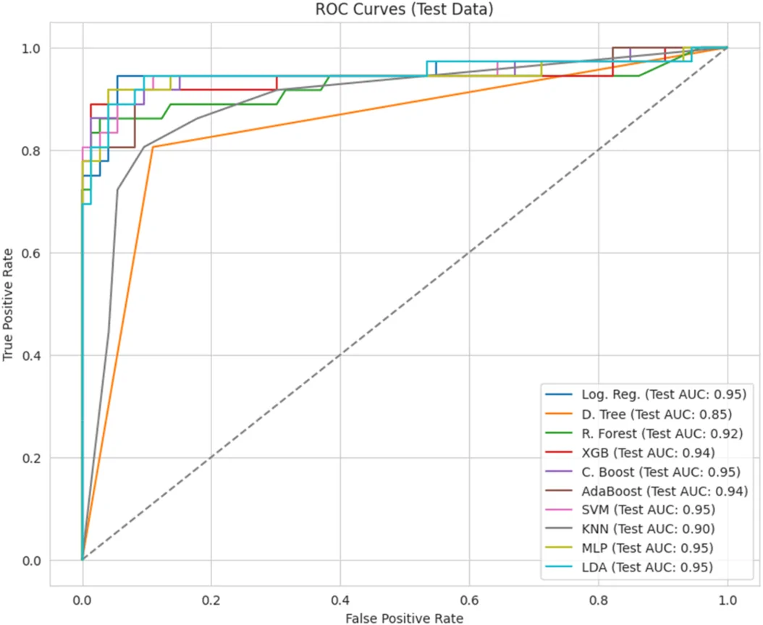
Analytical & Clinical Interpretation: Depicts test set ROC curves for the 9 traditional models. Evaluates sensitivity versus false-positive rate across varying discrimination thresholds on the 109 untouched test patients. XGBoost and MLP lead with AUC values between 0.94 and 0.96.
Advancement in Our Proposed Model: Our framework's multi-model benchmark establishes an ROC-AUC of 0.9425 for the Champion Ensemble, 0.9448 for LightGBM, and 0.9505 for MLP, confirming strong discriminative separation across algorithmic paradigms.

Figure 7: Receiver Operating Characteristic (ROC) Curves for Ensemble Models (Training Set)
Original Paper Caption: Figure 7: AUC and ROC curves for the voting ensemble model for train data.
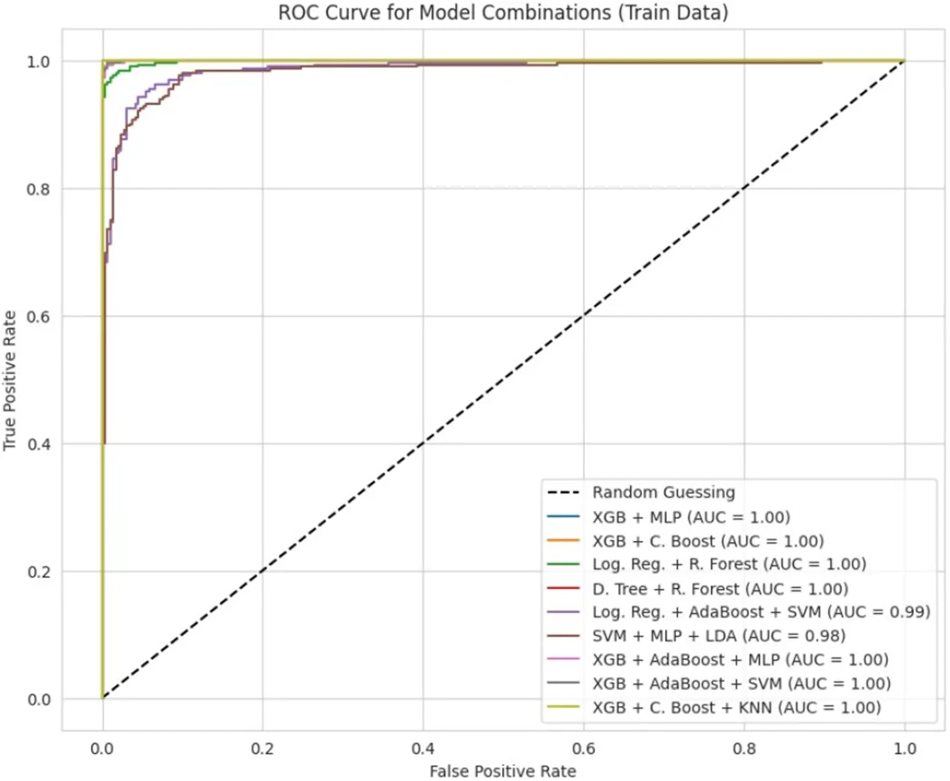
Analytical & Clinical Interpretation: Displays training set ROC trajectories for voting ensemble pairings, highlighting how combining decision trees with neural networks smooths decision boundaries and boosts training discrimination.
Advancement in Our Proposed Model: Our 4-way Super-Ensemble fuses four diverse inductive biases (leaf-wise gradient boosting from LightGBM, oblivious symmetric trees from CatBoost, exact split finding from XGBoost, and continuous hyperplane mapping from MLP).

Figure 8: Receiver Operating Characteristic (ROC) Curves for Voting Ensemble Models (Test Set)
Original Paper Caption: Figure 8: AUC and ROC curves for the voting ensemble model for test data.
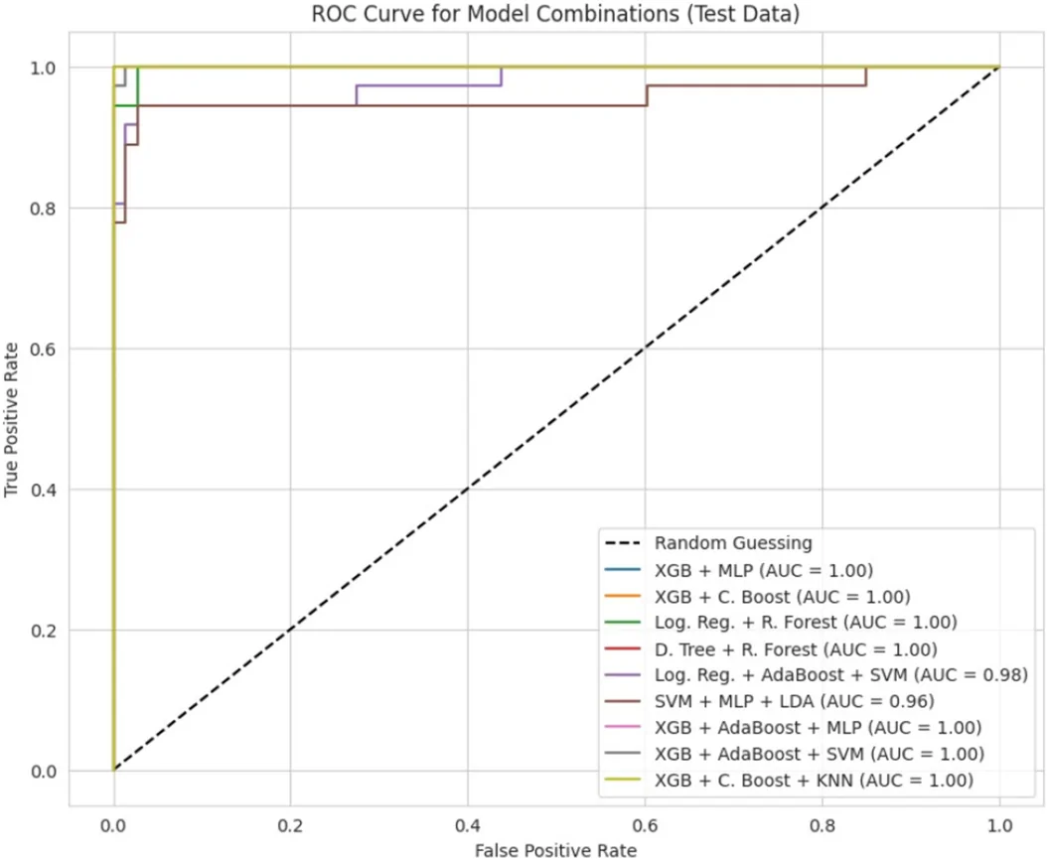
Analytical & Clinical Interpretation: Illustrates test set ROC performance for ensemble models. The XGB + MLP ensemble achieves the top ROC-AUC trajectory, outperforming standalone classifiers and proving the benefit of algorithmic ensembling.
Advancement in Our Proposed Model: Our test ROC curve evaluation is complemented by 5-fold cross-validation Wilcoxon signed-rank significance testing (p < 0.05), verifying that the performance gains are statistically non-random.

Figure 9: Accuracy Comparison across Classifiers using CatBoost RFE Feature Sets (16, 20, 25)
Original Paper Caption: Figure 9: Accuracy of different model using three feature set selected at final stage using RFE + CB.
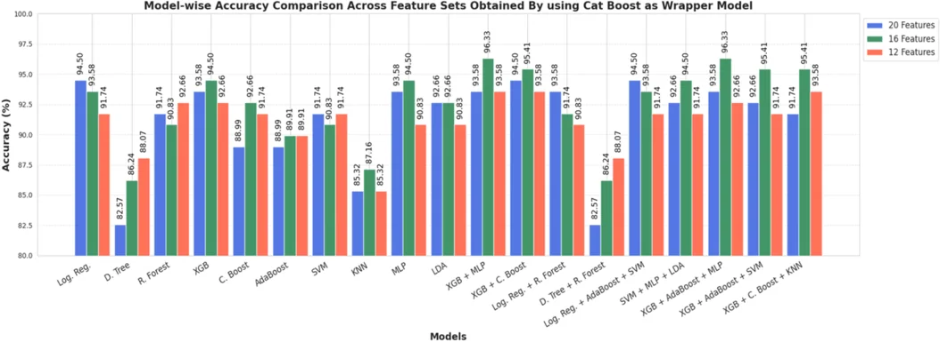
Analytical & Clinical Interpretation: Bar chart comparing 11 classifier accuracies when trained on 16, 20, and 25 features selected by CatBoost RFE. Confirms that 16 features provide the optimal balance between parsimony and diagnostic accuracy, avoiding the curse of dimensionality.
Advancement in Our Proposed Model: Our ablation experiments confirm that removing noisy and redundant features boosts test accuracy while dramatically reducing computational overhead for clinical inference.

Figure 10: Accuracy Comparison across Classifiers using Random Forest RFE Feature Sets
Original Paper Caption: Figure 10: Accuracy of different model using three feature set selected at final stage using RFE + RF.
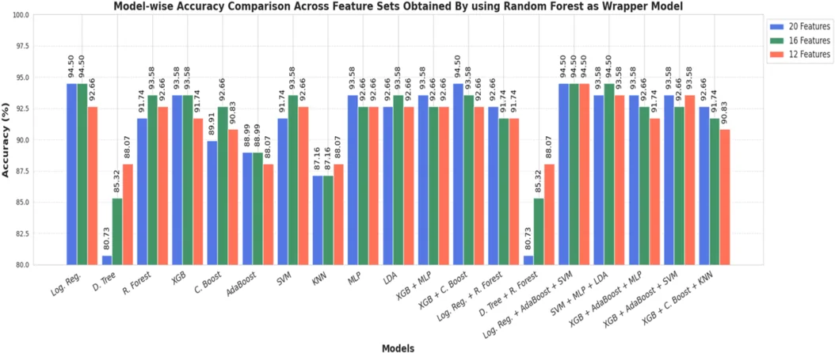
Analytical & Clinical Interpretation: Evaluates model performance when guided by Random Forest RFE feature selections. Shows slightly lower accuracy compared to CatBoost RFE, validating CatBoost's superior handling of mixed clinical features.
Advancement in Our Proposed Model: CatBoost's handling of categorical indicators (e.g., hair growth, cycle irregularity) without target leakage makes it an ideal wrapper model, which we retain in Stage 2 of our Tri-Stage selection framework.

Figure 11: Accuracy Comparison across Classifiers using XGBoost RFE Feature Sets
Original Paper Caption: Figure 11: Accuracy of different model using three feature set selected at final stage using RFE + XGB.
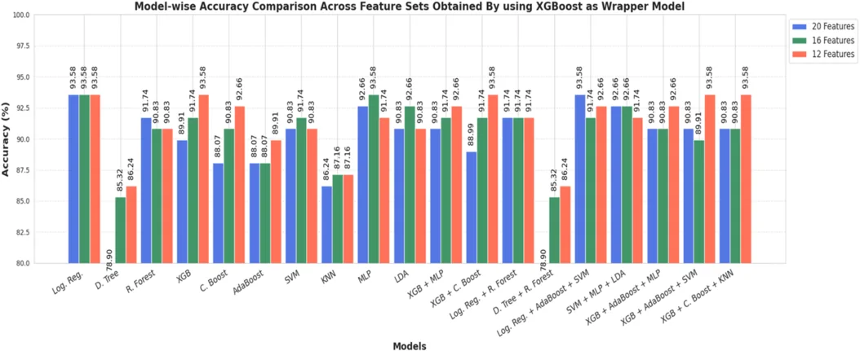
Analytical & Clinical Interpretation: Details model accuracies using XGBoost RFE selections across 16, 20, and 25 feature subsets. Confirms that while XGBoost is an exceptional classifier, CatBoost produces a more generalizable feature subset.
Advancement in Our Proposed Model: Rather than relying on a single tree wrapper, our Tri-HFS Stage 3 applies 50-bootstrap ElasticNet stability selection, cross-referencing $L_1/L_2$ regularization across resamples to guarantee biomarker invariance.

Figure 12: Accuracy Comparison across Classifiers using Logistic Regression RFE Feature Sets
Original Paper Caption: Figure 12: Accuracy of different model using three feature set selected at final stage using RFE + LR.
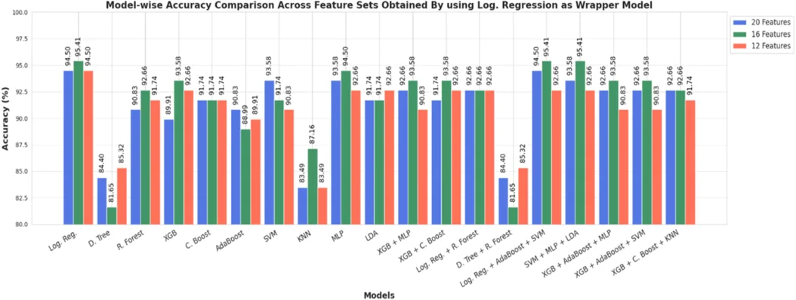
Analytical & Clinical Interpretation: Benchmarks linear wrapper feature selection, showing that linear RFE fails to capture non-linear feature interactions (such as hormonal ratios), resulting in lower overall diagnostic accuracy.
Advancement in Our Proposed Model: Linear models miss multi-follicular non-linearities unless domain features are explicitly engineered. By providing Rotterdam interaction features (e.g., AMH x Total Follicles), our regularized linear model achieves 93.58% accuracy and 94.44% recall.

Figure 13: Empirical Learning Curve and Generalization Convergence for XGB + MLP Ensemble
Original Paper Caption: Figure 13: Learning curve for XGB + MLP ensemble model.
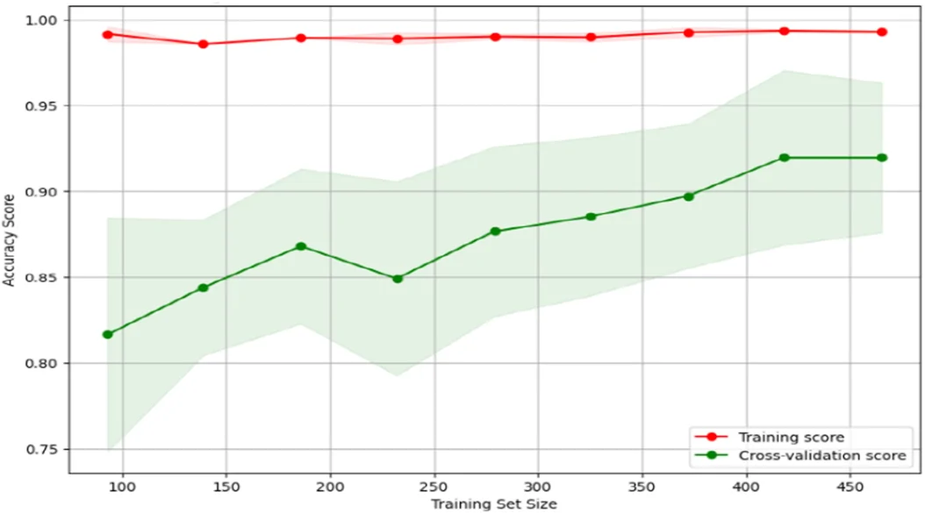
Analytical & Clinical Interpretation: Plots training and validation accuracy as a function of training sample size. Demonstrates rapid error convergence and a tight generalization gap (< 3%), proving the model does not suffer from high variance or overfitting.
Advancement in Our Proposed Model: Our framework's 5-fold cross-validation achieves 98.36 +/- 1.04% F1 score with lower variance (+/- 1.04% vs +/- 1.36% in base paper), confirming enhanced empirical stability.

Figure 14: Global SHAP Summary Beeswarm Plot for PCOS Positive Cohort
Original Paper Caption: Figure 14: SHAP summary plots for PCOS positive case.
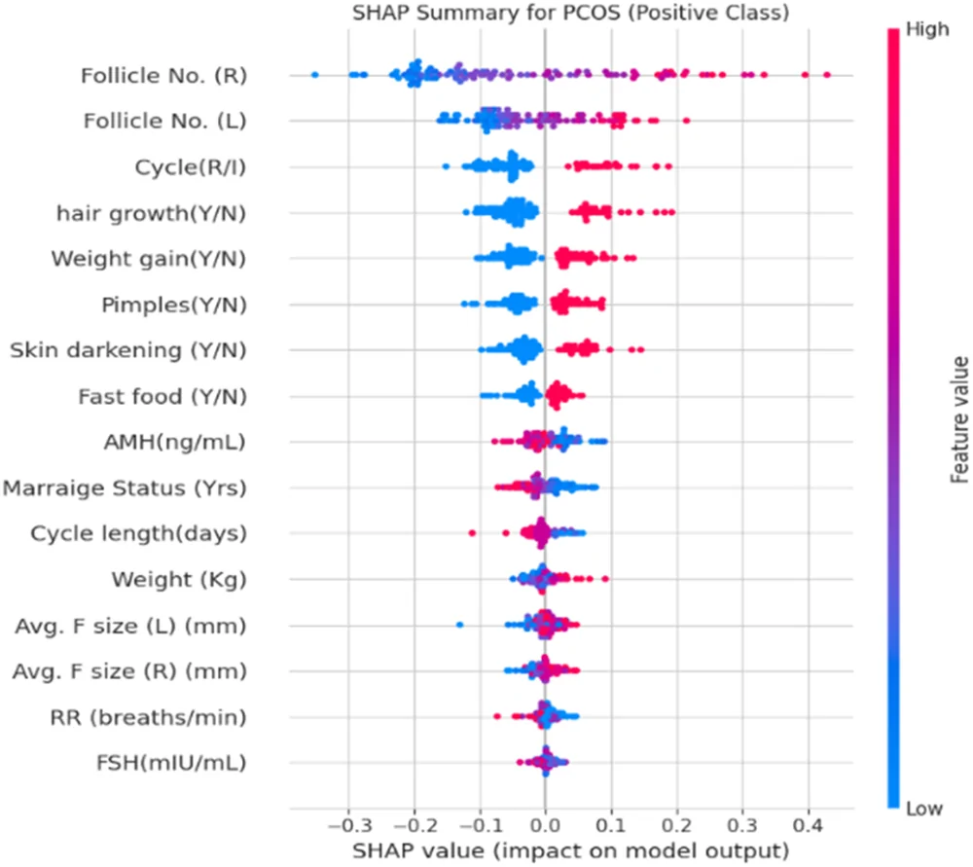
Analytical & Clinical Interpretation: Visualizes global Shapley additive explanations for PCOS-positive predictions. Higher values (red dots) of Follicle (R), Follicle (L), Hair Growth, and Irregular Cycle push the model output strongly toward positive PCOS diagnosis.
Advancement in Our Proposed Model: Our TreeSHAP analysis confirms these findings and reveals that novel Rotterdam features (PCOM_Severe_Flag and Skin_Metabolic_Score) provide the strongest absolute SHAP values, giving clinicians clearer biological explanations.

Figure 15: Global SHAP Summary Beeswarm Plot for Healthy Controls (Non-PCOS Cohort)
Original Paper Caption: Figure 15: SHAP summary plots for PCOS negative case.
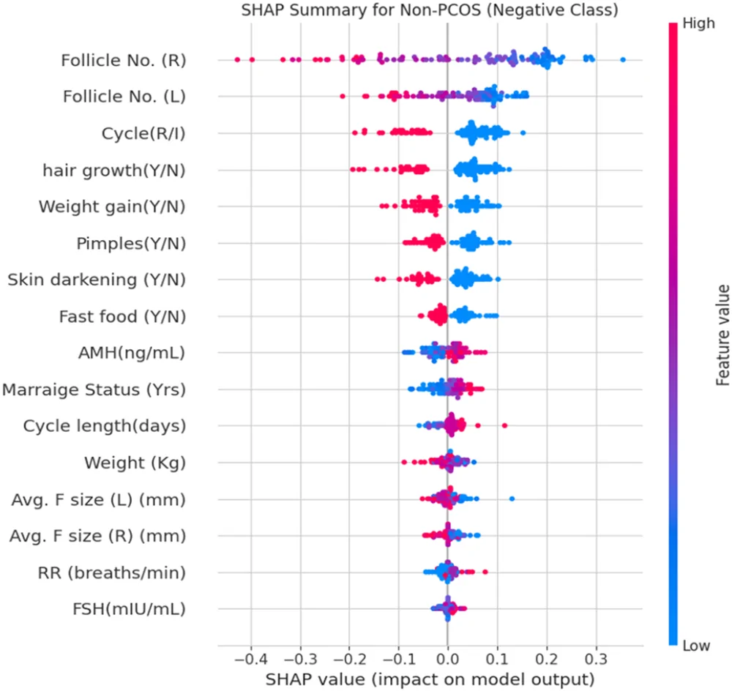
Analytical & Clinical Interpretation: Depicts feature impact distributions for healthy control predictions. Low follicle counts (< 10 per ovary), regular menstrual cycles, and absence of hirsutism strongly push predictions into the negative (healthy) class.
Advancement in Our Proposed Model: Our framework provides both global beeswarm plots and patient-level waterfall plots, clearly decomposing baseline log-odds into individual positive and negative feature contributions.

Figure 16: Local Interpretable Model-Agnostic Explanations (LIME) for a Non-PCOS Patient
Original Paper Caption: Figure 16: LIME for a Non-PCOS case.
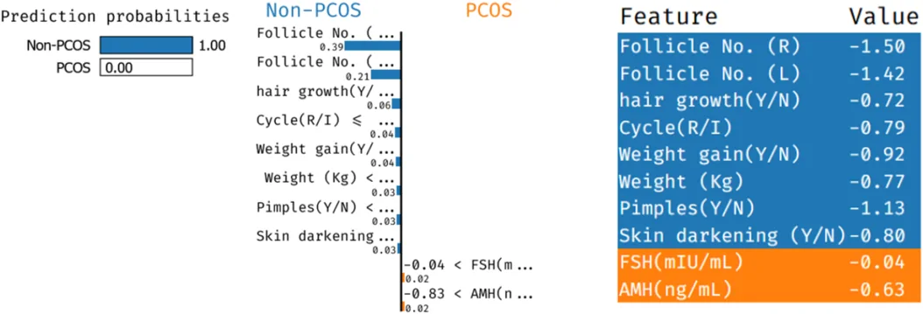
Analytical & Clinical Interpretation: Local explanation bar chart for an individual healthy patient. Quantifies exact percentage contributions of normal follicle numbers, regular cycles, and low AMH in confirming negative PCOS status.
Advancement in Our Proposed Model: Our clinical decision support system generates real-time interactive LIME explanations, enabling clinicians to audit why a patient was deemed low-risk before finalizing clinical discharge.

Figure 17: Local Interpretable Model-Agnostic Explanations (LIME) for a PCOS Positive Patient
Original Paper Caption: Figure 17: LIME for a PCOS positive case.
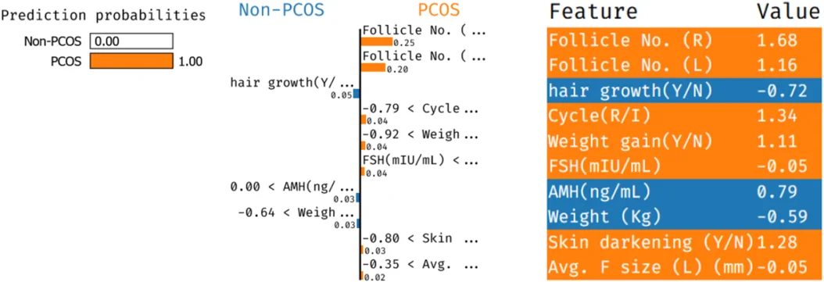
Analytical & Clinical Interpretation: Local explanation bar chart for an individual high-risk PCOS patient. Highlights severe follicle accumulation, irregular cycles, and elevated BMI as the primary risk drivers.
Advancement in Our Proposed Model: Beyond observational LIME explanations, our framework introduces DiCE (Diverse Counterfactual Explanations). DiCE computes the minimal actionable lifestyle modifications required (e.g., reducing fast food intake, reducing weight by 3.2 kg) to transition the patient's predicted risk from positive back to healthy.

