|  |  |  |  |  |  |  |
| --- | --- | --- | --- | --- | --- | --- |
|  | **American International University- Bangladesh (AIUB)** | | | | | |
|  |  |  | **Faculty of Engineering** | | | |
|  |  |  |  |  |  |  |
| **Course Name :** |  | Data Communication |  |  | |  |
| **Semester :** |  | Summer 20-21 |  | **Section:** | | E |
| **Faculty :** |  | Tanjil Amin |  |  |  |  |
|  |  |  |  |  |  |  |
| **Lab Report No :** |  | 3 |  |  |  |  |
|  |  |  |  |  |  | |
| **Student Name:** |  | Seaim,tanzimul haque |  | **Student ID:** | | 19-41676-3 |
|  |  |  |  |  |  |  |
|  |  |  |  |  |  | |
|  |  |  |  |  |  | |
| **Submission Date:** |  | 29 june 2021 |  | **Due Date :** | 30 june 2021 | |

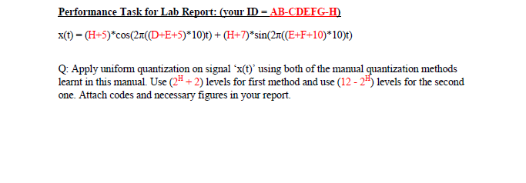

**Quantization Method : 1**

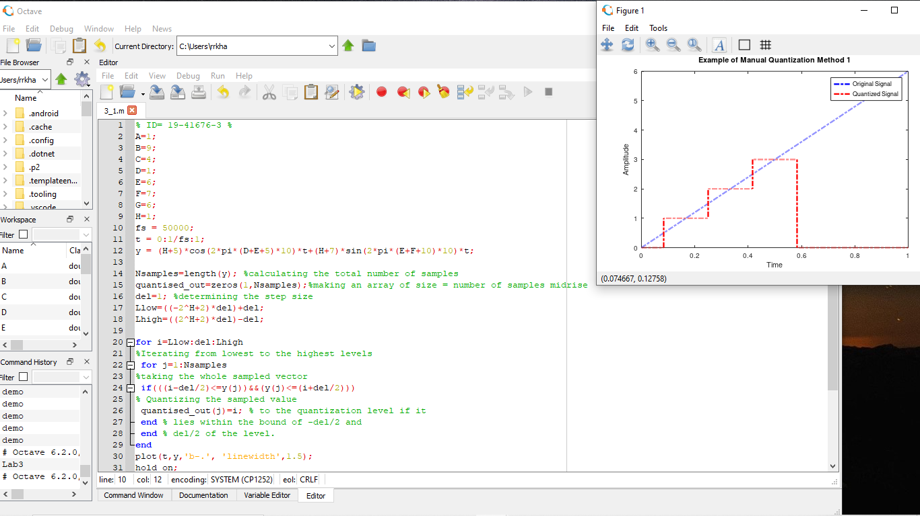

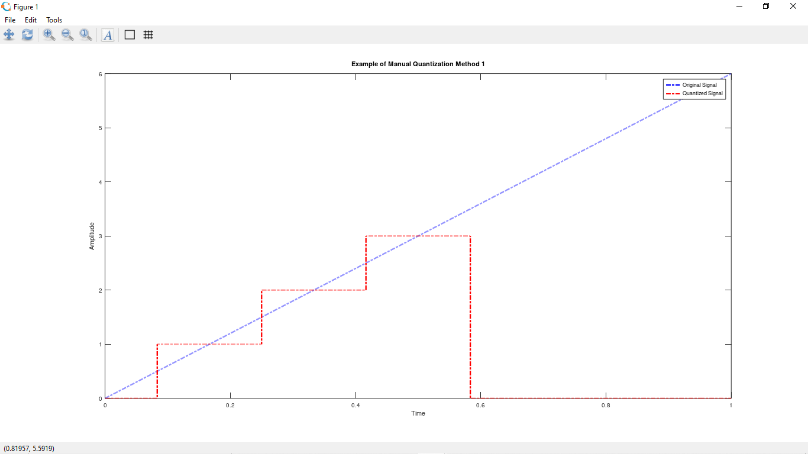

**Code:**

% ID= 19-41676-3 %

A=1;

B=9;

C=4;

D=1;

E=6;

F=7;

G=6;

H=3;

fs = 50000;

t = 0:1/fs:1;

y = (H+5)*cos(2*pi*(D+E+5)*10)*t+(H+7)*sin(2*pi*(E+F+10)*10)*t;

Nsamples=length(y); %calculating the total number of samples

quantised_out=zeros(1,Nsamples);%making an array of size = number of samples midrise

del=1; %determining the step size

Llow=((-2^H+2)*del)+del;

Lhigh=((2^H+2)*del)-del;

for i=Llow:del:Lhigh

%Iterating from lowest to the highest levels

for j=1:Nsamples

%taking the whole sampled vector

if(((i-del/2)<=y(j))&&(y(j)<=(i+del/2)))

% Quantizing the sampled value

quantised_out(j)=i; % to the quantization level if it

end % lies within the bound of -del/2 and

end % del/2 of the level.

end

plot(t,y,'b-.', 'linewidth',1.5);

hold on;

plot(t,quantised_out,'r-.', 'linewidth',1.5);

xlabel('Time')

ylabel('Amplitude')

title('Example of Manual Quantization Method 1')

legend('Original Signal','Quantized Signal')

**Quantization Method: 2**

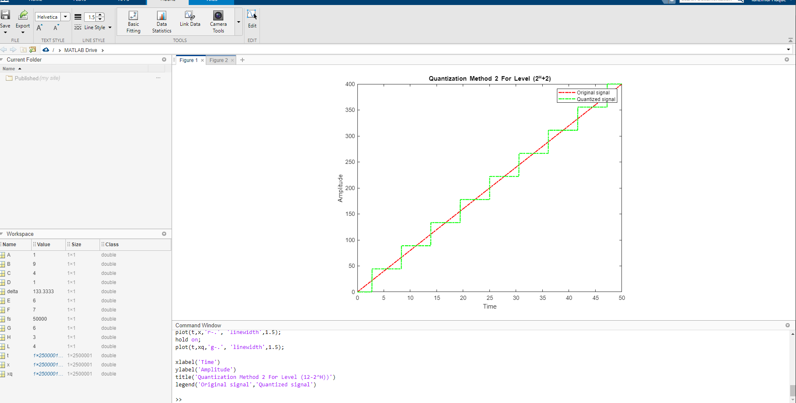

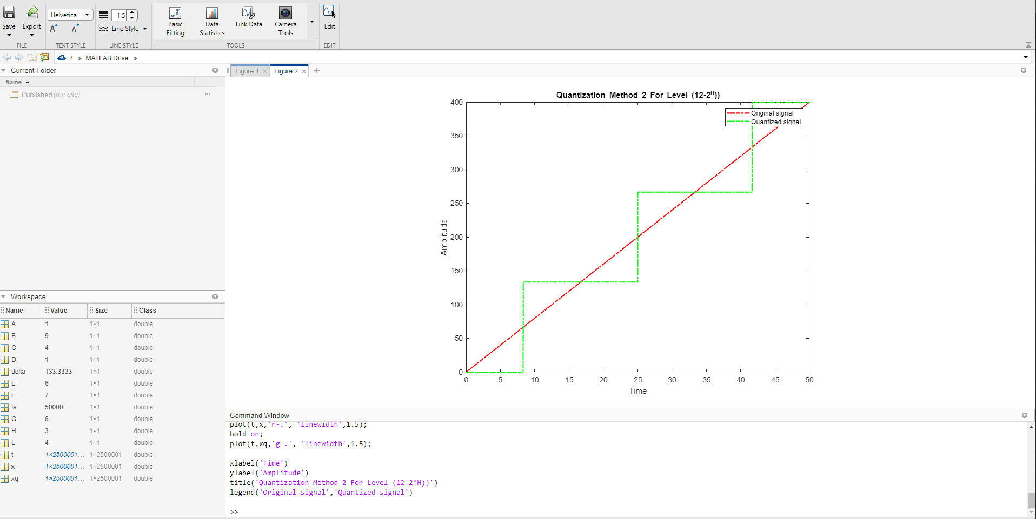

**Code:**

% ID=19-41676-3 %

A=1;

B=9;

C=4;

D=1;

E=6;

F=7;

G=6;

H=3;

fs=50000;

t = 0:1/fs:50;

x=(H+5)*cos(2*pi*(D+E+5)*10)*t+(H+7)*sin(2*pi*(E+F+10)*10)*t;

%--------Quantization For Level (2^H+2)------------%

L = (2^H+2);% Level=4 %

delta=(max(x)-min(x))/(L-1);

xq = min(x)+(round((x-min(x))/delta)).*delta;

plot(t,x,'r-.', 'linewidth',1.5);

hold on;

plot(t,xq,'g-.', 'linewidth',1.5);

xlabel('Time')

ylabel('Amplitude')

title('Quantization Method 2 For Level (2^H+2)')

legend('Original signal','Quantized signal')

%--------Quantization For Level (12-2^H)------------%

L = (12-2^H);% Level=10 %

delta=(max(x)-min(x))/(L-1);

xq = min(x)+(round((x-min(x))/delta)).*delta;

figure;

plot(t,x,'r-.', 'linewidth',1.5);

hold on;

plot(t,xq,'g-.', 'linewidth',1.5);

xlabel('Time')

ylabel('Amplitude')

title('Quantization Method 2 For Level (12-2^H))')

legend('Original signal','Quantized signal')

**Discussion**

1. There are a couple of bugs finished up with MATLAB
2. MATLAB has some limitation
3. Sometime calculation with id was difficult
4. Sometimes the graph looks different than normal sinusoidal graphs foe awkward for id values