**Name:Rahat,Kamal Uddin**

**ID:18-39160-3**

**Mid Term Lab Assignment**

**Course: Data Communication – E**

**Submission:2-07-2021**

Here, MY ID

18-39160-3   
A = 1  
B = 8  
C = 3  
D = 9  
E = 1  
F = 6  
G = 0  
H = 3

A1=A+G+1=1+0+1=2

A2=B+F+1=8+6+1=15

A3=D+E+H+1=9+1+3+1=14

f1=B+F+H+1=8+6+3+1=18

f2=D+E+H+1=9+1+3+1=14

f3=A+G+H+1=1+0+3+1=5

sd=H/2=3/2

Suppose you want to send a signal ‘st’ through a transmission medium.

st = s1 + s2 + s3.

s1 = A1*sin(2*pi*f1*t + pi/2).

s2 = A2*cos(2*pi*f2*t - pi/3).

s3 = A3*sin(2*pi*f3*t + pi/4).

**Answer To The Question No 1**

**Code**

clc

clear all

close all

A1 = 2;

A2 = 15;

A3 = 14;

f1 = 18;

f2 = 14;

f3 = 5;

sd = 3/2;

fs = 123456;

t = -0.5:1/fs:1.2;

S1 = A1*sin(2*pi*f1*t+pi/2);

S2 = A2*cos(2*pi*f2*t-pi/3);

S3 = A3*sin(2*pi*f3*t+pi/4);

plot(t,S1,'r',t,S2,'g',t,S3,'b','LineWidth',1.5);

xlabel('Time(sec)');

ylabel('Amplitude(v)');

title('Time vs Amp');

legend('S1','S2','S3');

**Output Figure**

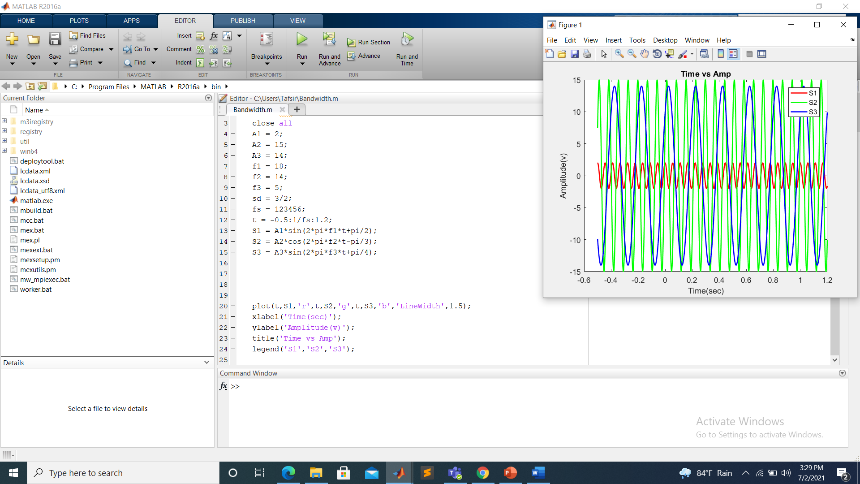

**Code**

clc

clear all

close all

A1 = 2;

A2 = 15;

A3 = 14;

f1 = 18;

f2 = 14;

f3 = 5;

sd = 3/2;

fs = 123456;

t = -0.5:1/fs:1.2;

S1 = A1*sin(2*pi*f1*t+pi/2);

S2 = A2*cos(2*pi*f2*t-pi/3);

S3 = A3*sin(2*pi*f3*t+pi/4);

fS1 = abs(fftshift(fft(S1))/(length(t)/2));

fS2 = abs(fftshift(fft(S2))/(length(t)/2));

fS3 = abs(fftshift(fft(S3))/(length(t)/2));

f = linspace(-fs/2,fs/2,length(t));

figure(1);

subplot(311);

plot(f, fS1,'b','LineWidth',1.5);

axis([-30 30 0 5]);

title('Frequency of S1');

xlabel('Frequency (Hz)');

ylabel('Magnitude');

legend('S1');

subplot(312);

plot(f, fS2,'g','LineWidth',1.5);

axis([-30 30 0 20]);

title('Frequency of S2');

xlabel('Frequency (Hz)');

ylabel('Magnitude');

subplot(313);

plot(f, fS3,'r','LineWidth',1.5);

axis([-30 30 0 20]);

title('Frequency of S3');

xlabel('Frequency (Hz)');

ylabel('Magnitude');

Output figure

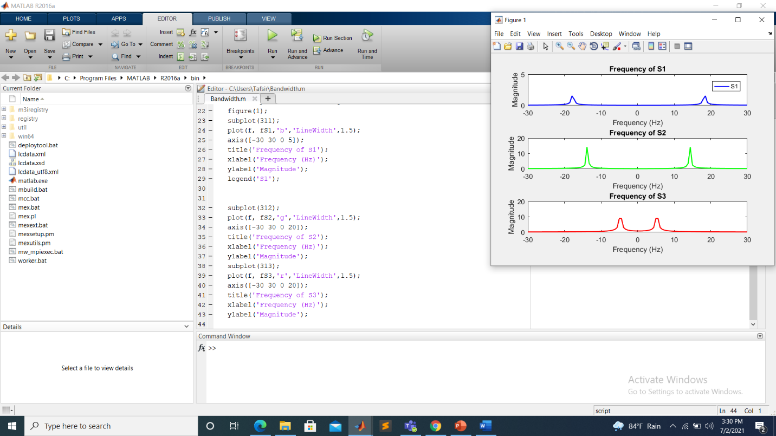

**Answer To The Question No 2**

**Code**

clc

clear all

close all

A1 = 2;

A2 = 15;

A3 = 14;

f1 = 18;

f2 = 14;

f3 = 5;

sd = 3/2;

fs = 123456;

t = -.5:1/fs:1.2;

S1 = A1*sin(2*pi*f1*t+pi/2);

S2 = A2*cos(2*pi*f2*t-pi/3);

S3 = A3*sin(2*pi*f3*t+pi/4);

st = S1 + S2 + S3;

nt = sd*randn(size(st));

noisy_sig = st + nt;

%Theory

p_xt = A1^2/2 + A2^2/2 +A3^2/2;

p_nt = sd^2;

SNR_th = p_xt/p_nt;

SNR_dB_th = 10*log10(SNR_th);

%Function

SNR_dB_func = snr(st,nt);

SNR_func = 10^(SNR_dB_func/10);

Comp_SNR = [SNR_theory SNR_func]

Comp_SNR_dB = [SNR_dB_theory SNR_dB_func]

**Output**

**Command Window SS**

BW_sig = obw(st,fs)

capacity = BW_sig*log2(1+SNR_th)

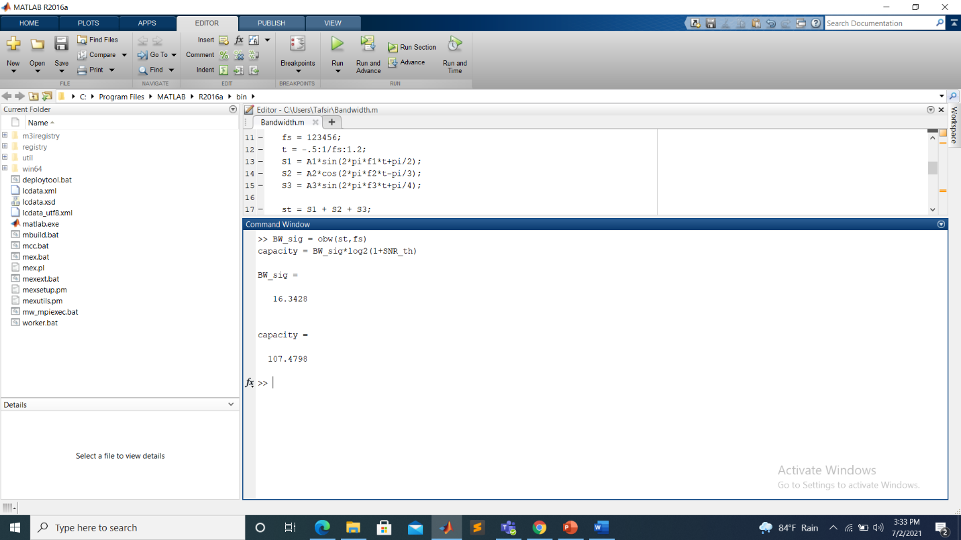

**Discussion:**