1. <https://github.com/hossain434/Docker_Sel_Grid_1> , In this script ‘OrderTest’ checks the homepage dropdown and ‘SearchTest’ checks the google search result.
2. Windows support only Docker Version 17.09.0-ce-win32. After install, docker app visible at bottom right corner of notification screen. Make sure in the settings check ‘Expose daemon on TCP://localhost:2375..’
3. Docker file: This is called source code for Image. This is useful if we have one image.

FROM openjdk:8-jre-slim

# Add the project jar & copy dependencies

ADD target/container-test.jar /usr/share/tag/container-test.jar (Jar version like 0.0.1 we don’t need to consider )

ADD target/libs /usr/share/tag/libs

# Add the suite xmls

ADD order-module.xml /usr/share/tag/order-module.xml

ADD search-module.xml /usr/share/tag/search-module.xml

# Command line to execute the test

# Expects below ennvironment variables

# BROWSER = chrome / firefox

# MODULE = order-module / search-module

# GRIDHOST = selenium hub hostname / ipaddress

ENTRYPOINT /usr/bin/java -cp /usr/share/tag/container-test.jar….

1. FROM openjdk:8-jre-slim – openjdk is a Docker Image with version 8. This Image has facility to create Java environment and run Java app.

More: <https://www.oreilly.com/learning/5-simple-tips-for-building-your-first-docker-image-with-java>

1. ‘ADD’ command is used to copy file to Image. So we can copy Jar, xml there to execute script.

To copy multiple files in a folder use ‘VOLUME’ command (I need to know how to use this).

1. ‘ENTRYPOINT’ command is used to execute the script.
2. In each Image we can create folder like arif/test (‘test’ image under ‘arif’ folder) or we can use their existing folder like ADD target/libs /usr/share/tag/libs – here ‘libs’ folder has been copied from local to /usr/share/tag/libs (We need to configure this in POM.xml).
3. Container creates automatically when Image is built and executed like when we hit ‘docker run’ in command prompt. Multiple images can be in one container but cannot be opposite. A docker container exits when its main process finishes.

Use: docker run -dit ubuntu to run the container in background in interactive mode. (I need to verify this)

1. Docker-compose.yml: Used when there are multiple images like image for Selenium hub, Chrome, Firefox etc and they are depended on each other.

Below yml file to setup Selenium Grid:

version: "3" // compose file format

services:

selenium-hub:

image: selenium/hub // image name ‘hub’ (built in) under selenium folder.

container_name: selenium-hub // image ‘hub’ will launch the running container named ‘selenium-hub’

ports:

- "4444:4444" // Image ‘hub’ will use this port

chrome:

image: selenium/node-chrome // built in image: node-chrome

depends_on:

- selenium-hub // node-chrome depends on container: selenium-hub

environment:

- HUB_PORT_4444_TCP_ADDR=selenium-hub

- HUB_PORT_4444_TCP_PORT=4444

firefox:

image: selenium/node-firefox

depends_on:

- selenium-hub

environment:

- HUB_PORT_4444_TCP_ADDR=selenium-hub

- HUB_PORT_4444_TCP_PORT=4444

search-module:

image: vinsdocker/containertest:demo

container_name: search-module

depends_on:

- firefox

- chrome

environment:

- MODULE=search-module.xml

- BROWSER=firefox

- SELENIUM_HUB=selenium-hub

order-module:

image: vinsdocker/containertest:demo

container_name: order-module

depends_on:

- firefox

- chrome

environment:

- MODULE=order-module.xml

- BROWSER=chrome

- SELENIUM_HUB=selenium-hub

6. maven doesn’t build docker-compose.yml (don’t know why) so I run this file from command prompt.

Through command prompt, I went to the file location and run

docker-compose up -d

Status: docker-compose ps

To bring down: docker-compose down

To increase chrome instance: docker-compose scale chrome=5

Please check the steps [**here**](https://docs.docker.com/compose/install/)for the installation of docker-compose.

<http://localhost:4444/grid/console>

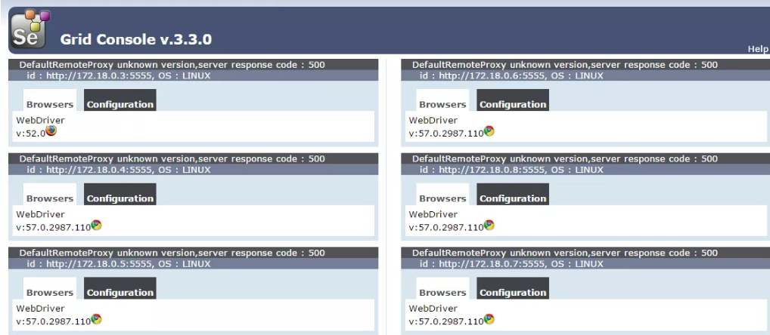

***To run script:*** docker run -e SELENIUM_HUB=10.195.79.159 -e MODULE=search-module.xml -e BROWSER=chrome vinsdocker/containertest:demo (here Ip address nothing but the local host of my machine. If I type localhost, it’s not working. I need to find better way to run script.)

1. By default the plugin will try to connect to docker on localhost:2375. If the docker is not running on your machine and you would like to use remote docker, set the DOCKER_HOST environment variable.

DOCKER_HOST=tcp://<host>:2375

1. Below config is used to create repository. I don’t know why we need to add since we added this image in docker-compose.yml.

<configuration>

<repository>vinsdocker/containertest</repository>

<tag>demo</tag>

</configuration>