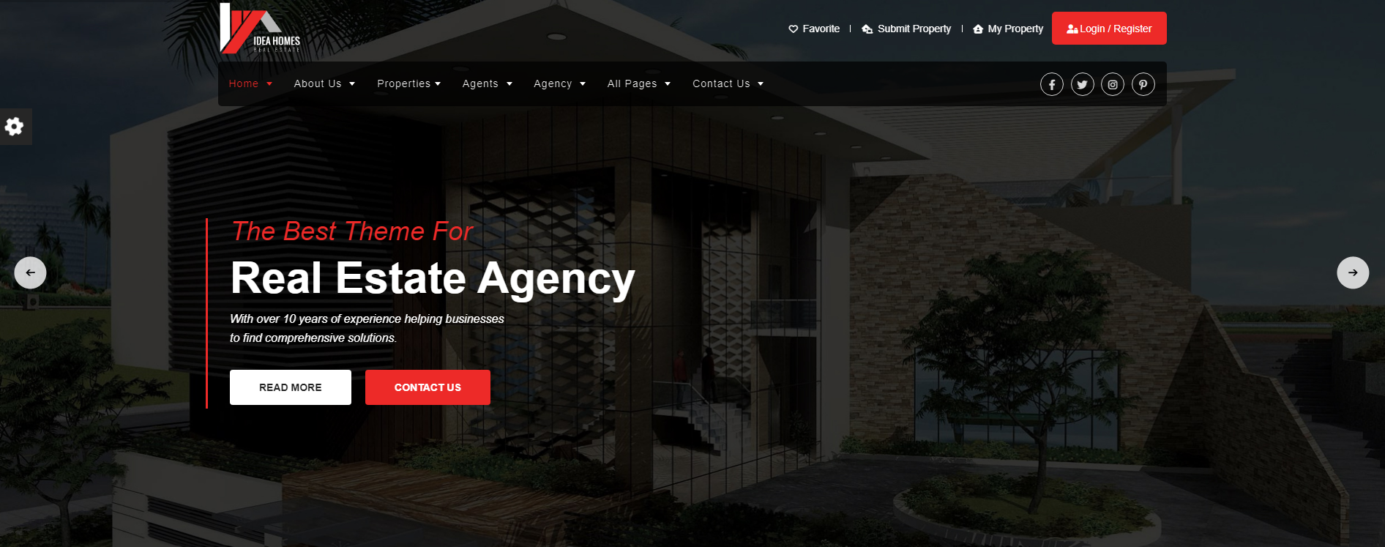
src: https://logicsforest.org/html-preview/ideahomes/idea-home-files/
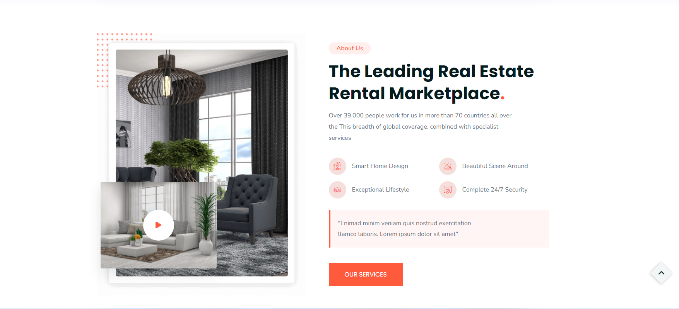
src: https://tunatheme.com/tf/html/quarter-preview/quarter/index.html

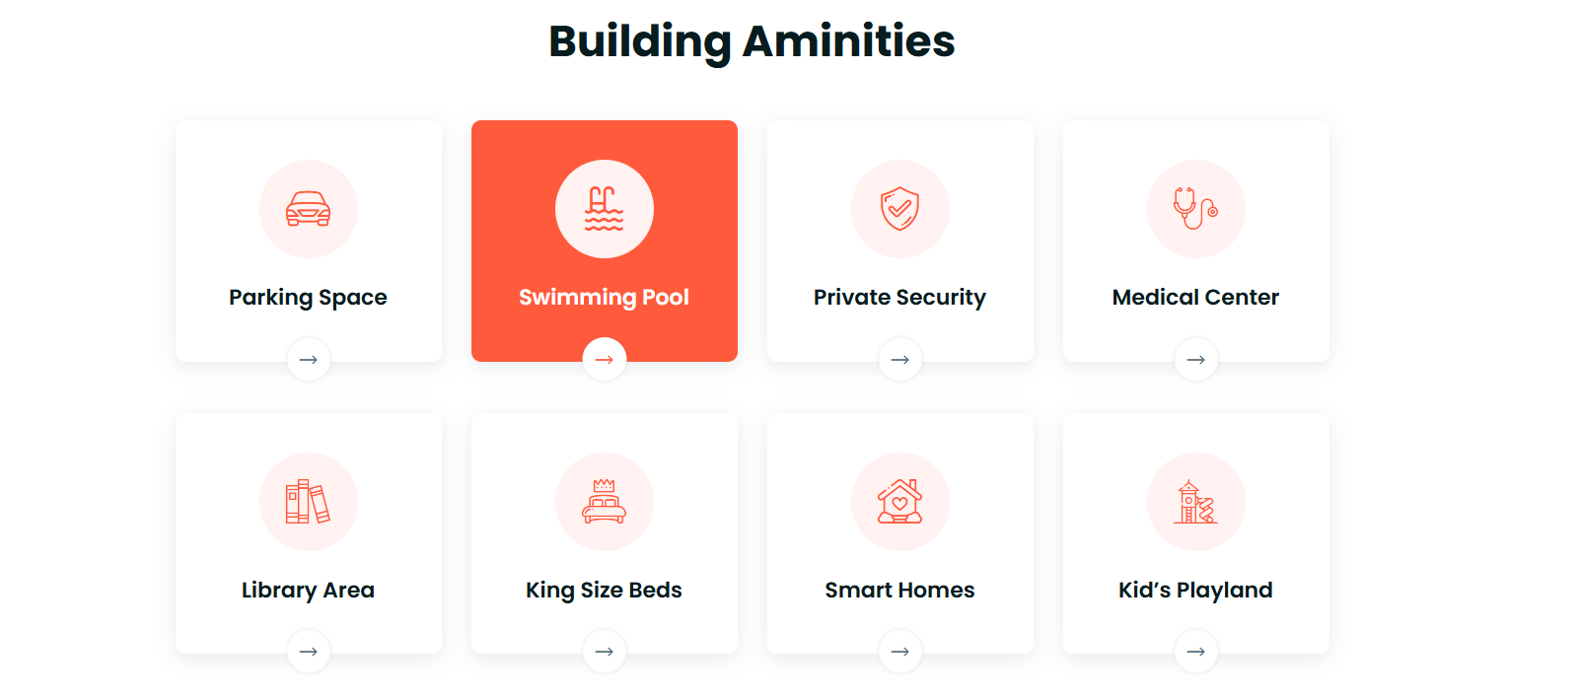
Src: https://tunatheme.com/tf/html/quarter-preview/quarter/index.html

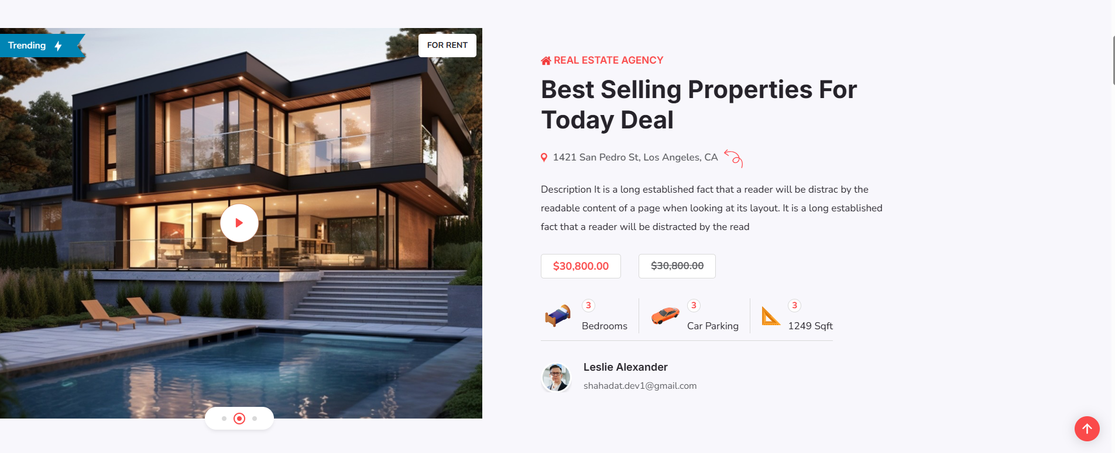
Src: https://risingtheme.com/html/demo-newvilla/newvilla/index-2.html

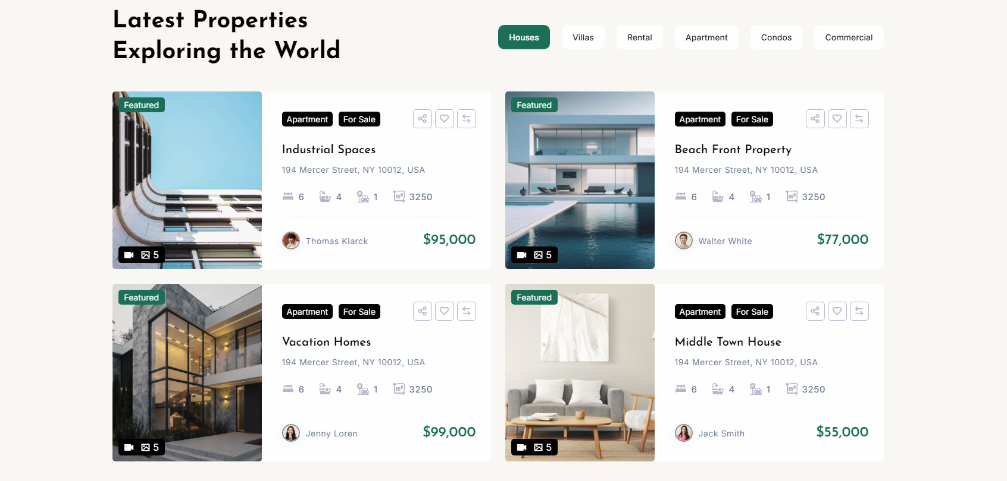
src: https://templates.envytheme.com/andora/default/index-2.html


Src: https://risingtheme.com/html/demo-newvilla/newvilla/index-4.html

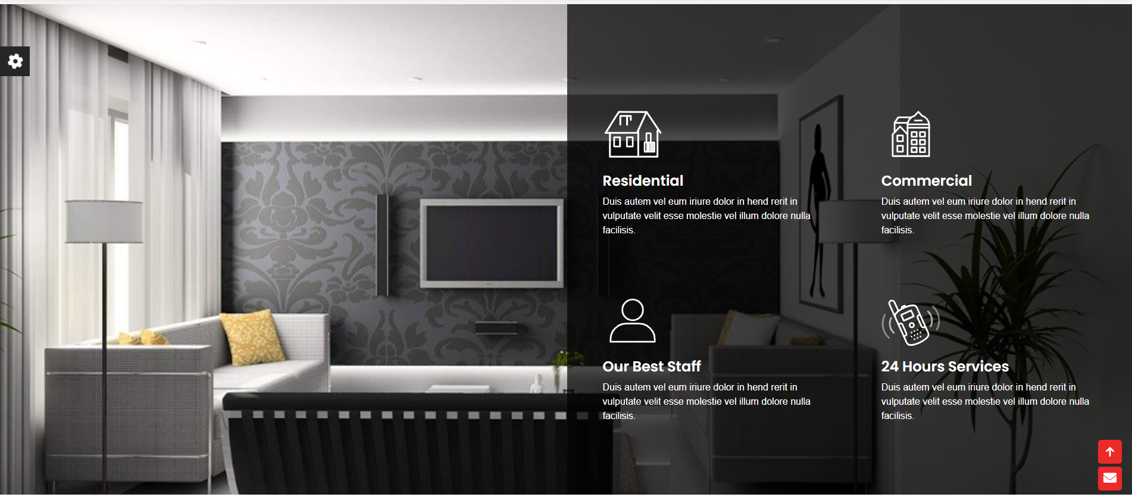
src: https://logicsforest.org/html-preview/ideahomes/idea-home-files/

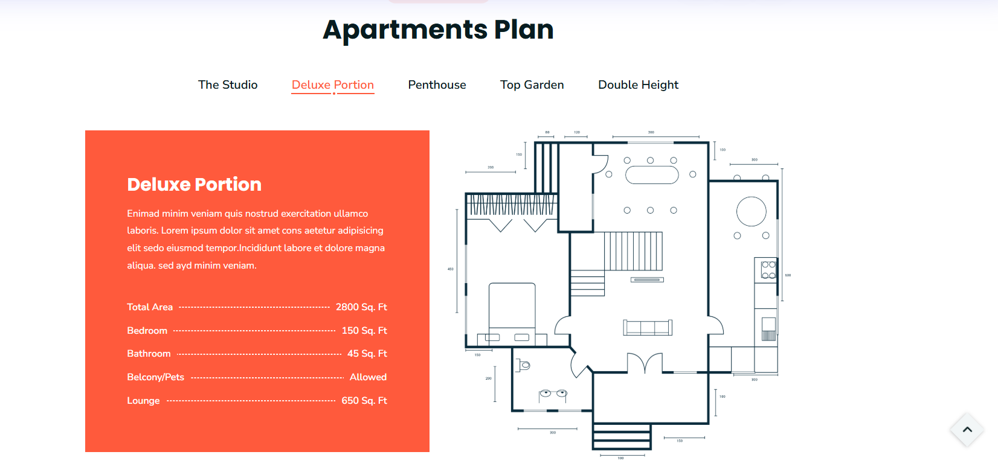
https://tunatheme.com/tf/html/quarter-preview/quarter/index.html

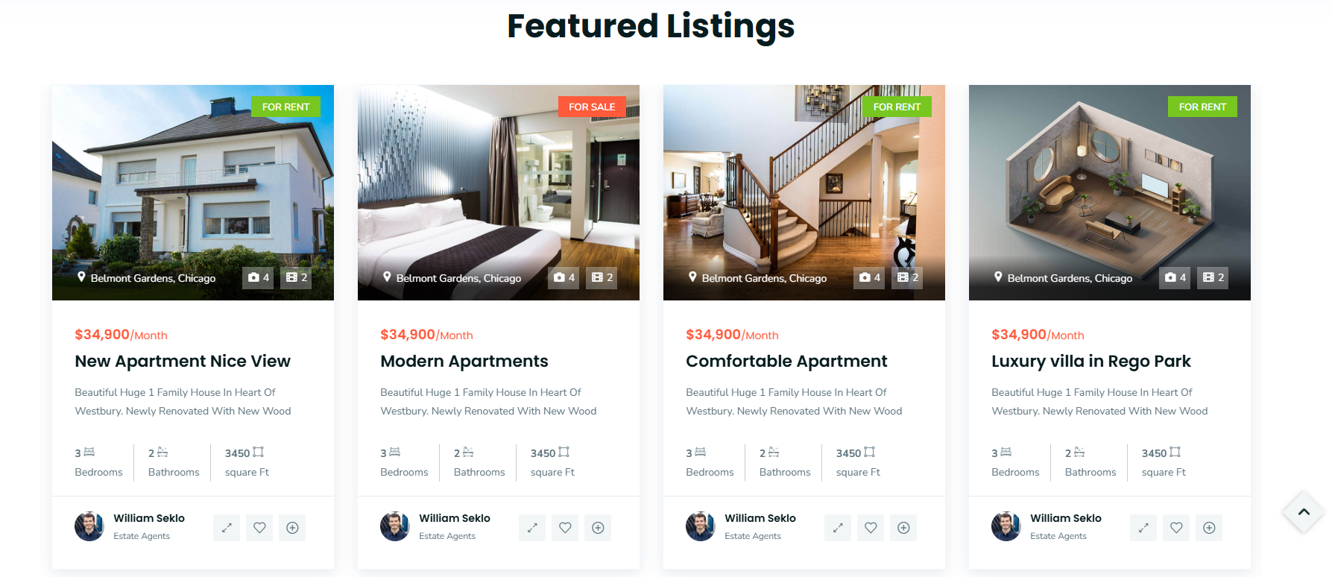
Src: https://tunatheme.com/tf/html/quarter-preview/quarter/index.html


Src: https://templates.envytheme.com/andora/default/index-2.html

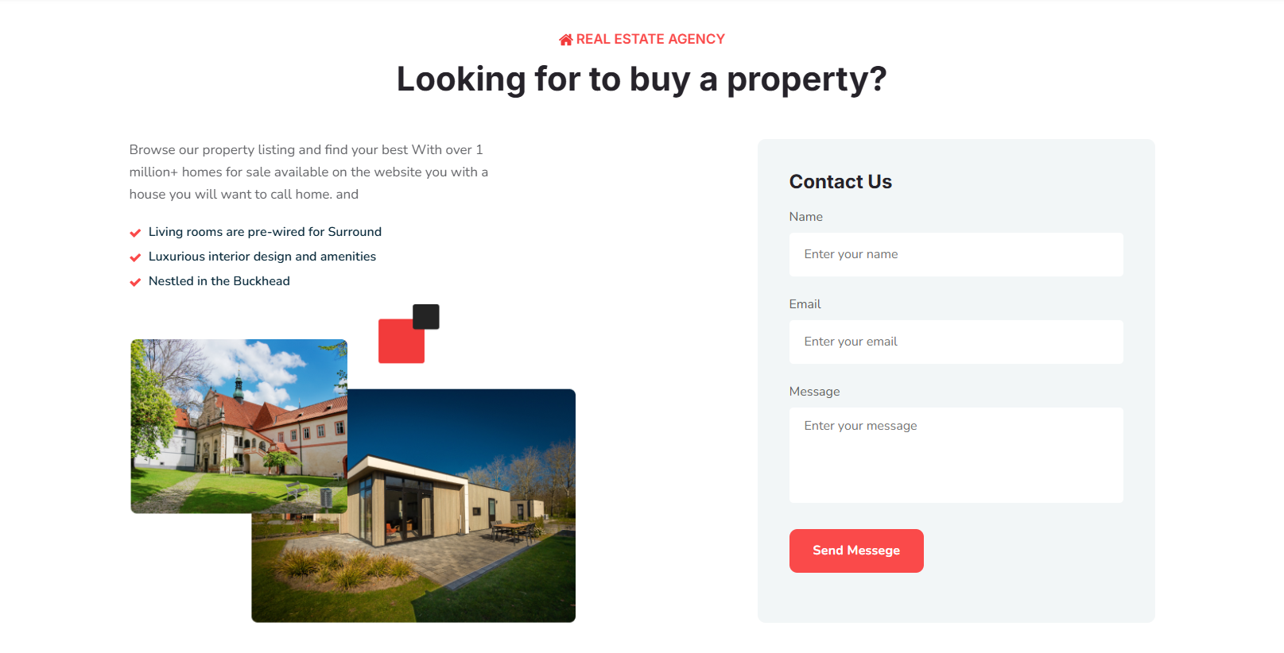
Src: https://risingtheme.com/html/demo-newvilla/newvilla/index-2.html

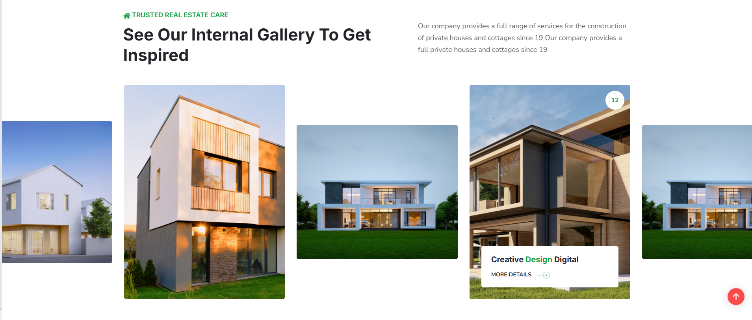
https://risingtheme.com/html/demo-newvilla/newvilla/index-5.html

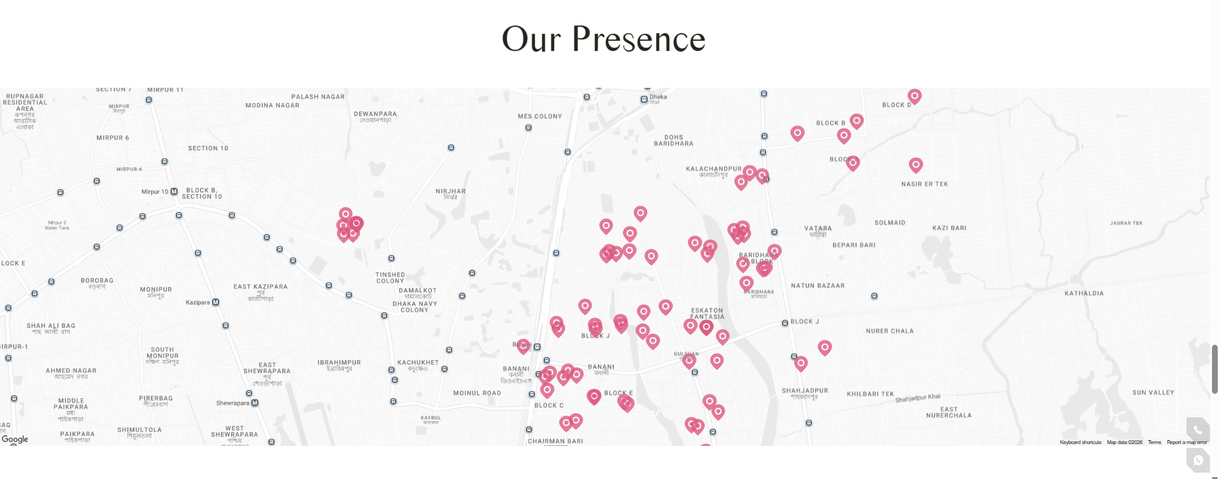
Src: https://navanarealestate.com/

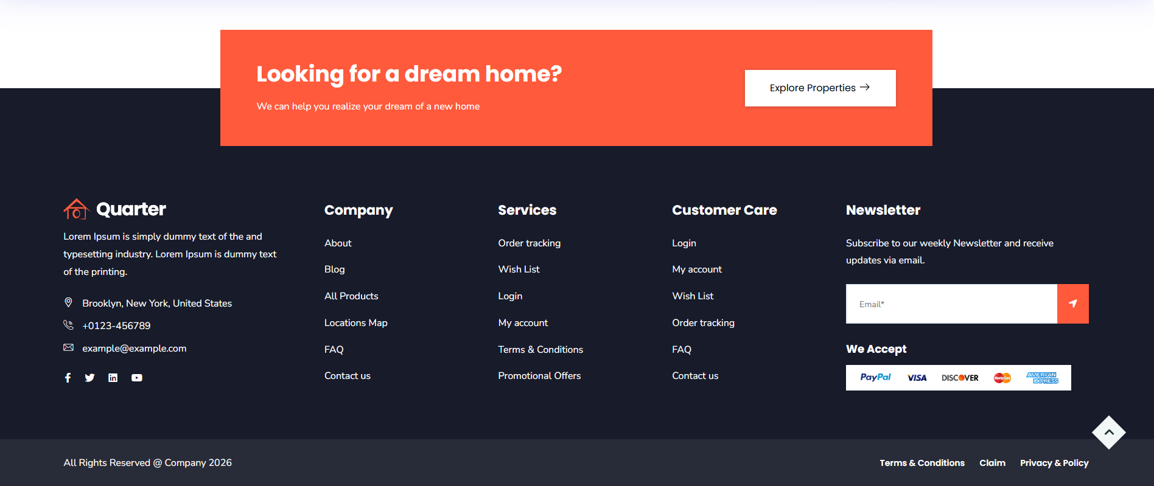
Src: https://tunatheme.com/tf/html/quarter-preview/quarter/index.html

Logo : 
here is color :
/* Brand Colors */
--mars-maroon: #7B1824;
--mars-maroon-dark: #60111A;
--mars-maroon-deep: #480B12;
--mars-maroon-noir: #14080B;

--mars-gold: #E5A922;
--mars-gold-light: #F3C843;
--mars-gold-glow: rgba(229, 169, 34, 0.4);
--mars-gold-subtle: rgba(229, 169, 34, 0.15);
--mars-gold-border: rgba(229, 169, 34, 0.25);

/* Canvas & Surfaces */
--mars-bg-light: #FAF7F2;
--mars-card-bg: #FFFFFF;
--mars-border-subtle: #E8DFD3;

/* Typography Colors */
--mars-text-main: #2B2B2B;
--mars-text-muted: #6B6560;
--mars-text-light: #FAF7F2;
--mars-text-white: #FFFFFF;

Using https://fontawesome.com/
Using: tailwind css

