**Introduction**

The purpose of the experiment was to investigate the effects of soaking temperature on the increase in beans (Phaseolus vulgaris) length over their dry length when soaked in water for 12 hours. The two soaking temperatures were room and refrigeration temperature.

**Materials and Methods**

The experiment was performed by allocating 30 dry beans at random to each temperature treatment conditional on the constraint that we have equal numbers of short, medium and long beans in each temperature treatment. The beans were labelled in order to keep track of the beans. The cold’s treatment water was chilled before the beans were immersed. After the beans were soaked for 12 hours, each bean’s-soaked length was recorded. The data was recorded in an excel sheet.

The statistical analyses used to analyze the results was independent sample t test. This test investigates whether there is a significant difference in the means of two independent groups. The two temperature treatments are independent thus the justification to use this type of test. Before the test was conducted the assumptions, which were investigated included the assumption of normality and the assumption of constant variance. The Q-Q plot, Anderson-Darling test and the Shapiro-Wilks testwas used to test for normality, Box plot was used to test for the presence of outliers in the data. The Levene’s and Bartlett's test was used to detect the presence of heteroscedasticity in the data.

**Results**

The study calculated the value of t manually by the following formula,

Putting the values in the above formula, the value of t calculated is given by:

Mean and variance of treatment one (Room temperature) 0.304 and 0.016 respectively. Mean and variance for treatment two (Chilled temperature) 0.238 and 0.007 respectively. Replacing the values in the formula above we have:

The probability of two tailed is 0.020

**Comment**

Since the p value is less than our chosen significance level α = 0.05, we have enough evidence to reject the null hypothesis, and conclude that the mean of the difference of length for room temperature and chilled temperature is significantly different. The positive t value indicates that the mean difference of length for the first treatment (Room temperature) is significantly greater than the mean difference of length for the second treatment (Chilled temperature).

Based on the results, we can state the following:

* The increase in bean length among the warm temperature (Room temperature) was significantly greater than that observed in the cool temperature (Chilled temperature) group (
* The average bean length for warm temperature is 0.066 mm long than the average bean length for cold temperature.

|  |  |  |  |  |  |  |
| --- | --- | --- | --- | --- | --- | --- |
| t | df | Sign. | Mean Difference | Std. Error | 95% Confidence Interval | |
| lower | upper |
| 2.39925 | 58 | .01966 | .06600 | .02751 | .01094 | .12106 |

As indicated in Figure 1, in both tested temperatures there was an increased length for the soaked beans compared to their initial weights.

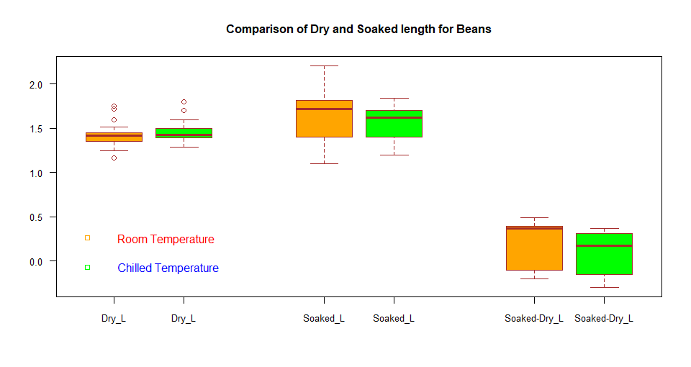

Fig1: Box plot for comparison of dry and soaked length for beans

**Check independent sample t-test assumptions: Test validity?**

The independent sample t-test assumes that, the data are normally distributed and the variance across groups are homogeneous. We can check that with some diagnostic plots and Some Non-parametric test.

**Check Outliers for each treatment:**

Outliers can be easily identified using box plot

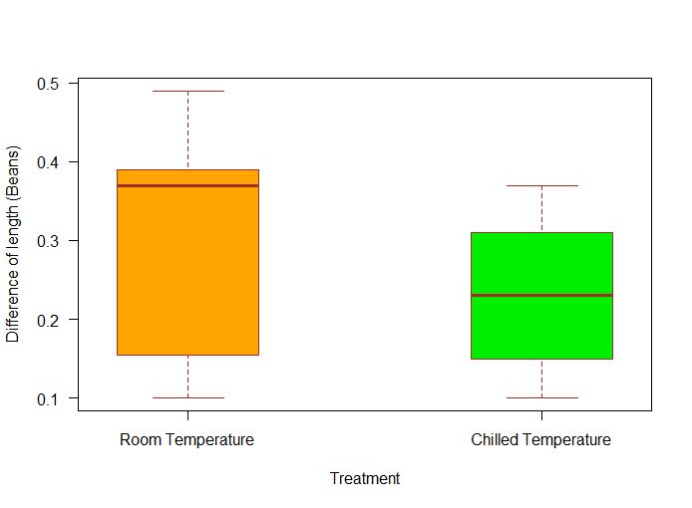

*Fig1*: *Boxplot for the differences of lengths at the two treatments*

**Comment**

There were no outliers in both treatment group

**Check Normality assumption for each treatment:**

The QQ plot is used to check the assumption that the data are normally distributed. It should approximately follow a straight line. In the plot below, the QQ plot are plotted for each treatment against the quantiles of the normal distribution. A 45-degree reference line is also plotted.

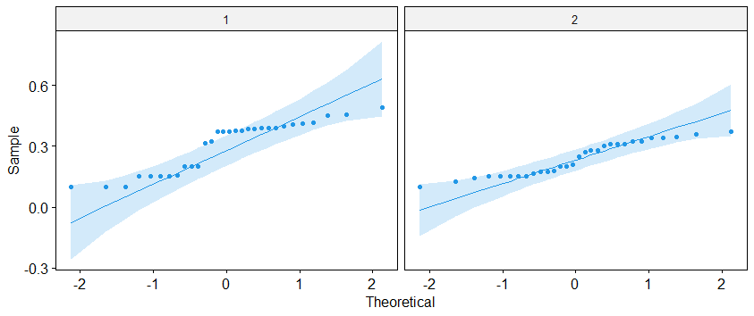

*Fig. 2 Q-Q plot for the treatment1 and treatment2*

The findings of the QQ plot are that majority of the observations for both treatment do not fall approximately along the reference line and thus the study concludes that the observations are not normally distributed. This conclusion is supported by the Anderson-Darling test and the Shapiro-Wilks test. If the data is normally distributed, the p-value should be greater than 0.05.

**Tests of Normality:**

***Table2***

|  |  |  |  |  |
| --- | --- | --- | --- | --- |
|  | Anderson-Darling | | Shapiro-Wilk | |
| Temperature | Statistic | p-value | Statistic | p-value |
| Room | 1.9379 | 0.0305 | 0.8583 | 0.0009 |
| Chilled | 1.1154 | 0.0053 | 0.9082 | 0.0134 |

**Comment:**

From table2, hence all the p value is less than 0.05 for each treatment, we have enough evidence to reject null hypothesis, which indicates that the normality assumption is violated. The conclusion from QQ plot is supported by the both Anderson-Darling and Shapiro-Wilk test.

**Remedial measures of normality assumption violation:**

From above the result we can find that the normality assumption is violated, to remedy the problem a suitable transformation is required. log, square-root and box cox transformation were performed but the data do not follow normality assumption under any circumstances.

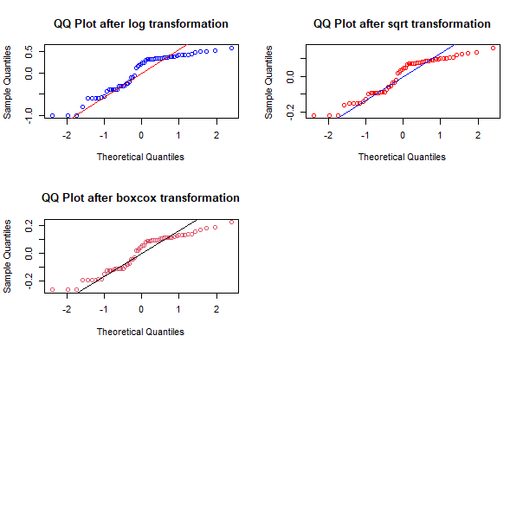

**Check the homogeneity of variance assumption**

For the assumption of constant variance, the results are presented in Table 2.

For the assumption of constant variance, the results are presented in Table 2

*Table 3: Levene’s and Bartlett test for constant variance*

|  |  |  |  |  |
| --- | --- | --- | --- | --- |
|  | Statistic | df 1 | df 2 | p-value |
| Levene’s Test | 11.09 | 1 | 58 | 0.00151 |
| Bartlett test | 4.5084 | 1 |  | 0.03373 |

**Comment**

From the output above we can see that the p-value is less than the significance level of 0.05. This means that there has enough evidence to reject the . Which suggest that the variance across treatment is statistically significantly different. Therefore, we cannot assume the homogeneity of variances in the different treatment groups. hence, we conclude that the assumption of constant variance is violated.

**Note**

From above the discussion, we can see that normality and homogeneity of variance assumption for independent sample t test is violated. When one or more of the assumptions for the Independent Samples t test are not met, we may want to run the non-parametric Mann-Whitney U Test instead.

**Rank Table**

Table4

|  |  |  |  |  |
| --- | --- | --- | --- | --- |
|  | Treatment | Obs. | Mean of Rank | Sum of Ranks |
| Difference of length | Room Temperature | 30 | 36.37 | 1091.00 |
| Chilled Temperature | 30 | 24.63 | 739.00 |

The table above is very useful because it indicates which treatment can be considered as effective for increasing the bean length, overall; namely, the treatment with the highest mean rank. In this case, the room temperature is effective for increasing the bean length.

**Test Statistics Table**

This table shows us the actual significance value of the test. Specifically, the **Test Statistics** table provides the test statistic, *U* statistic, as well as the asymptotic significance (2-tailed) *p*-value.

|  |  |
| --- | --- |
|  | Difference of length |
| Mann-Whitney U | 274.000 |
| Wilcoxon W | 739.000 |
| Z | -2.608 |
| Asymp. Sig. (2-tailed) | .009 |

From this data, it can be concluded that the increase in bean length among the warm temperature (Room temperature) was significantly greater than that observed in the cool temperature (Chilled temperature) group (*U* = 274, *p* = .009).