Evaluating the false-positive rate of single-cell copy-number and malignant-cell classifiers

Md. Jubayer Hossain^{1,2,*} (co-authors)
¹Center for Health Innovation, Research, Action, and Learning—Bangladesh
²DeepBio Ltd.
Correspondence: Md. Jubayer Hossain, Center for Health Innovation, Research, Action, and Learning—Bangladesh, E-email: contact.jubayerhossain@gmail.com
Abstract
Single-cell studies of cancer routinely partition cells into malignant and non-malignant compartments using copy-number inference or supervised classifiers, and every downstream claim — tumour heterogeneity, clonal architecture, malignant-cell programmes — inherits whatever errors that partition makes. These methods are almost never evaluated on tissue that contains no tumour, so their false-positive rate is unknown. We assembled 14 tumour-free single-cell RNA-seq datasets (36,528 cells, 76 donors, 10 healthy organs and 4 tissues from inflammatory-disease cohorts) and ran three widely used malignant-cell callers under five published decision rules. Every positive call in this panel is, by construction, false. Published rules produced false malignant calls in every tissue examined, at rates spanning 0.5–19.3% for the two-criterion rule of Tirosh and colleagues [1] and 4.5–78.0% for a forced two-group split. CopyKAT called 3.0–63.0% of cells aneuploid, exceeding 20% in 9 of 14 datasets; the supervised classifier ikarus called 0–100%, exceeding 50% in 4 of 14. Pooled over the panel, CopyKAT and ikarus each assigned roughly 31% of tumour-free cells to the malignant class. We then built in-silico positive controls by imposing arm-level dosage changes of known magnitude on real cells, and found that per-cell discrimination is near chance for single events (AUC 0.53) and reaches only 0.85 at 18 arm events. At matched false-positive rate, simply ranking cells by the continuous copy-number score detects roughly twice as many aneuploid cells as the published rule operating at that rate: the rules do not add information to the score, they choose a poor operating point on it. The false calls are not random. They share a reproducible pseudo-karyotype that correlates across independent tissues (median Spearman ρ = 0.54) and is predicted by local gene density (ρ = −0.53, P = 2×10⁻²¹): gene-dense regions appear deleted and gene deserts appear gained. Finally, we show that a cell-type-conditional empirical null, fitted on tumour-free reference cells and applied as a calibrated decision rule, holds the realized false-positive rate at or below its nominal target in 13 of 14 datasets (median 0.03%, maximum 0.43% at α = 5%), and that the single failure — a dataset from a different protocol — is repaired by drawing the null from held-out donors of the same dataset (27.1% → 0.03%). We provide the calibration as a small, caller-agnostic layer that consumes any per-cell copy-number score.
Keywords: single-cell RNA-seq; copy-number inference; malignant-cell classification; negative controls; false-positive rate; calibration

Introduction
The separation of malignant from non-malignant cells is the first irreversible decision in most single-cell cancer analyses. It defines the denominator for tumour-cell abundance, the population in which intratumoural heterogeneity is measured, the cells from which malignant expression programmes are derived, and the input to clonal reconstruction. Two families of method dominate. The first infers large-scale copy-number variation from average expression in sliding genomic windows, following the approach introduced for oligodendroglioma, melanoma and glioblastoma [2,1,3] and implemented in inferCNV [4], CopyKAT [5] and related tools [6,7,8,9,10]; cells are then declared malignant by thresholding a per-cell summary of the inferred profile, or by clustering cells on that profile and designating one or more clusters as tumour. The second trains a supervised classifier on labelled tumour and normal cells and applies it to new data; ikarus [11] is the most widely used example.
Both families are evaluated, when they are evaluated at all, on tumour samples — where the ground truth is itself often derived from the same or a closely related signal, and where a cell called malignant cannot easily be proven normal. The complementary experiment is rarely done: run the caller on tissue that contains no malignant cells and count the calls. Every such call is a false positive with certainty, requiring no ground-truth annotation beyond the provenance of the sample. This is the experiment we report here.
The question matters beyond method benchmarking. A false-positive rate of a few per cent would be a minor nuisance; a rate of tens of per cent would mean that a substantial fraction of the cells contributing to published malignant programmes are normal cells, and that apparent tumour heterogeneity partly reflects normal cell-type diversity misassigned to the tumour compartment. The direction of the resulting bias is not random if the false calls are themselves structured — if, for instance, the cells most likely to be miscalled are those with particular transcriptional or technical properties.
We address three questions. First, what is the false-positive rate of current malignant-cell calling in tumour-free tissue, and how does it depend on the decision rule rather than on the underlying score? Second, what drives the false calls — is there a systematic artefact, and can it be attributed to a property of the genome or of the assay? Third, can the decision step be replaced by a calibrated procedure with a controlled and verifiable false-positive rate, without retraining or replacing the underlying caller?

Results

A tumour-free panel on which every positive call is false
We assembled 14 single-cell RNA-seq datasets in which no malignant cells are expected (Supplementary Table S1). Ten are healthy adult organs from a multi-organ reference atlas [12] — bone marrow, kidney, large intestine, liver, lung, pancreas, skin, small intestine, spleen and stomach — profiled on a common 10x 3′ v3 protocol. Four are drawn from inflammatory-disease cohorts: epithelial and immune compartments of Crohn’s disease colon [13], psoriatic skin [14], and colon from an ulcerative colitis cohort [15]. The inflammatory-cohort tissues were included deliberately: inflammation induces strong, coordinated transcriptional programmes that are a plausible source of copy-number-like artefacts, and inflamed tissue is a common benign comparator in cancer studies. After subsampling, the panel comprises 36,528 cells from 76 donors.
We ran three callers across the full panel. The first is infercnvpy 0.6.1, a Python implementation of the inferCNV sliding-window algorithm (100-gene windows, 10-gene step), run in two reference modes: reference-free (each cell compared to the dataset mean) and immune-reference (T, B, NK, myeloid and related cells designated as diploid). The second is CopyKAT 1.2.5, run with the same immune reference. The third is ikarus 0.0.3, applied with its published pan-cancer gene signature and classifier. On the copy-number profiles we applied five decision rules taken from published practice: a forced two-group split, designation of the highest-scoring cluster as tumour, a per-cell quantile cutoff, a cutoff at a fixed multiple of the reference standard deviation, and the two-criterion rule of Tirosh and colleagues requiring both a high copy-number score and high correlation to the mean profile of the top-scoring cells.
Every caller and every rule produced false malignant calls, in every tissue (Figure 1a). With an immune reference, the two-criterion rule called 0.5–19.3% of cells malignant depending on the dataset; the forced two-group split called 4.5–78.0%. CopyKAT called 3.0–63.0% of cells aneuploid, exceeding 20% in 9 of 14 datasets and reaching 63.0% in both healthy large and small intestine, 50.3% in healthy skin and 49.8% in healthy pancreas; pooled over the panel it called 30.7% of tumour-free cells aneuploid. A further 0–80.6% of cells per dataset were returned as not.defined and are excluded from the denominators above; restricting to cells CopyKAT classified, the pooled rate is 35.3%. ikarus called 0–100% of cells tumour, exceeding 50% in 4 of 14 datasets, with 100% of Crohn’s colonic epithelium and 91.8% of healthy liver assigned to the tumour class, and 30.6% pooled. The three callers do not agree on which tissues are problematic: healthy liver is 91.8% tumour by ikarus and 10.3% aneuploid by CopyKAT, while healthy small intestine is 63.0% aneuploid by CopyKAT and 0.0% tumour by ikarus.
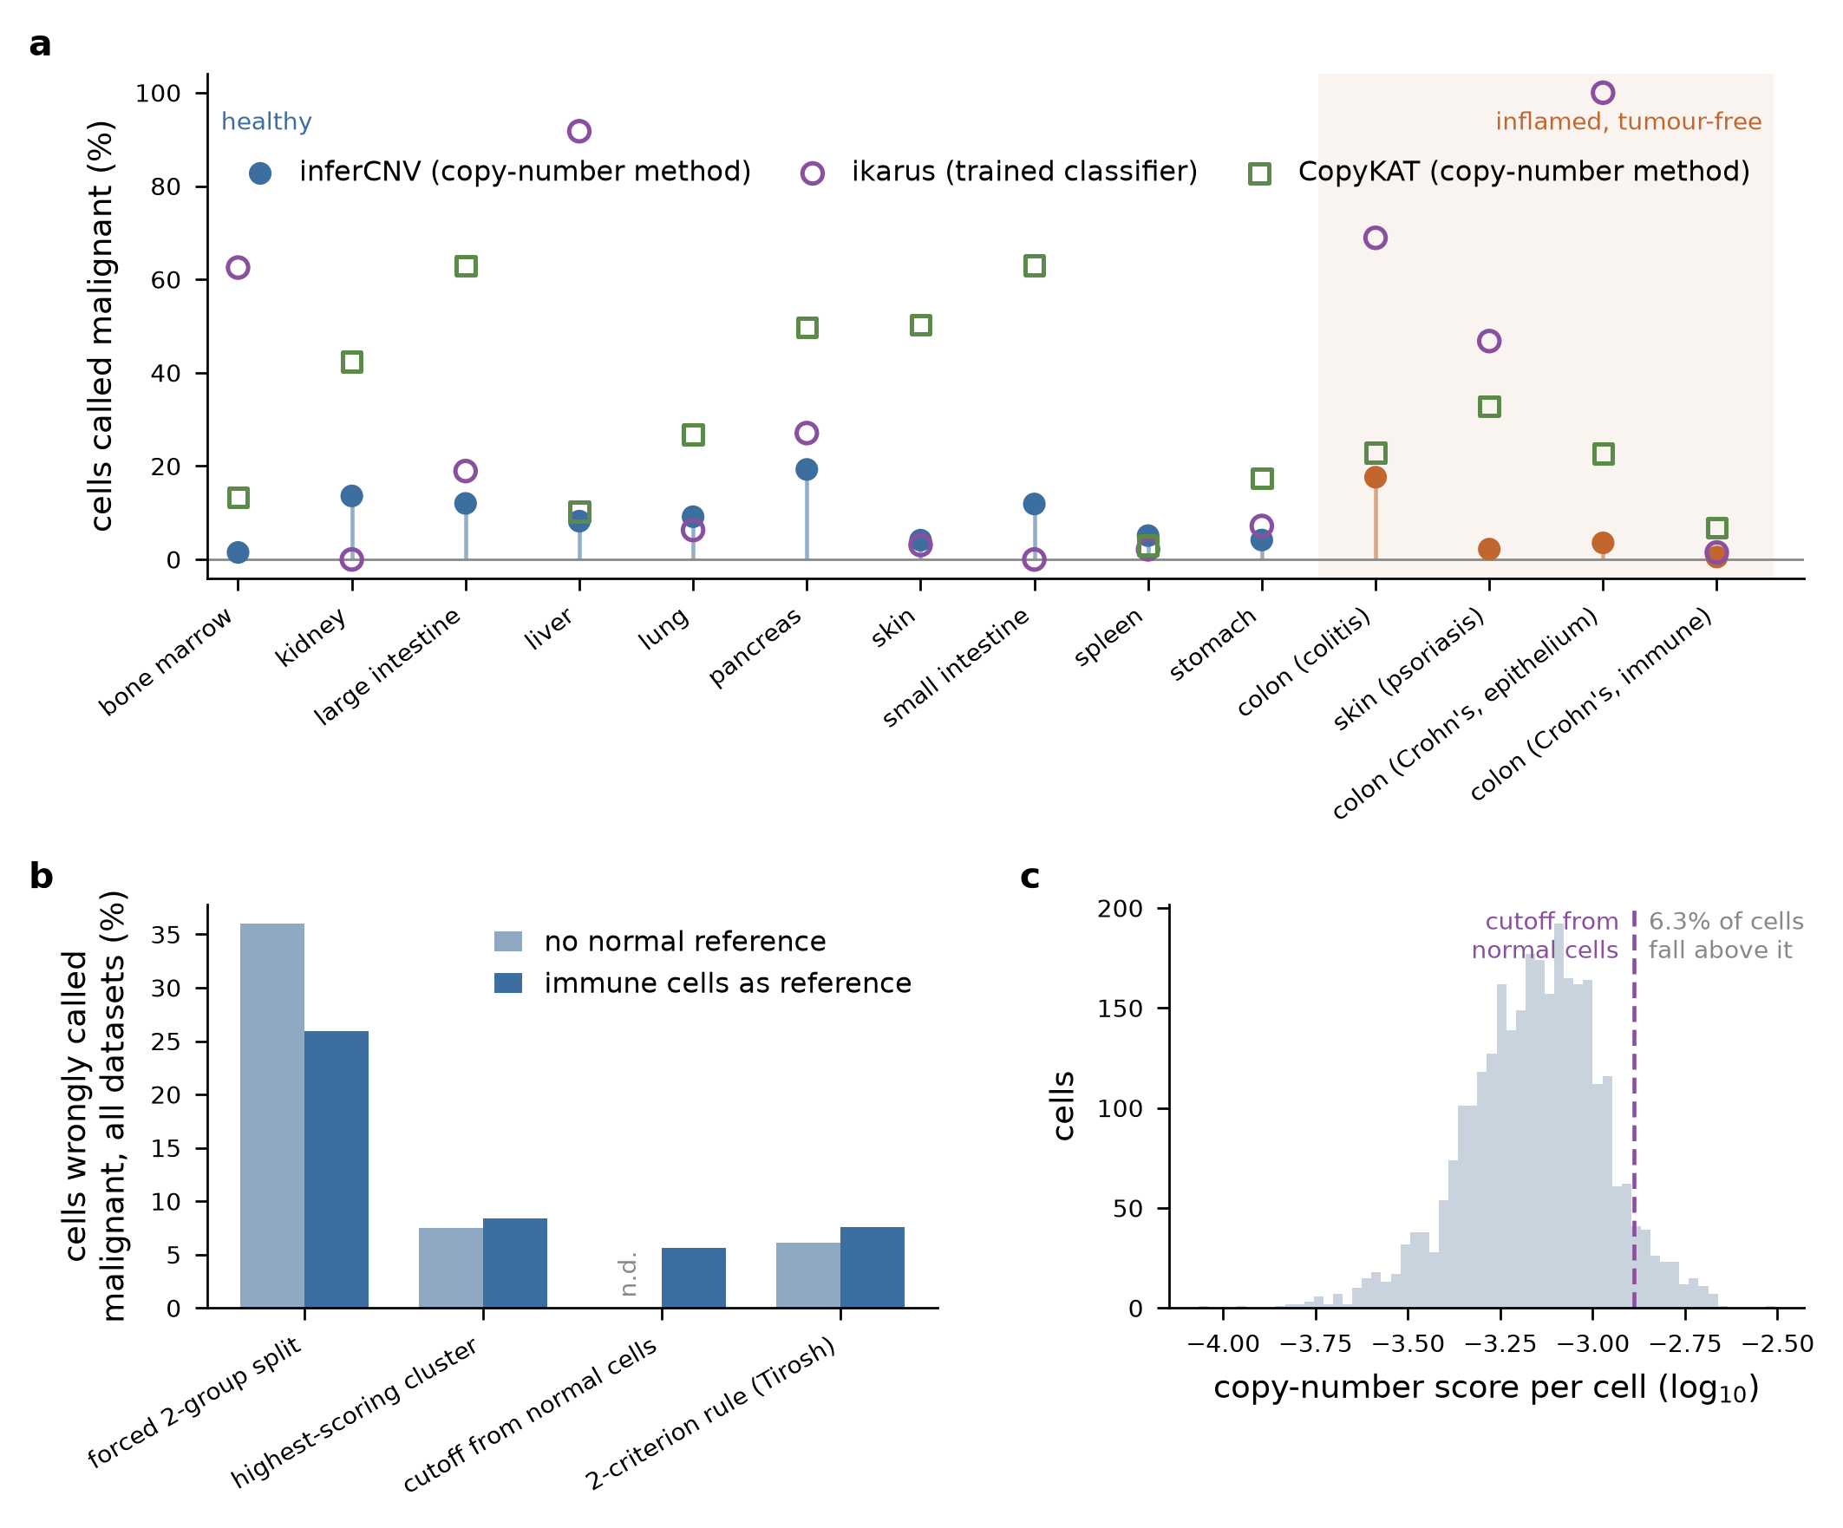
Malignant-cell callers assign tumour labels to tumour-free tissue. (a) Percentage of cells called malignant in each of 14 tumour-free datasets by infercnvpy under the two-criterion (Tirosh) rule, by CopyKAT, and by the supervised classifier ikarus. Every call shown is a false positive. The shaded region marks datasets from inflammatory-disease cohorts. inferCNV values use the immune-reference mode where an immune reference was available and the reference-free mode otherwise. (b) Pooled false-call rate across the panel for four decision rules applied to the same copy-number profiles, in reference-free and immune-reference modes. The reference-SD rule is undefined without a reference (n.d.). (c) Distribution of the per-cell copy-number score in healthy lung (immune-reference mode). The dashed line is the reference-SD cutoff realized on this dataset, which lands inside the bulk of the distribution and calls 6.3% of cells. The score is unimodal: there is no malignant mode to separate, so any cut selects a tail of an otherwise continuous distribution.
Two features of this result deserve emphasis. First, the rate is a property of the decision rule more than of the tissue: applied to the same copy-number profiles, the rules differ by more than an order of magnitude in pooled false-call rate (Figure 1b). Second, the score being thresholded is unimodal (Figure 1c). There is no malignant mode for a threshold to separate; any rule that must return a positive fraction will cut into the body of a normal distribution, and the fraction it returns is set by where the cut falls, not by the presence of tumour.

Positive controls: what the callers can actually detect
A high false-positive rate is only interpretable alongside the sensitivity that buys it. Because tumour-free tissue provides no positives, we constructed them: from each of three healthy tissues (lung, liver, spleen) we drew cells at random and imposed arm-level dosage changes of known burden on their expression, sampling whole chromosome arms and scaling the counts of all genes on the affected arms up or down before re-normalisation. This yields cells that are real in every respect except for a known, controlled karyotype, alongside untouched diploid companion cells from the same sample and protocol. We generated 8,994 such cells spanning burdens of 1 to 18 arm-level events.
Per-cell discrimination is weak at low burden and moderate at high burden (Figure 2a). The area under the ROC curve for separating aneuploid from diploid cells using the continuous copy-number score is 0.53 for a single arm event — indistinguishable from chance — rising to 0.85 at 18 events. This sets a ceiling on what any decision rule built on this score can achieve, and it is a modest ceiling: cells carrying fewer than about five arm-level changes are not reliably separable from normal cells by single-cell expression-based copy-number inference at this sequencing depth.
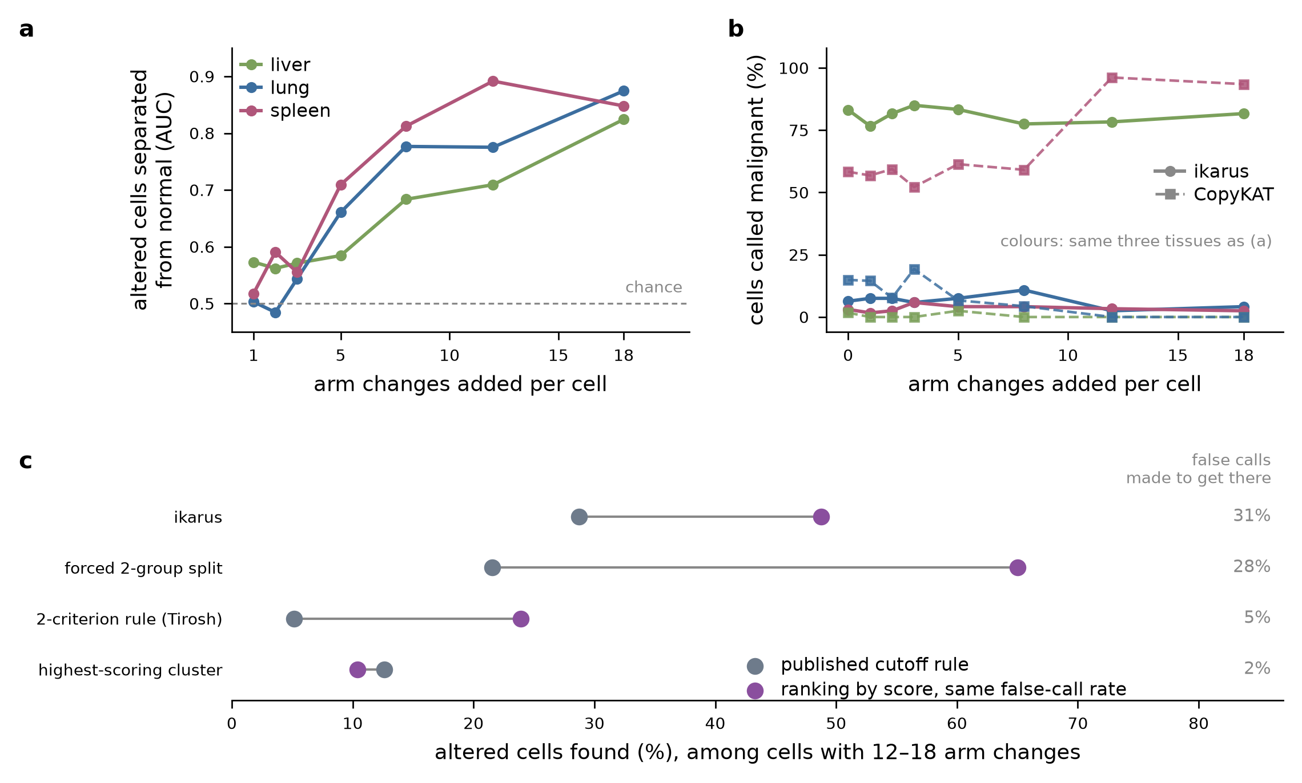
Figure 1. In-silico positive controls bound what the callers can detect. (a) Area under the ROC curve (AUC; 0.5 = chance, 1 = perfect separation) for separating aneuploid from diploid cells using the continuous copy-number score, as a function of the number of arm-level events imposed, in three tissues. (b) Percentage of cells called malignant by ikarus (solid) and CopyKAT (dashed) as a function of imposed karyotype burden; burden 0 denotes untouched diploid cells from the same sample. Neither caller responds to dosage, and in liver and lung CopyKAT calls the highest-burden cells least often. (c) Detection of aneuploid cells carrying 12–18 arm events, comparing each published rule (grey) with a threshold on the continuous score placed at exactly that rule’s false-call rate (purple). The right-hand column gives each rule’s false-call rate on diploid companion cells; the score threshold is matched to it, so both points in a row cost the same number of false calls. Values are means over three spike-in datasets.
Neither the supervised classifier nor CopyKAT responds to dosage (Figure 2b). The ikarus call rate on aneuploid cells (28.8% at 12–18 events) is indistinguishable from its call rate on the diploid companion cells in the same sample (30.9%). Whatever ikarus is detecting, it is not copy-number dosage; its calls track the transcriptional context of the tissue, which is consistent with both its 100% rate on Crohn’s colonic epithelium and its 0% rate on other datasets. CopyKAT’s response is erratic and tissue-dependent: in spleen it calls 58.3% of diploid companions and 94.9% of cells carrying 12–18 events aneuploid, in liver 1.7% and 0.0%, and in lung 14.9% and 0.0% — that is, in two of three tissues the cells with the largest imposed karyotypes are the ones it is least likely to call aneuploid. Because CopyKAT emits a categorical call rather than a per-cell score, it cannot be placed on the matched-false-positive-rate comparison below.
The comparison that matters for practice is between methods held at the same false-positive rate (Figure 2c). For each rule, we measured its false-call rate on the diploid companions and its detection rate on the aneuploid cells, then thresholded the continuous score at exactly that false-call rate and read off its detection rate. At every operating point, ranking cells by the raw score detects substantially more aneuploid cells than the rule that operates there: 23.9% versus 5.1% at 5.4% false calls (two-criterion rule), 65.0% versus 21.5% at 27.9% false calls (forced two-group split), and 48.8% versus 28.8% at 30.9% false calls (ikarus), all for cells carrying 12–18 arm events. The published rules therefore do not extract information the score does not contain; they select a poor operating point on it. The two-criterion rule is additionally uninformative about burden — its detection rate at 12–18 events (5.1%) is no higher than its detection rate averaged over all burdens (5.8%).

The false calls share a gene-density-driven pseudo-karyotype
If false calls were random, they would be a power problem. They are not. We compared the mean inferred copy-number profile of falsely called cells to that of uncalled cells within each dataset, in 10-Mb genomic bins (Figure 3a). The resulting difference profile is highly structured, with reproducible apparent losses and gains at specific loci — a pseudo-karyotype that a reader would naturally interpret as a shared clonal event.
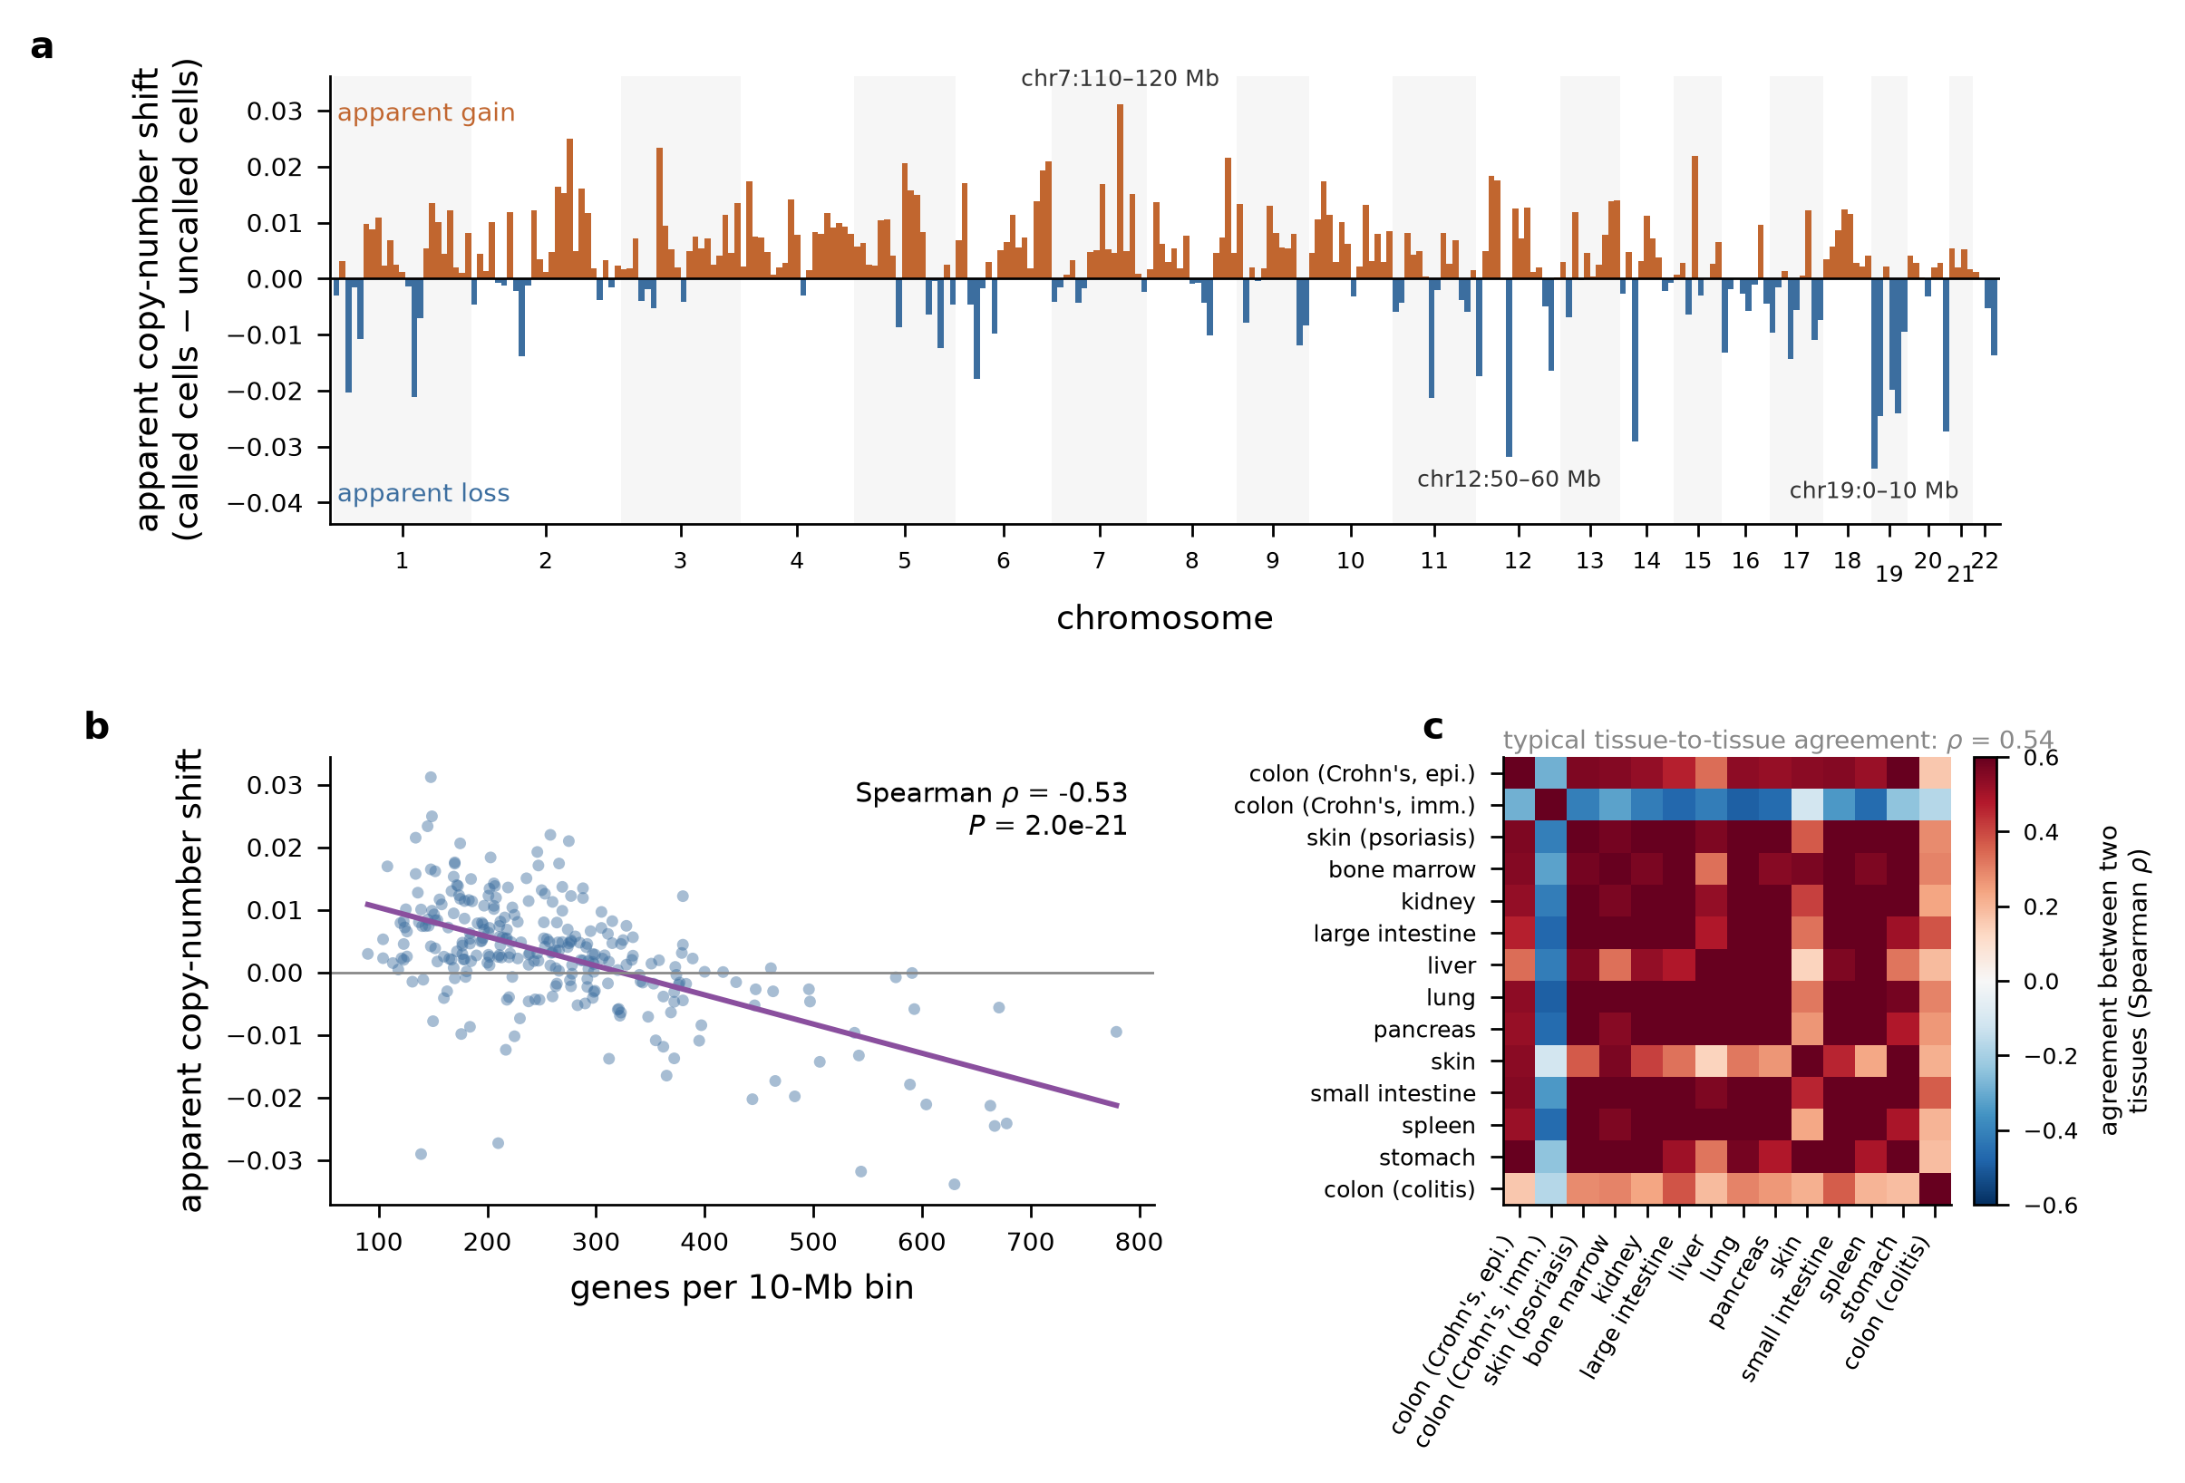
Figure 2. False calls share a reproducible, gene-density-driven pseudo-karyotype. A pseudo-karyotype is a chromosome-level pattern of apparent gains and losses that has no clonal basis. (a) Mean inferred copy-number difference between falsely called and uncalled cells, in 10-Mb bins, averaged across the tumour-free panel. Labels mark the three strongest bins. (b) Apparent copy-number shift against the number of genes per 10-Mb bin, with linear fit. Gene-dense regions appear deleted. (c) Spearman correlation between bin-level difference profiles of independent datasets. Reproducibility across tissues that share no biology indicates a technical rather than clonal origin.
This profile is reproducible across tissues that share no biology: bin-level difference profiles from independent datasets correlate with a median Spearman ρ of 0.54 (Figure 3c). A genuine clonal event cannot be shared by healthy kidney, healthy spleen and psoriatic skin.
The profile is predicted by local gene density (Figure 3b). Across 278 genomic bins, the apparent copy-number shift in falsely called cells correlates negatively with the number of genes in the bin (Spearman ρ = −0.53, P = 2×10⁻²¹): gene-dense regions appear deleted, and gene-poor regions appear gained. This is the expected signature of a compositional artefact. Sliding-window averaging of library-size-normalised expression makes each window’s value depend on relative, not absolute, expression; cells whose expression distribution is broader or narrower than the reference — for reasons of cell state, RNA content, or capture efficiency — acquire a systematic, gene-density-dependent deviation across the whole genome. Because that deviation is genome-wide and smooth, it survives the smoothing steps copy-number callers apply, and because it is shared by cells with similar technical properties, it clusters those cells together and makes them look like a clone. We tested and rejected an alternative explanation: clustered gene families (immunoglobulin, HLA, histone, keratin and other locus-restricted families) do not explain the profile as a family-level effect, although individual family loci appear among the strongest bins.

A calibrated decision procedure with a verifiable error rate
The preceding results locate the problem in the decision step, not in the copy-number score. We therefore replaced the decision step. The procedure fits an empirical null distribution of the per-cell copy-number score on tumour-free reference cells, conditional on cell type, residualising sequencing depth — because the score depends on depth, and cell types differ in depth. A query cell is called aneuploid if its score exceeds the 1 − α quantile of the null for its cell type. The procedure consumes any per-cell score and does not modify the caller.
Under leave-one-tissue-out validation — the null fitted on healthy tissues excluding the held-out dataset — the realized false-positive rate is at or below the nominal target across the range α = 1% to 10% (Figure 4a), in 13 of 14 datasets. At α = 5% the median realized rate is 0.03% and the maximum 0.43%, compared with 0.5–19.3% for the two-criterion rule on the same data (Figure 4b). The procedure is conservative rather than exact: a null pooled over ten tissues has heavier tails than any single tissue, so the realized rate falls below nominal. For an audit application this is the desired direction of error, but users seeking an exact rate should fit the null closer to the query data.
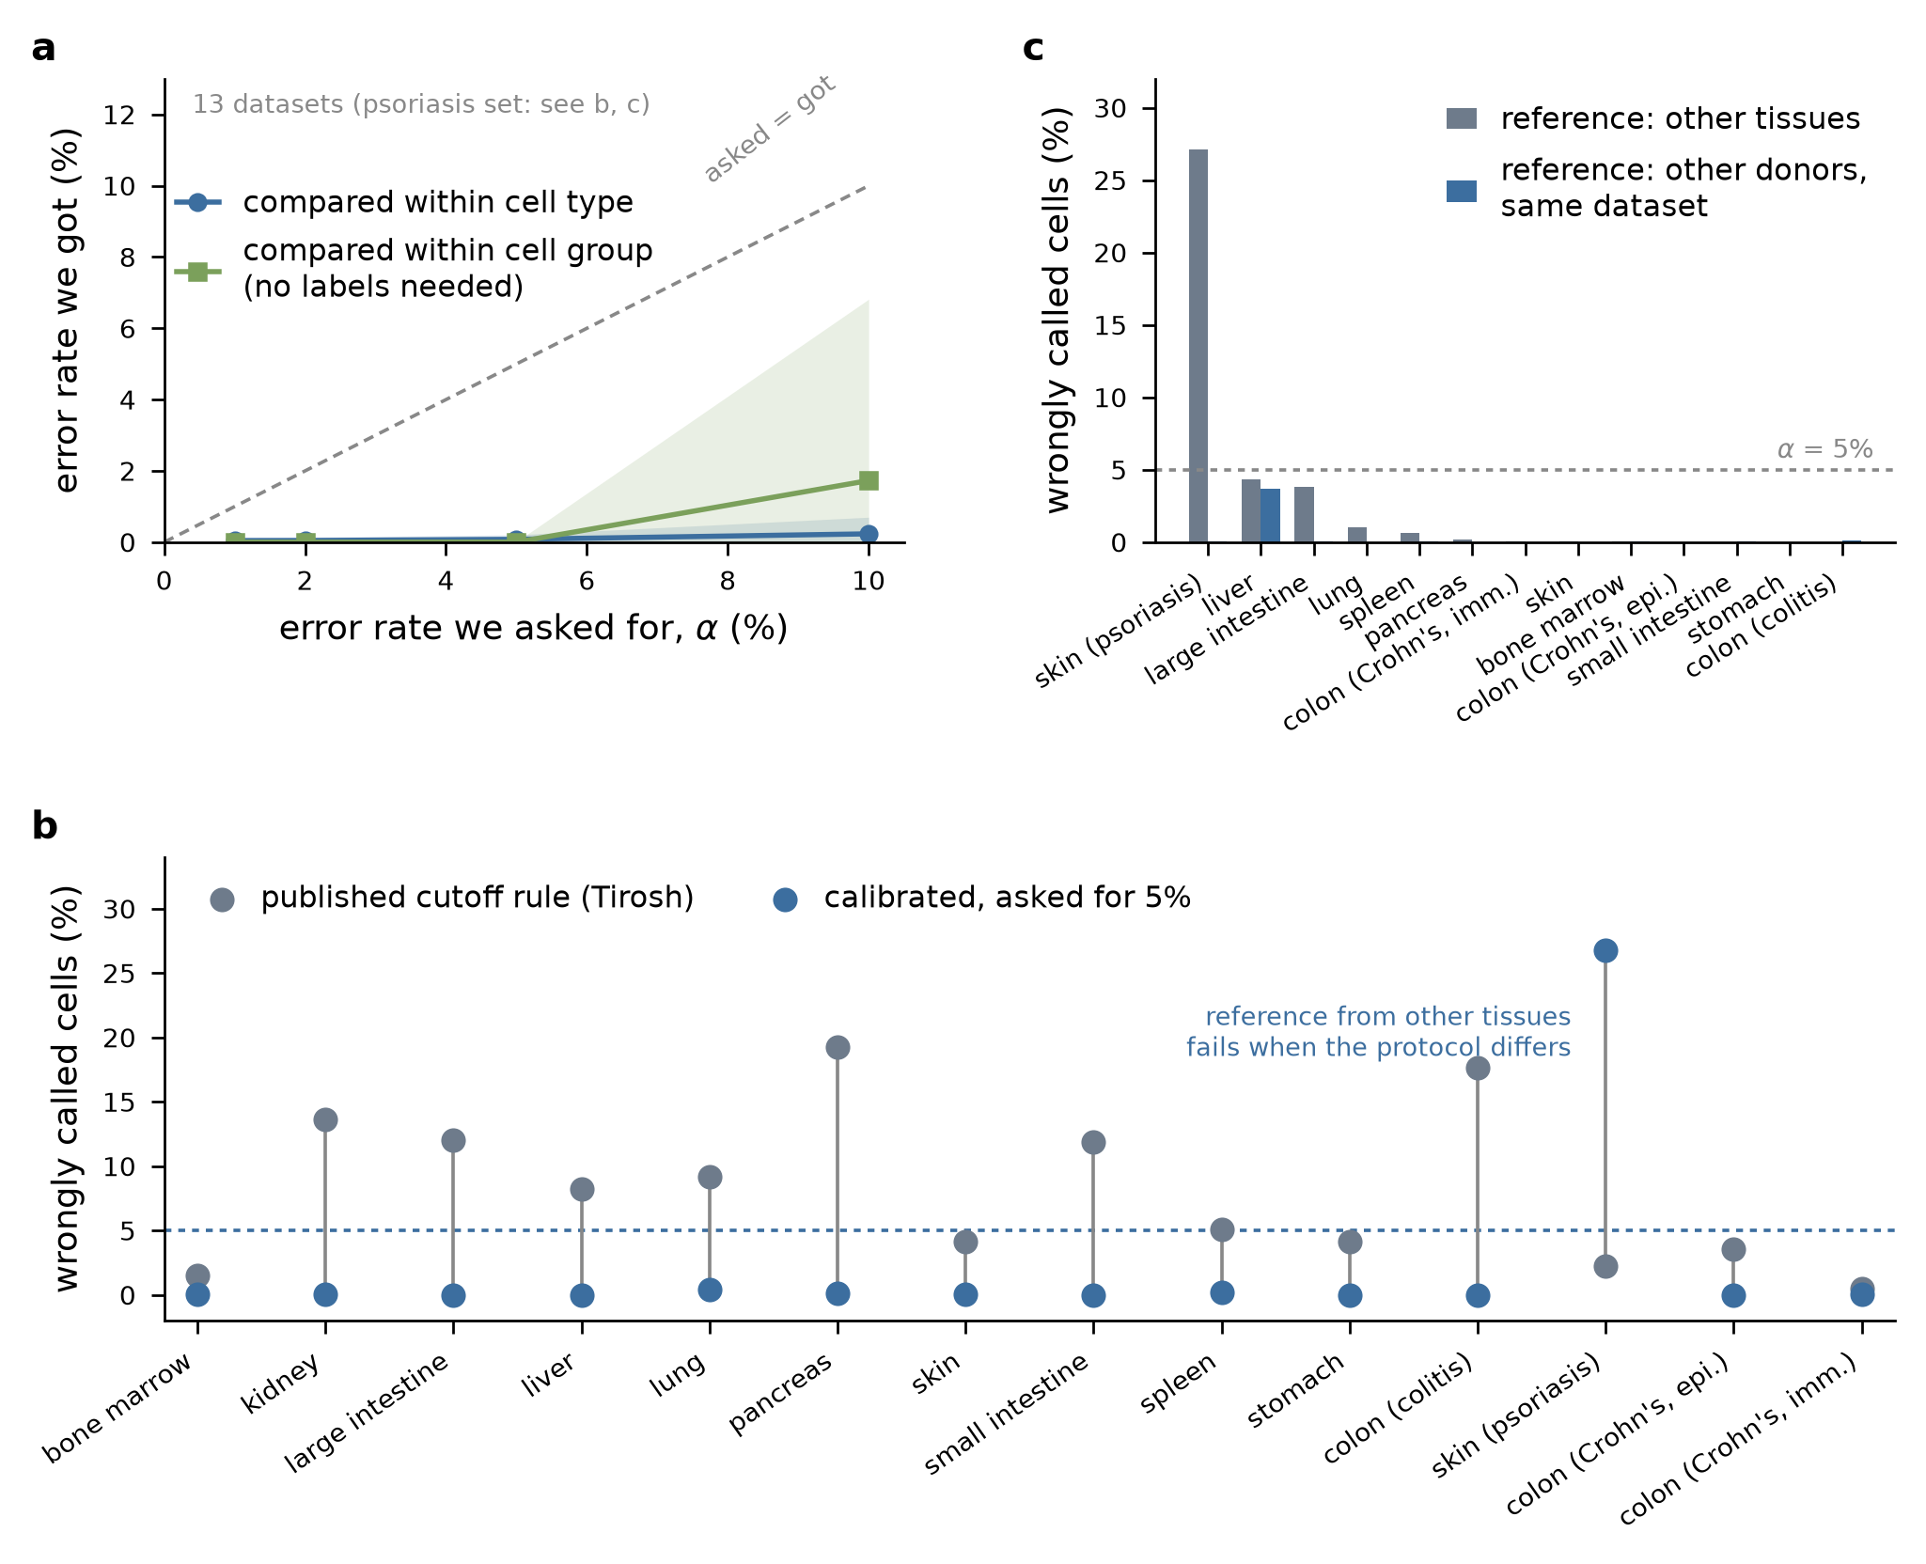
Figure 3. A cell-type-conditional empirical null gives a verifiable false-positive rate. (a) Realized versus nominal false-positive rate under leave-one-tissue-out validation, for cell-type-conditioned and label-free archetype-conditioned nulls (in the figure: the error rate we got versus the rate we asked for, comparing cells within their cell type or within a label-free cell group). Mean ± s.d. across 13 datasets; the protocol-shifted psoriatic skin dataset is excluded here and shown in (b) and (c). The dashed line is the nominal rate. (b) False-call rate per dataset for the two-criterion rule (grey) and for the calibrated procedure at α = 5% (blue). As in Fig. 1a, the rule rates use the immune-reference mode where an immune reference was available and the reference-free mode otherwise (Crohn’s epithelium). (c) Effect of the null’s provenance: a null (reference distribution) fitted on other tissues versus one fitted on held-out donors of the same dataset, at α = 5%, datasets ordered by the former.
Because cell-type labels are not always available, we also implemented a label-free variant that assigns each cell to one of a small set of transcriptional archetypes derived from reference centroids and conditions on the archetype instead of the label. It behaves similarly at α ≤ 5%, with more variability at α = 10% (Figure 4a).
The single failure is informative. On the psoriatic skin dataset, the cross-tissue null gives a realized rate of 27.1% — worse than the published rule it replaces. That dataset differs from the reference tissues in protocol and study of origin, and the score distribution shifts accordingly, so a null fitted elsewhere does not transfer. Refitting the null on held-out donors from the same dataset removes the failure entirely: 27.1% → 0.03%, with a maximum of 3.67% across all datasets analysed this way (Figure 4c). The practical recommendation follows directly: the null must be drawn from cells processed like the query cells, and where a study contains multiple donors, held-out donors from the same study are the appropriate source.

Discussion
Malignant-cell calling in single-cell RNA-seq is performed with tools whose false-positive rate on tumour-free tissue has not been measured. We measured it. Under published decision rules the rate is not small, not stable across tissues, and not primarily a property of the biology: it is set by where an essentially arbitrary threshold falls on a unimodal score.
The three findings compound. The score has limited per-cell discrimination for realistic karyotype burdens; the rules applied to it operate at points that waste even that discrimination; and the errors they make are systematically structured rather than random, producing an apparent shared karyotype driven by gene density. The last point is the most consequential for interpretation, because a structured false-positive population does not merely dilute a malignant compartment — it adds a coherent, reproducible, biologically meaningless signal to it, of exactly the kind that clonal analyses are designed to detect.
We do not conclude that copy-number inference from single-cell expression is without value. The continuous score carries real dosage information, and at high karyotype burden it discriminates well. The failure is in the conversion of that score into a binary label without a calibrated error rate. A cell-type-conditional empirical null, costing seconds of computation and requiring no change to the caller, converts an uncontrolled decision into one whose error rate can be stated and verified. Its conservativeness — and its failure under protocol shift, which we report rather than conceal — should both be understood before it is applied.
Several practical recommendations follow. Report a false-positive rate, measured on tumour-free cells processed identically, alongside any malignant compartment. Prefer the continuous score to a binary label wherever the downstream analysis permits. Where a binary label is required, set the threshold from an explicit null rather than from a clustering outcome or a fixed quantile. Treat an apparent shared karyotype among called cells as a warning sign, and check it against gene density before interpreting it as clonal. And do not transfer a null across protocols.

Limitations
This study was executed at reduced scale relative to its design, and the reductions are material enough to state explicitly.
Panel size. Each dataset was subsampled to approximately 3,000 cells to make the full factorial of callers, reference modes and decision rules tractable on a single workstation. The panel therefore covers 14 datasets and 36,528 cells, not the full atlases from which they are drawn. Rates reported per dataset carry sampling uncertainty accordingly; pooled rates are more stable than individual ones.
Callers covered. Two callers were run across the full panel: infercnvpy (a Python implementation of the inferCNV algorithm) and ikarus. The original R implementation of inferCNV [4] was not run; infercnvpy implements the same sliding-window algorithm but is not bit-identical, and rates reported here should not be attributed to the R package without verification. CopyKAT was run across the full panel, but on a subsample of at most 1,200 cells per dataset (591–1,210 cells, drawn proportionally across cell types) rather than the approximately 3,000 cells used for the other two callers, because of its single-threaded runtime; its rates therefore carry wider sampling uncertainty. CopyKAT was run in its default immune-reference configuration only, not across the five decision rules, since it emits a categorical call rather than a per-cell score. Several further callers in common use — CONICSmat [6], SCEVAN [10], Numbat [9] and other methods that use allelic information [7,8] — were not run at all. Numbat and related allele-aware methods are of particular interest because the artefact we describe is compositional and would not be expected to affect allelic imbalance in the same way; this is the most important untested extension of the audit.
Positive controls are in silico. The aneuploid cells are real cells with simulated arm-level dosage changes, not cells from tumours with karyotypes established by an orthogonal assay. The simulation imposes a clean multiplicative dosage effect and therefore, if anything, overstates detectability relative to real tumour cells, where dosage compensation, subclonal structure and focal events complicate the signal. The AUC values we report should be read as upper bounds.
No matched orthogonal ground truth. We did not analyse a dataset with matched single-cell DNA or bulk copy-number profiling, which would allow false-positive and false-negative rates to be measured on genuine tumour tissue rather than inferred from tumour-free tissue and simulation.
Composition of the inflammatory-cohort datasets. Of the four non-healthy datasets, three contain cells annotated as diseased and one (colon, ulcerative colitis cohort) contains only cells annotated as non-diseased from that cohort. Conclusions about inflammation as a driver of false calls rest on the former three.
Calibration validation. Leave-one-tissue-out validation uses tumour-free tissue only; the realized rate reported is a false-positive rate, not a false-discovery rate in the presence of true positives. The donor-held-out variant was restricted to datasets with at least two donors contributing at least 200 cells each.

Methods

Data
Healthy tissues were obtained from a multi-organ human cell reference atlas [12] via the CELLxGENE Census, selecting primary 10x 3′ v3 data from adult donors. Inflammatory-cohort datasets were obtained from the same source [13,14,15]. Each dataset was subsampled to at most approximately 3,000 cells, with cell-type proportions capped to avoid domination by a single type and all donors retained. Genes were restricted to those with an assigned chromosome and position in the annotation used by the callers. Per-dataset composition is given in Supplementary Table S1.

Copy-number inference
infercnvpy 0.6.1 [16] was run per dataset on log-normalised expression with 100-gene sliding windows and a 10-gene step, in two modes: reference-free (no reference category) and immune-reference, in which cells whose annotated type matched a curated immune vocabulary (T, B, NK, plasma, myeloid, monocyte, macrophage, dendritic, mast, granulocyte and their subtypes) were designated the reference category. Per-cell scores were computed from the resulting window matrix as the mean squared deviation (used throughout unless stated), the mean absolute deviation, and the correlation to the mean profile of the top-scoring decile.
CopyKAT 1.2.5 [5] was run in R 4.4.3 under the same immune-reference designation, with default parameters, on a per-dataset subsample of at most 1,200 cells drawn proportionally across annotated cell types. Cells returned as not.defined are reported separately and excluded from rate denominators unless stated.
ikarus 0.0.3 [11] was run with the published pan-cancer gene signature and logistic-regression classifier, using AUCell scoring [17] followed by cell-cell-network propagation as implemented in the package.

Decision rules
Five rules were applied to the infercnvpy output. (R1) Forced two-group split: Leiden clustering [18] of the CNV profile, clusters merged into two groups, the group with the higher mean score declared malignant. (R1b) Highest-scoring cluster: Leiden clustering at default resolution, the single highest-mean-score cluster declared malignant. (R2) Per-cell quantile: cells above the 90th percentile of the per-cell score declared malignant. (R3) Reference SD: cells whose score exceeds the reference-cell mean by more than a fixed multiple of the reference standard deviation; requires a reference and is undefined in reference-free mode. (R4) Two-criterion (Tirosh) [1,19]: cells exceeding both a score threshold and a threshold on correlation to the mean profile of the top-scoring cells.

In-silico aneuploid spike-ins
For each of three healthy tissues, cells were sampled at random and assigned a karyotype consisting of b chromosome arms drawn without replacement, each designated gain or loss with equal probability. Counts for genes on an affected arm were scaled by 1.5 (gain) or 0.5 (loss) before re-normalisation, so that the resulting cell has the library size and technical characteristics of a real cell with an altered relative expression profile. Burdens b ∈ 1, 2, 3, 5, 8, 12, 18 were generated. Untouched cells from the same tissue serve as diploid companions. Truth labels and burdens were held out of all scoring.

Calibration
Let s_{i} be the per-cell copy-number score and d_{i} the log total counts. Within each cell type t of the reference set, a regression of s on d is fitted and the residual r_{i} = s_{i} − ŝ(d_{i}) retained; the empirical distribution of r within type t is the null F_{t}. A query cell of type t receives p_{i} = 1 − F_{t}(r_{i}) and is called aneuploid if p_{i} ≤ α. Types with fewer than 100 reference cells are pooled into a global null. The label-free variant replaces t with the nearest reference centroid among a small set of transcriptional archetypes, computed on marker-gene-restricted expression.
Leave-one-tissue-out validation fits the null on all healthy tissues except the held-out dataset and applies it to the held-out dataset. The donor-held-out variant fits the null on all donors of a dataset except one and applies it to the held-out donor, cycling over donors contributing at least 200 cells.

Attribution analysis
Per-dataset difference profiles were computed as the mean window value of falsely called cells minus that of uncalled cells, aggregated into 10-Mb bins, retaining bins containing at least five windows. Gene counts per bin were computed from the same annotation used by the caller. Cross-tissue reproducibility was quantified as the Spearman correlation between bin-level difference profiles of different datasets, over bins present in at least six datasets. Clustered gene families were tested by comparing the mean difference in bins overlapping family loci with the genome-wide distribution.

Software and availability
Analyses used Python (3.13) with scanpy (1.11.5) [20], anndata (0.12.19), infercnvpy (0.6.1), ikarus (0.0.3), scikit-learn (1.9.1), numpy (2.4.6) and scipy (1.17.1), and R (4.4.3) with CopyKAT (1.2.50. All analysis code, result tables and figure scripts accompany this manuscript.
Data processing, figure generation and manuscript drafting were carried out with the assistance of an AI Assistant (Claude Science), under author direction and review. Every number reported here is produced by the accompanying code from public input data and is reproducible by running it; the authors are responsible for the analysis, its interpretation and the content of this manuscript.

Data availability
All datasets are public. The healthy-organ datasets are from the multi-organ reference atlas [12] as distributed by the CELLxGENE Census. The inflammatory-cohort datasets are CELLxGENE dataset 333491b4-ca9b-4369-8706-38f7bb5bcd46 (Crohn’s colon epithelial) and 1ddca82d-2948-4dbe-8bba-be9de7115bb7 (Crohn’s colon immune) [13], 75eae05f-4f07-4518-a434-ea0a0d7ac616 (psoriasis skin) [14] and 774d77e7-210d-4237-8ca8-8d2bb841a2e4 (ulcerative colitis cohort colon) [15]. The per-dataset panel definition, including download URLs, accompanies the analysis code.

Author contributions
All authors contributed to the conception and design of the study, the analysis and interpretation of the data, and the drafting and revision of the manuscript, and all authors approved the submitted version.

Competing interests
The authors declare no competing interests.

Funding
This work received no specific funding. All input data are public and all analyses were run on commodity hardware.

Code and data availability
All analysis code, figure scripts and result tables are provided as a single supplementary archive. All input datasets are public; accessions and download URLs are listed in Methods (Data availability) and in the panel definition shipped with the code.

References
- Tirosh I, et al. Dissecting the multicellular ecosystem of metastatic melanoma by single-cell RNA-seq. Science 2016;352:189-196. doi:10.1126/science.aad0501
- Tirosh I, et al. Single-cell RNA-seq supports a developmental hierarchy in human oligodendroglioma. Nature 2016;539:309-313. doi:10.1038/nature20123
- Patel AP, et al. Single-cell RNA-seq highlights intratumoral heterogeneity in primary glioblastoma. Science 2014;344:1396-1401. doi:10.1126/science.1254257
- inferCNV of the Trinity CTAT Project. Broad Institute of MIT and Harvard. https://github.com/broadinstitute/infercnv
- Gao R, et al. Delineating copy number and clonal substructure in human tumors from single-cell transcriptomes. Nature Biotechnology 2021;39:599-608. doi:10.1038/s41587-020-00795-2
- Müller S, et al. CONICS integrates scRNA-seq with DNA sequencing to map gene expression to tumor sub-clones. Bioinformatics 2018;34:3217-3219. doi:10.1093/bioinformatics/bty316
- Serin Harmanci A. CaSpER identifies and visualizes CNV events by integrative analysis of single-cell or bulk RNA-sequencing data. Nature Communications 2020;11:89. doi:10.1038/s41467-019-13779-x
- Fan J, et al. Linking transcriptional and genetic tumor heterogeneity through allele analysis of single-cell RNA-seq data. Genome Research 2018;28:1217-1227. doi:10.1101/gr.228080.117
- Gao T, et al. Haplotype-aware analysis of somatic copy number variations from single-cell transcriptomes. Nature Biotechnology 2022;41:417-426. doi:10.1038/s41587-022-01468-y
- De Falco A, et al. A variational algorithm to detect the clonal copy number substructure of tumors from scRNA-seq data. Nature Communications 2023;14:1074. doi:10.1038/s41467-023-36790-9
- Dohmen J, et al. Identifying tumor cells at the single-cell level using machine learning. Genome Biology 2022;23:123. doi:10.1186/s13059-022-02683-1
- The Tabula Sapiens Consortium. The Tabula Sapiens: A multiple-organ, single-cell transcriptomic atlas of humans. Science 2022;376:eabl4896. doi:10.1126/science.abl4896
- Kong L, et al. The landscape of immune dysregulation in Crohn’s disease revealed through single-cell transcriptomic profiling in the ileum and colon. Immunity 2023;56:444-458.e5. doi:10.1016/j.immuni.2023.01.002
- Gao Y, et al. Single cell transcriptional zonation of human psoriasis skin identifies an alternative immunoregulatory axis conducted by skin resident cells. Cell Death & Disease 2021;12:450. doi:10.1038/s41419-021-03724-6
- Smillie CS, et al. Intra- and Inter-cellular Rewiring of the Human Colon during Ulcerative Colitis. Cell 2019;178:714-730.e22. doi:10.1016/j.cell.2019.06.029
- infercnvpy: infer copy number variation (CNV) from single-cell transcriptomics data. https://github.com/icbi-lab/infercnvpy
- Aibar S, et al. SCENIC: single-cell regulatory network inference and clustering. Nature Methods 2017;14:1083-1086. doi:10.1038/nmeth.4463
- Traag VA, Waltman L, van Eck NJ. From Louvain to Leiden: guaranteeing well-connected communities. Scientific Reports 2019;9:5233. doi:10.1038/s41598-019-41695-z
- Puram SV, et al. Single-Cell Transcriptomic Analysis of Primary and Metastatic Tumor Ecosystems in Head and Neck Cancer. Cell 2017;171:1611-1624.e24. doi:10.1016/j.cell.2017.10.044
- Wolf FA, Angerer P, Theis FJ. SCANPY: large-scale single-cell gene expression data analysis. Genome Biology 2018;19:15. doi:10.1186/s13059-017-1382-0

