|  |
| --- |
| **C:\Users\faisal\Pictures\NSU_pic_download\n91267046457_2661.jpg**  **CSE 311L(Database Management System)**  **LAB-Week 03 (Part A)** |

Restricting and Sorting Data (Part A is based on Company2 schema)

Topics:

* Limiting the Rows Selected
* Restricting with Character Strings and Dates
* Comparison Conditions
* Other Comparison Conditions,

**Limiting the Rows Selected**

**SELECT employee\_id, last\_name, job\_id, department\_id**

**FROM emps**

**WHERE department\_id = 90 ;**

**Character Strings and Dates**

**SELECT last\_name, job\_id, department\_id**

**FROM emps**

**WHERE last\_name = ’WHALEN’;**

**Comparison Conditions**

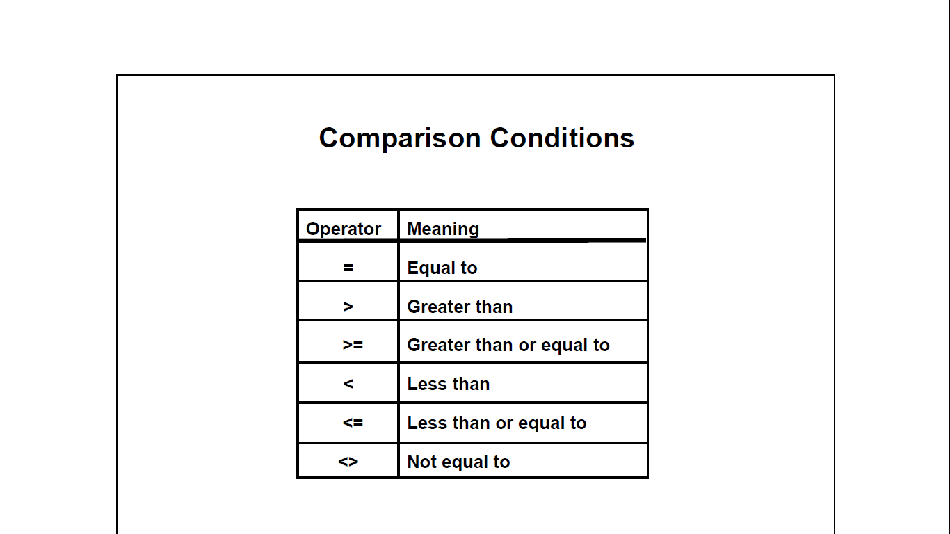

**SELECT last\_name, salary FROM emps**

**WHERE salary <= 3000;**

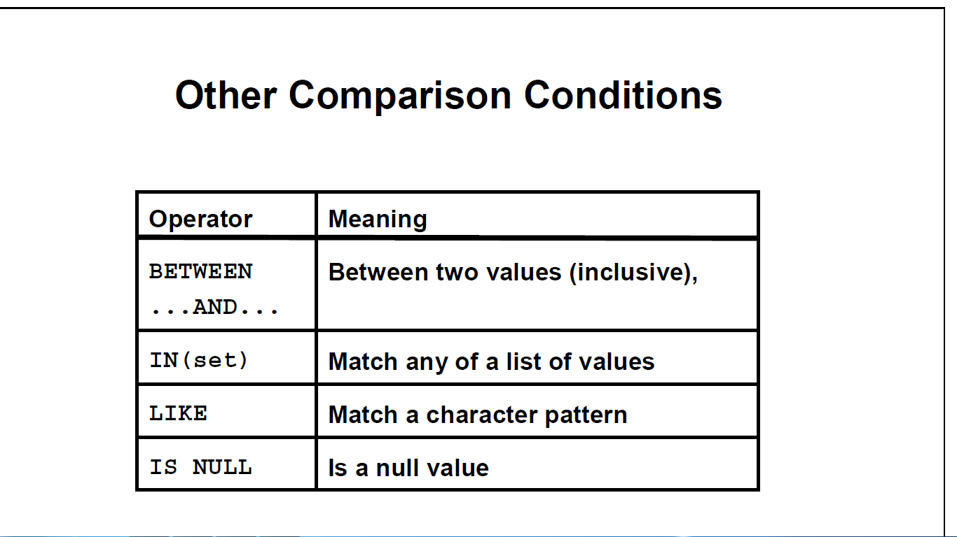

**Other Comparison Conditions**

SELECT last\_name, salary

FROM emps

WHERE salary BETWEEN 2500 AND 3500;

SELECT employee\_id, last\_name, salary, manager\_id

FROM emps

WHERE manager\_id IN (100, 101, 201);

**ORDER BY Clause**

SELECT last\_name, job\_id, department\_id, hire\_date

FROM emps

ORDER BY hire\_date DESC ;



**Sorting by Multiple Columns**

SELECT last\_name, department\_id, salary

FROM emps

ORDER BY department\_id, salary DESC;



**Activity 01:**

Display the employee last name, job ID, and start date of employees hired between February 20, 1998, and May 1, 1998. Order the query in ascending order by start date.

**Activity 02:**

Display the last name and department number of all employees in departments 20 and 50 in alphabetical order by name.

|  |
| --- |
| **C:\Users\faisal\Pictures\NSU_pic_download\n91267046457_2661.jpg**  **CSE 311L(Database Management System)**  **LAB-Week 03 (Part B)** |

Topics:

After completing this lesson, you should be able to restrict rows:

* Using the LIKE Condition
* Using the NULL Conditions
* Logical Conditions

**SET OPERATIONS (Based on Company.sql)**

SQL has directly incorporated some set operations such as union operation (UNION), set difference (MINUS) and intersection (INTERSECT) operations. The resulting relations of these set operations are sets of tuples; duplicate tuples are eliminated from the result. The set operations apply only to union compatible relations; the two relations must have the same attributes and the attributes must appear in the same order

**Query 5: Make a list of all project numbers for projects that involve an employee whose last name is 'Wong' as a worker or as a manager of the department that controls the project.**

Q5: **(SELECT PNAME FROM PROJECT, DEPARTMENT, EMPLOYEE**

**WHERE DNUM=DNUMBER AND MGRSSN=SSN AND LNAME='Wong')**

**UNION**

**(SELECT PNAME FROM PROJECT, WORKS\_ON, EMPLOYEE**

**WHERE PNUMBER=PNO AND ESSN=SSN AND NAME='Wong')**

**NESTING OF QUERIES**

A complete SELECT query, called a nested query, can be specified within the WHERE-clause of another query, called the outer query. Many of the previous queries can be specified in an alternative form using nesting

**Query 6: Retrieve the name and address of all employees who work for the 'Research'**

**department.**

**Q6: SELECT FNAME, LNAME, ADDRESS FROM EMPLOYEE WHERE DNO IN**

**(SELECT DNUMBER FROM DEPARTMENT WHERE DNAME='Research' )**

**Note:** The nested query selects the number of the 'Research' department. The outer query selectsan EMPLOYEE tuple if its DNO value is in the result of either nested query. The comparison operator IN compares a value v with a set (or multi-set) of values V, and evaluates to TRUE if v is one of the elements in V

In general, we can have several levels of nested queries. A reference to an unqualified attribute refers to the relation declared in the innermost nested query. In this example, the nested query is not correlated with the outer query

**EXPLICIT SETS**

It is also possible to use an explicit (enumerated) set of values in the WHERE-clause rather than a nested query

**Query 7: Retrieve the social security numbers of all employees who work on project**

**number 1, 2, or 3.**

Q9: SELECT DISTINCT ESSN FROM WORKS\_ON WHERE PNO **IN (1, 2, 3)**

**NULLS IN SQL QUERIES**

SQL allows queries that check if a value is NULL (missing or undefined or not applicable). SQL uses IS or IS NOT to compare NULLs because it considers each NULL value distinct from other NULL values, so equality comparison is not appropriate.

**Query 8: Retrieve the names of all employees who do not have supervisors.**

Q8: **SELECT FNAME, LNAME FROM EMPLOYEE WHERE SUPERSSN IS NULL**

**Note:** If a join condition is specified, tuples with NULL values for the join attributes are notincluded in the result

**SUBSTRING COMPARISON**

The LIKE comparison operator is used to compare partial strings. Two reserved characters are used: **'%'** (or '\*' in some implementations) replaces an arbitrary number of characters, and **'\_'** replaces a single arbitrary character.

**Query 9: Retrieve all employees whose address is in Houston, Texas. Here, the value of the** **ADDRESS attribute must contain the substring 'Houston,TX‘ in it.**

**Q9: SELECT FNAME, LNAME**

**FROM EMPLOYEE WHERE ADDRESS LIKE '%Houston,TX%'**

**Query 9: Retrieve all employees who were born during the 1950s.**

Here, '5' must be the 8th character of the string (according to our format for date), so the BDATE value is '\_\_\_\_\_\_\_5\_', with each underscore as a place holder for a single arbitrary character.

**Q9: SELECT FNAME, LNAME**

**FROM EMPLOYEE WHERE BDATE LIKE '\_\_\_\_\_\_\_5\_‘**

**Note:** The LIKE operator allows us to get around the fact that each value is considered atomicand indivisible. Hence, in SQL, character string attribute values are not atomic

**Using the LIKE Condition (based on company2.schema)**

* Use the LIKE condition to perform wildcard searches of valid search string values.
* Search conditions can contain either literal characters or numbers:

% denotes zero or many characters.

\_ denotes one character.

SELECT last\_name

FROM emps

WHERE last\_name LIKE ’\_o%’;

**The ESCAPE Option (based on company2.schema)**

**SELECT employee\_id, last\_name, job\_id**

**FROM emps**

**WHERE job\_id LIKE '%SA#\_%' ESCAPE '#';**



**Using the NULL Conditions (based on company2.schema)**

**SELECT last\_name, manager\_id**

**FROM emps**

**WHERE manager\_id IS NULL;**

**Logical Conditions**

**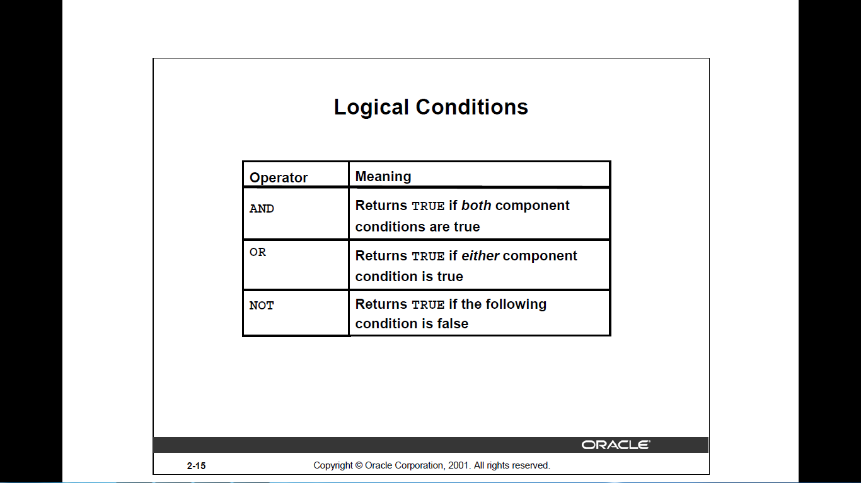**

**SELECT employee\_id, last\_name, job\_id, salary**

**FROM emps**

**WHERE salary >=10000**

**AND job\_id LIKE ’%MAN%’;**

****

**Using the NOT Operator**

SELECT last\_name, job\_id

FROM emps

WHERE job\_id

NOT IN (’IT\_PROG’, ’ST\_CLERK’, ’SA\_REP’);



**CORRELATED NESTED QUERIES**

A correlated nested query (or correlated subquery) is a type of SQL subquery that depends on values from the outer query. It is evaluated once for each row processed by the outer query, unlike a regular (uncorrelated) subquery which runs independently.

* A regular subquery runs first, then its result is used by the main query.
* A correlated subquery runs for every row selected by the outer query because it references a column from the outer query.

**Query 10: Retrieve the name of employees whose direct supervisor earns more than them**.

**Q10: SELECT fname, lname, salary, superssn FROM employee e1**

**WHERE salary < (**

**SELECT salary FROM employee e2**

**WHERE e2.ssn = e1.superssn );**

* This subquery refers to e1.superssn, which is a column from the outer query's current row (e1 alias).
* So for each row (each employee e1) processed by the outer query, the subquery uses that specific employee’s superssn value to look up the supervisor’s salary.
* This means the subquery cannot be executed independently without knowing which outer row it is referring to. It must be evaluated once per outer row.

In Q10, the nested query has a different result in the outer query. A query written with nested SELECT... FROM… WHERE... blocks and using the **= or IN** comparison operators can *always* be expressed as a single block query. For example, Q100 may be written as in Q10a

Q10a: **SELECT e1.fname, e1.lname, e1.salary, e1.superssn FROM employee e1,**

**employee e2 WHERE e1.superssn = e2.ssnAND e1.salary < e2.salary**;

**THE EXISTS FUNCTION**

EXISTS is used to check whether the result of a correlated nested query is empty (contains no tuples) or not. EXISTS is a logical operator in SQL that checks whether a subquery returns any rows.

* If the subquery returns at least one row, EXISTS returns TRUE.
* If the subquery returns no rows, EXISTS returns FALSE.

It’s often used in correlated subqueries to test row existence based on a condition involving the outer query. We can formulate Query 10 in an alternative form that uses EXIST.

**Q10b: SELECT fname, lname, salary, superssn FROM employee e1**

**WHERE EXISTS (**

**SELECT \* FROM employee e2**

**WHERE e2.ssn = e1.superssn**

**AND e2.salary > e1.salary);**

**Query 11: Find employees for whom there is no supervisor who earns less than or equal to them.**

**Q11: SELECT fname, lname, salary, superssn FROM employee e1**

**WHERE superssn IS NOT NULL AND NOT EXISTS (**

**SELECT \* FROM employee e2**

**WHERE e2.ssn = e1.superssn**

**AND e2.salary <= e1.salary);**