

Mastering Embedded System Online Diploma

[www.learn-in-depth.com](http://www.learn-in-depth.com)

First Term (Final Project 1)

Eng: Hossam Magdy Afifi

My Profile: <https://www.learn-in-depth.com/online-diploma/hossammagdy308%40gamil.com>

* **Requirement Diagram:**

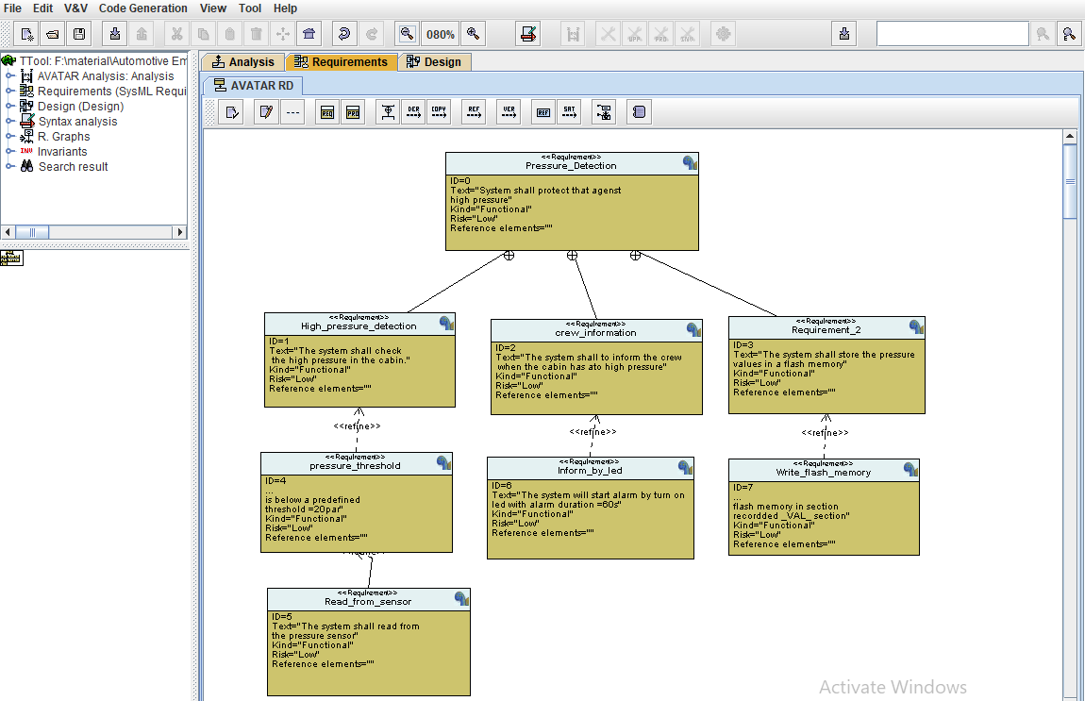

* **System Analysis:**

1. Use Case Diagram
2. Activity Diagram
3. Sequence Diagram
4. **Use Case Diagram**

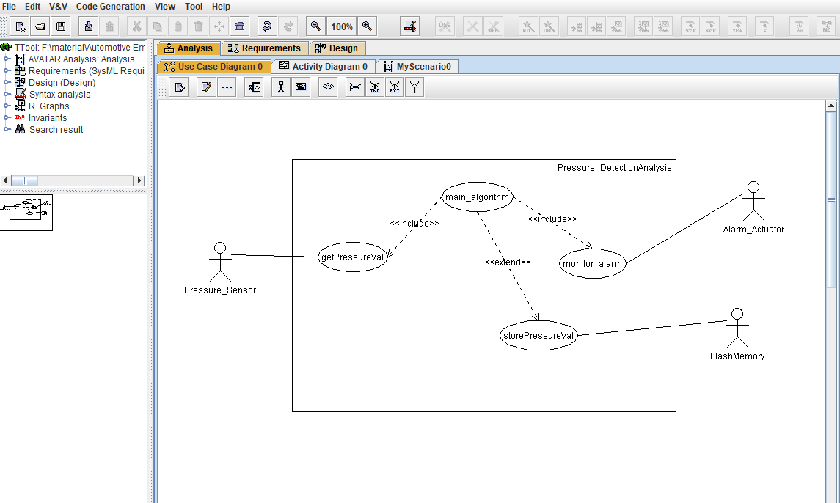

1. **Activity Diagram**
2. **Main Algorithm :**

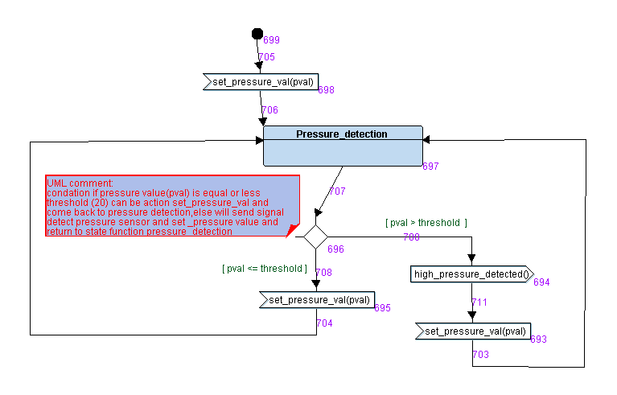

1. **Alarm Actuator Driver:**

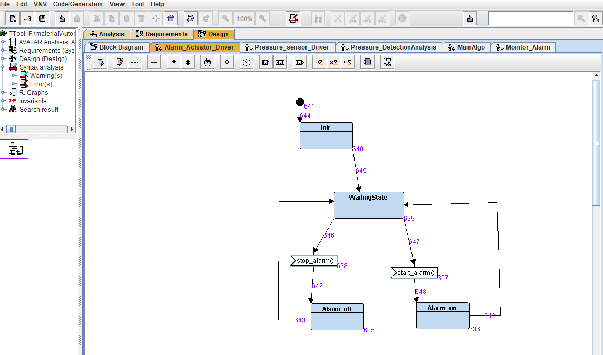

1. **Pressure Sensor Driver:**

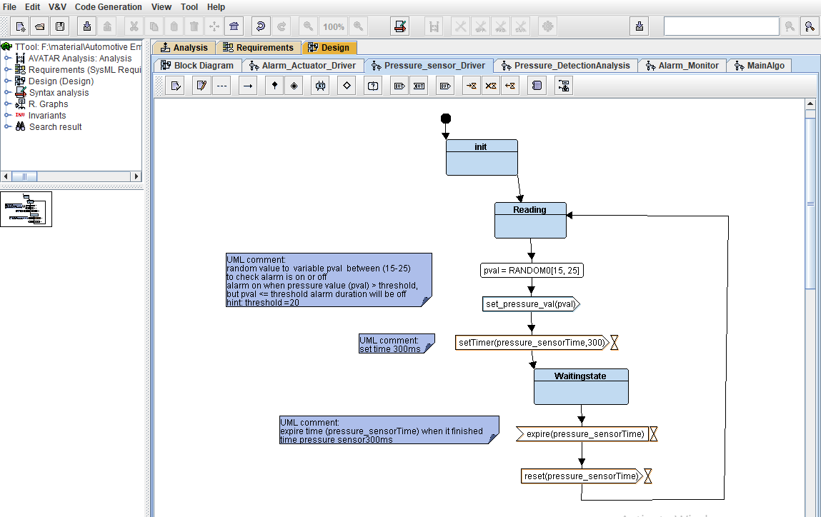

1. **Alarm Monitor:**

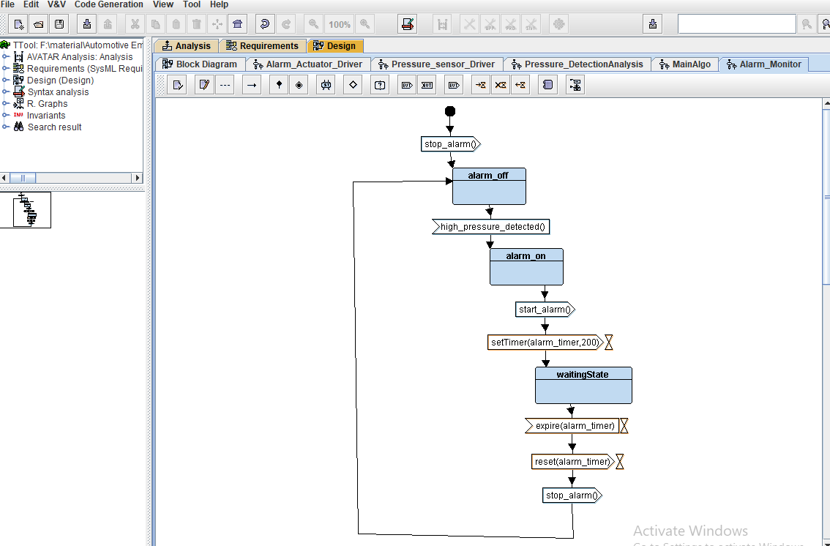

1. **Sequence Diagram :**

In the First, Pressure sensor reading value and alarm monitor was stated in stop alarm so alarm actuator is turn off.

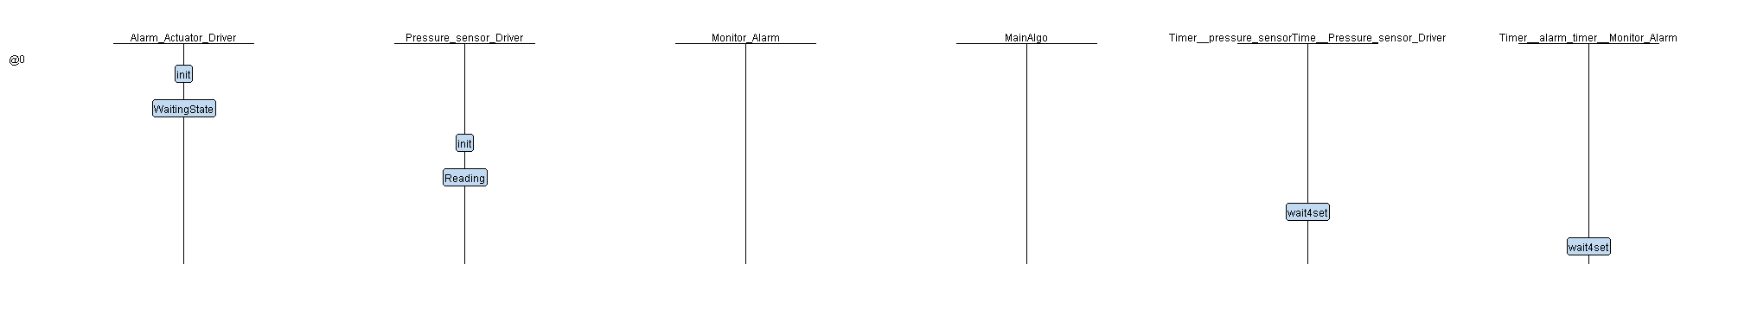

When pressure sensor reads less than threshold value, alarm actuator turned off and monitor alarm stop.

Next step, pressure sensor driver reads 25bar man algorithm check this value is less or more than threshold value, if pval is more than threshold start alarm monitor and alarm actuator turn on, alarm monitor turn on for delay time 300sec and turn off ,otherwise alarm monitor and alarm actuator stopped.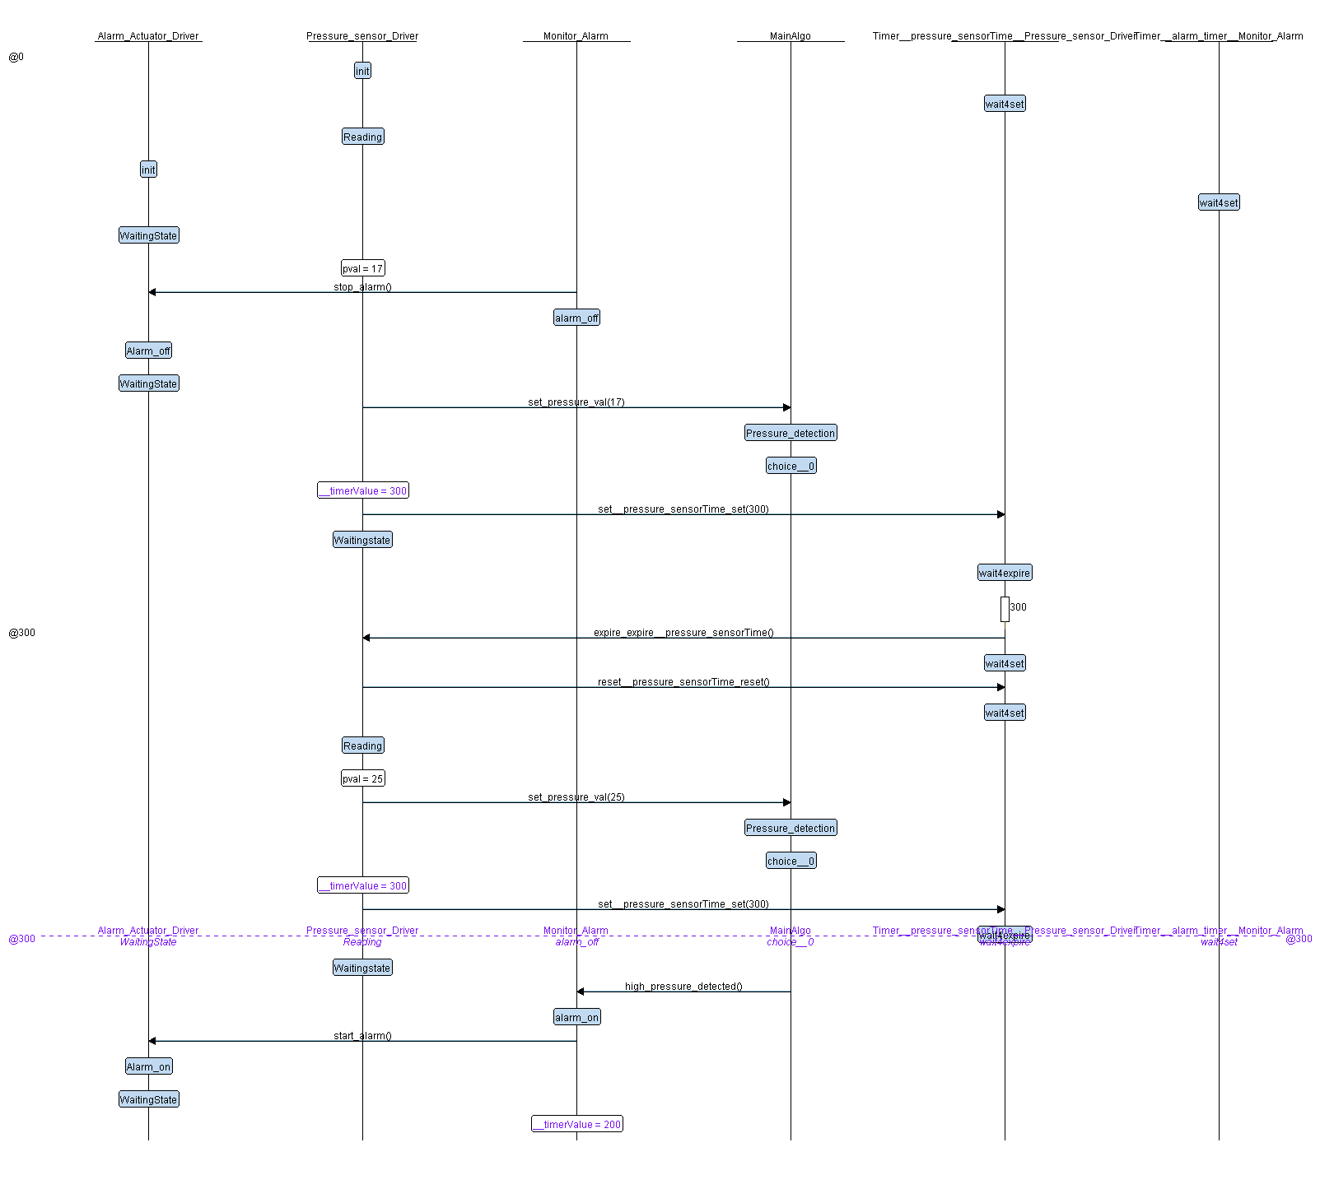

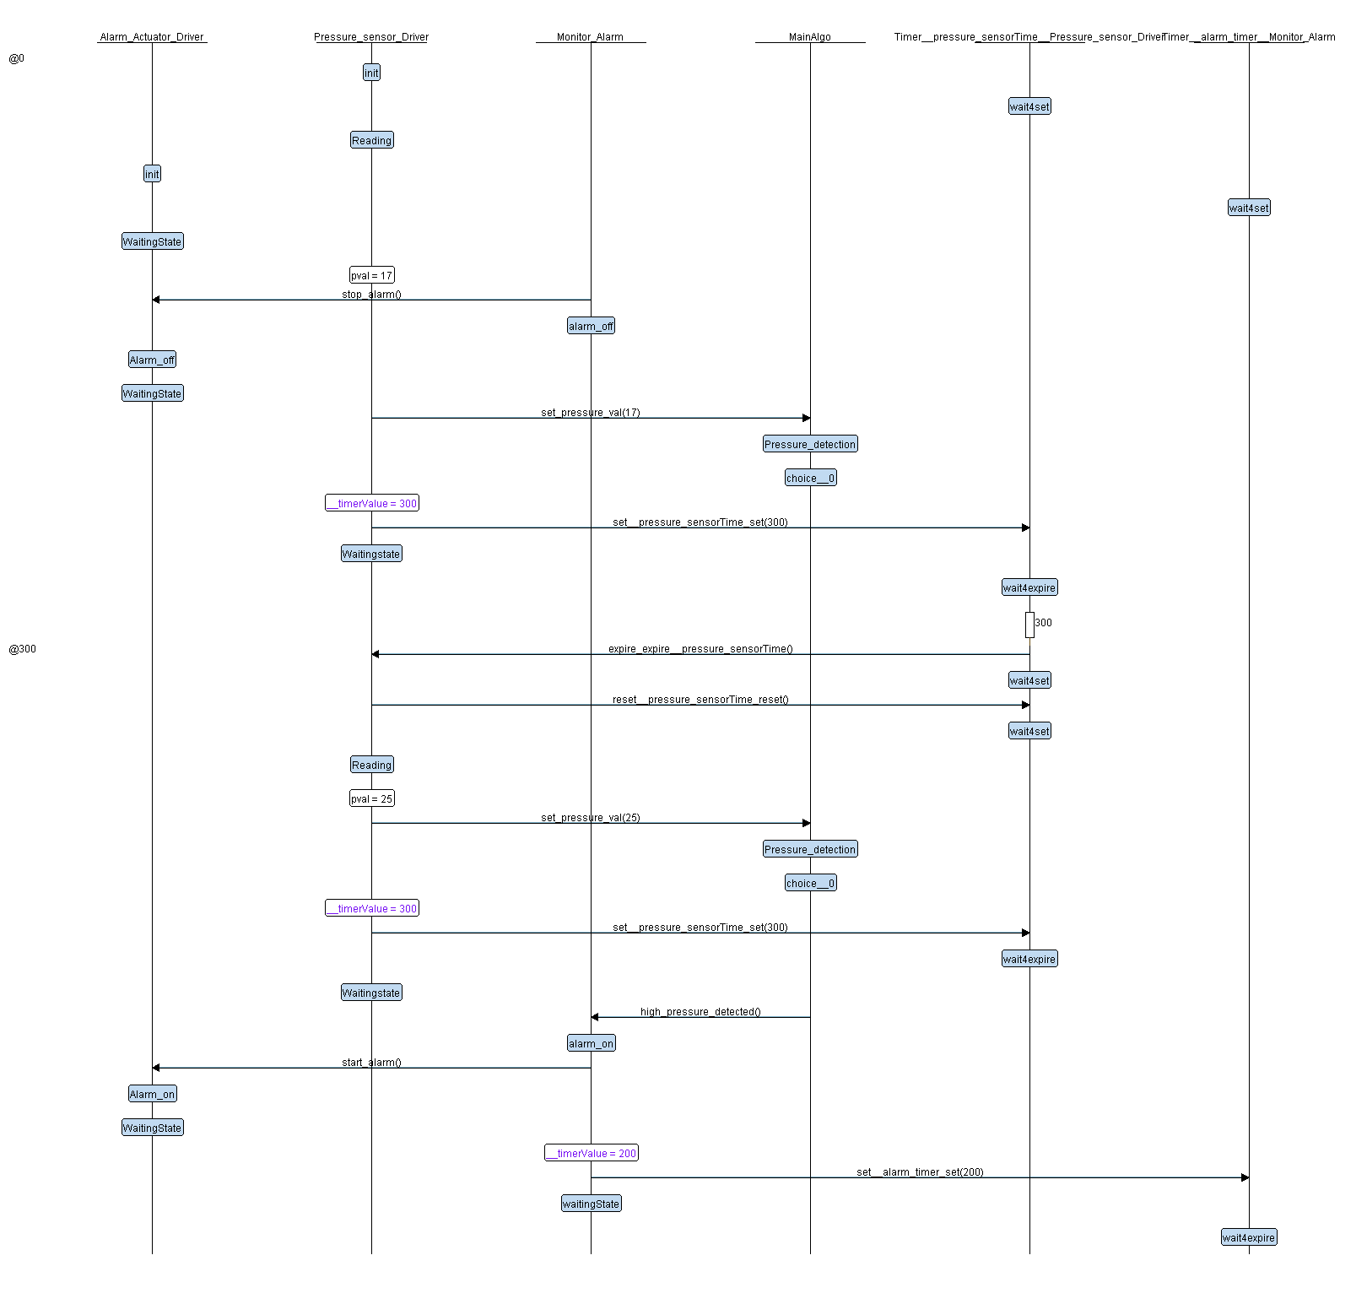

* **System design (State Machine):**

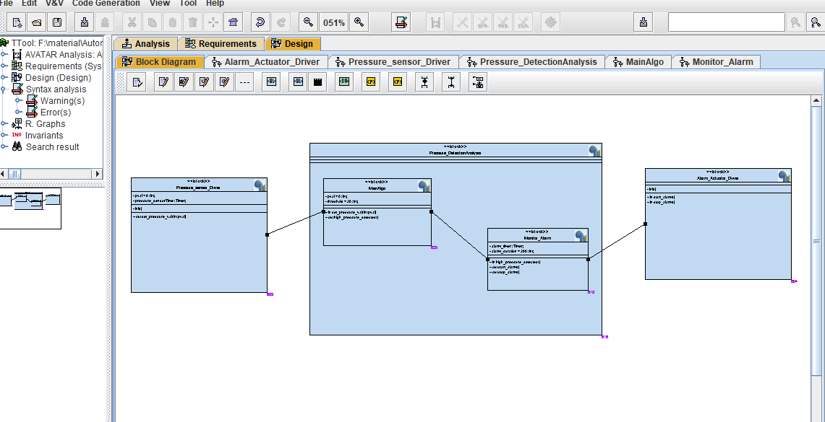

* **Simulation analysis:**

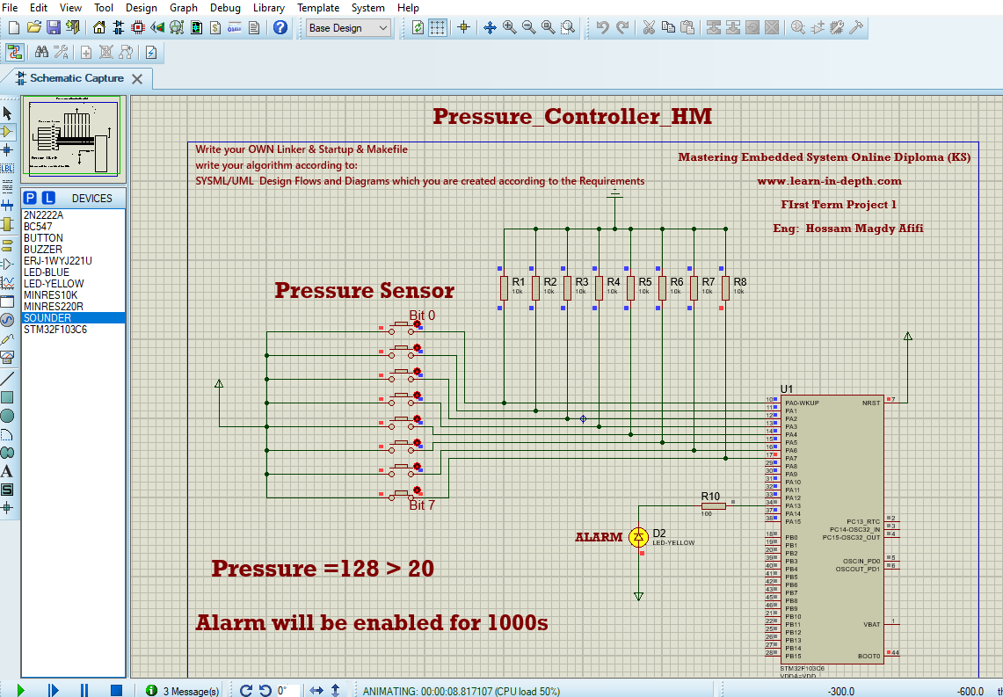

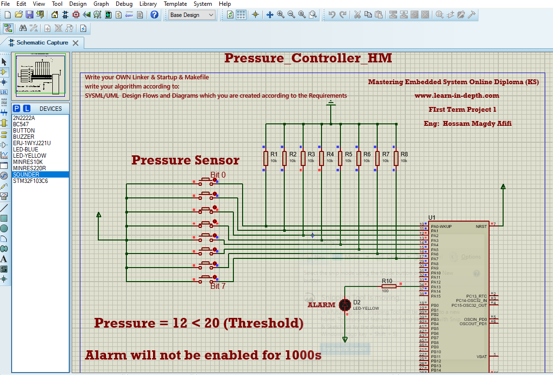

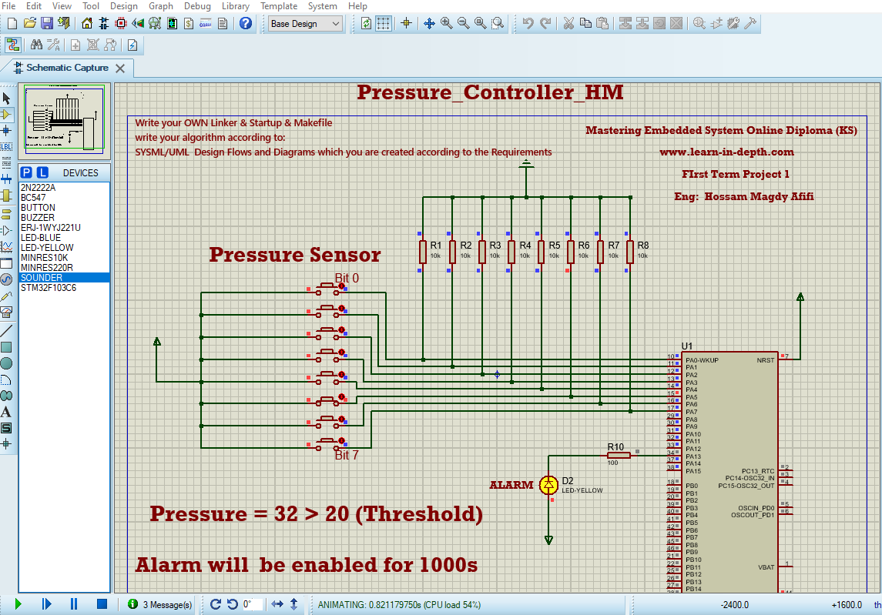

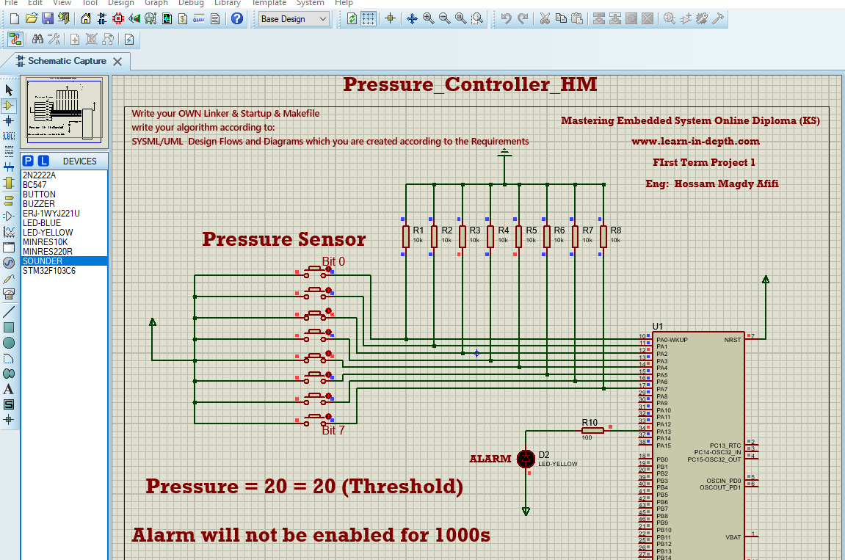

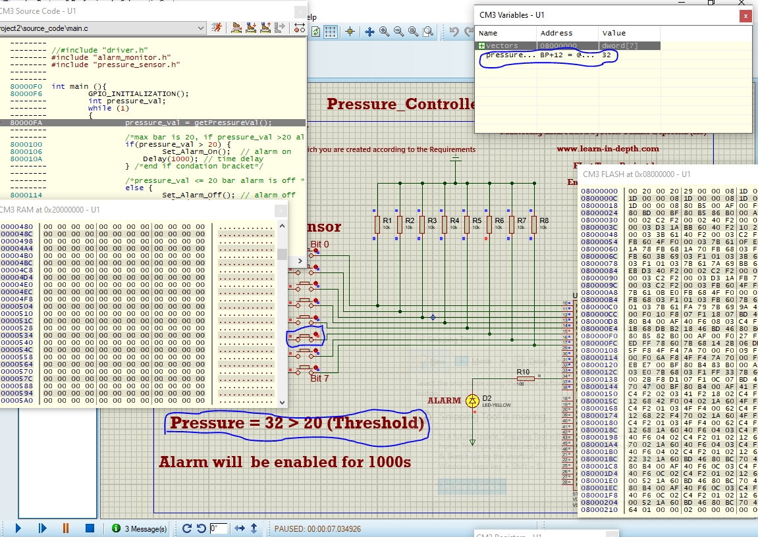

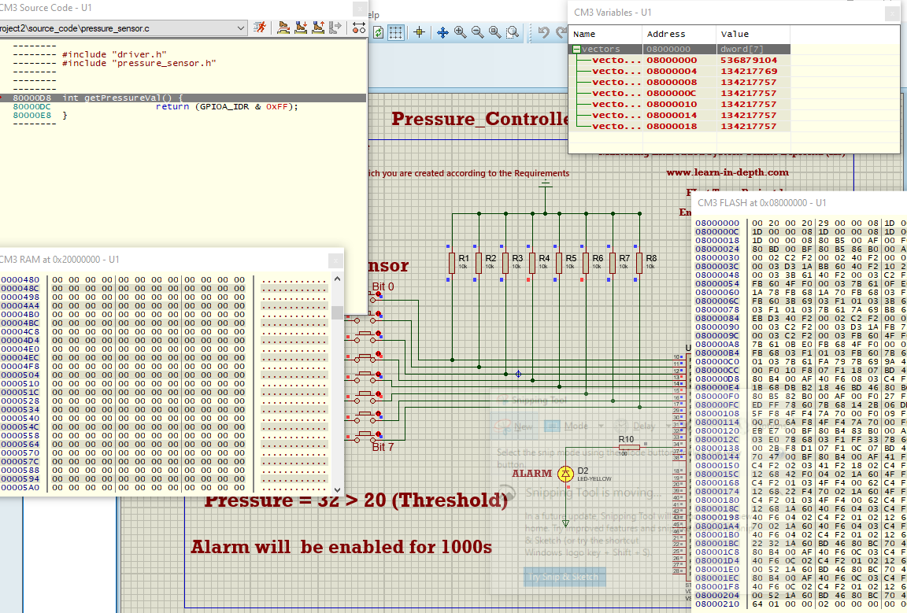

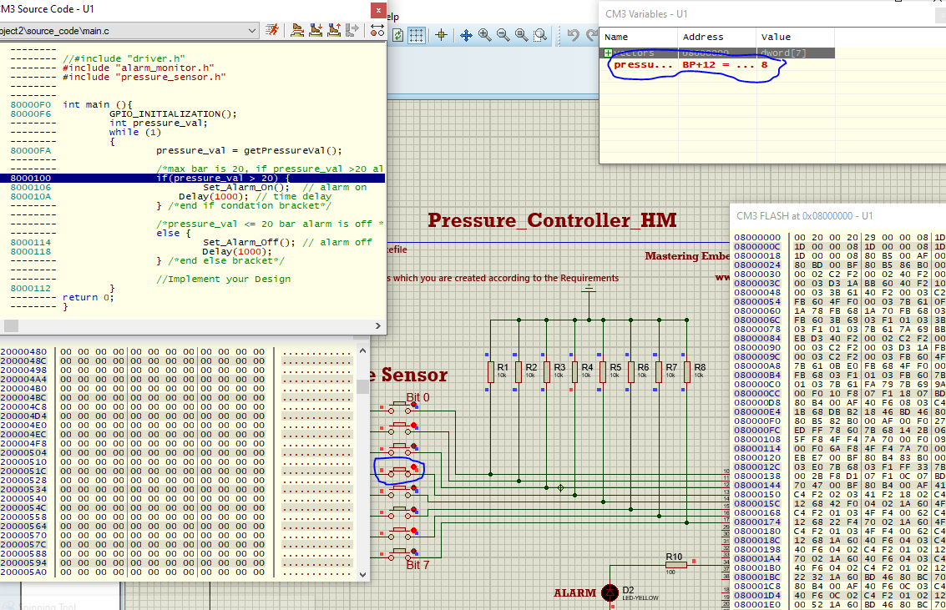

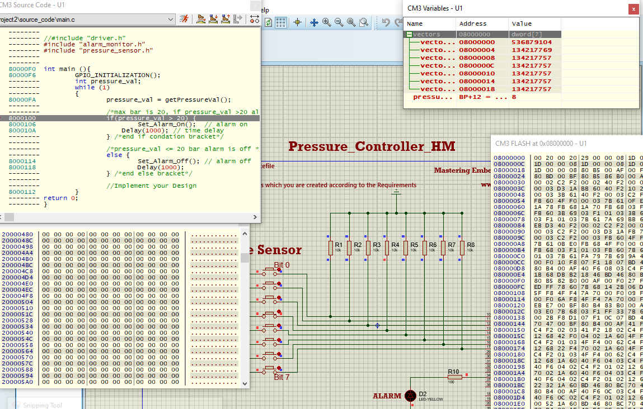

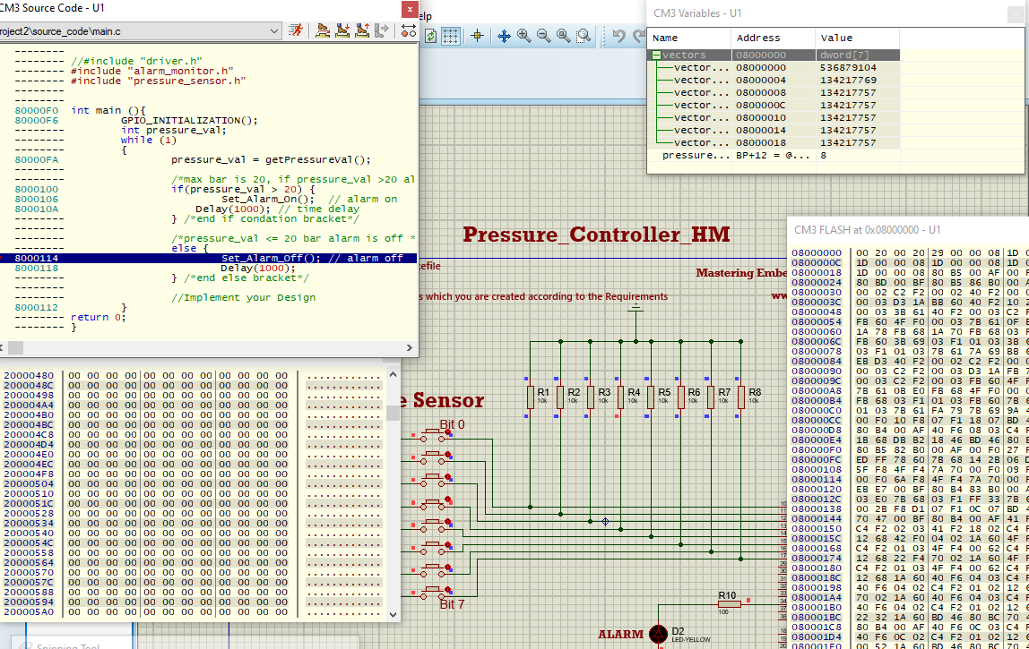

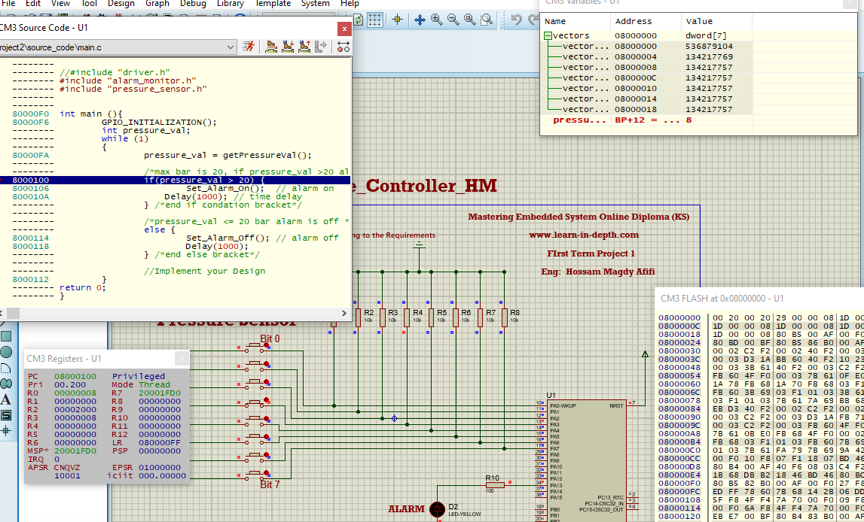

* **Make File:**

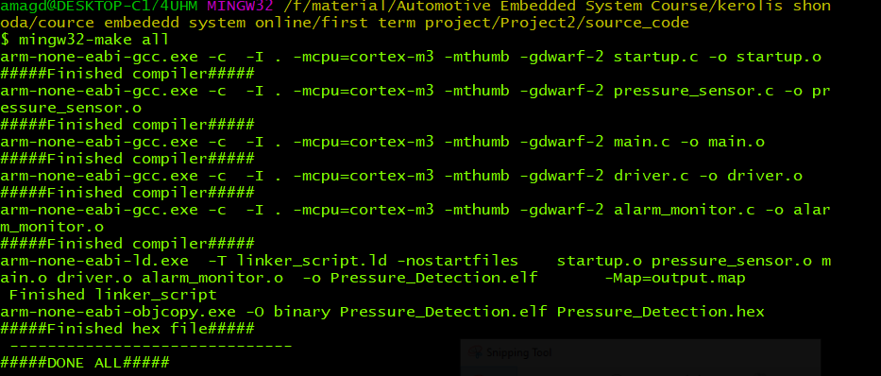

* **SW analysis:**

