**AIN SAHMS UNIVERSITY**

**FACULTY OF ENGINEERING**

**Senior2 Mechatronics Engineering program**

**Spring 2025**

**MCT445 – Mechatronics in Automotive Application**

**Lab (7)**

|  |  |
| --- | --- |
| **Name** | **Hossam Ahmed Mohamed Selem** |
| **ID** | **2001830** |

Table of Contents

List of figures 4

Introduction 5

Model 6

Parameters 7

Results 8

Model link 9

# List of figures

Figure 1-overview model 6

Figure 2-vehicle model 6

Figure 3-brake force 7

Figure 4-stateflow chart 7

Figure 5-direct driver force brake results 8

Figure 6-EBD force brake results 8

# Introduction

Electronic Brakeforce Distribution (EBD) is an advanced braking technology that dynamically adjusts the distribution of brake force between the front and rear wheels to optimize stopping performance and vehicle stability. Under braking, weight shifts toward the front axle, reducing the normal force—and hence traction—on the rear wheels. EBD compensates for this by reducing rear brake force and maximizing front braking efficiency.

In contrast to conventional braking systems that apply a fixed brake force ratio (e.g., 60:40), EBD responds in real time to vehicle load, speed, and wheel slip conditions. This helps prevent rear-wheel lockup, maintain optimal tire-road friction (typically near a wheel slip ratio of 0.2), and reduce stopping distance. In this experiment, EBD is implemented and compared against a fixed ratio braking system to evaluate its effectiveness in improving braking performance and safety.

# Model

Figure 1-overview model

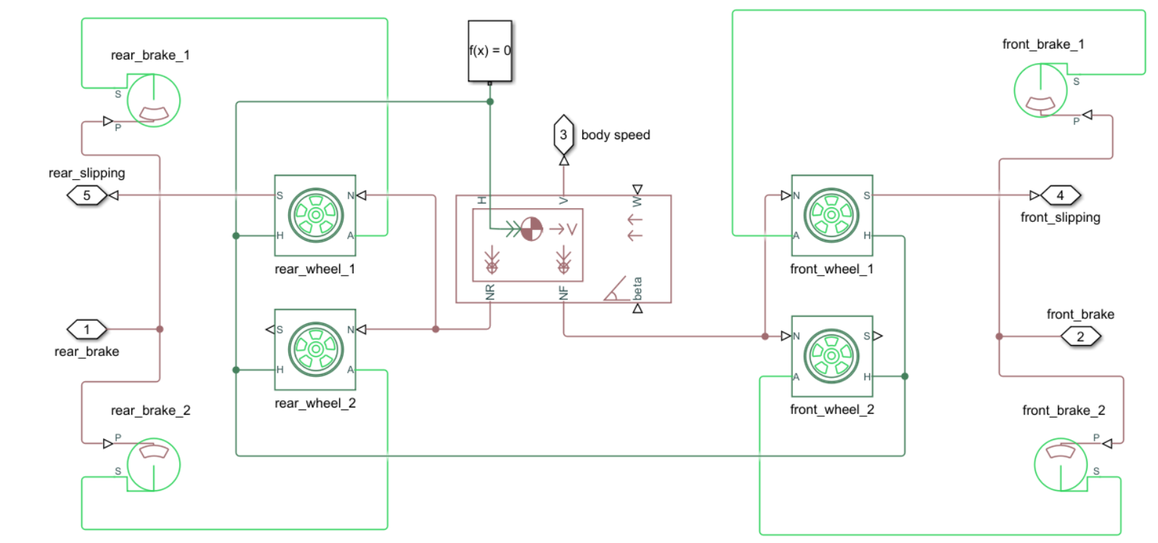

Figure 2-vehicle model

Figure 3-brake force

Figure 4-stateflow chart

# Parameters

Rear slip threshold = -0.0005

Slip diff threshold = 0.0001

Rear pressure increment = 1.03

# Results

Direct driver force brake:

Figure 5-direct driver force brake results

Stop dist = 100m

EBD force brake

Figure 6-EBD force brake results

Stop dist = 67m

# Model link

<https://github.com/hossam-selem/Automotive/tree/main/lab7-EBD>