Jenkins Plugin Installer Script
installer.sh & plugins.txt — Complete Breakdown with Illustrations

Overview
This script automates Jenkins plugin installation via the REST API. It handles authentication, token generation, and bulk plugin installation from a text file.
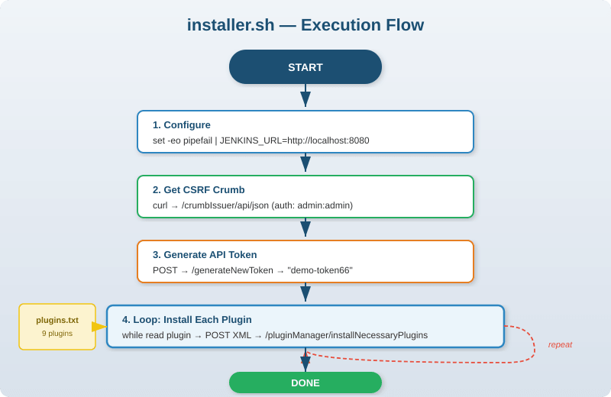
Figure 1: installer.sh Execution Flow

Step-by-Step Breakdown

Step 1: Script Configuration
- set -eo pipefail — Enables strict error handling. The script will exit immediately if any command fails or if a piped command fails.
- JENKINS_URL='http://localhost:8080' — Sets the target Jenkins server URL. Assumes Jenkins is running locally on the default port.

Step 2: Fetch CSRF Crumb
- Sends a GET request to Jenkins' /crumbIssuer/api/json endpoint.
- Authenticates with admin:admin (default credentials for a fresh Jenkins install).
- Saves session cookies to /tmp/cookies for reuse in later requests.
- Extracts the crumb value from the JSON response using jq.
Why is a crumb needed? Jenkins uses CSRF protection. Every POST request must include a valid crumb to prove it came from an authorized session.

Step 3: Generate API Token
- Sends a POST request to Jenkins' token generation endpoint.
- Includes the CSRF crumb in the request header (Jenkins-Crumb).
- Creates a token named 'demo-token66' for authenticating subsequent API calls.
- Extracts the token value from the JSON response using jq.
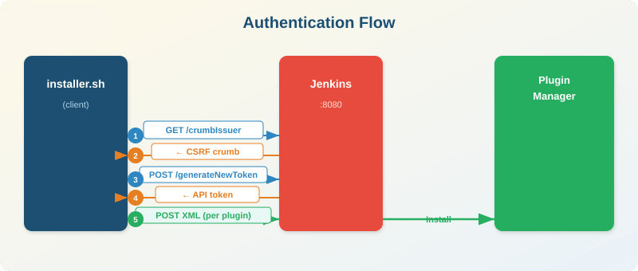
Figure 2: Authentication & Plugin Installation Sequence

Step 4: Plugin Installation Loop
- Reads plugins.txt line by line using a while read loop.
- For each plugin, constructs an XML payload: <jenkins><install plugin='name@version' /></jenkins>
- Sends an HTTP POST to /pluginManager/installNecessaryPlugins with Content-Type: text/xml.
- Authenticates with admin username + the generated API token (not the crumb).
- Prints progress for each plugin being installed.

Plugin List & Categories
The 9 plugins fall into three categories:
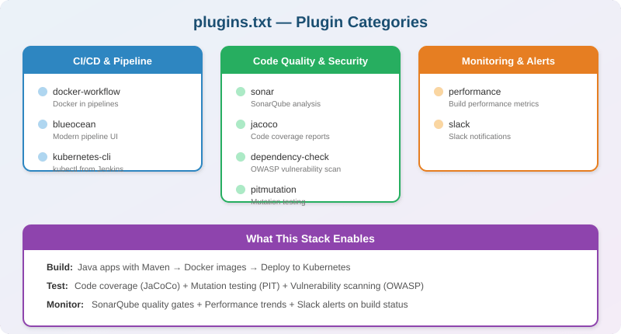
Figure 3: Plugin Categories & Capabilities
Plugin | Version | Category | Purpose
performance | 3.18 | Monitoring | Tracks build performance metrics over time
docker-workflow | 1.26 | CI/CD | Enables Docker commands in Jenkins Pipeline scripts
dependency-check | 5.1.1 | Security | OWASP vulnerability scanning of project dependencies
blueocean | 1.24.7 | CI/CD | Modern visual UI for pipeline creation and monitoring
jacoco | 3.2.0 | Quality | Publishes Java code coverage reports in build results
slack | 2.4.8 | Alerts | Sends build notifications to Slack channels
sonar | 2.13.1 | Quality | Integrates SonarQube for static code analysis
pitmutation | 1.0-18 | Quality | Reports mutation testing results to evaluate test quality
kubernetes-cli | 1.10.2 | CI/CD | Runs kubectl commands from Jenkins pipelines

Important Notes & Warnings
Area | Details
Security | Uses hardcoded admin:admin credentials. Only suitable for fresh dev/test setups, never for production.
CSRF Protection | The crumb is mandatory for all POST requests to Jenkins. Without it, requests are rejected as potential CSRF attacks.
Plugin Versions | All plugins are pinned to specific versions. Some may be outdated and could conflict with newer Jenkins releases.
Restart Required | Jenkins typically needs a restart after plugin installation for all plugins to fully activate.
Error Handling | set -eo pipefail ensures the script stops on first failure, but does not retry or provide detailed error messages.

