Digital Air Conditioner

Document Name | HLD
Version | 1
Start Date | 19/3/2016

Document History

Version | Date | Author | Status
1.0 | 19/3/2016 | Hadir Rashed | Initial Version
1.1 | 1/4/2016 | Belal Magdy | Adding the main application APIs

Table of contents
1 Introduction 4
1.1 Document Scope 4
1.2 Goals and Objectives 4
1.3 Context Diagram 4
1.4 Reference Documents 5
2 Design Constraints 6
2.1 Constraints on Initialization 6
2.2 Constraints on Inputs 6
2.3 Constraints on Outputs 6
2.4 Communication/Network Constraints 6
2.5 Diagnostic Constraints 6
3 Real Time Analysis 7
3.1 Processes Identification 7
3.2 Timing Bases Identification 7
3.3 Shared Resources 7
3.3.1 Hardware Resources 7
3.3.2 Software Resources 8
4 Architectural Design 9
4.1 Real Time Architecture 9
4.1.1 Components/Modules Design 9
4.1.1.1 <Component Name> 9
4.1.1.1.1 Offered Services 9
4.1.1.1.2 Configuration of the Component 9
4.2 Static Architecture 9
4.2.1 File Description 9
5 Design Alternatives and Justification 10

Introduction

Document Scope
This document seeks to define the high-level functionalities of the Digital Air Conditioner Screen.

Goals and Objectives
.
       • . Define the project level architecture of the system.
- Develop internal and external interfaces.
- Identify interface standards.
- Develop sub-system requirements.

Figure 1 : System context diagram

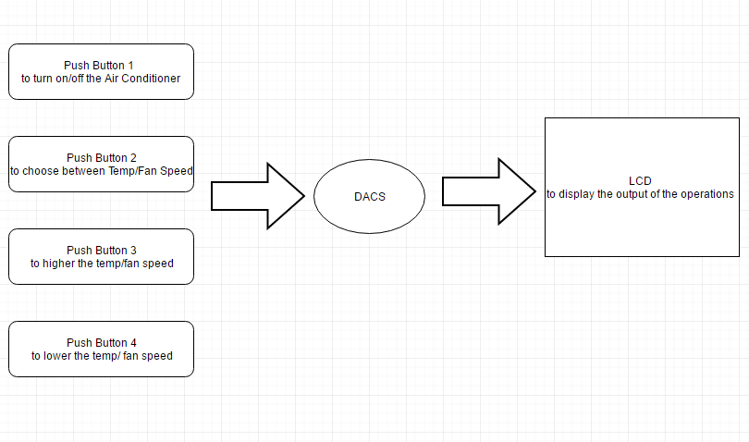

Interface | Description
Push Buttons | Push Buttons are used to increase or decrease the Fan speed or Temperature
LCD | LCD is used to display the different operations’ status.
Table 1: Interfaces description

Figure 2 : Control Flow diagram

API | Description | Inputs | Return Value
DIO_voidInit | Initialization of the Digital Input/Output Pins and ports | N/A | N/A
LCD_WriteData | Function to write data on the lcd | Copy_u8Data | N/A
LCD_voidInit | Initialization function of the lcd | N/A | N/A
LCD_VoidGotoxy | This function moves the cursor to a specific x and y | U8 LCD_u8x , U8 LCD_u8y | N/A
LCD_VoidString | Writes a string | U8* LCD_u8Ptr | N/A
LCD_VoidRowString | Writes a string in a specific row | U8 LCD_u8row U8* LCD_u8string | N/A
EEPROM_voidInit | EEPROM initialization | N/A | N/A
TSW_voidInit | Initialization function of the switch | N/A | N/A
TSW_u8GetState | Function to get the state of the button whether it’s pressed or not | Copy_u8SwitchIdx  Copy_u8PtrToVal | Error if the input value is out of the range define  Ok if the Input Value is in the range
app | The main function | N/A | N/A
Table 2: API description

Reference Documents

ID | Reference | Title
1 | Customer requirements
2 | DIO CDD | Digital input output Documentation
3 | EEPROM CDD | EEPROM Documentation
4 | SWITCH CDD | SWITCH CDD
5 | LCD CDD | LCD CDD

Design Constraints

Constraints on Initialization
N/A

Constraints on Inputs
N/A

Constraints on Outputs
N/A

Communication/Network Constraints
N/A

Diagnostic Constraints
N/A

Architectural Design

Real Time Architecture

Components/Modules Design

<Component Name>

Configuration of the Component

Generic Configuration of the Component

Static Architecture

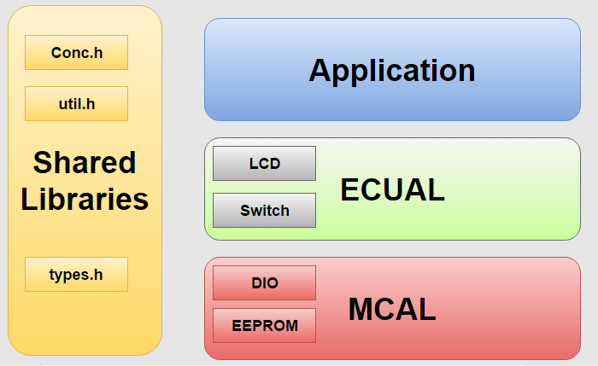

Figure 3 : The Files Structure

File Description
File Name | Description
DIO_prog.c | Contains the functions implementations of the DIO
DIO_config.h | Contains the public configurations of the DIO
DIO_interface.h | Contains the functions’ API’s
DIO_private.h | Contains the private configurations and functions of the DIO
LCD_ prog.c | Contains the functions implementations of the LCD
LCD_ config.h | Contains the public configurations of the LCD
LCD_ interface.h | Contains the functions’ API’s
LCD_ private.h | Contains the private configurations and functions of the LCD
TACTILE_ prog.c | Contains the functions implementations of the Tactile Switch
TACTILE_ config.h | Contains the public configurations of the Switch
TACTILE_ interface.h | Contains the functions’ API’s
TACTILE_ private.h | Contains the private configurations and functions of the Switch.
Types.h | Contains the used data types
Conc.h | Contains Macro that used to concatenate 8 bits
util.h | Contains some macros that manipulate bits in any register
Main.c | The Application File

