Exercise Five-P1

**4.1** Consider the following combinational circuit:

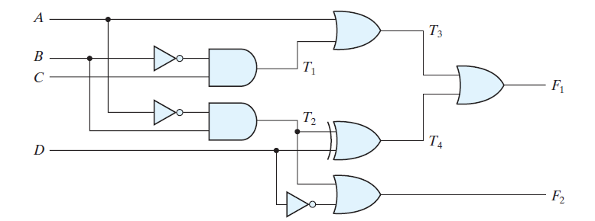

(b) List the truth table with 16 binary combinations of the four input variables. Then list

the binary values for *T*1 through *T*4 and outputs *F*1 and *F*2 in the table.

(c) Plot the output Boolean functions obtained in part (b) on maps and show that the

simplified Boolean expressions are equivalent to the ones obtained in part (a).

**4.3** For the circuit shown in Fig. 4.26 (Section 4.11),

(a) Write the Boolean functions for the four outputs in terms of the input variables.

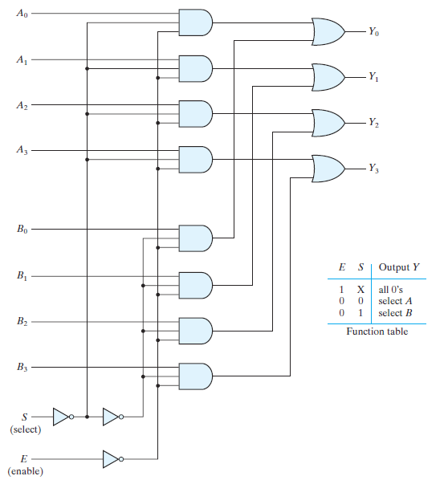

**4.4** Design a combinational circuit with three inputs and one output.

(b) The output is 1 when the binary value of the inputs is an even number.

**4.6** A majority circuit is a combinational circuit whose output is equal to 1 if the input variables

have more 1’s than 0’s. The output is 0 otherwise.

(b) Write and verify a Verilog gate-level model of the circuit.

**4.8** Design a code converter that converts a decimal digit from

(b) The 8, 4, –2, –1 code to Gray code.

**4.9** An ABCD-to-seven-segment decoder is a combinational circuit that converts a decimal digit

in BCD to an appropriate code for the selection of segments in an indicator used to display

the decimal digit in a familiar form. The seven outputs of the decoder *(a, b, c, d, e, f, g)* select

the corresponding segments in the display, as shown in Fig. P4.9(a). The numeric display

chosen to represent the decimal digit is shown in Fig. P4.9(b). Using a truth table and

Karnaugh maps, design the BCD-to-seven-segment decoder using a minimum number of gates. The six invalid combinations should result in a blank display.

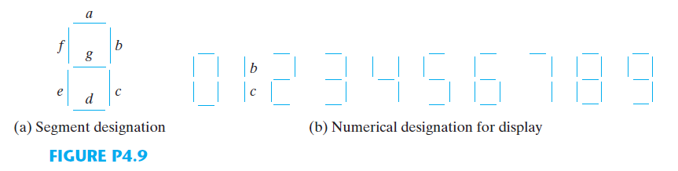

**4.11** Using four half-adders

(b)Design a four-bit combinational decrementer (a circuit that subtracts 1 from a four-bit

binary number).

**4.12** Design a half-subtractor circuit with inputs *x* and *y* and outputs *Diff* and B*out* . The circuit

subtracts the bits *x – y* and places the difference in *D* and the borrow in *B out* .

(a) Design a full-subtractor circuit with three inputs *x* , *y* , *B in* and two outputs *Diff* and

*B out* . The circuit subtracts *x* – *y* – *Bin* , where *Bin* is the input borrow, *B out* is the output

borrow, and *Diff* is the difference.

**4.18** Design a combinational circuit that generates the 9’s complement of a

(a)BCD digit.

(b) Gray-code digit.

**4.19** Construct a BCD adder–subtractor circuit. Use the BCD adder of Fig. 4.14 and the 9’s

complementer of problem 4.18. Use block diagrams for the components.

**4.21** Design a combinational circuit that compares two 4-bit numbers to check if they are equal.

The circuit output is equal to 1 if the two numbers are equal and 0 otherwise.