Cairo University

**Faculty of Statistical Studies and Research**

**Department of Computer and Information Sciences**

**Product Shop**

**A document Presented for E-commerce website**

**Submitted by**

|  |  |
| --- | --- |
| **ID** | **Name** |
| **202100493** | **Hossam Hasan Mahmoud Mohammed Yousif** |
| **202100548** | **Aya Gamal Abd El zaher Ramadan** |

**Supervised by**

**Dr. Shahira Azzazy**

**Cairo, Egypt**

Table of Contents

Introduction 3

Scope 4

purpose 5

System Architecture 5

System Requirement specifications 8

Requirement specifications 8

Requirement specifications Priority 8

User Stories 8

Work backlog 8

Project duration 8

Functional Requirement 9

Use Case diagram: 9

1- Guest 9

2- Customer 9

3- Admin 9

Use Case Description: 9

Traceability Matrix 9

According To Traceability Matrix: 10

Activity Diagram 10

Sequence Diagram 10

Non-Functional Requirement 10

Performance and scalability. 10

PERFORMANCE 10

SCALABILITY 10

Portability and compatibility. 11

PORTABILITY 11

COMPATIBILITY 11

Security. 11

Usability. 11

System Design 12

Component Diagram 12

Class Diagram 12

Entity Relationship Diagram (ERD) 12

Mapping 12

Testing 12

Test Cases 12

# Introduction

In the contemporary digital landscape, E-commerce has emerged as a pivotal force, transforming the way businesses engage with customers and conduct transactions. This proposal outlines the development of a sophisticated E-commerce website leveraging cutting-edge technologies, specifically focusing on Node.js, MongoDB, and advanced authentication mechanisms. This project aims to address the growing demand for secure, scalable, and feature-rich online platforms that facilitate seamless buying and selling experiences.

. Recently, there have been many e-commerce sites exported such as Amazon, e-bay or the stores that can sell products via social media channels like Facebook. How- ever, customers still find it difficult to choose the products they want because of the large variety of products on these sites and not focus on specific things. Moreover, the sellers have to spend a high amount of money on marketing or paying for fees. From there disadvantages, implement an online e-commerce web application for small grocery stores helps retailers can manage products on their own systems and not depend on the 3rd party website. For the customers, they can quickly search the products if it is available and come to store to pick it up and they can

contact directly to the shop owner to learn more about the products that they are looking for.

In order to make a website that can acquire the needs of both customers and retailers, MERN (MongoDB, Express.js framework, ReactJS library, NodeJS platform) is one of the powerful stacks that can help us to develop an e-commerce web application.

The proposed E-commerce website will encapsulate a range of modern functionalities essential for success in the online retail sphere. The utilization of Node.js will enable efficient server-side programming, ensuring rapid data processing and real-time updates. MongoDB, as the chosen database solution, offers the flexibility to manage complex data structures inherent to E-commerce platforms, while advanced authentication mechanisms will guarantee the security of user information and transactions

# Scope

1. The system is a type of interactive transaction-based application.
2. E-Commerce is buying and selling, marketing, servicing delivery and payment of products, service and information over internet
3. It differs form the traditional commerce in the way that it enables the trading of goods, money and information electronically from computer to computer. Business is done electronically and there is no longer a need for physical currency or goods to conduct business.
4. The functions included in e-commerce are : -
   1. Buying and selling of products.
   2. Shipping of products.
   3. Producing financial statements.
   4. All these function are without human intervention, which is termed as real ‘E’ in e-commerce

# purpose

E-commerce websites have become a ubiquitous feature of the modern digital landscape, offering a wide range of benefits and opportunities to businesses and consumers. Here are some of the most common objectives of an e-commerce website:

1. Increase Sales: This can be achieved by providing a user-friendly shopping experience, offering competitive prices, showcasing products effectively, and providing excellent customer service.
2. Improve Customer Engagement: Features such as customer reviews, and personalized recommendations can help to build customer engagement, loyalty and trust.
3. Increase Efficiency: By automating processes such as order fulfillment, inventory management, and payment processing,

# System Architecture

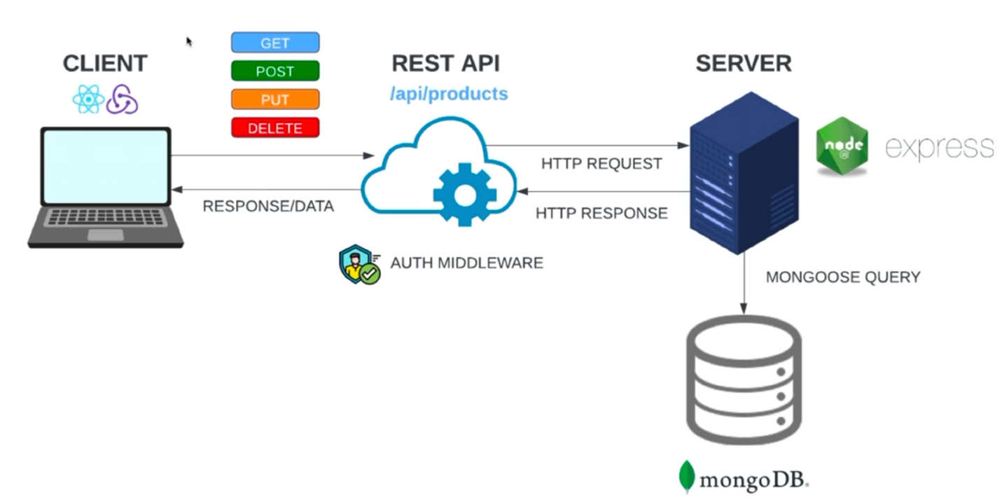

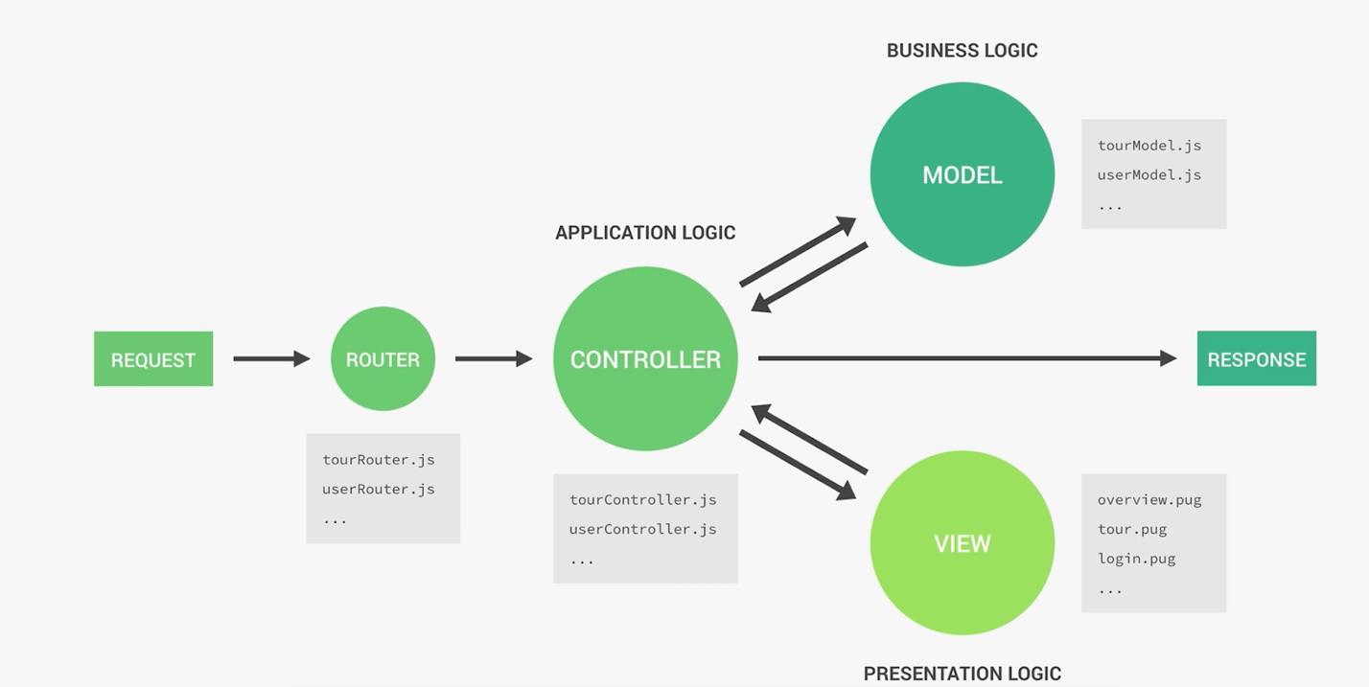

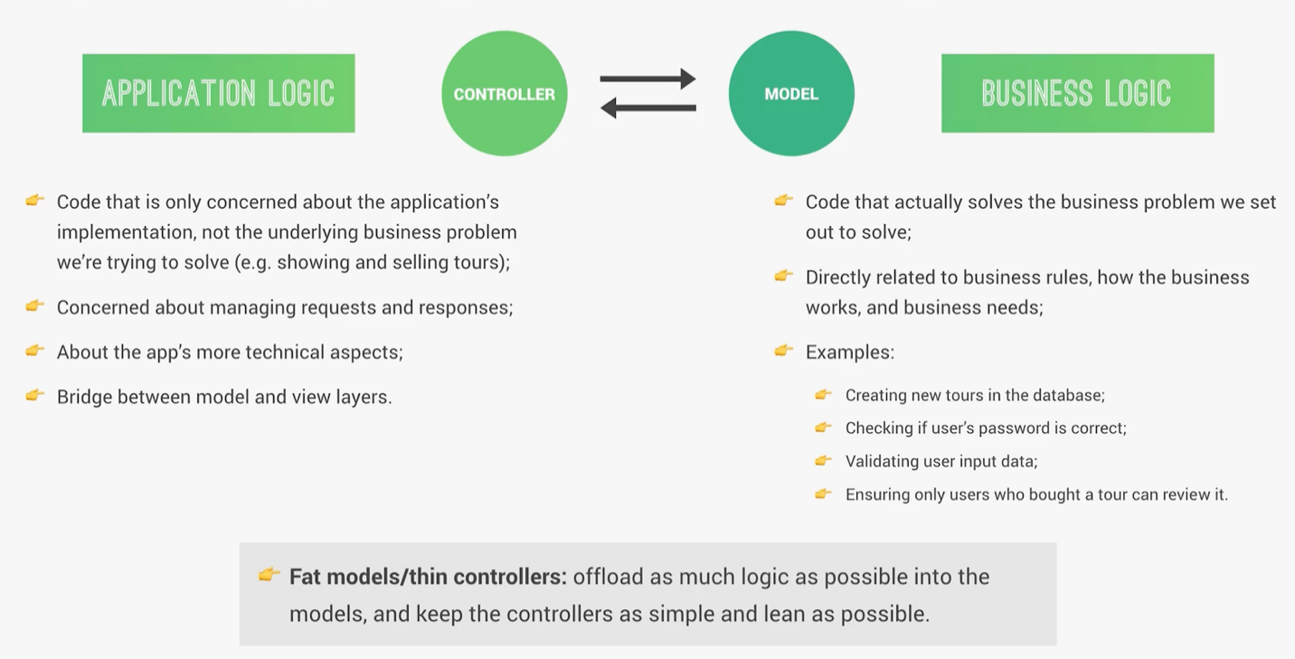

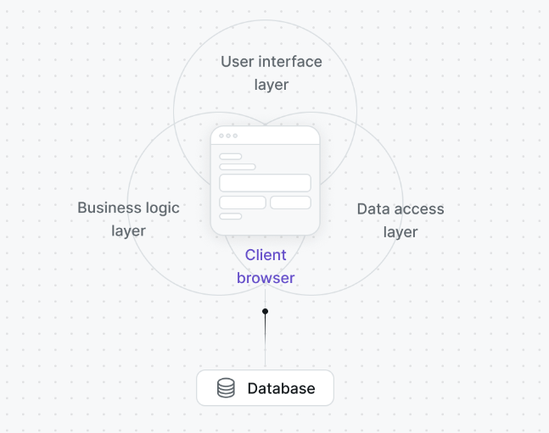

# System Requirement specifications

### Requirement specifications

### Requirement specifications Priority

### User Stories

### Work backlog

### Project duration

# Functional Requirement

## Use Case diagram:

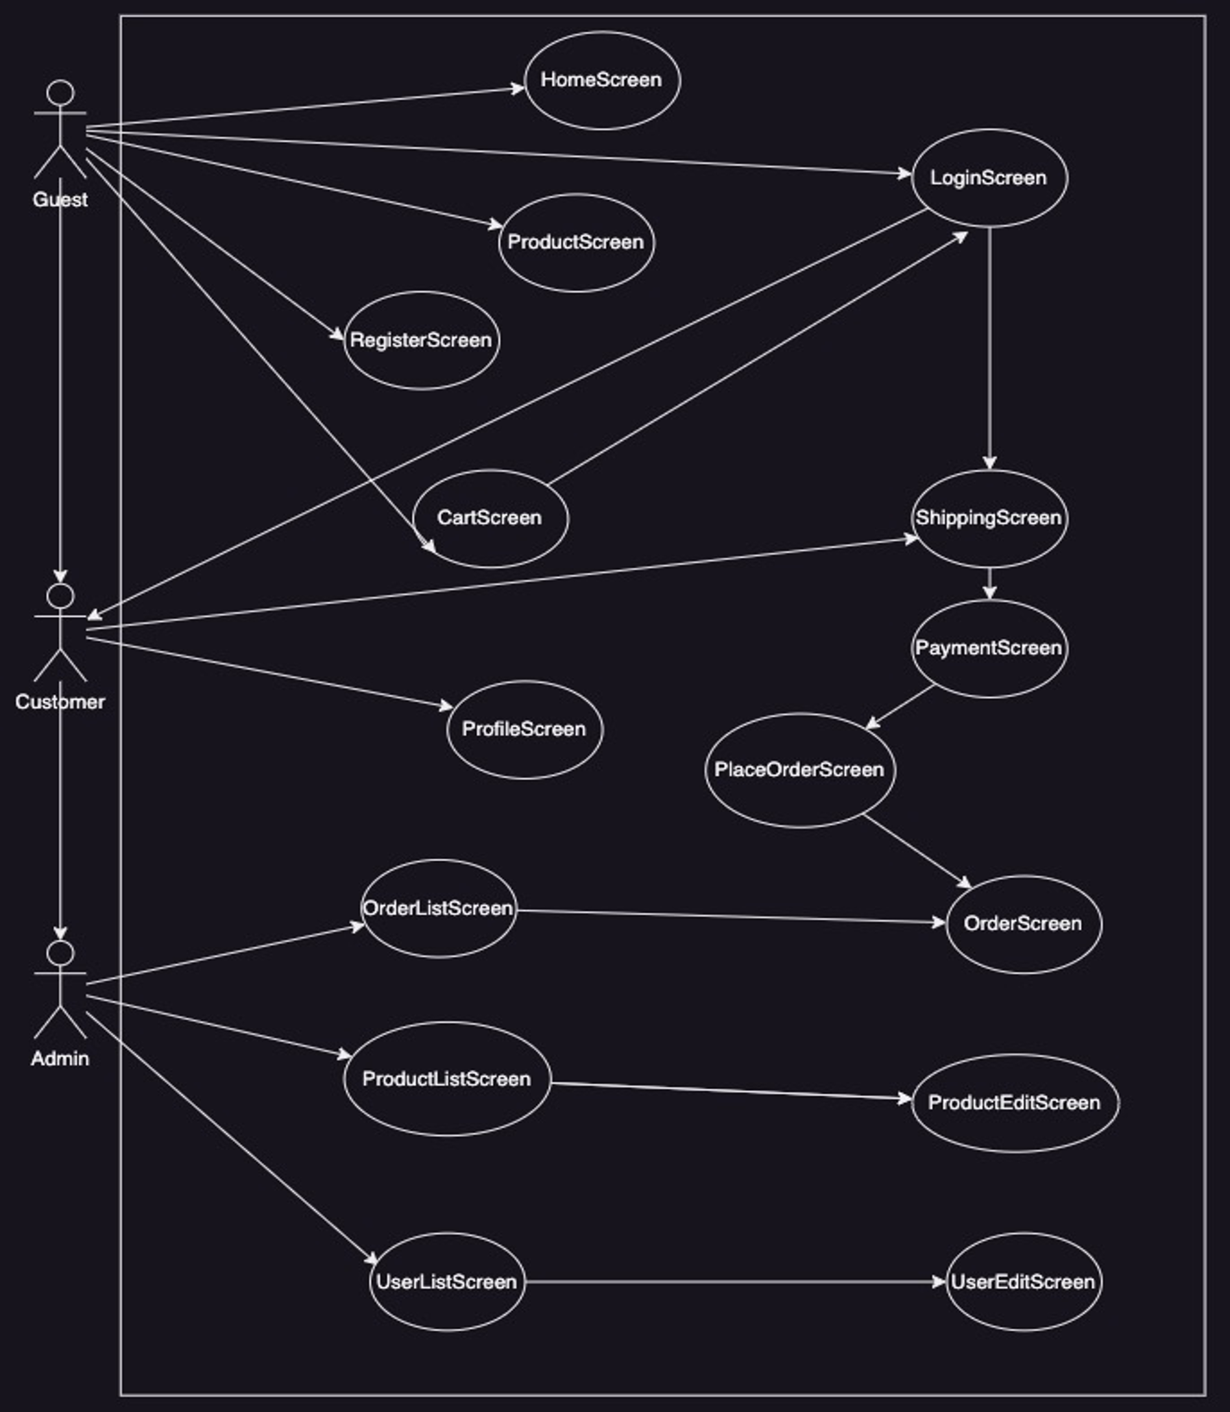

### Guest

### Customer

### Admin

## Use Case Description:

## Traceability Matrix

### According To Traceability Matrix:

## Activity Diagram

## Sequence Diagram

# Non-Functional Requirement

## Performance and scalability.

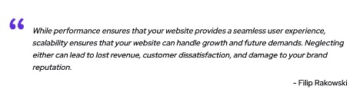

### PERFORMANCE

Refers to the speed and responsiveness of our site, i.e. The speed at which our site can load and respond to user actions. On the other hand, scalability means that our website can handle more visitors and more demand this directly affects the user experience. When pages take too long to load or the interface doesn't work properly, users can get frustrated and abandon their shopping carts, which can hurt our business revenue. Our website has high performance, fast page load times, fast response times and a smooth checkout process.

Another factor affecting website performance is that a poorly designed website with large amounts of graphics, plugins, and other elements can slow it down. That's why throughout our site we've used clean designs and optimized images that are faster and increase performance.

### SCALABILITY

Scalability refers to our site's ability to handle increased traffic and increased demand. As an e-commerce business grows, so does their website traffic, which can strain their resources. Our site can handle increased traffic without sacrificing performance or user experience.

As in the case of performance, there are many factors that have an impact on scalability.

Website scalability is crucial. When more people visit the site,

The structure of our site also plays a crucial role. A well-designed site architecture can handle a large number of requests without sacrificing performance.

## Portability and compatibility.

## PORTABILITY

This means that our site can handle all operating systems and all devices connected to the internet without any defect or damage to the site.

### COMPATIBILITY

This means that our site can be handled by different versions of operating systems, whether old or modern

## Security.

The site has the ability to keep customer data and not share it with parties that do not have the right to use it or even steal it from the site. The site also protects customers' financial data and ensures that they are not stolen.

## Usability.

Our site has a simple and easy-to-use interface design and icons so that the user can interact with the site and learn to use it from the first time and also does not require a lot of data that causes boredom and exit from the site quickly without carrying out the required process

# System Design

## Component Diagram

## Class Diagram

## Entity Relationship Diagram (ERD)

## Mapping

# Testing

## Test Cases