required hardware

1 Arduino uno

1 Arduino mega

2 nRF24 "chosse your suitable range and by it"

2 bread board

1 current sensor module

1 LM35

3 LCD 16*2

1 transformer

required software :

1-download the IDE from hare : https://www.arduino.cc/en/main/software

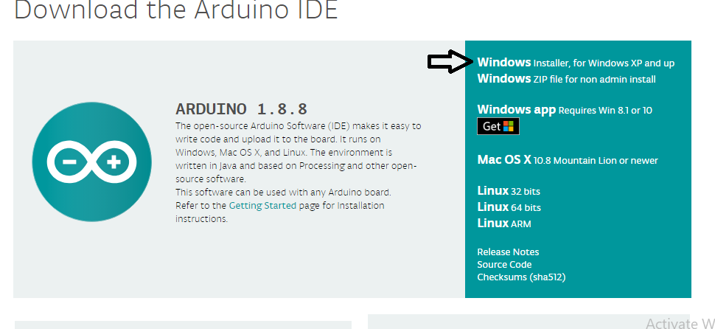

2-open the file named “nRT_trans”

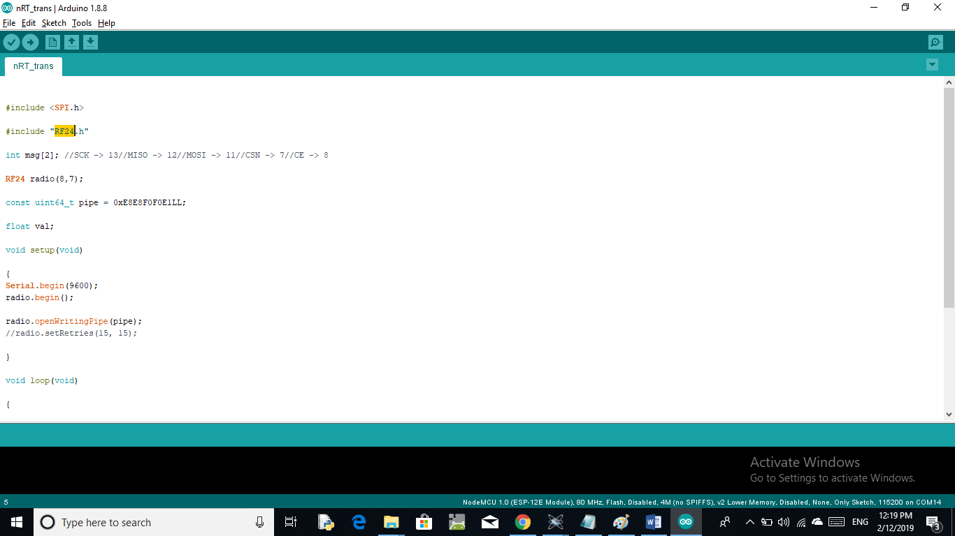

3- install the following library : “RF24” by this way :

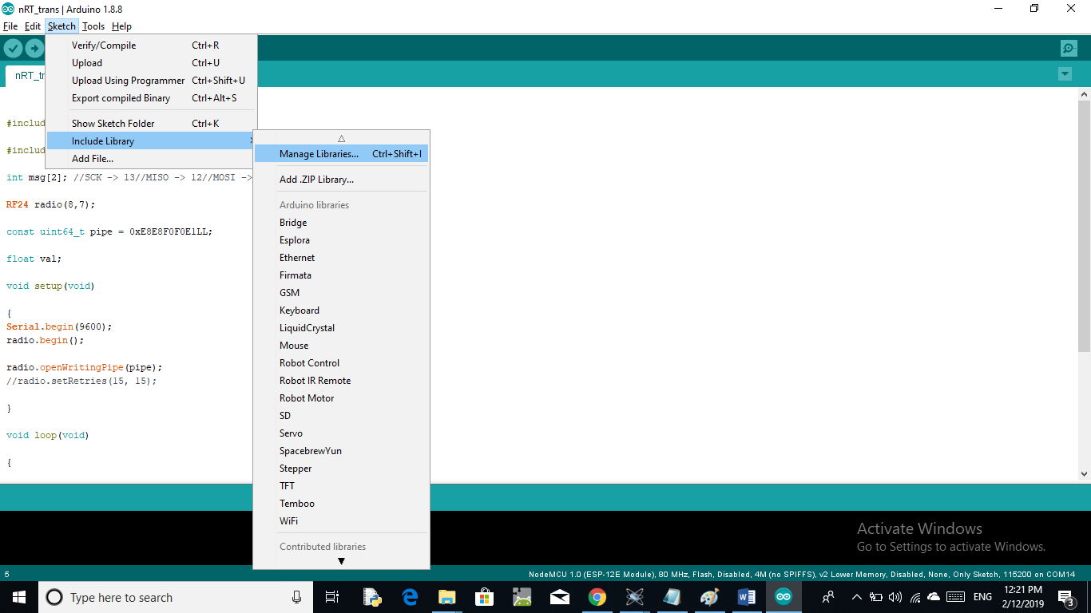

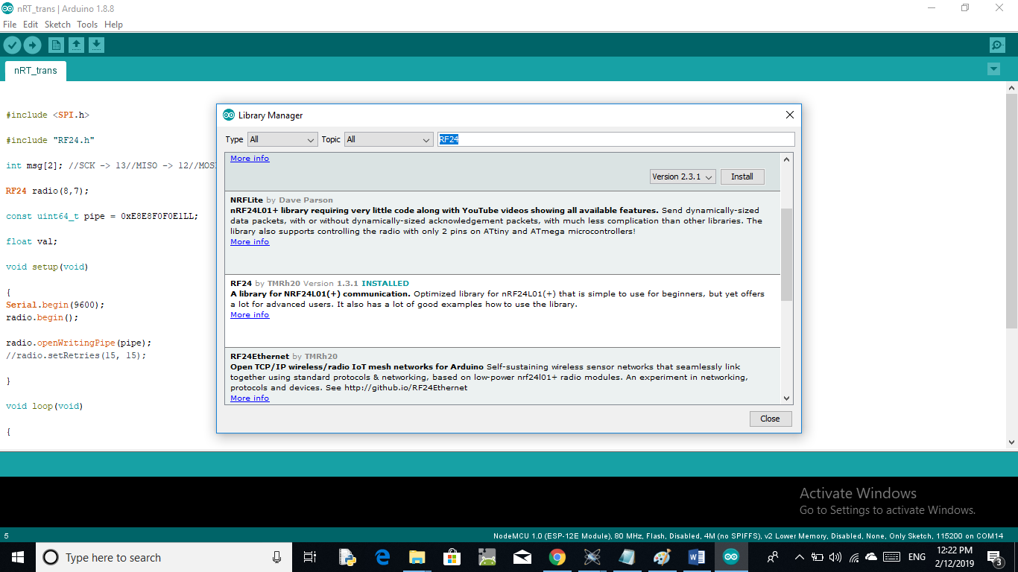

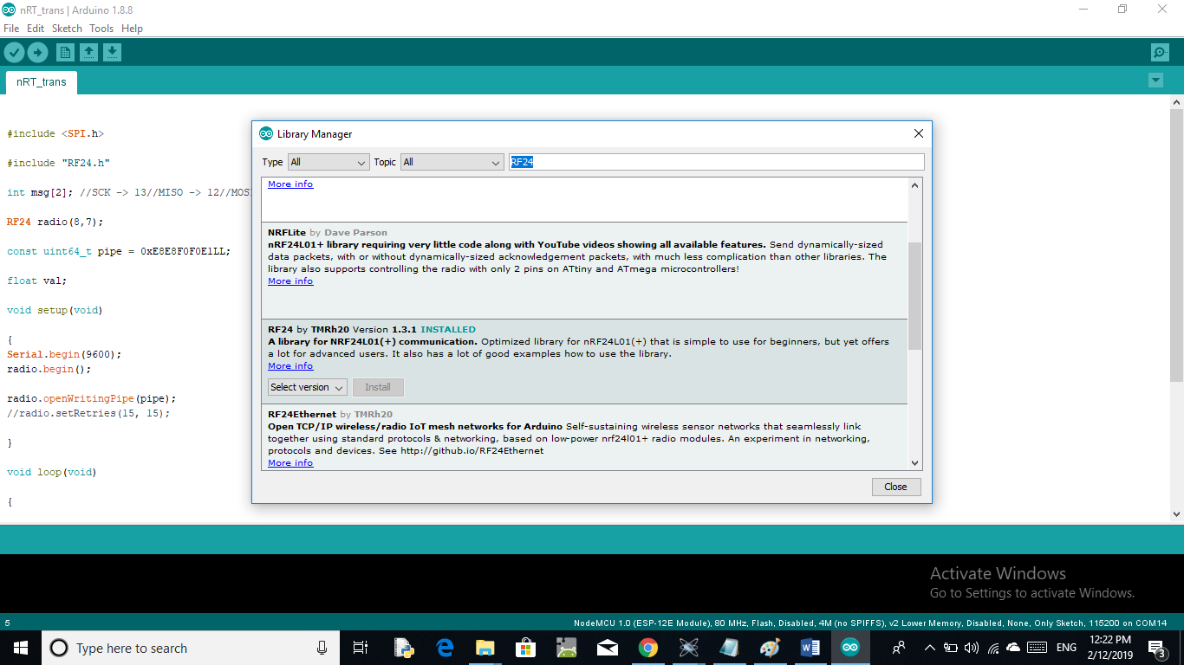

4-upload this code “nRF_trans” to the trans_circuit >> by this way :

1-connect the circuit exactly such the circuit diagram “trans_circuit”

2-connect the Arduino to computer

3- select the port >>by this way :

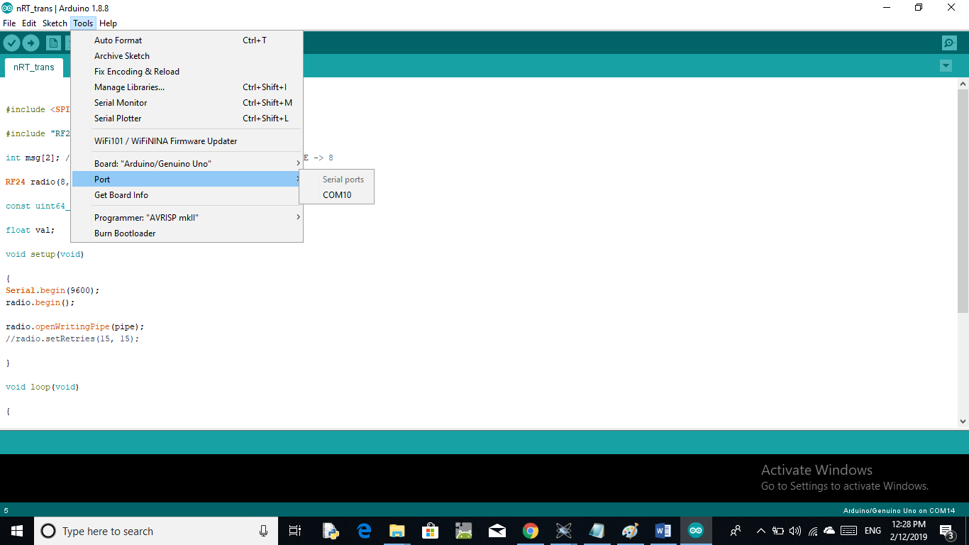

4- upload the code

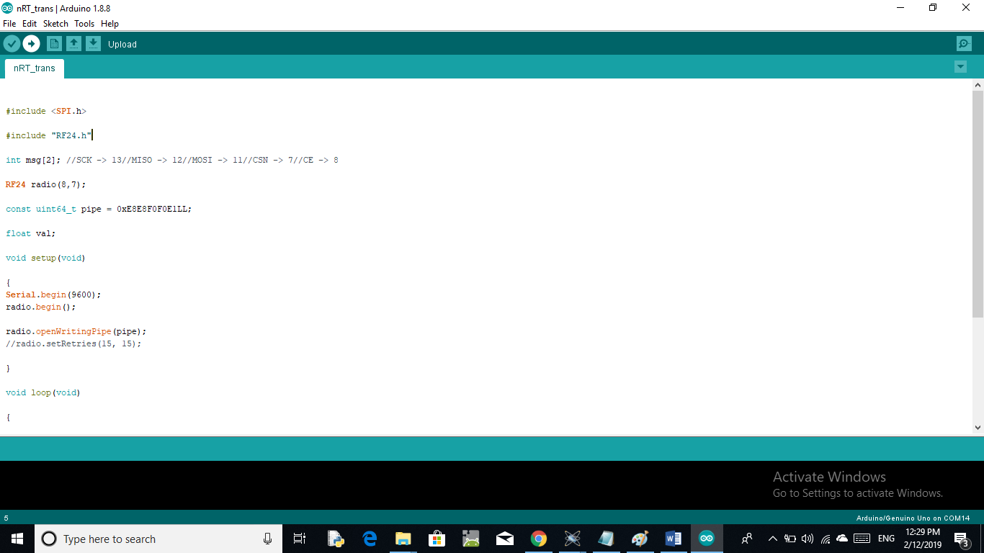

5-disconnect the Arduino from the computer

6-connect another circuit “rec_circuit” and connect its Arduino to the computer

7-rebeat the steps in the fourth step

8-connect tow Arduinos to the computer “computer just used as a power source and you can connect Arduinos by any power source”….

9-you can connect a (5v or 9v or 12v) power source by this way

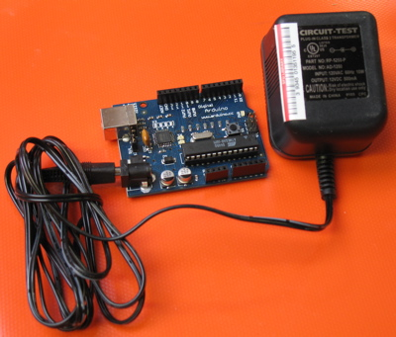

Thank you and good luck