**Mastering Embedded System Online Diploma**

**www.learn-in-depth.com First Term (Final Project 1 )**

**Eng. Hossam El-Dien Adel**

**My Profile:** **https://www.learn-in-depth.com/hossam.adel2024@gmail.com**

**Case Study:**

A client expects you to deliver the software of the following system

**Specification (from the client):**

*-A pressure controller informs the crew of a cabin with an alarm when the pressure exceeds 20 bars in the cabin.*

*-The alarm duration equals 60 seconds.*

**Assumptions:**

The controller set up and shutdown procedures are not modeled.

The controller maintenance is not modeled.

The pressure sensor never fails.

The alarm never fails.

The controller never faces power cut.

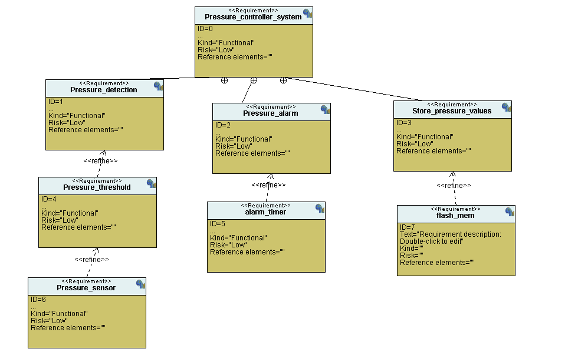**Requirements Diagram:**

*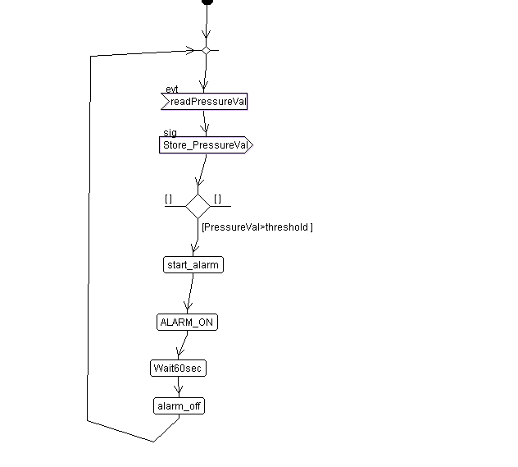***Activity Diagram:**

**Sequence Diagram:**

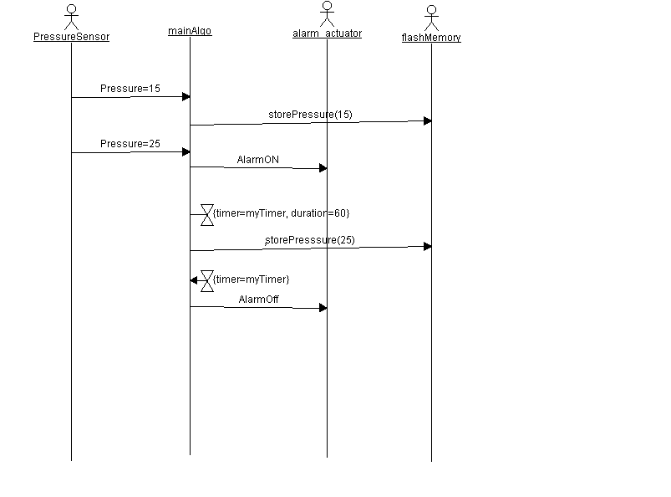

**System Design:**

**Pressure Controller design:**

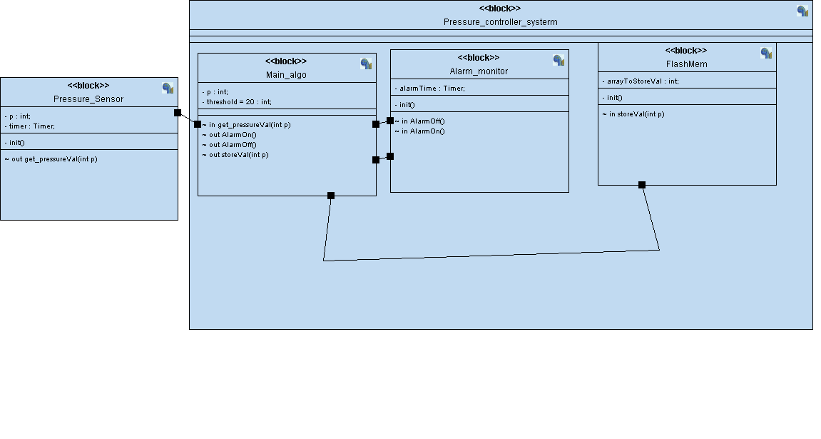

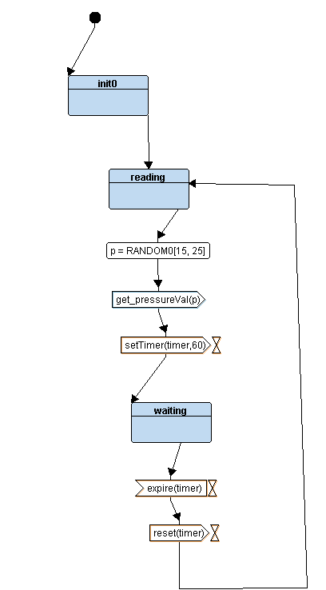**Pressure Sensor State Machine:**

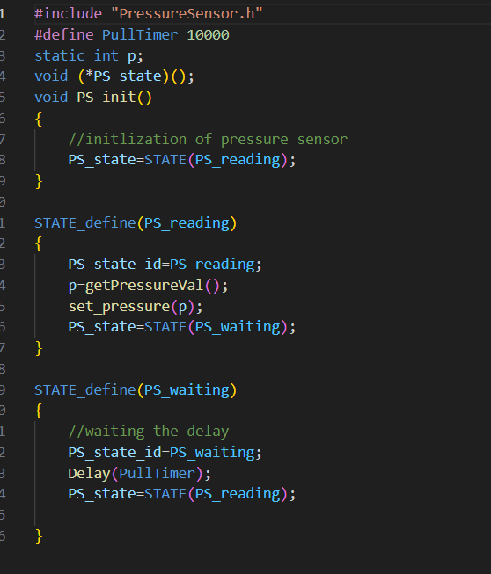

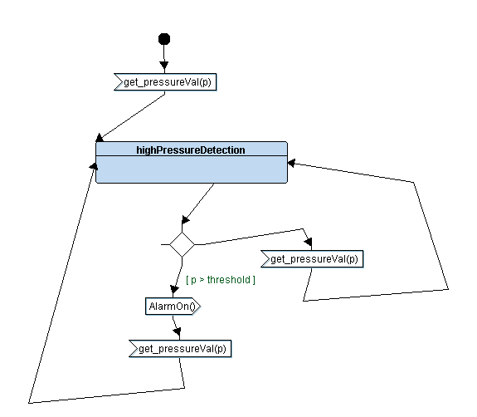**MainAlgo State Machine:**

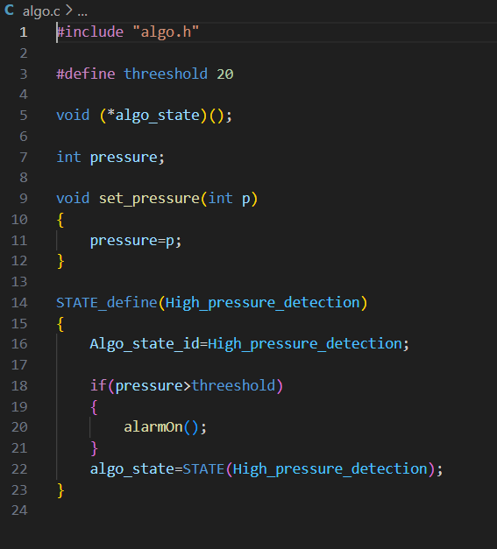

**Alarm Monitor State Machine:**

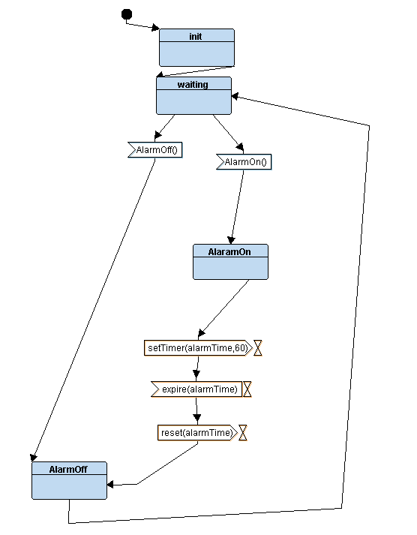

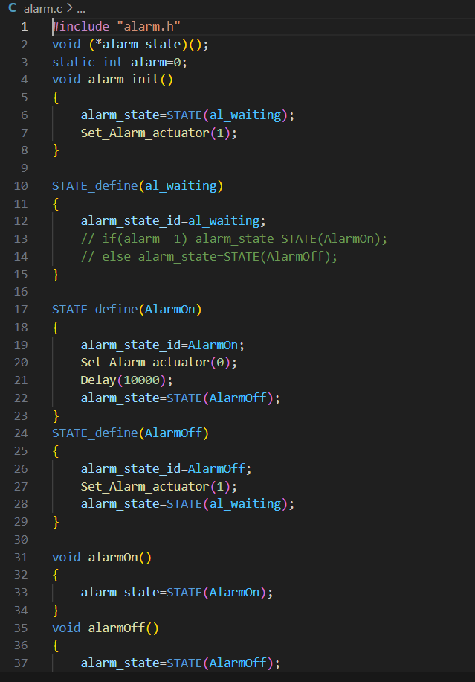

**Some SW analysis:**

***Section table:***

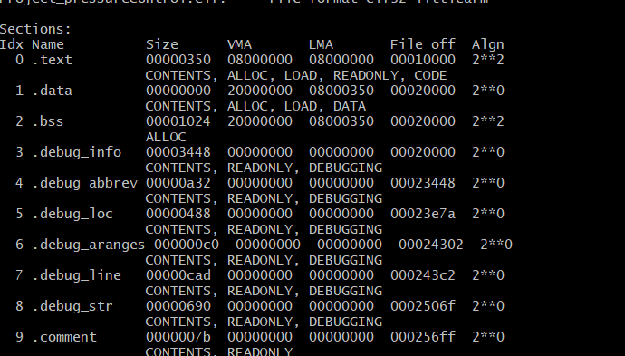

***Map file:*** 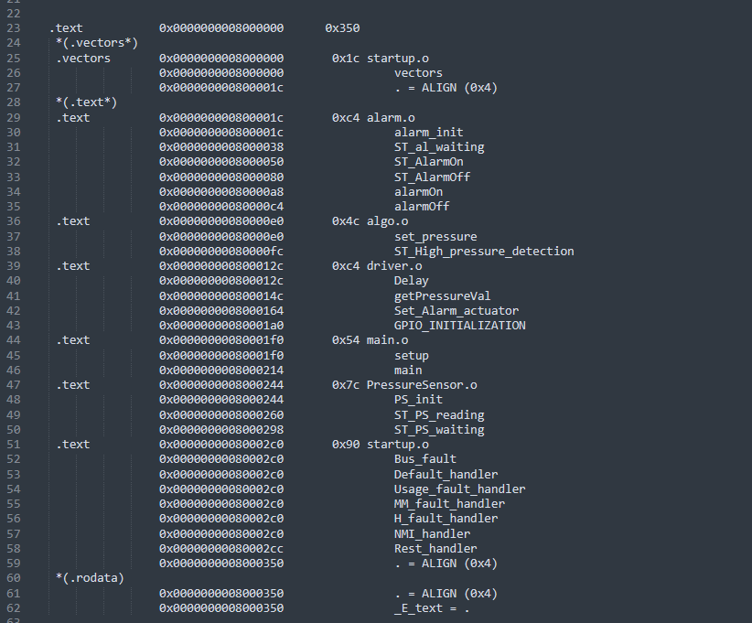

Simulation:

Pressure (0) < threshold (20)

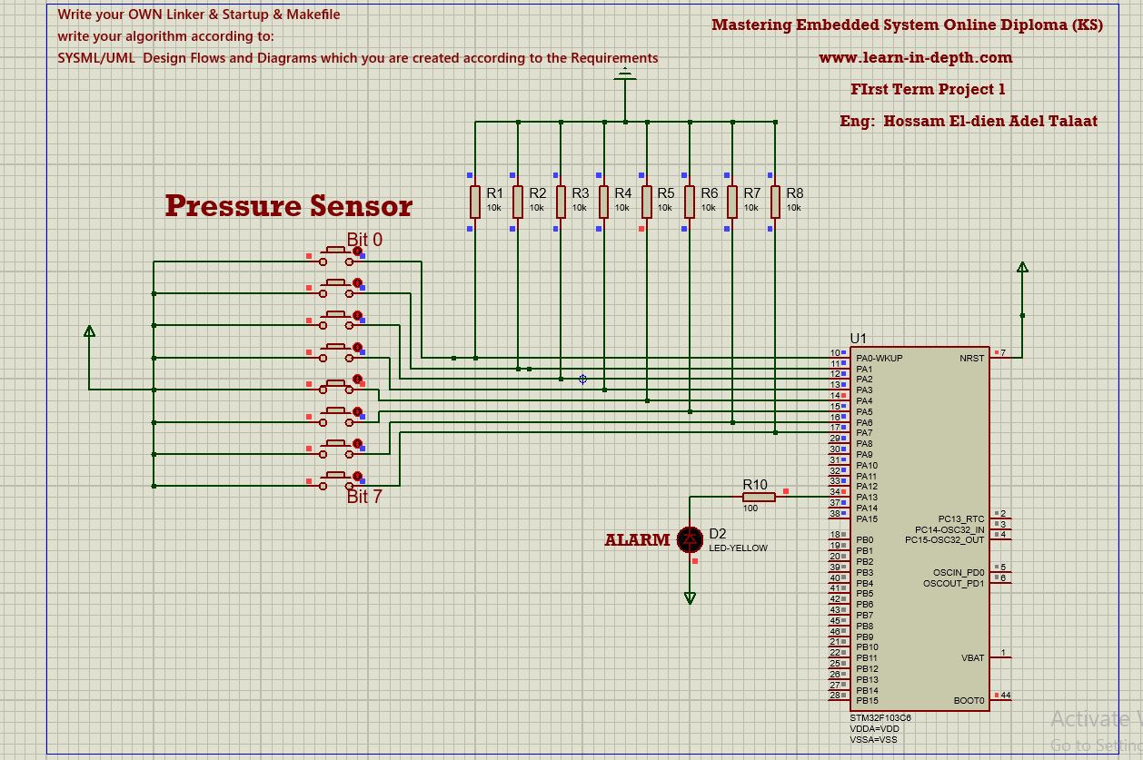

Pressure (48) > threshold (20)

