Exploratory Data Analysis (EDA) Report
Dataset for Data Analytics

1. Introduction
This report presents an Exploratory Data Analysis (EDA) of the dataset. The objective is to identify patterns, trends, distributions, and outliers to gain meaningful business insights.

2. Dataset Overview
Number of Rows: 1200
Number of Columns: 14
Columns: OrderID, Date, CustomerID, Product, Quantity, UnitPrice, ShippingAddress, PaymentMethod, OrderStatus, TrackingNumber, ItemsInCart, CouponCode, ReferralSource, TotalPrice

3. Descriptive Statistics
Quantity: Mean=2.95, Median=3, Min=1, Max=5
UnitPrice: Mean=356.41, Median=364.21, Min=11.39, Max=699.93
ItemsInCart: Mean=5.49, Median=5, Min=1, Max=10
TotalPrice: Mean=1053.97, Median=823.62, Min=11.39, Max=3456.40

4. Product Analysis
Chair generated the highest revenue, followed closely by Printer. Laptop and Tablet also contributed significantly.

5. Payment Method Analysis
Online payment is the most frequently used method. Usage of payment methods is relatively balanced.

6. Order Status Analysis
Cancelled and Returned orders account for a significant portion of orders and should be investigated.

7. Referral Source Analysis
Instagram is the strongest customer acquisition channel, followed by Email and Google.

8. Trend Analysis
June 2024 recorded the highest sales performance with total sales of 68,068.54.

9. Outlier Detection
Eight outliers were identified in TotalPrice using the IQR method.

10. Key Insights
1. Average order value is 1053.97.
2. Chair and Printer generate the highest revenue.
3. Instagram is the best referral source.
4. Online payment is the preferred method.
5. High cancellation and return rates require investigation.
6. June 2024 achieved the highest sales.
7. Eight outliers exist in TotalPrice.

11. Conclusion
The dataset provides valuable insights into customer purchasing behavior and sales performance. Several opportunities for business improvement were identified.

Orders by Product
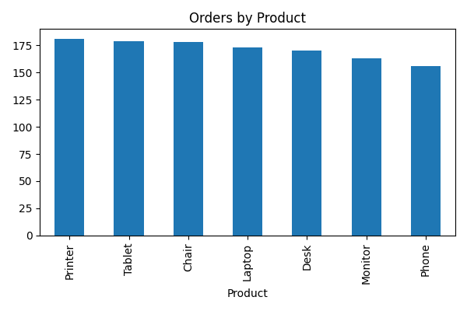

Payment Methods
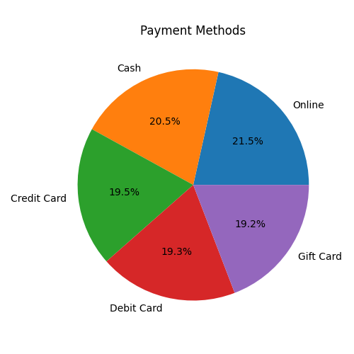

Referral Sources
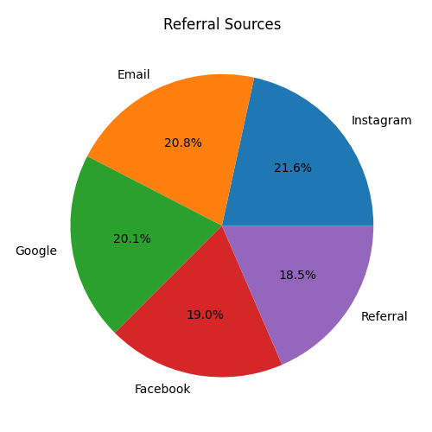

Monthly Sales Trend
