Enterprise RAG Store Assistant
Team Reference Documentation

1. Project Overview
The Enterprise RAG Store Assistant is a state-of-the-art Natural Language Processing (NLP) chatbot pipeline specifically built to handle Arabic text. It leverages Retrieval-Augmented Generation (RAG) to provide accurate, context-aware answers without hallucination.

2. Key Capabilities:
- Arabic intent classification using “aubmindlab/bert-base-arabertv02”.
- Semantic vector search caching (ChromaDB) for lightning-fast repeated queries.
- Local LLM integration (e.g., Qwen2.5) for high-privacy, context-injected generation.
- Domain-Driven Design (DDD) to ensure infinite scalability and layer modification.

2. Getting Started & Setup
Prerequisites
Python 3.11
CUDA Toolkit (If running PyTorch models on GPU)

Local Development Setup
1. Clone the Repository:
git clone https://github.com/hossamegy/Enterprise-Rag-Store-Assistant.git
cd Enterprise-Rag-Store-Assistant
2. Create a Virtual Environment
python -m venv venv

3. Install Dependencies:
pip install -r requirements.txt
Core packages include ’ fastapi’, ‘uvicorn’, ‘torch’, ‘transformers’, ‘sentence-transformers’ and ‘chromadb’.
4. Verify/Download Models:
Ensure your `DL_Models/` directory contains the necessary tuned weights (e.g., `arabic_intent_model.pt` and label encoders).

5. Run the Application:
For API Development: Run the FastAPI server.
uvicorn app:app --reload --host 0.0.0.0 --port 8000

## 3. Architecture Deep Dive (DDD & Clean Architecture)

Our foundation is built on **Domain-Driven Design**. The codebase enforces strict boundaries so that our core logic never intimately knows about HTTP requests or specific database drivers.

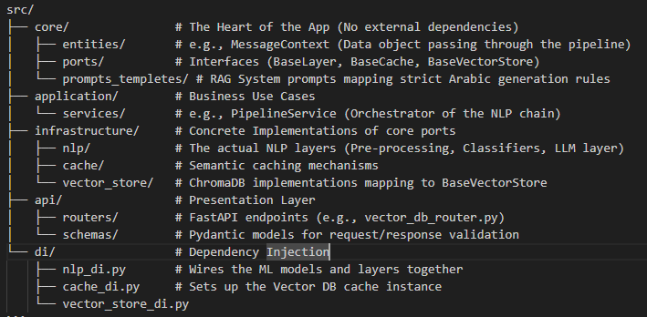
Directory Breakdown
The Chain of Responsibility (NLP Pipeline)
When an API request arrives, the [PipelineService] executes an ordered list of [BaseLayer] implementations. A typical request flows as follows:
1. GetCacheLayer: Performs a semantic search on previously asked questions. Short-circuits the pipeline if a >95% match is found.
2. PreprocessingLayer: Cleans Arabic text (removes emojis, normalizes characters).
3. ComplexityClassifierLayer: Flags if the question needs reasoning or is a simple FAQ.
4. IntentClassifierLayer`**: Predicts intent (`ask_price`, `compare_products`, etc.).
5. LocalLLMLayer: Injects context into the [rag_template.py]( prompt and invokes the local LLM.
6. SaveCacheLayer: Saves the LLM's new answer back to the semantic cache.

4. Team Contribution Guidelines

Adding a New NLP Layer
Need to add a Translation or Profanity Filter layer? DO NOT modify existing layers. Create a new one.

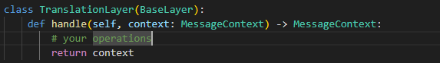
- Create the Layer: In “src/infrastructure/nlp/layers/”, implement the “BaseLayer” abstract class and add new property in MessageContext if uou need in “src\core\entities\message_context.py”
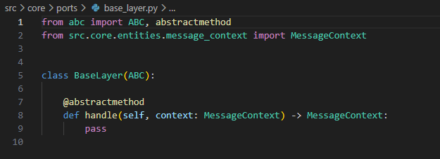

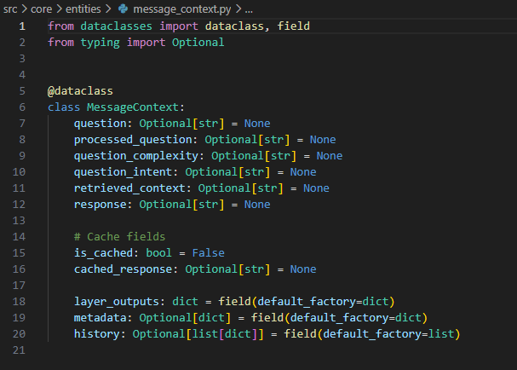

- Inject the Layer:** Open `src/di/nlp_di.py` and add `TranslationLayer()` to the `layers` list inside `build_nlp_pipeline()`. The order in the list *is* the order of execution.
Modifying Prompts
All LLM prompts live in “src/core/prompts_templetes/”.

If the local LLM starts hallucinating or ignoring Arabic constraints, **do not** write code to fix it. First, attempt to update `rag_template.py` with stricter instructions. The system prompt is our primary defense against hallucinations.

5. Deployment & Scaling

Caching Strategy
Our “vector_store” effectively acts as an intelligent semantic cache. For high availability, monitor the cache size.
By default, components in “di/*.py” use standard Python `@lru_cache(maxsize=1)” ensuring heavy objects (like HuggingFace models and DB clients) are strictly instantiated as Singletons.

Horizontal Scaling
1. API Scalability**: Because the FastAPI layer is entirely stateless, you can easily scale by running multiple Uvicorn workers (`uvicorn app:app --workers 4`).
2. LLM Inference**: If the system is bottlenecked by text generation, the “LocalLLMLayer” should be refactored to point to a dedicated inference server (like vLLM, Ollama, or Triton Inference Server) hosted on dedicated GPU machines, rather than loading model weights into the FastAPI process memory.
3. Database Externalization: ChromaDB currently runs locally. For production with multiple nodes, transition ChromaDB to a client-server setup by updating the “build_cache_chroma_db()” function in “di/cache_di.py” to point to the remote Chroma host.

