Lab 2

Convolution & Discrete Fourier Transform

Objective:
- Learn the concept of Convolution in the space domain.
- Learn the concept of Inverse Fourier Transform.
- Learn the concept of Multiplication in frequency domain.

Example: Inverse Fourier Transform
In this example, we show the transformation for an image from frequency domain to spatial domain using inverse Fourier Transform.
- Create a zeros matrix of size 21x21, then change the following pixels to be ones:
  - Pixels (9,10) and (11,10)
- Get the inverse Fourier transform of the image using ifft2.
- The result of ifft2 contains complex and very small values that must be pre-processed before displaying.
- This is done by getting the abs of the image.
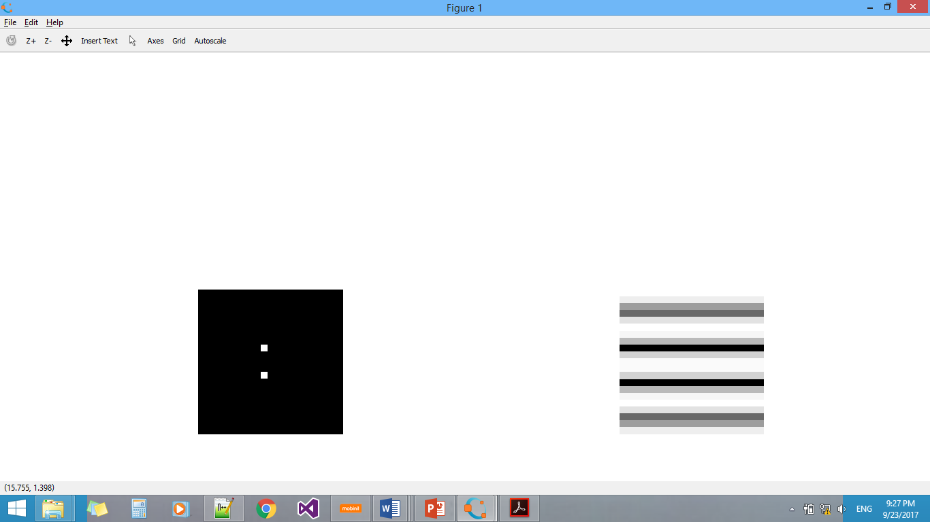
- Display each of the above images and its inverse.
- What image gives an inverse Fourier transformation to be something like this?

Example: Multiplication in frequency domain
In this exercise, we transfer the image and the filter to the frequency domain, hence we can perform a multiplication operation, then we inverse transfer the result.
- Read any image from your choice then convert it to gray level.
- Calculate the Fourier transform for it using fft2, then shift it using fftshift
- Generate the filter $\frac{1}{9}\left[1 1 1 1 1 1 1 1 1 \right]$ .
- Calculate the Fourier transform of the filter using fft( filter , rows(image), columns(image)).
- Perform a multiplication operation between the image and the filter in frequency domain using np.multiply.
- Display the result use the abs then log ( image +1 ) before plotting the image.
- Then you apply inverse fourier transformation using ifft2.
- To display the result use the abs then before the before plotting the image.

Experiment 1: Convolution in space domain (30minutes )
In this exercise we experiment convolution in space domain for 2d images and linear filters.
- Read any image from your choice then convert it to gray level.
- Generate another version of the image after adding salt and paper noise with density=0.05.
- Convolve in space domain using the function convolve2d the following filters with the images and write your comments about the results:
  - $\frac{1}{9}\left[1 1 1 1 1 1 1 1 1 \right]$ On the image after adding noise.
  - $\left[1 1 1 1 -8 1 1 1 1 \right]$ On the image without noise.
  - $\left[1 1 1 0 0 0 -1 -1 -1 \right]$ On the image without noise.
  - $\left[1 0 -1 1 0 -1 1 0 -1 \right]$ On the image without noise.
- After applying each filter display
- gray scaled original image
- image after adding noise to it
- The four images after applying the four filters
Images in one single figure using show_images function.
- What are the uses of these filters?
- How can we modify the filter to make the output more descriptive?
Useful New Functions and Attributes
Name | Attribute or Function | Usage
np.log | Function | to get log for matrix (element-wise)
np.abs | Function | to get absolute value for matrix (element-wise)
np.multiply | Function | to multiply two matrices (element-wise)
np.power | Function | to power a matrix (element-wise)
For Fourier Transform functions, check: https://docs.scipy.org/doc/scipy/reference/fftpack.html

