

**School of Computer Science**

**Faculty of Science**

**COMP-2650: Computer Architecture I: Digital Design**

**Winter 2021**

|  |  |  |  |  |
| --- | --- | --- | --- | --- |
| Title | Date | Time | Duration | Grade Release Date |
| **Midterm Exam** | Feb. 23, 2021 | 10:00 AM | 180 minutes | March 09, 2021 |

**Questions**

You must show your work and all steps for every question!

**Question 1: [10 marks: 2.5 marks each]**

Explain the following terms in two or three sentences.

* 1. Digital System
  2. Closure Postulate
  3. Duality
  4. Complement Postulate

**Question 2: [10 marks: 2.5 marks each]**

Assuming an unsigned number system (all numbers are positive), show the maximum number and the smallest unit of increment given 3 integer and 2 fraction positions in the octal number system and their equal decimal values.

1. (Max ?)8 = (?)10
2. (Smallest Unit ? )8 = (?)10

**Question 4: [10 marks]**

Show the minimum possible error when converting (16.4)10 to base-6 if only 5 positions are given in total for both integer and fraction parts. Report the error in base-10.

**Question 5: [10 marks: 2.5 marks each]**

Show the negative and positive numbers for (86)9 in base-3 using the signed-magnitude and signed-radix-complement number systems, given 8 positions for integer part with no fraction part:

1. Positive signed-magnitude
2. Negative signed-magnitude
3. Positive signed-radix-complement
4. Negative signed-radix-complement

**Question 6: [10 marks: 5 marks each]**

Perform the following arithmetics in singed-2’s-complement base-2 for the following *decimal* numbers using the least number of bits and check whether an overflow happens.

1. (+15) – (–1)
2. (+15) + (–16)

**Question 7: [10 marks: 5 marks each]**

Show that the binary operator XOR satisfies the following postulates in S={0,1}:

1. Identity
2. Inverse

**Question 9: [15 marks]**

Analyze the logic circuit shown below only for F1:

1. Show the truth table.
2. F1 = ∏ (?) .

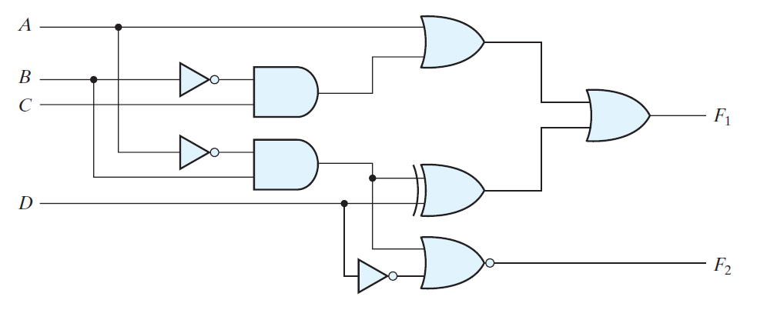

**Question 10: [25 marks]**

Design a 3-bit 2’s-complementer, that is, the output generates the 2’s-complement of the input binary number (e.g., 101 🡪 011):

1. Show the truth table.
2. Show the Boolean expression(s) for the output(s) in sum-of-minterms.
3. Algebraically, simplify the Boolean expression(s).
4. Design the circuit using NAND gates only.