

**School of Computer Science**

**Faculty of Science**

**COMP-2650: Computer Architecture I: Digital Design**

**Fall 2020**

|  |  |  |  |  |
| --- | --- | --- | --- | --- |
| Lab# | Date | Title | Due Date | Grade Release Date |
| Lab 05 | Oct 26-28, 2020 | **L05: Number Systems** | Nov. 11, 2020  Wednesday Midnight [AoE](https://www.timeanddate.com/time/zones/aoe) | Nov. 18, 2020 |

The fifth lab's objectives will be to master the topics in number systems, especially arithmetic, by implementing the algorithms with a programming language, herein, C/C++.

**Step 1. Environment Setup**

Our programming environment is the same as the first lab (Lab 01). In this lab, we want to extend our Lab 04 to support arithmetic on binary numbers. Particularly, we want to calculate the addition or subtraction of two binary numbers in signed-2’s-complement system.

As we discussed in the lectures, there are different ways to represent negative and positive numbers. In signed-radix-complement, we use positive numbers to show the negative numbers. So, there is no position for the sign. However, we can show that the bit in the highest significant position in signed-2’s-complement binary system acts *like* sign bit (not the same though!). This is because given n bits, the maximum number divided by 2 is (2n-1)÷2=2n-1 which is equal to the largest number given n-1 bits, i.e., 0111…111. So, all binary numbers equal or below this number is positive, having 0 in the n-th bit. This number plus 1 becomes 1000…000. All numbers equal or above this are negative and have 1 which is non-zero in the n-th bit. In summary, positive numbers has 0 and negative numbers has 1 in n-th bit. The only non-zero value in base-2 is 1. So, the n-th bit indicate the sign similar to the signed-magnitude.

In C/C++, you can define a variable that can store negative and positive numbers as **signed**. Indeed, any numeric variable in C/C++ is in signed-2’s-complement by default, and using the keyword **signed** is optional, as seen below! Please pay attention to the format specifier for **signed** variables in **scanf** and **printf,** which is "%d".

01 **#include** <stdio.h>

02 **int** **main**(**void**) {

03

04 **setbuf**(stdout, NULL);

05 **signed** **int** a; //you can drop ‘signed’ keyword

06

07 **printf**("Enter an integer number:\n");

08 **scanf**("%d", &a);

09

10 **printf**("The number is: \n");

11 //printf("Binary: %b \n", a); There is no option for binary!

12 **printf**("Octal: %o \n", a);

13 **printf**("Decimal: %d \n", a);

14 **printf**("Hexadecimal: %x \n", a); //Alphabet in small letters

15 **printf**("HEXAdecimal: %X \n", a); //Alphabet in capital letters

16 **return** 0;

17 }

You can check how the positive and negative numbers are stored in C/C++ using signed-2’s-complement by looking at memory locations. This can be done in Eclipse in Debug mode by using Memory and Monitors. To Debug your code, you can click on and run each line step-by-step using . You might be asked to locate the source code. Then, select the main.cpp from the src folder.

For instance, I ran the program in Debug mode and put a breakpoint when the program wants to print the output:

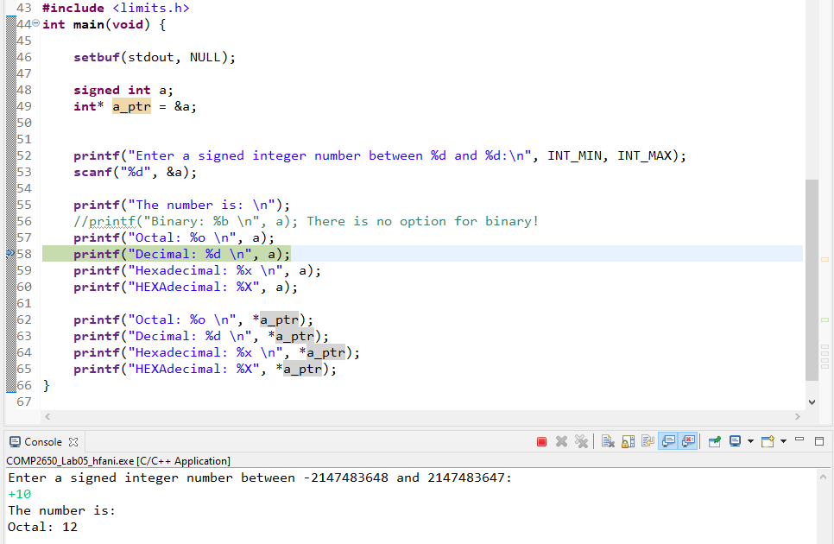

Basically, the program execution is stopped at the line with a breakpoint and the program is waiting for you to click on to execute the next statement. At this point, you are able to open the Memory to see the actual memory location for variables and the content. The Memory option is usually available in the right side of the Eclipse and looks like .

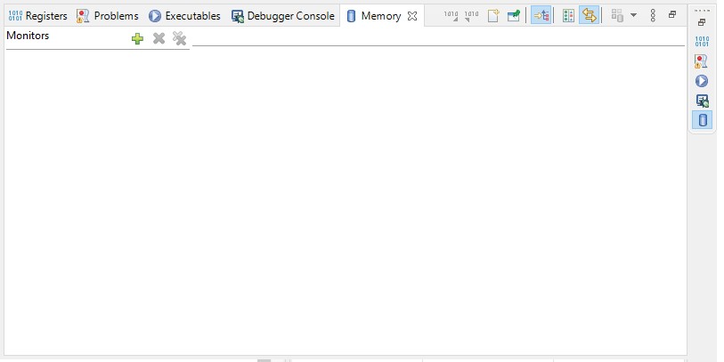

When the Memory panel opens, you have the option to enter an address of a memory location to see the content in the Monitors area.

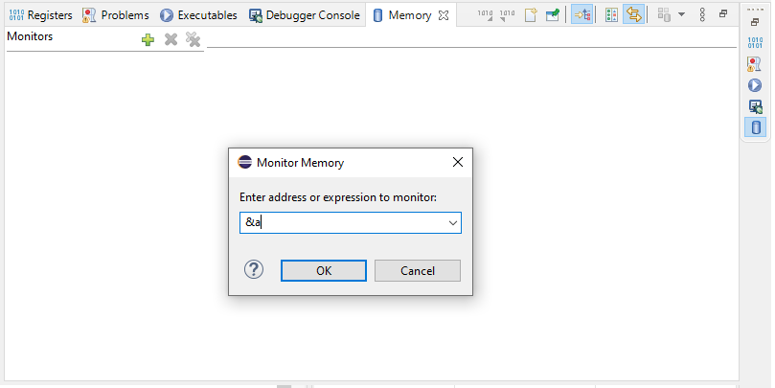

In our sample program, we ask the user to enter a signed number and we store the number is a variable called a in line# 08. So, in order to see what the actual value in the memory location for the variable a is, we need to find the address of the variable a. This can be done by & operator in C/C++ language.

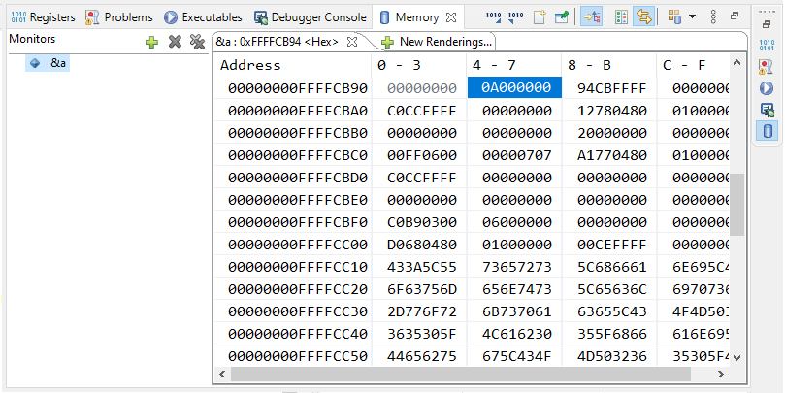

You can define different renderings of the memory locations by clicking on the New Renderings. I did so and chose Traditional:

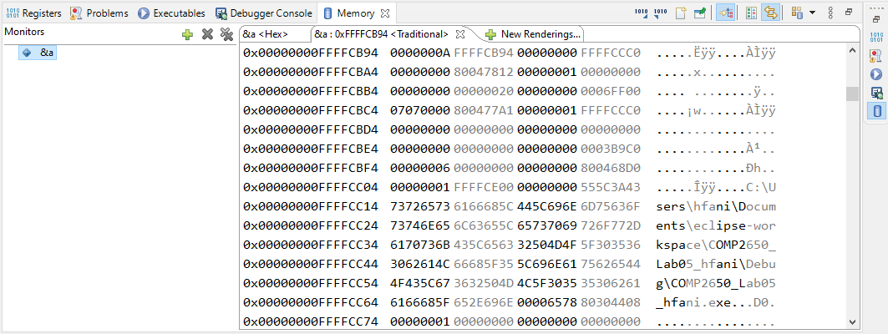

You can see that at the address &a (0xFFFFCB94), the content of memory is 0000000A in hexadecimal system which is equal to +10 in decimal system. Unfortunately, Eclipse does not allow you to see the bits since it would be very long stream of bits (32 bits). Nonetheless, we already knew that 0000000A is equal to 00…0001010 in binary system.

Let’s run the program for $-$ 10:

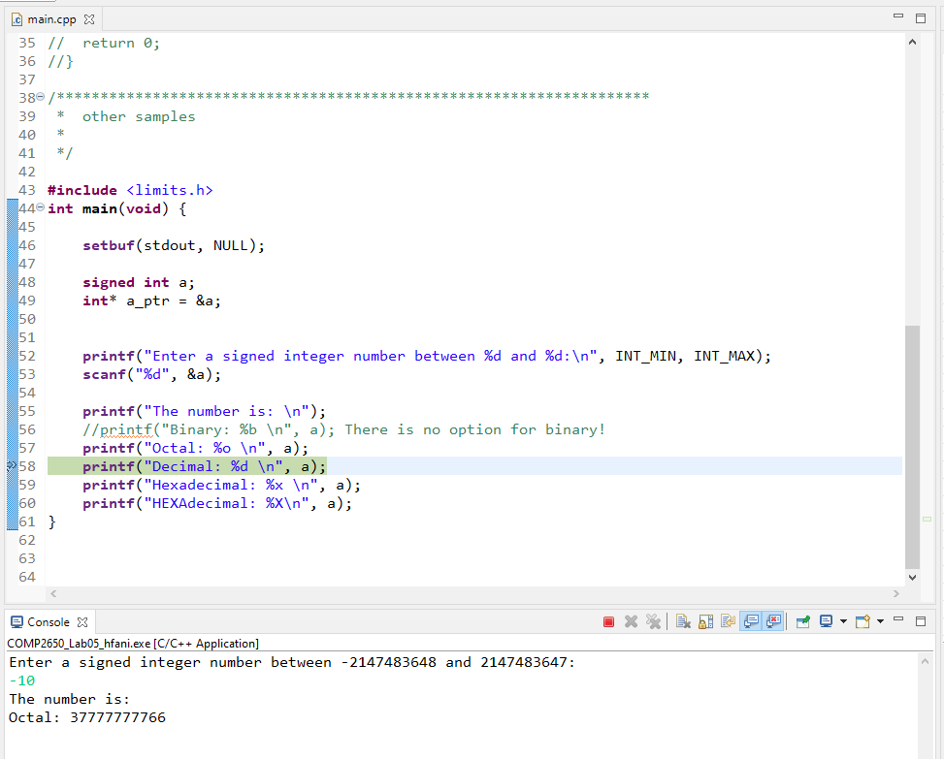

In the second run, the variable a has the same memory location[1]. As you can see, $-$ 10 is represented as FFFFFFF6 or 11…11110110. We expect that as in C/C++ the signed numbers are in the signed-2’s-complement system. So, $-$ 10 is represented as the 2’s-complement of +10:

2’s-comp(00…000001010) = 11…1110110

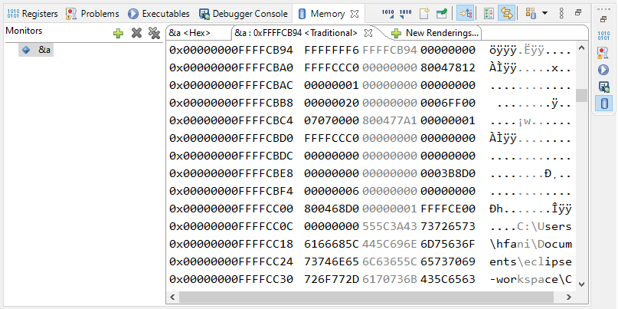

You may be tempted to explore what has been stored in other memory locations. Probably, peeking at other programs running in the memory. Is it possible? In the Operating System course, you learn how an OS gives memory to a program to run and more.

**Regarding overflow,** C/C++ does not raise an error or exception when an overflow happens in **signed** numeric variables. We explain this in the following program:

00 **#include** <limits.h>

01 **#include** <stdio.h>

02 **int** **main**(**void**) {

03

04 **setbuf**(stdout, NULL);

05 **int** a;

06

07 **printf**("Enter a signed integer number between %d and %d:\n", INT_MIN, INT_MAX);

08 **scanf**("%d", &a);

09

10 **printf**("The number is: \n");

11 //printf("Binary: %b \n", a); There is no option for binary!

12 **printf**("Octal: %o \n", a);

13 **printf**("Decimal: %d \n", a);

14 **printf**("Hexadecimal: %x \n", a); //Alphabet in small letters

15 **printf**("HEXAdecimal: %X \n", a); //Alphabet in capital letters

16 **return** 0;

17 }

From the library <limits.h>, we can find the minimum and maximum for a given type in C/C++. Here, we used INT_MAX for the maximum and INT_MIN for the minimum **signed** integer, which is equal to 2147483647 and -2147483648 in C/C++:

Enter a signed integer number between -2147483648 and 2147483647:

2147483647

The number is:

Octal: 37777777777

Decimal: 2147483647

Hexadecimal: 7fffffff

HEXAdecimal: 7FFFFFFF

Enter a signed integer number between -2147483648 and 2147483647:

-2147483648

The number is:

Octal: 20000000000

Decimal: -2147483648

Hexadecimal: 80000000

HEXAdecimal: 80000000

Now, let’s create an overflow by entering the maximum number + 1:

Enter a signed integer number between -2147483648 and 2147483647:

2147483648

The number is:

Octal: 20000000000

Decimal: -2147483648

Hexadecimal: 80000000

HEXAdecimal: 80000000

This number would be 32 bits with the highest bit equal to 1 and all other remaining bits equal to 0. Why? Simply increment the maximum **signed** integer by one unit in base-2. However, this number is equal to -2147483648 which is a negative number in C/C++. A positive number becomes a negative number in signed-2’s-complement which is an overflow. You see that the program did not raise any error or exception about an overflow though.

Let’s create an overflow by entering the minimum number – 1:

Enter an unsigned integer number between -2147483648 and 2147483647:

-2147483649

The number is:

Octal: 17777777777

Decimal: 2147483647

Hexadecimal: 7fffffff

HEXAdecimal: 7FFFFFFF

The minimum signed number minus 1 is equal to (given 32 bits):

= 100...0000 – 1

= 100...0000 + 2’s-comp(00...0001)

= 100...0000 + 11...1111 (sum of two negative number)

= (carry=1)011...1111

= ignore carry 🡪 011...1111 (positive number)

As seen, the result is the maximum positive number. Sum of a two negative number becomes a positive number. This is an instance of overflow, but the program did not raise any error and exception.

In this lab, since our program stores the input bits in an array of integers, we cannot use C/C++’s signed-2’s-complement directly. We have to either *i)* implement the signed-2’s-complement algorithm for addition and subtraction, or *ii)* convert the input bits stored in the integer arrays to an integer variable and then use the built-in addition or subtraction in C/C++. Also, we want to let the user know whether an overflow happens.

**Step2. Writing Modular Programs**

In Lab 04, we added a header arithmetic_tools.h and a source file arithmetic_tools.cpp for arithmetic. Let’s add new functions to the header file and the source file to implement all functions related to arithmetic in signed-2’s-complement number systems.

**arithmetic_tools.h**

**void** func_signed_2s_addition(**int** a[], **int** b[], **int** result[]);

**void** func_signed_2s_subtraction(**int** a[], **int** b[], **int** result[]);

**arithmetic_tools.cpp**

**#define** MAX 8//Byte = 8 bits

**void** func_signed_2s_addition(**int** a[], **int** b[], **int** result[]){...}

**void** func_signed_2s_subtraction(**int** a[], **int** b[], **int** result[]){...}

As seen, header files contain only the signatures of the functions and not the bodies. Please look at the ‘;’ in the end of each function. Now we are ready to add the headers to our main program and use the functions in each separate file:

00 **#include** <stdio.h>

01 **#include** "arithmetic_tools.h"

02 **#include** "logic_tools.h"

03 **#include** "comp_tools.h"

04 **#define** MAX 8//Byte = 8 bits

05 **int** **main**(**void**) {

06 **setbuf**(stdout, NULL);

07

08 **int** x[MAX];

09 **int** y[MAX];

10

11 **printf**("Enter the first binary number:\n");

12 **for**(**int** i=0; i < MAX; i = i + 1){

13 **scanf**("%d", &x[i]);

14 }

15 **printf**("Enter the second binary number:\n");

16 **for**(**int** i=0; i < MAX; i = i + 1){

17 **scanf**("%d", &y[i]);

18 }

19

20 **int** z[MAX];

21 //func_and(x, y, z);

22 //func_not(x, z);

23 func_signed_2s_addition(x, y, z);

24 **printf**("The first number AND second binary yield:\n");

25 **for**(**int** i=0; i < MAX; i = i + 1){

26 **printf**("%d", z[i]);

27 }

28

29 **return** 0;

30}

**Lab Assignment**

You should complete the above program under the name of a project COMP2650_Lab05_{UWinID} that firstly outputs a menu of commands as follows:

Enter the command number:

1. Exit
2. Addition in signed-2’s-complement
3. Subtraction in signed-2’s-complement

Based on the user's chosen number of commands, the program should then ask for the two inputs. After that, the program asks to what base the user wants to see the results. Then, it applies the command and prints out the result in the requested base. For instance, if a user selects (1), the program should accept two inputs in signed-2’s-complement as follows:

Enter the first binary number:

x0 =

x1 =

...

x7 =

Enter the second binary number:

y0 =

y1 =

...

y7 =

When the user enters the two binary numbers, the program asks for a base number to print out the result:

Enter the output base:

1. Binary
2. Octal
3. Decimal
4. Hexadecimal

Then the program applies the 1) Addition in signed-2’s-complement command on the input x and y and prints the result on the selected base and comes back to the main menu. Other commands should follow the same flow. If the user selects (0), the program ends. Please restrict the user to enter inputs within the range {0,1}. For instance, if the user enters 2, -1, …, print out an error message and come back to ask for correct inputs. Also, print an error/warning message whether an overflow happened during the arithmetic.

It is required to write a *modular* program. For arithmetic in signed-2’s-complement, you can re-use the 2’s-complement function in comp_tools.h or any other functions you already developed.

**Deliverables**

You will prepare and submit the program in one single zip file COMP2650_Lab05_{UWinID}.zip containing the following two items:

1. The entire project folder COMP2650_Lab05_{UWinID}, including the code (source) files and executable file.
2. The result of the commands in the file COMP2650_Lab05_Results_{UWinID}.jpg/pdf. Simply make a screenshot of the results and save it. If multiple images, please print them all into a single pdf file. You have to include at least one instance of calculation with overflow and without overflow for each arithmetic in the command list.
3. A lab report document in the PDF file COMP2650_Lab05_Report_{UWinID}.pdf. It should include:
4. Your name, UWinID, and student number
5. One paragraph describes the program that you attached, along with any prerequisites needed to build and run the program. *Please note that if your program cannot be built and run on our computer systems, you will lose marks.*

In sum, your final zip file for the submission includes 1 folder (entire project folder), 1 image/pdf (results snapshot) and 1 pdf (report). *Please follow the naming convention as you lose marks otherwise.* Instead of {UWinID}, use your own UWindsor account name, e.g., mine is [hfani@uwindsor.ca](mailto:hfani@uwindsor.ca), so,

COMP2650_Lab05_hfani.zip

* COMP2650_Lab05_hfani
  + src
    - arithmetic_tools.cpp
    - arithmetic_tools.h
    - main.cpp
  + COMP2650_Lab05_hfani [.exe in MS-Windows]
* COMP2650_Lab05_Report_hfani.pdf
* COMP2650_Lab05_Results_hfani.jpg or COMP2650_Lab05_Results_hfani.pdf

1. In this course, we can assume that this is a coincidence that different runs of the same program has same memory locations. However, in Operating System course, you will learn that this is not a coincidence.