|  |  |
| --- | --- |
| The UWindsor Logo | University of Windsor  Faculty of Science  School of Computer Science | COMP-2650  Computer Architecture I: Digital Design  Winter 2022 |

|  |  |  |  |  |
| --- | --- | --- | --- | --- |
| Assignment# | Date | Title | Due Date | Grade Release Date |
| Lec 12 | Week 12 | **Sequential Logic** | April 13, 2022, Wednesday 4 AM EDT | April 18, 2022 |

The objectives of the lecture (weekly) assignments are to practice on topics covered in the lectures as well as improve the student’s critical thinking and problem-solving skills in ad hoc topics that are closely related but not covered in the lectures. Lecture assignments also help students with research skills, including the ability to access, retrieve, and evaluate information (information literacy.)

**Deliverables**

You should answer 2 of the below questions based on your preference using an editor like MS Word, Notepad, and the likes or pen in papers. In the latter case, you have to write and scan the papers clearly and merge them into a single file. In the end, you have to submit all your answers in one single pdf file lec12_UWinID.pdf containing the question ids for the answer. Please note that if your answers cannot be read, you will lose marks. Please follow the naming convention as you lose marks otherwise. Instead of UWinID, use your own UWindsor account name, e.g., mine is hfani@uwindsor.ca, so my submission would be: lec12_hfani.pdf

**Lecture Assignments**

**(select only 2 questions based on your preference)**

1. Timing Diagram is a diagram that shows the state of a sequential logic within time dimension. Complete the following diagram for Q (main output) for the following cases:
   1. Active high JK latch
   2. Active low JK latch
   3. Positive edge JK
   4. Negative edge JK
   5. Dual-edge JK

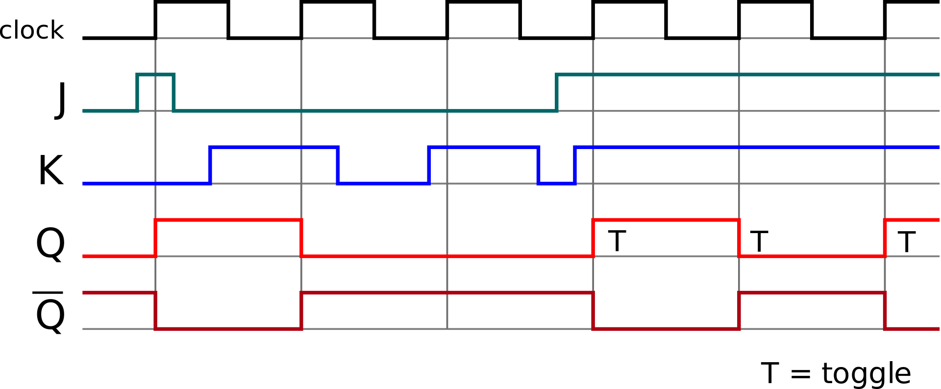

1. Analyze the following design based on different values of X and Y and determine whether it can store a bit of information. If yes, form the characteristic table and show each of the set, reset, store, and complement actions if available. Otherwise, explain the problem with the design.

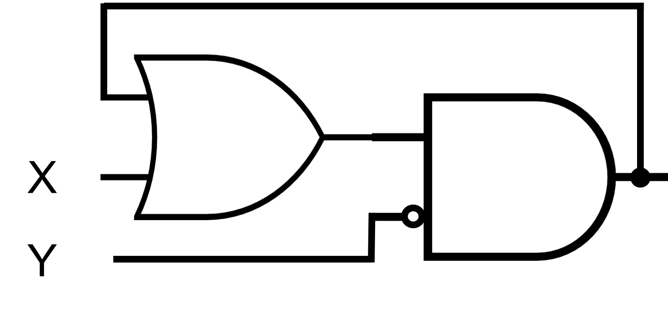

1. Analyze the following design based on different values of X and Y and determine whether it can store a bit of information. If yes, form the characteristic table and show each of the set, reset, store, and complement actions if available. Otherwise, explain the problem with the design.

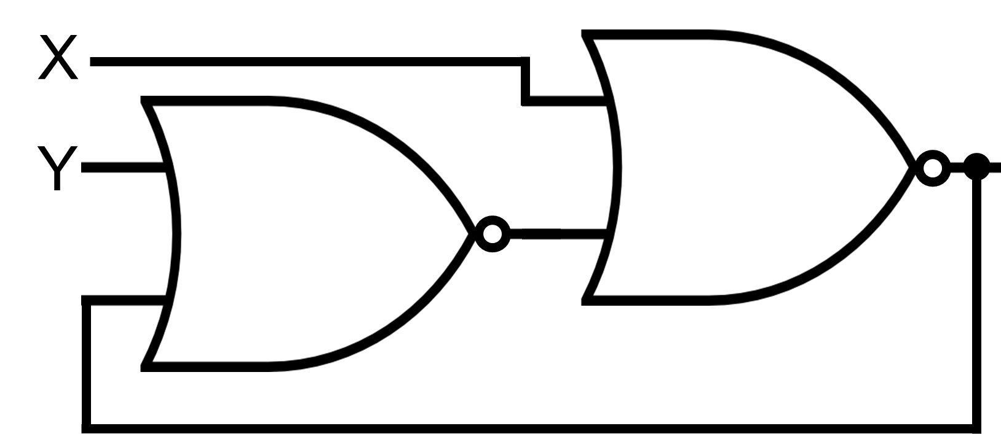

1. Derive the state table and the state diagram of the sequential circuit shown below. Explain the function that the circuit performs.

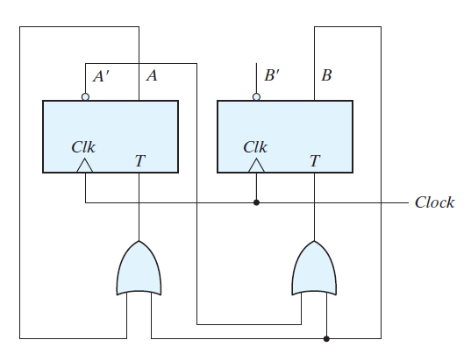

1. Design gated T using gated JK. “Gated” is another name for “latch”.
2. Design JK flip-flop using gated JKs (latches).
3. Design SR flip-flop using gated SRs (latches).
4. Design T flip-flop using gated Ts (latches).
5. Flip-Flops that are triggered on both the rising (positive edge) and the falling (negative edge) edge of the clock are called *dual*-edge-triggered flip-flops. Such a flip-flop may be built using two single-edge-triggered flip-flops. Design a dual-edge-triggered for D latch.