

**School of Computer Science**

**Faculty of Science**

**COMP-2650: Computer Architecture I: Digital Design**

**Fall 2020**

|  |  |  |  |  |
| --- | --- | --- | --- | --- |
| Assignment# | Date | Title | Due Date | Grade Release Date |
|  |  | **Sequential Logic** |  |  |

**Lecture Assignments**

A **state equation** (also called a transition equation) specifies the next state as a function of the present state and inputs (if any). For instance, given the following state table,

|  |  |  |  |  |
| --- | --- | --- | --- | --- |
| Input | Q(T) | | Q(T+1) | |
| X | B | A | B | A |
| 0 | 0 | 0 | 1 | 1 |
| 0 | 0 | 1 | 1 | 1 |
| 0 | 1 | 0 | X | 0 |
| 0 | 1 | 1 | 0 | 0 |
| 1 | 0 | 0 | 0 | 1 |
| 1 | 0 | 1 | 0 | 1 |
| 1 | 1 | 0 | X | 0 |
| 1 | 1 | 1 | 1 | 0 |

Q(T+1)A or simply A(T+1) is equal to sum of those minterms that makes the next state 1 based on the current states of all other memory units and the inputs:

Q(T+1)A =A(T+1)=F(X, B, A)=∑(0,1,4,5)

Similarly, for B,

Q(T+1)B =B(T+1)=F(X, B, A)=∑(0,1,7) + d(2,6)

So, we have:

(a) Output equation: the sum of minterms that make the *output* 1 (or product of MAXTERMs that make the output 0)

(b) Input (excitation) equation: the sum of minterms that make *the input to the flip-flop* 1 (or product of MAXTERMs that make the input to the flip-flop 0) based on an action required for the flip-flop

(c) State equation: the sum of minterms that make the *next state* 1 (or product of MAXTERMs that make the next state 0)

They all follow the same principle: writing the equation (Boolean function) based on the current state and the input variables. In the following questions, you might be given or asked to write the state equations for each flip-flop.

1. A PN flip-flop has four operations: clear to 0, no change, complement, and set to 1, when inputs P and N are 00, 01, 10, and 11, respectively. Design PN flip-flop using:
2. JK-FF
3. RS-FF
4. D-FF
5. T-FF

(*Hint: this design problem can be seen as the design for a sequential circuit with 1 memory unit, 2 inputs (X=P, Y=N) and two outputs (F1=Q and F2=F1’=Q'.*)

1. A sequential circuit with two D flip-flops A and B, two inputs, x and y; and one output z is specified by the following next-state equations (look at the beginning of the assignments for what the state equation is) and output equations:

A(t + 1) = xy’ + xB

B(t + 1) = xA + xB’

z = A

(a) List the state table for the sequential circuit.

(b) Draw the corresponding state diagram.

(c) Draw the logic diagram of the circuit.

1. A sequential circuit has two inputs x and y, and one output S. It consists of a full-adder circuit connected to a D flip-flop, as shown below. Derive the state table and state diagram of the sequential circuit.

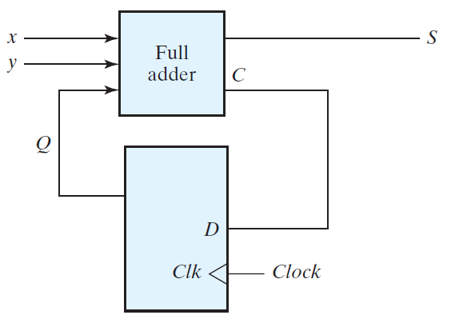

1. A sequential circuit has two JK-FFs A and B and one input x. The circuit is described by the following input (excitation) equations:

JA = x; KA = B

JB = x; KB = A’

(a) Draw the state table of the circuit.

(b) Draw the state diagram of the circuit.

1. A sequential circuit has two JK flip-flops A and B, two inputs x and y, and one output z. The flip-flop input equations and circuit output equation are:

JA = Bx + B’y’; KA = B’xy’

JB = A’x; KB = A + xy’

z = Ax’y’ + Bx’y’

(a) Is this circuit a Moore model or Mealy model? Explain your answer.

(b) Draw the logic diagram of the circuit.

(c) Tabulate the state table.

(c) Derive the state equations for A and B (look at the beginning of the assignments for the state equation).

1. For the following state table

|  |  |  |  |  |
| --- | --- | --- | --- | --- |
| Present State | Next State | | Output | |
| x=0 | x=1 | x=0 | x=1 |
| a | f | b | 0 | 0 |
| b | d | c | 0 | 0 |
| c | f | e | 0 | 0 |
| d | g | a | 1 | 0 |
| e | d | c | 0 | 0 |
| f | f | b | 1 | 1 |
| g | g | h | 0 | 1 |
| h | g | a | 1 | 0 |

Draw the corresponding state diagram.

1. A sequential circuit has three flip-flops A, B, C; one input xin and one output yout. The state diagram is shown below. The circuit is to be designed by treating the unused states as don't-care conditions. Analyze the circuit obtained from the design to determine the effect of the unused states.
2. Use D-FF in the design.
3. Use JK-FF in the design.

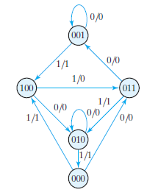

(*Hint: as seen, some states (nodes) are missing, such as 101, 110 and 111. If we reach at these values in the memory units at some point, the next state is not determined, that is, don't cater conditions. When writing the input equations and Boolean function for the output, you can assume any binary value inside the memory unit. It helps with more simplification.*)

1. Design the sequential circuit specified by the state diagram below, using T-FF.

