

**School of Computer Science**

**Faculty of Science**

**COMP-2650: Computer Architecture I: Digital Design**

**Fall 2020**

|  |  |  |  |  |
| --- | --- | --- | --- | --- |
| Assignment# | Date | Title | Due Date | Grade Release Date |
| Lec 09 | Nov 23-25, 2020 | **W11: Sequential Logic** | Dec. 02, 2020 + Extension  Wednesday Midnight [AoE](https://www.timeanddate.com/time/zones/aoe) | Dec. 09, 2020 |

The objectives of the lecture (weekly) assignments are to practice on topics covered in the lectures as well as improving the student’s critical thinking and problem-solving skills in ad hoc topics that are closely related but not covered in the lectures. Lecture assignments also help students with research skills, including the ability to access, retrieve, and evaluate information (information literacy).

**Deadline:** According to the school’s policy, no assignment can be due on the last week of class or after. Also, we are not able to remove the assignments for the last two weeks since it changes the course outline for the marking schema which is not possible at this time of the semester. This conflict of policies happens because we extend the deadlines for the labs for two weeks in order to reduce the workload. So, here is the solution:

* The official due date is what is mentioned above: Dec. 02, 2020, Wednesday Midnight AoE.
* There is an extension of 1 week to the official deadline for all students. Therefore, we accept submission till Dec. 09, 2020 Wednesday Midnight AoE.
* The difficulty of this week and next week’s assignments are in easy level that students can do the assignments within the official due date.

**Lecture Assignments Deliverables**

You should answer two of the below questions based on your preference using an editor like MS Word, Notepad, and the likes or pen in papers. You have to write and scan the papers clearly and merge them into a single file in the latter case. In the end, you have to submit all your answers in one single pdf file COMP2650_Lec09_{UWinID}.pdf containing the following items:

1. Your name, UWinID, and student number
2. The question Id for each answer. Preferably, the questions should be answered in order of increasing Ids. *Please note that if your answers cannot be read, you will lose marks.*
3. Including the questions in your submission pdf file is optional.

*Please follow the naming convention as you lose marks otherwise.* Instead of {UWinID}, use your own UWindsor account name, e.g., mine is [hfani@uwindsor.ca](mailto:hfani@uwindsor.ca), so, my submission would be: COMP2650_Lec09_hfani.pdf

**Lecture Assignments**

**(select only 2 questions based on your preference)**

1. Timing Diagram is a diagram that shows the state of a sequential logic within time dimension. Complete the following diagram for Q (main output) for the following cases:
   1. Active high JK latch
   2. Active low JK latch
   3. Positive edge JK
   4. Negative edge JK
   5. Dual-edge JK

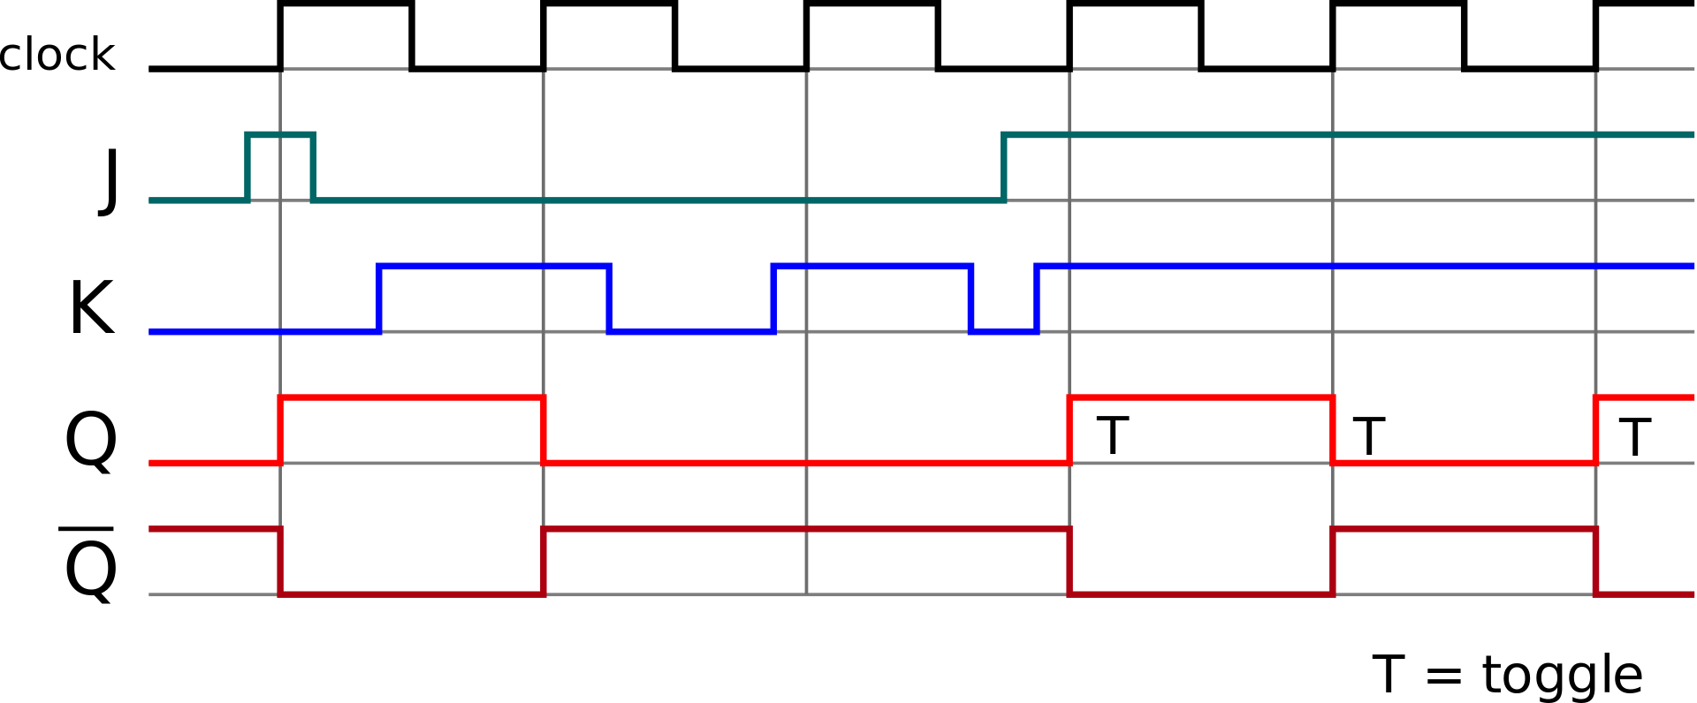

1. Analyze the following design based on different values of X and Y and determine whether it can store a bit of information. If yes, form the characteristic table and show each of the set, reset, store, and complement actions if available. Otherwise, explain the problem with the design.

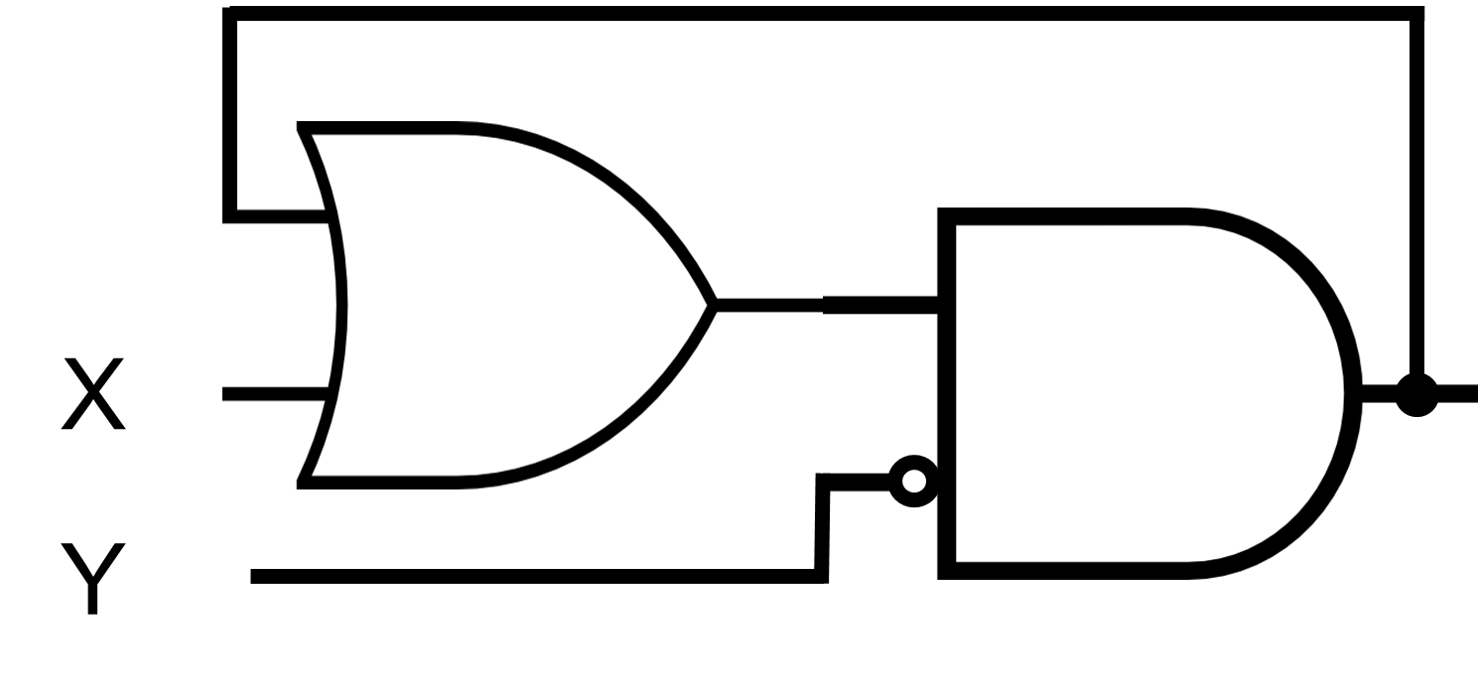

1. Analyze the following design based on different values of X and Y and determine whether it can store a bit of information. If yes, form the characteristic table and show each of the set, reset, store, and complement actions if available. Otherwise, explain the problem with the design.

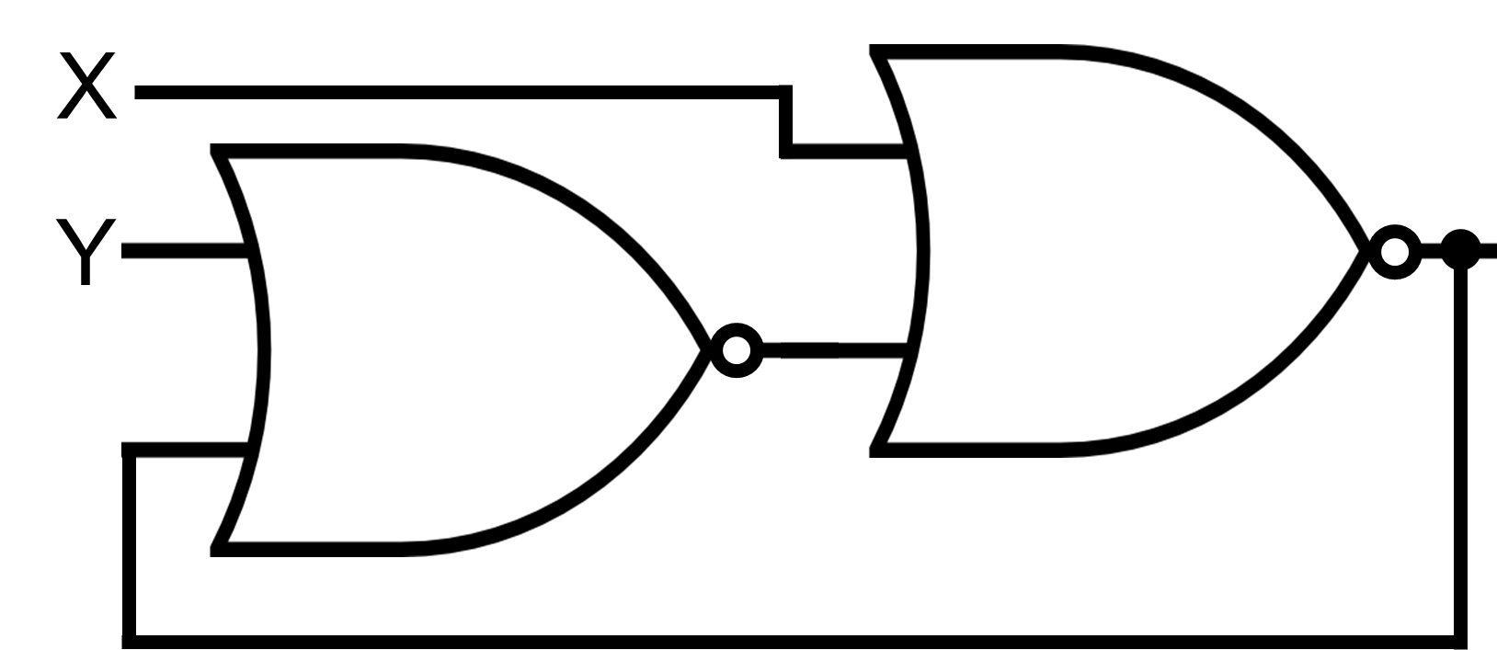

1. Derive the state table and the state diagram of the sequential circuit shown below. Explain the function that the circuit performs.

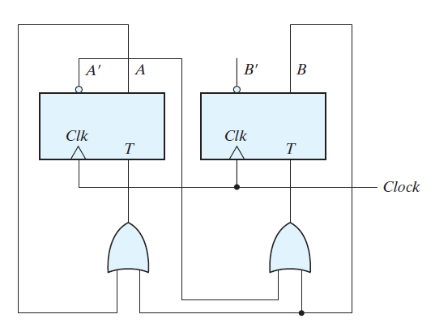

1. Design gated T using gated JK. “Gated” is another name for “latch”.
2. Design JK flip-flop using gated JKs (latches).
3. Design SR flip-flop using gated SRs (latches).
4. Design T flip-flop using gated Ts (latches).
5. Flip-Flops that are triggered on both the rising (positive edge) and the falling (negative edge) edge of the clock are called *dual*-edge-triggered flip-flops. Such a flip-flop may be built using two single-edge-triggered flip-flops. Design a dual-edge-triggered for D latch.