

**School of Computer Science**

**Faculty of Science**

**COMP-2560: System Programming, Fall 2021**

|  |  |  |  |  |
| --- | --- | --- | --- | --- |
| Lec# | Date | Title | Due Date | Grade Release Date |
| Lec02 | Week 02 | **Intro System Programming** | Sept. 29, 2021, Wednesday 4:00 AM EDT | Oct. 04, 2021 |

The objectives of the weekly lecture assignments (Lecs) are to practice on topics covered in the lectures as well as improving the student's *critical thinking and problem-solving skills in ad hoc topics that are closely related but not covered in the lectures*. Lecture assignments also help students with research skills, including accessing, retrieving, and evaluating information (information literacy).

**Lecture Assignments Deliverables**

You should answer **two questions** below using an editor like MS Word, Notepad, and the likes or pen in papers. In the latter case, you must scan the papers clearly and merge them into a **single file** lec02_uwindid.pdf containing your name*,* uwinid*,* student#. **Please note that if your answers cannot be read, you will lose marks.** Please follow the naming convention as you lose marks otherwise. Instead of uwindid, use your own account name, e.g., mine is [hfani@uwindsor.ca](mailto:hfani@uwindsor.ca), so my submission would be: lec02_hfani.pdf

**Lecture Assignments**

*Select two questions based on your preference!*

1. What do we talk about when we talk about system programming, system-level programming, and application-level programming?
2. Hossein is thinking of what *restart* does to his computer system. He thinks, *"if the restart button turns off the computer system, then there is no power to the system. Without power, no part of the system can turn on the system. How the system turns on after then?"* Help him!
3. UNIX did not initially recognize the mouse as an input device (still existing commercial versions have a problem with it.) At what level of programming and in what programming language do we need to write code to expand UNIX to support mouse inputs? Justify your answer.

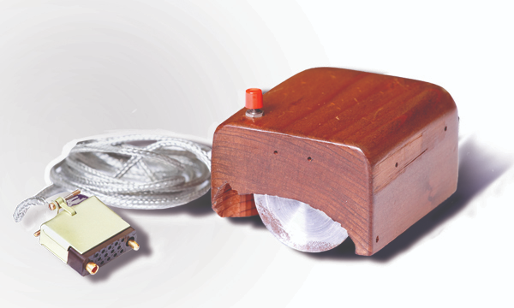

*The first prototype of a computer mouse, as designed by Bill English from Engelbart's sketches[1]*

1. Explain the trip that a mouse click takes to the UNIX kernel.
2. Is it able to have multiple MBRs? Justify your answer.
3. Is it able to have multiple operating systems at the same time running in a computer system? Justify your answer.
4. Is it able to select one from multiple operating systems to be run in a computer system? How? Justify your answer.
5. Assume you're a system-level programmer that develops an OS with a shell. You are thinking of scenarios where the shell crashes, another program kills it, or the user kills it, etc. What workaround do you provide except turning off and then turning on or restarting the computer system?

1. https://www.macworld.com/article/1137400/mouse40.html