Peggy is gone!
Our family pet Peggy has been missing since last Sunday. We last saw her chasing a butterfly in the park by Blue Lake. Peggy is a white West Highland Terrier. She's a very reliable, playful, and loving dog. Have you seen Peggy, or perhaps taken her home with you? Then please call us! Bobby (9 yrs.) and Tom (11yrs.) miss their little friend very much!
The Peters family, Tel.:(222) 555-1234
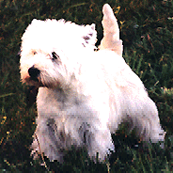Peggy's picture

Runaway Dog
-Peggy-

Tel.:(222) 555-1234
Runaway Dog
-Peggy-

Tel.:(222) 555-1234
Runaway Dog
-Peggy-

Tel.:(222) 555-1234
Runaway Dog
-Peggy-

Tel.:(222) 555-1234
Runaway Dog
-Peggy-

Tel.:(222) 555-1234
Runaway Dog
-Peggy-

Tel.:(222) 555-1234
Runaway Dog
-Peggy-

Tel.:(222) 555-1234

