  TEXT HERE |  | TEXT HERE
  TEXT HERE |  | TEXT HERE
  TEXT HERE |  | TEXT HERE
  TEXT HERE |  | TEXT HERE
  TEXT HERE |  | TEXT HERE
  TEXT HERE |  | TEXT HERE
  TEXT HERE |  | TEXT HERE
  TEXT HERE |  | TEXT HERE
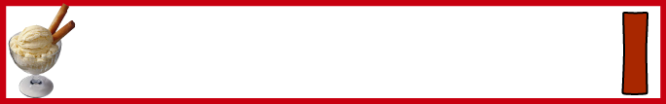  TEXT HERE | 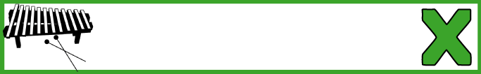 | TEXT HERE
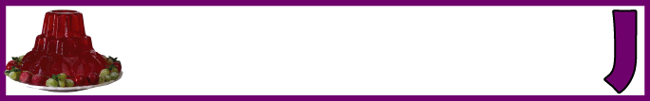  TEXT HERE | 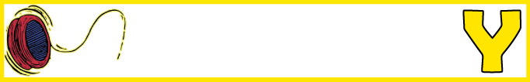 | TEXT HERE
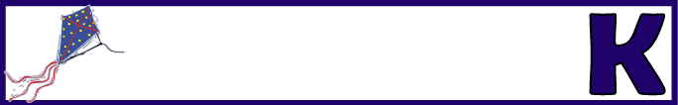    TEXT HERE |  | TEXT HERE
  TEXT HERE |  | TEXT HERE
    TEXT HERE |  | TEXT HERE
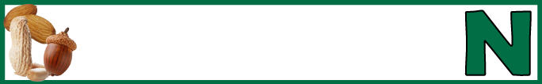  TEXT HERE |  | 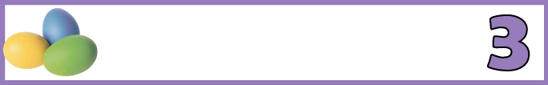  TEXT HERE
  TEXT HERE | 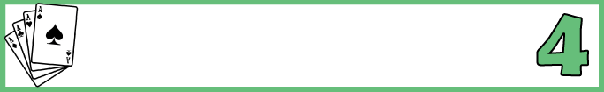 | TEXT HERE

