Gallery PicturePerfect
... a unique framework for art

, November 2006
This year we are once again pleased to be able to introduce new and intriguing artists in Gallery PicturePerfect. This brochure, in which three of our new discoveries are presented, gives you a quick impression of what you can expect. We hope you enjoy the works of these unique artists as much as we do.
Your
Gallery PicturePerfect

Randy Peacehol
It's not difficult to notice the influence of prominent New York Pop-Art artists on the 25 year-old Berlin artist Randy Peacehol. Nevertheless, he has succeeded in creating his own style. We would like to present two of his newest works here.


Unconventional Idea (1993)
Acrylic on Canvas, approx. 1 x 1 m
$4,000




The Process of Creativity (1995)
Acrylic on Canvas, approx. 160 x 40 cm
$3,500

Wladimir Kakowski
Kakowski was born in 1964 in Belgrad. Since 1975 he has been living in Hamburg, where he studied at the Institute for the Arts. His works are clearly influenced by the artistic movement of the late sixties. His unusual combinations of otherwise conventional techniques yield exceptional results.
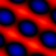
Police Blues (1996)
Airbrush / Collage, approx. 130 x 90 cm
$3,000
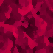
Red Jelly (1994)
Collage, approx. 80 x 125 cm
$4,500
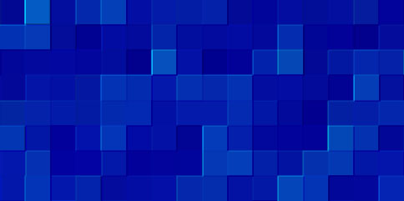
North Sea (1995)
Collage, approx. 160 x 80 cm
$5,000

J. P. Mirondrian
Mirondrian was born in 1954 in Sevilla. The clear "sign language" popularized by this Pop-Art artist is based mainly on everyday symbols, familiar to us all.

Equality (1993)
Acrylic on Canvas, approx. 53 x 53 cm

$3,000
Recycle (1994)
Acrylic on Canvas, approx. 70 x 70 cm

$1,500

