Who is using OpenOffice.org?
What do you need to run OpenOffice.org Version 2?

- Windows 98, Windows ME, Windows 2000 (Service Pack 2 or higher), Windows XP, Windows 2003
- 128 Mbytes RAM
- 200 Mbytes available disk space
- 800 x 600 or higher resolution with at least 256 colours

- Linux kernel version 2.2.13 or higher, glibc2 version 2.2.0 or higher
- 128 Mbytes RAM
- 200 Mbytes available disk space
- X-Server with 800 x 600 or higher resolution with at least 256 colours
- rpm package manager

- SPARC or x86 platform
- Solaris 8 OS or higher
- 128 Mbytes RAM
- 250 Mbytes available disk space
- X-Server with 800 x 600 or higher resolution with at least 256 colours

- Note: currently supported version is OpenOffice.org 1.1.2
.

Note: for full functionality with OpenOffice.org Version 2 (including Base) you will also need a Java Runtime Environment (JRE) installed. For a free of charge download for your system, visit http://java.com
Tens of millions of users worldwide have adopted OpenOffice.org as their preferred office software. Both private individuals and organisations appreciate the OpenOffice.org advantage:
Governments and Public Administrations
- open-source licencing demonstrates vendor-neutrality and best value for money
- OpenDocument support guarantees access to information for future generations
- OpenOffice.org is easily translated into local languages (including complex text)
Educational Sector (Schools, Colleges, Universities...)
- no software compliance / audits / hassles
- issue free copies of the software to students with their course
- opportunities for experiencing international collaborative working over the internet by co-operating in projects within the OpenOffice.org community
Not-for-Profit Organisations (Charities, Voluntary Organisations, Non-Governmental Organisations)
- no software licence worries or costs
- no restrictions on number of users able to use the software (ideal for part-ime / occasional volunteer workers)
- no need to retrain volunteers familiar with other legacy office software
Small/Medium Enterprises (SMEs)
- no software licence compliance audits; no enforced software upgrades
- easy to migrate from other legacy software packages
- swap files with partners using other software packages
- stable, reliable software – no time-wasting crashes
Own Equipment Manufacturers (PC Manufacturers / Builders)
- deliver a high-quality PC bundle at the lowest possible cost
- compatible with buyers’ legacy data
- no requirement to state ‘we recommend OpenOffice.org’ on all your advertising literature

No Licence change with Version 2
What hasn’t changed is that OpenOffice.org remains a genuine open-source product:


- You may download OpenOffice.org completely free of any licence fees, use it for any purpose – private, educational, government and public administration, commercial – and pass on copies free of charge to family, friends, students, employees, etc.

- We actively encourage developers and users to help us make the product better, and make it better known, through joining in the world-wide OpenOffice.org community.

Microsoft Windows, Office, Word, Excel, and PowerPoint are trademarks or registered trademarks of Microsoft Inc. Linux is a registered trademark of Linus Torvalds. Sun, StarOffice, and Solaris are trademarks or registered trademarks of Sun Microsystems, Inc. Apple and MAC OS are registered trademarks of Apple Computer, Inc. Flash is either a registered trademark or trademark of Macromedia, Inc. in the U.S. and/or other countries All other products, services, companies, events and publications are trademarks, registered trademarks, or service marks of their respective owners in the U.S. and / or other countries.
The contents of this Document are subject to the Public Documentation License Version 1.0 (the "License"); you may only use this Document if you comply with the terms of this License. A copy of the License is available on the OpenOffice.org community website: http://www.openoffice.org/licenses/PDL.html The Initial Writer of the Original Document is John McCreesh for the OpenOffice.org Marketing Project Copyright (c) 2005. All Rights Reserved. (Initial Writer contact: jpmcc@openoffice.org). This document version 20050417ENA3.
What do you need to run OpenOffice.org Version 2?
- Windows 98, Windows ME, Windows 2000 (Service Pack 2 or higher), Windows XP, Windows 2003
- 128 Mbytes RAM
- 200 Mbytes available disk space
- 800 x 600 or higher resolution with at least 256 colours
- Linux kernel version 2.2.13 or higher, glibc2 version 2.2.0 or higher
- 128 Mbytes RAM
- 200 Mbytes available disk space
- X-Server with 800 x 600 or higher resolution with at least 256 colours
- rpm package manager
- SPARC or x86 platform
- Solaris 8 OS or higher
- 128 Mbytes RAM
- 250 Mbytes available disk space
- X-Server with 800 x 600 or higher resolution with at least 256 colours
- Note: currently supported version is OpenOffice.org 1.1.2
.

Note: for full functionality with OpenOffice.org Version 2 (including Base) you will also need a Java Runtime Environment (JRE) installed. For a free of charge download for your system, visit http://java.com
Quality Office Suite
The Friendly Solution

Another first for the most innovative, most usable office software package in the world
The Open Answer

OpenOffice.org Version 1 was the first product to deliver the benefits of open-source software to mass-market users, delivering essential everyday software tools completely free of charge. Translated into over 30 languages, available on all major computing platforms (Microsoft Windows, Mac OS X X11, GNU/Linux, Solaris), OpenOffice.org Version 1 is now in use by tens of millions of delighted users worldwide.
With Version 2, it gets even better
- the first office suite to use the new OASIS OpenDocument format, the future-proof international standard for office software
- easier to install, with a whole new look and feel, matched to the type of computer in use
- more intuitive, more easy to use than ever, with a host of new usability features
- introducing a major new component, Base: an easy-to-use database manager with a fully integrated database
- more compatible with other software packages; minor glitches, formatting, and font problems occasionally found with Microsoft Office files have been eliminated

But the licence is still the same: you may download OpenOffice.org Version 2 completely free of any licence fees, use it for any purpose – private, educational, government and public administration, commercial – and pass on copies free of charge to family, friends, students, employees, etc.
OpenOffice.org Version 2 is available now
- download today from http://download.openoffice.org
- order a CD-ROM from a distributor http://distribution.openoffice.org/cdrom
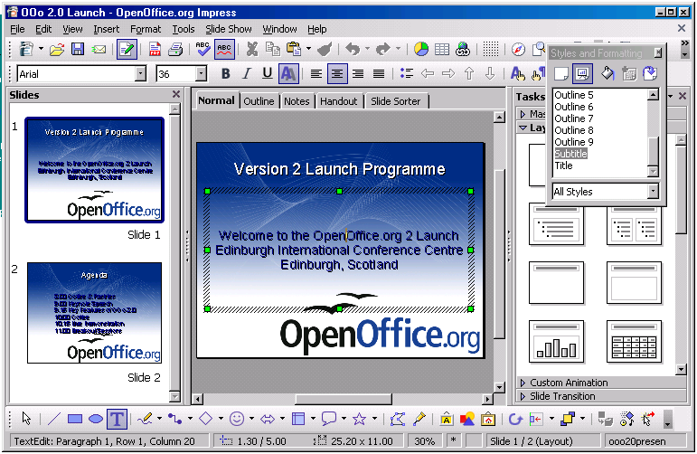Impress, OpenOffice.org's tool for creating dynamic presentations
Writer – for all your Documents
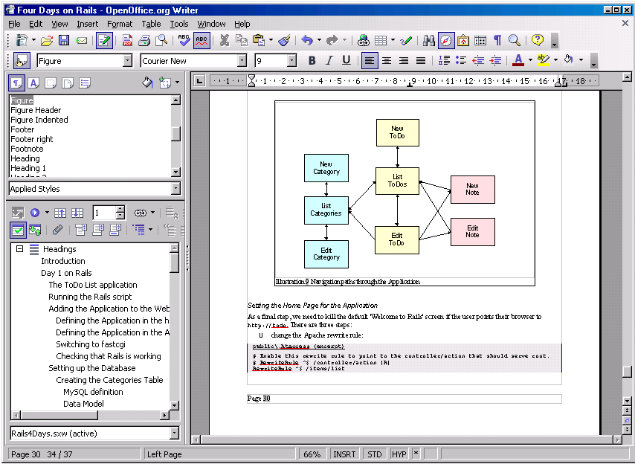
Writer is OpenOffice.org’s word processor: use it for anything from writing a quick letter to producing an entire book with embedded illustrations, cross-references, tables of contents, indexes, bibliographies... Auto-complete, auto-format, and real-time spelling check make light work of the hardest task. Writer is powerful enough to tackle desktop publishing tasks such as creating multi-column newsletters, brochures – the only limit is your imagination.
Calc – the all-purpose Spreadsheet
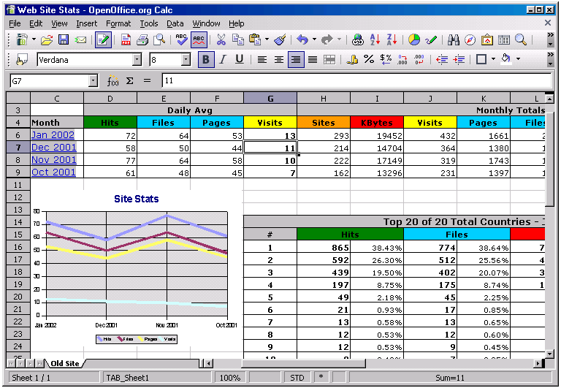
Use Calc to bring your numbers under control. This powerful spreadsheet has all the tools you need to calculate, analyse, summarise, and present your data in numerical reports or sizzling graphics. A fully-integrated help system makes entering complex formulas a breeze. Sophisticated decision-making tools are just a few mouse clicks away. Pull in external data using the Data Pilot, and sort it, filter it, and produce subtotals and statistical analyses. Use previews to select from thirteen categories of 2-D and 3-D charts including line, area, column, pie, XY, stock and net with dozens of variants.
The Friendly Solution
Base – the new way to access databases
New to Version 2, Base enables you to manipulate database data seamlessly within OpenOffice.org. Create and modify tables, forms, queries, and reports, either using your own database or Base’s own built-in HSQL database engine.
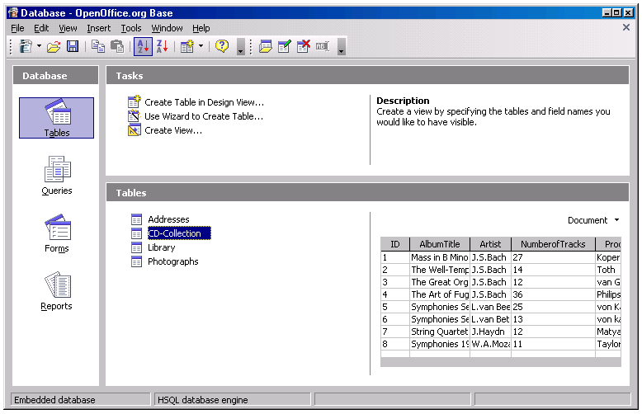
and much more...
OpenOffice.org also contains Draw, a full-featured 2-D / 3-D graphics program (see illustration below), Impress for creating presentations (see illustration on the front page of this brochure), and Math, a specialist editor for mathematical symbols. The powerful built-in pdf and Flash creators introduced in Version 1 are also significantly enhanced in Version 2.
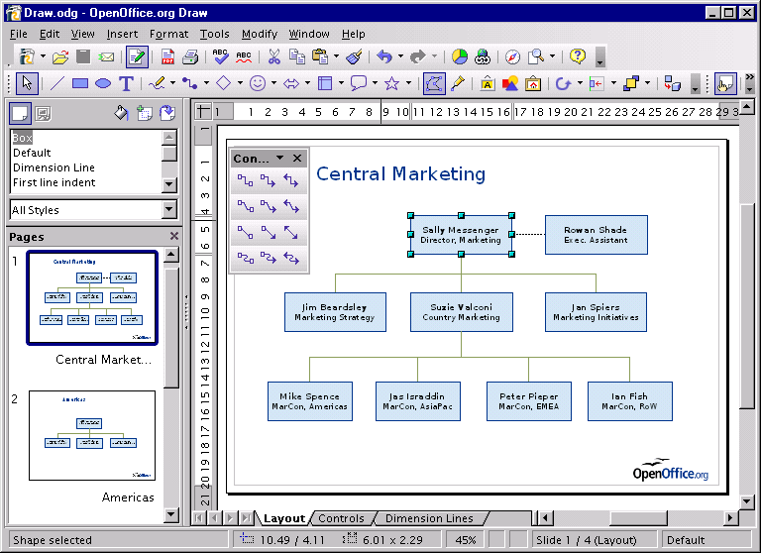
Note: unlike some of its competitors, OpenOffice.org is not a collection of separate pieces of software which have been bundled together. From the start, OpenOffice.org has been built as a single piece of software, making it exceptionally easy to move from one component to another. It looks the same, works the same, because underneath it is the same. Add in a common and consistent help system, and it’s no accident that OpenOffice.org is easy to use even for beginners.

