
Connecting to a PostgreSQL data source:
A real life case study

Contents
Overview ii
Copyright and trademark information ii
Feedback ii
Acknowledgments ii
Modifications and updates ii
Introduction 1
The detail 2
Setting up the ODBC data source on the laptop 2
Registering the data source with OpenOffice.org 3
Using the data source to set up queries 5
Use the queries to make a spreadsheet 7

Overview
This article gives a description of how to use PostgreSQL as an external data source to OpenOffice.org

Copyright and trademark information
The contents of this documentation are subject to the Public Documentation License, Version 1.0 (the “License”); you may only use this documentation if you comply with the terms of this License. A copy of the License is available at:
http://www.openoffice.org/licenses/PDL.rtf.
The Original Documentation is Connecting to a PostgreSQL data source: A real life case study. The Initial Writer of the Original Documentation is Garry Saddington © 2005. All Rights Reserved. (Initial Writer contact: garry@scholarpack.org. Contact the Initial Writer only to report errors in the documentation. For questions regarding how to use the software, subscribe to the Users mailing list and post your question there: http://support.openoffice.org/index.html.)

All trademarks within this guide belong to legitimate owners.

Feedback
Please direct any comments or suggestions about this document to:
authors@user-faq.openoffice.org

Acknowledgments

Modifications and updates
Version | Date | Description of Change
0.1 | 15/01/05 | First draft
0.2 | 12/02/05 | Corrections applied

Introduction
At my place of work (a school) we have a web based management information system which uses a PostgreSQL database server. Recently we have written parental reports for the students that have included examination grades. Our school statistician was asked to provide a breakdown of the grades using various criteria for the use of senior management. However, our statistician is not yet an OpenOffice.org convert and prefers the use of Microsoft Excel for his calculations!
I therefore had to solve the problem of exporting data from an open source database management system to a proprietary file format. I first considered a simple .csv file export but that would have created too much work for our Microsoft expert. I then realised that OpenOffice.org could make this job so simple that there was really no other option. I therefore decided to:
- Use a laptop with OpenOffice 1.9.65 installed to connect to the server running PostgreSQL on our LAN (local area network).
- Configure the database on this server as an ODBC (Open Data Base Connection) data source for use on the laptop.
- Register this data source with OpenOffice.org.
- Construct a query to extract the necessary data.
- Run the query in an OpenOffice.org spreadsheet.
- Drag the query results to the spreadsheet.
- Save the resulting spreadsheet as an Excel file.
- 15 minutes later our Microsofty had two Excel files and everyone went home happy.
This is the detail of how to repeat such a connection to a PostgreSQL database server and how to make a useful query to this server. The operating system in use is Linux exclusively and more precisely SuSE 9.1 (a similar procedure can be accomplished using Windows, and this will be the subject of a future part in this section of the database guide.)

Note | It is the opinion of the writer that PostgreSQL is the DBMS of choice for open source projects. This is due to its level of standards compliance and its licensing. (see www.postgresql.org for details)

The detail

Setting up the ODBC data source on the laptop
Open your system's ODBC configurator. In SuSE this is ODBCConfig (type in a terminal, you will need to be root). | 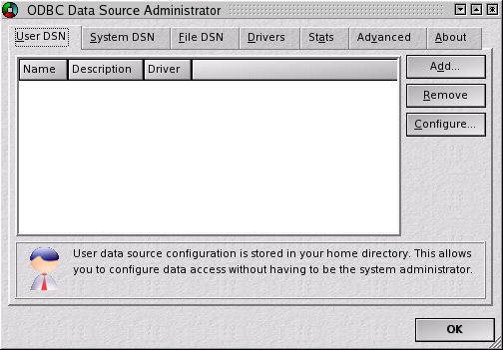
Add the driver needed. To set up a new driver press configure to open the following dialog. | 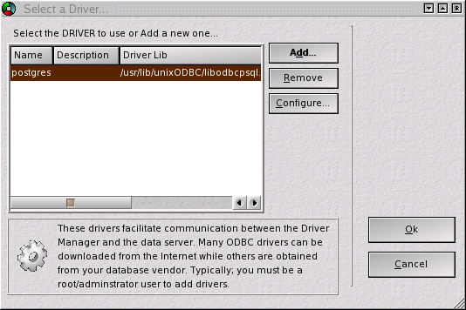
Setup the driver and relevant setup file, this is where they can be found.  (driver)  /usr/lib/unixODBC/libodbcpsql.so  (setup)  /usr/lib/unixODBC/libodbcpsqlS.so | 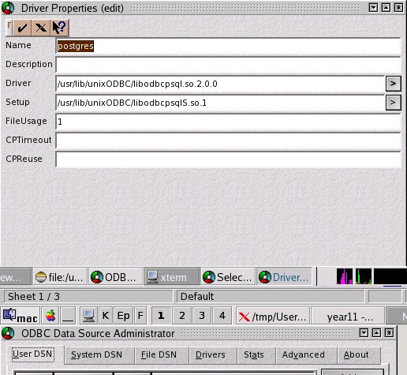
Press OK on driver setup page to open the data source properties page. Enter database name, username and password. The server can be an IP address or a host name if /etc/hosts or DNS is configured. Use localhost if it is on the same computer as the OpenOffice installation. Accept the default port unless you have changed it in the Postgres configuration. Click the tick. | 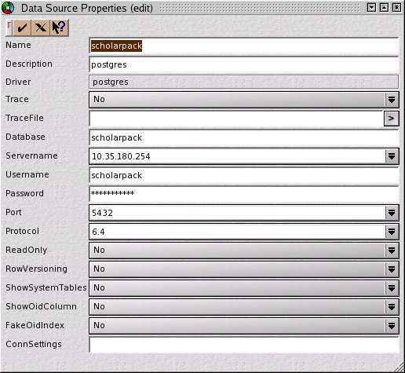
I have set up my data source as a system source but it could equally be a User data source (see dialog box). We now have a data source ready to use. | 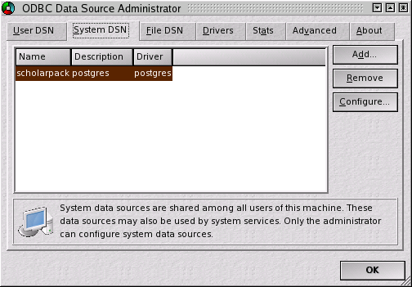

Registering the data source with OpenOffice.org
From any OpenOffice.org document choose new database and the add new data source dialog opens. Click connect to an existing database. | 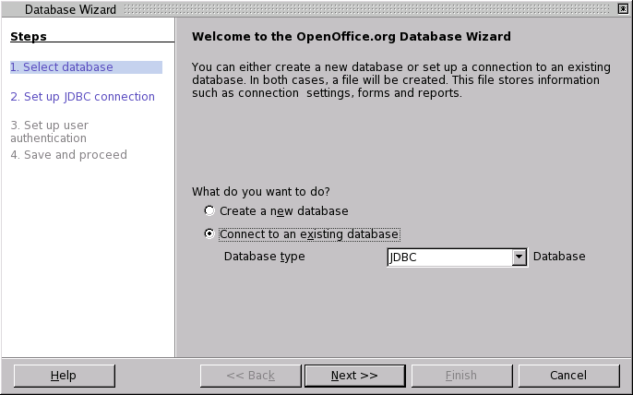
Drop the database type list down and select ODBC. Click next. | 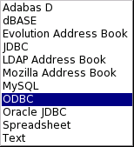
Type in the name of the ODBC database previously configured. Or click browse to show the ODBC database browser as shown below. | 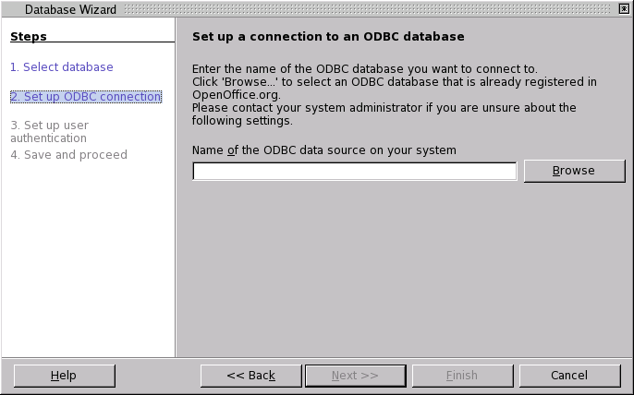
Select the relevant data source. | 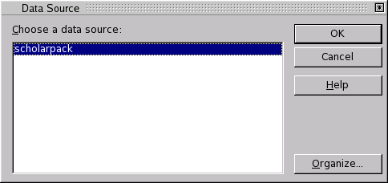
Fill in user name and whether password is required. Click next. | 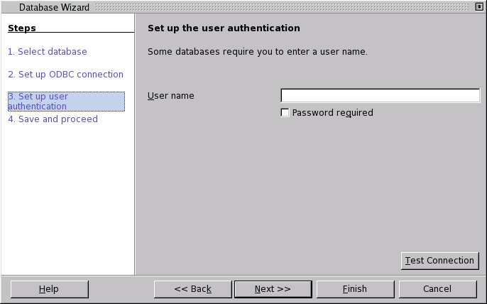
Allow the wizard to register the data source with OpenOffice.org and open for editing. Click finish. | 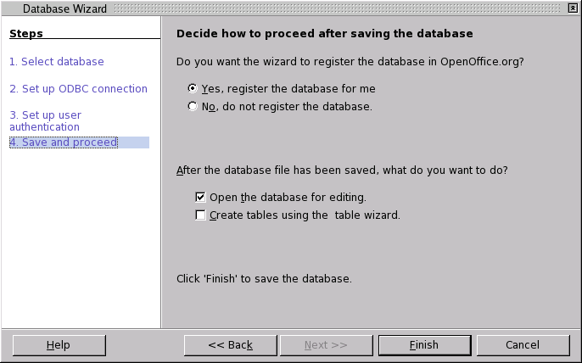
Give the new database a name and save it. | 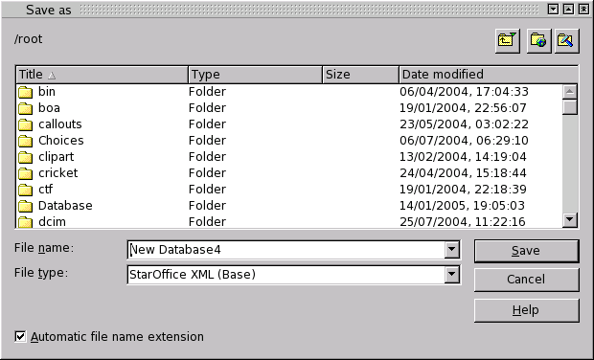

Using the data source to set up queries
Database window opens. | 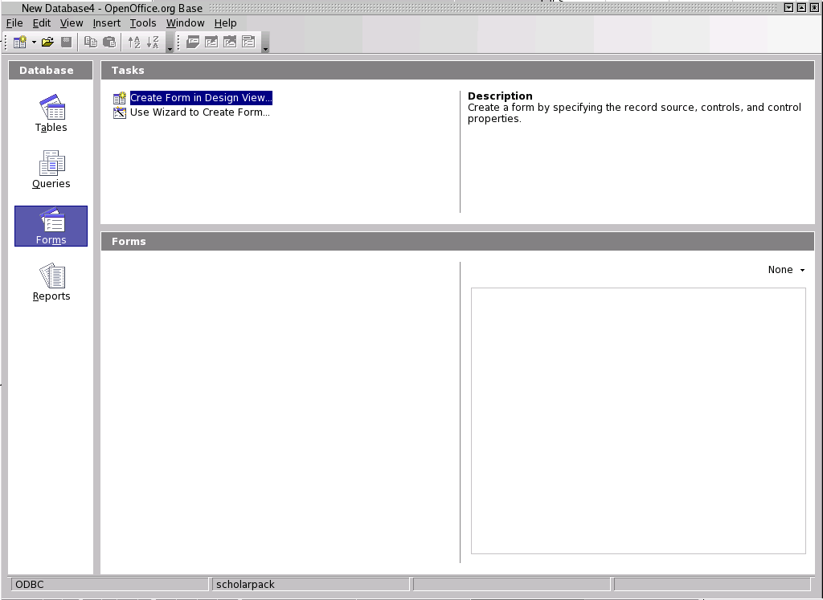
Select tables to show the tables in the data source. This is a large application so there are plenty of tables. Select queries and then 'Create query in design view'. | 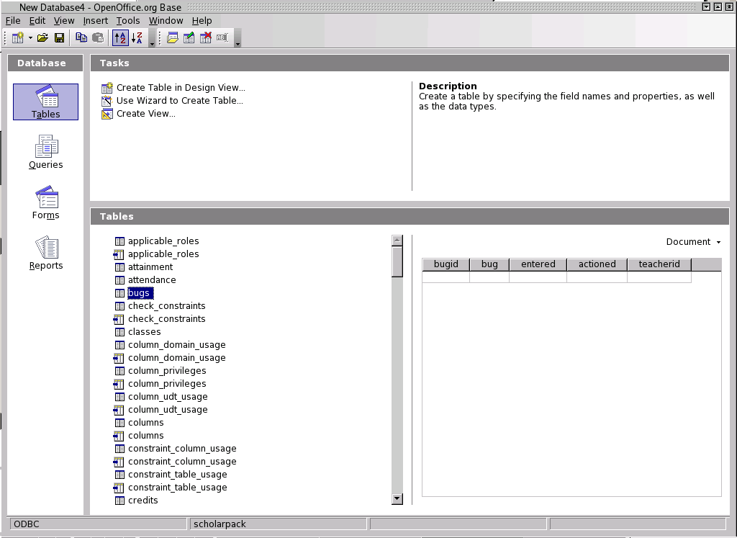
Design view opens. Add the tables that are needed for the query. | 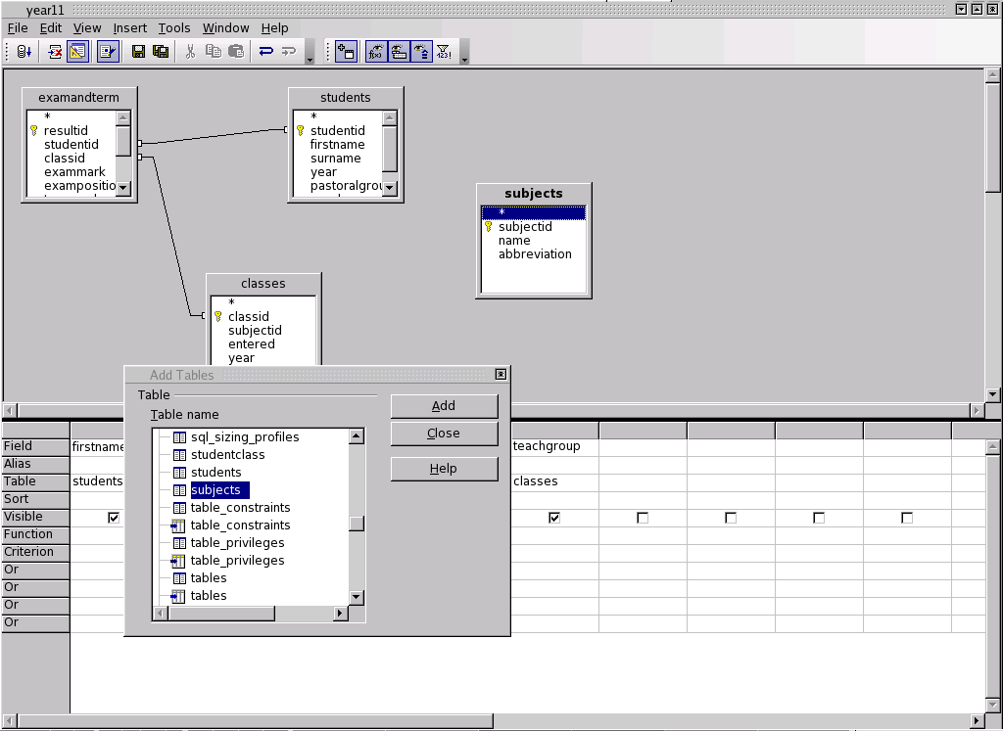
Define the relationships between the tables. Select the fields to be displayed in the query and the criteria necessary. Save the query and close the design view. | 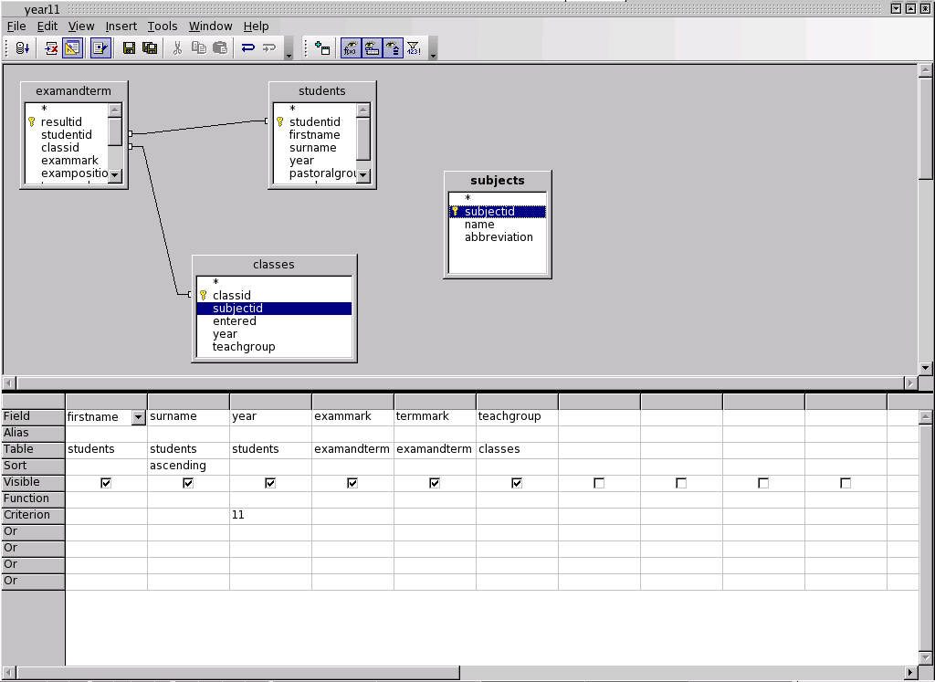
Back in the database window the new queries are displayed. Double click a query and the result set is displayed as shown below. | 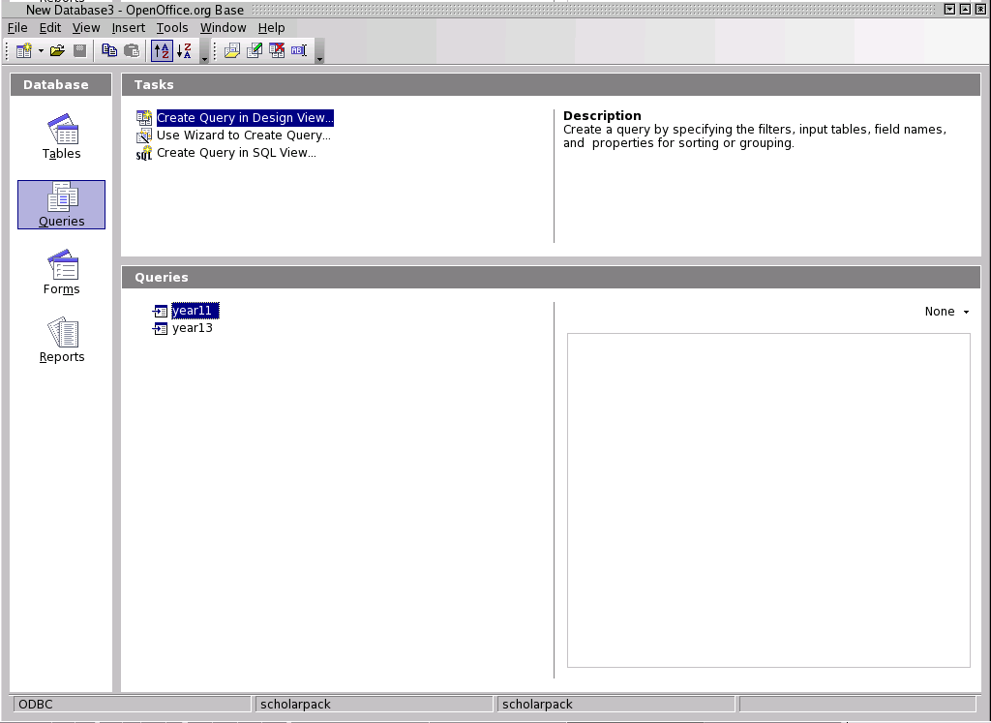
A result set displayed using the database application. | 

Use the queries to make a spreadsheet
Pressing F4 while a new spreadsheet is open will reveal the data source browser. Selecting the query previously defined will display the result set in the database window.  Click here, hold and drag the data  into cell A1. A new spreadsheet is populated. Now do a save as and choose MS Excel. | 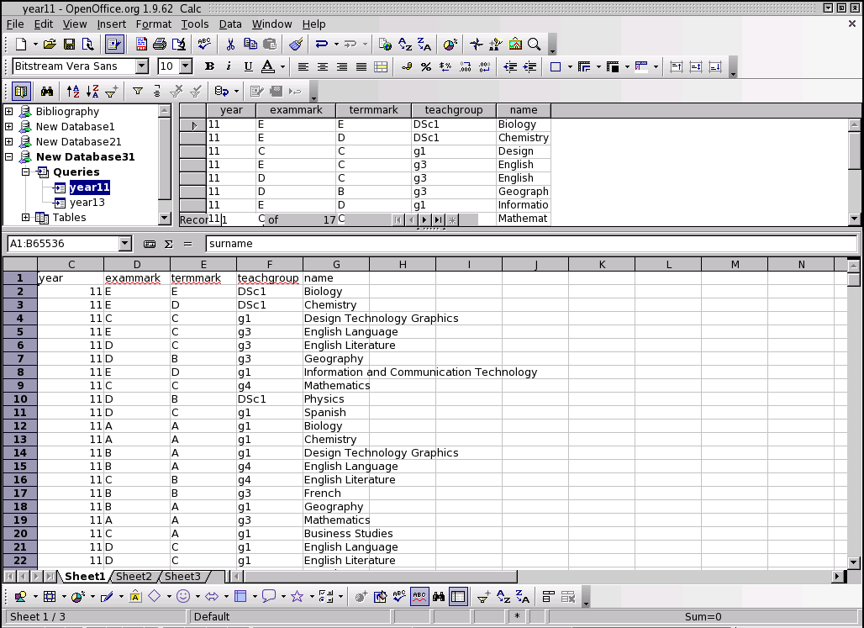

That is how OpenOffice.org has helped me keep a colleague happy. The power of OpenOffice.org base is in how simple it makes even the most complex of operations. There is no other all in one tool that can rival the data access provided by OpenOffice.org.

