Task 1 — Dataset Investigation
Neyshekar Persian ASR · carried out before any training code was written
Every figure below is reproducible: verify_task1.py replays the cleaning pipeline from the raw parquet shards and flags any number here it cannot reproduce, and plot_dataset.py prints the same statistics it draws.

1. What assumptions can you make about the dataset?
Six assumptions, each written as something that could turn out to be false so the investigation had a way of being wrong rather than merely confirming itself.
- Hallucination-prone samples. Whisper's decoder always emits a token, so audio with no speech does not produce an empty string — it produces hallucinated text, often looping. I assume some files contain long silences.
- Duration outliers. The feature extractor uses a fixed 30-second window. Files under ~1 s lack context; files over 30 s are silently truncated, breaking audio–text alignment. The dataset card claims a 27-second maximum, but a claim is not a measurement.
- Orthographic anomalies. Persian text often carries Arabic codepoints — Arabic yeh (U+064A) for Persian yeh (U+06CC), Arabic kaf (U+0643) for Persian kaf (U+06A9). They look near-identical but are distinct symbols to the tokenizer. I also assume numbers appear as digits, which does not match audio where they are spoken as words.
- Audio–text misalignment. Some rows may pair long audio with a very short transcript. Detectable as outliers in speech-rate statistics, without listening to anything.
- Duplication. Duplicate rows likely exist in text, audio, or both, inflating the weight of particular sentences and pushing the model toward memorisation.
- Sampling-rate inconsistency. The encoder operates only at 16 kHz. The card claims all audio already is; resampling should be applied defensively rather than trusted.

2. Are there duplicated transcripts?
Yes, and they must be separated into kinds. The same transcript with different audio is valuable — one sentence across several speakers is exactly the variation the model needs. The same transcript with the same audio is redundancy, and a sentence repeated many times becomes a hallucination trigger.
Text was standardised across all 40,008 raw records first, so that identical sentences typed with different conventions would not fail to match.
Anomaly | Records | Share | Action
Arabic yeh / kaf codepoints | 1,480 | 3.70% | mapped to Persian yeh and kaf
Numeric digits | 1,191 | 2.98% | spelled out as Persian words

Verification confirmed zero remaining Arabic characters and zero remaining digits. A temporary fingerprint — spaces, ZWNJ, diacritics and punctuation stripped — was then used for comparison only; it is never a training label, since word error rate cannot be computed on text without spaces.
Category | Rule | Records | Action
Exact row duplicates | identical audio and text | 134 | dropped
Short conversational phrases | under 15 chars or 4 words | 3,479 | kept in full
Long repeats, 2–3 copies | — | 18,520 | kept in full
Long repeats, over 3 copies | capped at 3 | 1,191 kept | 532 dropped

The three thresholds are the only judgement calls. Short phrases are exempt because high frequency is a property of spoken Persian rather than a defect, and removing them would bias the model against the utterances it meets most often. The cap of three is the compromise between losing multi-speaker variety below it and letting one sentence pull the decoder toward reciting it above.
Result: 666 records removed from 40,008, leaving 39,342 — 98.34% retained.

Duplication across the train/validation split
The split was made on unique id, so no recording appears on both sides — verified, the id overlap is zero. But it was not made on transcript content, and the same sentence is often recorded by several speakers.
Measure | Value
Validation rows whose transcript also occurs in training | 3,061 (51.9%)
Of those, long transcripts (≥15 characters and ≥4 words) | 2,595 (44.0% of validation)
Recordings shared between the two splits | 0

This is not leakage in the strict sense — no validation waveform was trained on. But Whisper's decoder is a language model, so for half the validation set it is producing a sentence it was trained to produce. Reported validation WER is therefore optimistic relative to unseen text, and the 44% figure shows this is not merely an artefact of common short phrases. The fix is a transcript-disjoint split; it was not applied because the split was already fixed before this was measured and re-splitting would have invalidated the training run. It is recorded as a known limitation rather than left to be discovered.

3. Are there invalid audio files?
Yes, but negligibly few. A vectorised header scan across all 40,008 samples answered this without decoding 7 GB of audio.
Check | Result | Statistic (final set) | Value
Corrupted headers | 0 | Records | 39,332
Absolute digital silence | 0 | Total audio | 62.1 hours
Files longer than 30 s | 0 | Duration mean / median | 5.69 s / 5.04 s
Files shorter than 1.0 s | 10 (dropped) | Duration min / max | 1.02 s / 27.18 s
 |  | Duration p95 / p99 | 11.54 s / 15.60 s

On the ceiling. The measured maximum is 27.18 s. The dataset card claims 27 s, so the true value exceeds the documented one — slightly, but it exceeds it. The conclusion is unchanged: nothing approaches the 30 s boundary, so no file is truncated. The value of measuring is that this is now established rather than assumed.
On the floor. The 10 sub-second files were dropped; below roughly one second the encoder has too little context to build a useful representation.

4. Are there suspicious samples?
Yes. The remaining records are all valid, but validity and suitability differ. Speech rate and signal amplitude surfaced two large groups that are individually well-formed yet pose a specific threat to training stability.
Low speech rate. 11,036 samples (28.06%) fall below 8.0 characters per second, against a median of 9.30. A short transcript over a long recording means the extra duration is silence or noise, not unspoken words. This matters because silence is the input that triggers Whisper's documented failure mode: the decoder falls back on its language prior and emits text that was never spoken. Training on such files teaches that silence maps to text.
Amplitude clipping. 8,693 samples (22.10%) peak at or above 0.99, meaning the waveform hit the digital ceiling. Clipping injects broadband harmonic energy that was not in the signal, which propagates into the log-Mel spectrogram as spurious high-frequency content and appears during fine-tuning as large gradients on affected batches.
Together these touch roughly half the dataset, so removal was rejected: it would have destroyed the corpus to fix something better handled in preprocessing, and would have trained the model on a distribution unlike the audio it will receive. The investigation was allowed to determine the Task 2 preprocessing instead.
Finding | Preprocessing response
Long silences (28.06% below 8 CPS) | Energy-based trimming of leading and trailing silence, 100 ms margin retained, 1.0 s floor so trimming can never create a sub-second sample
Clipping (22.10% at the ceiling) | Peak normalisation to −3 dBFS as a single scalar multiplication, leaving relative dynamics untouched

Neither step is standard in a Whisper fine-tuning recipe. Both are present because this investigation found a specific reason for them.

5. Distribution analysis
Each histogram shows both distributions. The brief asks for an investigation of the dataset as delivered — the black outline; the filled bars are the corpus after cleaning, which is what the model saw. Overlaying them answers a question neither can alone: whether cleaning distorted the data. It did not.
 | Raw (40,008) | Cleaned (39,332) | Change
Mean duration | 5.67 s | 5.69 s | +0.01 s
Median duration | 5.04 s | 5.04 s | 0.00 s
Mean transcript (characters) | 53.9 | 54.3 | +0.4

Removing 1.7% of the corpus moved the mean duration by 0.01 s and the median by nothing. Transcripts grew very slightly longer, which is the visible trace of the 1,191 rows whose digits were spelled out — a cleaning step that shortened transcripts would deserve scrutiny; one that lengthens them this way is doing what it was written to do.
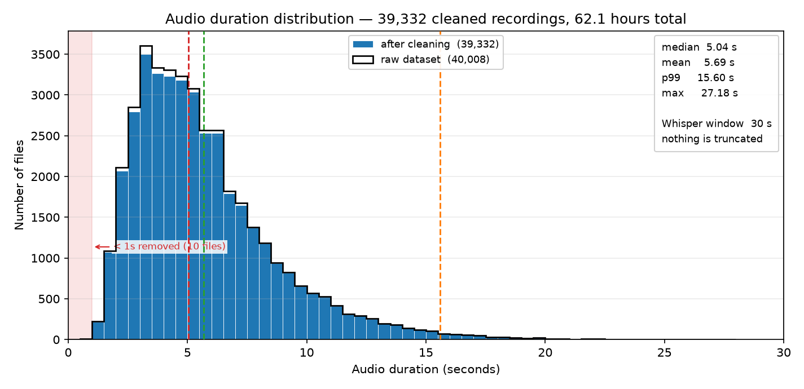
Figure 1 — Audio duration. Filled bars: after cleaning. Outline: raw dataset.
Unimodal and right-skewed, peaking near three seconds. The mean above the median is the signature of the long tail. The longest file is 27.18 s against a 30 s window and 99% of the corpus is under 15.60 s, so nothing is truncated — the failure mode assumption 2 was written to catch is ruled out.
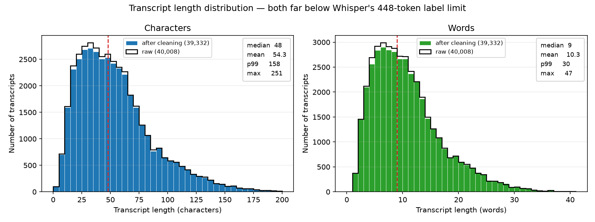
Figure 2 — Transcript length in characters and in words, raw against cleaned.
The same shape, as expected: transcript length is duration multiplied by speech rate. The ceiling that matters here belongs to the decoder — Whisper generates at most 448 tokens, and the longest transcript is 251 characters, roughly 100 tokens. Label truncation at 448 is implemented defensively in the collator, and this distribution confirms it never fires. Worth verifying rather than assuming, because a truncated label silently teaches the model to stop mid-sentence.
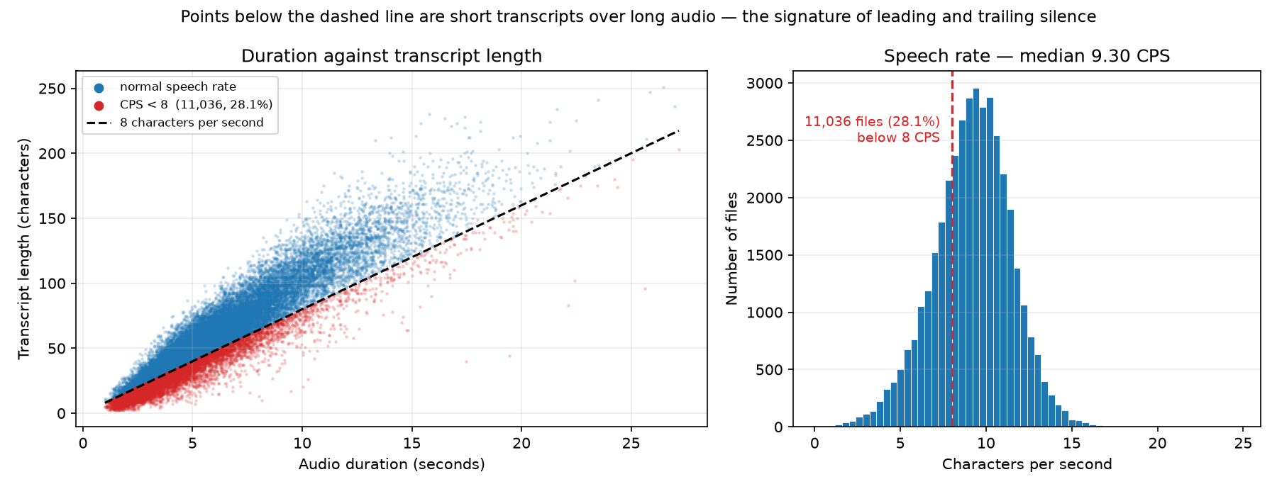
Figure 3 — Duration against transcript length, and the distribution of speech rate.
A qualification on the silence finding. The left panel shows a strongly linear relationship, which rules out assumption 4: no distinct population pairs long audio with a one-word transcript. The right panel shows why that matters. The speech-rate distribution is unimodal and near-symmetric around 9.30 CPS, so the 8.0 threshold does not separate two populations — it cuts the left flank of one. The honest reading is not that 28% of the dataset is broken, but that speech rate varies continuously and 8.0 is a defensible yet arbitrary line. This does not weaken the preprocessing decision: silence trimming works on each file's actual waveform, removing whatever is present and leaving clean files untouched. The threshold was used for reporting, never for deciding.

Summary of the cleaning pipeline
Stage | Records | Change
Raw dataset | 40,008 | —
After removing exact duplicates | 39,874 | −134
After capping long repeats at 3 copies | 39,342 | −532
After removing sub-second audio | 39,332 | −10
Final, used for training | 39,332 | 98.31% retained

Split into 33,432 training and 5,900 validation records on unique id.

6. If training becomes unstable, which characteristics of this dataset would you investigate first?

