Task 1 — Dataset Investigation
Neyshekar Persian ASR · investigation carried out before any training code was written
Every figure quoted in this section is reproducible. Running verify_task1.py replays the cleaning pipeline directly from the raw parquet shards, importing the same helper functions the pipeline itself uses rather than a reimplementation of them, and prints a MISMATCH line against any number here that it cannot reproduce. The distribution plots and the statistics printed beside them come from a single script, plot_dataset.py, so the figures and the prose cannot drift apart.

1. What assumptions can you make about the dataset?
Six assumptions were formed before looking at the data. Each is written as something that could turn out to be false, so that the investigation had a way of being wrong rather than simply confirming itself.
- 1. Hallucination-prone samples. Whisper's decoder is autoregressive and always emits a token. Given audio with no speech in it, it does not return an empty string — it falls back on its language prior and produces text that was never spoken, often looping. I assume some portion of this dataset contains long silences or noise-only stretches.
- 2. Duration outliers. The feature extractor operates on a fixed 30-second window. Audio below roughly one second lacks the context the encoder needs; audio above thirty seconds is silently truncated, which breaks the alignment between speech and transcript. The dataset card states a 27-second maximum, but a claim on a card is not a measurement.
- 3. Orthographic anomalies. Persian text in the wild routinely contains Arabic codepoints in place of their Persian equivalents: Arabic yeh (U+064A) for Persian yeh (U+06CC), and Arabic kaf (U+0643) for Persian kaf (U+06A9). The two pairs are visually near-identical but are distinct codepoints, so the tokenizer treats them as unrelated symbols and splits what should be one embedding across two. I also assume numbers appear as digits, which does not match audio in which they are spoken as words.
- 4. Audio–text misalignment. I assume some rows pair a long recording with a very short transcript, or the reverse. This is detectable as outliers in speech-rate statistics without listening to anything.
- 5. Duplication. I assume duplicate rows exist in text, in audio, or in both. Left in place they inflate the weight of particular sentences and push the model toward memorisation.
- 6. Sampling-rate inconsistency. Whisper's encoder operates only at 16 kHz. The dataset card claims all audio already is, but as with the duration claim, resampling should be applied defensively rather than trusted.

2. Are there duplicated transcripts?
Yes, and they have to be separated into kinds before deciding what to do, because in speech recognition the word covers two opposite situations. The same transcript paired with different audio is valuable: it gives the model one sentence across several speakers, accents and recording conditions, which is precisely the variation it needs. The same transcript paired with the same audio is pure redundancy, and a sentence repeated many times becomes a hallucination trigger.

Normalising before comparing
Comparing raw strings would produce false negatives, since two identical sentences typed with different conventions do not match as strings. Text was therefore standardised across all 40,008 raw records first.
Anomaly | Records | Share | Action
Arabic yeh / kaf codepoints | 1,480 | 3.70% | mapped to Persian yeh (U+06CC) and kaf (U+06A9)
Numeric digits | 1,191 | 2.98% | lexicalised — the numeral 12 replaced by the Persian word for twelve

Verification after the pass confirmed zero remaining Arabic characters and zero remaining digits in the training labels.
A temporary fingerprint column was then built by stripping spaces, zero-width non-joiners, diacritics and punctuation. It exists only to answer whether two rows are the same sentence, and is never used as a training label — a transcript without spaces is not a transcript, and word error rate cannot be computed on one.

The deduplication policy
Category | Rule | Records | Action
Exact row duplicates | identical audio and identical text | 134 | dropped
Short conversational phrases | under 15 characters or under 4 words | 3,479 | kept in full
Long repeats, 2–3 copies | — | 18,520 | kept in full
Long repeats, over 3 copies | capped at 3 | 1,191 kept | 532 dropped

The three thresholds are the only judgement calls in the pipeline, and each has a reason. Short phrases — greetings, one-word confirmations — are exempt because they genuinely recur at high frequency in any speech corpus — that is a property of spoken Persian rather than a defect, and removing them would bias the model against the utterances it will meet most often. The cap of three on long sentences is the compromise between two failure modes: below it, multi-speaker variety is discarded; above it, one sentence gains enough weight to pull the decoder toward reciting it.
Result: 666 records removed from 40,008, leaving 39,342 — a retention rate of 98.34%.

Duplication across the train/validation split
The analysis above concerns duplication within the dataset. There is a second form that matters more for how the final metrics should be read.
The split was made on the unique id, so no recording appears on both sides — verified, the id overlap is exactly zero. But the split was not made on transcript content, and because the same sentence is often recorded by several speakers, the same text can land in both halves.
Measure | Value
Validation rows whose transcript also occurs in training | 3,061 (51.9%)
Of those, long transcripts (≥15 characters and ≥4 words) | 2,595 (44.0% of validation)
Recordings shared between the two splits | 0

This is not leakage in the strict sense: no validation waveform was trained on, and the acoustic task on those rows is genuinely unseen. But Whisper is an encoder–decoder model and its decoder is a language model, so for half the validation set it is producing a sentence it has already been trained to produce. Reported validation WER is therefore optimistic relative to performance on unseen sentences, and the 44% figure shows this is not explained away as an artefact of common short phrases.
The honest fix is a transcript-disjoint split, in which no fingerprint appears on both sides. That was not done here because the split was already fixed before this was measured and re-splitting would have invalidated the training run. It is recorded as a known limitation of the reported metrics rather than left for a reader to discover.

3. Are there invalid audio files?
Yes, but they are a negligible fraction. Invalid here means corrupted, silent, or outside the temporal range Whisper can use. A vectorised header scan across all 40,008 samples answered this without decoding 7 GB of audio into memory.
Check | Result
Unreadable or corrupted headers | 0
Absolute digital silence (all-zero amplitude) | 0
Files longer than 30 s | 0
Files shorter than 1.0 s | 10 (dropped)

On the ceiling. The measured maximum is 27.18 seconds. This is worth stating precisely, because the dataset card claims a 27-second maximum and the true value exceeds it — slightly, by 0.18 s, but it exceeds it. The practical conclusion is unchanged: nothing approaches the 30-second boundary, so no file is truncated and no audio–text alignment is broken by the feature extractor. The value of measuring rather than trusting is that this is now established rather than assumed.
On the floor. The 10 sub-second files were dropped. Below roughly one second there is not enough context for the encoder to build a useful representation, and such samples contribute noise to the gradient rather than signal.
After deduplication and audio validation, 39,332 records remain.
Statistic | Value
Records | 39,332
Total audio | 62.1 hours
Duration — mean | 5.69 s
Duration — median | 5.04 s
Duration — standard deviation | 2.98 s
Duration — min / max | 1.02 s / 27.18 s
Duration — 95th / 99th percentile | 11.54 s / 15.60 s

4. Are there suspicious samples?
Yes. The 39,332 remaining records are all valid, but validity and suitability are different questions. Examining speech rate and signal amplitude surfaced two large groups that are individually well-formed yet collectively pose a specific threat to training stability.

Finding 1 — low speech rate, indicating silence
11,036 samples (28.06%) fall below 8.0 characters per second, against a corpus median of 9.30. A low value means a short transcript stretched over a long recording. Since the transcripts were verified as accurate, the extra duration is not unspoken words — it is silence, background noise, or dead air at the edges of the clip.
Why it matters. Silence is the specific input that triggers Whisper's best-documented failure mode. The decoder always produces a token; given an encoder state carrying no speech it falls back on its language prior and emits text that was never spoken, frequently looping. Training on a large share of samples containing substantial silence teaches the model that silence maps to text, which is exactly the association that should be broken.

Finding 2 — amplitude clipping
8,693 samples (22.10%) reach a peak absolute amplitude at or above 0.99, meaning the waveform hit the digital ceiling and its peaks were flattened.
Why it matters. Clipping is not merely quiet distortion. Flattening a peak injects broadband harmonic energy that was not in the original signal, and this propagates into the log-Mel spectrogram as spurious high-frequency content. During fine-tuning that appears as unusually large gradients on the affected batches.

Why these were not removed
Together the two groups touch roughly half the dataset. Dropping them would have destroyed the corpus to fix a problem better addressed in preprocessing, and the resulting model would be trained on a distribution no longer resembling the audio it will actually receive. The investigation was therefore allowed to determine the Task 2 preprocessing rather than the Task 1 filtering.
Finding | Preprocessing response
Long silences (28.06% below 8 CPS) | Energy-based trimming of leading and trailing silence, retaining a 100 ms margin, with a 1.0 s floor so trimming can never create a sub-second sample
Clipping (22.10% at the ceiling) | Peak normalisation to −3 dBFS, applied as a single scalar multiplication so relative dynamics are untouched

Neither step is standard in a Whisper fine-tuning recipe. Both are in the pipeline because this investigation found a specific reason to put them there, and each traces back to the measurement that motivated it.

5. Distribution analysis
Both the raw and the cleaned distributions are shown on each histogram. The brief asks for an investigation of the dataset before any training code is written, so the subject is the corpus as delivered — the black outline. The filled bars are the corpus after cleaning, which is what the model actually saw. Plotting only the cleaned version would show the result of my own work rather than the data under investigation; plotting only the raw version would describe a corpus that was never trained on. Overlaying them answers a question neither can answer alone: whether the cleaning distorted the data.
It did not.
 | Raw (40,008) | Cleaned (39,332) | Change
Mean duration | 5.67 s | 5.69 s | +0.01 s
Median duration | 5.04 s | 5.04 s | 0.00 s
Max duration | 27.18 s | 27.18 s | 0.00 s
Mean transcript (characters) | 53.9 | 54.3 | +0.4
Mean transcript (words) | 10.2 | 10.3 | +0.1

Removing 1.7% of the corpus moved the mean duration by 0.01 s and the median by nothing at all. The cleaning was targeted rather than a reshaping of the corpus. Had the outlines diverged, that would have been a warning that the filtering introduced a bias worth examining before training on the result — which is the reason to draw both rather than assume.

Audio duration
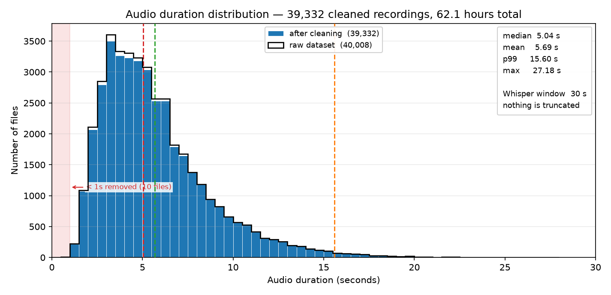
Figure 1 — Audio duration. Filled bars: after cleaning. Black outline: raw dataset.
The distribution is unimodal and right-skewed, peaking around three seconds with a long thin tail. The mean sitting above the median is the arithmetic signature of that tail: a small number of long recordings pull the average up while most files are shorter than it.
Nothing is truncated. The longest file is 27.18 s against Whisper's 30 s window, and 99% of the corpus is under 15.60 s. No audio is cut off, so no transcript describes speech the encoder never received. This is the failure mode assumption 2 was written to catch, and the measurement rules it out.
The window is fixed, which is expensive. Whisper pads every input to exactly 3,000 mel frames regardless of true length. With a median of 5.04 s, roughly 83% of every forward pass is padding. This is a property of the architecture rather than a defect in the data and cannot be fixed by filtering, but it explains why throughput here is governed by the number of samples and not by their duration, and why length-bucketing — which helps substantially for architectures with variable-length inputs — buys nothing. The consequence appears in Task 2: the memory budget is the same whether the audio is 2 seconds or 20.

Transcript length
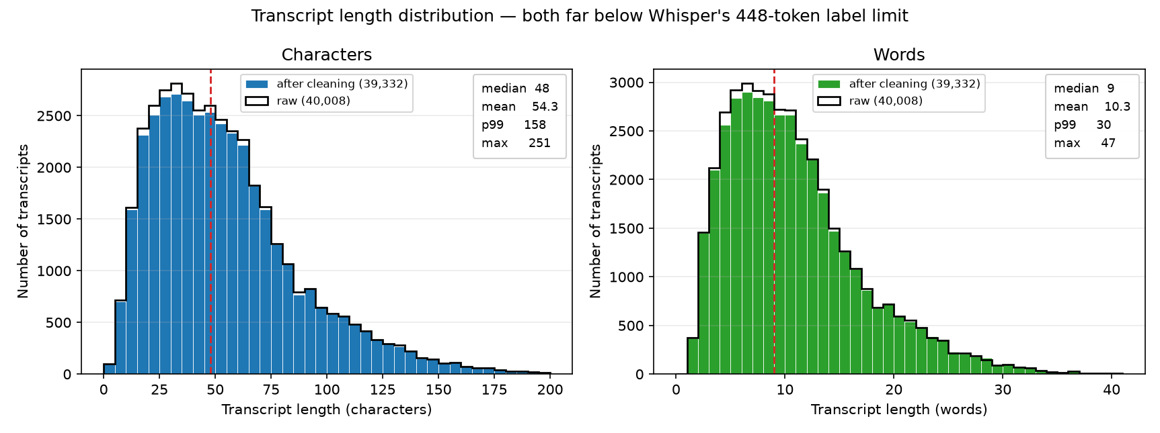
Figure 2 — Transcript length in characters and in words, raw against cleaned.
Statistic | Characters | Words
Mean | 54.3 | 10.3
Median | 48 | 9
99th percentile | 158 | 30
Max | 251 | 47

The same right-skewed shape, which is expected: transcript length is essentially duration multiplied by speech rate, so it inherits the duration distribution's form.
The relevant ceiling here belongs to the decoder rather than the encoder. Whisper generates at most 448 tokens. The longest transcript is 251 characters, which for Persian subword tokenisation is roughly 100 tokens — well under half the limit. Label truncation at 448 is implemented in the collator as a defensive measure, and this distribution confirms it never actually fires. That is worth knowing rather than assuming, because a truncated label silently teaches the model to stop mid-sentence.
The raw and cleaned outlines differ very slightly here, and in a direction worth noting: the cleaned transcripts are marginally longer, 54.3 characters against 53.9. That is not an error. Lexicalisation replaced each numeral with its spoken form, which adds characters while making the text a more faithful record of what was said. A cleaning step that shortened transcripts would deserve scrutiny; one that lengthens them by spelling out numbers is doing exactly what it was written to do, and the +0.4 shift is the visible trace of the 1,191 rows that contained digits.

Speech rate, and a qualification on the silence finding
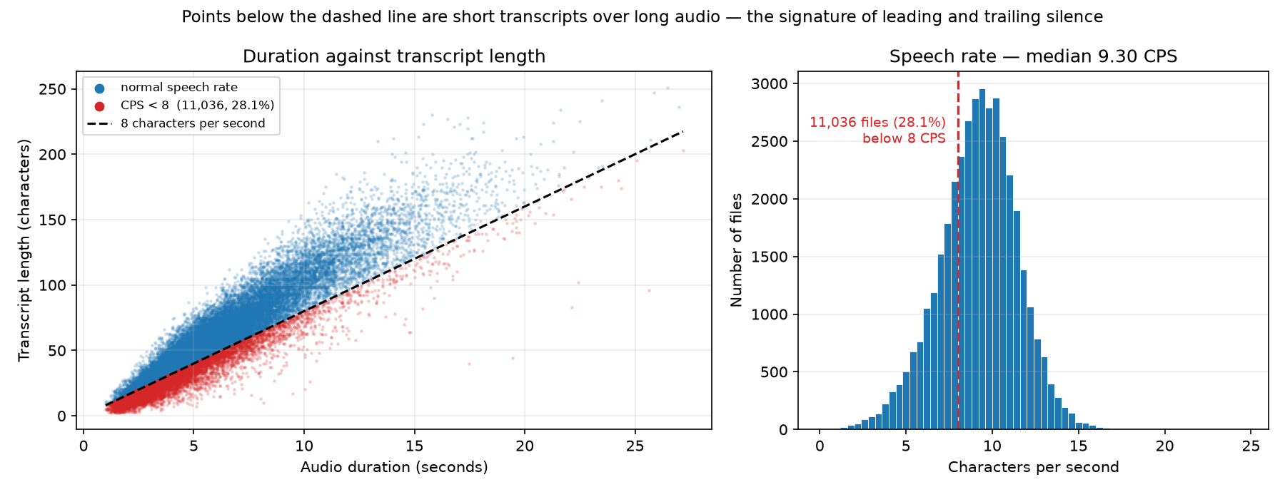
Figure 3 — Duration against transcript length, and the distribution of speech rate.
The left panel plots duration against transcript length. The relationship is strongly linear, which is itself a useful negative result: transcripts are broadly faithful to their audio, and assumption 4 — that some rows pair long audio with a one-word transcript — does not hold as a distinct population. The points below the 8 CPS line form a boundary of the same cloud, not a detached cluster.
The right panel makes this explicit. The speech-rate distribution is unimodal and close to symmetric, centred on 9.30 characters per second. The 8.0 threshold does not separate two populations; it cuts into the left flank of one.
This qualifies the finding in section 4, and is stated rather than glossed over. The honest reading is not that 28% of the dataset is broken. It is that speech rate varies continuously, that files at the low end contain proportionally more non-speech audio, and that 8.0 CPS is a defensible but arbitrary place to draw a line. Silence trimming remains the right response, and importantly it does not depend on the threshold being correct: the trimming operates on each file's actual waveform, removing whatever silence is present and leaving files with none untouched. The threshold was used for reporting, never for deciding. A report describing the low tail as a separate defective subset would be claiming more than this plot supports.

6. If training becomes unstable, which characteristics would you investigate first?
In the order I would actually check them, with the reason each is ranked where it is.
- 1. The low speech-rate tail — silence. Whisper's decoder always emits a token, so an encoder state carrying no speech drives it onto its language prior — the documented mechanism behind hallucination and repetition loops. Instability from this source has a recognisable signature: loss spikes on particular batches rather than a rising trend, and degenerate repeated output at evaluation. It is first because it affects 28% of the corpus and because it damages the model in a way the loss curve alone may not reveal — a model can be looping at generation time while its teacher-forced loss still looks healthy.
- 2. Amplitude clipping. 22.10% of files peak at or above 0.99. Clipping injects broadband harmonic energy that was never in the signal, which propagates into the spectrogram as spurious high-frequency content, and the expected symptom is large gradients concentrated on affected batches. Second rather than first because the damage is bounded — a distorted spectrogram is still a spectrogram — whereas silence teaches an actively wrong mapping.
- 3. Repetition structure in the transcripts. If one sentence carries enough weight, the decoder starts reciting it. This corpus has 39,332 records over 26,626 distinct transcript fingerprints, so repetition is substantial by construction. The cap of three copies is what bounds it, and I would question that threshold before anything else in the cleaning pipeline, because it has the most direct route to decoder collapse.
- 4. Transcript overlap between the splits. 51.9% of validation transcripts also occur in training. This does not destabilise training, but it distorts the signal used to detect instability: validation loss and WER look healthier than reality on those rows, which could mask a developing problem. When the training and validation curves disagree, this is the first thing to rule out before concluding anything about generalisation.
- 5. Duration and label-length outliers. Ranked last because this investigation established there are none: no file exceeds Whisper's window, no transcript approaches the 448-token limit, and the sub-second files were removed. It stays on the list because it is the standard first suspect, and it is worth being able to say it has already been excluded by measurement rather than by assumption.
What I would do in practice. Log the gradient norm at every step, identify the steps where it spikes, map those back to the sample ids in the batch, and look up their speech rate and peak amplitude. That turns the ranking above from a list of hypotheses into a test: if the spiking batches are enriched for low-CPS or clipped samples relative to the corpus rate, the cause is identified rather than guessed. The gradient-norm logging this requires is already in the pipeline, and the plot it produces appears in Task 3.

Summary of the cleaning pipeline
Stage | Records | Change
Raw dataset | 40,008 | —
After removing exact duplicates | 39,874 | −134
After capping long repeats at 3 copies | 39,342 | −532
After removing sub-second audio | 39,332 | −10
Final, used for training | 39,332 | 98.31% retained

Split into 33,432 training and 5,900 validation records on unique id.

