Task 3 — Analysis of the Learning Process
Neyshekar Persian ASR · 3 epochs, 6,270 optimizer steps on a single NVIDIA L4

1. What was measured
Quantity | Frequency | How it is computed
Training loss | every 10 steps | teacher-forced cross-entropy on the training batch
Validation loss | every 1,500 steps | teacher-forced cross-entropy on held-out data
WER and CER | every 1,500 steps | free autoregressive generation, compared to the reference

Loss and error rate are not the same measurement. Loss is computed with teacher forcing: at every position the model is handed the correct previous tokens and only predicts the next one. WER and CER require it to generate the whole transcript unaided, so an early mistake propagates. The two can move independently, and a falling loss does not by itself mean the transcripts are improving.
Each in-training evaluation ran over a fixed, seeded 500-row subset of the validation split rather than all 5,900 rows, because generation is expensive — those five evaluations cost 49 minutes, and the full split took 1 h 53 min on its own. Final metrics were measured over the whole split. Where the two disagree, section 4 uses the disagreement rather than ignoring it.

2. Results
Step | Epoch | Train loss | Val loss | WER % | CER %
1,500 | 0.72 | 0.4192 | 0.16152 | 16.30 | 4.77
3,000 | 1.44 | 0.2081 | 0.12877 | 12.50 | 3.12
4,500 | 2.15 | 0.1110 | 0.10067 | 9.57 | 2.28
6,000 | 2.87 | 0.0779 | 0.08704 | 8.19 | 1.94
6,270 | 3.00 | 0.0678 | 0.08567 | 8.17 | 1.90
final, all 5,900 rows | 3.00 | — | 0.08627 | 8.05 | 2.00

 | First evaluation | Last evaluation | Reduction
Validation loss | 0.16152 | 0.08567 | 47.0%
WER | 16.30% | 8.17% | 49.9%
CER | 4.77% | 1.90% | 60.2%

The training-loss column is a single logged value, and single values are noisy — each is the mean over 10 steps, or 160 samples. At step 1,500 the logged value is 0.4192 while the mean of the ten surrounding points is 0.3563. Figure 1 carries a moving average for that reason.

3. Loss
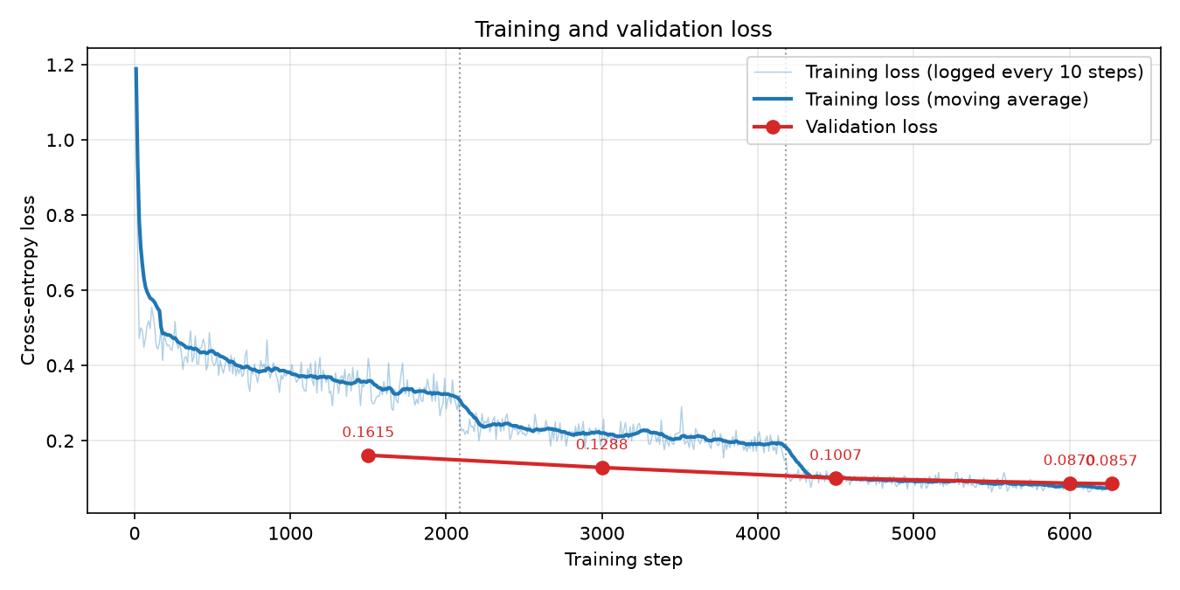
Figure 1 — Training and validation loss. Dotted lines mark the epoch boundaries.
Training loss fell from 1.1888 to 0.0678. Nearly two thirds of that drop happens within the first thirty steps, before the learning rate has finished warming up, and the curve then sits between 0.43 and 0.51 for the next several hundred steps with no trend at all. Validation loss fell at every measurement and never rose.

The steps at the epoch boundaries
Training loss does not decline evenly. It steps down where each epoch ends. Averaging the 200 steps either side separates that step from the within-epoch trend:
 | Decline within the epoch | Step at the boundary that follows
Epoch 1 (steps 1–2,090) | 0.5294 → 0.3115 (−0.2179) | 0.3115 → 0.2384 (−0.0731)
Epoch 2 (steps 2,091–4,180) | 0.2384 → 0.1863 (−0.0521) | 0.1863 → 0.1050 (−0.0813)
Epoch 3 (steps 4,181–6,270) | 0.1050 → 0.0748 (−0.0302) | —

From the second epoch onward the drop at the instant of crossing a boundary is larger than the entire decline across the epoch that follows: −0.0813 at the boundary against −0.0302 over the whole of epoch 3. Across the run, 34% of the total training-loss reduction happens at two instants; excluding the first epoch as initial adaptation, the boundaries account for 65% of everything after it.
Nothing about the optimiser changes at an epoch boundary — the learning rate decays linearly straight through it. The only thing that changes is that the model starts seeing examples it has already seen, so a step down at exactly that point means the improvement comes from re-exposure rather than from continued generalisation. Validation loss has no steps anywhere; it falls smoothly and decelerates. Those two facts together locate where the remaining training-loss reduction was going by the third epoch.

Where the curves cross
Step | Training | Validation | Which is lower
1,500 | 0.4192 | 0.16152 | validation, by 0.258
3,000 | 0.2081 | 0.12877 | validation, by 0.079
4,500 | 0.1110 | 0.10067 | validation, by 0.010
6,000 | 0.0779 | 0.08704 | training, by 0.009
6,270 | 0.0678 | 0.08567 | training, by 0.018

Validation loss starting below training loss looks wrong and is not. LoRA dropout of 0.05 is active while training loss is measured and disabled during evaluation, so the model is handicapped in the first measurement and not the second; and training loss is averaged over a window during which the model is still improving, while validation loss is a snapshot taken at the end of it. The two are level at step 4,500 — a gap of 0.010 in a quantity that has fallen by an order of magnitude — and by step 6,000 the order has reversed and the gap is widening. In Figure 1 the crossing appears slightly earlier, because the plotted training curve is a moving average while the table reports the value logged at each evaluation step. Either way the reversal happens during the third epoch, which lines up with the epoch-boundary pattern above. It is the beginning of the process that becomes overfitting if training continues, not overfitting itself.

4. Word and character error rate
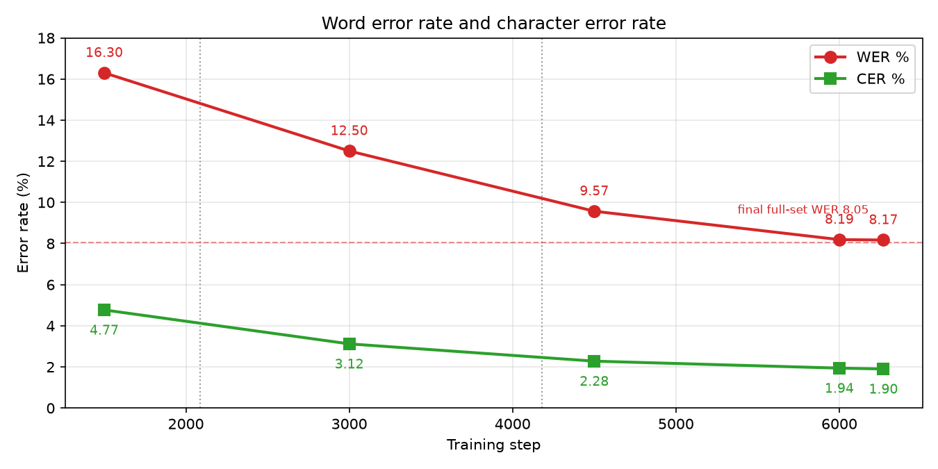
Figure 2 — WER and CER at each evaluation. The dashed line is the final full-split WER.
Interval | WER change | Steps
1,500 → 3,000 | −3.80 points | 1,500
3,000 → 4,500 | −2.93 points | 1,500
4,500 → 6,000 | −1.38 points | 1,500
6,000 → 6,270 | −0.02 points | 270

The last figure is not a small improvement — it is below the measurement floor. The same checkpoint scored 8.17% on the 500-row subset and 8.05% on the full 5,900 rows: a 0.12-point disagreement between two measurements of one identical model. The last observed change is six times smaller than that. The defensible statement is that WER stopped moving measurably after step 6,000, not that it improved slightly.
CER ends at 1.90% against a WER of 8.17%, a ratio better than four to one. WER marks a whole word wrong if one character differs; CER counts only the differing characters, so a ratio this wide means most of what remains is small differences inside otherwise-correct words rather than whole words misrecognised. Task 4 takes those errors apart and finds a quarter of them are Persian spacing and homophone-letter conventions — exactly the kind of error that inflates WER while barely touching CER.

5. Overfitting, convergence and stability
Validation loss decreased at all five measurements and was still decreasing at the end. WER and CER decreased monotonically. The training/validation gap at the end was 0.018. Overfitting is the opposite pattern — training loss falling while validation loss and error rates rise — and it appears nowhere in this run. Two structural reasons make it unlikely at this scale: LoRA trains 15.7 M of 1.56 B parameters, which is very little capacity in which to memorise 33,432 samples, and the linear schedule had decayed the learning rate to 1.6e-07 by the end.
Convergence is a different question, and the model had effectively converged by step 6,000: WER did not move measurably over the final 270 steps, and section 3 shows where the remaining training-loss improvement was going. A fourth epoch would most likely have continued that trade. The run stopped in a reasonable place, though it stopped there because the brief specified three epochs, not because a criterion fired.
Training was stable throughout. The gradient norm stayed bounded — minimum 0.205, maximum 2.759, median 0.948, only four of 626 points above 2.0, and no drift. Clipping was active rather than unnecessary: train.py does not set max_grad_norm, so the default of 1.0 applied and 44.6% of updates were rescaled. One NaN norm was logged at step 1,080, with ordinary neighbours and no spike in the loss — the fp16 scaler detecting an overflow, skipping that update, working as designed.
One caveat applies to every number above. Task 1 established that 51.9% of validation transcripts also occur in training, with different audio, so the decoder has already been trained to produce half of these sentences. That affects the level of every figure here, but not the shapes — the epoch steps, the crossover, the flattening — which are what the analysis rests on.

